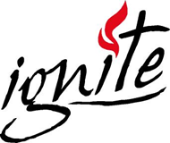  August | 2018
Sunday | Monday | Tuesday | Wednesday | Thursday | Friday | Saturday
 |  |  | 1 | 2 | 3 | 4
 |  |  |  | NewsBoys Concert  Leave 4:00 pm | Lock In -Start 2:30pm | Lock In End 9:30-10:00
5 | 6 | 7 | 8 | 9 | 10 | 11
Sunday School 9:30 |  | Bible Study 1:00 pm | Duck Derby 5:00 HAP
12 | 13 | 14 | 15 | 16 | 17 | 18
Sunday School 9:30
19 | 20 | 21 | 22 | 23 | 24 | 25
Sunday School 9:30
26 | 27 | 28 | 29 | 30 | 31
Sunday School 9:30  WOW Preview |  |  |  |  | Game Night 7:00-11:00

