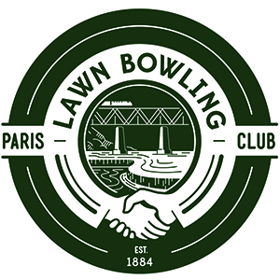
2024 PARIS LAWN BOWLING CLUB
NEW MEMBERSHIP APPLICATION/RENEWAL FORM

Membership cost for the 2024 Paris Lawn Bowling Club season (ADULT) IS $100.00.
Membership cost for the 2024 Paris Lawn Bowling Club season (YOUTH) is $0
Price includes a mandatory association fee for the Ontario Lawn Bowls Association.

Please check one of the following:
NEW Membership Application Membership Renewal

Please check one of the following:
I am an Adult (18+) I am a Youth (12-17)

Which sessions do you anticipate playing (choose as many as you like):
Tuesday Evenings @ 7pm
Thursday Evenings @ 7pm

How to Complete Form & Submit Payment:

Print out and complete this form along with your waiver and bring it in person to the club along with your $100 annual membership fee, payable either in cash or cheque at the start of your first session.

If you wish to pay via eTransfer, please send it to parislawnbowlingclub@gmail.com . Please use password parisbowls for your eTransfer.

Please make your cheque payable to Paris Lawn Bowling Club. Your cashed cheque will be your receipt.

Full Name:

Address:

City: | ON:

Telephone: | Cell:

Email Address:

Person to notify in case of emergency:

Name: | Telephone:

I hereby make application for membership in the Paris Lawn Bowling Club and agree to abide by the Club’s Constitution, By-laws, Rules & Regulations.
Signature: _____________________________  S | Date: ________________

PARIS LAWN BOWLING CLUB 169 GRAND RIVER STREET NORTH PARIS ON
PARISLAWNBOWLINGCLUB.CA

