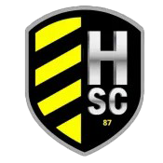
HSC RECREATIONAL
ASSISTANT COACHING
INFORMATION FORM

NAME ____________________________ AGE GROUP_________________ (U10 & up co-ed or Girls) _____________

CHILD PROTECTING __________________________________________
(Your child must be listed as a protected player on the Head Coaches Application)

CONTACT PHONE _____________________ SHIRT SIZE (Men’s Polo Shirt) ________

EMAIL (This is the way the league will contact you. Please use an email address you check on a regular basis) __________________________________________________________________

NUMBER OF YEARS COACHING WITH FHYSC __________________________

DO YOU HAVE A HEAD COACH CHOSEN TO WORK WITH YOU?
YES _____ NO _____

IF YES: (EACH TEAM WILL BE ALLOWED ONLY 1 ASSISTANT COACH)
– WHO IS YOUR HEAD COACH? ______________________________________

IF WE NEED TO PLACE YOU IN A HEAD COACHING POSITION, IS THAT SOMETHING YOU WILL CONSIDER?

YES _____ NO _____

