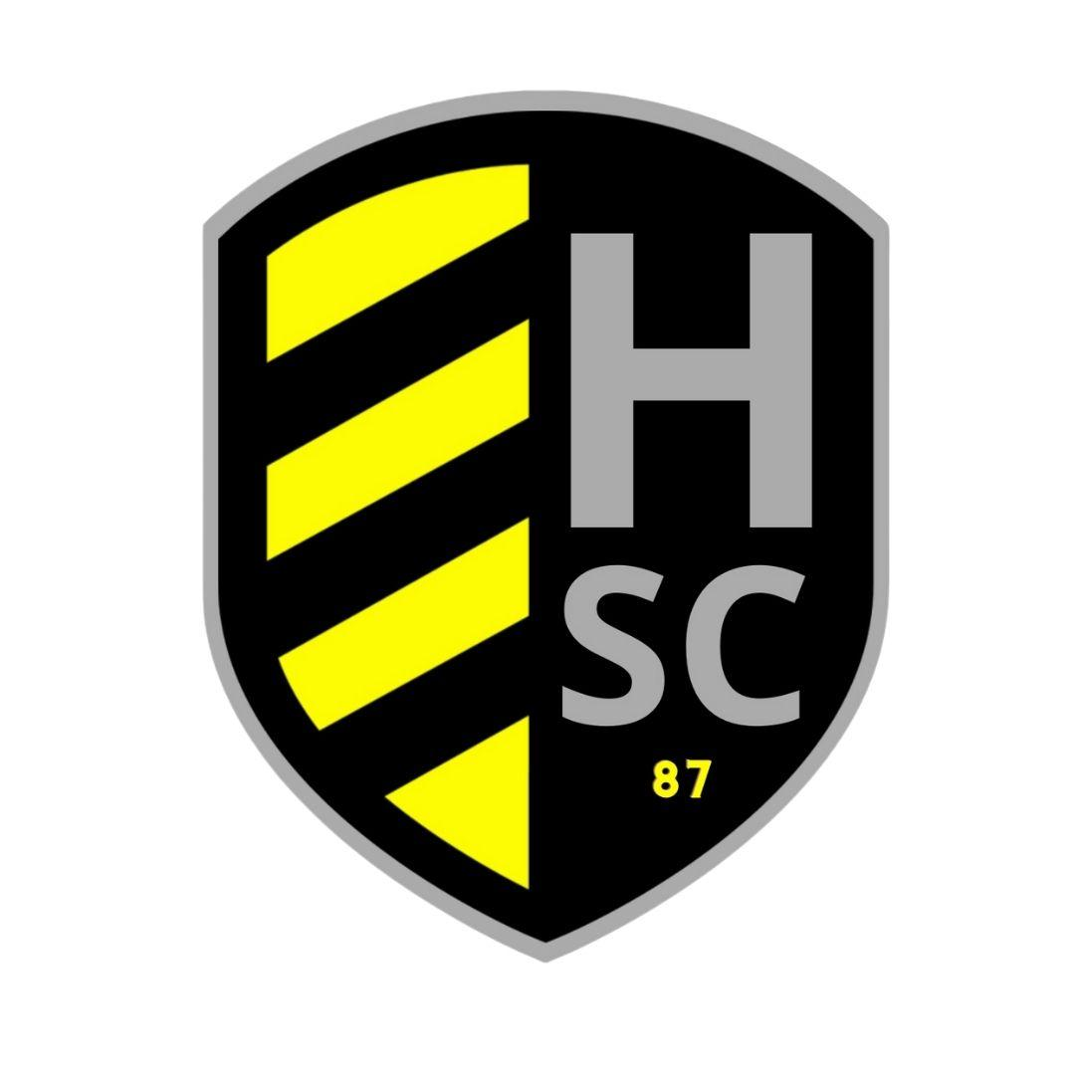
Hernando Soccer Club
P.O. Box 15691
Spring Hill
Florida
34604
www.hernandosoccerclub.com
Dear Sponsor:
Thank You for considering Hernando Soccer Club as a sponsorship opportunity for the upcoming soccer season.
In order to continue our successful programs for the youth of our community we rely on local businesses that serve our community to provide sponsorship to help underwrite the cost of the program. Hernando Soccer Club is a non-profit 501(c)(3) corporation committed to the development of local youth both on and off the soccer field in and around Hernando County. All donations are used solely for the advancement of our youth development programs and are the major source of our club’s funding.
Your donation will guarantee that this becomes a successful and enjoyable season. Please give this request careful consideration. For your convenience we have attached to this letter a form and a list of our available sponsorship opportunities. Simply fill in the form and return it to us along with your contribution.
All donations over $100 donation will be recognized in our program book which is distributed to over 1,000 soccer families, as well as on our website. Feel free to follow our progress in the coming season at www.hernandosoccerclub.com .
Thank you for helping to make another season a reality.
Please retain this letter to substantiate your contribution.
Kindest Regards,
Hernando Soccer Club.

Sponsor packet and further corporate sponsorship opportunities available at
www.hernandosoccerclub.com

H.S.C Sponsorship Opportunities
Please check your sponsorship choices below.
FENCE SIGN + TEAM SPONSOR $550 ☐ SIGN RENEWAL + TEAM SPONSOR $450 ☐
RECREATION TEAM SPONSOR $300 ☐ SIGN RENEWAL NO TEAM SPONSOR $450 ☐
HALF PAGE PROGRAM AD $100 ☐ HEAT TEAM / PLAYER SPONSOR $300 ☐
QUARTER PAGE PROGRAM AD $50☐ KICK WALL SPONSOR $1500 ☐ $2500 ☐
FIELD SPONSORS $1000 1 2 3 (circle one) FIELD SPONSOR $750 4 5 6 (circle one)
COMPETITIVE PRACTICE JERSEY SPONSOR $2500 (2 Available-Must Refer to Treasurer)
CONCESSION SPONSOR $1000______
COMPETITIVE JERSEY SPONSOR $10,000 ______
OTHER SPONSORSHIP (please specify) $_________
Please write the name as you would like for it to appear on our website and / or sponsor awards
Company Name / Sponsor Name:
Name of Player to be credited with sponsor (if any):
Contact Person:
Address:
City: St: Zip:
Email:
Phone :( ) Cell: ( )
Check #: Name on Check:
Credit Card #: Expiration:
Name on Card:
RECREATIONAL SPONSORS PLEASE NOTE: There is limited space on the uniforms. Although we can print whatever you request, please be aware that the more letters we use the smaller they will appear. We suggest the use of abbreviations where possible, (i.e. Inc., Co., Ins., etc.).
THIS SECTION FOR RECREATIONAL TEAM SPONSORS ONLY
REQUEST Uniform Color (subject to availability):
If you have a child participating in the league, please state the child’s name and the age group they will play in Child’s Name: Age Group: U
**PLEASE NOTE: A sponsor’s child is not automatically protected to a team unless the Head Coach has listed their name as one of the protected players.
Office use: Date received: Amount $

