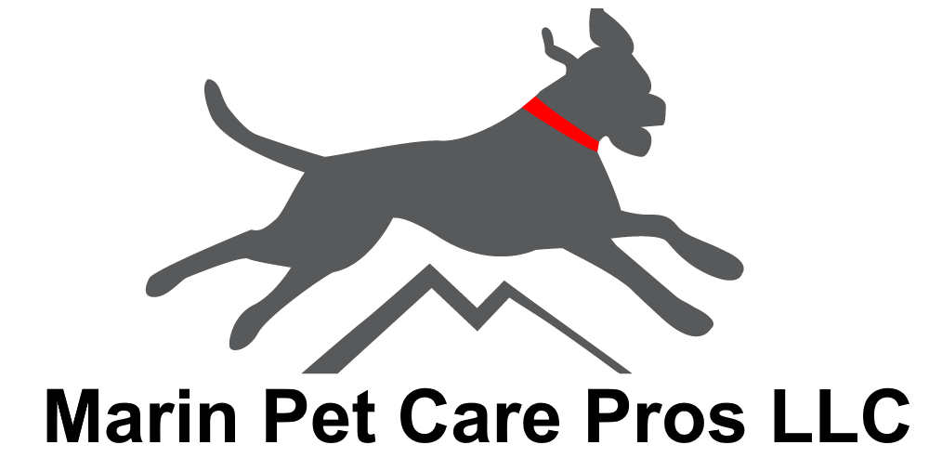 CERTIFIED BASIC OBEDIENCE TRAINING WITH BASIA TOLSCIK, M.A.

IN-DEPTH TRAINING CONSULTATION
All training begins with an In-Depth Training Consultation to assess your dog’s needs, offer preliminary advice, and create a customized Training Plan for their Board & Train stay with us. The cost of the 1.5 hr. consultation (conducted via Zoom or in person at MPCP in Novato) is $200, half of which is applied to your dog’s Board & Train week. Board & Train is priced at $250/day for a minimum stay of one week; two weeks recommended for optimal results. Discount of 20% applied to Week 2. All Board & Train programs end with a mandatory (and complimentary) Training Debrief at MPCP on pick-up day so that you can continue reinforcing what they have learned and build on their success. INSTRUCTIONS: √ Check off the behaviors and/or commands for your dog’s Board & Train THEN number them from highest to lowest priority in the space provided, starting with #1 being of highest priority to you for your pup. Together with the Trainer you will prioritize what you want accomplished during your pup’s Board & Train.
LIST OF BOARD & TRAIN BEHAVIORS AND COMMANDS:

CRATE TRAINING / POTTY TRAINING
Introducing your puppy or dog to their comfy den and teaching them where to go when it’s time to eliminate. Teaching both puppies and adult dogs how to signal when they need to go. We will agree on the best “potty word” to use with your pup. PRIORITY#____

CHEWING / MOUTHING / BITE INHIBITION
Teaching your puppy or dog what is okay to chew and how not to use human hands and arms as chew toys. For puppies: mastering bite inhibition or how not to bear down when they use their mouth. PRIORITY#____

SIT
This is the first command that most dogs and puppies learn in basic obedience and your first exposure to learning how to manage your dog. PRIORITY#____

DOWN
This is the next command most dogs and puppies will learn after accomplishing SIT: to lie down on command. (Must know how to SIT.) PRIORITY#____

STAY
Your dog or puppy will learn how to stay in position until you release them. We will agree on the best “release word” for this command. (Must know SIT and/or DOWN.) PRIORITY#____

RECALL / COME
One of the most important commands for your dog or puppy to know: to come to you when called. We’ll have them coming to you 100% of the time, even with distractions. PRIORITY#____

LOOSE LEASH WALKING / HEEL
Walking politely on leash without pulling you or lagging behind makes for a pleasant experience for both you and your dog or puppy. We will choose the best technique and/or tool to have them staying by your side. PRIORITY#____

OFF
This command addresses not only NOT jumping up on people but also keeping off of surfaces that you don’t want your dog or puppy on such as your bed or kitchen counter. Otherwise known as “four (paws) on the floor!” PRIORITY#____

DROP IT
This command has your dog or puppy releasing the item they have in their mouth to you without your having to pry their jaws open. PRIORITY#____
Call Basia Tolscik, M.A. at Marin Pet Care Pros today at (415) 259-8150 or email basia@marinpetcarepros.com to schedule your 1.5 hr. In-Depth Training Consultation via Zoom or at MPCP. We look forward to being of service to you and your pup!

LEAVE IT
This command stops your dog or puppy from putting anything in their mouth that you don’t want them to. It also teaches them to leave another dog (or human) alone on command. Your dog or puppy will also learn the opposite of this command: TAKE IT. PRIORITY#____

BARKING
Create an ON and OFF switch for your dog’s or puppy’s barking. Training techniques will differ based on the reason for the barking, which is a normal expression of emotion for dogs. PRIORITY#____

DIGGING
Teaching your dog or puppy how NOT to excavate your backyard. Tips, techniques, and solutions for dissuading them from doing so and creating proper outlets for their normal desire to dig. PRIORITY#____

TRICKS & OTHER COMMANDS
Who doesn’t like to show off with their dog?! Here are some fun commands that can be added (time- and ability-permitted) to your dog’s Board & Train selections. Circle the one(s) you want. Don’t see yours? Write it in below!
SHAKE / PAW HIGH FIVE TOUCH
ROLL OVER PLAY DEAD FINISH
SPEAK SING FETCH
PERCH KISS STAND
WAIT WATCH ME (JUMP) OVER
SIT UP/ SIT PRETTY COMMANDO/CRAWL
Copyright © 2024 MarinPetCarePros.com – All Rights Reserved Revised 1/2024

