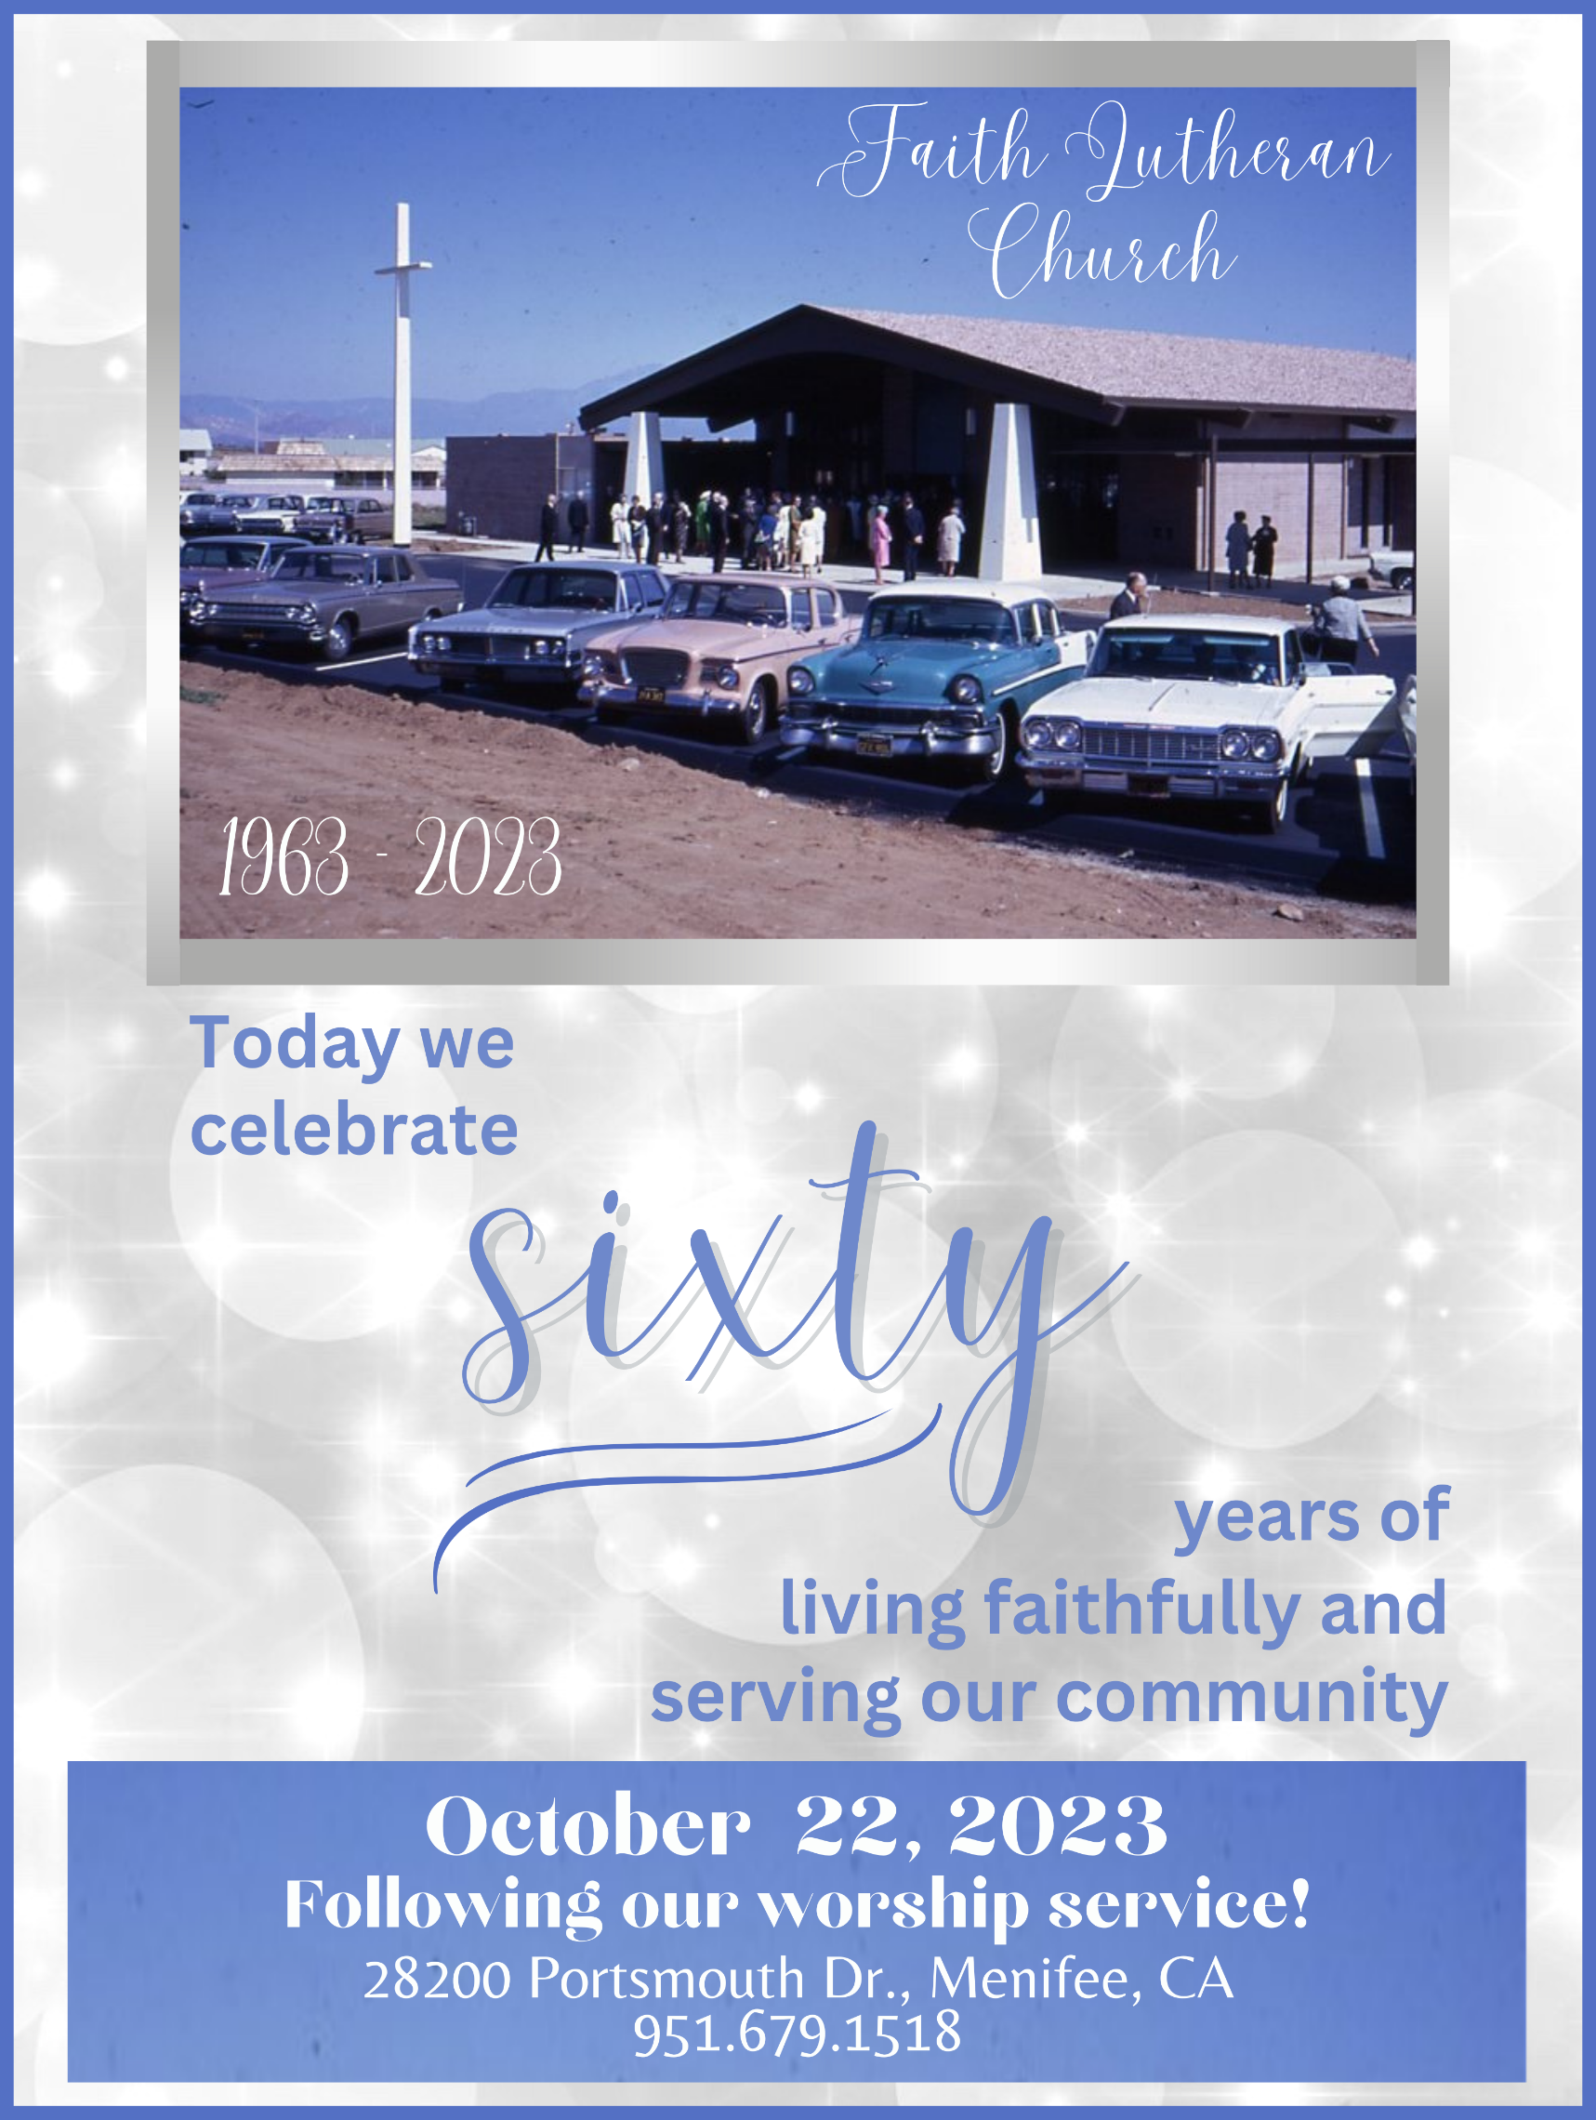
Worship Plan for Sunday, October 22, 2023 * 21st Sunday after Pentecost

Gathering
The Holy Spirit calls us together as the people of God.

Confession and Forgiveness
Blessed be the holy Trinity, ☩ one God, who forgives all our sin, whose mercy endures forever.
Amen.
God of all mercy and consolation, come to the help of your people, turning us from our sin to live for you alone. Give us the power of your Holy Spirit that we may confess our sin, receive your forgiveness, and grow into the fullness of Jesus Christ, our Savior and Lord.
Amen.
Let us confess our sin in the presence of God and of one another.
Most merciful God,
we confess that we are captive to sin and cannot free ourselves. We have sinned against you in thought, word, and deed, by what we have done and by what we have left undone. We have not loved you with our whole heart; we have not loved our neighbors as ourselves. For the sake of your Son, Jesus Christ, have mercy on us. Forgive us, renew us, and lead us, so that we may delight in your will and walk in your ways, to the glory of your holy name.
Amen.
In the mercy of almighty God, Jesus Christ was given to die for us, and for his sake God forgives us all our sins. As a called and ordained minister of the church of Christ, and by his authority, I therefore declare to you the entire forgiveness of all your sins, in the name of the Father, and of the ☩ Son, and of the Holy Spirit.
Amen.

Thanksgiving for Baptism
In the name of the Father, and of the ☩ Son, and of the Holy Spirit.
Amen.
Joined to Christ in the waters of baptism, we are clothed with God's mercy and forgiveness. Let us give thanks for the gift of baptism. We give you thanks, O God, for in the beginning your Spirit moved over the waters and by your Word you created the world, calling forth life in which you took delight.

Through the waters of the flood you delivered Noah and his family. Through the sea you led your people Israel from slavery into freedom. At the river your Son was baptized by John and anointed with the Holy Spirit. By water and your Word you claim us as daughters and sons, making us heirs of your promise and servants of all.

We praise you for the gift of water that sustains life, and above all we praise you for the gift of new life in Jesus Christ. Shower us with your Spirit, and renew our lives with your forgiveness, grace, and love.

To you be given honor and praise through Jesus Christ our Lord in the unity of the Holy Spirit, now and forever.
Amen.

And now please turn to hymn 835
Please stand as you are willing and able.
Gathering Song: All Creatures, Worship God Most High! (ELW 835)

Greeting
The grace of our Lord Jesus Christ, the love of God, and the communion of the Holy Spirit be with you all.
And also with you.

PRAYERS FOR THE ANNIVERSARY OF THE CHURCH
Let us pray.
Most High God, whom the heavens cannot contain, we give you thanks for the gifts of those who have built this house of prayer to your glory; we praise you for the fellowship of those who by their use have made it holy; and we pray that all who seek you here may find you and be filled with joy and peace, through Jesus Christ, our Savior and Lord, who lives and reigns with you and the Holy Spirit, one God, now and forever.
Amen.
O God, you have promised through your Son to be with your church forever. We give you thanks for those who founded this community of believers and for the signs of your presence in our congregation. Increase in us the spirit of faith and love, and make our fellowship an example to all believers and to all nations. We pray through Jesus Christ, our Savior and Lord, who lives and reigns with you and the Holy Spirit, one God, now and forever.
Amen.
Gracious Father, we pray for your holy catholic church. Fill it with all truth and peace. Where it is corrupt, purify it; where it is in error, direct it; where in anything it is amiss, reform it; where it is right, strengthen it; where it is in need, provide for it; where it is divided, reunite it; for the sake of Jesus Christ, your Son, our Lord.
Amen.
Almighty God, grant to your church your Holy Spirit and the wisdom which comes down from heaven, that your word may not be bound but have free course and be preached to the joy and edifying of Christ’s holy people, that in steadfast faith we may serve you and in the confession of your name abide to the end; through Jesus Christ, our Savior and Lord.
Amen.
Draw your church together, O God, into one great company of disciples, together following our teacher Jesus Christ into every walk of life, together serving in Christ’s mission to the world, and together witnessing to your love wherever you will send us; for the sake of Jesus Christ our Lord.
Amen.
Most high and holy God, pour out upon us your one and unifying Spirit, and awaken in every confession of the whole church a holy hunger and thirst for unity in you; through Jesus Christ, our Savior and Lord.
Amen.
We give thanks oh God, for your gift of Faith Lutheran Church’s 60 years of ministry, for the baptisms, weddings, celebrations of life and all the souls who have found you in and through this congregation. May your Holy Spirit guide us in years to come in how to serve our neighbor and draw ever closer to you; through Jesus Christ, our Savior and Lord.
Amen.

Prayer of the Day
Let us pray.
Sovereign God, raise your throne in our hearts. Created by you, let us live in your image; created for you, let us act for your glory; redeemed by you, let us give you what is yours, through Jesus Christ, our Savior and Lord.
Amen.

Children's Chat with Video Slideshow

Word
God speaks to us in scripture reading, preaching, and song.

First Reading: Isaiah 45:1-7
¹Thus says the Lord to his anointed, to Cyrus, whose right hand I have grasped to subdue nations before him and strip kings of their robes, to open doors before him—and the gates shall not be closed: ²I will go before you and level the mountains, I will break in pieces the doors of bronze and cut through the bars of iron, ³I will give you the treasures of darkness and riches hidden in secret places, so that you may know that it is I, the Lord, the God of Israel, who call you by your name. ⁴For the sake of my servant Jacob, and Israel my chosen, I call you by your name, I surname you, though you do not know me. ⁵I am the Lord, and there is no other; besides me there is no god. I arm you, though you do not know me, ⁶so that they may know, from the rising of the sun and from the west, that there is no one besides me; I am the Lord, and there is no other. ⁷I form light and create darkness, I make weal and create woe; I the Lord do all these things.
The word of the Lord.
Thanks be to God.
Psalmody: Psalm 96:1-9
¹Sing to the Lord a new song; sing to the Lord, all the earth.
²Sing to the Lord, bless the name of the Lord; proclaim God's salvation from day to day.
³Declare God's glory among the nations and God's wonders among all peoples.
⁴For great is the Lord and greatly to be praised, more to be feared than all gods.
⁵As for all the gods of the nations, they are but idols; but you, O Lord, have made the heavens.
⁶Majesty and magnificence are in your presence; power and splendor are in your sanctuary.
⁷Ascribe to the Lord, you families of the peoples, ascribe to the Lord honor and power.
⁸Ascribe to the Lord the honor due the holy name; bring offerings and enter the courts of the Lord.
⁹Worship the Lord in the beauty of holiness; tremble before the Lord, all the earth.
Amen.

Second Reading: 1 Thessalonians 1:1-10
¹Paul, Silvanus, and Timothy, To the church of the Thessalonians in God the Father and the Lord Jesus Christ: Grace to you and peace. ²We always give thanks to God for all of you and mention you in our prayers, constantly ³remembering before our God and Father your work of faith and labor of love and steadfastness of hope in our Lord Jesus Christ. ⁴For we know, brothers and sisters beloved by God, that he has chosen you, ⁵because our message of the gospel came to you not in word only, but also in power and in the Holy Spirit and with full conviction; just as you know what kind of persons we proved to be among you for your sake. ⁶And you became imitators of us and of the Lord, for in spite of persecution you received the word with joy inspired by the Holy Spirit, ⁷so that you became an example to all the believers in Macedonia and in Achaia. ⁸For the word of the Lord has sounded forth from you not only in Macedonia and Achaia, but in every place your faith in God has become known, so that we have no need to speak about it. ⁹For the people of those regions report about us what kind of welcome we had among you, and how you turned to God from idols, to serve a living and true God, ¹⁰and to wait for his Son from heaven, whom he raised from the dead—Jesus, who rescues us from the wrath that is coming.
Word of God, word of life.
Thanks be to God.

Gospel Acclamation (ELW p. 151)
Alleluia. Lord, to whom shall we go? You have the words of eternal life. Alleluia.

Gospel: Matthew 22:15-22
The holy gospel according to Matthew.
Glory to you, O Lord.
¹⁵Then the Pharisees went and plotted to entrap [Jesus] in what he said. ¹⁶So they sent their disciples to him, along with the Herodians, saying, “Teacher, we know that you are sincere, and teach the way of God in accordance with truth, and show deference to no one; for you do not regard people with partiality. ¹⁷Tell us, then, what you think. Is it lawful to pay taxes to the emperor, or not?” ¹⁸But Jesus, aware of their malice, said, “Why are you putting me to the test, you hypocrites? ¹⁹Show me the coin used for the tax.” And they brought him a denarius. ²⁰Then he said to them, “Whose head is this, and whose title?” ²¹They answered, “The emperor’s.” Then he said to them, “Give therefore to the emperor the things that are the emperor’s, and to God the things that are God’s.” ²²When they heard this, they were amazed; and they left him and went away.
The gospel of the Lord.
Praise to you, O Christ.

Sermon

And now please turn to hymn 836
Please stand as you are willing and able.
Hymn of the Day: Joyful, Joyful We Adore Thee (ELW 836)

ASSISTING MINISTER: Apostle's Creed
I believe in God, the Father almighty, creator of heaven and earth. I believe in Jesus Christ, God’s only Son, our Lord, who was conceived by the Holy Spirit, born of the virgin Mary, suffered under Pontius Pilate, was crucified, died, and was buried; he descended to the dead. On the third day he rose again; he ascended into heaven, he is seated at the right hand of the Father, and he will come to judge the living and the dead. I believe in the Holy Spirit, the holy catholic church, the communion of saints, the forgiveness of sins, the resurrection of the body, and the life everlasting. Amen.

Pastor and Assisting Minister: Prayers of Intercession
Trusting in the transformative power of God’s loving Spirit, let us pray for the church, the world, and all in need.
Faithful God, your Spirit animates the church throughout the world and binds believers near and far into the body of Christ. Equip us for the work of faith, and enlarge our hearts for the labor of love. God of grace,
hear our prayer.
Creating God, the sea roars, the earth rejoices, and the heavens are glad at the wonder of all you have made. Bless the work of ecologists and conservationists and all those who safeguard the riches of creation. God of grace,
hear our prayer.
Sovereign God, your rule and authority is over the cosmos. As you once worked through the ruler Cyrus for the good of your people, accomplish your purposes through the work of elected leaders and public servants. Guide them with your wisdom and compassion. God of grace,
hear our prayer.
Caring God, your arms enfold all who are lonely, oppressed, despairing, sick, and suffering, especially Jamie, JoLynne Buehring; the Burke family; Arnette Calkins; Jessica Clark; Vicki Crow; Arlene Dressler; Carole Erickson; Mandi Hadden; Don Little; Patsy Loughboro; Sue Macias; Donna McCain; Jean Miles; Sandra Miller; Thordis Moe; Carol Morris; Michael Myers; Sheila Neal; Ray and June Paxton; Joelle Ramos; Marilyn Rieti; Karen Schnaufer and family; Dee Seel; Joyce Stromberg; Jim and Kay Thomas; David Vendetti, Diana Ward; Peggy Westby; Harold Whitford; the homebound; the emergency responders; and those grieving and anticipating surgery/tests. At this time, we also pray for those we name aloud or silently in our hearts.
Pour out your abundant mercy on all whom this world has neglected, abandoned, and forgotten, that they may know your joy. God of grace,
hear our prayer.
Almighty God, all our life belongs to you. When earthly idols threaten to lead your church astray, remind us that you alone are the source of our eternal hope. Direct the work of church treasurers, councils, and all who manage financial matters. God of grace,
hear our prayer.
Everlasting God, the saints of every age have sung your praise and shared your word. We give you thanks for their witness and pray that we may join them as citizens of your unending kingdom. God of grace,
hear our prayer.
Gracious God, into your hands we commend all for whom we pray, trusting in your unending love and amazing grace; through Jesus Christ, our Savior.
Amen.

Peace
The peace of Christ be with you always. And also with you.
Offering
At this time, we remember that the giving of our offering is an authentic part of worship. Whether you give of your time, talents, or treasures, a combination of them, or are discerning how you can give to God's beloved community, thank you so much for all the ways you give and help to make the ministries of this church possible!

Assisting Minister: Offering Prayer
Let us pray.
Holy God, gracious and merciful, you bring forth food from the earth and nourish your whole creation. Turn our hearts toward those who hunger in any way, that all may know your care; and prepare us now to feast on the bread of life, Jesus Christ, our Savior and Lord.
Amen.

And now please turn to hymn 654
Please feel free to either listen to our musical offering or sing along
Musical Offering: The Church's One Foundation (ELW 654)

Great Thanksgiving
Dialogue (ELW p. 152)
The Lord be with you.
And also with you.

Lift up your hearts.
We lift them to the Lord.

Let us give thanks to the Lord our God.
It is right to give our thanks and praise.

Preface (ELW p. 153)
It is indeed right, our duty and our joy, that we should at all times and in all places give thanks and praise to you, almighty and merciful God, through our Savior Jesus Christ; who on this day overcame death and the grave, and by his glorious resurrection opened to us the way of everlasting life. And so, with all the choirs of angels, with the church on earth and the hosts of heaven, we praise your name and join their unending hymn:

Holy, Holy, Holy (ELW p. 153)
Holy, holy, holy Lord, Lord God of pow’r and might: Heav’n and earth are full of your glory. Hosanna in the highest. Blessed is he who comes in the name of the Lord. Hosanna in the highest.

Thanksgiving at the Table (ELW p. 153)
Holy, mighty, and merciful Lord, heaven and earth are full of your glory. In great love you sent to us Jesus, your Son, who reached out to heal the sick and suffering, who preached good news to the poor, and who, on the cross, opened his arms to all.

In the night in which he was betrayed, our Lord Jesus took bread, and gave thanks;
broke it, and gave it to his disciples, saying: Take and eat; this is my body, given for you. Do this for the remembrance of me.

Again, after supper, he took the cup, gave thanks, and gave it for all to drink, saying:
This cup is the new covenant in my blood, shed for you and for all people for the forgiveness of sin. Do this for the remembrance of me.

Remembering, therefore, his death, resurrection, and ascension, we await his coming in glory.

Pour out upon us the Spirit of your love, O Lord, and unite the wills of all who share this heavenly food, the body and blood of Jesus Christ, our Lord; to whom, with you and the Holy Spirit, be all honor and glory, now and forever.
Amen.

Gathered into one by the Holy Spirit, let us pray as Jesus taught us.
Our Father, who art in heaven, hallowed be thy name, thy kingdom come, thy will be done, on earth as it is in heaven. Give us this day our daily bread; and forgive us our trespasses, as we forgive those who trespass against us; and lead us not into temptation, but deliver us from evil. For thine is the kingdom, and the power, and the glory, forever and ever. Amen.

Instruction for Communion
As you are comfortable, you are invited to come forward to receive communion. All of God’s children are welcome to Christ’s table.
Gather at the altar rail to receive the communion elements or if you wish to receive a blessing, please cross your arms over your chest. You may commune yourself once you’ve received the communion elements. Please commune the bread first, turn over the vessel and then carefully open the grape juice. A gluten-free option is available upon request. Please deposit empty cups in the provided baskets on your way back to your seat.
If you would like communion brought to you at your seat, indicate by raising your hand for the Assisting Minister to see and they will bring communion to you.

Invitation to Communion
Taste and see that the Lord is good.

During Distribution: Here Is Bread (ELW 483)
During Distribution: Eat This Bread: Jesus Christ, Bread of Life (ELW 472)

Communion
The body of Christ, given for you.
The blood of Christ, shed for you.
Amen.

Prayer after Communion
Let us pray.
God of abundance, with this bread of life and cup of salvation you have united us with Christ, making us one with all your people. Now send us forth in the power of your Spirit, that we may proclaim your redeeming love to the world and continue forever in the risen life of Jesus Christ, our Lord.
Amen.

Announcements
Monday, the 23rd: Outreach will meet at 10:00 in person and on Zoom. Pastor Tom will be attending, as well.
Tuesday, the 24th: Hymn Planning meets at 10:00 on Zoom
Wednesday, the 25th: Remembering & Honoring meets at 10:00 in person; the Finance Team meets at 1:00 in person and on Zoom; Bingo Game Day starts at 2:00 in person; Outreach meets at 3:30 in person and on Zoom
Thursday, the 26th: Bible Study begins at 2:00 in person and on Zoom; the Cheer Committee meets at 4:00 in person
Friday, the 27th: Al-Anon meets at 10:30 in the Fellowship Hall
Sunday School will not be held today, but we will resume on October 29th.
Next Sunday, the 29th is New Member Sunday AND Reformation Sunday!
For the month of October, we are collecting boxed potatoes and stuffing, grocery bags, and empty egg cartons for the Community Cupboard. Please place donations in the wire basket in the foyer.
For more information and a complete monthly calendar, contact the church office. You can also go to the narthex and sign up to have the Forecaster and weekly announcements sent to you via email or via phone call. Thank you!

Blessing
The Lord bless you and keep you.
The Lord’s face shine on you with grace and mercy.
The Lord look upon you with favor and ☩ give you peace.
Amen.

And now please turn to hymn 365
Please stand as you are willing and able.
Sending Song: Jesus Christ Is Risen Today (ELW 365)

Dismissal
Go in peace. Serve the Lord.
Thanks be to God.

From sundaysandseasons.com. Copyright © 2023 Augsburg Fortress. All rights reserved.

