JOYcabulary Lesson Template

Title: What Are Words Really? | Author: Alexi Lubomirski
Genre/Unit: JOYcabulary Launch | Shared Reading: “Words”  Jill Eggleton

Objective: to raise the level of word consciouness

Standards:

Knowledge Building: Words matter. Words have power. They can be positive or negative.

Vocabulary
Word | Page | Student Friendly Definition
random | 4 | by chance; no pattern or purpose
inspire | 4 | to give a new idea or make a strong feeling of interest or excitement
glum | 10 | Sad or gloomy
consider | 22, 34 | to think carefully about
surround | 22 | to form a circle around
confidence | 26 | a sense of trust or faith in a person, thing, or yourself
repeat | 30 | to say or do again
unique | 30 | different from everything or everyone else

Warm Up Poem:
Words

I like words like
Lickety-split,
Whacky-doo
Slippity-slop,
And Hullabaloo.

I like words like
Zippity-zoom,
Zippity-zap,
Gurgly-glug,
And flippity-flap.

I like words that
Twist and jerk
To make my tongue
Do some work.

Jill Eggleton
Reading:
Page # | Accountable Talk | JOYcabulary
Before Reading | Look at the cover. Think about the title question. T&T | Jot responses on a chart
During Reading  P. 1 - 12 | Words can make you feel good or unhappy; make you laugh; joyful | Jot happy, unhappy and silly words kids already know.
P. 13 - 20 | There’s an old saying: Sticks and stones can break my bones, but words will never harm you.  Is that really true? | Let’s look at our list and circle harmful words. How do people feel when they hear them? Use them?
P. 21 - 38 | Word choice is important in what we say to others, in what we write, and how we even think! | Look at the mean word list. What are some other ways we could say those words so they wouldn’t be painful.
precise | Concept Word | We need to use precise words (clear; exact) so our listeners and readers understand exactly what we mean.

Extensions:

Verticals
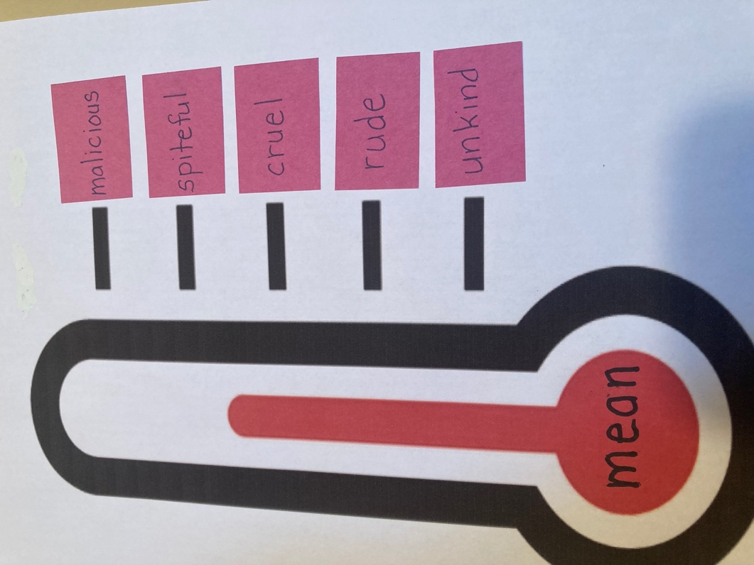

Next Steps:

Read another Launch book (Ex: The Word Collector – Peter H. Reynolds)
Students can begin to collect words: in a ring; in a journal; in a box, etc) A classroom collection can be displayed with words sorted into groups.

