SUPERCHIPS POWERGATE 3 INSTRUCTIONS:
BEFORE YOU START, PLEASE NOTE:
You cannot do any damage to the ECU whilst reading it, only when programming it. They usually only fail if the battery goes flat so please ensure your air conditioning, radio, lights, auto wipers, phone chargers etc. are all off whilst reading and programming. If you have a battery charger, it is wise to connect it to your vehicle battery to eliminate the risk of damage occurring.
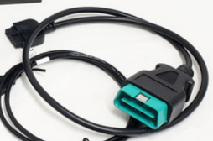
FIRST STEP:
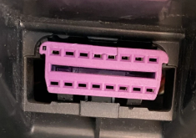
Plug the supplied lead (Fig 1) into the Powergate 3, then plug the green plug into the diagnostic port similar to Fig 2.

Fig 1. Fig 2.
The handheld unit will power up without ignition being on.
Turn on the key to power up the ECU, but do not start the engine. With keyless cars press the start button with your foot off the brake so to not start the engine.
Select ‘Tuning’ and then select the car that is the closest match to your car, if your model isn’t listed.
Then Arrow over and it will say “stock file missing”,
The unit will then ask “do you want to read it now”?
Select “YES” and it will start reading out the OEM Stock File.
DO NOT TOUCH ANYTHING, LET IT COMPLETE THE READING PROCESS.
Once read process completed, unplug and turn the key off or start button to power down the vehicle.
You now need to transfer the file to us for modification.
Email the original read file to the outlet you purchased the unit from, either: jason@aspacsolutions.com or peter@superchips.co.nz
SECOND STEP:
On your PC or Laptop, you must now install the Powergate 3 Software. There is a USB in the box, if not please find application here
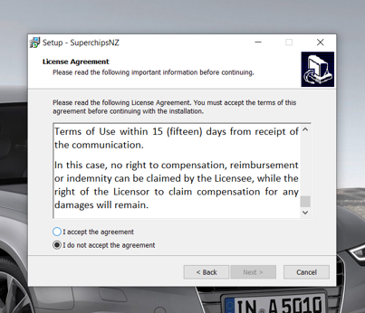
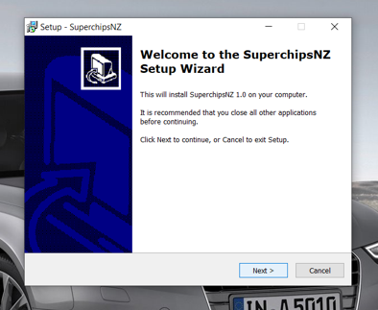 Scroll down agreement & accept.

Once the Powergate 3 Software is installed, plug in the Powergate 3 unit into the computers USB port, it will identify the device and update it.
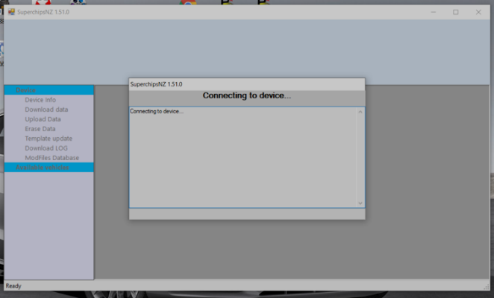
YOU MUST HAVE A GOOD WORKING INTERNET CONNECTION TO USE THE POWERGATE 3.

If it says it cannot initialize the device, unplug it and plug it in again, ensure the software is kept running. It will eventually identify the device and start working.
Once the Powergate 3 finishes updating, then you can select download data in the software, this is your OEM file read. It makes it much easier if you name your file, like Make-model-year-rego.oem. Save this file to your documents on your computer, not your desktop.
Then you open an email. Select “attach file” and select the file you just saved and email your file for tuning making sure that you include all your contact and vehicle information.
Please leave a mobile number not a land line. (this will enable us to txt you)
NOTE: YOU ONLY READ THE OEM FILE ONE TIME, YOU NEVER NEED TO READ IT A SECOND TIME!
THIRD STEP:
Program your car. We modify the file and send it back to you via email. Save the file we send back to you as an attachment in our email to your documents.
Open the Powergate 3 Software again and link up to your Powergate device. Now you select Upload Data. This will upload the new tune to the Powergate 3.
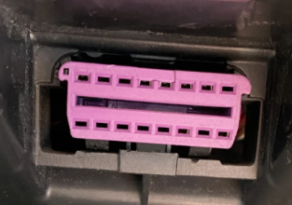
Go to your car, plug into the OBDII port the same as in Fig 1 & 2 and select tuning.
Select the tuned file we sent you that you have saved, switch ignition on and off when the unit instructs you to do so and program your car!
Note: With windows 8, you must disable the signature driver enforcement before you download the Powergate SW. You can find hundreds of links online to see how to do this. Simply google search how to disable signature driver enforcement in windows 8 and they will all pop up for you many videos and instructions.
ATTENTION: IF YOU EVER GET AN ERROR WHILE PROGRAMMING DO NOT TURN KEY OFF OR UNPLUG POWERGATE!!! THIS WILL DAMAGE THE ECU!!! PLEASE GO BACK TO TUNING AND START THE PROGRAMMING OF THE FILE AGAIN OR PROGRAM BACK TO STOCK AND START AGAIN.
THE PROGRAMMING MUST COMPLETE SUCCESSFUL BEFORE YOU DISCONNECT THE CABLE.
TURN OFF THE KEY! YOU ARE NOW READY TO GO!

