NAME:______________________
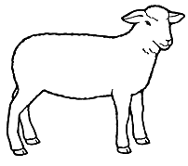 PHONE:_____________________
Weight:_______Ear Tag:_______
KILL FEE PAID YES OR NO $_____

*SHOULDER: STEAKS- Thickness = ____________ # PER PACKAGE:_______
ROASTS-
* NECK BONE YES / NO
* SHANKS: YES / NO
* RIBLETS: YES / NO
*RIB SECTION: RACK OF LAMB
CHOPS – Thickness = _______ # PER PACKAGE ___________

*LOIN: CHOPS- Thickness = ________ # PER PACKAGE _________

*LEGS: ROASTS HALF / WHOLE
STEAKS – Thickness = ________ # PER PACKAGE _________
- STEW – PACKAGE SIZE : __________
- GRIND – PACKAGE SIZE :__________
SPECIAL REQUESTS: __________________________________________________________________________________________________________________________________________________________________________________________________________________________________________
# OF CRATES:___________
_____________________________________________________________________________________________________________________
PICK UP DOCUMENTATION: DATE & TIME PICKED UP:___________________ TOTAL CRATE COUNT: _________________ EMPLOYEE INITIALS:___________CUSTOMERS INITIALS:____________

