Nicole Banks, LMT Massage Intake Form Terri Hallenbeck, LMT

Name _________________________________________DOB_________________
Address_____________________________________________________________
Phone____________________________ Email_____________________________
Occupation_____________________ Emergency Contact_______________________
Referred By__________________________________________________________
Health History
Have you ever had a professional massage before? Yes No
Do you have difficulty laying on your back, front or side? Yes No
Do you have any allergies to lotions, oils or ointments? Yes No
Are you wearing any contact lenses, dentures or hearing aids? Yes No
Do you have any repetitive movement in your work or hobby? Yes No
Are you pregnant? If yes, how many months_______ Yes No
Are you under any medical supervision? Yes No
Are you currently taking any medication? Yes No
If yes, please list ______________________________________________________
___________________________________________________________________
Please check any condition listed below that applies to you:
( ) Contagious skin condition ( ) Deep vein thrombosis/blood clots
( ) Open sores or wounds ( ) Joint disorder
( ) Easy bruising ( ) Osteoporosis
( ) Recent accident or surgery ( ) Epilepsy
( ) Artificial joint ( ) Headaches/ Migraines
( ) Allergies / Sensitivities ( ) Cancer
( ) Heart condition ( ) Diabetes
( ) High or low blood pressure ( ) Decreased sensation
( ) Back / Neck problems ( ) Fibromyalgia
( ) TMJ ( ) Carpal tunnel syndrome
Please explain any condition that you have marked above including any not listed ______________________________________________________________________________________________________________________________________
Please circle any areas that you would like to concentrate on during the session:
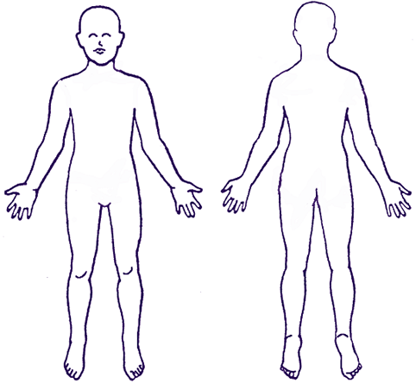

Informed Consent
I (print name) _______________________ understand that Nicole Banks/Terri Hallenbeck is an educated and Licensed Massage Therapist. The massage I receive is provided for the basic purpose of relaxation and relief of muscular tension. If I experience any pain or discomfort during the session, I will inform Nicole/Terri immediately. I further understand that massage should not be construed as a substitute for medical examination, diagnosis or treatment. I should see a physician, chiropractor or other qualified medical specialist for any mental or physical ailment that I am aware of. I affirm that I have stated all my known medical conditions, and answered all questions honestly and to the best of my knowledge. I understand that I may terminate the session at any time regardless of prior given consent. Nicole/Terri may also refuse to work on any client or part of their body with just and reasonable cause. I agree to keep Nicole/Terri updated as to any changes to my medical profile and understand that Nicole/Terri will not be liable should I fail to do so.

Clients Signature_____________________________________ Date_____________

Health History Update
Date ____________
Changes to medical history ____________________________________________________________________________________________________________________________________________________________________________________________________________________________________________________________________________
Client Signature________________________________________

Date ____________
Changes to medical history ____________________________________________________________________________________________________________________________________________________________________________________________________________________________________________________________________________
Client Signature________________________________________

Date ____________
Changes to medical history ____________________________________________________________________________________________________________________________________________________________________________________________________________________________________________________________________________Client Signature________________________________________

