RICHARD LEO HUNT
SAG Eligible
www.richardleohunt.com

Height: 6’3” email: richardleohunt@gmail.com
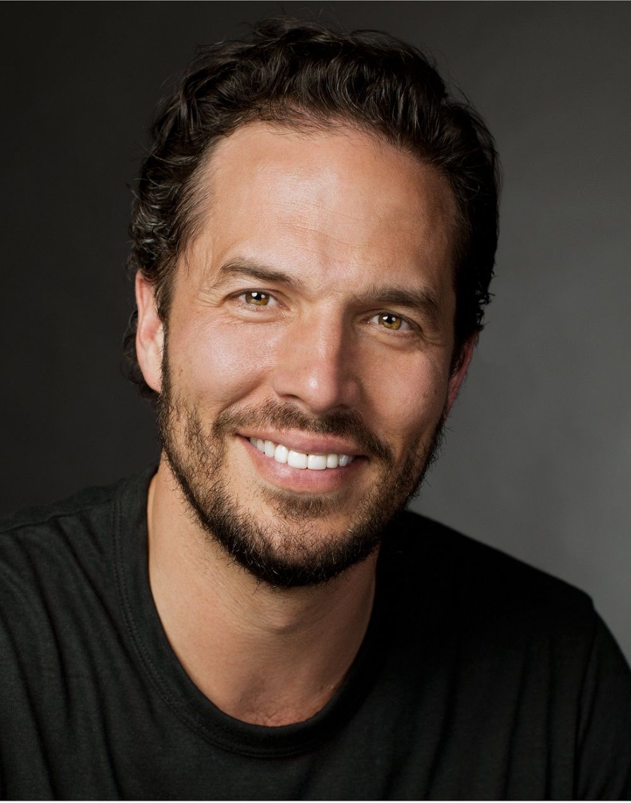
Weight: 210
Build: Athletic
Hair: Brown
Eyes: Brown

FILM
Soldier’s Joy Cody Kincaid (Lead) Director: Danny Ramsey
Summer of ’67 Policeman (Featured) Mainstreet Productions
The Silent Natural #71 Pitcher DMY HOY, LLC (SAG)
Wicked Ones The Wicked One Jonestown Films

TV
Dogwood Pass Sheriff Tom Ramey Director: Lana Read (Post-Production-Pilot)
The Randoms Michael Finch Director: Tom Dallis (Post-Production-Pilot)

COMMERCIAL
Ruby Tuesday Principal Vayner Media
Cracker Barrel Principal Havas

WEB SERIES
Remnant 13 Michael Gracely (Principal) Lindsey Industries

TRAINING

Acting in Commercials Alan Dysert
Mastering the Audition Process Regina Moore
Improvisation Techniques Barry McAlister
Advanced Scene Study Workshop Jamie Elliott
Acting for Film and TV - The Actor’s School Alan Dysert
Audition Workshop Jo Doster
Scene Study Workshop Ricki Maslar
Scene Study Workshop Brad Wilson

EDUCATION B.S. Chemistry / Math
M.S. Engineering Technology Management
Ed.D. Organizational Leadership
Military: U. S. Army / Military Police / Air Assault / Airborne / Special Reaction Team / Weapons Training

SPECIAL SKILLS and INTERESTS

Military Training / Basketball / Track / Baseball / Football / Coaching / Snow Skiing / Hiking /
Fitness Training / Firearm Proficient / Chemist / Algebra Teacher / Business Owner

