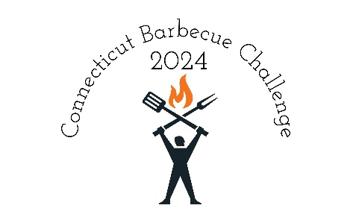
July 12 – 13, 2024
Four Town Fairgrounds
56 Egypt Road
Somers, CT 06071
Cooks Packet

BASIC INFORMATION:
Contacts: Geoff Mullen 860-305-5400 Scott MacDonald 959-282-0067

INCLUDED: Each contest's entry fee includes water, 20+ amp electric, (power is included in your entry fee). Bathrooms are available on site, unfortunately no showers. Sites are approximately 30'x30'. Teams are responsible for providing their own meat, supplies and preparation equipment.
Trash: A dumpster will be available on site, please place your garbage in the dumpster.
Please keep your site clean, it is expected to be in the same condition that you found it when you got there throughout the contest and when you leave. Any team that leaves their site “trashed” Will not be invited back to a New England Barbecue, Inc hosted event. We want to be able to come back to Four Town Fairgrounds again.

Fires- No open fires will be allowed on site. This includes Solo stoves, campfires etc. This is a town ordinance for the Fairground. Any team found with a campfire going will be asked to leave the contest immediately.
Quiet Time – 11:00 PM to 7:00 AM there is a neighborhood adjacent to the fairground we ask that you please be respectful of the neighbors
ELIGIBILITY: Teams must enter the 4 main Masters categories to be eligible for Grand and Reserve Grand Champion. (Chicken, Ribs, Pork and Brisket)
KCBS RULES: Click here for 2024 KCBS RULES & REGULATIONS
FEES: The general price for the Masters contest will be $375.00 the one meat chicken contest will be $85.00. Payment in full is required when you sign up.
Masters contest: Chicken, Ribs, Brisket, and Pork. Turn ins will follow KCBS rules.

ONE-MEAT CONTESTS: The Master of Chicken is open to all teams on Friday night. This contest gives your team an opportunity to try out new flavor profiles and get instant feedback that can be used for the next day’s cook. The cost is $85.00 with an 8-team minimum per contest. Teams can earn category TOY points by participating.
TEAM CANCELLATION POLICY: Change of plans, work, wedding, etc. – NO REFUNDS will be given. Death in family, emergency surgery, wreck, military deployment – FULL REFUND that has paid and cannot attend can: 1) Rollover entry to another New England Barbecue, Inc contest or to next year; 2) Sell entry to another team and notify us who will take your place; or 3) IF we sell out all team spaces AND have a team wanting to get in, we’ll refund you after the new team has paid.

CODE OF CONDUCT POLICY: New England Barbecue, Inc provides an experience that should be safe and free from threatening and intimidating conduct, including aggressive behavior, bullying, or loud and obnoxious vocalizing. We have a ZERO TOLERANCE policy toward any team whose members exhibit violence or threats of violence of any form; those teams will be asked to leave immediately without refund and will not be invited to another New England Barbecue, Inc contest. Please respect our hosts and your fellow teams.

Payouts:
Masters Contest overall: Each Category:
Grand Champion: $1200.00 1st Place $300.00
Reserve Champion: $800.00 2nd Place $200.00
Third overall: $600.00 3rd Place $150.00
Fourth overall: $450.00 4th Place $100.00
Fifth overall: $350.00 5th Place $75.00

One Meat Chicken:
1st Place $250.00
2nd Place $150.00
3rd Place $100.00

Timeline

Friday July 12, 2024

9:00 AM – Teams may start to arrive.
10:00 AM – Meat inspection by KCBS representatives begins.
3:00 PM – Cooks Meeting for both Master of Chicken and KCBS Masters four meat
5:30 PM KCBS Judges Meeting
7:00 PM – Master of Chicken turn in.
8:30 PM – Awards
11:00 PM Quiet Time Begins

Saturday July 13, 2024
7:00 AM Quiet Time Ends
9:22 AM Good Luck Toast
10:30 AM KCBS Judges Meeting
12:00 PM KCBS Chicken Turn in
12:30 PM KCBS Pork Ribs Turn in
1:00 PM KCBS Pork Shoulder Turn In
1:30 PM KCBS Beef Brisket Turn In
Approximately 3:30 PM Awards

Local Stores

Geissler’s Supermarket Big Y Grocery Store
95 South Road Somers, CT 67 Prospect Hill Road East Windsor, CT

Walmart Super Center Big Y Grocery Store
44 Prospect Hill Road East Windsor, CT 135 West Road Ellington, CT

