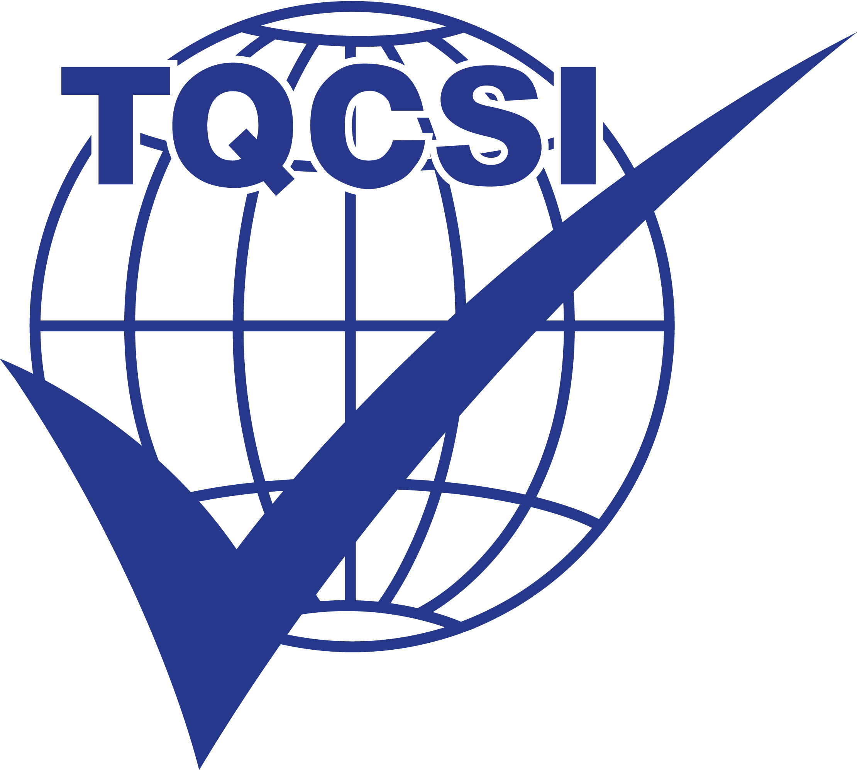TQCS INTERNATIONAL PTY LTD
ABN 59 065 953 924

ENQUIRY FORM

COMPANY DETAILS
Company Name:
Trading Name:
EIN:
Website:
Postal Address:
Site Address:
Telephone:
Primary Contact Name:
Job Title:
Email: |  |  | Mobile:
Accounts Department Email:

STANDARD(S) REQUIRED FOR CERTIFICATION
ISO 9001:2015 | ISO 27001:2013 | TQCSI QHSE Code
ISO 14001:2015 | FSSC 22000 (V5) | TQCSI IS Code
ISO 45001:2018 | ISO 22000:2018 | TQCSI HR Code
ISO 55001:2014 | TQCSI HACCP Code | TQCSI SBQM Code
Others:

CONSULTANCY
Did a consultancy assist with the development and implementation of the management system? | Yes If Yes:  No | Name of consultancy:  Name of consultant:

INTEGRATED MANAGEMENT SYSTEM
Is the management system integrated for all Standards (ie same IMS management; common manual/instructions relevant to ISO Clauses 4, 5, 6, 9 & 10; integrated management review, internal auditing, objectives, approach to system processes, nonconformance reporting, corrective action, continual improvement and management support, including document control). | Yes No

TRANSFER OF CERTIFICATION
Transferring from another Certification Body? Yes No If Yes, complete the following:

Certification Body: | Standard(s): | Expiry Date:

SITES FOR CERTIFICATE & NO. OF EMPLOYEES:
Address | Full Time | Part Time / Casual | Total  (full time employees) FTE
Head Office (address if different to above):

WORK OFF SITE:
Does the Company conduct work off-site? Yes No If Yes, complete the following:
How many employees regularly work off-site:

PROCESSES: Describe the major processes/activities (eg design, fabrication, packaging, storage, distribution)
The scope of registration covers:

PRODUCTS OR SERVICES: Describe the types of products or services
TECHNOLOGIES USED:
MAJOR ACTIVITIES OUTSOURCED:

