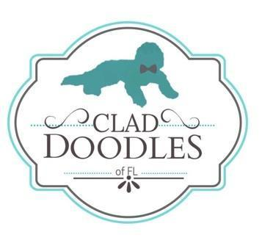
RESERVATION CONTRACT
This reservation contract is to place a reservation for a Clad Doodles ____________puppy in the name of the buyer listed below and to protect both BREEDER and BUYER’S interests.
Date of Contract: __________
This PUPPY RESERVATION FEE CONTRACT is effective when signed below by both BREEDER (whether singular or plural) and BUYER (whether singular or plural). The following terms and conditions are agreed to between BREEDER AND BUYER:
$500 fee from BUYER is to secure the reservation of the puppy. The reservation fee will hold a designated puppy from specified litter as stated below. Fee is non-refundable, except in the following instances: Fee is fully refundable if BREEDER, Clad Doodles, is unable to provide the puppy requested below within the time described; due to non-pregnancy or not enough puppies born in a litter.
Purchase price for a pet puppy is ______, minus the $500 reservation fee. The $500 Reservation Fee can be made by applepay, PayPal friends and family, Venmo, or gooddog.com website.
Payment schedule and policy is as described:
- ● $500​ Reservation fee due to secure picking position.
- ● _______ (balance) Due at Puppy “Gotcha Day” Age 8 weeks - CASH ONLY.
Additional Boarding fees are due in ADVANCE once an arrangement of picking up puppy beyond 8 weeks old is made and once health certificate issued. Boarding rates are $20/day.
Balance MUST be paid in FULL prior to shipping or at the time of pick-up by Buyer. This purchase price does NOT include any delivery charges which are calculated separately on an as needed basis.
The Breeder reserves the right to cancel this contract, in which case any fees will be refunded in full. Puppies will not be released to new homes until they are at least 8 weeks old with a Florida Health Certificate. Puppies are sold as PETS, and no Breeding rights are given
1. Reservation for Puppy (Name of Breed): ____________________________
2. Puppy Parents Names: ______________________________________
3. Kennel Name:
Clad Doodles, LLC
Telephone: _______
E-mail: CladDoodles@gmail.com
4. The Buyer(s) NAME: (Print)__________________________________
E-mail______________________
Street:_______________________________City_____________________State__________Zip________
Telephone:______________________
Breeder(s) Signature:_____________________________________Date:_____________________
Buyer(s) Signature:_____________________________________Date:_____________________

