Registration Details
5 (starting school this fall) -12 years of Age
8:00 – 5:00pm Regular Camp Hours

PART A: CAMPER INFORMATION

Camper First Name Last Name Birth Date D/M/YY Grade Gender

Camper resides with Medicare Number

PART B: FAMILY/GUARDIAN INFORMATION
Home Phone Email
Parent 1 First Name Last Name Cell Phone Business Phone
Parent 2 First Name Last Name Cell Phone Business Phone
Family Address Apt/Unit City/town Postal Code

PART C: ADULT EMERGENCY & AUTHORIZED PICK UP CONTACT INFORMATION
A minimum of 2 other adult emergency contacts are required. Only the adults listed below & Family Guardian will be allowed to pick up camper

1 First Name Last Name Cell Phone Business Phone Relationship to Camper

2 First Name Last Name Cell Phone Business Phone Relationship to Camper

Participants may be photographed. These photographs may be used in print or online media for the current or following years’ programs. Please indicate that you are aware of this policy by checking the appropriate box:

□ I grant Inside Out Nature Centre permission to publish (online, television, and/or printed, etc.) my son/daughter’s image pertaining to program promotional materials

□ I do NOT wish my son/daughters image to be used in program promotional materials.

“Sparking Children’s Curiosities InsideOut”

For more information, Camp Questions, Rules and Regulation guidelines
Please contact:

506-672-0770
insideoutnaturecentre@gmail.com



Offering children in Saint John and surrounding communities a summer recreational day camp experience for children and youth, providing quality programs in a caring and open environment which embraces diversity and encourages personal growth, according to each individual’s uniqueness, strengths, needs and abilities. Keeping campers active and happy this summer while helping them grow and learn!

Please send this form and payment to:
659898 NB Inc
P.O. Box 27036, Saint John, NB E2M 5S8
Tel: 506-672-0770
Toll-free: 1-866-672-0770
Or email: insideoutnaturecentre@gmail.com

DATE | Theme | Price | Session √
Week 1  June 25th – 29th InsideOut Week | All things inside Out and Upside down Forests, fitness, fun! | 175.00
Week 2  July 3rd – July 6th  InsideOut Oh Canada week | All things Canadian EH! (Short Week) | 155.00
Week 3  July 9th – July 13th InsideOut Science week | All things sparking curiosity | 175.00
Week 4  July 16th – July 20th InsideOut Splash week | All things wet & wild | 175.00
Week 5  July 23rd - July 27th InsideOut Culture week | All things Past, Present & Future | 175.00
Week 6  July 30th – Aug 3rd  InsideOut Masterpiece Beach | All things Music & Art in Nature | 175.00
Week 7  Aug 6th – Aug 10th  InsideOut Rocks!  & Leadership Week | All things Stonehammer UNESCO Global Geopark week (Short Week) | 155.00
Week 8  Aug 13th – Aug 17th  InsideOut Survivor week | All things unplugged & Healthy | 175.00
Week 9  Aug 20th – Aug 24th InsideOut Animal wonders | All things Hairy, Furry, feathery & Scalely! | 175.00
Week 10  Aug 27th – Aug 31st  Get ready to Party Inside Out! | New Years, Valentine’s Day, St. Patrick’s Day, Halloween, and of course, everyone’s birthday, are all wrapped into one festive week! | 175.00

Summer Recreational Day Camp Program 2018

Lakeside@ Lily Lake Pavilion in Rockwood Park, Saint John NB
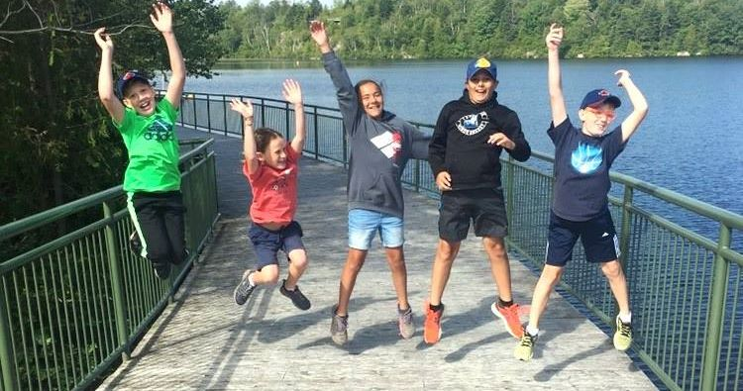

Weekly Camp Highlights:
- Daily Swimming & Playground Activities
- Fun & Educational Field Trips in the Park with some special guests
- Daily Paddling/Soft Adventure Activities
- Inside & Outside Rock Climbing Wall
- Morning & Afternoon Nutrition Break
- Family rates for 2 or more campers
- Tax Included

“Sparking Children’s Curiosities InsideOut”

