**Registration Details**

**5 (starting school this fall) -12 years of Age**

**Leadership Camps 13 to 16 years of age**

**8:00am – 5:00pm Regular Camp Hours**

**PART A: CAMPER INFORMATION**

Camper First Name Last Name Birth Date D/M/YY Grade Gender

Camper resides with Medicare Number

**PART B: FAMILY/GUARDIAN INFORMATION**

Home Phone Email

Parent 1 First Name Last Name Cell Phone Business Phone

Parent 2 First Name Last Name Cell Phone Business Phone

Family Address Apt/Unit City/town Postal Code

**PART C: ADULT EMERGENCY & AUTHORIZED PICK UP CONTACT INFORMATION**

A minimum of 2 other adult emergency contacts are required. Only the adults listed below & Family Guardian will be allowed to pick up camper

1 First Name Last Name Cell Phone Business Phone Relationship to Camper

2 First Name Last Name Cell Phone Business Phone Relationship to Camper

Participants may be photographed. These photographs may be used in print or online media for the current or following years’ programs. Please indicate that you are aware of this policy by checking the appropriate box:

□ I grant Inside Out Nature Centre permission to publish (online, television, and/or printed, etc.) my son/daughter’s image pertaining to program promotional materials

□ I do NOT wish my son/daughters image to be used in program promotional materials.

**“Sparking Children’s Curiosities Inside&Out”**

For more information, Camp Questions, Rules and Regulation guidelines

Please contact:

506-672-0770

[insideoutnaturecentre@gmail.com](mailto:insideoutnaturecentre@gmail.com)



**Connecting Children with Nature**

* Improved Behaviour by reducing stress, anger & aggression
* Develops self-esteem, take personal responsibility, co-operate with and respect the needs of others
* Extends their personal horizons through greater appreciation and understanding of the world and its people around them
* Understanding the need for sustainable relationships between people and their environment
* Enhances practical problem solving and team work skills
* Promotes a positive and knowledgeable response towards personal health and well being
* Reduces nearsightedness
* Improve focus & Attention

Please send this form and payment to:

**659898 NB Inc**

**P.O. Box 27036, Saint John, NB E2M 5S8**

**Tel: 506-672-0770**

**Toll-free: 1-866-672-0770**

**Or email:** [**insideoutnaturecentre@gmail.com**](mailto:insideoutnaturecentre@gmail.com)

|  |  |  |  |
| --- | --- | --- | --- |
| **DATES** | **Theme** | **Price** | **Session**  **√** |
| Week 1  July 2nd – July 5th | All things (Canadian EH!)  **short week** | 155.00 |  |
| Week 2  July 8th – July 12th | All things  (Buggin’ out)  Biology: Bugs, frogs and fish | 175.00 |  |
| Week 3  July 15th – July 19th | All things  (wet &wild) Swimming and Wilderness Fun | 175.00 |  |
| Week 4  July 22rd- July 26th | All things  (Adventureland)  Kayaking, hikes, survival and fun | 175.00 |  |
| Week 5  July 29th– Aug 2nd | All things  Music & Art in the park. | 175.00 |  |
| Week 6  Aug 6th – Aug 9th  **Leadership week**  **Grades (7- 9)** | All things  (Rockin)  (Stonehammer) UNESCO Global | 155.00 |  |
| Week 7  Aug 12th – Aug 16th  **& Leadership Week Grades (7 – 9)** | All things  (Survivor week) | 175.00 |  |
| Week 8  Aug 19th– Aug 23rd | Animal planet  All things: Hairy and fury. | 175.00 |  |
| Week 9  Aug 26th – Aug 30th | PARTY in the PARK!!!!! Pizza, friends, laughs, hikes, and swimming. | 175.00 |  |

Research indicates that children who take time to disconnect from devices and connect with nature and within themselves experience powerful and permanent changes in their overall well-being. Fortunately, our highly inclusive and culturally oriented camps give children the opportunity to meet new friends who are also looking to build their relationship with nature and learning about the outdoors. Children attending our camps will be surrounded with highly motivated outdoor facilitators that help campers enhance their knowledge of the outdoors and inspire their curiosities about nature.



**Unlock the summer Adventure of a lifetime in 2019!!!!**

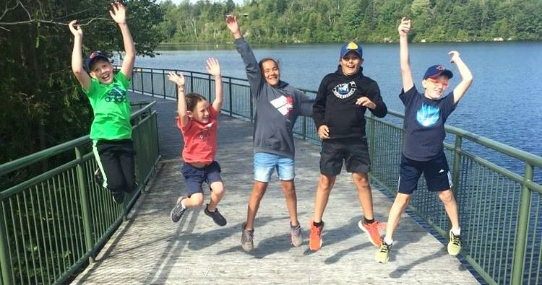

**What makes our camps unique?**

* **Our nature-oriented programs consist of a variety of Adventures that are safe, fun and provide educational programs including field trips, unique physical challenges, games and lots of social activities.**
* **Our camps allow children to step out of their comfort zone and into the iconic New-Brunswick Wilderness to learn about themselves in relation to what our natural world has to offer and provides them with the opportunity to experience “DIGITAL DETOX”**
* **Our programs include daily paddling skills with kayaks and canoes, playground, inside and outside rock climbing, arts and crafts, cultural activities, hikes and swimming.**
* **DID YOU KNOW? If you have more than one child attending our camps you qualify for a discount. Ask us about it ☺**

***“Sparking Children’s Curiosities Inside&Out”***