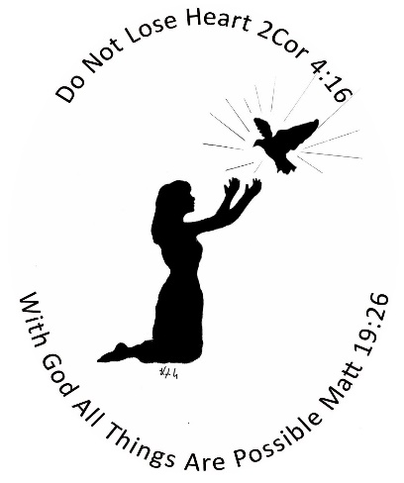

WOMEN’S MINISTRY CENTER
2418 BLOOMER DR., ALTON IL
618 433-8308
SERVICES FOR WOMEN:
PROFESSIONAL WOMEN’S CLOTHING
EVERYDAY WOMEN’S CLOTHING
NIGHTTIME WEAR (GOWNS, PAJAMAS)
SHEETS, BLANKETS, TOWELS, WASHCLOTHS
SHOES
SCRUBS
UNDERGARMENTS—BRA’S, UNDERWEAR, SOCKS
CHILDREN’S CLOTHING
DIAPERS
TOILET PAPER/LAUNDRY DETERGENT/DISH SOAP
PERSONAL HYGIENE PRODUCTS—SHAMPOO, TOOTHPASTE, TOOTHBRUSHES, DEODORANT, SANITARY PRODUCTS, BAR SOAP, BODY WASH, “DEPENDS” UNDERGARMENTS FOR WOMEN
MUST BRING ID AND PROOF OF INCOME
YOU MAY COME IN ONCE A MONTH
PLEASE CALL THE CENTER AT 618 433-8308 FOR APPOINTMENT

