Basic Information

First Name: _________________ Last Name: _____________________ DOB: ____________

Treatment History

- Have you ever tried any other aesthetic procedures in the past?
◻Yes ◻No

- If “yes”, which ones?

_______________________________________________________________

- How did you hear about us?

◻Friend/Family ◻TV/Radio ◻Internet ◻Other: ____________

Background Information (please check all that apply)

◻Botox in the past 30 days ◻Fillers in the past 90 days
◻Surgery in the past 6 months ◻Breast implants
◻Pregnant and/or breastfeeding ◻Active/Past Cancer
◻Kidney and/or Liver disease ◻Uncontrolled Diabetes
◻Lymphatic disorders ◻Uncontrolled Diabetes
◻Severe allergy to cold ◻Severe Raynaud’s Syndrome ◻Eczema, rashes, or dermatitis ◻Open or infected wounds ◻Circulation disorders ◻Pacemaker/metal implants ◻Mesh inserts ◻Incision scar(s) in the desired area ◻HIV/AIDS ◻Body piercings in the desired area
◻Using topical antibiotics ◻Progressive diseases (MS, ALS, etc.)

Lifestyle Information

- How many times per week do you exercise? ___________________

- How much water do you drink per day? _______________________

- How would you rate your diet?
◻ Extremely healthy ◻ Generally healthy ◻ Needs improvement

- Please circle your areas of concern:

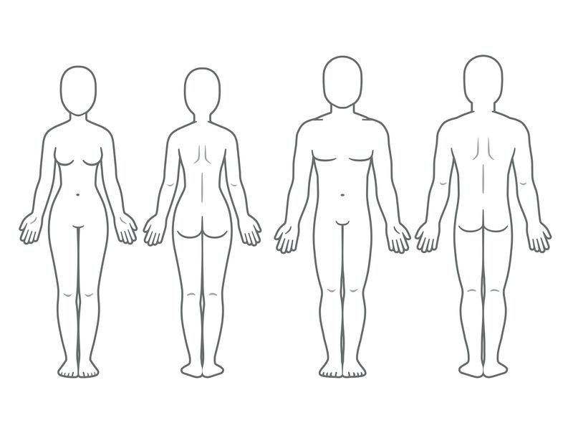

- Have any other treatments/diets/exercise regimens helped these areas?

____________________________________________________________________

- What is your goal with PDX CryoBody?

____________________________________________________________________

- Do you have any questions about treatment?

_____________________________________________________________________

