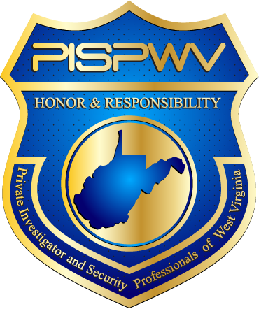 | Private Investigator and Security Professionals of WV
4th Quarter 2015 | Volume 1, Number 1
In This Issue  - Effective Ways to Grow Your Business  - Website Fundamentals  - Save the Date  Leadership  Robert Fluharty  President  Larry Peters  VP of Investigators  Benjamin Moore  VP of Security  Michael Mounts  VP of Training  Diane Lewis  Treasurer  Lisa Turley  Secretary  Links  www.pispwv.org  Check out the website for other members; events and news.  www.nciss.org  For national issues check out National Council of Investigation and Security Services  www.wvsos.com  To learn more about licensing from the West Virginia Secretary of State  www.wvago.gov  For questions about bond certificates | Effective Ways to Grow Your Business  Depending on the size of your business and staff, growing your business will look different for a variety of reasons but some basic principles apply to all shapes and sizes. One, know your market. Ask any seasoned professional what is constant in business – change. Our industry has changed and deciding where your niche of interest is will help you meet the needs of your client. A majority of our members are small in nature. Find ways to reach the client you wish to serve. Having a website is a great tool to tell your story. Look in the article below for important items to include in your website. Another way to grow your business is quality business cards. Having your information in a readable nice sized font along with the services you provide is a great introduction tool to give a potential client. Offering a quality product to your clients is a great way to earn the trust of your client and assist in future business and more clients. Look for more ways in the next newsletter to grow your business.  Website Fundamentals  Having a website can be a great tool to share your business with others. If you chose to have multiple pages you will want to make sure every page has the same contact/business placement information for consistency. Have a mobile website in addition to your traditional website designed for tablet and/or smartphone users with live links connecting them to your phone number and/or email address will connect a potential client. Stay tuned for more tips.  Save the Date  Upcoming PISPWV Meeting Dates  - Thursday February 4, 2016 – Charleston  - Saturday, May 9, 2016 – Stonewall Jackson  - Saturday, August 13, 2016 – Wheeling  - Fri-Sat, October 21-22, 2016 – Training in Morgantown (pending WVU Home Schedule)  PISPWV  Post Office Box 11236  Charleston, West Virginia 25339

