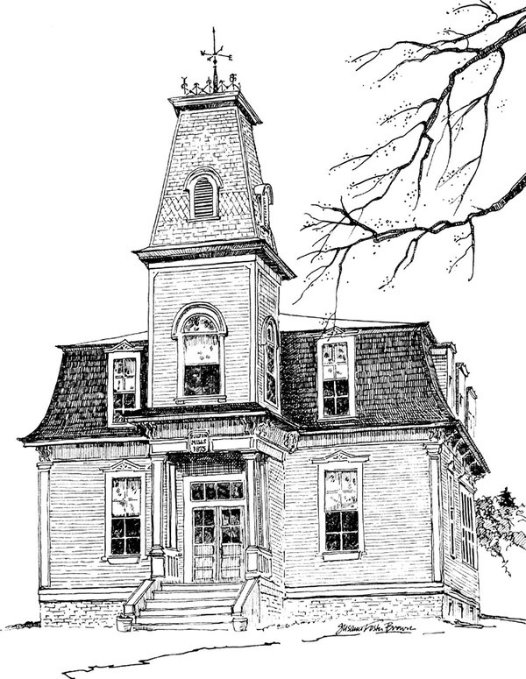
Milton Free Public Library
13 Main St., PO Box 127 Milton Mills, NH 03852
(603) 473-8535 / info@miltonfreepubliclibrary.org www.miltonfreepubliclibrary.org

Summer hours and services as of June 1, 2024:
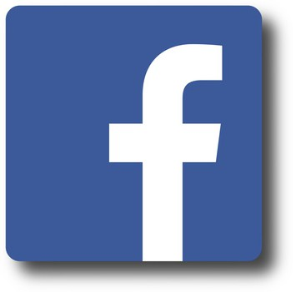
Tuesday: 10:00 AM – 6:00 PM
Wednesday: 10:00 AM-1:00 PM & 3:00-6:00 PM
Thursday: 10:00 AM – 1:00 PM
Friday: 1:00 – 7:00 PM
Saturday 10:00 AM-1:00 PM
Tuesdays Story Time 10 AM
Summer Reading June 29 - August 17, Thursdays 10AM Story + Craft

Online Services: NH Downloadable Books, Hoopla, Interlibrary Loan Please visit the "Resources" menu on our website for more information!

Thank you for being a patron!

