MINUTES

Minutes of the “South Geneva Road Water District Informational Meeting” of the Sodus Town Board held June 29, 2017 beginning at 6:00 pm in the Sodus Town Court Room located at 14-16 Mill St. Sodus, NY 14551

All Town of Sodus Board Meetings are open to the public.

Steven M. LeRoy, Town Supervisor
Present: David LeRoy, Deputy Supervisor-Councilperson
Kelly Grey, Councilperson
Jim Quinn, Councilperson
Don Ross, Councilperson

Recording Secretary: Lori Diver, Town Clerk

Absent: N/A

Others Present: Marty Aman, Wayne County Water Authority
Dave Doyle, MRB Group Engineers
Per Sign in Sheet

Supervisor LeRoy opened the meeting at 6:00 pm.

*******SEE PAGE 2*******
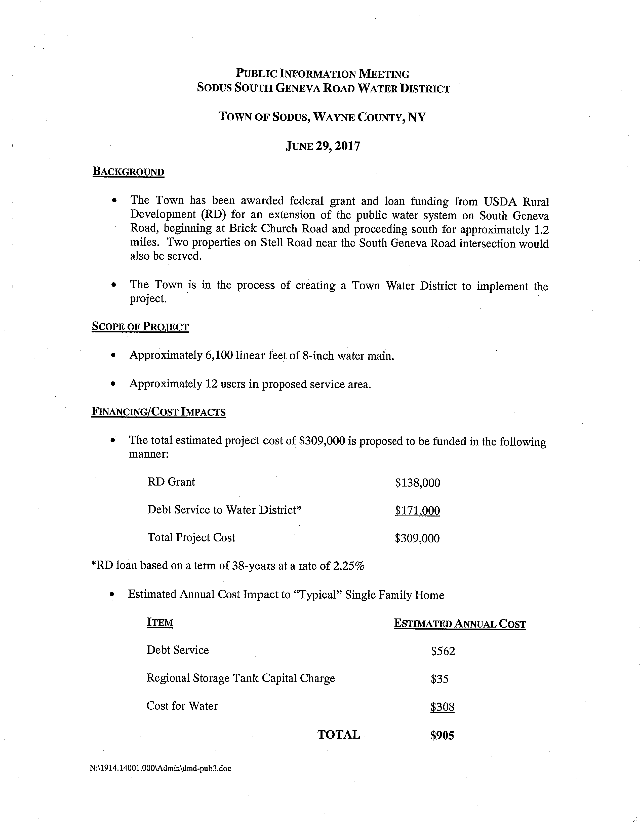

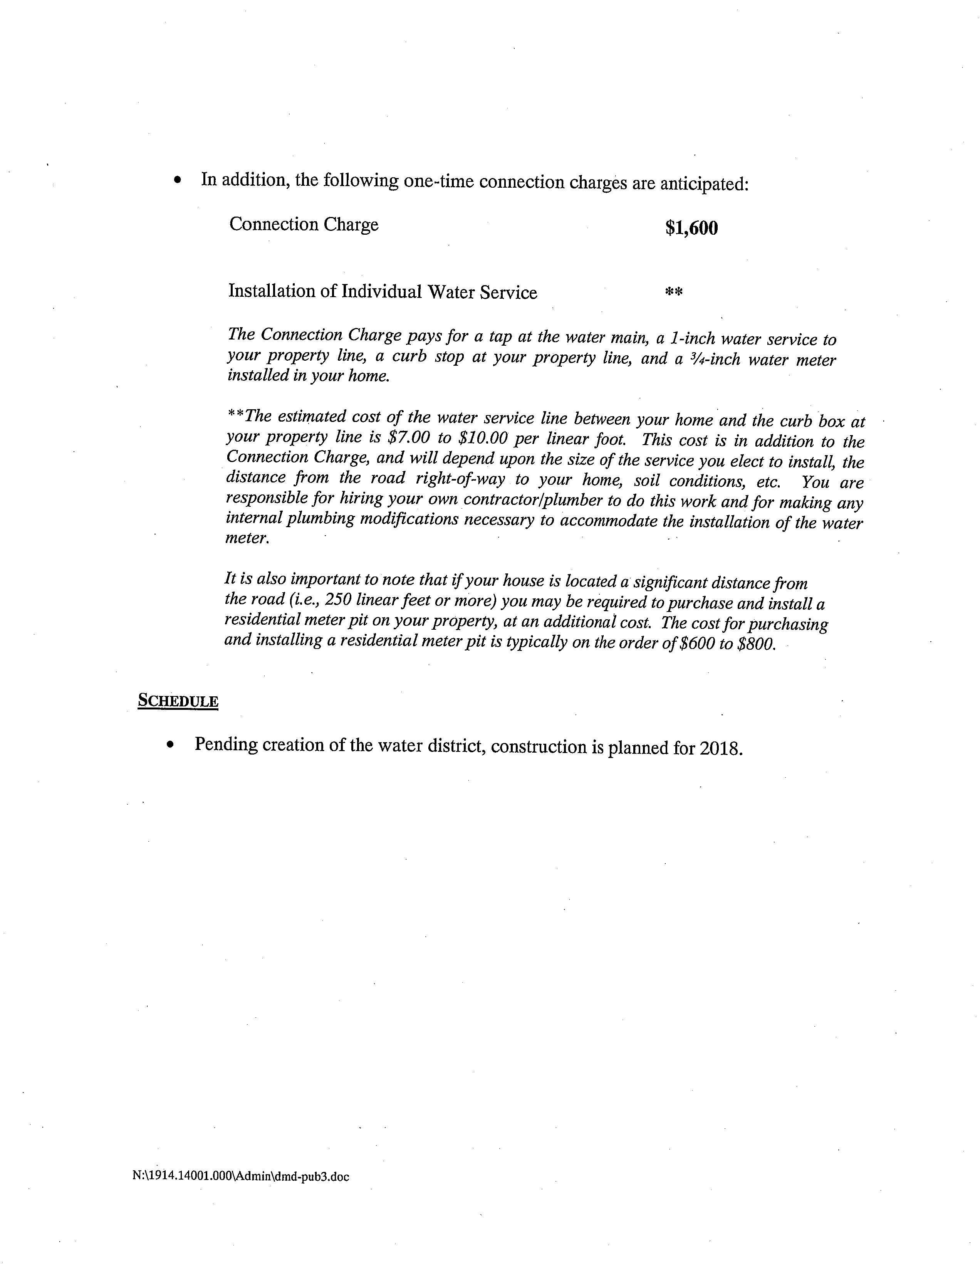Councilperson David LeRoy motioned to adjourn the Public Informational Meeting was seconded by Councilperson Don Ross. Upon roll call the following votes were heard, Supervisor Steven LeRoy, aye; Grey, aye; Councilperson David LeRoy, aye, Quinn, aye; Ross, aye. Motion carried.
Meeting adjourned at 6:30 p.m.

Recording Secretary,

Lori Diver
Sodus Town Clerk

