Sodus Town Board Agenda
April 11, 2023
5:30 PM
Open with Pledge Allegiance
Roll Call: (Lori Diver)
Supervisor Johnson, Councilperson LeRoy, Councilperson Ross (Zoom), Councilperson Tertinek, Councilperson Willmott

EXECUTIVE SESSION (5:30 PM):
- Motion to enter into Executive Session regarding medical, financial, credit or employment history of a particular person or corporation or relating to appointment promotion demotion discipline or removal.
Time_________________

- Motion to exit out of Executive Session and enter back into regular session.
Time _________________

Public Speakers:
N/A

Agenda:
Minutes: Motion to file the following minutes:
- March 23, 2023 Special Board Meeting (Don and Chris must abstain-unable to attend this meeting)
- March 23, 2023 Regular Town Board Meeting

- Supervisor’s Report

- Town Clerk’s Report

- Tax Collection Report

- Resolution to Approve Bills 6-2023

- Public Works Committee: Councilperson David LeRoy
(Highway, Drainage)
- Motion to file Highway Superintendent’s Report

- Salt Barn:

- Drainage N/A

- Buildings and Grounds Committee: Councilperson Chris Tertinek
(Town Property, Animal Control, Code Enforcement, Flood Damage)
- Motion to file Code Enforcement Report – Frank Gahr
- Motion to file Dog Control Officer Report– Robert Snyder
- Flood Damage Prevention – Chris Tertinek

- Recreation/Environmental Committee: Councilperson Cathy Willmott
(Recreation, Assessor, Parks, Cemeteries)
- Motion to file Sodus Recreation Report-Sheila Fisher
- Motion to file Assessor’s Report – Nathan Mack
- Motion to file Camp Beachwood/Sodus Groundskeeper Report – Sal Vittozzi

- Public Safety Committee: Councilperson Don Ross
(Fire, Ambulance, Emergency Preparedness - WC, Water Authority - WC)

- Town Hall Committee: Supervisor Scott Johnson
(Personnel, Town Council, Court, Assessor, Building Inspector, Boards/Committees, Insurances, Finance, Environmental)
Correspondence & Information
- Discussion regarding Spring Cleanup and Fall Cleanup (Dale Pickering).

- Discussion regarding emergency evacuation plan (Dave LeRoy).

- Motion to reschedule the Regular Town Board Meeting from Tuesday May 9, 2023 to Tuesday May 16, 2023 commencing at 6:00 PM.

- Motion to bid out Gravel Products which include; “Ice Control Sand”, “Bank Run”, “2 inch Minus Items # 4”, and “CR2 Crushed Gravel”, and “5/8 inch Minus Fine Crushed Gravel and “3–6-inch Cobbles” and to hold bid opening on May 16, 2023 at 6:00 PM and allow Lori Diver to advertise (Dale Pickering).

- Updated letter (April 3, 2023) received from Village of Sodus Point Trustee Laurie Verbridge regarding Traffic Calming, Route 14 Sodus Point, NY.

- Resolution authorizing Supervisor Johnson to sign Online Auction Contract Agreement for sale of government assets by online auction.

- Resolution approving payroll for omitted employee Vicky Pascarella that worked for the Winter Recreation Program. Her hourly rate of pay is $14.20 and she worked 16 hours.

- Resolution to transfer $232.50 from the contingent account A1990.9 to A7989.4 to reimburse the Neighborhood Association of Sodus Point for the Bingo License purchased December of 2019 for Bingo to be held in the year of 2020.

- Resolution authorizing Alternative Technology Technical Solutions to acquire and establish .gov email domains of up to 10 email boxes for Town of Sodus employees. The pricing is as follows:

25GB pro email box (annual subscription) | 7 | $39.48 | $276.36
80GB pro plus email box (annual subscription) | 3 | $71.88 | $215.64
One time domain transfer fee | 1 | $25 | $25
Labor + travel | 8 | $65 | $520
TOTAL (initial setup and 1 year subscription) |  |  | $1037

*Annual subscription fee estimated of $492.00 will be billed by Alternative Technology

*Annual subscription fee subject to change by email host

Scope of Work:
Acquire .gov domain. Transfer domain to register.com host. Set up 10 email boxes and migrate each user email to a new server.

- Motion to adjourn meeting.
Time _________________

MINUTES
Minutes of the Regular Town Board Meeting commencing at 5:30 PM in the courtroom held April 11, 2023 located at 14-16 Mill St. Sodus, NY 14551.
All meetings are open to the public.

In addition, this meeting was available through Zoom. Legal Notices were published and posted accordingly.

Present: Scott Johnson, Supervisor
Chris Tertinek, Councilperson
Cathy Willmott, Councilperson

Recording Secretary: Lori Diver Sodus Town Clerk

Absent: David LeRoy, Councilperson/Deputy Supervisor
Don Ross, Councilperson

Others Present: Amy Kendall, Town Attorney
Tom Putnam, Town Justice
Robert Fratangelo, Town Justice
Jay Dewispelaere, Former Town Bailiff
Bree Crandell, Supervisor Clerk
Dale Pickering, Highway Superintendent
Sal Vittozzi, Camp Beechwood Caretaker
Robert Snyder, Dog Control Officer

Supervisor Scott Johnson called the Regular Town Board Meeting to order commencing at 5:30 PM and Lori Diver opened with roll call.

Councilperson Cathy Willmott motioned to enter into Executive Session at 5:31 PM regarding medical, financial, credit or employment history of a particular person or corporation or relating to appointment promotion demotion discipline or removal was seconded by Councilperson Chris Tertinek. Upon roll call the following votes were heard, Scott Johnson, aye; David LeRoy, absent; Don Ross, absent; Chris Tertinek, aye; and Cathy Willmott; aye. Motion carried.

Councilperson Cathy Willmott motioned to exit out of Executive Session at 5:59 PM regarding medical, financial, credit or employment history of a particular person or corporation or relating to appointment promotion demotion discipline or removal was seconded by Councilperson Chris Tertinek. Upon roll call the following votes were heard, Scott Johnson, aye; David LeRoy, absent; Don Ross, absent; Chris Tertinek, aye; and Cathy Willmott; aye. Motion carried.

Public Speakers:
Town Justice Thomas Putnam announced his retirement as Sodus Town Justice effective April 30, 2023. Robert Fratangelo and Thomas Putnam introduced Jay DeWispelaere to the Town Board. Fratangelo and Putnam suggested as Putnam’s replacement that DeWispelaere be appointed until the next general election as interim Town Justice as Putnam’s replacement. DeWispelaere shared with the Town Board his current credentials.
Jay assured the Town Board there was no conflicts with his current position as Director of the Cayuga Probation Department.

Councilperson Cathy Willmott motioned to accept Town Justice Tom Putnam’s resignation effect April 30, 2023 was seconded by Councilperson Chris Tertinek. Upon roll call the following votes were heard, Scott Johnson, aye; David LeRoy, absent; Don Ross, absent; Chris Tertinek, aye; and Cathy Willmott; aye. Motion carried.

Councilperson Cathy Willmott motioned to appoint Jay DeWispelaere as interim Town Justice May 1, 2023 until the next general election was seconded by Councilperson Chris Tertinek. Upon roll call the following votes were heard, Scott Johnson, aye; David LeRoy, absent; Don Ross, absent; Chris Tertinek, aye; and Cathy Willmott; aye. Motion carried.

MINUTES
Minutes from March 23, 2023 Special Town Board Meeting was presented to the Town Board to be filed. Because Ross and Tertinek had to abstain from this vote, there was not a quorum to vote on approval of these minutes. Minutes will be tabled until the next regular meeting.

Minutes from March 23, 2023 was presented to the Town Board to be filed. Councilperson Chris Tertinek motioned to file these Minutes, which was seconded by Councilperson Cathy Willmott. Upon roll call the following votes were heard, Scott Johnson, aye; David LeRoy, absent; Don Ross, absent; Chris Tertinek, aye; and Cathy Willmott; aye. Motion carried.

SUPERVISOR’S REPORT
The Supervisor’s monthly report was presented for March 2023. Councilperson Cathy Willmott motioned to file this report, which was seconded by Councilperson Chris Tertinek. Upon roll call the following votes were heard, Scott Johnson, aye; David LeRoy, absent; Don Ross, absent; Chris Tertinek, aye; and Cathy Willmott; aye. Motion carried.

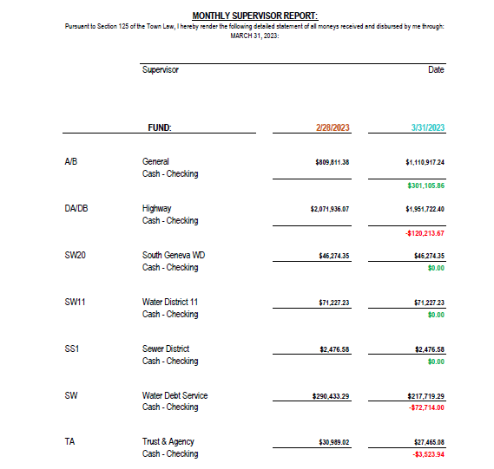

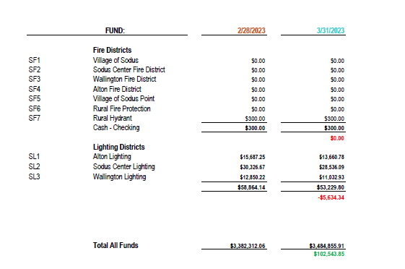

TOWN CLERK’S REPORT
The Town Clerk’s Reports, Town Clerk’s bank statements for audit and bank register for March 2023 was presented. Note: bank statement and bank register are listed in detail with Town Clerk cash book for 2023. For security reasons and confidentiality, it cannot be published in Minutes. Councilperson Chris Tertinek motioned to file these reports, which was seconded by Councilperson Cathy Willmott. Upon roll call the following votes were heard, Scott Johnson, aye; David LeRoy, absent; Don Ross, absent; Chris Tertinek, aye; and Cathy Willmott; aye. Motion carried.

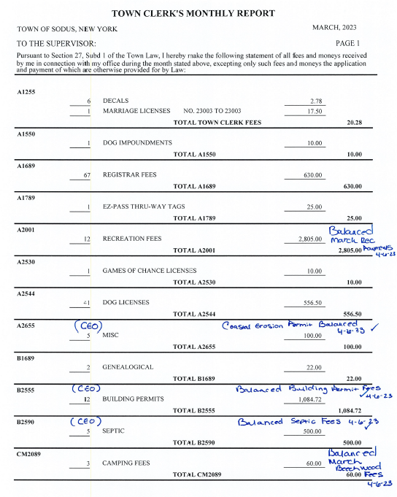

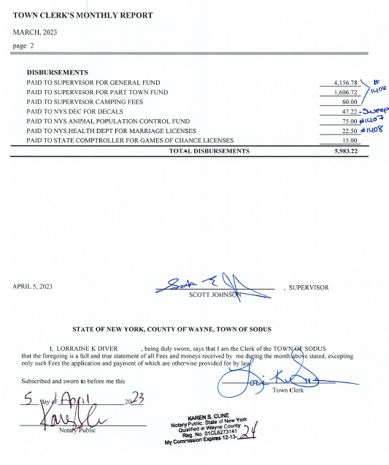

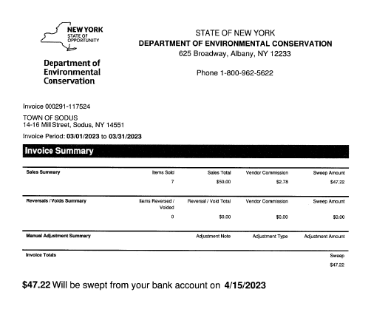

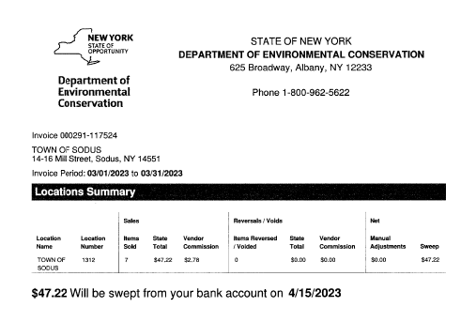
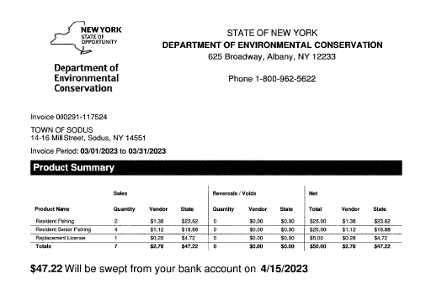

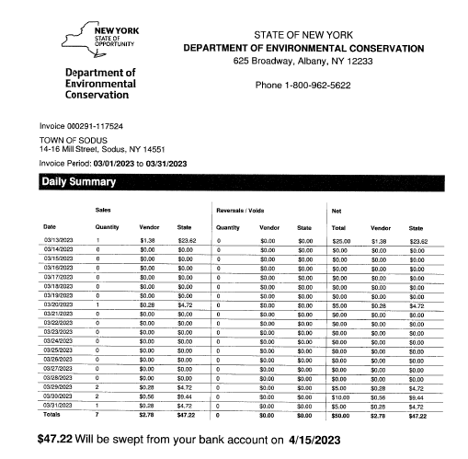

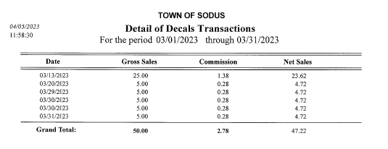

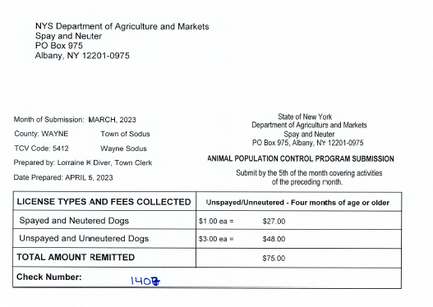

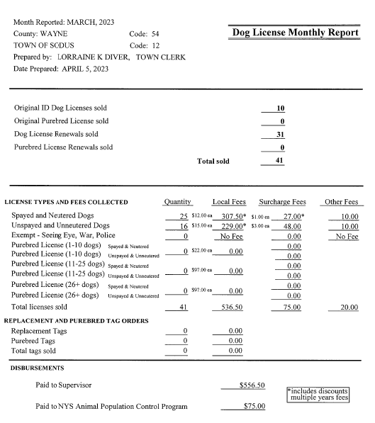

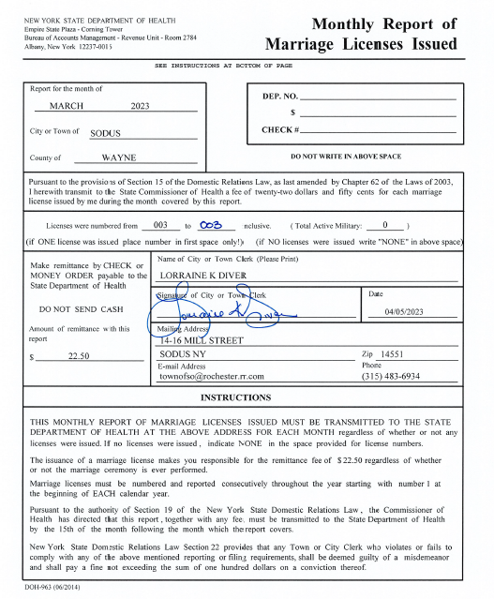

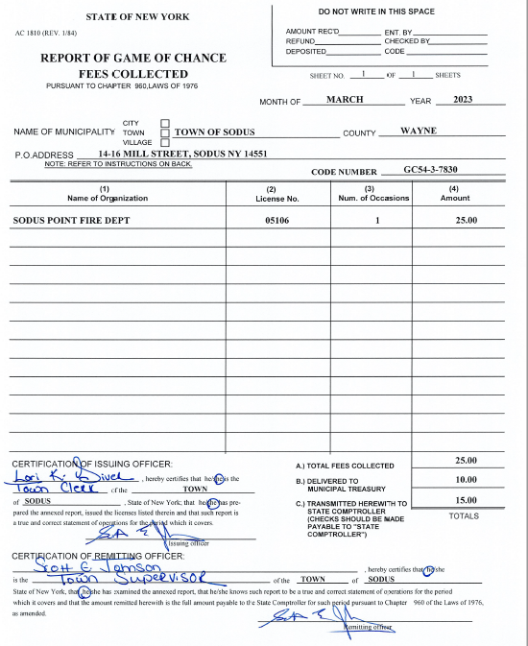
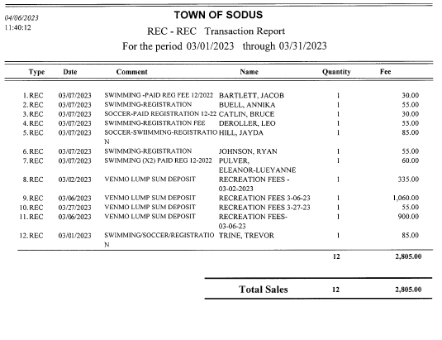

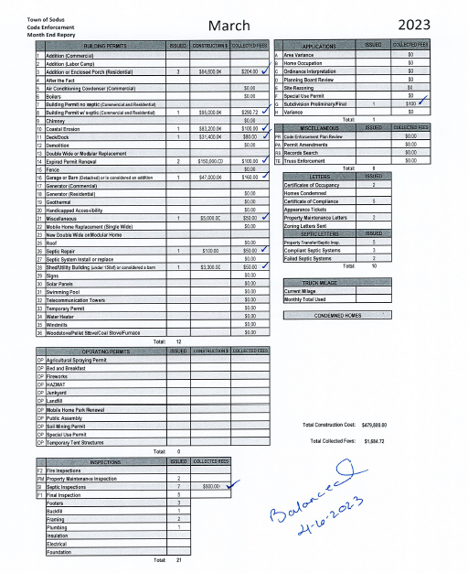
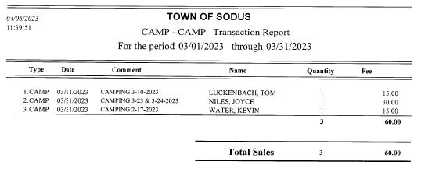

TAX COLLECTION REPORT
The Tax Collection Report, Tax Collector bank statements for audit and bank register for March 2023 was presented. Councilperson Cathy Willmott motioned to file this report, which was seconded by Councilperson Chris Tertinek. Upon roll call the following votes were heard, Scott Johnson, aye; David LeRoy, absent; Don Ross, absent; Chris Tertinek, aye; and Cathy Willmott; aye. Motion carried.
Note: bank statement and bank register are listed in detail with Tax Collection cash book for 2023. For security reasons and confidentiality, it cannot be published in Minutes.

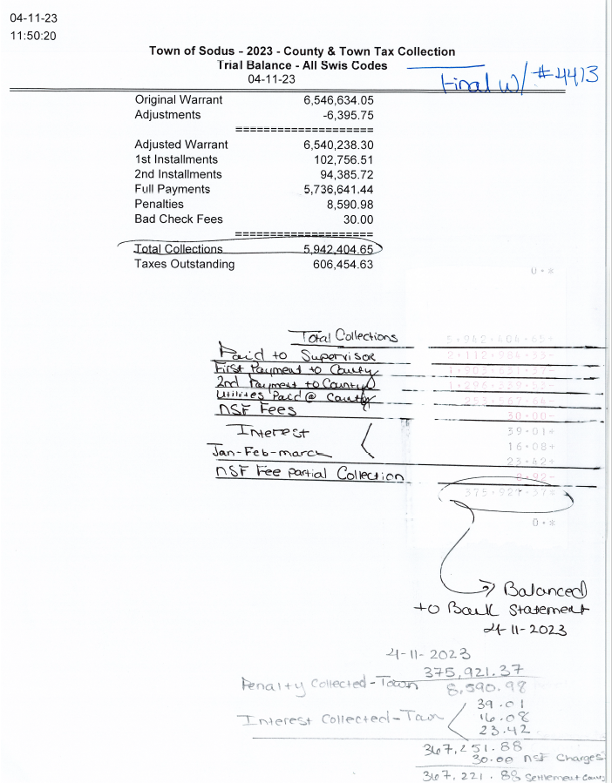

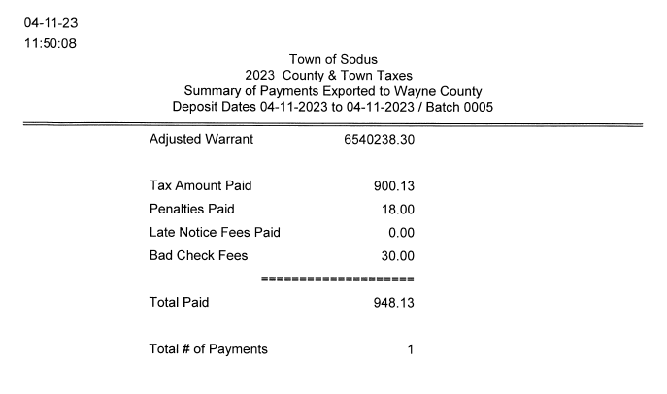
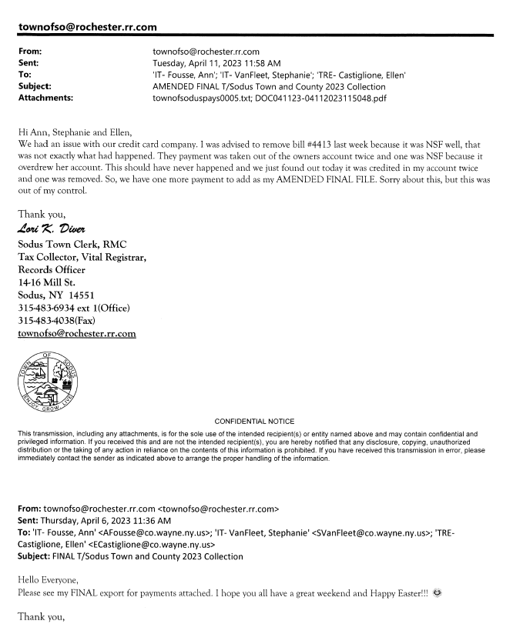

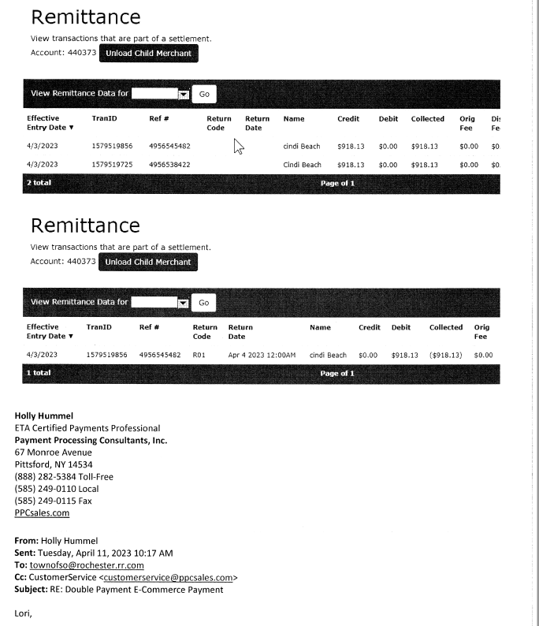

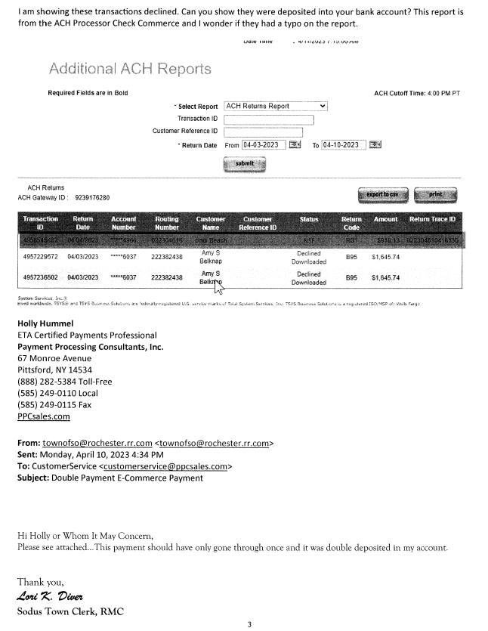

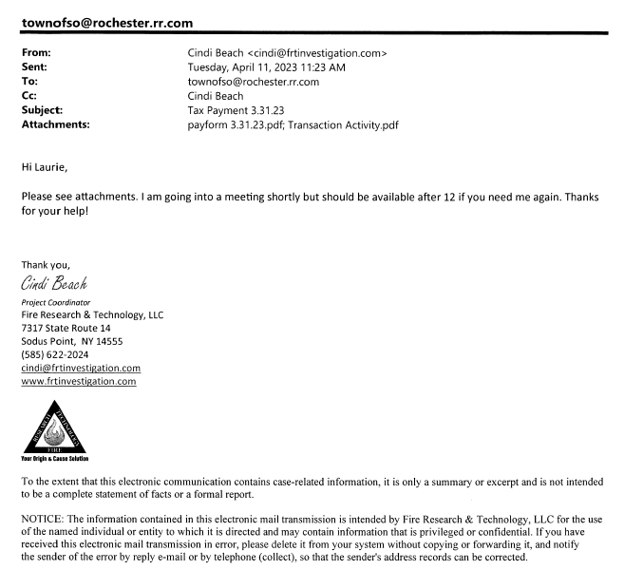

ABSTRACT
RESOLUTION TO PAY ABSTRACT NO. 06
(01 04-2023)
WHEREAS, the following bills were presented for payment on Abstract 06:

General 149-176 $ 33,640.01
Highway 085-102 $ 30,374.77
Special District 008-008 $ 946.50
Special Dist. Fire. 010-011 $ 36,000.00
Sewer District 002-002 $ 488.00
Capital Projects 025-025 $ 2,500.00
GRAND TOTAL: $ 103,949.28

NOW BE IT RESOLVED, Councilperson Chris Tertinek motioned to approve payment of these bills as reviewed for Abstract No. 06, which was seconded by Councilperson Cathy Willmott. Upon roll call the following votes were heard, Scott Johnson, aye; David LeRoy, absent; Don Ross, absent; Chris Tertinek, aye; and Cathy Willmott; aye. Resolution Adopted.

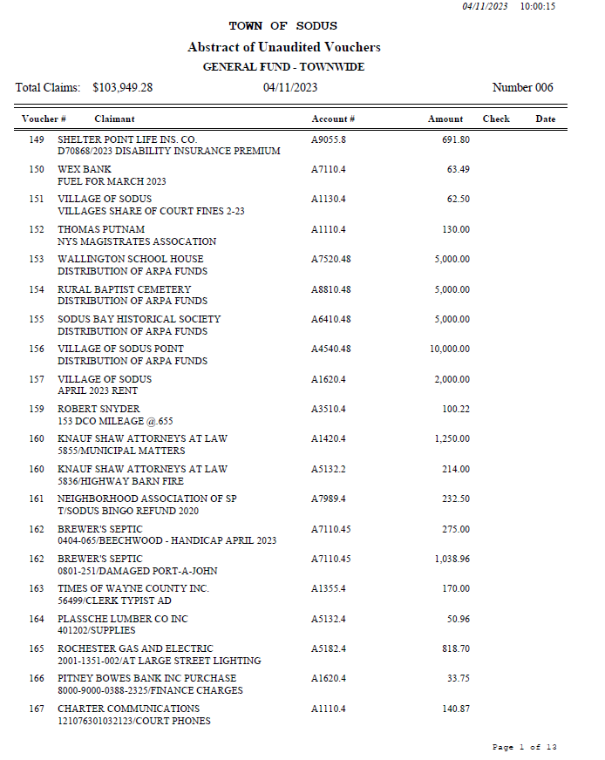

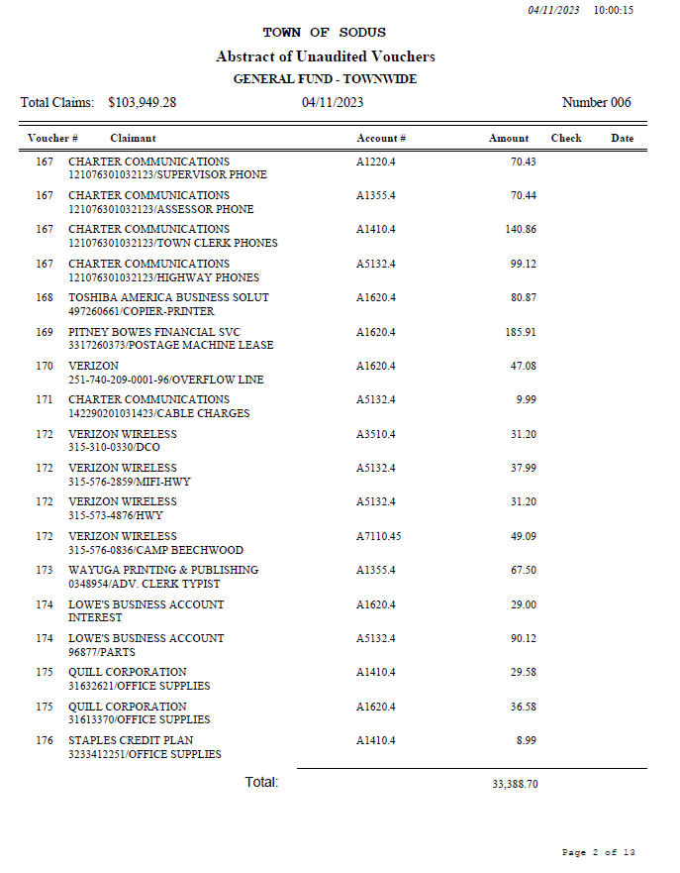
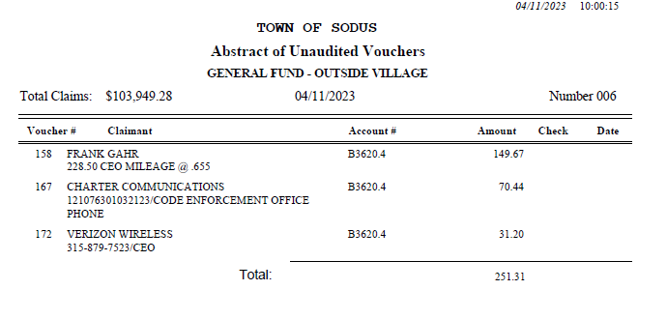
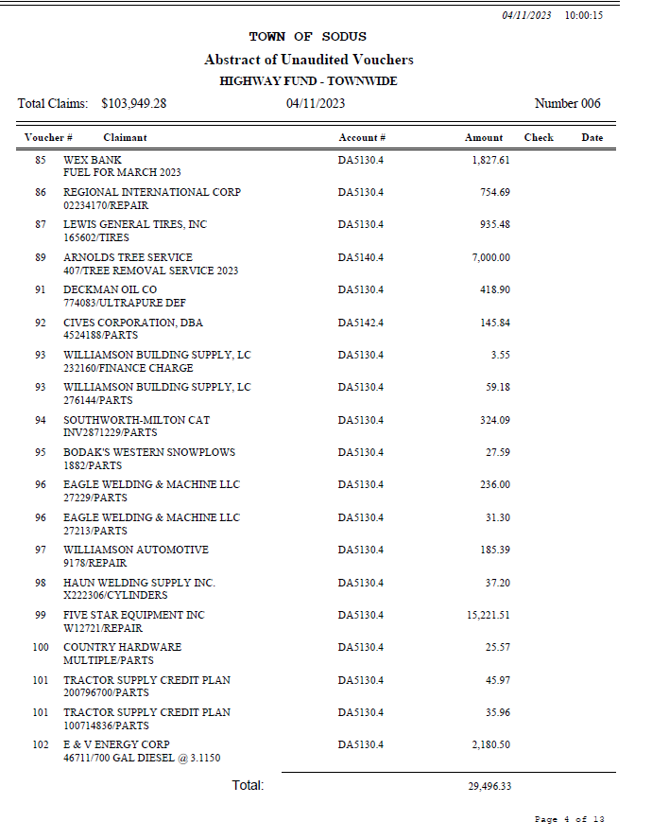

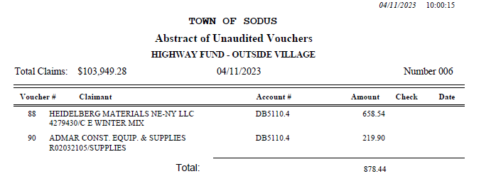

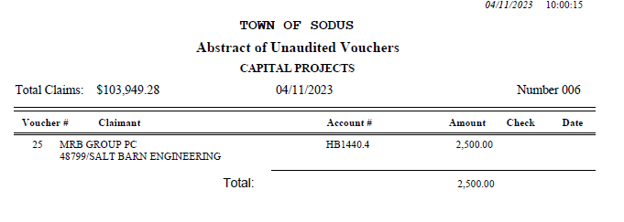
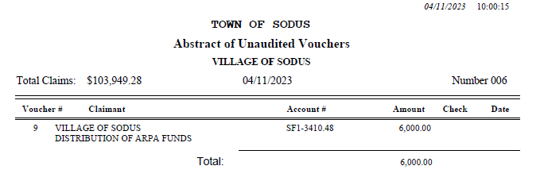
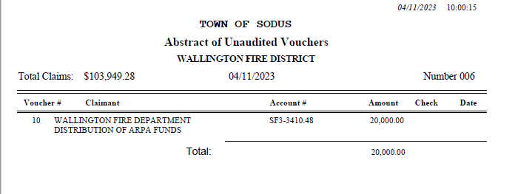

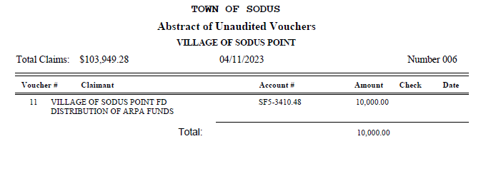
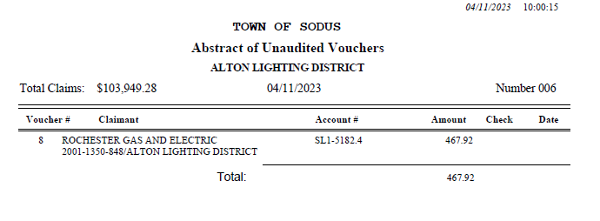
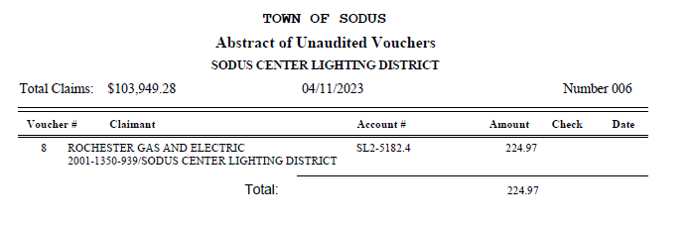
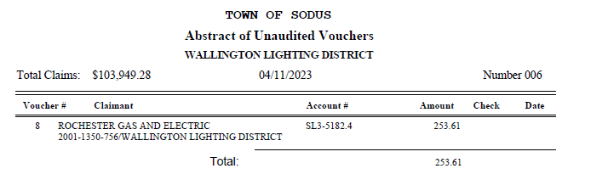
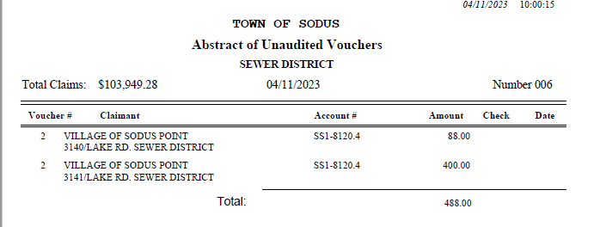

PUBLIC WORKS COMMITTEE: Councilperson David LeRoy, Chair
(Highway, Drainage - Deputy Town Supervisor)
HIGHWAY REPORT:
(Dale Pickering – Highway Superintendent)
Councilperson Chris Tertinek motioned to file the monthly Highway March 2023 report from Dale Pickering Highway Superintendent was seconded by Councilperson Cathy Willmott. Upon roll call the following votes were heard, Scott Johnson, aye; David LeRoy, absent; Don Ross, absent; Chris Tertinek, aye; and Cathy Willmott; aye. Motion carried.

- Salt Barn:
  - Dale Pickering Highway Superintendent stated that all of the salt has been relocated to start the new salt barn construction.
- RG&E N/A

- Drainage N/A

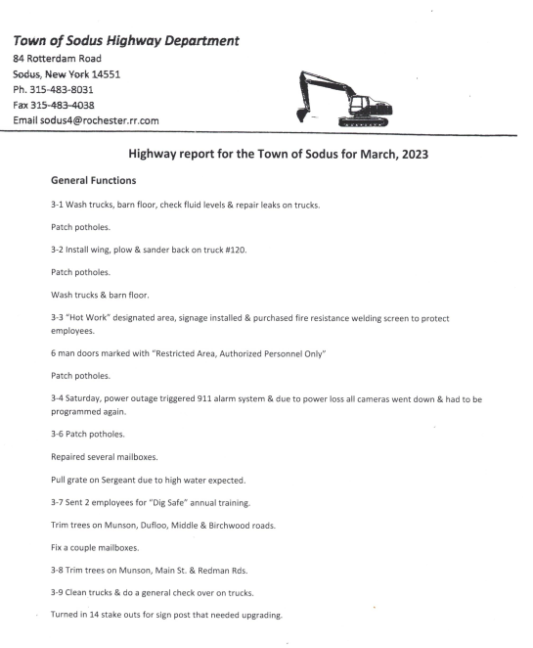
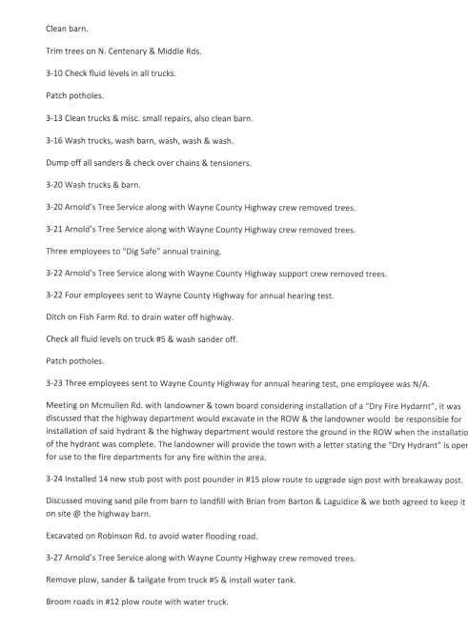

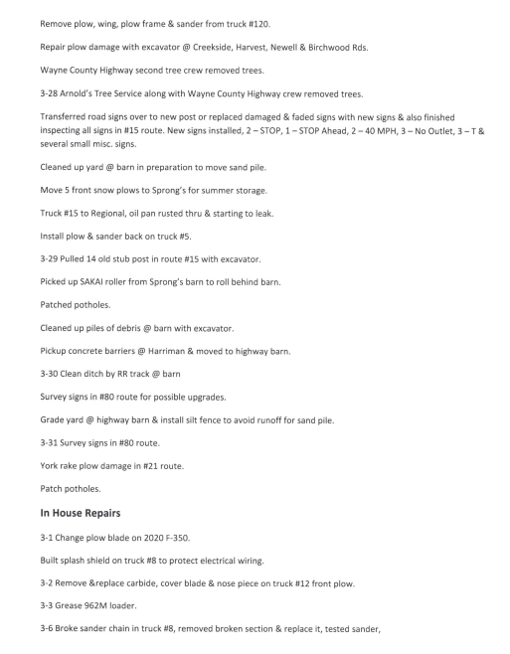

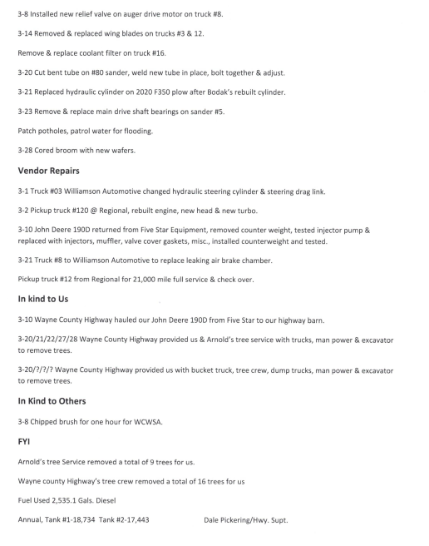
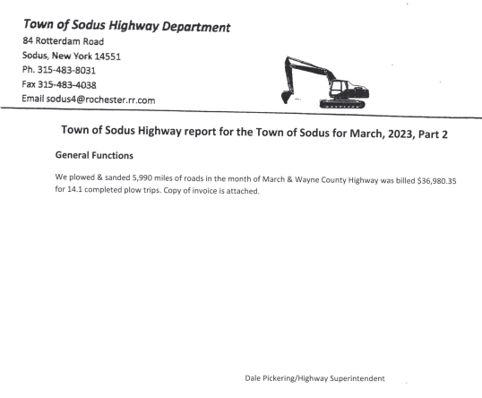
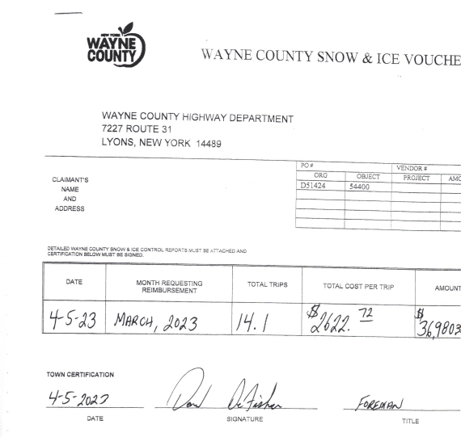

BUILDINGS AND GROUNDS COMMITTEE: Councilperson Chris Tertinek, Chair
(Town Property, Animal Control, Flood Damage Prevention)
CODE ENFORCEMENT REPORT:
Frank Gahr- CEO
Councilperson Chris Tertinek motioned to file the monthly March 2023 Code Enforcement Report as written, was seconded by Councilperson Cathy Willmott. Upon roll call the following votes were heard, Scott Johnson, aye; David LeRoy, absent; Don Ross, absent; Chris Tertinek, aye; and Cathy Willmott; aye. Motion carried.

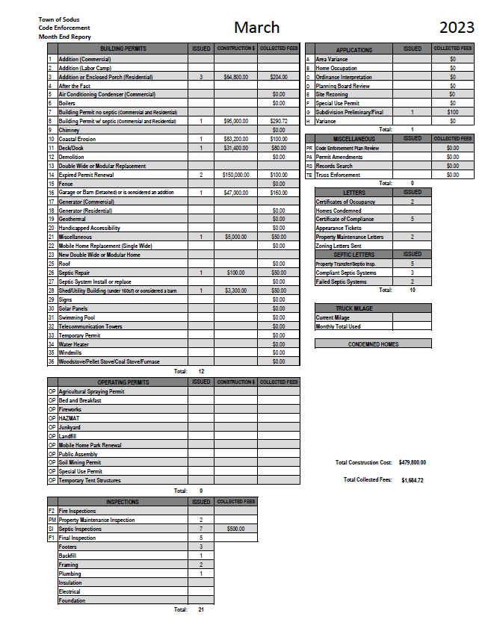

DOG CONTROL REPORT:
Robert Snyder, Primary DCO
Vacant- Secondary DCO
Councilperson Chris Tertinek motioned to file the monthly March 2023 Dog Control report as written, was seconded by Councilperson Cathy Willmott. Upon roll call the following votes were heard, Scott Johnson, aye; David LeRoy, absent; Don Ross, absent; Chris Tertinek, aye; and Cathy Willmott; aye. Motion carried.

March 2023 Dog Control Report
03-09-2023 Dog complaint 104 & N. Centenary Rd, 2 dogs running at large. Drove around for a while no dogs spotted. 9:00AM
03-09-2023 Dog complaint on Curtiss Ave, dog was tied on chain that was so short it couldn’t move. Went to the address, dog was found and was just out to use the bathroom. 10:30 AM
03-16-2023 911 call to follow up on dog complaint. Owner has made appointments for shots and follow up care.
03-18-2023 Dog complaint running at large on 104 and Ridge Rd. No dog was located.
3-21-2023 911 call, dog was on beach and taken to the Wayne County Humane Society. 2:00 PM
3-22-2023 Dog complaint running at large on Shaker Rd in Alton. Dog was transported to the Humane Society 2:00 PM
3-23-2023 911 call. Dog was hit on N. Geneva Rd. Transported the dog to the Lyons Vet. Owner was contacted and informed where her dog was.

Mileage: 153 miles traveled
Respectfully Submitted,
Robert Snyder, DCO

FLOOD DAMAGE PREVENTION REPORT-Code 69:
Chris Tertinek, Councilperson
Councilperson Chris Tertinek shared his flood damage prevention report. The lake is at 246.3ft ASL; up about 7 inches from last month. Presently 9 inches above long-time average. Presently, 1 inch below last year. The long term forecast for mid-September is 245.1 ft ASL; 6.5 inches higher than in 2022.

RECREATION/ENVIRONMENTAL COMMITTE: Councilwoman Cathy Willmott
(Recreation, Assessor, Parks, Cemeteries)
CAMP BEECHWOOD-PARKS-CEMETERIES REPORTS:
Recreation Report
(Sheila Fisher, Recreation Director)
Councilperson Chris Tertinek motioned to file the monthly March 2023 Recreation report from Sheila Fisher, Recreation Director was seconded by Councilperson Cathy Willmott. Upon roll call the following votes were heard, Scott Johnson, aye; David LeRoy, absent; Don Ross, absent; Chris Tertinek, aye; and Cathy Willmott; aye. Motion carried.

Director’s Report
Sodus Recreation Board Meeting
April 3, 2023

Programs:
- Soccer and Swim lessons ended Saturday, March 25th.
- We had a very successful season!

The following message was shared in Forum (Morning Announcements) the Monday after our Winter Swim lessons ended. I thought it would be nice to share with all of you. We had many wonderful compliments to our program this Winter.

“Rooting For All of the students who are Sodus Recreation Swim Instructors: I have been watching high school students giving life-saving swimming lessons to children of all ages for the past several Saturdays, and I have been floored by what I am seeing. You young people are amazing. You are doing something incredible - teaching children - that many adults are not even able to do. It requires patience, empathy, quick-thinking, attention, strategizing, spontaneous encouragement, and change of approach, while following a curriculum. With a live audience. In the water. You are doing this with smiles on your faces. You are reassuring nervous or shy children. You are celebrating new skills with the outgoing ones. You are making children feel safe with you, and feel safe in the water, in 30 minute intervals. You are helping children who are scared to be in the water at all, or who are nervous to put their heads under water, even when they are standing; you are helping children feel confident and strong learning to move their arms in the water, to stroke through water, or even to dive under and learn the skills to swim laps. I am watching two of my kids, who have two completely different personalities and skill levels, being taught to their unique needs by different instructors. And you are amazing. I doubt that when I was your age I ever had your calm, your poise, your competence; I know I did not have your patient ability to teach the way I see all of you teaching. It brings me joy to see the way you all make this look so natural. I am so impressed by all of you. Your families and community are blessed to have students with your character. Thank you. - A Swim Lesson Parent!”

Our Program Profit was: $4867.15.
$55.00 was collected by a participant who could not attend due to illness. We will hold payment to use toward a summer program.

Payroll:

- Employees: of the following employees list was emailed to both Cathy W. & Bree.
- Total payroll cost was $6229.90

Recreation Board:
- We met on March 20th @ 5:30pm in the Town Hall Board Room. Those in attendance were: Jen Davis, Mary Zecher Paton & Cathy Wilmott. We have set our remaining meetings for the year for the following dates. All at the Town Hall at 5:30pm tentatively.
- June 5, 2023
- Sept. 11, 2023
- Nov. 13, 2023

Budget updates:
Scott contacted me regarding some of our Minimum wage payroll coming from Jay Roscups Work Steady Program. I will connect with Jay for more info.

Camp Beechwood March 2023
March was a fairly busy month here at the park. With the onset of milder weather at the end of the month, daily attendance is on the rise again while camping was still at a minimum. We did have 3 scout troops at the end of the month though (Pittsford, Webster and Greece). Spring clean-up is being done throughout the park and is a tall order this year due to fallen trees. The multiflora rose removal down the main trail is still being worked on as well. The ice rink was taken down and the red barn is being cleaned out again and set up for the upcoming green season. I'm receiving a good number of calls about camping this season, so it looks like it's going to be another incredibly busy summer here at Beechwood.

Submitted By:
Sal Vittozzi
Camp Beechwood Caretaker

Councilperson Chris Tertinek motioned to file the monthly March 2023 Camp Beechwood report from Sal Vittozzi, Caretaker was seconded by Councilperson Cathy Willmott. Upon roll call the following votes were heard, Scott Johnson, aye; David LeRoy, absent; Don Ross, absent; Chris Tertinek, aye; and Cathy Willmott; aye. Motion carried.

Councilperson Cathy Willmott motioned to allow Highway Superintendent to surplus and donate the 2006 DOOLT TRLR BK to Camp Beechwood was seconded by Councilperson Chris Tertinek. Upon roll call the following votes were heard, Scott Johnson, aye; David LeRoy, absent; Don Ross, absent; Chris Tertinek, aye; and Cathy Willmott; aye. Motion carried.

Assessor’s Report
(Nathan Mack, Assessor)
Councilperson Cathy Willmott motioned to file the monthly March 2023 report from Sole Assessor Nathan Mack was seconded by Councilperson Cathy Chris Tertinek. Upon roll call the following votes were heard, Scott Johnson, aye; David LeRoy, absent; Don Ross, absent; Chris Tertinek, aye; and Cathy Willmott; aye. Motion carried.

tOWN OF sODUS

ASSESSOR’S OFFICE
Date: April 5, 2023 Respectfully Submitted by: Nathan Mack

AROUND THE OFFICE

- The 2023 Level of assessment will be 71. This is a change from last year which was 81 on the 2022 assessment roll.
- Notices for individuals that did not qualify or failed to re-apply for exemptions will be mailed.
- Any notices regarding a change in assessment will be mailed before the Tentative Roll on May 1st.
- The office is offering informal appointments for taxpayers to discuss Their Assessment.
- Grievance Day will be held on May 23, 2023.
- The tentative assessment roll will be available to view on May 1st in the Assessor’s Office and posted online at the Wayne County Website.

PUBLIC SAFETY/DRAINAGE/ENVIRONMENT COMMITTEE: Councilperson Don Ross, Chair (Fire, Ambulance, Emergency Preparedness)
Councilperson Don Ross emailed the Wayne County 911 Report and SESA Minutes. Ross was absent. Supervisor Scott Johnson noted that Wayne County is moving forward with the new ambulance. They currently are working with the Village of Sodus Water & Sewer and are waiting on an easement. They are hoping to break ground early fall.

TOWN HALL COMMITTEE: Scott Johnson, Supervisor
(Personnel, Clerks, Justices, Assessor, Building Inspector, Town Council, Boards, Insurances, Finance)
N/A

CORRESPONDENCE & INFORMATION

Highway Superintendent Dale Pickering discussed with the Sodus Town Board there will be no Spring Cleanup for 2023 given the construction of the new salt barn being built. Once the construction is complete the cleanup will be held at a later date. There was mention of turning the fall-cleanup into 2-days rather than 1.

Councilperson Chris Tertinek motioned to reschedule the regular town board meeting from May 9, 2023 at 6:00 PM to May 16, 2023 at 6:00 PM and allow Lori Diver Sodus Town Clerk to advertise was seconded by Councilperson Cathy Willmott. Upon roll call the following votes were heard, Scott Johnson, aye; David LeRoy, absent; Don Ross, absent; Chris Tertinek, aye; and Cathy Willmott; aye. Motion carried.

Councilperson Cathy Willmott motioned to bid out Gravel Products which include; “Ice Control Sand”, “Bank Run”, “2 inch Minus Items # 4”, and “CR2 Crushed Gravel”, and “5/8 inch Minus Fine Crushed Gravel and “3–6-inch Cobbles” and to hold bid opening on May 16, 2023 at 6:00 PM and allow Lori Diver to advertise was seconded by Councilperson Chris Tertinek. Upon roll call the following votes were heard, Scott Johnson, aye; David LeRoy, absent; Don Ross, absent; Chris Tertinek, aye; and Cathy Willmott; aye. Motion carried.

Updated letter (April 3, 2023) received from Village of Sodus Point Trustee Laurie Verbridge regarding Traffic Calming Route 14 Sodus Point, NY.

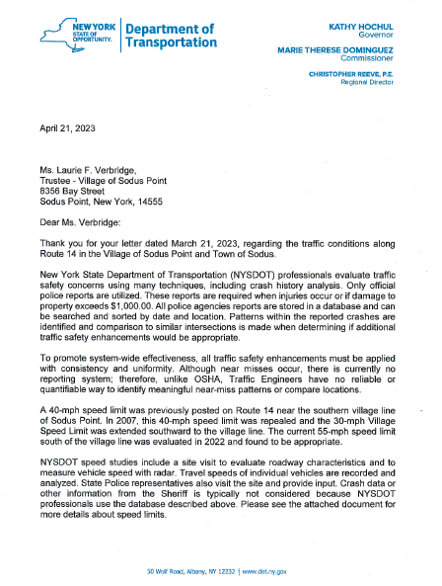

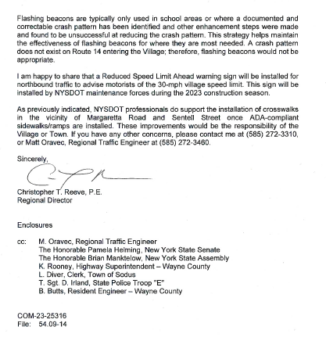

ONLINE AUCTION AGREEMENT FOR SALE OF GOVERNMENT ASSETS BY ONLINE AUCTION
(02 04-2023)
Supervisor Johnson offered the following resolution for its adoption:

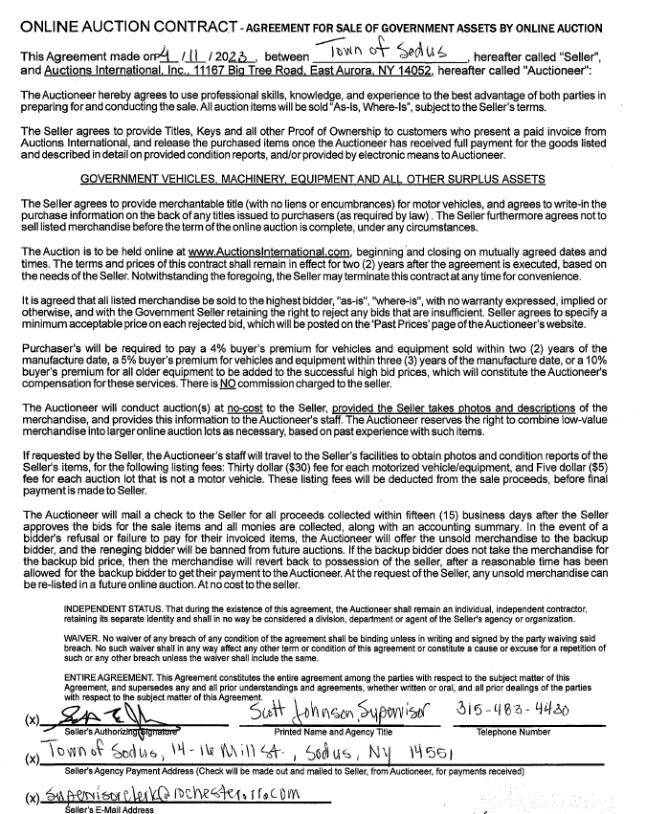

RESOLVED, Councilperson Cathy Willmott motioned to adopt resolution (02 04-2023) and authorize Supervisor Scott Johnson to sign was seconded by Councilperson Chris Tertinek. Upon roll call the following votes were heard, Scott Johnson, aye; David LeRoy, absent; Don Ross, absent; Chris Tertinek, aye; and Cathy Willmott; aye. Resolution adopted.

VICKY PASCARELLA WINTER RECREATION
(03 04-2023)
Supervisor Johnson offered the following resolution for its adoption:

RESOLVED, Councilperson Cathy Willmott motioned to adopt resolution (03 04-2023) approving payroll for omitted employee Vicky Pascarella that worked for the Winter Recreation Program for 2023. Her hourly rate of pay is $14.20 and she worked 16 hours was seconded by Councilperson Chris Tertinek. Upon roll call the following votes were heard, Scott Johnson, aye; David LeRoy, absent; Don Ross, absent; Chris Tertinek, aye; and Cathy Willmott; aye. Resolution adopted.

TRANSFER FUNDS TO REIMBURSE THE NEIGHBORHOOD ASSOCIATION OF SODUS POINT
(04 04-2023)
Supervisor Johnson offered the following resolution for its adoption:

RESOLVED, Councilperson Cathy Willmott motioned to adopt resolution (04 04-2023) to transfer $232.50 from the contingent account A1990.9 to A7989.4 to reimburse the Neighborhood Association of Sodus Point for the Bingo License purchased December of 2019 for Bingo to be held in the year of 2020 was seconded by Councilperson Chris Tertinek. Upon roll call the following votes were heard, Scott Johnson, aye; David LeRoy, absent; Don Ross, absent; Chris Tertinek, aye; and Cathy Willmott; aye. Resolution adopted.

RESOLUTION
ALTERNATIVE TECHNOLOGY .GOV EMAILS
(05 04-2023)
The following resolution was presented for its adoption:
*Annual subscription fee estimated of $492.00 will be billed by Alternative Technology

*Annual subscription fee subject to change by email host

Scope of Work:
Acquire .gov domain. Transfer domain to register.com host. Set up 10 email boxes and migrate each user email to a new server.

RESOLVED, Councilperson Chris Tertinek motioned to adopt resolution (05 04-2023) authorizing Alternative Technology Technical Solutions to acquire and establish .gov email domains of up to 10 email boxes for Town of Sodus employees. The pricing is listed above was seconded by Councilperson Cathy Willmott. Upon roll call the following votes were heard, Scott Johnson, aye; David LeRoy, absent; Don Ross, absent; Chris Tertinek, aye; and Cathy Willmott; aye. Resolution adopted.

RESOLUTION
AEDs & REPLACEMENT KITS -CAMP BEECHWOOD
(06 04-2023)
The following resolution was presented for its adoption:
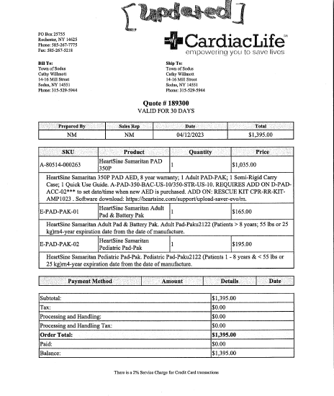

RESOLVED, Councilperson Chris Tertinek motioned to adopt resolution (06 04-2023) authorizing purchase of AEDs with Cardiac Life as listed on the previous page and to use ARPA funds to purchase the AEDs was seconded by Councilperson Cathy Willmott. Upon roll call the following votes were heard, Scott Johnson, aye; David LeRoy, absent; Don Ross, absent; Chris Tertinek, aye; and Cathy Willmott; aye. Resolution adopted.

Councilperson Chris Tertinek will follow up on dock quote for Harriman Park.

Discussion was held that the Planning Board is looking for an Ad-Hoc Planning Board Member. Supervisor Scott Johnson will speak with Sean Lamb to see if he is interested.

A motion by Councilperson Cathy Willmott to adjourn the Regular Town Board Meeting was seconded by Councilperson Chris Tertinek. Upon roll call the following votes were heard, Scott Johnson, aye; David LeRoy, absent; Don Ross, absent; Chris Tertinek, aye; and Cathy Willmott; aye. Resolution adopted.

Meeting adjourned at 6:58 PM

Recording Secretary,
Lori K. Diver

