Sodus Town Board Agenda
Regular Month End-Town Board Meeting
April 27, 2023
4:00 PM
Roll Call: (Lori Diver)
Supervisor Johnson, Councilperson LeRoy, Councilperson Ross, Councilperson Tertinek, Councilperson Willmott

Agenda:

- Resolution to hire Meredith Carroll as Assessment Clerk. The position will be 15 hours per week, $15.44 hourly a 6-month probationary period and starting date will be May 1, 2023.
First_________________ Seconded____________________

- Motion to approve March 23, 2023 tabled minutes (Cathy and Chris needs to abstain).

- Resolution authorizing payment of Abstract # 07-2023 for payment.
First_________________ Seconded____________________

- Resolution authorizing Supervisor Johnson to sign the CME Associates, Inc. Structural Materials Testing and Special Inspection Services
First_________________ Seconded____________________

- Resolution authorizing Supervisor Johnson to sign Notice to Proceed regarding the general construction of the new Salt Storage Building.
First_________________ Seconded____________________

- Resolution adopting annual software support contract for Town Clerk Plus with Dog QuickPay Software (5-1-2023 to 4/30-2024) in the amount of $994.00.
First_________________ Seconded____________________

- Resolution adopting Wayne County Bid for weed spraying from Chase Ent in the amount of $3,090.00.
First_________________ Seconded____________________

- Motion to Surplus equipment to Auction International from the Sodus Town Highway Department.
Surplus:
  - (14) Verizon phones, Model #T46S
  - Clark Forklift, Model #C500 55-Serial # 355-190-3131 (Parts Only)
  - Spectra Precision Laser, Model Laserplane 130 w/ 10ft. rod, receiver and tripod
First_________________ Seconded____________________

- Motion to adjourn meeting
First_________________ Seconded____________________

MINUTES
Minutes of the Month End Town Board Meeting commencing at 4:00 PM in the upstairs meeting room April 27, 2023 at 4:00 PM located at 14-16 Mill St. Sodus, NY 14551.
All meetings are open to the public.
In addition, this meeting was available through Zoom. Legal Notices were published and posted accordingly.

Present: Scott Johnson, Supervisor
David LeRoy, Councilperson/Deputy Supervisor
Don Ross, Councilperson
Chris Tertinek, Councilperson
Cathy Willmott, Councilperson

Recording Secretary: Lori Diver Sodus Town Clerk

Absent: N/A

Others Present: Bree Crandell, Supervisor Clerk
Dave Doyle, MRB
Lucille Heck
Meredith Carroll, Assessor Clerk Position
Nathan Mack, Assessor
Dale Pickering, Highway Superintendent

Supervisor Scott Johnson called the Month End Town Board Meeting to order commencing at 4:00 PM and Lori Diver opened with roll call. All were present.

RESOLUTION
MERRIDITH CARROLL-ASSESOR CLERK
(07 04-2023)
Supervisor Johnson offered the following resolution for its adoption:

NOW BE IT RESOLVED; Councilperson Don Ross motioned to authorize Nathan Mack Assessor to hire Meredith Carroll as Assessment Clerk. The position will be 15 hours per week, $15.44 hourly and a 6-month probationary period was seconded by Councilperson Cathy Willmott. Upon roll call the following votes were heard, Scott Johnson, aye; David LeRoy, aye; Don Ross, aye; Chris Tertinek, aye; and Cathy Willmott; aye. Resolution Adopted.

ABSTRACT
RESOLUTION TO PAY ABSTRACT No. 07
(08 04-2023)

WHEREAS, the following bills were presented for payment on Abstract 07:

General 177-200 $ 27,304.93
Highway 104-113 $ 20,447.15
Trust Agency 038-039 $ 2,923.24
Capital Projects 026-026 $ 1,410.00
GRAND TOTAL: $ 52,085.32

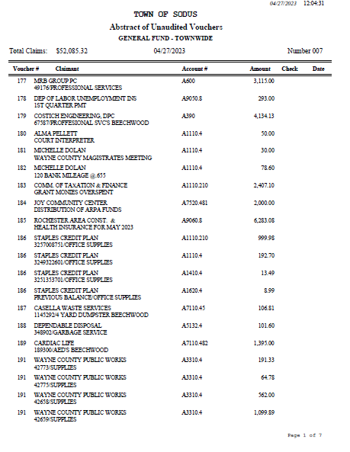

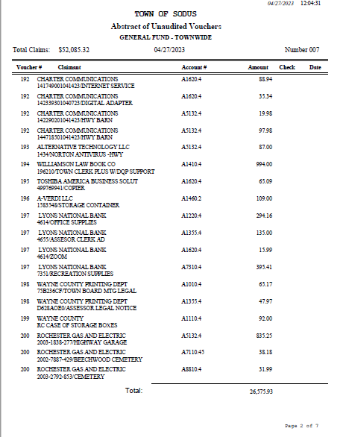

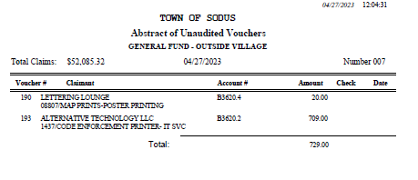

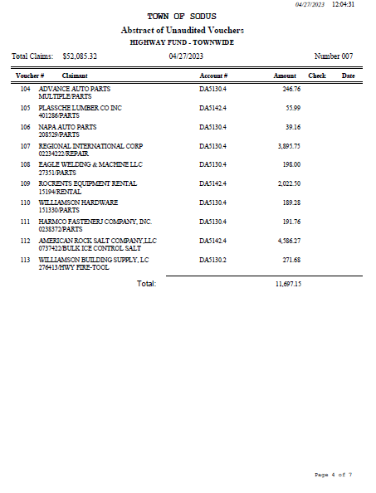

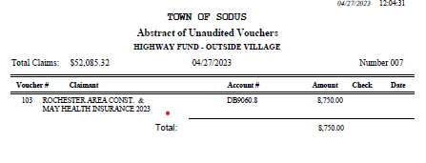

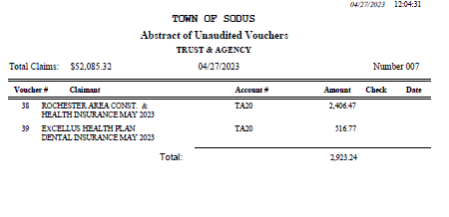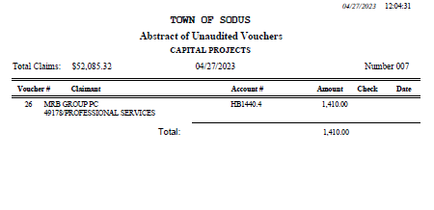

NOW BE IT RESOLVED, Councilperson Chris Tertinek motioned to authorize payment for Abstract # 7 as listed and adopt this resolution which was seconded by Councilperson Don Ross. Upon roll call the following votes were heard, Scott Johnson, aye; David LeRoy, aye; Don Ross, aye; Chris Tertinek, aye; and Cathy Willmott; aye. Resolution Adopted.

RESOLUTION
CME ASSOCIATES AGREEMENT-SALT BARN
(08 04-2023)
NOW BE IT RESOLVED; Councilperson Cathy Willmott motioned to authorize Supervisor Scott Johnson to sign CME Associates, Inc Agreement crossing off section Exhibit 1 “At an additional cost defined in Exhibit 1” per Amy Kendall Town Attorney approval which was seconded by Councilperson Don Ross. Upon roll call the following votes were heard, Scott Johnson, aye; David LeRoy, aye; Don Ross, aye; Chris Tertinek, aye; and Cathy Willmott; aye. Resolution Adopted.

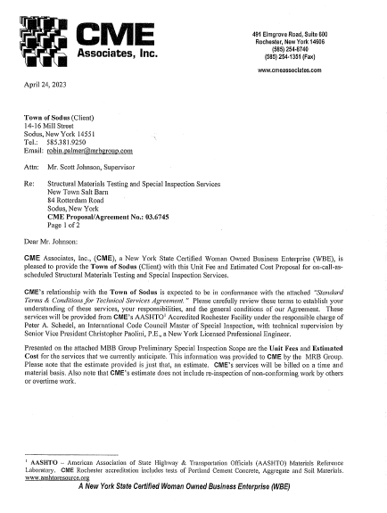

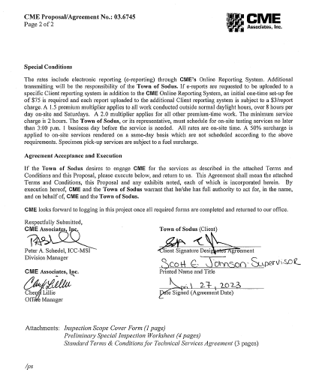

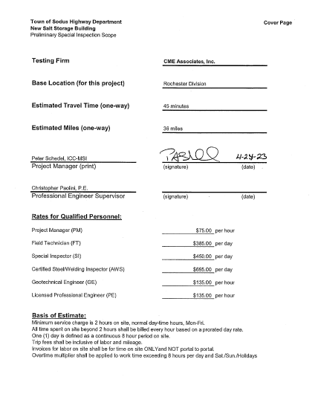

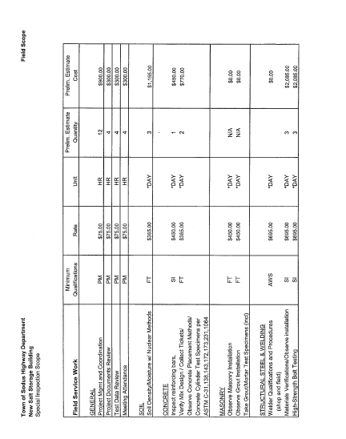

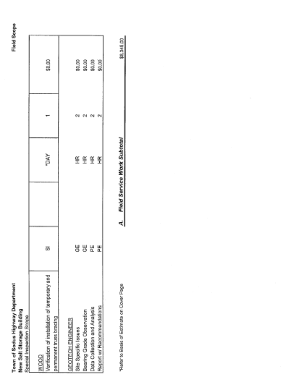

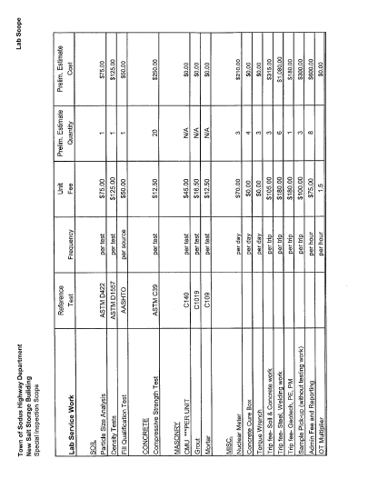

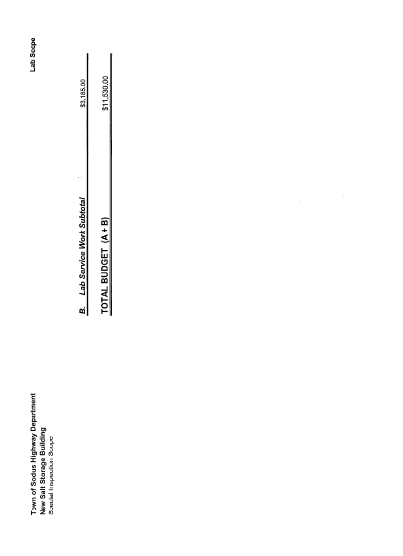
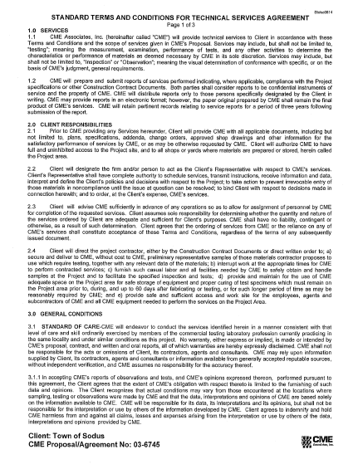

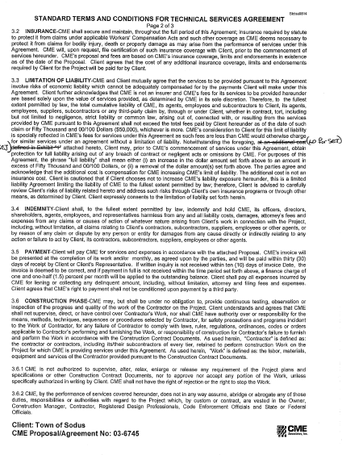

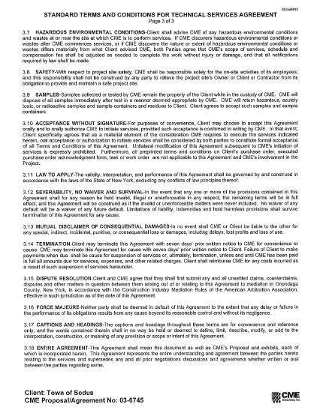

RESOLUTION
NOTICE TO PROCEED-SALT BARN
(09 04-2023)
NOW BE IT RESOLVED; Councilperson Cathy Willmott motioned to authorize Supervisor Scott Johnson to sign “Notice to Proceed” which was seconded by Councilperson Don Ross. Upon roll call the following votes were heard, Scott Johnson, aye; David LeRoy, aye; Don Ross, aye; Chris Tertinek, aye; and Cathy Willmott; aye. Resolution Adopted.

RESOULTION
WILLIAMSON LAW BOOK- ANNUAL TOWN CLERK PLUS WITH DOG QUICKPAY SOFTWARE IT SERVICES
(10 04-2023)
NOW BE IT RESOLVED; Councilperson David LeRoy motioned to authorize Town Supervisor Scott E. Johnson to sign Annual Town Clerk Plus with dog QuickPay Software IT Service (5-1-2023 to 4/30-2024) was seconded by Councilperson Cathy Willmott. Upon roll call the following votes were heard, Scott Johnson, aye; David LeRoy, aye; Don Ross, aye; Chris Tertinek, aye; and Cathy Willmott; aye. Resolution Adopted.
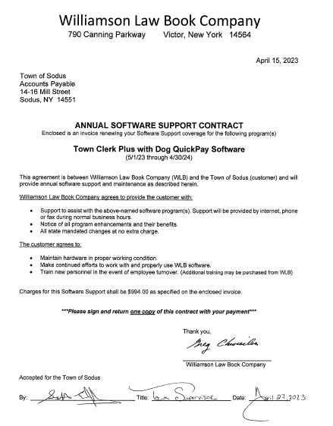

RESOULTION
WAYNE COUNTY BID FOR WEED SPRAYING FROM CHASE ENT.
(11 04-2023)
NOW BE IT RESOLVED; Councilperson David LeRoy motioned to authorize Highway Superintendent to adopt and accept Wayne County Bid for weed spraying from Chase Ent. In the amount of $3,090.00 was seconded by Councilperson Cathy Willmott. Upon roll call the following votes were heard, Scott Johnson, aye; David LeRoy, aye; Don Ross, aye; Chris Tertinek, aye; and Cathy Willmott; aye. Resolution Adopted.

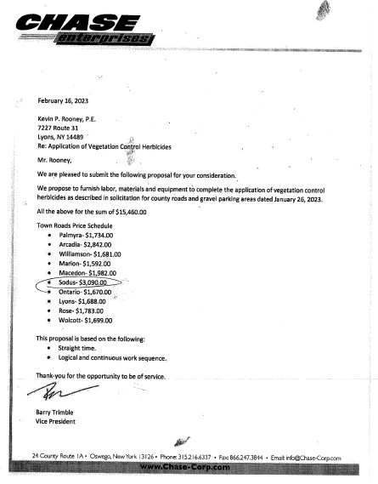

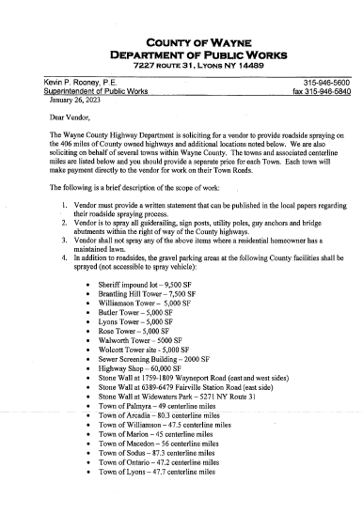
Councilperson David LeRoy motioned to authorize Highway Superintendent to surplus equipment to Auction International was seconded by Councilperson Chris Tertinek. Upon roll call the following votes were heard, Scott Johnson, aye; David LeRoy, aye; Don Ross, aye; Chris Tertinek, aye; and Cathy Willmott; aye. Motion approved.

Surplus:
- (14) Verizon phones, Model #T46S
- Clark Forklift, Model #C500 55-Serial #355-190-3131 (Parts Only)
- Spectra Precision Laser, Model Laserplane 130 w/ 10ft. rod, receiver and tripod.

Councilperson Cathy Willmott authorizing Supervisor Johnson or Councilperson LeRoy to sign PW-30 form for contractor to work for 10-hour days for the Salt Barn build was seconded by Councilperson Chris Tertinek. Upon roll call the following votes were heard, Scott Johnson, aye; David LeRoy, aye; Don Ross, aye; Chris Tertinek, aye; and Cathy Willmott; aye. Motion carried.

Councilperson Chris Tertinek motioned to change the month end board meeting to May 30th, 2023 upstairs at 4:00 PM and allow Lori Diver Sodus Town Clerk to advertise was seconded by Councilperson Cathy Willmott. Upon roll call the following votes were heard, Scott Johnson, aye; David LeRoy, aye; Don Ross, aye; Chris Tertinek, aye; and Cathy Willmott; aye. Motion carried.

Councilperson Don Ross motioned to adjourn the Month End Town Board Meeting was seconded by Councilperson Chris Tertinek. Upon roll call the following votes were heard, Scott Johnson, aye; David LeRoy, aye; Don Ross, aye; Chris Tertinek, aye; and Cathy Willmott; aye. Motion carried. 4:37 PM

Minutes Written By:
Lori K. Diver
Sodus Town Clerk, RMC

