MINUTES
Minutes of the Month End Town Board Meeting commencing at 3:00 PM in the upstairs meeting room April 28, 2022 located at 14-16 Mill St. Sodus, NY 14551.
All meetings are open to the public.
In addition this meeting was available through Zoom. Legal Notices were published and posted accordingly.

Present: Scott Johnson, Supervisor
David LeRoy, Councilperson/Deputy Supervisor
Don Ross, Councilperson
Chris Tertinek, Councilperson (arrived at 3:10 PM)
Cathy Willmott, Councilperson

Recording Secretary: Lori Diver, Sodus Town Clerk-RMC

Absent: N/A

Others Present: Bree Crandell- Supervisor Clerk
Julia O’Sullivan, Town Attorney
Amy Kendall, Town Attorney

Supervisor Scott Johnson called the Month End Town Board Meeting to order commencing at 3:00 PM and Lori Diver opened with roll call. All were present.

BID Opening for Town Cleanup 3:00 PM
LEGAL NOTICE
NOTICE TO BIDDERS
FOR
2022 TOWN OF SODUS CLEANUP

The Town of Sodus will be holding its Spring Cleanup Friday June 3 – Saturday June 4 from 8:30 AM to 3:30 PM and its Fall Cleanup Saturday October 1- 8:30 AM – 3:30 PM.

NOTICE IS HEREBY GIVEN in accordance with Section 103 of the General Municipal Law, sealed bids need to be mailed or dropped off at the Sodus Town Clerk’s Office, 14-16 Mill Street, Sodus NY, 14551. Bids will be accepted up until 1:00 PM April 27, 2022. Bids will be publicly opened and read at the 3:00 PM Thursday April 28, 2022 Month End-Town Board Meeting held in the upstairs meeting room located at 14-16 Mill St., Sodus NY. Bids must be sealed and marked on the outside of the envelope “2022 Town of Sodus Cleanup Bid” and must contain a non-collusive bidding certificate. No email Bids can be accepted. Specifications are available at the Town Clerk’s Office. The Sodus Town Board reserves the right to reject any or all bids. All meetings are open to the public.

By Order of the Sodus Town Board
Lori K. Diver
Sodus Town Clerk, RMC
April 18, 2022

There was only one BID received. The BID received was from ALPCO Recycling, Inc. is listed as follows:

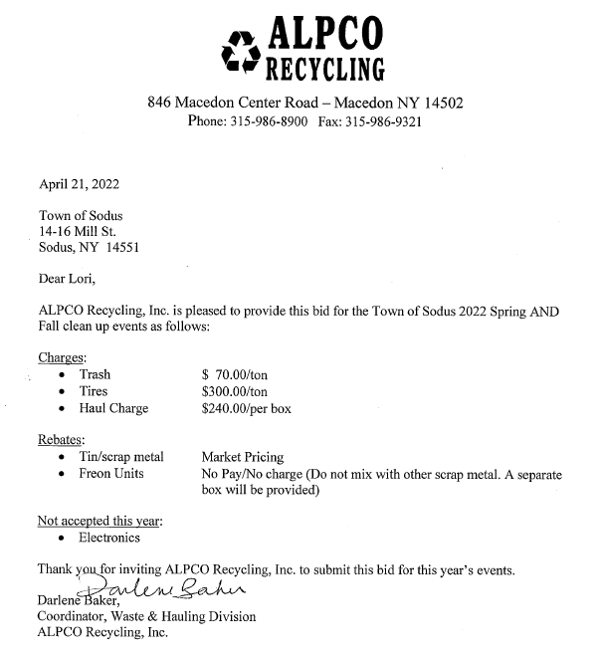BID AWARD TOWN OF SODUS SPRING & FALL CLEANUP 2022
RESOLUTION
(05 04-2022)
Supervisor Johnson offered the following resolution for its adoption,

NOW THEREFORE BE IT RESOLVED, Councilperson David LeRoy motioned to award ALPCO Recycling, Inc. the BID for the Town of Sodus Spring and Fall Cleanup for 2022 was seconded by Councilperson Cathy Willmott. Upon roll call the following votes were heard, Scott Johnson, aye; David LeRoy, aye; Don Ross, aye; Chris Tertinek, absent; and Cathy Willmott; aye. Resolution Adopted.

WILLIAMSON LAW BOOK TOWN CLERK PLUS W/DOG QUICK PAY IT SVC.
RESOLUTION
(06 04-2022)
Supervisor Johnson offered the following resolution for its adoption,

NOW THEREFORE BE IT RESOLVED, Councilperson Cathy Willmott motioned to adopt and approve Lori Diver to sign annual software support contract with Williamson Law Book for the Town Clerk Plus with Dog Quick Pay Software in the amount of $864.00 for 2022 was seconded by Councilperson David LeRoy. Upon roll call the following votes were heard, Scott Johnson, aye; David LeRoy, aye; Don Ross, aye; Chris Tertinek, absent; and Cathy Willmott; aye. Resolution Adopted.

SCHOOL STREET BRIDGE –SLATE HILL CONSTRUCTORS INC.
RESOLUTION
(07 04-2022)
Supervisor Johnson offered the following resolution for its adoption,

WHEREAS, the bidders for the April 22, 2022 bid opening for the Rehabilitation of School Street Bridge over Salmon Creek (BIN 2210710) are as follows, and

WHEREAS,
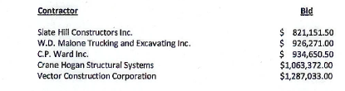, and
NOW THEREFORE BE IT RESOLVED, Councilperson David LeRoy motioned to adopt this resolution to approve the lowest bidder to Slate Hill Constructors, Inc. for the “Rehabilitation of School St. Bridge over Salmon Creek (BIN 2210710)” and to allow Supervisor Scott Johnson to sign the recommendation and award provided by Barton and Loguidice and request NYS concurrence to award project was seconded by Councilperson Don Ross. Upon roll call the following votes were heard, Scott Johnson, aye; David LeRoy, aye; Don Ross, aye; Chris Tertinek, absent; and Cathy Willmott; aye. Resolution Adopted.
ABSTRACT
RESOLUTION TO PAY ABSTRACT No. 7
(08 04-2022)
WHEREAS, the following bills were presented for payment on Abstract 7:
General 163-191 $ 25,142.66
Highway 119-135 $ 23,010.05
Trust & Agency 008-009 $ 2,044.38
GRAND TOTAL: $ 50, 0197.09
Councilperson David LeRoy motioned to adopt this resolution which was seconded by Councilperson Cathy Willmott. Upon roll call the following votes were heard, Scott Johnson, aye; David LeRoy, aye; Don Ross, aye; Chris Tertinek, aye; and Cathy Willmott; aye. Resolution Adopted.

Supervisor Johnson and the Sodus Town Board discussed the Harriman Park dock. There was much discussion about lowering the dock and other ideas that possibly could resolve when there is high water and low water levels. Johnson said he would talk with Senator Pam Helming to see if there are any grants to help with the costs.

Town Clerk Lori Diver discussed the current cemetery contracts that were returned. The contracts will allow the Town of Sodus to manage cemeteries on private property.
Joy Rural Union Cemetery Association, Swales Family Cemetery and Bushnell Cemetery are the only 3 contracts signed by the owners.
Wallace Stevenson Cemetery and Whitbeck School Cemetery, both owners said, “No.” Lefurgey Burial Ground was transferred from private land to the Sodus Rural Cemetery per Nathan Mack, Assessor. New England Cemetery-Centenary Cemetery and South Sodus Cemetery agreements came back to the Town Clerk’s office undeliverable. All additional cemetery contracts have not been returned.
There was discussion about the additional contracts that have not been returned. Amy Kendall Town Attorney advised the Town Board, unless those contracts have been returned and signed, the Town of Sodus cannot manage those cemeteries.

Councilperson David LeRoy motioned to approve travel requests for Supervisor Scott Johnson, Supervisor Clerk Breynn Crandell and Susie Jacobs to attend Town Finance School May 16 – May 17 was seconded by Councilperson Chris Tertinek. Upon roll call, the following votes were heard Supervisor Scott Johnson, aye; LeRoy, aye; Ross, aye; Tertinek, aye; and Willmott, aye. Motion carried.

Councilperson David LeRoy motioned to enter into Executive Session regarding a personnel issue with a particular person at 3:25 PM was seconded by Councilperson Chris Tertinek. Upon roll call the following votes were heard, Scott Johnson, aye; David LeRoy, aye; Don Ross, aye; Chris Tertinek, aye; and Cathy Willmott; aye. Motion carried.

Councilperson Cathy Willmott motioned to exit out of Executive Session at 4:10 PM and enter into an Attorney Client Privilege Meeting was seconded by Councilperson Chris Tertinek. Upon roll call the following votes were heard, Scott Johnson, aye; David LeRoy, aye; Don Ross, aye; Chris Tertinek, aye; and Cathy Willmott; aye. Motion carried.

Councilperson Chris Tertinek motioned to enter back into Executive Session at 4:55 PM regarding a personnel issue with a particular person was seconded by Councilperson Cathy Willmott. Upon roll call the following votes were heard, Scott Johnson, aye; David LeRoy, aye; Don Ross, aye; Chris Tertinek, aye; and Cathy Willmott; aye. Motion carried.

Councilperson Chris Tertinek motioned to exit out of Executive Session at 5:00 PM regarding a personnel issue with a particular person was seconded by Councilperson Cathy Willmott. Upon roll call the following votes were heard, Scott Johnson, aye; David LeRoy, aye; Don Ross, aye; Chris Tertinek, aye; and Cathy Willmott; aye. Motion carried.

Councilperson Chris Tertinek motioned to enter into Regular Session at 5:10 PM was seconded by Councilperson Cathy Willmott. Upon roll call the following votes were heard, Scott Johnson, aye; David LeRoy, aye; Don Ross, aye; Chris Tertinek, aye; and Cathy Willmott; aye. Motion carried.

Councilperson David LeRoy motioned to hire Jonathan Stoll for the currently vacant position of Highway Motor Equipment Operator on a full time basis pending pre-employment alcohol/drug testing was seconded by Councilperson Cathy Willmott. Upon roll call the following votes were heard, Scott Johnson, aye; David LeRoy, aye; Don Ross, aye; Chris Tertinek, aye; and Cathy Willmott; aye. Motion carried.

Councilperson David LeRoy motioned to hire James Michalke for the upcoming soon to be vacant position at the Town of Sodus Highway for the second Highway Motor Equipment Operator on a full time basis pending pre-employment alcohol/drug testing starting August 1, 2022 was seconded by Councilperson Cathy Willmott. Upon roll call the following votes were heard, Scott Johnson, aye; David LeRoy, aye; Don Ross, aye; Chris Tertinek, aye; and Cathy Willmott; aye. Motion carried.

There was discussion on keeping the Code Enforcement Officer at 20 hours or adding to the hours. If the new CEO is hired for more than 20 hours, he/she will have to meet the qualifications from Wayne County, NY and have a civil service exam. Per motion at the April 12, 2022 meeting, Lori Diver will run ad for the position with hours to be determined.

Councilperson Chris Tertinek motioned to adjourn the meeting was seconded by Councilperson Don Ross. Upon roll call the following votes were heard, Scott Johnson, aye; David LeRoy, aye; Don Ross, aye; Chris Tertinek, aye; and Cathy Willmott; aye. Motion carried.

Meeting adjourned at 5:13 PM
Recording Secretary,

Minutes Written By:
Lori Diver Sodus Town Clerk, RMC

