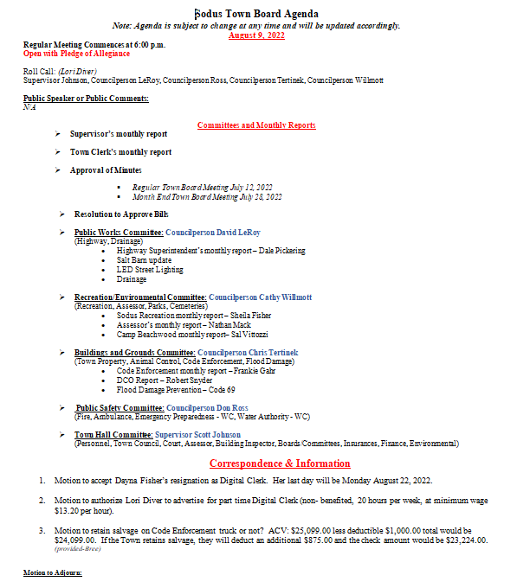

DRAFT MINUTES
Minutes of the Regular Town Board Meeting commencing at 6:00 PM in the upstairs meeting room August 9, 2022 located at 14-16 Mill St. Sodus, NY 14551.
All meetings are open to the public.
In addition this meeting was available through Zoom.
Legal Notices were published and posted accordingly.

Present: Scott Johnson, Supervisor
David LeRoy, Councilperson/Deputy Supervisor
Don Ross, Councilperson
Chris Tertinek, Councilperson
Cathy Willmott, Councilperson

Recording Secretary: Lori Diver, Sodus Town Clerk-RMC

Absent: N/A

Others Present: Sal Vittozzi- Camp Beechwood
Robert Snyder, DCO Officer
Bree Crandell, Supervisor Clerk

Supervisor Scott Johnson called the Regular Town Board Meeting to order commencing at 6:00 PM with the Pledge of Allegiance and Lori Diver opened with roll call. All were present.

PUBLIC SPEAKER:
N/A

SUPERVISOR’S REPORT
The Supervisor’s report was presented for July 2022. Councilperson David LeRoy motioned to accept and file this report, which was seconded by Councilperson Don Ross. Upon roll call the following votes were heard, Scott Johnson, aye; David LeRoy, aye; Don Ross, aye; Chris Tertinek, aye; and Cathy Willmott; aye. Motion carried.
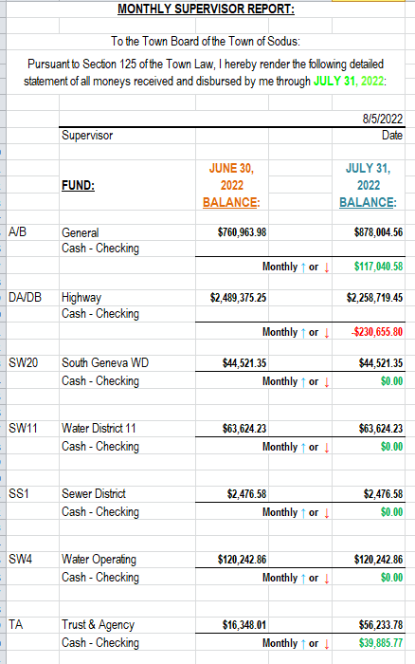

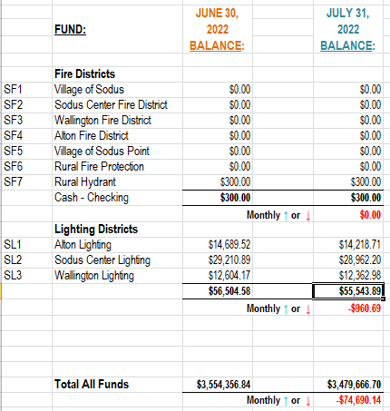

TOWN CLERK’S REPORT
The Town Clerk’s Report, Town Clerk’s bank statements for audit, and bank register for July 2022 were presented. Councilperson Chris Tertinek motioned to accept and file these reports, which was seconded by Councilperson David LeRoy. Upon roll call the following votes were heard, Scott Johnson, aye; David LeRoy, aye; Don Ross, aye; Chris Tertinek, aye; and Cathy Willmott; aye. Motion carried.

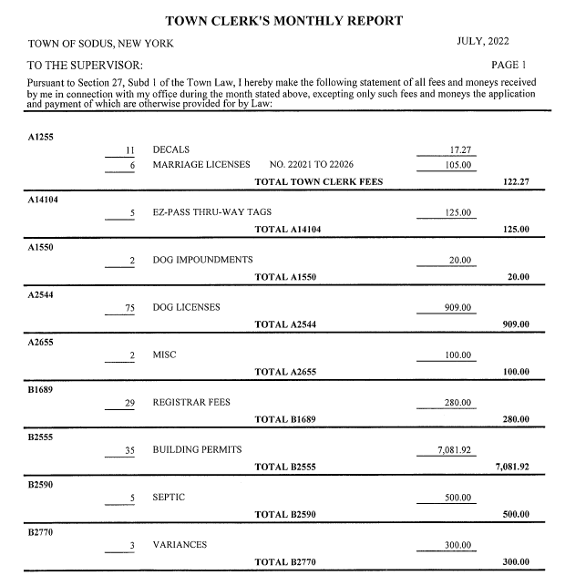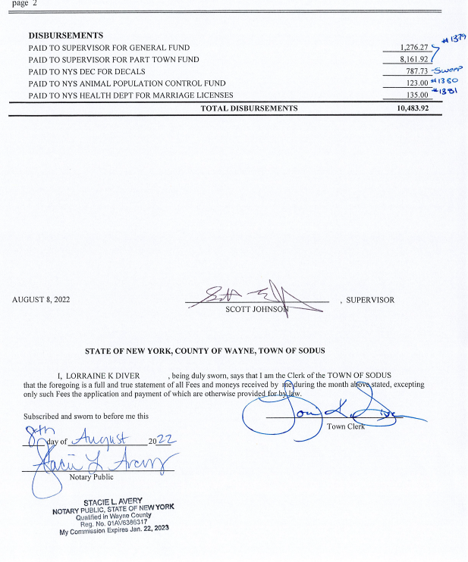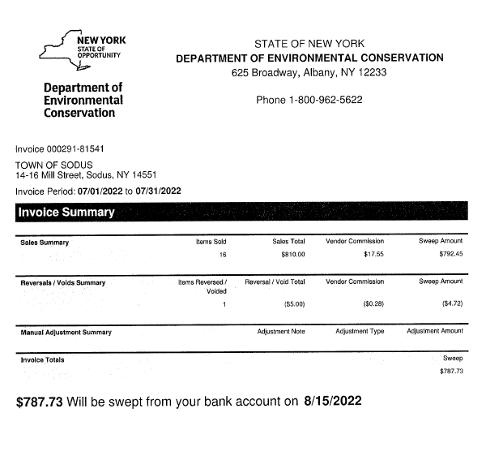
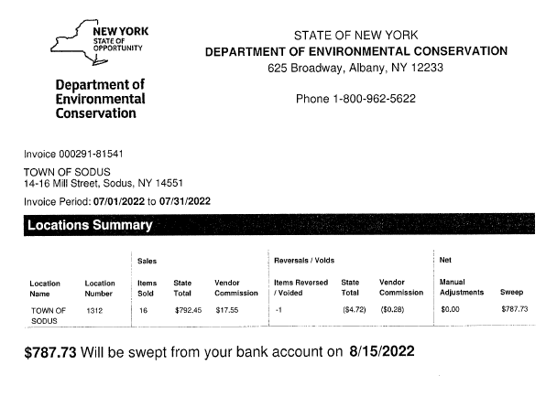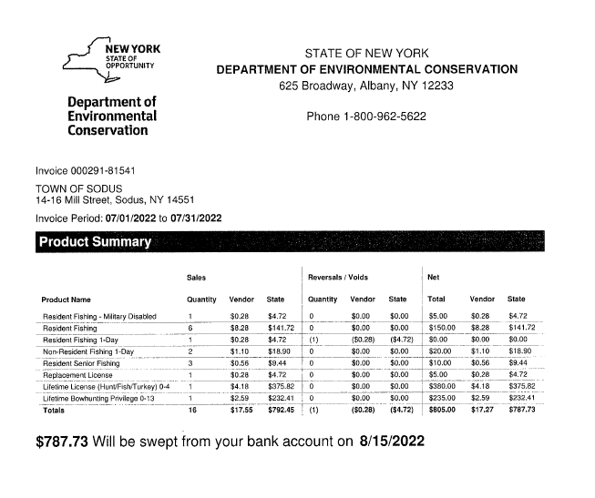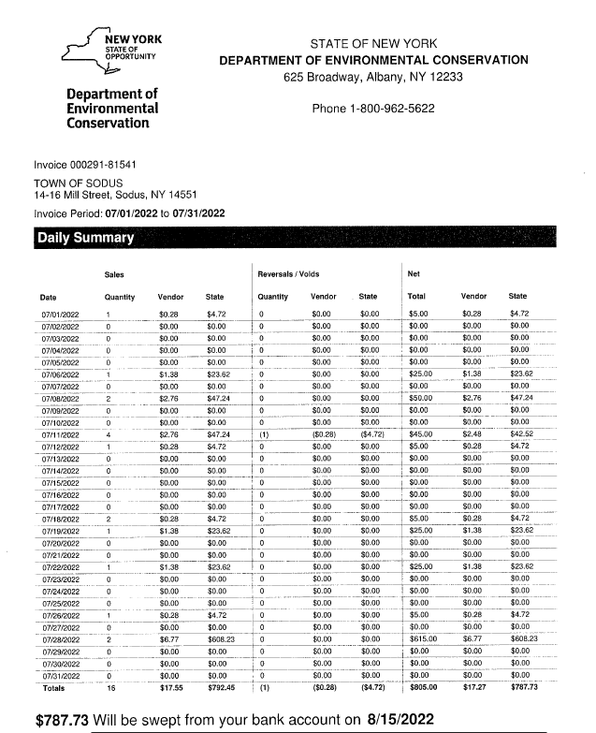

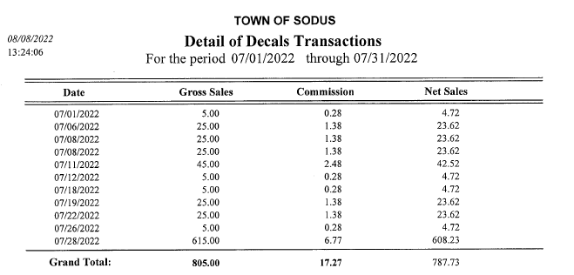
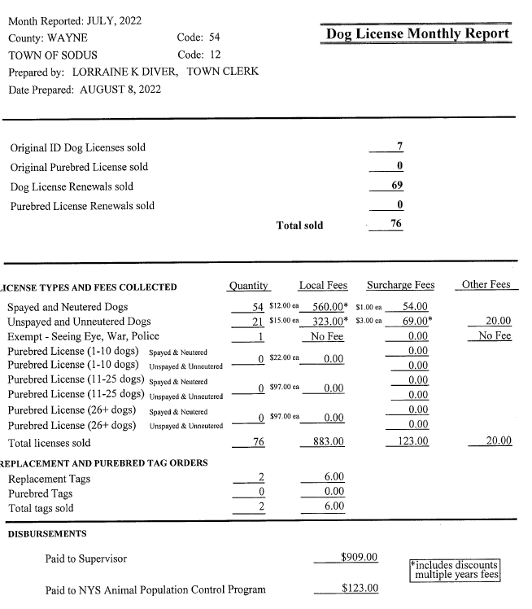
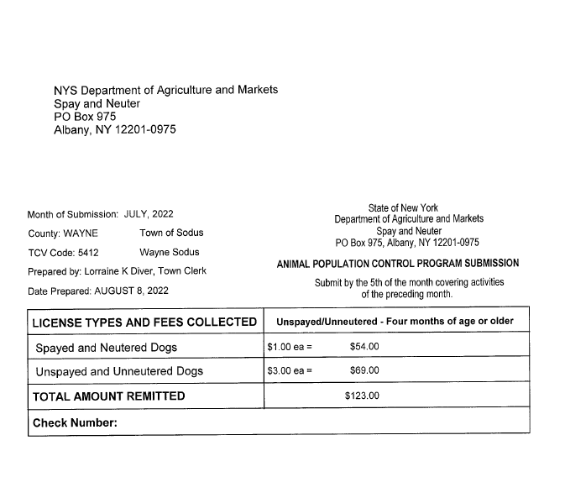
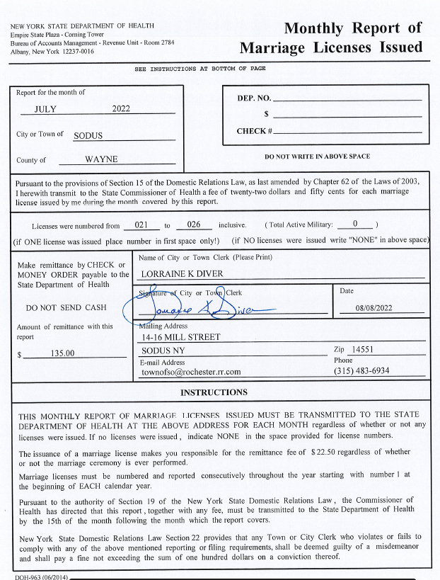

MINUTES
Minutes from July 12, 2022 and July 28, 2022 was presented to the Town Board for approval. Councilperson Cathy Willmott motioned to accept and file these Minutes, which was seconded by Councilperson Don Ross. Upon roll call the following votes were heard, Scott Johnson, aye; David LeRoy, aye; Don Ross, aye; Chris Tertinek, aye; and Cathy Willmott; aye. Motion carried.

ABSTRACT
RESOLUTION TO PAY ABSTRACT No. 14
- 8-2022)
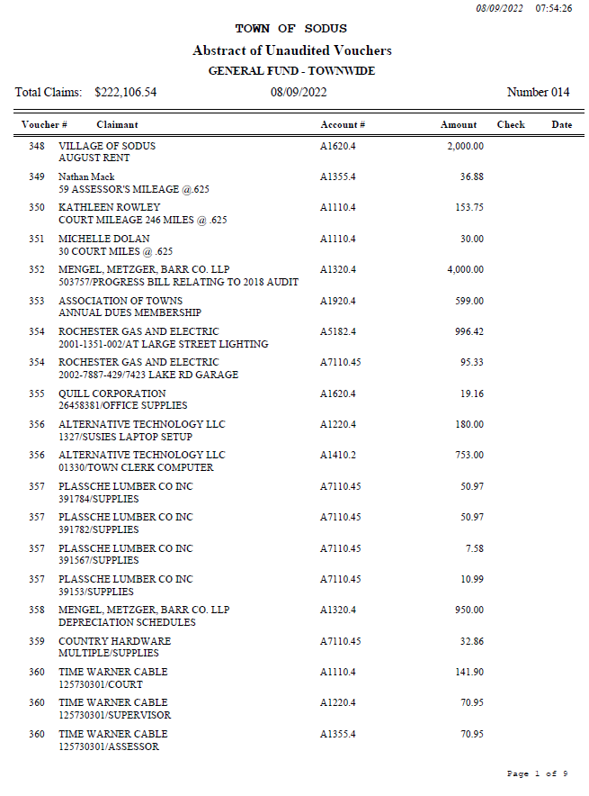
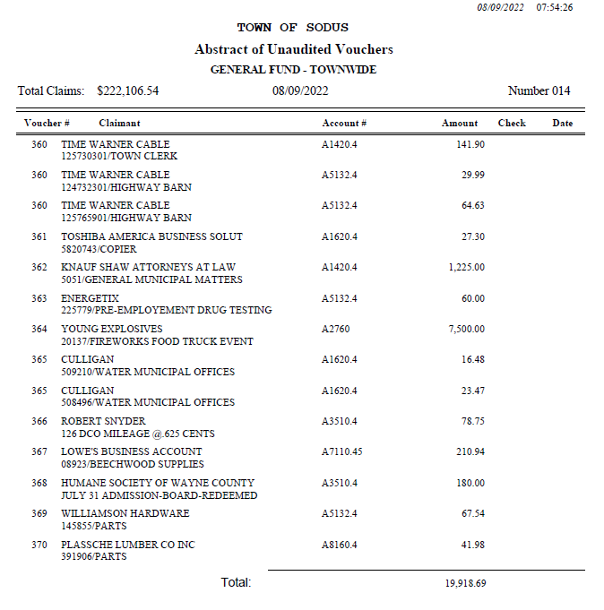
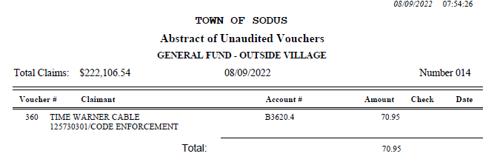
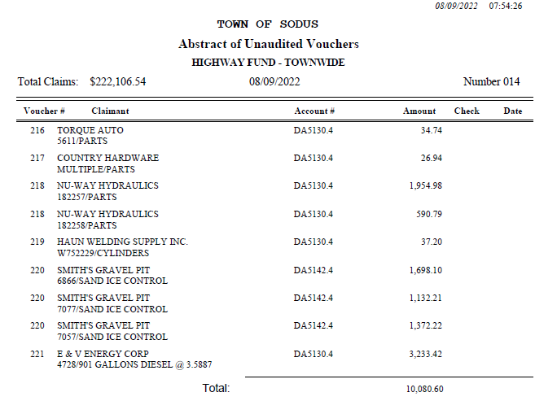
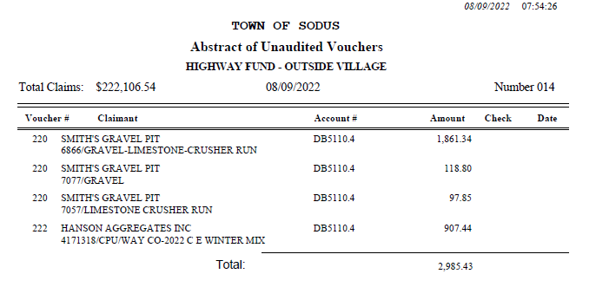
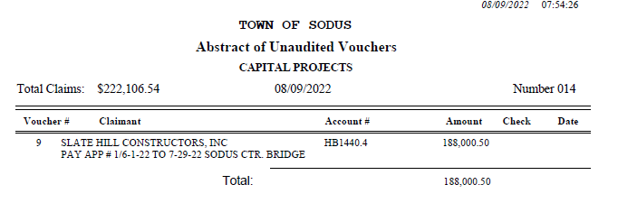
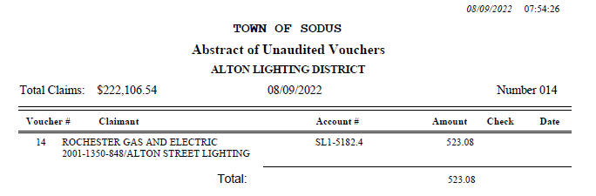
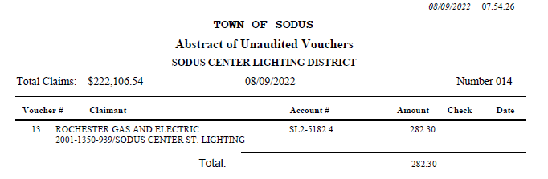
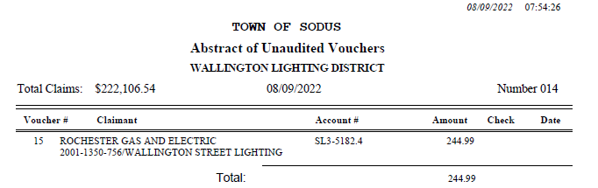

NOW BE IT RESOLVED, Councilperson Don Ross motioned to pay Abstract # 14 as listed and adopt this resolution which was seconded by Councilperson David LeRoy. Upon roll call the following votes were heard, Scott Johnson, aye; David LeRoy, aye; Don Ross, aye; Chris Tertinek, aye; and Cathy Willmott; aye. Resolution Adopted.

PUBLIC WORKS COMMITTEE: Councilperson David LeRoy, Chair
(Highway, Drainage - Deputy Town Supervisor)
HIGHWAY REPORT:
(Dale Pickering – Highway Superintendent)
Councilperson Cathy Willmott motioned to accept and file the monthly July 2022 Highway Report from Dale Pickering Highway Superintendent was seconded by Councilperson Chris Tertinek. Upon roll call the following votes were heard, Scott Johnson, aye; David LeRoy, aye; Don Ross, aye; Chris Tertinek, aye; and Cathy Willmott; aye. Motion carried.

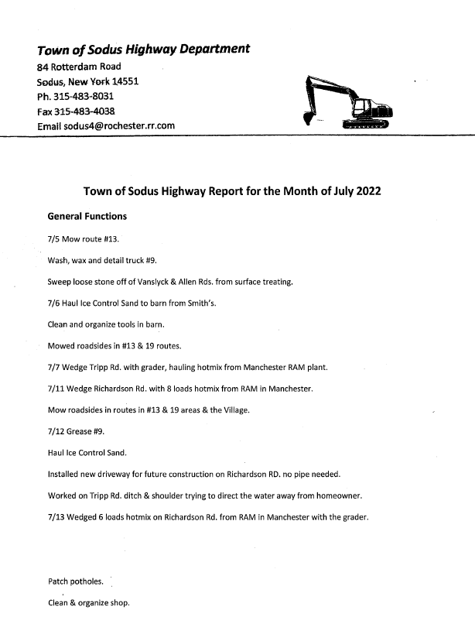
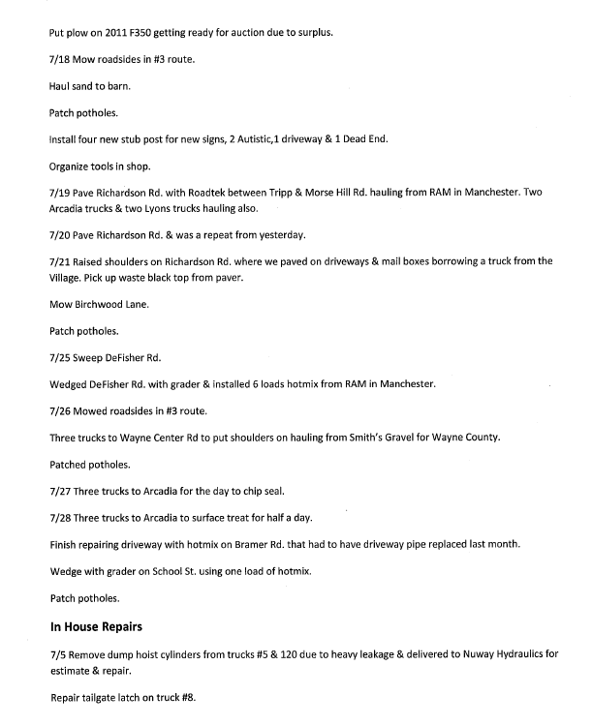
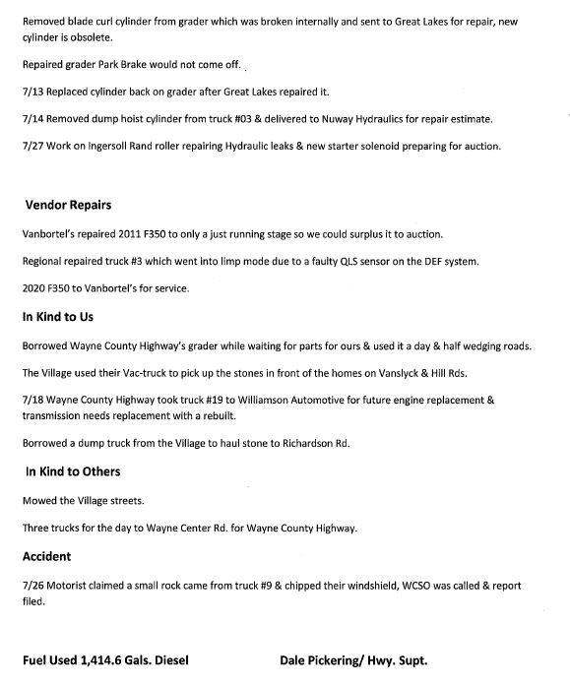

LED STREET LIGHTING:
Councilperson David LeRoy was informed that the LED lights have been shipped for the Town of Sodus street lighting project with RG&E.

SALT BARN UPDATE:
Councilperson David LeRoy has the official proposed plans of the new Salt Barn. When Highway Superintendent Dale Pickering comes back from vacation, Dave will sit down with Dale and review plans.

DRAINAGE
There are no new updates on McMullen Rd drainage issue. Councilperson David LeRoy will contact Dale when he gets back.

Supervisor Johnson discussed the Sodus Center Bridge and how well the project is coming.

RECREATION/ENVIRONMENTAL COMMITTE: Cathy Willmott, Councilperson
(Recreation, Assessor, Parks, Cemeteries)
Recreation Report
Councilperson Chris Tertinek motioned to accept and file the monthly July 2022 Town Recreation Report from Director, Sheila Fisher was seconded by Councilperson David LeRoy. Upon roll call the following votes were heard, Scott Johnson, aye; David LeRoy, aye; Don Ross, aye; Chris Tertinek, aye; and Cathy Willmott; aye. Motion carried.

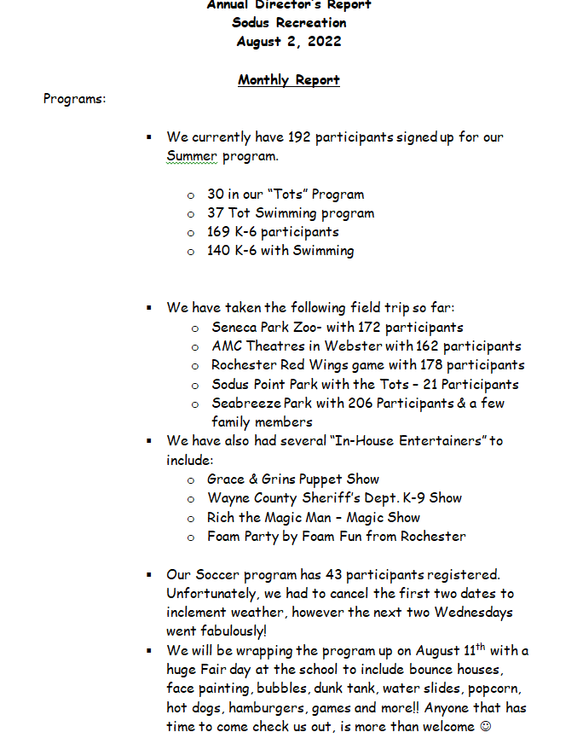
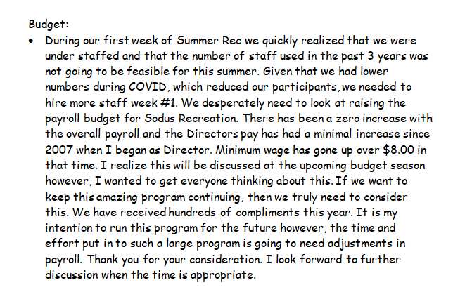
Assessor’s Report
(Nathan Mack, Assessor)
Councilperson David LeRoy motioned to accept and file the monthly July 2022 Assessor’s Report from Sole Assessor, Nathan Mack was seconded by Councilperson Don Ross. Upon roll call the following votes were heard, Scott Johnson, aye; David LeRoy, aye; Don Ross, aye; Chris Tertinek, aye; and Cathy Willmott; aye. Motion carried.
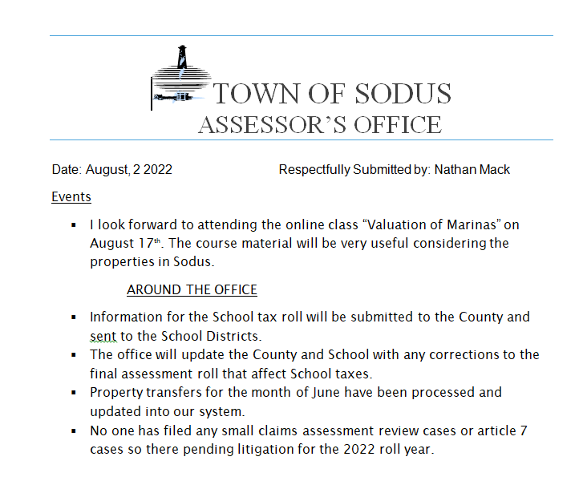

Camp Beechwood/Sodus Groundskeeper Report
(Sal Vittozzi-Caretaker-Sodus Town Groundkeeper)
Councilperson Don Ross motioned to accept the monthly July 2022 Camp Beechwood-Parks & Cemeteries Report from Sal Vittozzi; Sodus Town Groundskeeper-Caretaker was seconded by Councilperson David LeRoy. Upon roll call the following votes were heard, Scott Johnson, aye; David LeRoy, aye; Don Ross, aye; Chris Tertinek, aye; and Cathy Willmott; aye. Motion carried.

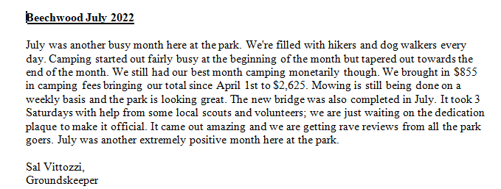

Sal Vittozzi, Caretaker stated it was a very busy month at the park and there was a great turnout of campers in July. The bridge is completed at Beechwood. Lynda Faulks and friends stained the bridge. They did an amazing job. The young group of teenagers from Jay Roscup’s group has done an astounding job helping over this summer. Mark Ketchem and Werner Lutz helped assist tremendously with the bridge too.

It was mentioned that over 5 Eagle Scouts have done projects at Beechwood and completed them. Vittozzi would like to see some recognition to each Eagle Scout. Town Clerk Lori Diver stated that normally a letter is sent from the Troop Leader with a form to fill out for each Eagle Scout. Once this is submitted, each Eagle Scout is also awarded a proclamation from the Town Board. Vittozzi and Supervisor Johnson both shared that maybe there is a new leader and unaware of the protocol.
Vittozzi is going to contact one of the parents to see if he can get some more information of whom the Town should contact.

BUILDINGS AND GROUNDS COMMITTEE: Councilperson Chris Tertinek, Chair
(Town Property, Animal Control, Flood Damage Prevention)
CODE ENFORCEMENT REPORT:
(Frankie Gahr- CEO)
Councilperson Don Ross motioned to accept the monthly July 2022 Code Enforcement Report was seconded by Councilperson Cathy Willmott. Upon roll call the following votes were heard, Scott Johnson, aye; David LeRoy, aye; Don Ross, aye; Chris Tertinek, aye; and Cathy Willmott; aye. Motion carried.
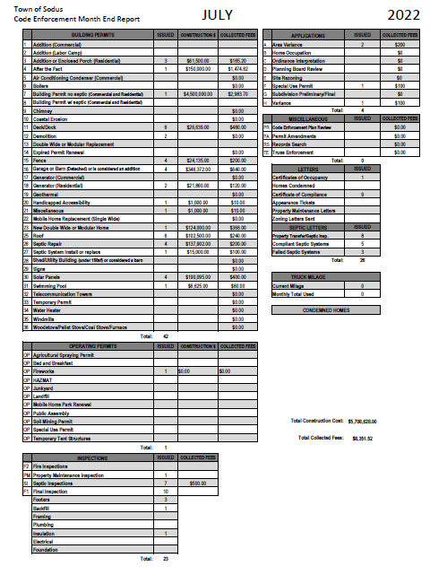

DOG CONTROL REPORT:
(Robert Snyder, Primary DCO)
(Vacant Position- Secondary DCO)
Councilperson David LeRoy motioned to accept the monthly July 2022 Dog Control Report was seconded by Councilperson Don Ross. Upon roll call the following votes were heard, Scott Johnson, aye; David LeRoy, aye; Don Ross, aye; Chris Tertinek, aye; and Cathy Willmott; aye. Motion carried.

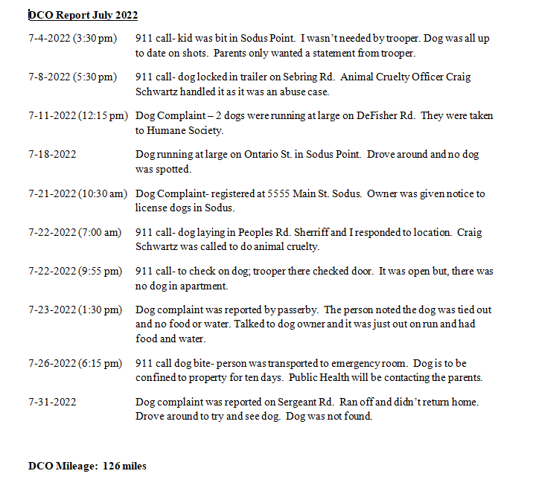
FLOOD DAMAGE PREVENTION REPORT-Code 69:
(Chris Tertinek, Councilperson)
Councilperson Chris Tertinek gave his monthly Flood Damage Prevention Report.
Lake Level
- Now at 245.57 ASL, 4” below long-term average. Tertinek stated we may start hearing complaints about the water levels being so low.
- Outlook- Will stay below average past January.
- Mid November level will slowly rise.
- Mid November the level will be at ~244 feet ASL (1958 DD low level 243.3 or 9 inches) more than the charted depth on the navigational chart.

REPORT FROM PLANNING BOARD:
One person has tested + for Covid-19. All others that tested were clear.

PUBLIC SAFETY/DRAINAGE/ENVIRONMENT COMMITTEE: Councilperson Don Ross, Chair (Fire, Ambulance, Emergency Preparedness)
Councilperson Don Ross gave his monthly report. The 911 call statistics and SESA minutes were submitted to the Board.

Silver Waters Community Ambulance Service Inc. is having a 2022 Bluegrass and BBQ Fundraiser Saturday, September 17, 2022 5:30 PM to 9:00 PM at Sodus Bay Heights Golf Club 7030 Bayview Drive, Sodus Point, NY 14555. The cost is $65.00 per person.

Councilperson Ross discussed that the Wayne County Water & Sewer Authority are doing hydrant maintenance in the Town.

TOWN HALL COMMITTEE: Scott Johnson, Supervisor –
(Personnel, Clerks, Justices, Assessor, Building Inspector, Town Council, Boards, Insurances, Finance)

CORRESPONDENCE & INFORMATION

Councilperson Don Ross motioned to accept Dayna Fisher Digital Clerk’s resignation Tuesday August 9, 2022 was seconded by Councilperson Cathy Willmott. Her last day will be August 22, 2022. Upon roll call, the following votes were heard Supervisor Scott Johnson, aye; LeRoy, aye; Ross, aye; Tertinek, aye; and Willmott, aye. Resolution Adopted.

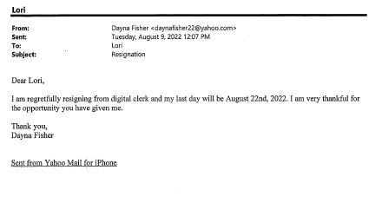
The Town Board under Town Clerk Lori Diver’s request tabled the authorization for Lori Diver to advertise for a part time Digital Clerk. Diver would like to research a little more before an advertisement is placed.

Councilperson Don Ross motioned for the Town to NOT retain salvage with the Code Enforcement Truck was seconded by Councilperson Chris Tertinek. The ACV: is $25,099.00 less deductible $1,000.00. The total of the check from the insurance company will be $24,099.00. Upon roll call the following votes were heard, Scott Johnson, aye; David LeRoy, aye; Don Ross, aye; Chris Tertinek, aye; and Cathy Willmott; aye. Motion carried.

Councilperson David LeRoy motioned to adjourn the meeting was seconded by Councilperson Don Ross. Upon roll call the following votes were heard, Scott Johnson, aye; David LeRoy, aye; Don Ross, aye; Chris Tertinek, aye; and Cathy Willmott; aye. Motion carried.

Meeting adjourned at 6:52 PM
Recording Secretary,

Minutes Written By:
Lori Diver
Sodus Town Clerk, RMC

