Sodus Town Board Agenda
Note: Agenda is subject to change at any time and will be updated accordingly.
December 13, 2022
Regular Meeting Commences at 6:00 p.m.
Open with Pledge of Allegiance

Roll Call: (Lori Diver)
Supervisor Johnson, Councilperson LeRoy, Councilperson Ross-Absent, Councilperson Tertinek,
Councilperson Willmott-Zoomed
Public Speaker or Public Comments:
N/A
Committees and Monthly Reports
- Supervisor’s monthly report

- Town Clerk’s monthly report

- Approval of Minutes

    - November 8, 2022 –Minutes
    - November 29, 2022-Minutes (Scott Johnson –abstain-absent)

- Resolution to Approve Bills –Abstract #21-2022

- Public Works Committee: Councilperson David LeRoy
(Highway, Drainage)
- Highway Superintendent’s monthly report – Dale Pickering
- Salt Barn update
- LED Street Lighting
- Drainage

- Recreation/Environmental Committee: Councilperson Cathy Willmott
(Recreation, Assessor, Parks, Cemeteries)
- Sodus Recreation monthly report – Sheila Fisher
- Assessor’s monthly report – Nathan Mack
- Camp Beachwood monthly report– Sal Vittozzi

- Buildings and Grounds Committee: Councilperson Chris Tertinek
(Town Property, Animal Control, Code Enforcement, Flood Damage)
- Code Enforcement monthly report – Frankie Gahr
- DCO Report – Robert Snyder
- Flood Damage Prevention – Code 69

- Public Safety Committee: Councilperson Don Ross
(Fire, Ambulance, Emergency Preparedness - WC, Water Authority - WC)

- Town Hall Committee: Supervisor Scott Johnson
(Personnel, Town Council, Court, Assessor, Building Inspector, Boards/Committees, Insurances, Finance, Environmental)

Correspondence & Information
- Resolution re-appointing Daryl D. Minier to the Board of Assessment Review 10-01-2022 to 9-30-2027.

- Motion to rescind resolution from the November 29, 2022 Month End Meeting for Local Law 3-2022 (to reduce number of members and term of appointments for the Planning Board).
(Chris).

- Motion to allow Lori Diver Sodus Town Clerk to advertise legal notice to reduce number of members and increase term of appointments for the Planning Board (Local Law 1-2023) including; holding the public hearing on January 10, 2023 at 6:00 PM.

Motion to Adjourn:

MINUTES
Minutes of the Regular Town Board Meeting commencing at 6:00 PM in the downstairs courtroom December 13, 2022 located at 14-16 Mill St. Sodus, NY 14551.
All meetings are open to the public.
In addition this meeting was available through Zoom. Legal Notices were published and posted accordingly.

Present: Scott Johnson, Supervisor
David LeRoy, Councilperson/Deputy Supervisor
Chris Tertinek, Councilperson
Cathy Willmott, Councilperson-Zoomed (unable to vote)

Recording Secretary: Lori Diver, Sodus Town Clerk-RMC

Absent: Councilperson Don Ross

Others Present: Sal Vittozzi, Camp Beechwood
Robert Snyder, DCO
Bree Crandell, Supervisor Clerk (Zoomed)
Dale Pickering, Highway Superintendent
Dave Doyle, MRB
Amy Kendall, Town Attorney

Supervisor Scott Johnson called the Regular Town Board Meeting to order commencing at 6:00 PM with the Pledge of Allegiance and Lori Diver opened with roll call. All were present with the exception of Don Ross was absent and Cathy Willmott-Zoomed (unable to vote).

PUBLIC SPEAKER:
(Dave Doyle, MRB)
Dave Doyle with MRB discussed with the Board that the Town and the two residents on Emerald Point Rd met regarding proposed WD No. 12. There was discussion about having another public informational meeting regarding WD No. 12 in the near future.

Doyle shared briefly the Salt Barn Storage Project. There was discussion about the funding and if it is all set-in place for bidding to begin in January of 2023. The Town will follow up to make sure everything is in place for this to happen.

SUPERVISOR’S REPORT
The Supervisor’s report was presented for November 2022. Councilperson Chris Tertinek motioned to accept and file this report, which was seconded by Councilperson David LeRoy. Upon roll call the following votes were heard, Scott Johnson, aye; David LeRoy, aye; Don Ross, absent; Chris Tertinek, aye; and Cathy Willmott; (Zoomed-unable to vote). Motion carried.

MONTHLY SUPERVISOR REPORT:
Pursuant to Section 125 of the Town Law, I hereby render the following detailed statement of all moneys received and disbursed by me through: NOVEMBER 30, 2022:
 | Supervisor |  |  | Date
 |  | OCTOBER 31, 2022 BALANCE |  | NOVEMBER 30, 2022 BALANCE
FUND:
A/B | General | $390,316.81 |  | $475,239.87
 | Cash - Checking
 |  |  | Monthly ? or ? | $84,923.06
DA/DB | Highway | $1,915,503.56 |  | $1,796,073.29
 | Cash - Checking
 |  |  | Monthly ? or ? | -$119,430.27
SW20 | South Geneva WD | $44,521.35 |  | $44,521.35
 | Cash - Checking |  | Monthly ? or ? | $0.00
SW11 | Water District 11 | $63,624.23 |  | $63,624.23
 | Cash - Checking |  | Monthly ? or ? | $0.00
SS1 | Sewer District | $2,476.58 |  | $2,476.58
 | Cash - Checking |  | Monthly ? or ? | $0.00
SW4 | Water Operating | $120,242.86 |  | $120,242.86
 | Cash - Checking |  | Monthly ? or ? | $0.00
TA | Trust & Agency | $12,249.26 |  | $52,165.24
 | Cash - Checking |  | Monthly ? or ? | $39,915.98
 |  | OCTOBER 31, 2022 BALANCE |  | NOVEMBER 30, 2022 BALANCE
FUND:
 | Fire Districts
SF1 | Village of Sodus | $0.00 |  | $0.00
SF2 | Sodus Center Fire District | $0.00 |  | $0.00
SF3 | Wallington Fire District | $0.00 |  | $0.00
SF4 | Alton Fire District | $0.00 |  | $0.00
SF5 | Village of Sodus Point | $0.00 |  | $0.00
SF6 | Rural Fire Protection | $0.00 |  | $0.00
SF7 | Rural Hydrant | $300.00 |  | $300.00
 | Cash - Checking | $300.00 |  | $300.00
 |  |  | Monthly ? or ? | $0.00
 | Lighting Districts
SL1 | Alton Lighting | $12,588.81 |  | $12,016.00
SL2 | Sodus Center Lighting | $28,076.34 |  | $27,761.96
SL3 | Wallington Lighting | $11,551.14 |  | $11,257.77
 |  | $52,216.29 |  | $51,035.73
 |  |  | Monthly ? or ? | -$1,180.56
 | Total All Funds | $2,601,450.94 |  | $2,605,679.15
 |  |  | Monthly ? or ? | $4,228.21

TOWN CLERK’S REPORT
The Town Clerk’s Report, Town Clerk’s bank statements for audit, and bank register for November 2022 were presented. Councilperson David LeRoy motioned to accept and file these reports, which was seconded by Councilperson Chris Tertinek. Upon roll call the following votes were heard, Scott Johnson, aye; David LeRoy, aye; Don Ross, absent; Chris Tertinek, aye; and Cathy Willmott; (Zoomed-unable to vote). Motion carried.
Note: Town Clerk bank register and bank statement made available upon request with banking detailed info to be redacted. Not published for security reasons.

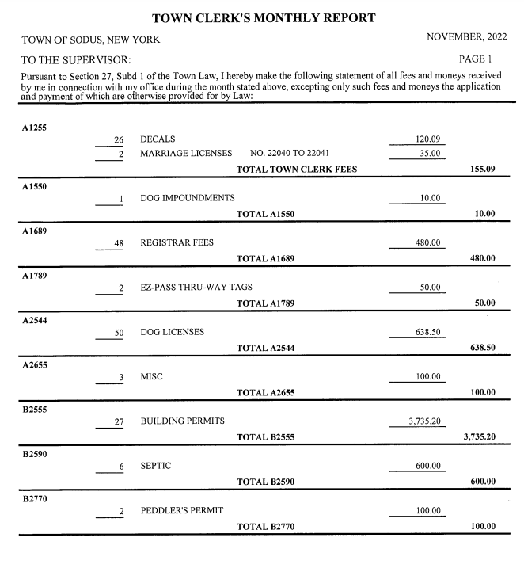
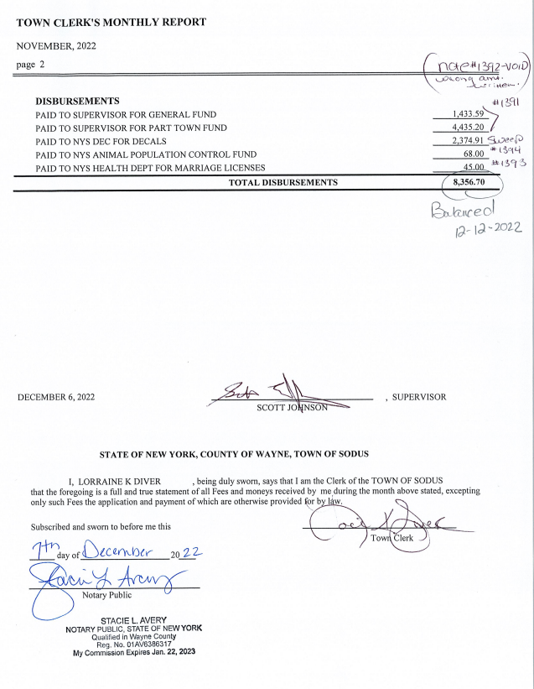

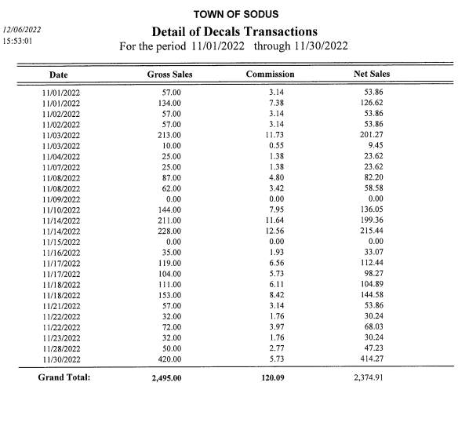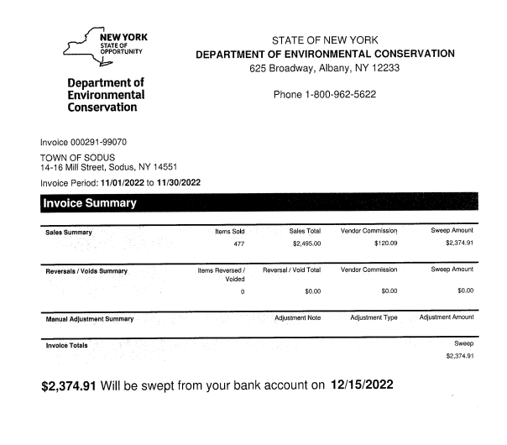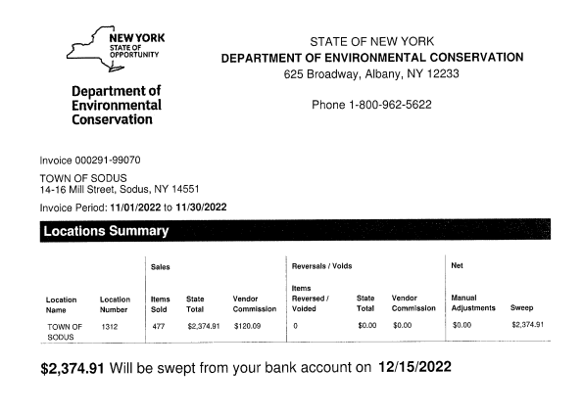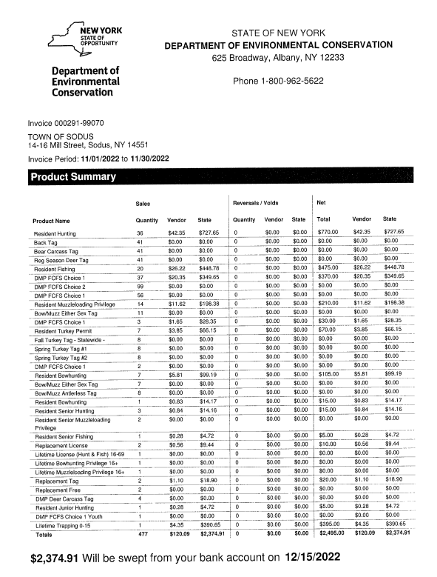

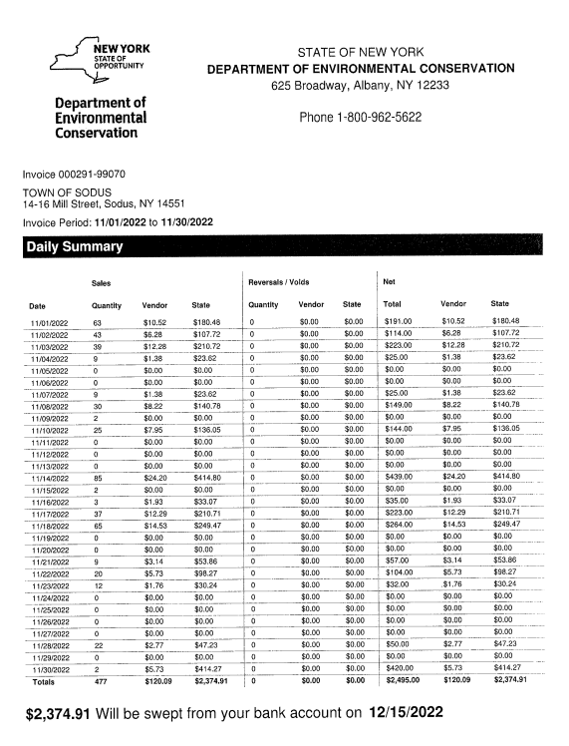

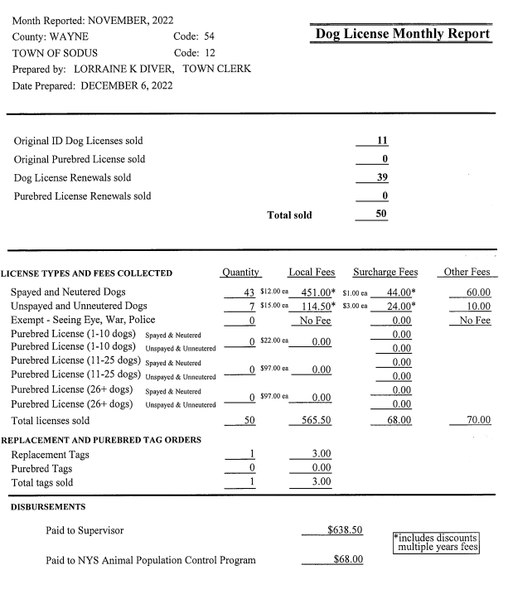
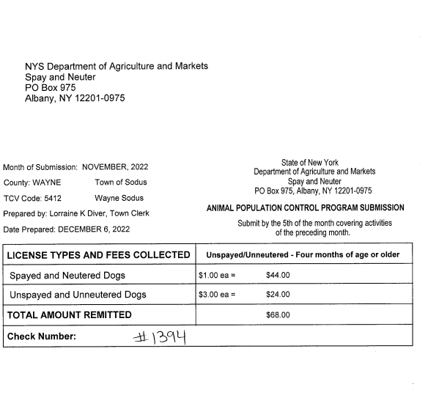
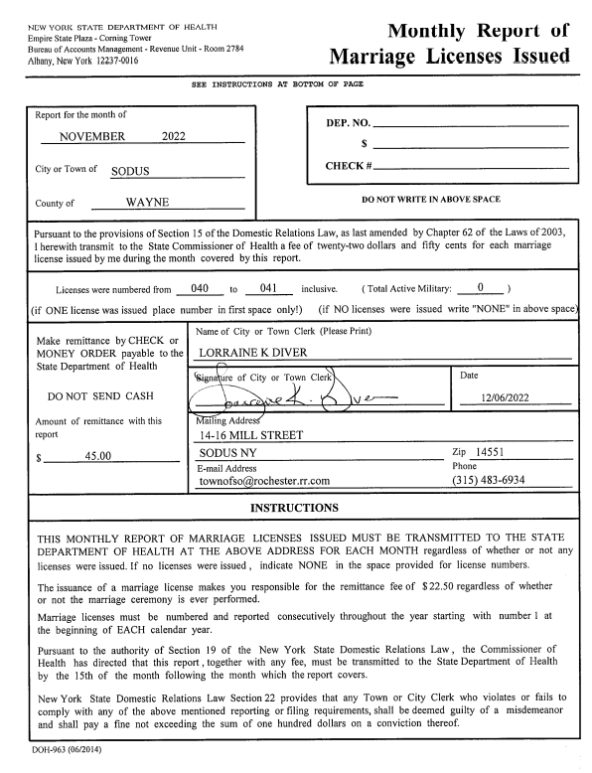

MINUTES
Minutes from November 8, 2022 was presented to the Town Board for approval. Councilperson David LeRoy motioned to accept and file these Minutes, which was seconded by Councilperson Chris Tertinek. Upon roll call the following votes were heard, Scott Johnson, aye; David LeRoy, aye; Don Ross, absent; Chris Tertinek, aye; and Cathy Willmott; (Zoomed-unable to vote). Motion carried.

Minutes from the November 29, 2022 was presented to the Town Board for approval. The minutes will have to be tabled until the January 2023 meeting due to Supervisor Scott Johnson was absent from this meeting hence; there is no quorum to vote on approval of these minutes for this meeting.

ABSTRACT
RESOLUTION TO PAY ABSTRACT No. 21
- 12-2022)
WHEREAS, the following bills were presented for payment on Abstract 21:

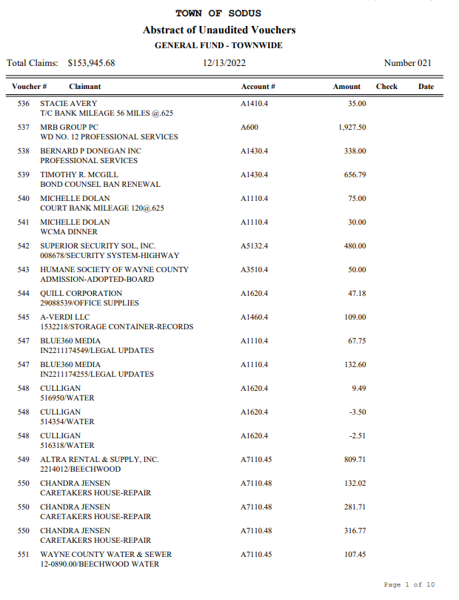
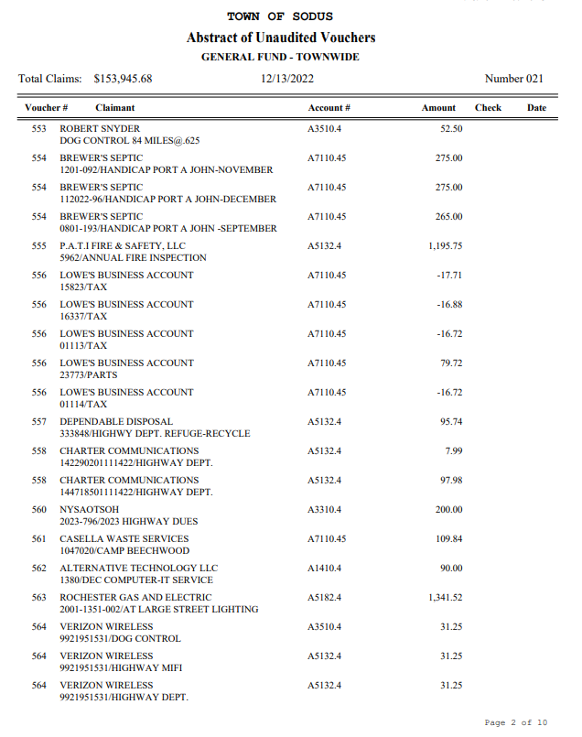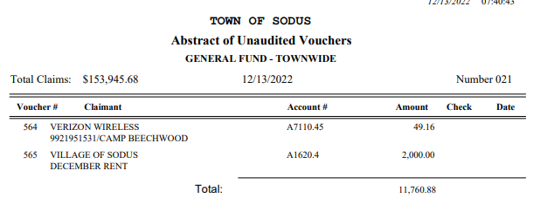

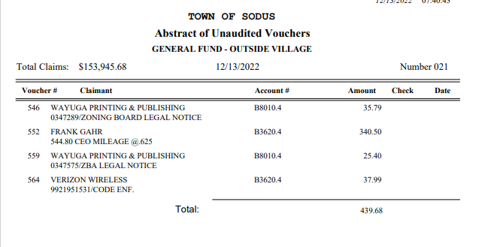
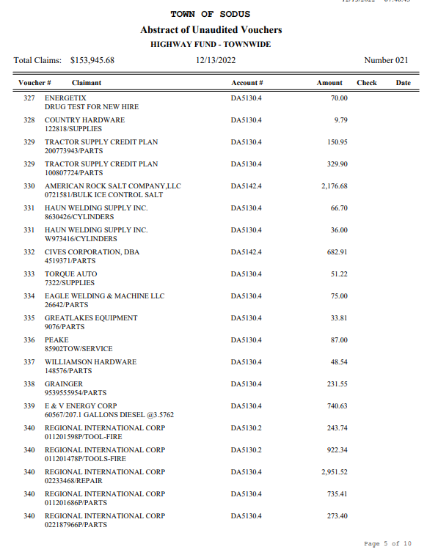
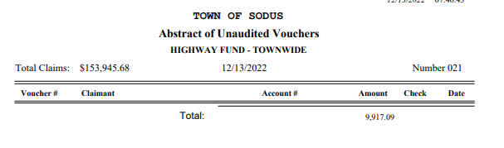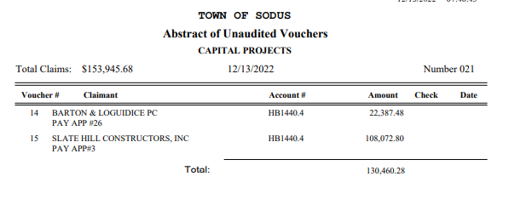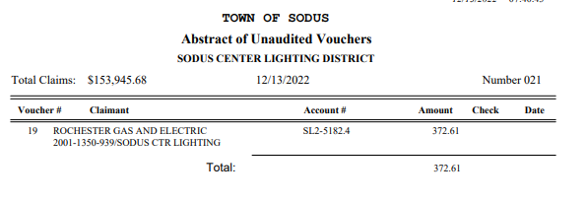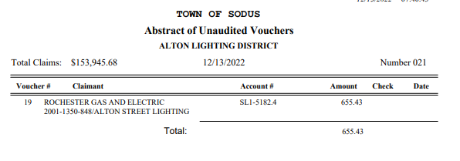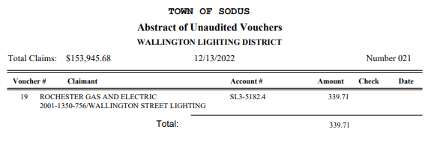

NOW BE IT RESOLVED, Councilperson Chris Tertinek motioned to authorize payment for Abstract # 21 as listed and adopt this resolution which was seconded by Councilperson David LeRoy. Upon roll call the following votes were heard, Scott Johnson, aye; David LeRoy, aye; Don Ross, absent; Chris Tertinek, aye; and Cathy Willmott; (Zoomed-unable to vote). Resolution Adopted.

PUBLIC WORKS COMMITTEE: Councilperson David LeRoy, Chair
(Highway, Drainage - Deputy Town Supervisor)
HIGHWAY REPORT:
(Dale Pickering – Highway Superintendent)
Councilperson David LeRoy motioned to accept and file the monthly November 2022 Highway Report from Dale Pickering Highway Superintendent was seconded by Councilperson Chris Tertinek. Upon roll call the following votes were heard, Scott Johnson, aye; David LeRoy, aye; Don Ross, absent; Chris Tertinek, aye; and Cathy Willmott; (Zoomed-unable to vote). Motion carried.

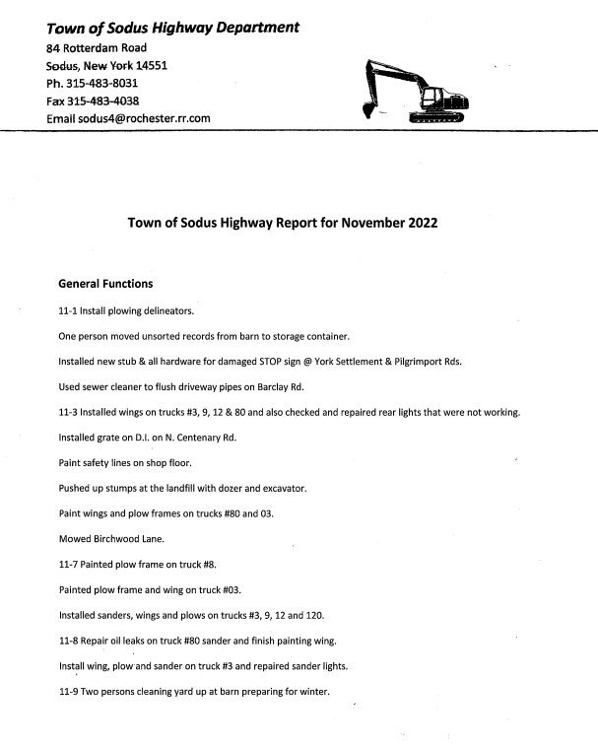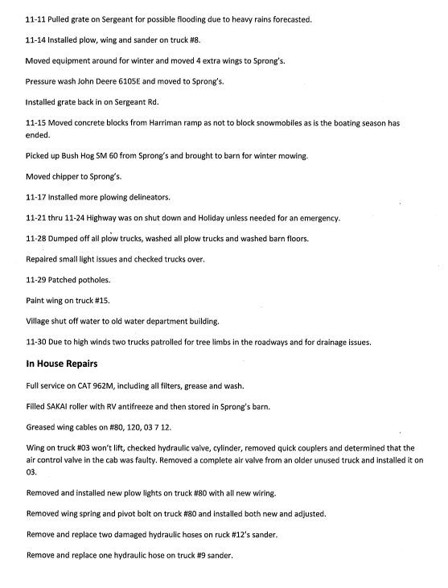
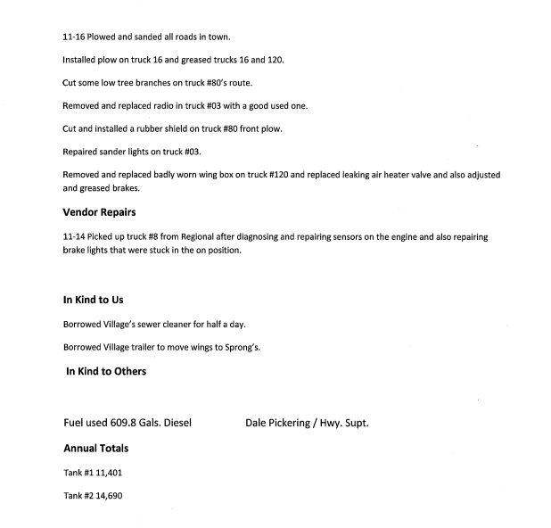

LED STREET LIGHTING:
Councilperson David LeRoy said the LED Lighting Project should start being installed in the Town of Sodus by the end of the week.

SALT BARN UPDATE:
Dave Doyle, MRB gave update under public comments

DRAINAGE
N/A

RECREATION/ENVIRONMENTAL COMMITTE: Cathy Willmott, Councilperson
(Recreation, Assessor, Parks, Cemeteries)
Recreation Report
Councilperson Chris Tertinek motioned to accept and file the monthly November 2022 Town Recreation Report from Director, Sheila Fisher was seconded by Councilperson David LeRoy. Upon roll call the following votes were heard, Scott Johnson, aye; David LeRoy, aye; Don Ross, absent; Chris Tertinek, aye; and Cathy Willmott; (Zoomed-unable to vote). Motion carried.
Director’s Report
Sodus Recreation Board Meeting
December 6, 2022

Programs:
- Currently we have a girls travel basketball program being Coached by Katie Hall. They began in Mid-October and will practice on Tuesday & Thursday evenings. Games will be held on Saturdays within Wayne County and travel to and from games will be the responsibility of the parents.
- Cathy and I were able to meet along with Bree & Susie at the Town Hall and go over some upcoming policy changes regarding programs, supply ordering and collection of program payments.
- We have reached out to the current Sodus Recreation Board members to ask who wants to stay on as an active Board member. I have requested that they let us know by December 23, 2022. Once the Board is established and selected, we will hold quarterly meetings.

Assessor’s Report
(Nathan Mack, Assessor)
Councilperson David LeRoy motioned to accept and file the monthly November 2022 Assessor’s Report was seconded by Councilperson Chris Tertinek. Upon roll call the following votes were heard, Scott Johnson, aye; David LeRoy, aye; Don Ross, absent; Chris Tertinek, aye; and Cathy Willmott; (Zoomed-unable to vote). Motion carried.

tOWN OF sODUS

ASSESSOR’S OFFICE
Date: December 6, 2022 Respectfully Submitted by: Nathan Mack

AROUND THE OFFICE
- The Town Clerk will be preparing the mailing and receiving of the Town and County tax bills come January. The Assessment office will provide any assistance to their office during this timeframe.
- A list of all the transfers and address changes that have occurred between the time my file was sent to the County and when the tax bills will be mailed has been created. I will update the Town Clerks office with these changes.
- We are in the process of mailing out all exemption renewal forms. Renewal forms for exemptions that require them are due back by March 1st, 2023.

Camp Beechwood/Sodus Groundskeeper Report
(Sal Vittozzi-Caretaker-Sodus Town Groundkeeper)
Councilperson David LeRoy motioned to accept the monthly November 2022 Camp Beechwood-Parks & Cemeteries Report from Sal Vittozzi; Sodus Town Groundskeeper-Caretaker was seconded by Councilperson Chris Tertinek. Upon roll call the following votes were heard, Scott Johnson, aye; David LeRoy, aye; Don Ross, absent; Chris Tertinek, aye; and Cathy Willmott; (Zoomed-unable to vote). Motion carried.

CAMP BEECHWOOD REPORT

November was a quiet yet busy month here at the park. In the beginning of the month, we hosted two Boy Scout camping weekends and the final mowing of season was done. We are still seeing our fair share of hikers and dog walkers as winter weather has not quite set in on us yet. A few windstorms took down 3 large trees in the park in November, one of which completely blocked the main trail from the west entrance. I used $800 from the camping funds to purchase a saw big enough to cut through them and a log pick to move the cuttings. I also purchased 4 new cameras for security which came out to $360. Once we receive the cameras, I’ll activate them on to our current plan and pay ahead on the bill out of our camping fund as well. The next major project scheduled is the addition of a skating rink in front of the red barn and lighting up the west entrance for the winter season. Most of the frame material will be repurposed from the old rubber band bridge, but approximately $300 of lumber will need to be purchased new, as well as a liner for the rink. The rest of materials and lighting will be paid for by our camping fund as well. Any of the remaining money in the camping fund will be used for tools and supplies to keep the park running smoothly for the remainder of this year and the next.
Submitted By:
Sal Vittozzi
Camp Beechwood Caretaker

BUILDINGS AND GROUNDS COMMITTEE: Councilperson Chris Tertinek, Chair
(Town Property, Animal Control, Flood Damage Prevention)
CODE ENFORCEMENT REPORT:
(Frankie Gahr- CEO)
Councilperson Chris Tertinek motioned to accept the monthly November 2022 Code Enforcement Report was seconded by Councilperson David LeRoy. Upon roll call the following votes were heard, Scott Johnson, aye; David LeRoy, aye; Don Ross, absent; Chris Tertinek, aye; and Cathy Willmott; (Zoomed-unable to vote). Motion carried.

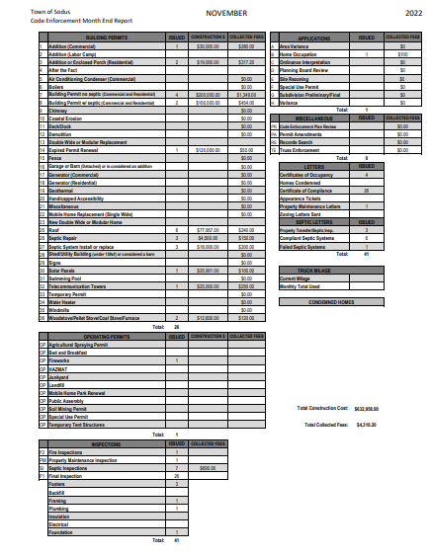

DOG CONTROL REPORT:
(Robert Snyder, Primary DCO)
(Vacant Position- Secondary DCO)
Councilperson David LeRoy motioned to accept the monthly November 2022 Dog Control Report was seconded by Councilperson Chris Tertinek. Upon roll call the following votes were heard, Scott Johnson, aye; David LeRoy, aye; Don Ross, absent; Chris Tertinek, aye; and Cathy Willmott; (Zoomed-unable to vote). Motion carried.

DOG CONTROL REPORT-NOVEMBER 2022
11-8-2022 911-CALL: Dog running at large at Main & Centenary Rd. Dog was transported to the Humane Society.
10:30 PM

11-19-2022 DOG COMPLAINT: Dog running at large on Tunley Rd. Dog was not located. I did not receive any further calls.
3:10 PM

11-27-2022 DOG RUNNING AT LARGE: Mill St. Sodus; dog was taken to Humane Society.
2:30 PM

MILEAGE: 84 MILES

Report Submitted,
Robert Snyder, DCO

FLOOD DAMAGE PREVENTION REPORT-Code 69:
(Chris Tertinek, Councilperson)
Councilperson Chris Tertinek gave his monthly Flood Damage Prevention Report.
Lake Level
- Lake at 244.26 feet ASL; about 3 inches higher than last month, and about same amount of change expected for the next two months
- Presently still about four inches below the long time average and about seven inches lower than a year ago.
- The long term forecast till mid-May is still below the long time average. Unless unforeseen weather occurs, the water level will be lower in 2023 than 2022.

PUBLIC SAFETY/DRAINAGE/ENVIRONMENT COMMITTEE: Councilperson Don Ross, Chair (Fire, Ambulance, Emergency Preparedness)
Councilperson Don Ross was absent but, he did submit his report.

SESC November 20, 2022
Village of Sodus Fire Station.

Roll Call: Randy Crandell (WFCo), President; David Gent SFCo; Matt Scott and Justin Condon, SFCo, Jim Pettit, (SCFCo) Treasurer; Bill Kallusch SWAC; Donald Ross (WFCo), Secretary

Meeting called to order by Pres Crandell at 0840.

Motion by by Matt, second by Jim, to accept minutes as distributed. MC

Alton Fire Co: Not Present

Sodus Fire Co:
-Matt reported that calls have been consistent ~178 to date. The company is looking for feedback regarding brands and types of JAWS tools to replace their out of service unit. They prefer used if available.
-Additionally, Matt reviewed their participation with the ambulance regarding ED calls.

Sodus Center Fire Co:
-Chief Pettit has experienced an increase in brush fires lately, along with other calls. Brush truck still awaiting parts but it's in service.
-The company's 100th anniversary celebration and parade along with the Wayne County Convention, will be held August 5th, 2023. Spots are available for vendors. Fire Police needed.
-Christmas Parade, Saturday, December 10th to line up at the School. Fire Police are needed in several areas. Discussion followed. Please be sure that ALL FIRE units are at the front of the parade for quick response in the event of an emergency.

Sodus point Fire Co: Not Present

Wallington Fire Co:
-Randy reported 85 calls to date along with numerous training events.
-To date, training with Cold Water Suits has take place at Sodus Center Pond and on Sodus Bay at Krenzer's Marine. More classes will be forthcoming.
-Christmas Raffle tickets are all sold, thanks to everyone whom purchased and/or assisted with the selling.

SWAC/EMS:
-Bill Kallusch had time to mention their 4th of July Celebration at the Point next year just as he was called to respond to an emergency. Thank you Bill.

STAC: Not Present
-No participation from STAC. We are aware that the ambulance remains housed at Matt King's residence, outside of the township.

Fairville Fire Co: Not Present

Coordinator: Not Present

Town of Sodus:
-Don updated the group relative to water main shared services progress. A request for active hydrant locations was made as some were bagged, others were not and some bags have been removed. Are any active yet? Hydrants need markings for the winter. Update: A list was provided by Jason Monroe and distributed by Don.
-Sodus Center Bridge is finally open and it looks great!

Committee Reports:
Dave-Fire Prevention was held at the school and well received. They are planning to refine and target the program for next year. Unfortunately, the chopper was diverted to a call so could not participate this year. All material should be reviewed so everyone brings the same handouts to the event.

Matt-The railroad drill was a huge success, 100% positive from all attendees. This training covered placards, train cars and confined spaces.

Jim-Reviewed tanker participation at Fairville to include deck guns, blitz attack and potential delays. A pumper should always man a hydrant to fill tankers, it's much faster.
-Randy will obtain an updated Ops channel sheet to distribute.

Old Business:
None

New Business:
Randy- pump tests to be conducted at Wallington. Also, per Justin, SFD will be testing E26 and TA29. Jim Pettit noted that SCFCo has a hose test device available but it does only one length at a time.

UPCOMING EVENTS AND FUNDRAISERS!
- Sodus Christmas Parade Dec 10
- Wallington Fireworks Dec 11

Treasurer's report:
Per Jim the balance is $1243.04 after purchasing school supplies. Motion by Matt, second by Randy, to accept report. M carried

Next Meeting- January 15th at Sodus Center Fire Station (Breakfast Provided). Meeting begins at 0830.

Motion to adjourn Don R, Sec by Jim P, MC and meeting ended promptly at 0941.

Respectfully Submitted,

TOWN HALL COMMITTEE: Scott Johnson, Supervisor –
(Personnel, Clerks, Justices, Assessor, Building Inspector, Town Council, Boards, Insurances, Finance)

CORRESPONDENCE & INFORMATION

BOARD OF ASSEMENT REVIEW –DARYL MINIER
RESOLUTION
- 12-2022)
Supervisor Johnson offered the following resolution for its adoption,

WHEREAS, the Town of Sodus has chosen to reappoint Daryl Minier to the Board of Assessment Review, and

NOW THEREFORE BE IT RESOLVED, the Sodus Town Board re-appoints Daryl Minier to the Board of Assessment Review, and

NOW THEREFORE BE IT FURTHER RESOLVED, the term will begin October 01, 2022 and end September 30, 2027, and

Councilperson David LeRoy motioned to appoint Daryl Minier to the Board of Assessment Review was seconded by Councilperson Chris Tertinek. Upon roll call the following votes were heard, Scott Johnson, aye; David LeRoy, aye; Don Ross, absent; Chris Tertinek, aye; and Cathy Willmott; (Zoomed-unable to vote). Resolution Adopted.

Councilperson Chris Tertinek motioned to rescind resolution from the November 29, 2022 Month End Meeting for Local Law 3-2022 (to reduce number of members and term of appointments for the Planning Board) was seconded by Councilperson David LeRoy. Upon roll call the following votes were heard, Scott Johnson, aye; David LeRoy, aye; Don Ross, absent; Chris Tertinek, aye; and Cathy Willmott; (Zoomed-unable to vote). Motion carried.

Councilperson Chris Tertinek motioned to allow Lori Diver Sodus Town Clerk to advertise legal notice to reduce the number of members and increase term of appointments for the Planning Board (Local Law 1-2023) including; holding the public hearing on January 10, 2023 at 6:00 PM was seconded by Councilperson David LeRoy. Upon roll call the following votes were heard, Scott Johnson, aye; David LeRoy, aye; Don Ross, absent; Chris Tertinek, aye; and Cathy Willmott; (Zoomed-unable to vote). Motion carried.

Councilperson Chris Tertinek motioned to adjourn meeting was seconded by Councilperson David LeRoy. Upon roll call the following votes were heard, Scott Johnson, aye; David LeRoy, aye; Don Ross, absent; Chris Tertinek, aye; and Cathy Willmott; (Zoomed-unable to vote). Motion carried.

Meeting Adjourned 6:47 PM

Minutes Written By,
Lori Diver
Sodus Town Clerk, RMC

