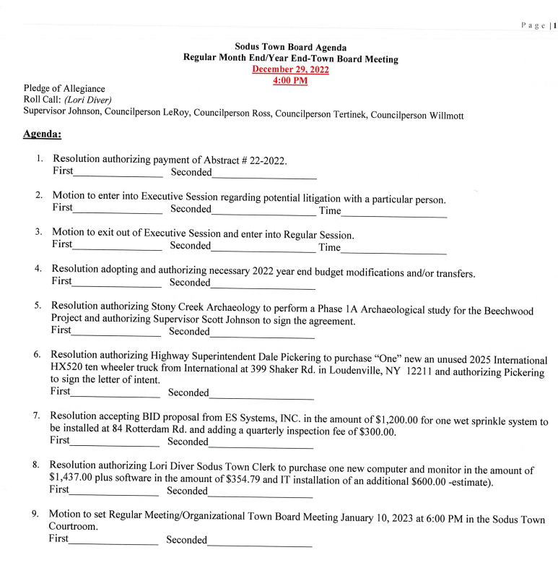

MINUTES
Minutes of the Month End Town Board Meeting commencing at 4:00 PM in the upstairs meeting room December 29, 2022 at 4:00 PM located at 14-16 Mill St. Sodus, NY 14551.
All meetings are open to the public.
In addition this meeting was available through Zoom. Legal Notices were published and posted accordingly.

Present: Scott Johnson, Supervisor
David LeRoy, Councilperson/Deputy Supervisor
Chris Tertinek, Councilperson
Cathy Willmott, Councilperson (Zoomed-unable to vote)

Recording Secretary: Lori Diver Sodus Town Clerk

Absent: Don Ross, Councilperson

Others Present: Amy Kendall, Town Attorney
Susie Jacobs, Zoomed
Bree Crandell, Supervisor Clerk

Supervisor Scott Johnson called the Month End Town Board Meeting to order commencing at 4:00 PM and Lori Diver opened with roll call. All present with the exception of Councilperson Don Ross-absent, Cathy Willmott Zoomed-unable to vote.

ABSTRACT
RESOLUTION TO PAY ABSTRACT No. 22
(03 12-2022)

WHEREAS, the following bills were presented for payment on Abstract 22:

(See Page 3-8)

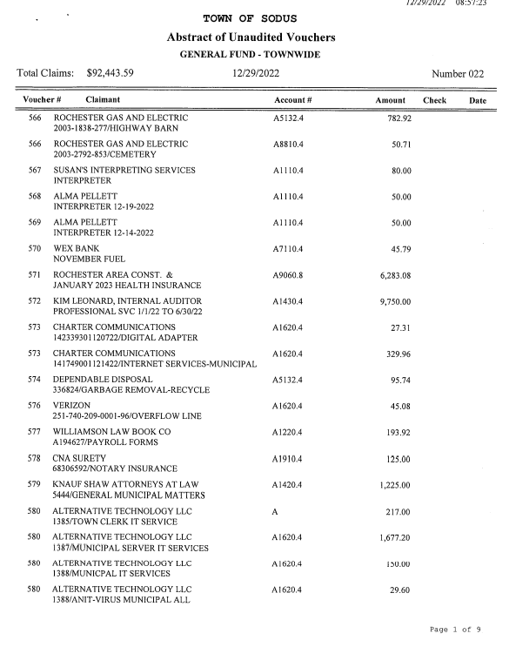
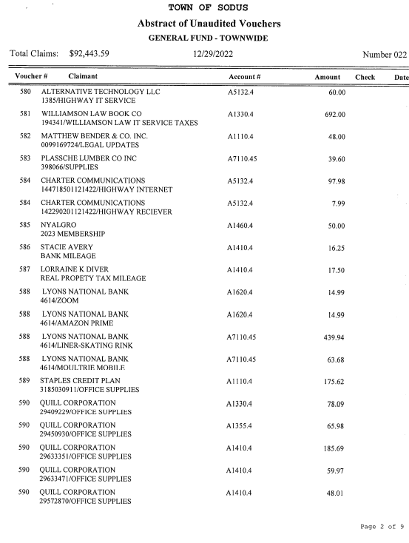
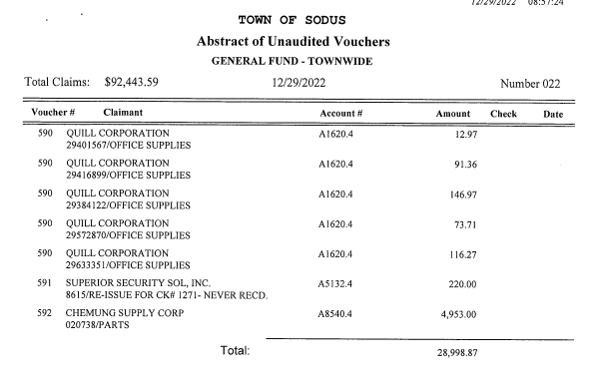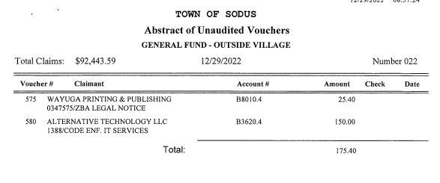
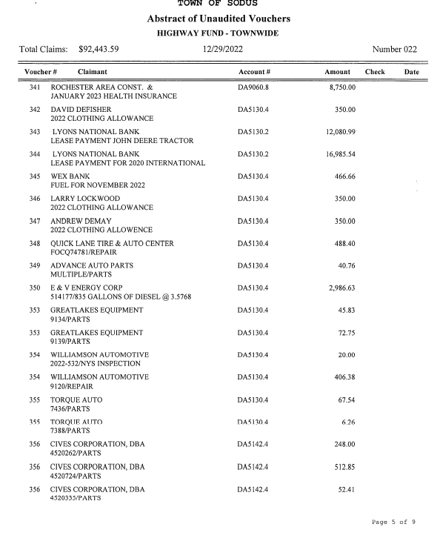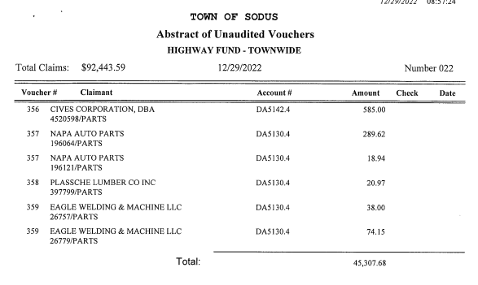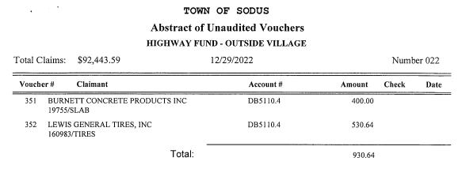
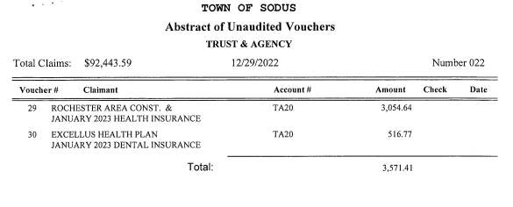
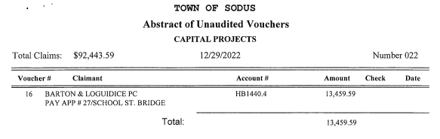

NOW BE IT RESOLVED, Councilperson David LeRoy motioned to authorize payment for Abstract # 22 as listed and adopt this resolution which was seconded by Councilperson Chris Tertinek. Upon roll call the following votes were heard, Scott Johnson, aye; David LeRoy, aye; Don Ross, absent; Chris Tertinek, aye; and Cathy Willmott; Zoomed-unable to vote. Resolution Adopted.

YEAR END 2022 BUDGET MODIFICATIONS AND/OR TRANSFERS
RESOLUTION
(04 12-2022)
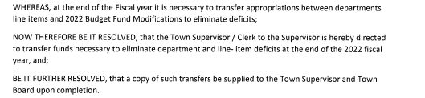

NOW BE IT RESOLVED, Councilperson David LeRoy motioned adopting this resolution was seconded by Councilperson Chris Tertinek. Upon roll call the following votes were heard, Scott Johnson, aye; David LeRoy, aye; Don Ross, absent; Chris Tertinek, aye; and Cathy Willmott; Zoomed-unable to vote. Resolution Adopted.

STONY CREEK ARCHEOLOGY-PHASE 1B ARCHEOLOGICAL STUDY BEECHWOOD
RESOLUTION
(05 12-2022)

NOW BE IT RESOLVED, Councilperson Chris Tertinek motioned authorizing Stony Creek Archaeology to perform Phase 1B Archaeological study for the Beechwood Grant and authorizing Supervisor Scott Johnson to sign the agreement which was seconded by Councilperson David LeRoy. Upon roll call the following votes were heard, Scott Johnson, aye; David LeRoy, aye; Don Ross, absent; Chris Tertinek, aye; and Cathy Willmott; Zoomed-unable to vote. Resolution Adopted.

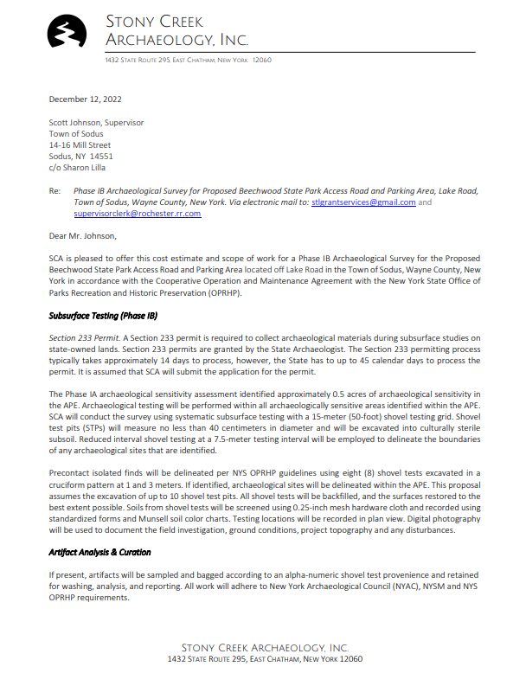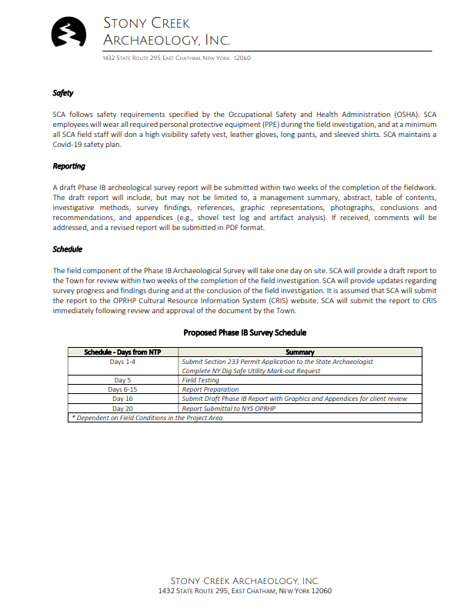
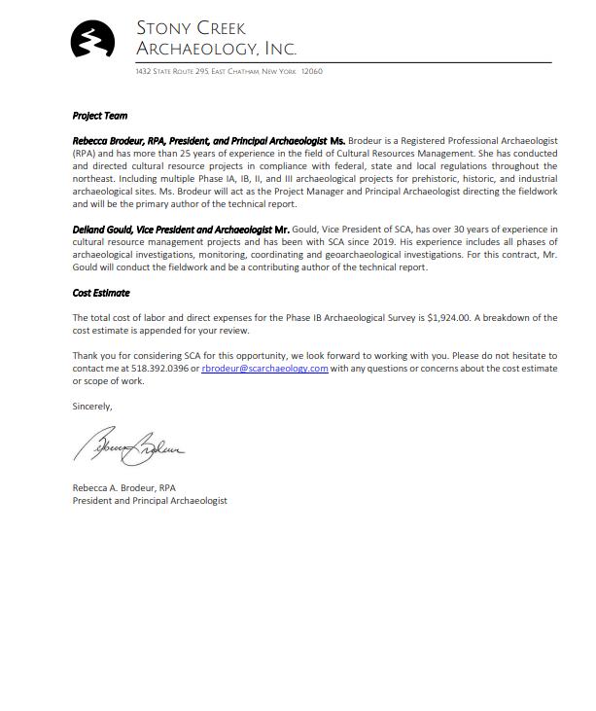

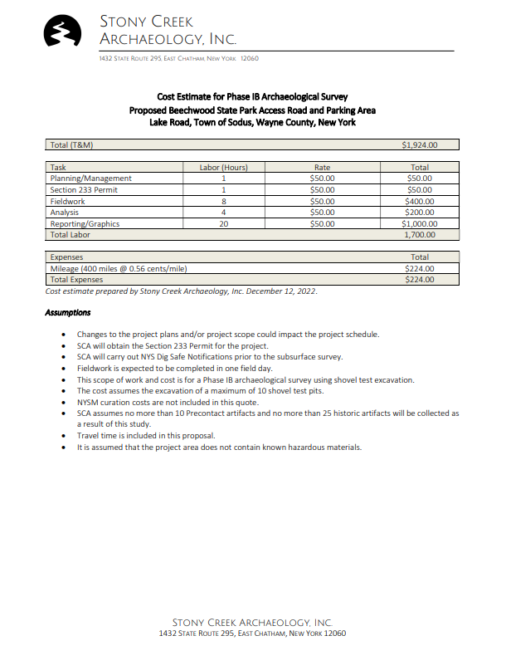
HIGHWAY PURCHASE-2025 INTERNATIONAL HX520 TEN-WHEELER TRUCK
RESOLUTION
(06 12-2022)

NOW BE IT RESOLVED, Councilperson Chris Tertinek motioned authorizing Dale Pickering Highway Superintendent to purchase “One” new an unused 2025 International HX520 ten-wheeler truck from International at 399 Shaker Rd. in Loudenville, NY 12211 and authorizing Pickering to sign the letter of intent which was seconded by Councilperson David LeRoy. Upon roll call the following votes were heard, Scott Johnson, aye; David LeRoy, aye; Don Ross, absent; Chris Tertinek, aye; and Cathy Willmott; Zoomed-unable to vote. Resolution Adopted.

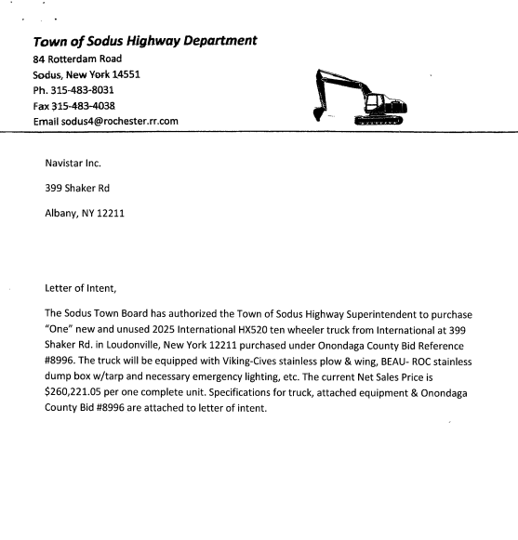
ES SYSTEMS, INC. SPRINKLER SYSTEM
RESOLUTION
(07 12-2022)
NOW BE IT RESOLVED, Councilperson David LeRoy motioned to accept BID proposal from ES Systems, inc. in the amount of $1,200.00 for one wet sprinkler system to be installed at 84 Rotterdam Rd. and adding a quarterly inspection fee of $300.00 was seconded by Councilperson Chris Tertinek. Upon roll call the following votes were heard, Scott Johnson, aye; David LeRoy, aye; Don Ross, absent; Chris Tertinek, aye; and Cathy Willmott; Zoomed-unable to vote. Resolution Adopted.
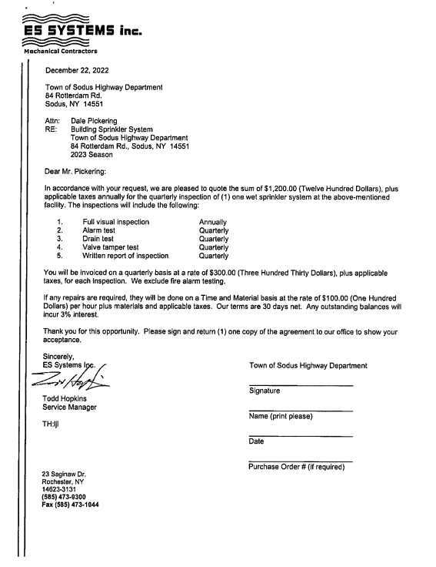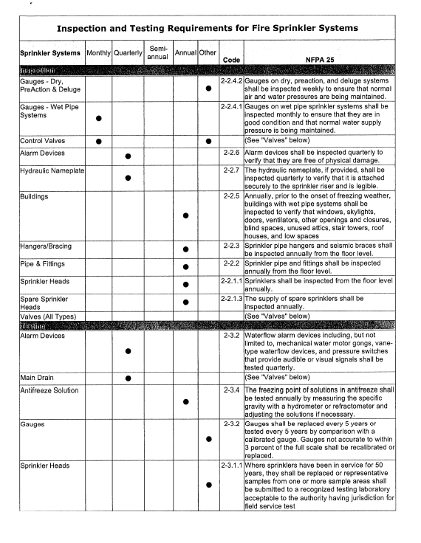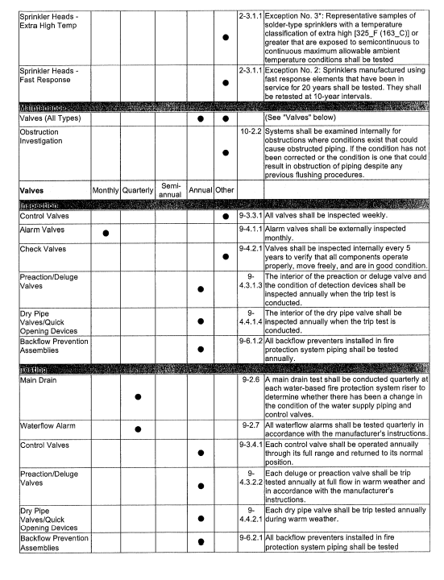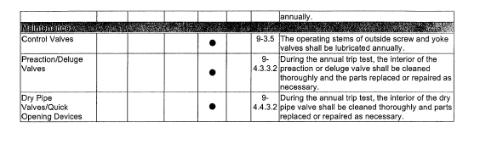

ALTERNATIVE TECHNOLOGY, LLC -TOWN CLERK COMPUTER
RESOLUTION
(08 12-2022)
NOW BE IT RESOLVED, Councilperson David LeRoy motioned to authorize Town Clerk Lori Diver to purchase one new computer and monitor in the amount of $1,437.00 plus software in the amount of $354.79 and IT installation of an additional $600.00-estimate) was seconded by Councilperson Chris Tertinek. Upon roll call the following votes were heard, Scott Johnson, aye; David LeRoy, aye; Don Ross, absent; Chris Tertinek, aye; and Cathy Willmott; Zoomed-unable to vote. Resolution Adopted.
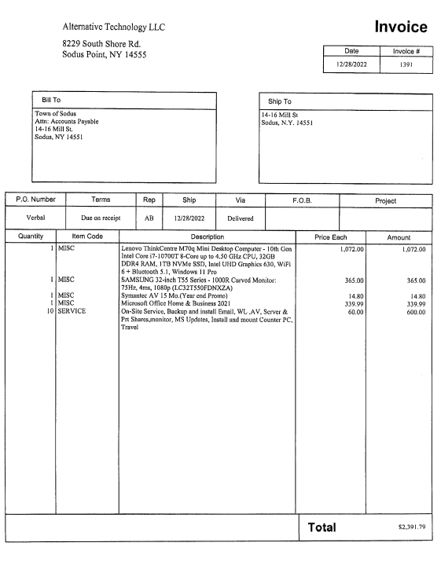

Motion by Councilperson Chris Tertinek to set Organizational Town Board Meeting to January 10, 2023 at 6:00 PM in the Sodus Town Courtroom was seconded by Councilperson David LeRoy. Upon roll call the following votes were heard, Scott Johnson, aye; David LeRoy, aye; Don Ross, absent; Chris Tertinek, aye; and Cathy Willmott; Zoomed-unable to vote. Motion carried.

Motion by Councilperson David LeRoy to enter into Executive Session regarding medical, financial, credit or employment history of a particular person or corporation or relating to appointment promotion demotion discipline or removal was seconded by Councilperson Chris Tertinek. Upon roll call the following votes were heard, Scott Johnson, aye; David LeRoy, aye; Don Ross, absent; Chris Tertinek, aye; and Cathy Willmott; Zoomed-unable to vote. Motion carried.
Time: 4:20 PM

Motion by Councilperson David LeRoy to exit out of Executive Session and enter into Regular Session was seconded by Councilperson Chris Tertinek. Upon roll call the following votes were heard, Scott Johnson, aye; David LeRoy, aye; Don Ross, absent; Chris Tertinek, aye; and Cathy Willmott; Zoomed-unable to vote. Motion carried.
Time: 4:40 PM

Councilperson David LeRoy motioned to adjourn the Month End Town Board Meeting was seconded by Councilperson Chris Tertinek. Upon roll call the following votes were heard, Scott Johnson, aye; David LeRoy, aye; Don Ross, absent; Chris Tertinek, aye; and Cathy Willmott; Zoomed-unable to vote. Motion carried. 4:40 PM

Minutes Written By:
Lori K. Diver
Sodus Town Clerk, RMC

