MINUTES
Minutes of the Month End Town Board Meeting commencing at 4:30 PM in the downstairs courtroom February 24, 2022 located at 14-16 Mill St. Sodus, NY 14551.
All meetings are open to the public.
In addition this meeting was available through Zoom. Legal Notices were published and posted accordingly.

Present: Scott Johnson, Supervisor-Zoom
David LeRoy, Councilperson/Deputy Supervisor
Don Ross, Councilperson Zoom
Chris Tertinek, Councilperson
Cathy Willmott, Councilperson

Recording Secretary: Lori Diver, Sodus Town Clerk-RMC

Absent: N/A

Others Present: Dale Pickering, Highway Superintendent
Amy Kendall, Town Attorney
Steve Zonneville- ZBA Chair
Chandra Jensen, Code Enforcement Clerk
Craig Schwartz, Code Enforcer
Sal Vittozzi, ZBA Member
Bree Crandell- Supervisor Clerk
Lori Lancaster, Lancaster Tank & Trailer Wash
Duane Lancaster, Lancaster Tank & Trailer Wash
Tim Rogers, Lancaster Tank & Trailer Wash

Deputy Supervisor David LeRoy called the Month End Town Board Meeting to order commencing at 4:30 PM with the Pledge of Allegiance and Lori Diver opened with roll call. All were present.

PUBLIC SPEAKER:
(Lori Lancaster, Duane Lancaster, Tim Rogers-Lancaster Truck Wash Station)
Lori Lancaster and Duane Lancaster came before the Sodus Town Board in regards to a letter they received from Code Enforcer Craig Schwartz dated February 9, 2022 as follows: (see page 2)
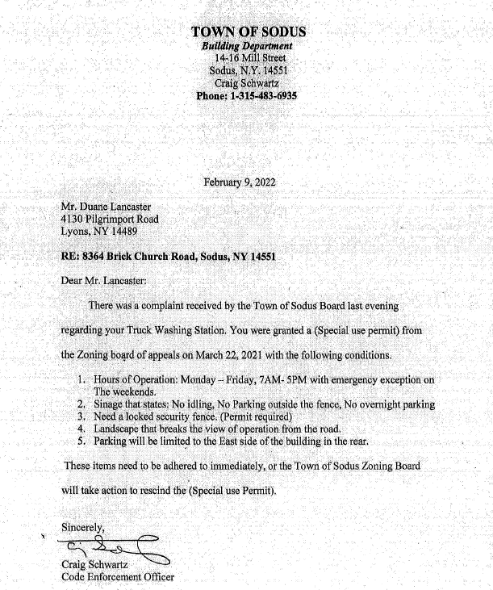
Lori Lancaster presented to the Town Board the following: (in her writing-see below):

I have brought with me the documentation of our business which contains the facts and the true information that you were not given during the meeting on February 8th from Bruce, Wanda and Gary.

If we had been informed that there was a complaint about our Tank & Trailer Wash we could have gladly come on that date to give you the facts and our side or at least be able to respond to the concerns that were brought up before your board.

In October of 2019 we purchased 8.5 acres of land at 8364 Brick Church Road, Sodus, NY which was zoned as Agricultural. On that land was a large barn and a small structure you might call a small barn or garage. The land was to say the least an eyesore. There were overgrown bushes, weeds and a few trees, the property had not been maintained in years.

We received a letter from the Town of Sodus Code Enforcement Officer, Craig Schwartz on Feb. 11, 2022 outlining the complaint in regards to the conditions that we needed to put into place for our business.

I went back to the original DECISION letter dated 3/22/21 that we received 3/24/2021 – to compare them. Nowhere does it state that there was a date for the conditions to be completed. It also stated Approval of the Application #1505 subject to conditions so it was taken that we would be given time to complete these conditions. Our business did not officially open until December 16, 2021.

I went back to the meeting minutes of 3/22/21 again and reviewed them. Again, there was no deadline for completion or a statement that said that these conditions had to be completed before the business could open.
In that meeting my husband, Duane, explained what his plans were for the project and there were a lot of questions asked by the Board and by some of the Guests since the meetings are open to the public. This was just a plan and it could change with approvals needed.
Before filling out any application we did our homework and a lot of time was given to how the operation would work, how it would look and the steps that needed to be done in order to get this business done –ALL IN COMPLIANCE with Zoning, approvals of all Boards and obtain permits and inspections needed.
So I am addressing the conditions from the original approval of 3/22/21:
- Operating hours – 7am – 5pm with emergency exception on the weekends.
- Signage that states: No idling, no parking outside fence, no overnight parking.
- Landscape to break the view of the operation from the road. (Because of the delayed opening due to delayed supplies to complete the building it will not be able to be done until spring)
- Parking will be limited to the East side of the building in the rear. (From the drawings the parking is in the rear of the building so that would be south)

On the Letter dated 2/9/22 we now have 5 items listed.
Concerning to me I contacted the Zoning Officer to set up an appointment on 2/15/2022 at 8:10am where we addressed all of the above and we have a plan and an agreement to take care of the above items.

Items from the 3/22/2021 letter of items to be complied with:
- Done
- Done- signage along with secured gates across the 2 driveways. (This now does not allow my brother in law who is in a wheelchair access to the business.
- put in trailer to block view – okayed by zoning officer (if we decide on other landscape option this will not be done until the ground thaws)
- no issues as we are allowed to park in our parking lot but need to have direction of where parking is as it is located via the architectural drawings at the South.
(End of Lori’s discussion items with the Town Board)
The Town Board was glad to hear of the changes made to date. The Town Board explained that this would have to be turned back over to the ZBA Board regarding the details of the Special Use Permit. The Town Board has no authority over the Special Use Permit. Chandra Jensen Code Enforcement Clerk explained that the Zoning Board will be meeting regarding the particulars of the Special Use Permit. The meeting was originally scheduled for March but will be in April because Lori Lancaster will not be able to make the meeting in March. An exact meeting date has not been determined yet for April according to Chandra.

Lori Lancaster and Duane Lancaster thanked the Town Board for putting them on the agenda so quickly. Tim Rogers wanted the Board to know that there were no major concerns with the Lancaster Tank & Trailer Wash. No further public comments were made.

CORRESPONDENCE & INFORMATION

Councilperson Chris Tertinek motioned to approve Supervisor Johnson to sign the annual Payroll Software support contract with Williamson Law Book in the amount of $950.00 for 2022 was seconded by Councilperson Cathy Willmott. Upon roll call, the following votes were heard Supervisor Scott Johnson, aye; LeRoy, aye; Ross, aye; Tertinek, aye; and Willmott, aye. Motion carried.

Councilperson David LeRoy motioned to change the starting time of the Regular Town Board Meetings to 6:00 PM effective immediately was seconded by Councilperson Don Ross. Upon roll call, the following votes were heard Supervisor Scott Johnson, aye; LeRoy, aye; Ross, aye; Tertinek, aye; and Willmott, aye. Motion carried.

ABSTRACT
RESOLUTION TO PAY ABSTRACT No. 3
(06 02-2022)
WHEREAS, the following bills were presented for payment on Abstract 3:

General 063-101 $ 53,760.95
Highway 049-074 $ 75,114.55
Village of Sodus Fire 006-006 $ 38,100.00
Village of SP Fire 007-007 $ 38,100.00
Trust & Agency 004-005 $ 2,044.38
GRAND TOTAL: $ 207,119.88
Councilperson Don Ross motioned to adopt this resolution which was seconded by Councilperson Cathy Willmott. Upon roll call the following votes were heard, Scott Johnson, aye; David LeRoy, aye; Don Ross, aye; Chris Tertinek, aye; and Cathy Willmott; aye. Resolution Adopted.

Councilperson David LeRoy motioned to allow the Sodus Point Fire Department to use the Town of Sodus land directly across from the fire department for parking on June 4th, November 4th, and December 3rd, 2022 was seconded by Councilperson Don Ross. Upon roll call, the following votes were heard Supervisor Scott Johnson, aye; LeRoy, aye; Ross, aye; Tertinek, aye; and Willmott, aye. Motion carried.

Councilperson Don Ross motioned to allow Lori Diver to advertise a legal notice for Harriman Park Floating Dock Bid and to hold bid opening at the Regular Month End Town Board Meeting Thursday March 24, 2022 at 4:30 PM was seconded by Councilperson Chris Tertinek. Upon roll call, the following votes were heard Supervisor Scott Johnson, aye; LeRoy, aye; Ross, aye; Tertinek, aye; and Willmott, aye. Motion carried.

Councilperson David LeRoy motioned to approve Highway Superintendent Dale Pickering to purchase weed spray for roadside spraying of weeds in the amount of $2,630.35 was seconded by Councilperson Don Ross. Upon roll call, the following votes were heard Supervisor Scott Johnson, aye; LeRoy, aye; Ross, aye; Tertinek, aye; and Willmott, aye. Motion carried.

DISCUSSION:
- The Town Board would like Kristine Kellogg to attend our Regular Town Board Meeting to discuss insurance and the paid FMLA plan. Bree Crandell Supervisor Clerk will see if she can attend our meeting.
Councilperson David LeRoy motioned to adjourn the meeting was seconded by Councilperson Cathy Willmott. Upon roll call the following votes were heard, Scott Johnson, aye; David LeRoy, aye; Don Ross, aye; Chris Tertinek, aye; and Cathy Willmott; aye. Motion carried.

Meeting adjourned at 5:07 PM
Recording Secretary,

Minutes Written By:
Lori Diver Sodus Town Clerk, RMC

