Sodus Town Board Agenda
Regular Month End-Town Board Meeting
February 28, 2023
4:00 PM
Roll Call: (Lori Diver)
Supervisor Johnson, Councilperson LeRoy, Councilperson Ross-Zoom, Councilperson Tertinek, Councilperson Willmott

Agenda:

- Resolution authorizing payment of Abstract # 04-2023 for payment.
First_________________ Seconded____________________ (emailed).

- Discussion on Court Audit for the Unified Court System. (Letter sent via email)

- Resolution allowing Supervisor Scott Johnson to sign letters to organizations receiving budgetary financial support for 2023. These organizations include, FB Verschoot Memorial Post, Sodus Point Tourism Booth, Sodus Go-Getters, Sodus Bay Historical Society, Home Meal Service, Wallington School House. (Email sent with letters and agreements)
First_________________ Seconded____________________

- Discussion on John Williams request with petitions to extend the water line on Joy Rd. (Informal petitions signed with detail of residents wanting water and informal easements signed-emailed)

- Resolution authorizing the change of hourly wage increase for Michelle Dolan Justice Court Clerk from $18.57 hourly to $20.33 per hour retroactive January 1, 2023. (Resolution emailed)
First_________________ Seconded____________________

- Discussion on $1,000.00 payment to Joy Community Schoolhouse (email sent).

- Motion to adjourn meeting
First_________________ Seconded____________________

MINUTES
Minutes of the Month End Town Board Meeting commencing at 4:00 PM in the upstairs meeting room February 28, 2023 at 4:00 PM located at 14-16 Mill St. Sodus, NY 14551.
All meetings are open to the public.
In addition, this meeting was available through Zoom. Legal Notices were published and posted accordingly.

Present: Scott Johnson, Supervisor
David LeRoy, Councilperson/Deputy Supervisor
Don Ross, Councilperson (Zoom)
Chris Tertinek, Councilperson
Cathy Willmott, Councilperson

Recording Secretary: Lori Diver Sodus Town Clerk

Absent: N/A

Others Present: Bree Crandell, Supervisor Clerk

Supervisor Scott Johnson called the Month End Town Board Meeting to order commencing at 4:00 PM and Lori Diver opened with roll call. All were present.

ABSTRACT
RESOLUTION TO PAY ABSTRACT No. 4
(10 02-2023)

WHEREAS, the following bills were presented for payment on Abstract 4:

General 085-105 $ 26,267.96
Highway 050-058 $ 24,901.24
Special Districts 001-005 $ 308,773.00
Trust Agency 033-034 $ 2,923.24
Capital Projects 019-019 $ 7,786.61
GRAND TOTAL: $ 370,652.05

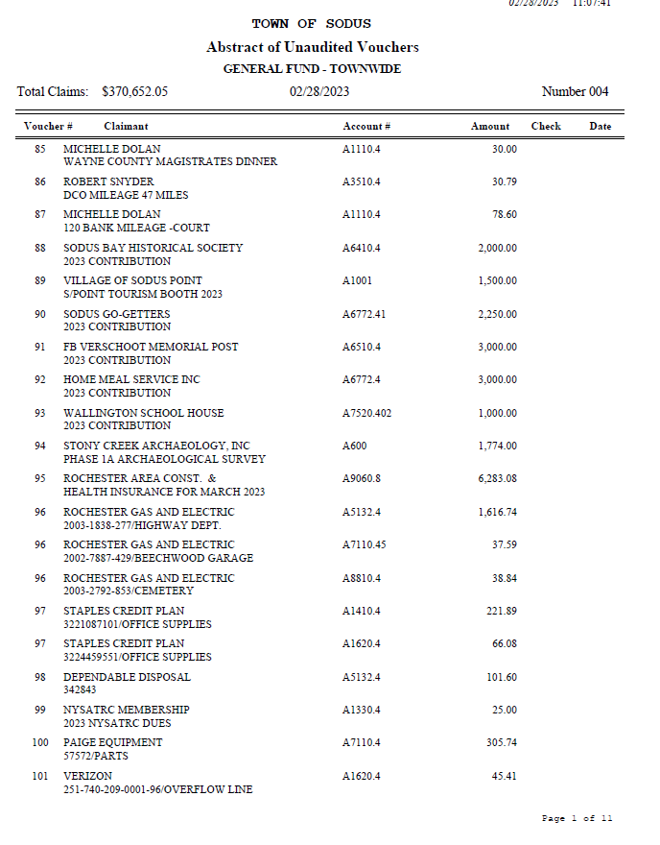

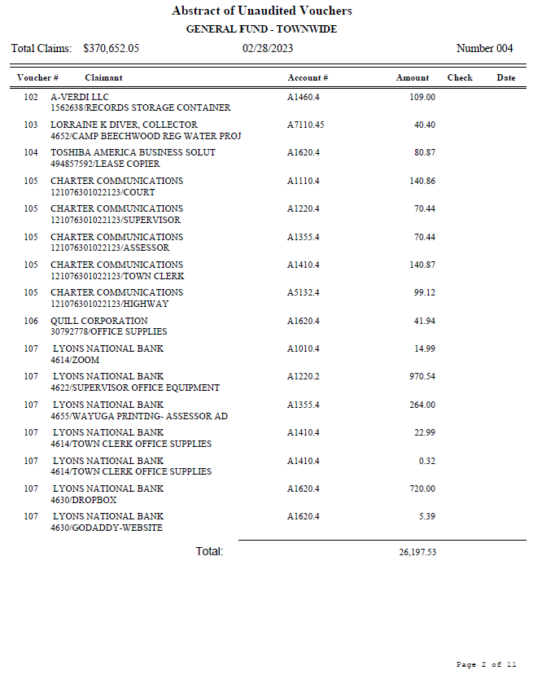

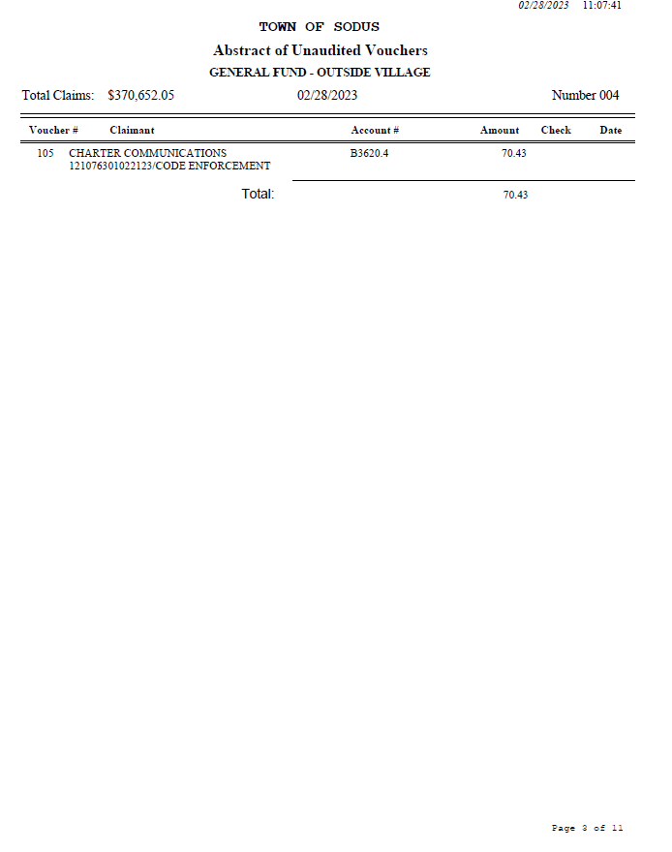

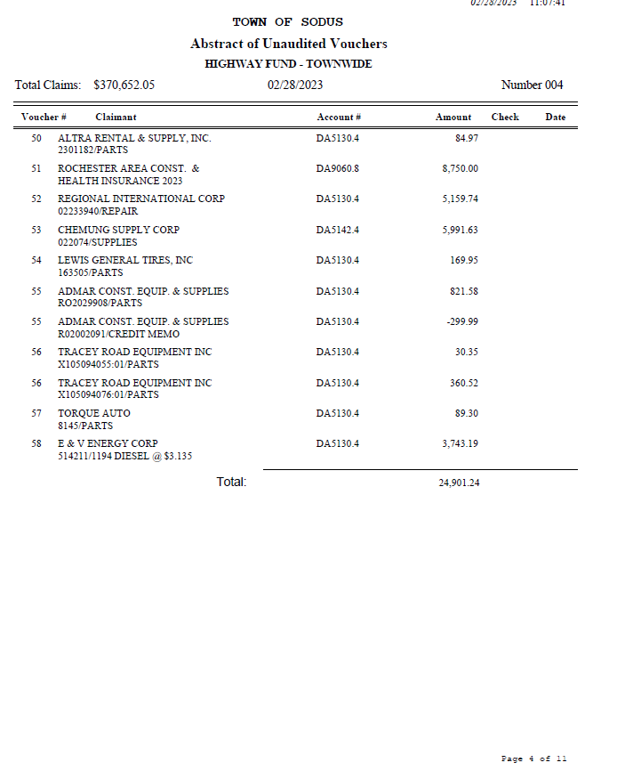

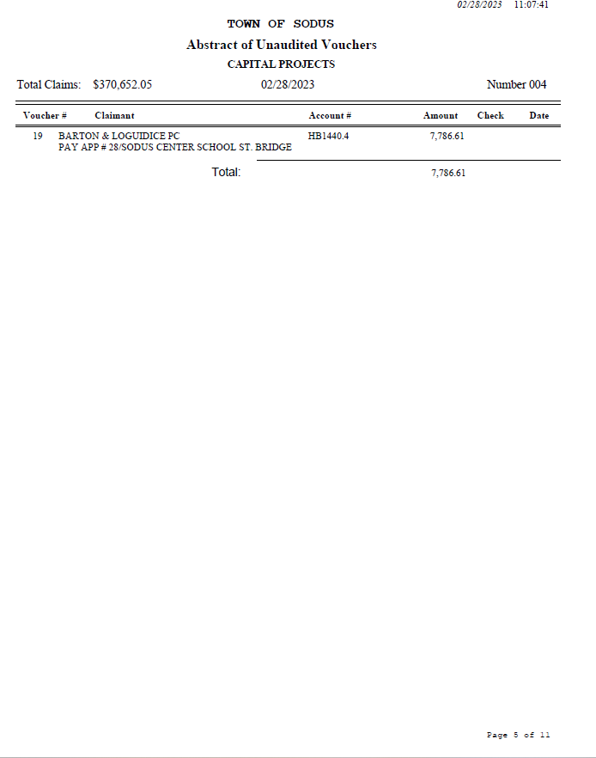

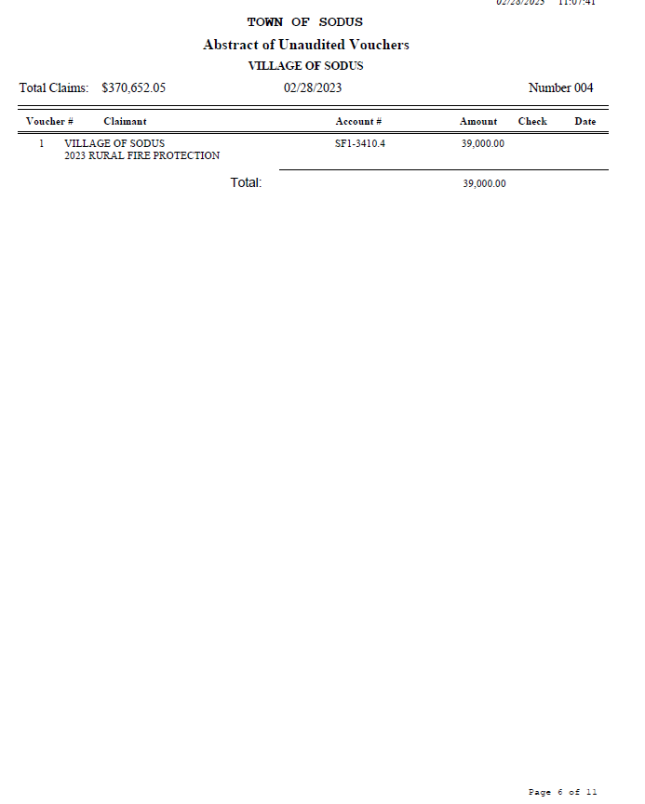

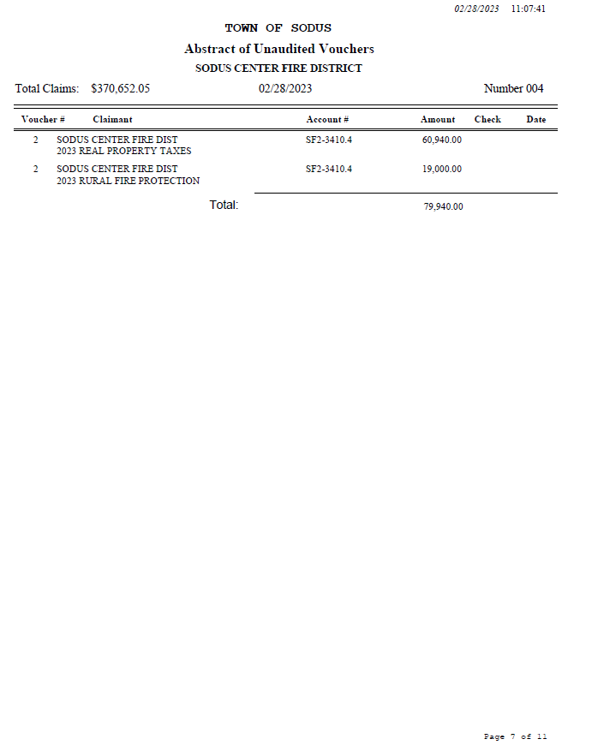

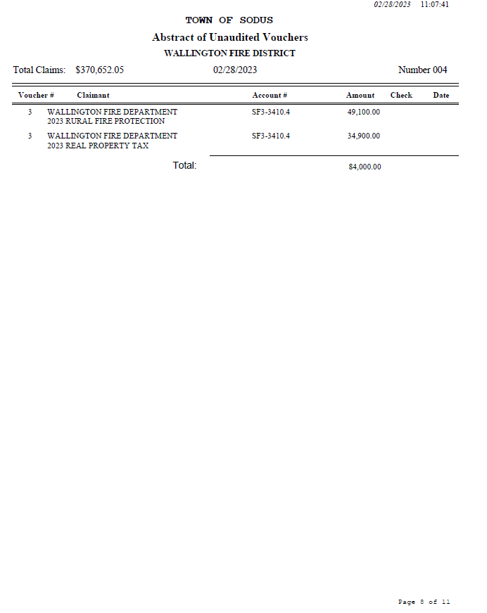

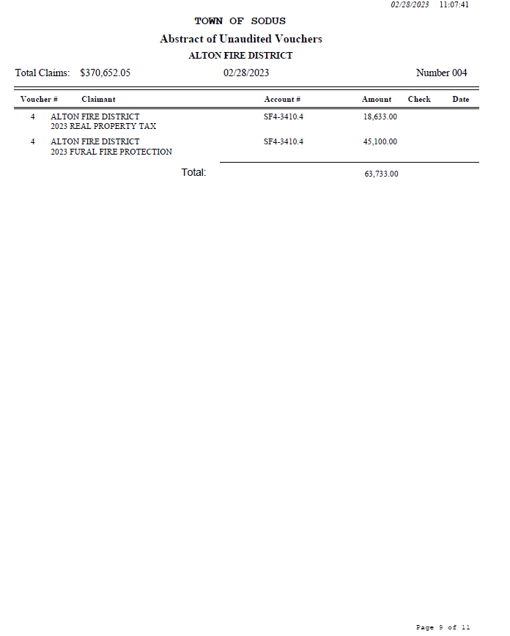

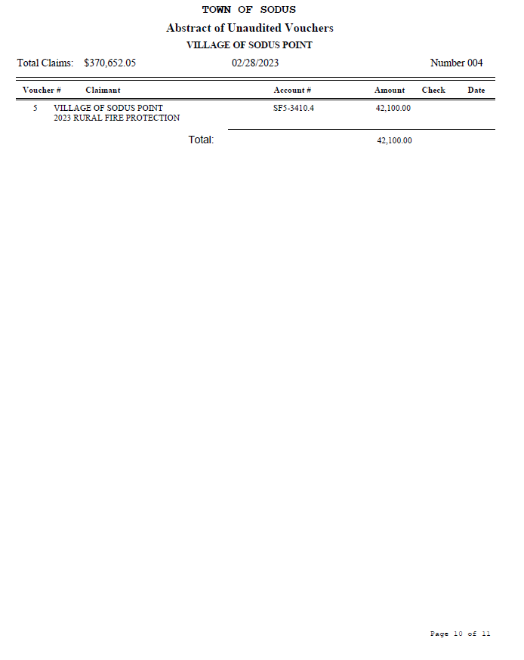

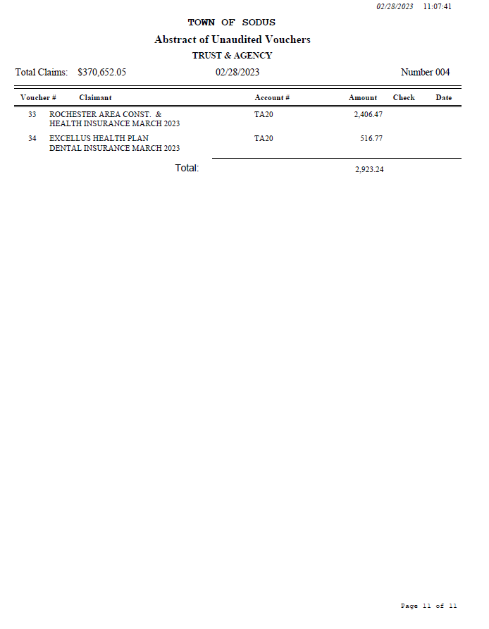
NOW BE IT RESOLVED, Councilperson David LeRoy motioned to authorize payment for Abstract # 4 as listed and adopt this resolution which was seconded by Councilperson Don Ross. Upon roll call the following votes were heard, Scott Johnson, aye; David LeRoy, aye; Don Ross, aye; Chris Tertinek, aye; and Cathy Willmott; aye. Resolution Adopted.

Discussion was held on letter received from State of New York Unified Court System dated February 23, 2023. Councilperson David LeRoy will set up time to review books with Court Clerk Michelle Dolan.

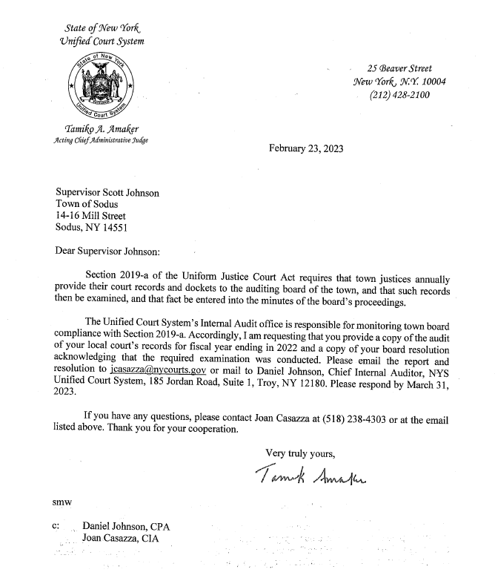
BUDGETARY FINANCIAL SUPPORT-2023 ORGANIZATIONS
RESOLUTION
(11 02-2023)
NOW BE IT RESOLVED, Councilperson Cathy Willmott motioned to authorize Supervisor Scott Johnson to sign letters to organizations receiving budgetary financial support for 2023. These organizations include; FB Verschoot Memorial Post, Sodus Point Tourism Booth, Sodus Go-Getters, Sodus Bay Historical Society, Home Meal Service, Wallington School House and adopt this resolution which was seconded by Councilperson Chris Tertinek. Upon roll call the following votes were heard, Scott Johnson, aye; David LeRoy, aye; Don Ross, aye; Chris Tertinek, aye; and Cathy Willmott; aye. Resolution Adopted. Note: Letters and agreements are as follows:

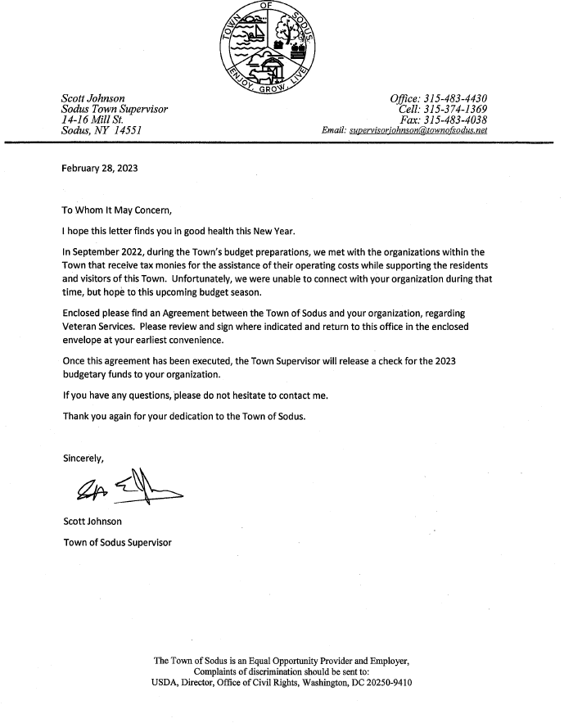

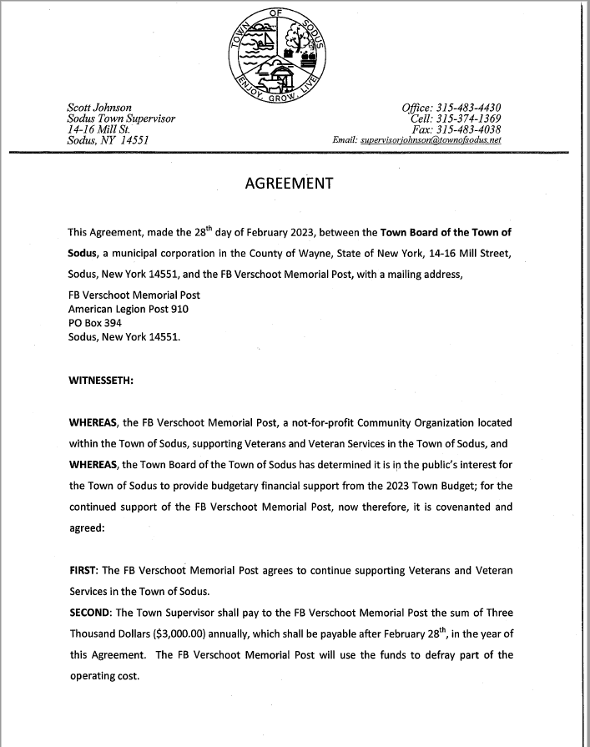

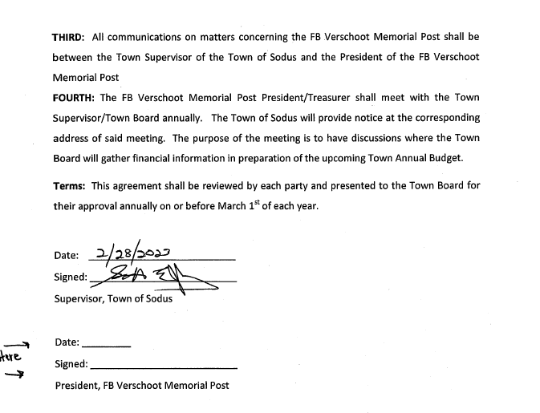

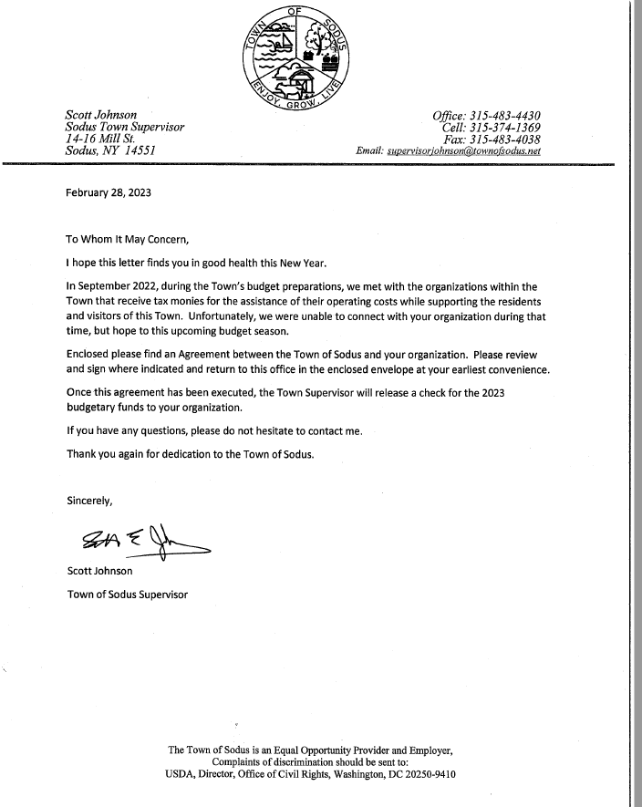

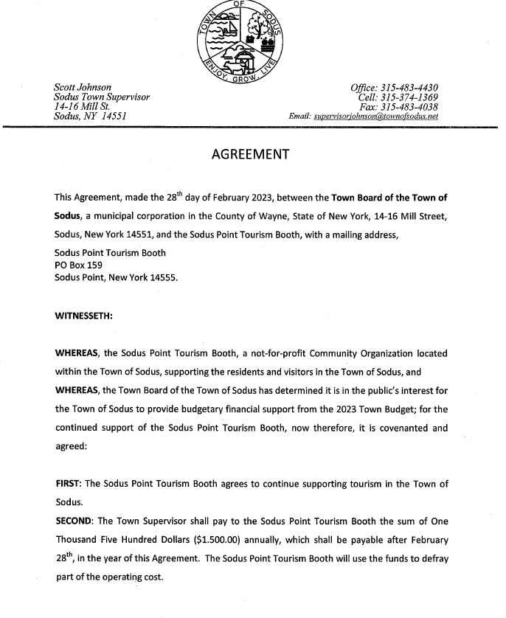
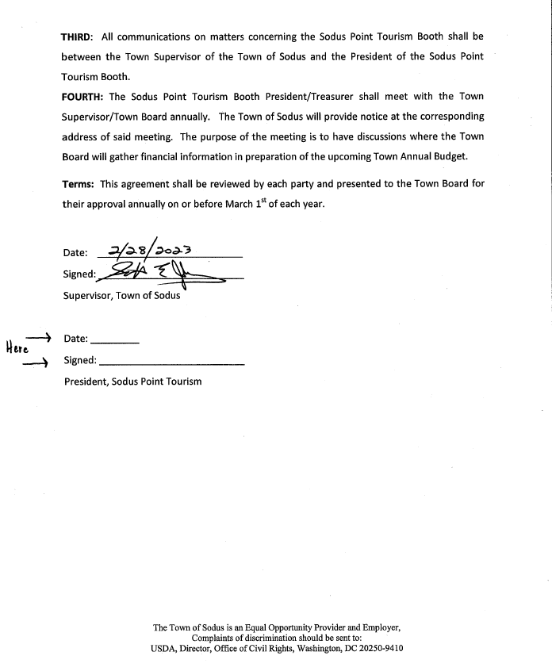

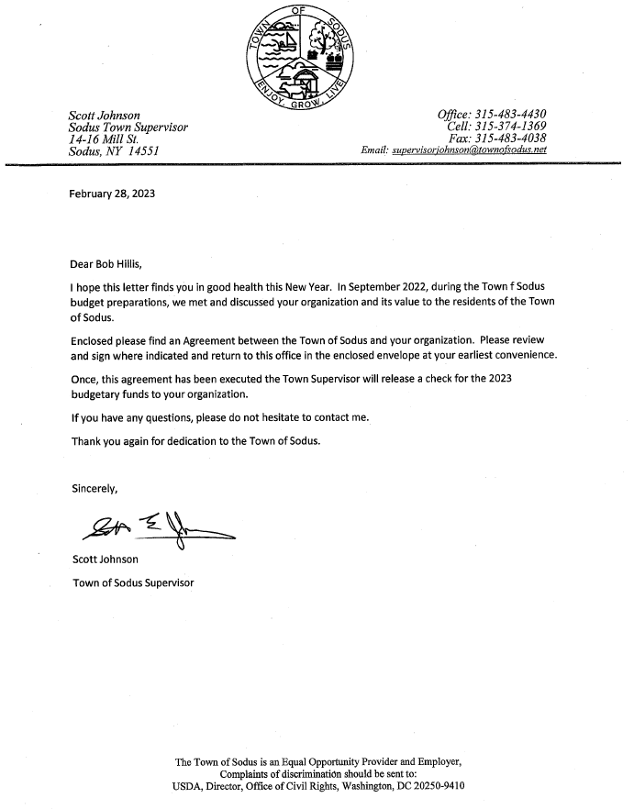

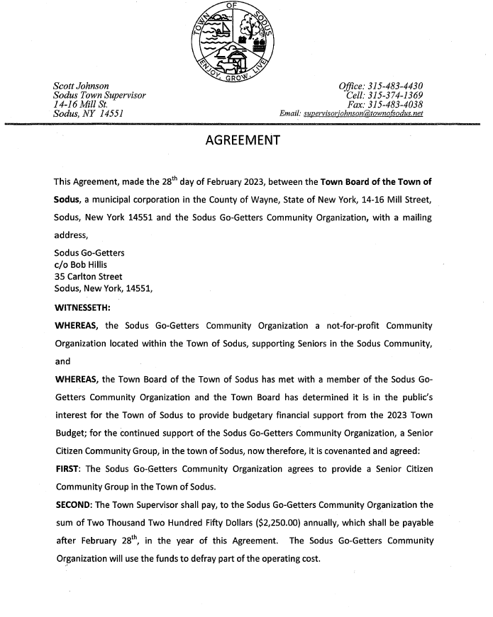
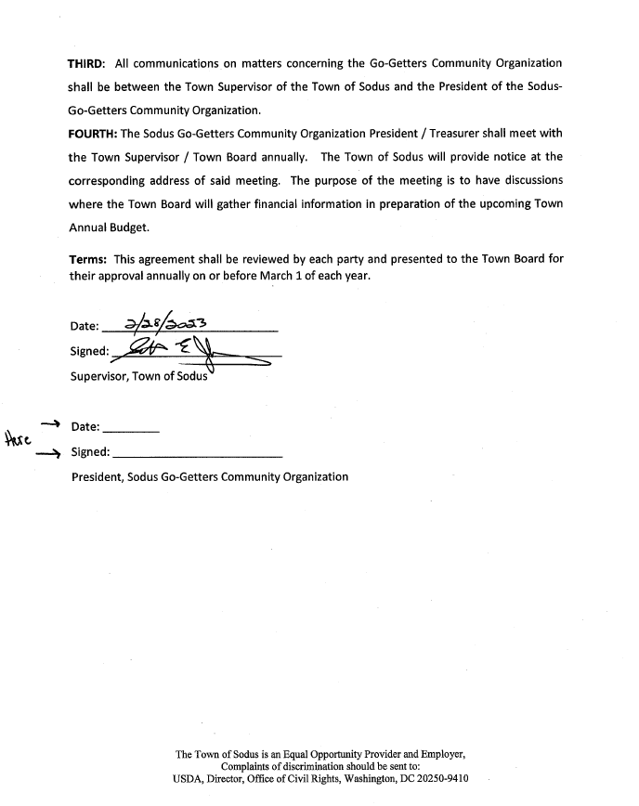

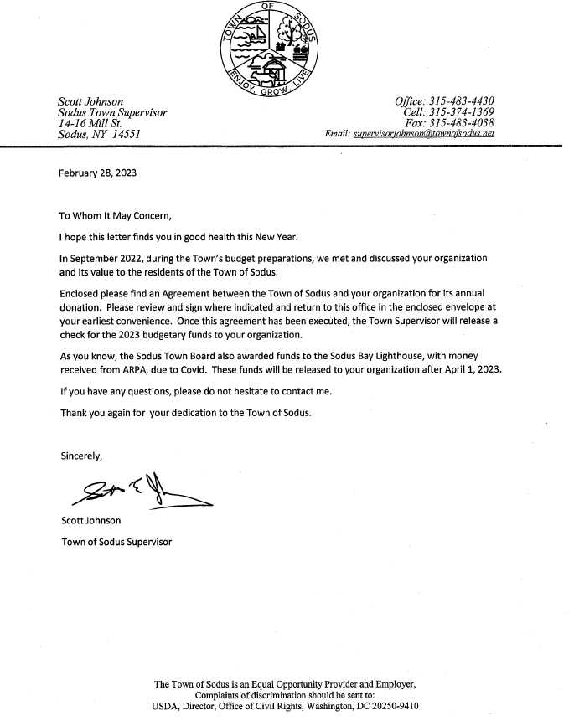

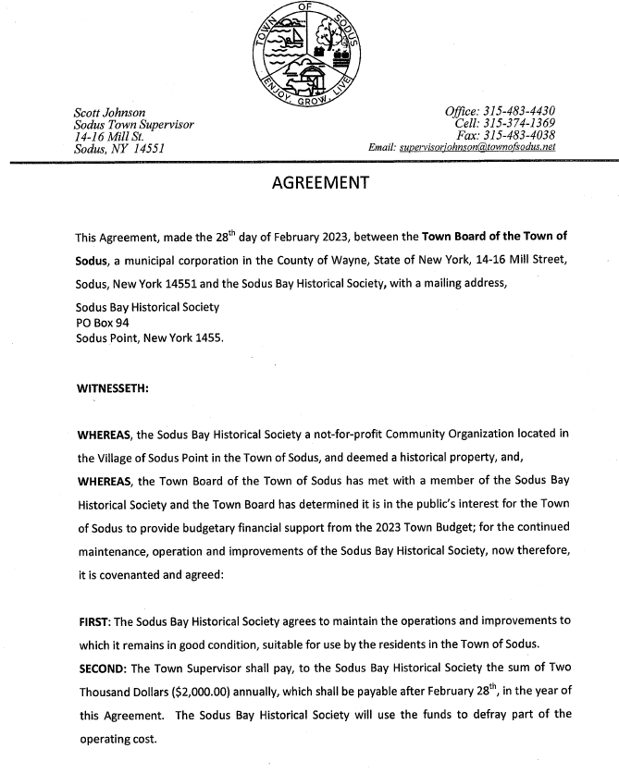
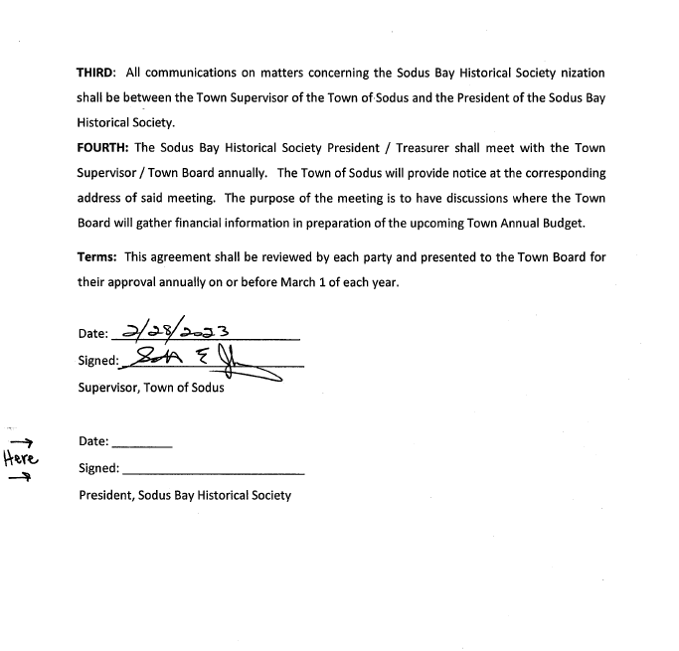

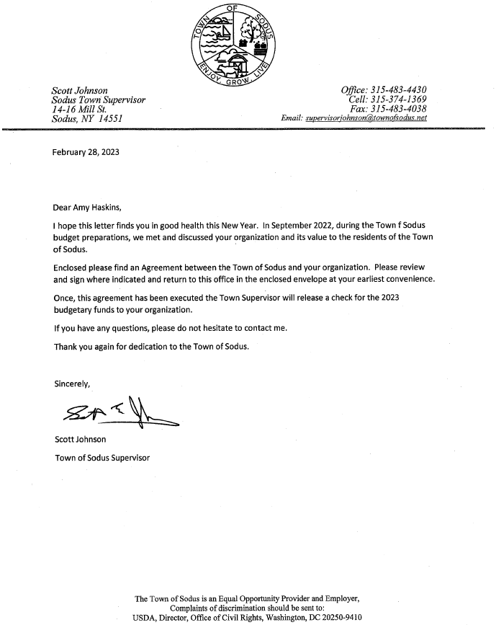

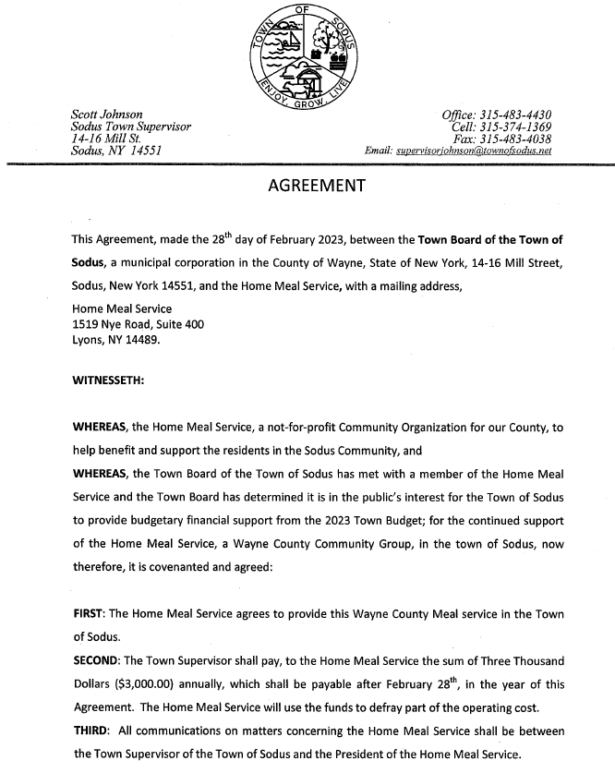

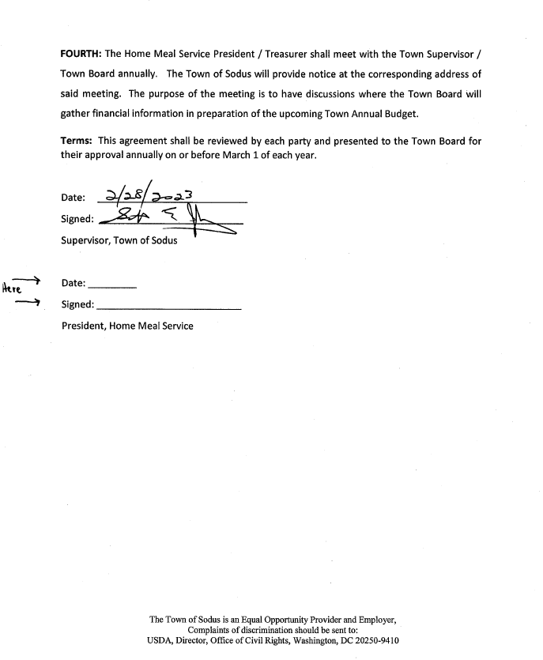

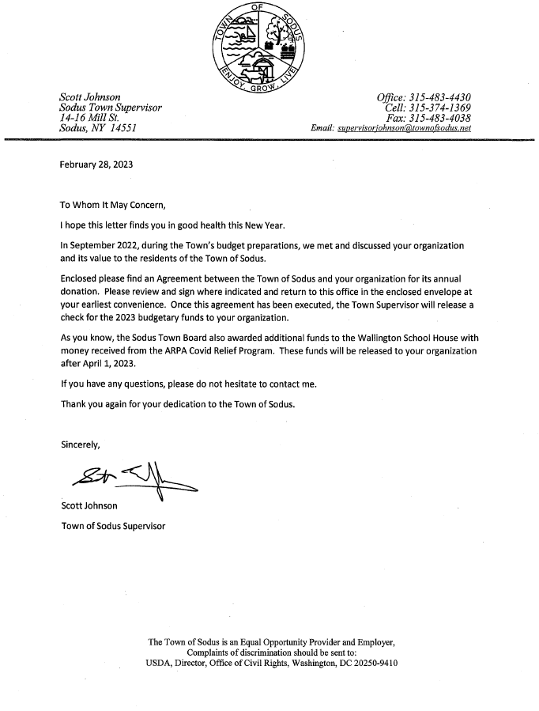

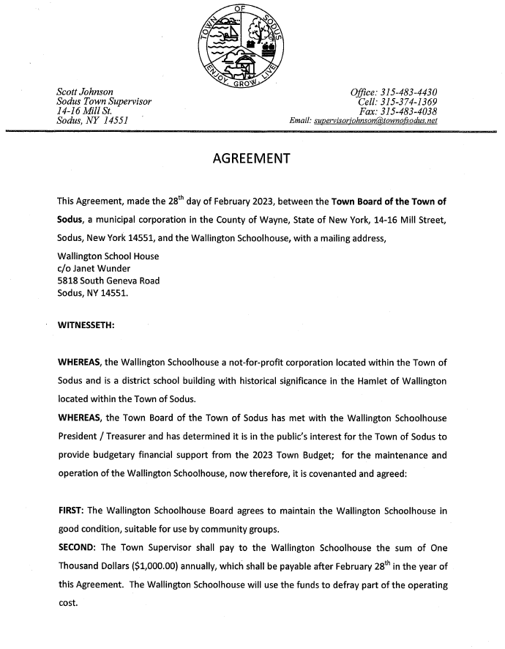

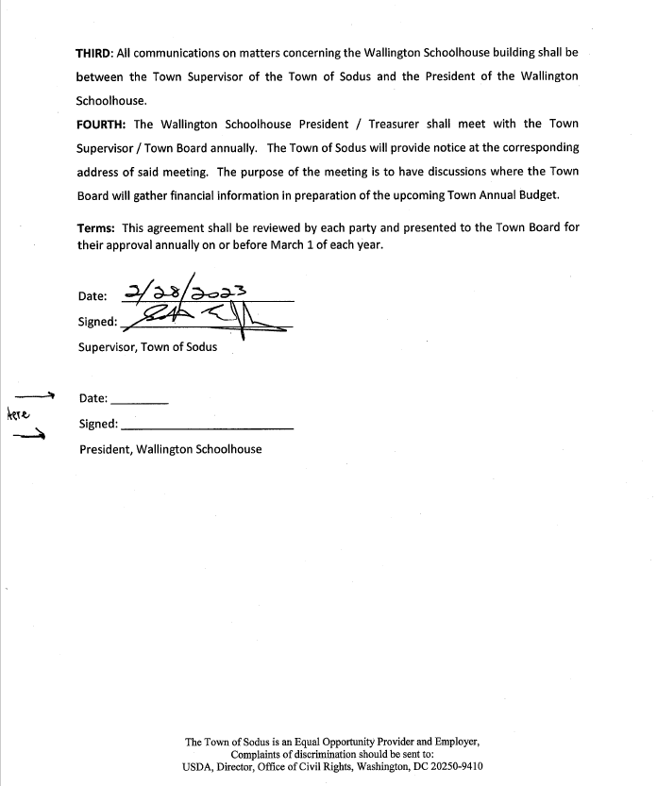

Discussion was held regarding informal residential petitions from John Williams requesting to extend water on Joy Rd. The Sodus Town Board acknowledges the petitions were received and will discuss with Dave Doyle MRB if we can add the remainder of Joy Rd. that needs water into the current proposed water district 12.
Councilperson Chris Tertinek motioned to file these petitions as received with the Town Clerk was seconded by Councilperson Don Ross. Upon roll call the following votes were heard, Scott Johnson, aye; David LeRoy, aye; Don Ross, aye; Chris Tertinek, aye; and Cathy Willmott; aye. Motion carried.
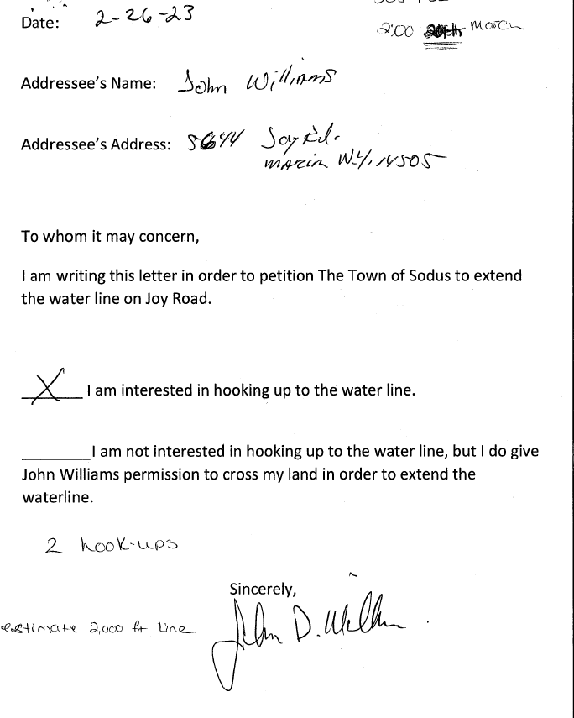

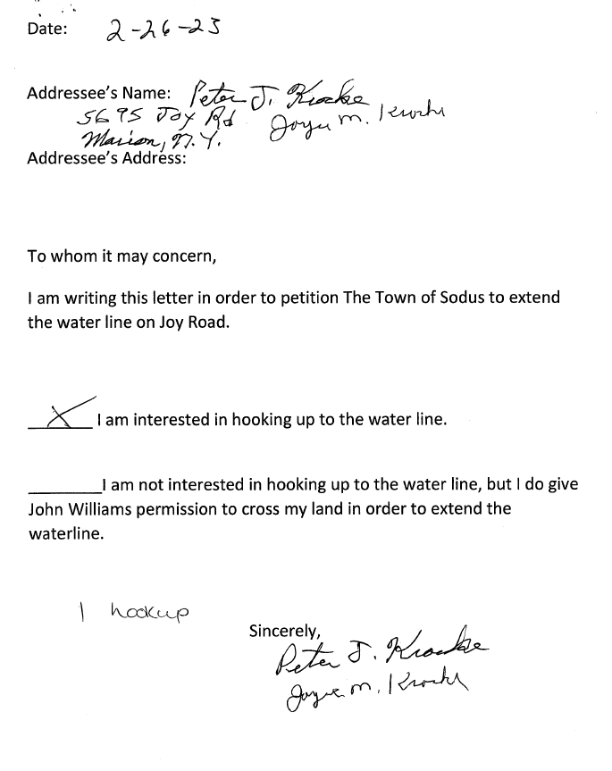

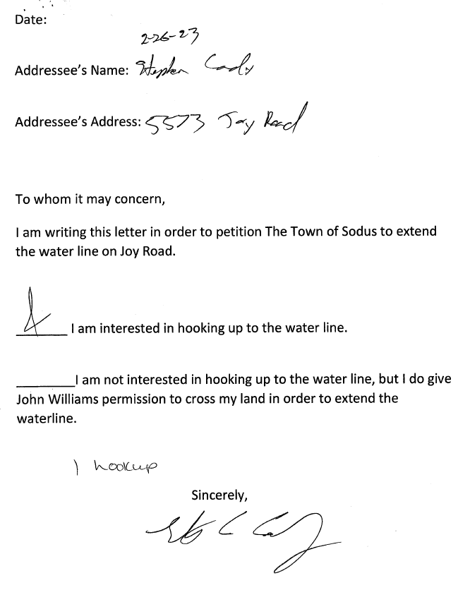

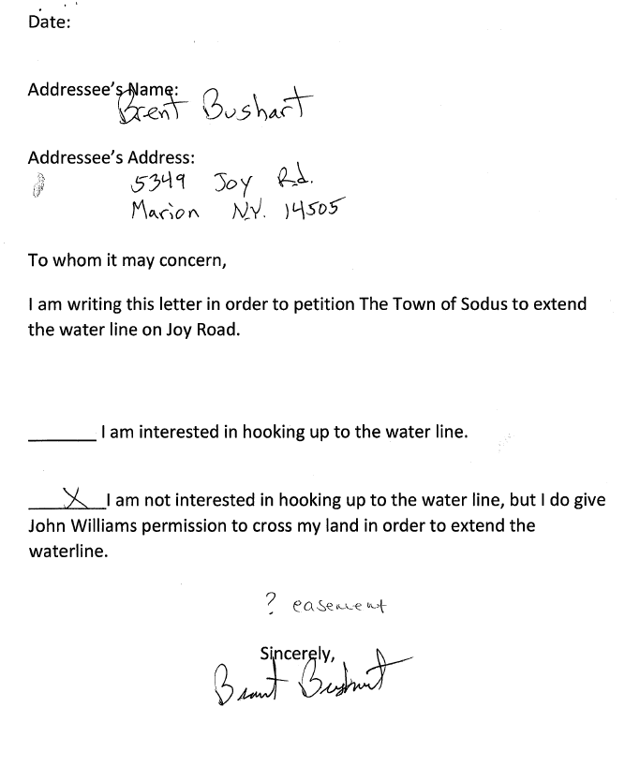

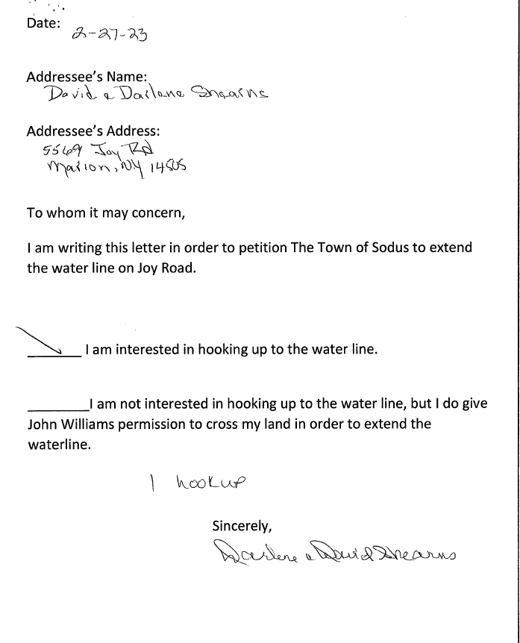

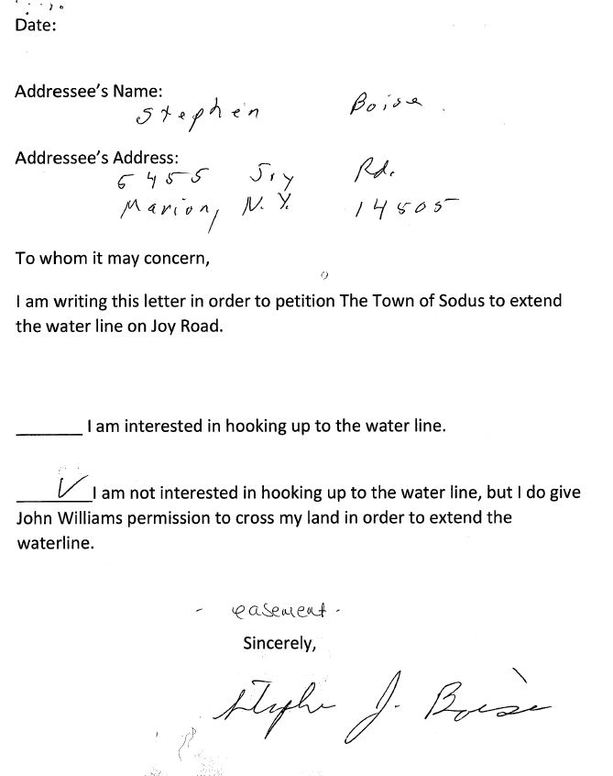

MICHELLE DOLAN COURT CLERK
RESOLUTION
(12 02-2023)
RESOLUTION AUTHORIZING THE CHANGE OF HOURLY WAGE INCREASE FOR MICHELLE DOLAN JUSTICE COURT CLERK:

WHEREAS, The Town Board and the Court Justice agree that an increase to the 2023 Hourly Wage for Michelle Dolan is justified, and
WHEREAS, there is sufficient funds in the Justice Court Clerk 2023 Town Budget allowing for an expenditure of $3,200.00 from A1110.14; and
WHEREAS, Michelle Dolans, Hourly Wage will increase from $18.57 per Hour to $20.33 per hour, an increase of $1.76 per hour, totaling $3,200.00, and be retroactive to January 1, 2023.
BE IT RESOLVED, that Michelle Dolans 2023 Hourly Wage is to be increased to $20.33 effective January 1, 2023, from Budget Line A1110.14, for an expenditure not to exceed $3,200.00; and
NOW BE IT RESOLVED, Councilperson Chris Tertinek motioned to adopt this resolution which was seconded by Councilperson David LeRoy. Upon roll call the following votes were heard, Scott Johnson, aye; David LeRoy, aye; Don Ross, aye; Chris Tertinek, aye; and Cathy Willmott; aye. Resolution Adopted.

Discussion was held on the Joy Community Center 2023 budgetary financial support on hold for payment.

JOY COMMNITY SCHOOLHOUSE 2023 BUDGETARY FINANCIAL SUPPORT
RESOLUTION
(13 02-2023)
NOW THEREFORE BE IT RESOLVED, a motion was made by Councilperson Dave LeRoy to authorize payment in the amount of $1,000.00 (for the regular financial support) to be paid at the Regular Board Meeting in March and to pay an additional $2,000.00 in ARPA funds (to be paid in April) to help the Joy Community Schoolhouse Association meet the amount requirements to apply for the Constellation Grant for repair to the building was seconded by Councilperson Cathy Willmott. Upon roll call the following votes were heard, Scott Johnson, aye; David LeRoy, aye; Don Ross, aye; Chris Tertinek, aye; and Cathy Willmott; aye. Resolution Adopted.

Councilperson Dave LeRoy discussed that the BID openings for the Salt Barn is March 2, 2023 at 10:00 AM in the Sodus Town Courtroom. The BID will be approved at the Regular Board Meeting to be held March 14, 2023.

Councilperson Dave LeRoy motioned to adjourn the Month End Town Board Meeting was seconded by Councilperson Chris Tertinek. Upon roll call the following votes were heard, Scott Johnson, aye; David LeRoy, aye; Don Ross, aye; Chris Tertinek, aye; and Cathy Willmott; aye. Motion carried. 4:15 PM

Minutes Written By:
Lori K. Diver
Sodus Town Clerk, RMC

