**Sodus Town Board Agenda**

**January 10, 2023**

**Meeting Commences at 6:00 p.m.**

**Open with Pledge Allegiance**

Roll Call: *(Lori Diver)*

Supervisor Johnson, Councilperson LeRoy, Councilperson Ross (Zoom-unable to vote), Councilperson Tertinek, Councilperson Willmott

**Public Hearing Local Law 1-2023 6:00 PM**

* Motion to enter into Public Hearing for Local Law no. 1-2023

First____________________ Second___________________ Time ___________________

**Lori Diver reads the following legal notice:**

**TOWN OF SODUS**

**Proposed Local Law No. 1**

**of the year 2023**

**A Local Law to Reduce the Number of Planning Board Members in the Town of Sodus**

Be it Enacted by the Town Board of the Town of Sodus as follows:

1. **Legislative Intent.** It is the intent of this local law to amend Town of Sodus Code to reduce the number of members of the planning board from seven (7) to five (5), which is to take effect upon the next two expirations of terms of the current planning board members.
2. **Authority.** This local law is adopted pursuant to Municipal Home Rule Law §10 and Town Law §271(7).
3. **Section 4-4 of the Town Code of the Town of Sodus is hereby amended to read as follows:**

**§ 4-4. Number and Term of Appointment, Planning Board**

The number of members of the planning board is reduced from seven (7) to five (5). In accordance with Town Law §271(7), the reduction is to take effect upon the next two expirations of terms of the current planning board members after the date of enactment of this law. Subsequent to the members of the Planning Board first appointed, their successor(s) shall be appointed for the term of five years from and after the expiration of the terms of their predecessors in office.

1. **Severability.** If any provision of this Local Law is determined to be unconstitutional or invalid, the validity and enforceability of the remainder shall not be affected.
2. **Effective Date.** This Local Law shall take effect immediately upon filing with the Secretary of State.

**Ask for public comments**

**__________________________________________________________________________________________**

**____________________________________________________________________________________________________________________________________________________________________________________**

* Motion to close Public Hearing

First____________________ Second___________________ Time ___________________

* Resolution adopting Local Law 1-2023 as listed above in legal notice.
* First____________________ Second___________________ Time ___________________

**Agenda:**

**Minutes:**

November 29, 2022 (Scott has to abstain) – (tabled at our December 13, 2022 meeting-did not have a quorum)

December 13, 2022 (Cathy and Don have to abstain)

December 29, 2022 (Cathy and Don have to abstain)

* **Supervisor’s monthly report & yearly report**
* **Town Clerk’s monthly and yearly report**
* **Tax Collection Report**
* **Resolution to Approve Bills**

1. **Public Works Committee:** **Councilperson David LeRoy**

(Highway, Drainage)

* Highway Superintendent’s monthly & yearly report *(all monthly reports for 2022 combined-already sent) –* Dale Pickering
* RG&E:
* Salt Barn:
* Drainage *N/A*

1. **Buildings and Grounds Committee:** **Councilperson Chris Tertinek**

(Town Property, Animal Control, Code Enforcement, Flood Damage)

* Code Enforcement monthly and yearly report – Frank Gahr
* Dog Control Officer monthly and yearly report– Robert Snyder

*(Backup DCO- Craig Schwartz)*

* Flood Damage Prevention – Code 69

1. **Recreation/Environmental Committee:** **Councilperson Cathy Willmott**

(Recreation, Assessor, Parks, Cemeteries)

* Sodus Recreation monthly and yearly report -Sheila Fisher
* Assessor’s monthly and yearly report – Nathan Mack
* Camp Beachwood/Sodus Groundskeeper monthly and yearly report – Sal Vittozzi

1. **Public Safety Committee:** **Councilperson Don Ross**

(Fire, Ambulance, Emergency Preparedness - WC, Water Authority - WC)

1. **Town Hall Committee:** **Supervisor Scott Johnson**

(Personnel, Town Council, Court, Assessor, Building Inspector, Boards/Committees, Insurances, Finance, Environmental)

**Correspondence & Information**

**Executive Session:**

* Motion to enter into Executive Session regarding medical, financial, credit or employment history of a particular person or corporation or relating to appointment promotion demotion discipline or removal
* Motion to exit Executive Session and enter into regular session

1. Resolution appointing Zoning Board and Planning Board Member Appointments
2. Motion authorizing Supervisor Johnson to sign letter of support for the Williamson-Sodus Airport for its continued airport sustainability project to upgrade and improve infrastructure.
3. Motion authorizing Supervisor Johnson to sign letter of support for the Williamson-Sodus Airport for its continued airport sustainability project to rehabilitate the main taxiway surface.
4. Resolution allowing Lori Diver Tax Collector to sign Annual Software Support Contract for 2023 with Williamson Law Book.
5. Resolution authorizing Highway Superintendent Dale Pickering to authorize the repair on the International 5500i 6x4 in the amount of $32,112.63 from the Regional International quote.
6. Motion authorizing Town Clerk Lori Diver to send advertisement for bids to the Lakeshore News for the new salt barn building (written by MRB).
7. Motion allowing Lori Diver to advertise for local law 2-2023 to amend the aged persons’ exemption to adjust for inflation and hold the public hearing on February 14, 2023 at 6:00 PM.
8. Motion to approve Lori Diver Sodus Town Clerk to purchase newer model replacement printer to not exceed $645.00 with shipping of $65.00 and approximately 2 hours of labor.

**Organizational Meeting**

1. Set monthly compensation amount for Zoning and Planning Board Members (55.00 + 60.00 chair)
2. Resolution adopting 2023 Wage Schedule
3. Authorization to perform 2022 year-end budgetary transfers
4. Authorization to pay certain positions on a monthly or bi-weekly schedule
5. Authorization to pay Bonds, Notes, Interest, Contracts, Utility and Insurance Bills prior to audit
6. Set date and time for Town Board Meetings (second Tuesday of each month at 6:00 pm + fourth Thursday of the month at 4:00 pm unless otherwise specified.)
7. Determine closing dates/holidays (*dates sent via email and in accordance of Employee Handbook)*
8. Set Highway Superintendent’s purchasing authorization ($1,000.00)
9. Authorization to allow designated personnel (with Board approved travel request) to attend Association of Towns Conference in NYC and/or other appropriate educational conferences
10. Authorize Supervisor to deposit Interest Certificates
11. ~~Authorize Supervisor to sign rental agreement with Village of Sodus ($2,000.00 per month)~~ already signed in 2022.
12. Authorization to pay Sodus Go Getters ($2,250.00)
13. Authorization to pay Joy School House ($1000.00)
14. Authorize to pay Veteran Services ($3,000.00)
15. Authorization of pay Home Meal Service ($3000.00)
16. Authorization of payment to Wallington School House ($1,000.00) and ($5,000.00 ARPA Funds)
17. Authorization to pay Brickchurch Rural Baptist Cemetery ($100.00) and ($5,000.00 ARPA Funds)
18. Authorization to pay Sodus Bay Historical Society ($2,000.00) and ($5,000.00 ARPA Funds)
19. ~~Authorization to sign contract with Humane Society~~
20. Authorization of payment to Sodus Point Tourism Booth ($1500.00)
21. Appointment of Town Council (Knauf Shaw LLP) and authorize Supervisor Johnson to sign agreement
22. Appointment of Town Special Prosecutor (currently Mathew St. Martin)
23. Appointment of Town Budget Officer Bree Crandell
24. ~~Appointment of Town Health Officer * 4-year appointment (currently Dr. Choudhury)~~ (*done every four years)*
25. Appointment of Town Auditor –Mengel, Metzger Barr & Co. LLP. (Ray Wager)
26. Appointment of Town Historian (currently Sandy Hopkins)
27. Designate Bank Depository (currently Lyons National Bank)
28. Designate Official Newspaper (currently Lakeshore News)
29. Authorization allowing Town Employees to attend meetings relative to their respective departments
30. Appointment of Town Board Committees *(Supervisor-leave as is?)*
31. Adopt 2023 Standard Mileage Rate (.655 cents per mile for business miles driven)
32. Appoint Alternative Technology (Dennis Lewis) to perform Town of Sodus IT services
33. ~~Re-appoint Lorraine Diver as Tax Collector, FOIL Officer, Records Officer, and Vital Records for a 4-year appointment.~~ *(Done every four years)*

* Motion to adjourn__________

**MINUTES**

Minutes of the Regular Town Board Meeting/Organizational Meeting January 10, 2023 held in person at the Town of Sodus courtroom 14-16 Mill St. Sodus, NY.

All meetings are open to the public and by Zoom.

Present: Scott Johnson, Supervisor

David LeRoy, Councilperson/Deputy Supervisor

Don Ross, Councilperson-*Zoom*

*(Unable to vote-location not advertised)*

Chris Tertinek, Councilperson

Cathy Willmott, Councilperson

Recording Secretary: Lori Diver, Town Clerk

Absent: Sal Vittozzi, Groundskeeper-*absent*

Others Present: Dave Doyle, MRB

Bree Crandell, Supervisor Clerk-*Zoom*

Susie Jacobs-*Zoom*

Dale Pickering, Highway Superintendent-*Zoom*

Amy Kendall, Town Attorney-*Zoom*

Robert Snyder, Dog Control Officer

Casey Carpenter, Times of Wayne County-*Zoom*

Supervisor Scott Johnson called the Regular Town Board and Organizational Town Board Meeting to order commencing at 6:00 PM with the Pledge of Allegiance and Lori Diver opened with roll call.

Supervisor Johnson, Councilperson LeRoy, Councilperson Ross-Zoom *(Unable to vote-location not advertised),* Councilperson Tertinek and Councilperson Willmott were all present.

**Public Hearing Local Law No. 1- 2023 6:00 PM:**

Councilperson David LeRoy motioned to enter into public hearing local law 1-2023 at 6:00 PM, which was seconded by Councilperson Cathy Willmott. Upon roll call the following votes were heard, Supervisor Scott Johnson, aye; David LeRoy, aye; Don Ross *(Zoom-unable to vote location not advertised)* Chris Tertinek, aye; and Cathy Willmott; aye. Motion carried.

**Lori Diver read the following legal notice:**

**TOWN OF SODUS**

**NOTICE OF PUBLIC HEARING**

**PLEASE TAKE NOTICE** that, pursuant to Section 20 of the Municipal Home Rule Law, a public hearing will be held by the Town Board of the Town of Sodus on January 10, 2023 at 6:00 p.m. at the Sodus Town Hall, 14-16 Mill Street, in the Town of Sodus, Wayne County, New York in the upstairs meeting room, to consider the adoption of Local Law No. 1 of 2023 of the Town of Sodus, amending Town Code §4-4 to specify the number of members of the Planning Board, and to reduce the number of Planning board Members from 7 to 5 following the expiration of the next two terms.

All persons interested shall be given an opportunity to be heard. Local Law No. 1 of 2023 is listed in this legal notice and available for public inspection during regular business hours at the Town Clerk’s office and on the Town of Sodus website at [www.townofsodus.net](http://www.townofsodus.net)

Dated: December 22, 2022

By Order of the Sodus Town Board

Lori K. Diver

Sodus Town Clerk, RMC

Supervisor Scott Johnson asked for public comments, hearing no public comments Councilperson Chris Tertinek motioned to close the public hearing for local law 1-2023 at 6:05 PM, which was seconded by Councilperson David LeRoy. Upon roll call the following votes were heard, Supervisor Scott Johnson, aye; David LeRoy, aye; Don Ross, abstain *(Zoom-unable to vote location not advertised)* Chris Tertinek, aye; and Cathy Willmott; aye. Motion carried.

**TOWN OF SODUS**

**Local Law No. 1**

**of the year 2023**

**A Local Law to Reduce the Number of Planning Board Members in the Town of Sodus**

Be it Enacted by the Town Board of the Town of Sodus as follows:

1. **Legislative Intent.** It is the intent of this local law to amend Town of Sodus Code to reduce the number of members of the planning board from seven (7) to five (5), which is to take effect upon the next two expirations of terms of the current planning board members.
2. **Authority.** This local law is adopted pursuant to Municipal Home Rule Law §10 and Town Law §271(7).
3. **Section 4-4 of the Town Code of the Town of Sodus is hereby amended to read as follows:**

**§ 4-4. Number and Term of Appointment, Planning Board**

The number of members of the planning board is reduced from seven (7) to five (5). In accordance with Town Law §271(7), the reduction is to take effect upon the next two expirations of terms of the current planning board members after the date of enactment of this law. Subsequent to the members of the Planning Board first appointed, their successor(s) shall be appointed for the term of five years from and after the expiration of the terms of their predecessors in office.

1. **Severability.** If any provision of this Local Law is determined to be unconstitutional or invalid, the validity and enforceability of the remainder shall not be affected.
2. **Effective Date.** This Local Law shall take effect immediately upon filing with the Secretary of State.

Councilperson Cathy Willmott motioned to adopt local law 1-2023 was seconded by Councilperson Chris Tertinek. Upon roll call, the following votes were heard Supervisor Scott Johnson, aye; LeRoy, aye; Ross, abstain (unable to vote-address was not published in a legal notice for Zoom); Tertinek, aye; and Willmott, aye. Local Law Adopted.

***MINUTES***

Minutes from November 29, 2022 (tabled at our December 13, 2022 meeting-did not have quorum to vote on this set of Minutes) was presented to the Town Board for approval. Councilperson Chris Tertinek motioned to accept and file these Minutes, which was seconded by Councilperson Cathy Willmott. Upon roll call the following votes were heard, Supervisor Scott Johnson, abstain (unable to vote-was absent from this meeting), David LeRoy, aye; Don Ross, abstain (unable to vote-address was not published in a legal notice for Zoom) Chris Tertinek, aye; and Cathy Willmott; aye. Motion carried.

Minutes from December 13, 2022 was presented to the Town Board for approval. Councilperson Chris Tertinek motioned to accept and file these Minutes, which was seconded by Councilperson David LeRoy. Upon roll call the following votes were heard, Supervisor Scott Johnson, aye; David LeRoy, aye; Don Ross, abstain (unable to vote-address was not published in a legal notice for Zoom) Chris Tertinek, aye; and Cathy Willmott; abstain (unable to vote-was absent from this meeting). Motion carried.

Minutes from December 29, 2022 was presented to the Town Board for approval. Councilperson David LeRoy motioned to accept and file these Minutes, which was seconded by Councilperson Chris Tertinek. Upon roll call the following votes were heard, Supervisor Scott Johnson, aye; David LeRoy, aye; Don Ross, abstain (unable to vote-address was not published in a legal notice for Zoom) Chris Tertinek, aye; and Cathy Willmott; abstain (unable to vote-was absent from this meeting). Motion carried.

***SUPERVISOR’S REPORT***

The Supervisor’s monthly report was presented for December 2022 and 2022 yearly. Councilperson David LeRoy motioned to accept and file this report, which was seconded by Councilperson Cathy Willmott. Upon roll call the following votes were heard, Scott Johnson, aye; David LeRoy, aye; Don Ross, abstain (unable to vote-address was not published in a legal notice for Zoom); Chris Tertinek, aye; and Cathy Willmott; aye. Motion carried.

|  |  |  |  |  |  |  |  |  |  |
| --- | --- | --- | --- | --- | --- | --- | --- | --- | --- |
| **MONTHLY SUPERVISOR REPORT:** | | | | | | | | |  |
| Pursuant to Section 125 of the Town Law, I hereby render the following detailed statement of all moneys received and disbursed by me through: DECEMBER 31, 2022: | | | | | | | | |  |
|  |  |
|  |  | |  | |  | |  | |  |  |
|  |  | |  | |  | |  | |  |  |
|  | Supervisor | |  | |  | | Date | |  |  |
|  |  | |  | |  | |  | |  |  |
|  |  | | **NOVEMBER 30, 2022 BALANCE** | |  | | **DECEMBER 31, 2022 BALANCE** | |  |  |
|  |  | |  | |  |  |
|  |  | |  | |  |  |
|  |  | |  | |  |  |
| **FUND:** | | |  | |  | |  | |  |  |
|  |  | |  | |  | |  | |  |  |
| A/B | General | | **$475,239.87** | |  | | **$293,690.44** | |  |  |
|  | Cash - Checking | |  | |  | |  | |  |  |
|  |  | |  | |  | | **-$181,549.43** | |  |  |
|  |  | |  | |  | |  | |  |  |
| DA/DB | Highway | | **$1,796,073.29** | |  | | **$2,114,320.90** | |  |  |
|  | Cash - Checking | |  | |  | |  | |  |  |
|  |  | |  | |  | | **$318,247.61** | |  |  |
|  |  | |  | |  | |  | |  |  |
| SW20 | South Geneva WD | | **$44,521.35** | |  | | **$39,721.35** | |  |  |
|  | Cash - Checking | |  | |  | | **-$4,800.00** | |  |  |
|  |  | |  | |  | |  | |  |  |
|  |  | |  | |  | |  | |  |  |
| SW11 | Water District 11 | | **$63,624.23** | |  | | **$43,019.23** | |  |  |
|  | Cash - Checking | |  | |  | | **-$20,605.00** | |  |  |
|  |  | |  | |  | |  | |  |  |
|  |  | |  | |  | |  | |  |  |
| SS1 | Sewer District | | **$2,476.58** | |  | | **$2,476.58** | |  |  |
|  | Cash - Checking | |  | |  | | **$0.00** | |  |  |
|  |  | |  | |  | |  | |  |  |
|  |  | |  | |  | |  | |  |  |
| SW4 | Water Operating | | **$120,242.86** | |  | | **$120,242.86** | |  |  |
|  | Cash - Checking | |  | |  | | **$0.00** | |  |  |
|  |  | |  | |  | |  | |  |  |
|  |  | |  | |  | |  | |  |  |
| TA | Trust & Agency | | **$52,165.24** | |  | | **$14,832.40** | |  |  |
|  | Cash - Checking | |  | |  | | **-$37,332.84** | |  |  |
|  |  | |  | |  | |  | |  |  |
|  |  | | **NOVEMBER 30, 2022 BALANCE** | |  | | **DECEMBER 31, 2022 BALANCE** | |  |  |
|  |  | |  | |  |  |
|  |  | |  | |  |  |
|  |  | |  | |  |  |
| **FUND:** | | |  | |  | |  | |  |  |
|  |  | |  | |  | |  | |  |  |
|  | **Fire Districts** | |  | |  | |  | |  |  |
| SF1 | Village of Sodus | | $0.00 | |  | | $0.00 | |  |  |
| SF2 | Sodus Center Fire District | | $0.00 | |  | | $0.00 | |  |  |
| SF3 | Wallington Fire District | | $0.00 | |  | | $0.00 | |  |  |
| SF4 | Alton Fire District | | $0.00 | |  | | $0.00 | |  |  |
| SF5 | Village of Sodus Point | | $0.00 | |  | | $0.00 | |  |  |
| SF6 | Rural Fire Protection | | $0.00 | |  | | $0.00 | |  |  |
| SF7 | Rural Hydrant | | $300.00 | |  | | $300.00 | |  |  |
|  | Cash - Checking | | **$300.00** | |  | | **$300.00** | |  |  |
|  |  | |  | |  | | **$0.00** | |  |  |
|  | **Lighting Districts** | |  | |  | |  | |  |  |
| SL1 | Alton Lighting | | $12,016.00 | |  | | **$11,360.57** | |  |  |
| SL2 | Sodus Center Lighting | | $27,761.96 | |  | | **$27,389.35** | |  |  |
| SL3 | Wallington Lighting | | $11,257.77 | |  | | **$10,918.06** | |  |  |
|  |  | | **$51,035.73** | |  | | **$49,667.98** | |  |  |
|  |  | |  | |  | | **-$1,367.75** | |  |  |
|  |  | |  | |  | |  | |  |  |
|  |  | |  | |  | |  | |  |  |
|  |  | |  | |  | |  | |  |  |
|  |  | |  | |  | |  | |  |  |
|  | **Total All Funds** | | **$2,605,679.15** | |  | | **$2,715,604.58** | |  |  |
|  |  | |  | |  | | **$109,925.43** | |  |  |
| **YEARLY SUPERVISOR REPORT:** | | | | | | | | | | | |  |
| Pursuant to Section 125 of the Town Law, I hereby render the following detailed statement of all moneys received and disbursed by me JANUARY 1, 2022 through DECEMBER 31, 2022: | | | | | | | | | | | |  |
|  | | | | | | | | | | | |  |
|  | |  | |  | |  | |  | | | |  |
|  | |  | |  | |  | |  | | | |  |
|  | |  | |  | |  | |  | | | |  |
|  | | Supervisor | |  | |  | | Date | | | |  |
|  | |  | |  | |  | |  | | | |  |
|  | |  | |  | |  | |  | | | |  |
|  | |  | |  | |  | |  | | | |  |
|  | |  | |  | |  | |  | | | |  |
|  | |  | | **MONTHLY BEGINNING BALANCE** | |  | | **MONTHLY ENDING BALANCE** | | | |  |
| **FUND:** | | **MONTH:** | |  | |  | |  | | | |  |
| **GENERAL A/B** | | **JANUARY** | | $386,134.63 | | **↑** | | $1,003,690.63 | | | | $617,556.00 |
|  | | **FEBRUARY** | | $1,003,690.63 | | **↓** | | $887,181.07 | | | | -$116,509.56 |
|  | | **MARCH** | | $887,181.07 | | **↓** | | $778,424.53 | | | | -$108,756.54 |
|  | | **APRIL** | | $778,424.53 | | **↑** | | $796,299.55 | | | | $17,875.02 |
|  | | **MAY** | | $796,299.55 | | **↑** | | $843,645.83 | | | | $47,346.28 |
|  | | **JUNE** | | $843,645.83 | | **↓** | | $760,963.98 | | | | -$82,681.85 |
|  | | **JULY** | | $760,963.98 | | **↑** | | $878,004.56 | | | | $117,040.58 |
|  | | **AUGUST** | | $878,004.56 | | **↓** | | $581,887.12 | | | | -$296,117.44 |
|  | | **SEPTEMBER** | | $581,887.12 | | **↓** | | $494,044.76 | | | | -$87,842.36 |
|  | | **OCTOBER** | | $494,044.76 | | **↓** | | $390,316.81 | | | | -$103,727.95 |
|  | | **NOVEMBER** | | $390,316.81 | | **↑** | | $475,239.87 | | | | $84,923.06 |
|  | | **DECEMBER** | | $475,239.87 | | **↓** | | $293,690.44 | | | | -$181,549.43 |
|  | |  | |  | |  | |  | | | | **-$92,444.19** |
|  | |  | |  | |  | |  | | | |  |
|  | |  | | **MONTHLY BEGINNING BALANCE** | |  | | **MONTHLY ENDING BALANCE** | | | |  |
| **FUND:** | | **MONTH:** | |  | |  | |  | | | |  |
| **HIGHWAY DA/DB** | | **JANUARY** | | $1,768,548.67 | | **↑** | | $2,054,255.62 | | | | $285,706.95 |
|  | | **FEBRUARY** | | $2,054,255.62 | | **↑** | | $2,611,252.27 | | | | $556,996.65 |
|  | | **MARCH** | | $2,611,252.27 | | **↑** | | $2,632,280.20 | | | | $21,027.93 |
|  | | **APRIL** | | $2,632,280.20 | | **↓** | | $2,568,013.91 | | | | -$64,266.29 |
|  | | **MAY** | | $2,568,013.91 | | **↑** | | $2,596,459.86 | | | | $28,445.95 |
|  | | **JUNE** | | $2,596,459.86 | | **↓** | | $2,489,375.25 | | | | -$107,084.61 |
|  | | **JULY** | | $2,489,375.25 | | **↓** | | $2,258,719.45 | | | | -$230,655.80 |
|  | | **AUGUST** | | $2,258,719.45 | | **↓** | | $2,223,921.89 | | | | -$34,797.56 |
|  | | **SEPTEMBER** | | $2,223,921.89 | | **↓** | | $2,136,738.10 | | | | -$87,183.79 |
|  | | **OCTOBER** | | $2,136,738.10 | | **↓** | | $1,915,503.56 | | | | -$221,234.54 |
|  | | **NOVEMBER** | | $1,915,503.56 | | **↓** | | $1,796,073.29 | | | | -$119,430.27 |
|  | | **DECEMBER** | | $1,796,073.29 | | **↑** | | $2,114,320.90 | | | | $318,247.61 |
|  | |  | |  | |  | |  | | | | **$345,772.23** |
|  | |  | |  | |  | |  | | | |  |
|  | |  | |  | |  | |  | | | |  |
|  | |  | |  | |  | |  | | | |  |
|  | |  | |  | |  | |  | | | |  |
|  | |  | |  | |  | |  | | | |  |
|  | |  | |  | |  | |  | | | |  |
|  | |  | |  | |  | |  | | | |  |
|  | |  | |  | |  | |  | | | |  |
|  | |  | | **MONTHLY BEGINNING BALANCE** | |  | | **MONTHLY ENDING BALANCE** | | | |  |
| **FUND:** | | **MONTH:** | |  | |  | |  | | | |  |
| **WATER OPERATING** | | **JANUARY** | | $119,605.82 | | **↑** | | $120,239.61 | | | | $633.79 |
|  | | **FEBRUARY** | | $120,239.61 | | **↑** | | $120,242.86 | | | | $3.25 |
|  | | **MARCH** | | $120,242.86 | | ─ | | $120,242.86 | | | | **$0.00** |
|  | | **APRIL** | | $120,242.86 | | ─ | | $120,242.86 | | | | **$0.00** |
|  | | **MAY** | | $120,242.86 | | ─ | | $120,242.86 | | | | **$0.00** |
|  | | **JUNE** | | $120,242.86 | | ─ | | $120,242.86 | | | | **$0.00** |
|  | | **JULY** | | $120,242.86 | | ─ | | $120,242.86 | | | | **$0.00** |
|  | | **AUGUST** | | $120,242.86 | | ─ | | $120,242.86 | | | | **$0.00** |
|  | | **SEPTEMBER** | | $120,242.86 | | ─ | | $120,242.86 | | | | **$0.00** |
|  | | **OCTOBER** | | $120,242.86 | | ─ | | $120,242.86 | | | | **$0.00** |
|  | | **NOVEMBER** | | $120,242.86 | | ─ | | $120,242.86 | | | | **$0.00** |
|  | | **DECEMBER** | | $120,242.86 | | ─ | | $120,242.86 | | | | **$0.00** |
|  | |  | |  | |  | |  | | | | **$637.04** |
|  | |  | |  | |  | |  | | | |  |
|  | |  | | **MONTHLY BEGINNING BALANCE** | |  | | **MONTHLY ENDING BALANCE** | | | |  |
| **FUND:** | | **MONTH:** | |  | |  | |  | | | |  |
| **SEWER DISTRICT** | | **JANUARY** | | $2,476.58 | | ─ | | $2,476.58 | | | | $0.00 |
|  | | **FEBRUARY** | | $2,476.58 | | ─ | | $2,476.58 | | | | $0.00 |
|  | | **MARCH** | | $2,476.58 | | ─ | | $2,476.58 | | | | $0.00 |
|  | | **APRIL** | | $2,476.58 | | ─ | | $2,476.58 | | | | $0.00 |
|  | | **MAY** | | $2,476.58 | | ─ | | $2,476.58 | | | | $0.00 |
|  | | **JUNE** | | $2,476.58 | | ─ | | $2,476.58 | | | | $0.00 |
|  | | **JULY** | | $2,476.58 | | ─ | | $2,476.58 | | | | $0.00 |
|  | | **AUGUST** | | $2,476.58 | | ─ | | $2,476.58 | | | | $0.00 |
|  | | **SEPTEMBER** | | $2,476.58 | | ─ | | $2,476.58 | | | | $0.00 |
|  | | **OCTOBER** | | $2,476.58 | | ─ | | $2,476.58 | | | | $0.00 |
|  | | **NOVEMBER** | | $2,476.58 | | ─ | | $2,476.58 | | | | $0.00 |
|  | | **DECEMBER** | | $2,476.58 | | ─ | | $2,476.58 | | | | $0.00 |
|  | |  | |  | |  | |  | | | | **$0.00** |
|  | |  | |  | |  | |  | | | |  |
|  | |  | |  | |  | |  | | | |  |
|  | |  | |  | |  | |  | | | |  |
|  | |  | |  | |  | |  | | | |  |
|  | |  | |  | |  | |  | | | |  |
|  | |  | |  | |  | |  | | | |  |
|  | |  | |  | |  | |  | | | |  |
|  | |  | |  | |  | |  | | | |  |
|  | |  | |  | |  | |  | | | |  |
|  | |  | | **MONTHLY BEGINNING BALANCE** | |  | | **MONTHLY ENDING BALANCE** | | | |  |
| **FUND:** | | **MONTH:** | |  | |  | |  | | | |  |
| **SW#11** | | **JANUARY** | | $64,473.34 | | **↑** | | $92,683.34 | | | | $28,210.00 |
|  | | **FEBRUARY** | | $92,683.34 | | ─ | | $92,683.34 | | | | $0.00 |
|  | | **MARCH** | | $92,683.34 | | **↓** | | $89,254.58 | | | | -$3,428.76 |
|  | | **APRIL** | | $89,254.58 | | ─ | | $89,254.58 | | | | $0.00 |
|  | | **MAY** | | $89,254.58 | | **↓** | | $71,229.23 | | | | -$18,025.35 |
|  | | **JUNE** | | $71,229.23 | | **↓** | | $63,624.23 | | | | -$7,605.00 |
|  | | **JULY** | | $63,624.23 | | ─ | | $63,624.23 | | | | $0.00 |
|  | | **AUGUST** | | $63,624.23 | | ─ | | $63,624.23 | | | | $0.00 |
|  | | **SEPTEMBER** | | $63,624.23 | | ─ | | $63,624.23 | | | | $0.00 |
|  | | **OCTOBER** | | $63,624.23 | | ─ | | $63,624.23 | | | | $0.00 |
|  | | **NOVEMBER** | | $63,624.23 | | ─ | | $63,624.23 | | | | $0.00 |
|  | | **DECEMBER** | | $63,624.23 | | **↓** | | $43,019.23 | | | | -$20,605.00 |
|  | |  | |  | |  | |  | | | | **-$21,454.11** |
|  | |  | |  | |  | |  | | | |  |
|  | |  | | **MONTHLY BEGINNING BALANCE** | |  | | **MONTHLY ENDING BALANCE** | | | |  |
| **FUND:** | | **MONTH:** | |  | |  | |  | | | |  |
| **SW#20** | | **JANUARY** | | $39,721.35 | | **↑** | | $46,321.35 | | | | $6,600.00 |
|  | | **FEBRUARY** | | $46,321.35 | | ─ | | $46,321.35 | | | | $0.00 |
|  | | **MARCH** | | $46,321.35 | | ─ | | $46,321.35 | | | | $0.00 |
|  | | **APRIL** | | $46,321.35 | | ─ | | $46,321.35 | | | | $0.00 |
|  | | **MAY** | | $46,321.35 | | ─ | | $46,321.35 | | | | $0.00 |
|  | | **JUNE** | | $46,321.35 | | **↓** | | $44,521.35 | | | | -$1,800.00 |
|  | | **JULY** | | $44,521.35 | | ─ | | $44,521.35 | | | | $0.00 |
|  | | **AUGUST** | | $44,521.35 | | ─ | | $44,521.35 | | | | $0.00 |
|  | | **SEPTEMBER** | | $44,521.35 | | ─ | | $44,521.35 | | | | $0.00 |
|  | | **OCTOBER** | | $44,521.35 | | ─ | | $44,521.35 | | | | $0.00 |
|  | | **NOVEMBER** | | $44,521.35 | | ─ | | $44,521.35 | | | | $0.00 |
|  | | **DECEMBER** | | $44,521.35 | | **↓** | | $39,721.35 | | | | -$4,800.00 |
|  | |  | |  | |  | |  | | | | **$0.00** |
|  | |  | |  | |  | |  | | | |  |
|  | |  | |  | |  | |  | | | |  |
|  | |  | |  | |  | |  | | | |  |
|  | |  | |  | |  | |  | | | |  |
|  | |  | |  | |  | |  | | | |  |
|  | |  | |  | |  | |  | | | |  |
|  | |  | |  | |  | |  | | | |  |
|  | |  | |  | |  | |  | | | |  |
|  | |  | |  | |  | |  | | | |  |
|  | |  | |  | |  | |  | | | |  |
|  | |  | |  | |  | |  | | | |  |
|  | |  | | **MONTHLY BEGINNING BALANCE** | |  | | **MONTHLY ENDING BALANCE** | | | |  |
| **FUND:** | | **MONTH:** | |  | |  | |  | | | |  |
| **FIRE DISTRICTS** | | **JANUARY** | | $300.00 | | **↑** | | $305,273.00 | | | | $304,973.00 |
|  | | **FEBRUARY** | | $305,273.00 | | **↓** | | $300.00 | | | | -$304,973.00 |
|  | | **MARCH** | | $300.00 | | ─ | | $300.00 | | | | $0.00 |
|  | | **APRIL** | | $300.00 | | ─ | | $300.00 | | | | $0.00 |
|  | | **MAY** | | $300.00 | | ─ | | $300.00 | | | | $0.00 |
|  | | **JUNE** | | $300.00 | | ─ | | $300.00 | | | | $0.00 |
|  | | **JULY** | | $300.00 | | ─ | | $300.00 | | | | $0.00 |
|  | | **AUGUST** | | $300.00 | | ─ | | $300.00 | | | | $0.00 |
|  | | **SEPTEMBER** | | $300.00 | | ─ | | $300.00 | | | | $0.00 |
|  | | **OCTOBER** | | $300.00 | | ─ | | $300.00 | | | | $0.00 |
|  | | **NOVEMBER** | | $300.00 | | ─ | | $300.00 | | | | $0.00 |
|  | | **DECEMBER** | | $300.00 | | ─ | | $300.00 | | | | $0.00 |
|  | |  | |  | |  | |  | | | | **$0.00** |
|  | |  | |  | |  | |  | | | |  |
|  | |  | | **MONTHLY BEGINNING BALANCE** | |  | | **MONTHLY ENDING BALANCE** | | | |  |
| **FUND:** | | **MONTH:** | |  | |  | |  | | | |  |
| **LIGHTING DISTRICTS** | | **JANUARY** | | $48,955.04 | | **↑** | | $61,955.67 | | | | $13,000.63 |
|  | | **FEBRUARY** | | $61,955.67 | | **↓** | | $60,808.50 | | | | -$1,147.17 |
|  | | **MARCH** | | $60,808.50 | | **↓** | | $59,761.34 | | | | -$1,047.16 |
|  | | **APRIL** | | $59,761.34 | | **↓** | | $58,645.12 | | | | -$1,116.22 |
|  | | **MAY** | | $58,645.12 | | **↓** | | $57,590.59 | | | | -$1,054.53 |
|  | | **JUNE** | | $57,590.59 | | **↓** | | $56,504.58 | | | | -$1,086.01 |
|  | | **JULY** | | $56,504.58 | | **↓** | | $55,543.89 | | | | -$960.69 |
|  | | **AUGUST** | | $55,543.89 | | **↓** | | $54,493.52 | | | | -$1,050.37 |
|  | | **SEPTEMBER** | | $54,493.52 | | **↓** | | $53,398.04 | | | | -$1,095.48 |
|  | | **OCTOBER** | | $53,398.04 | | **↓** | | $52,216.29 | | | | -$1,181.75 |
|  | | **NOVEMBER** | | $52,216.29 | | **↓** | | $51,035.73 | | | | -$1,180.56 |
|  | | **DECEMBER** | | $51,035.73 | | **↓** | | $49,667.98 | | | | -$1,367.75 |
|  | |  | |  | |  | |  | | | | **$712.94** |
|  | |  | |  | |  | |  | | | |  |
|  | |  | |  | |  | |  | | | |  |
|  | |  | |  | |  | |  | | | |  |
|  | |  | |  | |  | |  | | | |  |
|  | |  | |  | |  | |  | | | |  |
|  | |  | |  | |  | |  | | | |  |
|  | |  | |  | |  | |  | | | |  |
|  | |  | |  | |  | |  | | | |  |
|  | |  | |  | |  | |  | | | |  |
|  | |  | |  | |  | |  | | | |  |
|  | |  | | **MONTHLY BEGINNING BALANCE** | |  | | **MONTHLY ENDING BALANCE** | | | |  |
| **FUND:** | | **MONTH:** | |  | |  | |  | | | |  |
| **TRUST & AGENCY** | | **JANUARY** | | $47,899.67 | | **↑** | | $64,214.60 | | | | $16,314.93 |
|  | | **FEBRUARY** | | $64,214.60 | | ↓ | | $48,536.45 | | | | -$15,678.15 |
|  | | **MARCH** | | $48,536.45 | | ↓ | | $35,428.17 | | | | -$13,108.28 |
|  | | **APRIL** | | $35,428.17 | | ↓ | | $34,693.60 | | | | -$734.57 |
|  | | **MAY** | | $34,693.60 | | ↓ | | $29,553.08 | | | | -$5,140.52 |
|  | | **JUNE** | | $29,553.08 | | ↓ | | $16,348.01 | | | | -$13,205.07 |
|  | | **JULY** | | $16,348.01 | | **↑** | | $56,233.78 | | | | $39,885.77 |
|  | | **AUGUST** | | $56,233.78 | | ↓ | | $38,433.63 | | | | -$17,800.15 |
|  | | **SEPTEMBER** | | $38,433.63 | | **↑** | | $39,674.01 | | | | $1,240.38 |
|  | | **OCTOBER** | | $39,674.01 | | ↓ | | $12,249.26 | | | | -$27,424.75 |
|  | | **NOVEMBER** | | $12,249.26 | | **↑** | | $52,165.24 | | | | $39,915.98 |
|  | | **DECEMBER** | | $52,165.24 | | ↓ | | $14,832.40 | | | | -$37,332.84 |
|  | |  | |  | |  | |  | | | | **-$33,067.27** |
|  | |  | |  | |  | |  | | | |  |
|  | |  | |  | |  | |  | | | |  |
|  | |  | |  | |  | |  | | | |  |
|  | |  | |  | |  | |  | | | |  |
|  | |  | |  | | **TOTAL FOR OVERALL 2022 YEAR:** | | | | | | **$200,156.64** |

***TOWN CLERK’S REPORT***

The Town Clerk’s Reports, Town Clerk’s bank statements for audit and bank register for December 2022 report and 2022 Yearly Town Clerk’s report was presented.

Note: bank statement and bank register are listed in detail with Town Clerk cash book for 2022. For security reasons and confidentiality, it cannot be published in Minutes. Councilperson Cathy Willmott motioned to accept and file these reports, which was seconded by Councilperson David LeRoy. Upon roll call the following votes were heard, Scott Johnson, aye; David LeRoy, aye; Don Ross, abstain (unable to vote-address was not published in a legal notice for Zoom); Chris Tertinek, aye; and Cathy Willmott; aye. Motion carried.

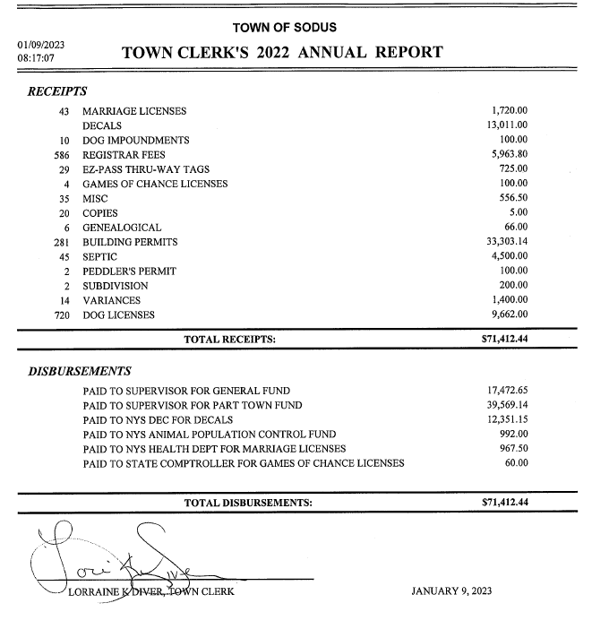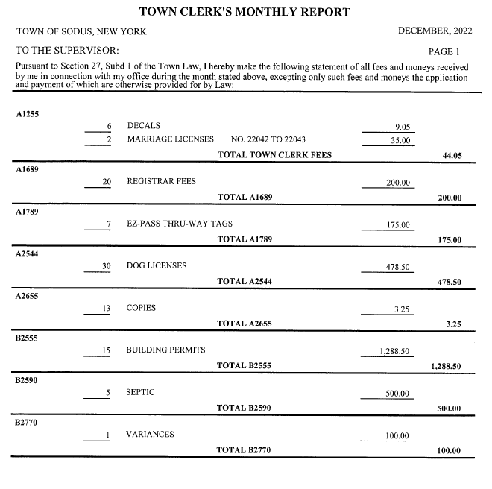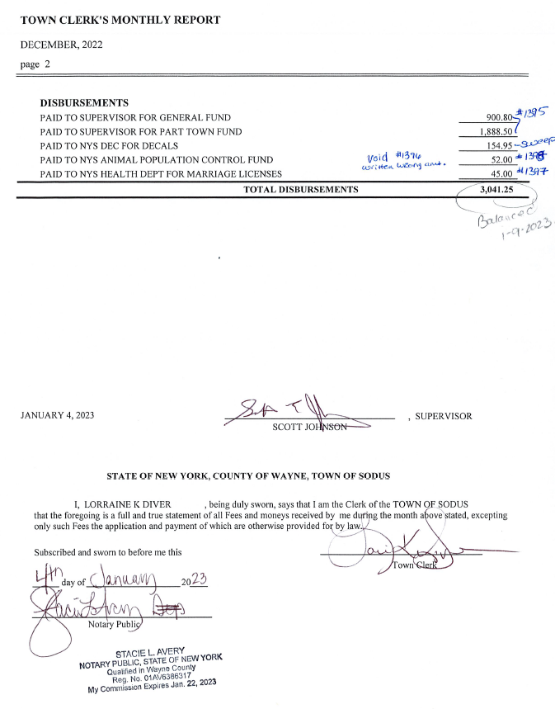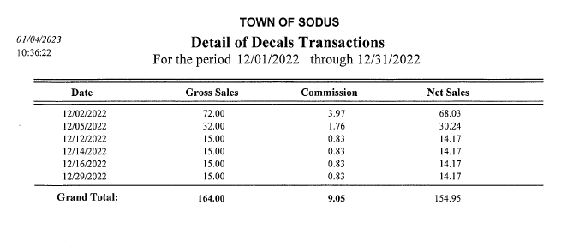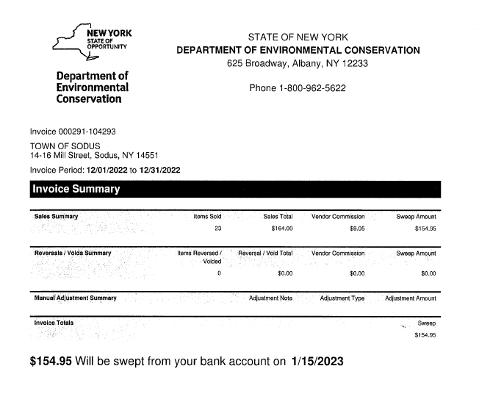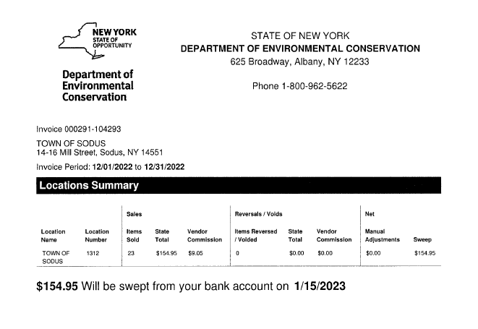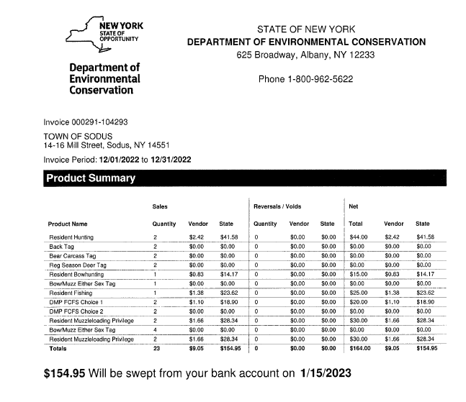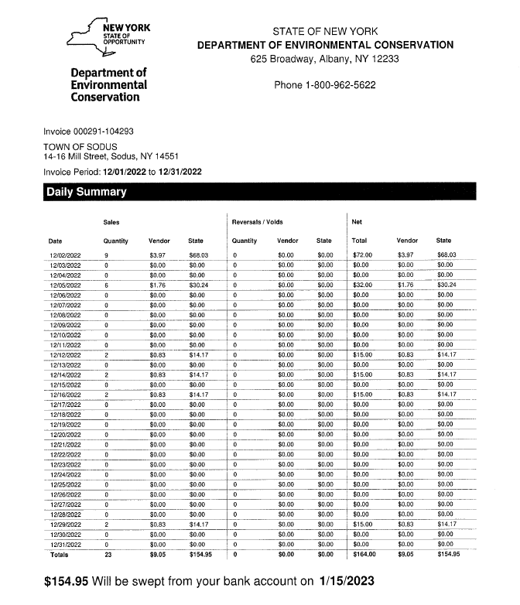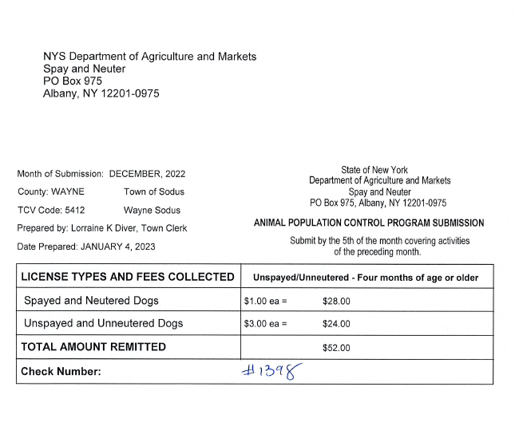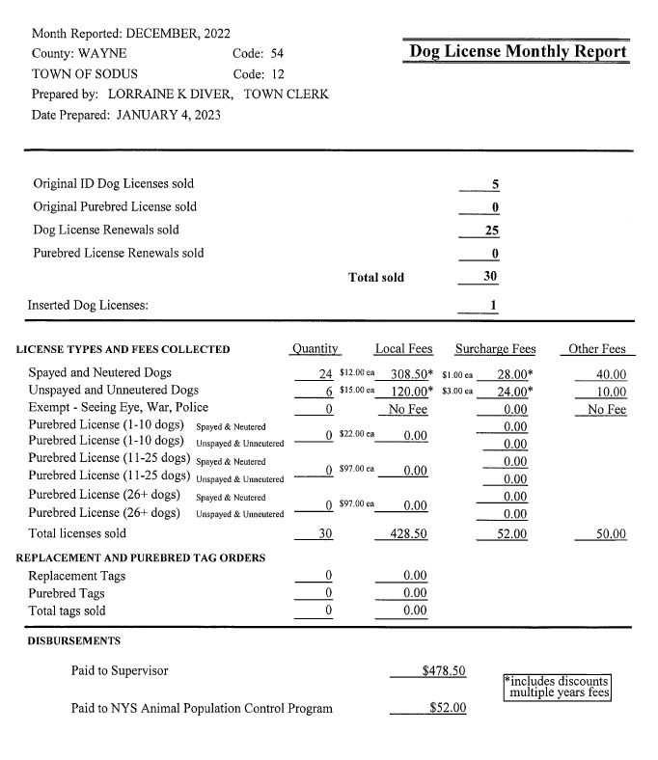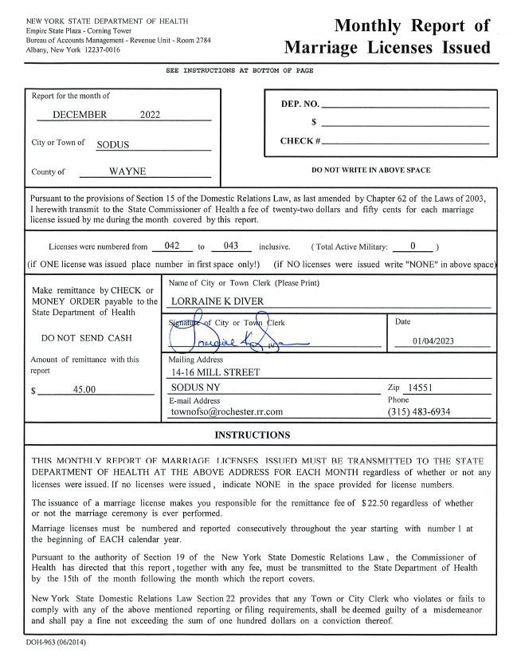

***TAX COLLECTION REPORT***

The Tax Collection Report, Tax Collector bank statements for audit and bank register for January 2023 was presented. Councilperson Chris Tertinek motioned to accept and file these reports, which was seconded by Councilperson Cathy Willmott. Upon roll call the following votes were heard, Scott Johnson, aye; David LeRoy, aye; Don Ross, abstain (unable to vote-address was not published in a legal notice for Zoom); Chris Tertinek, aye; and Cathy Willmott; aye. Motion carried.

Note: bank statement and bank register are listed in detail with Tax Collection cash book for 2023. For security reasons and confidentiality, it cannot be published in Minutes.

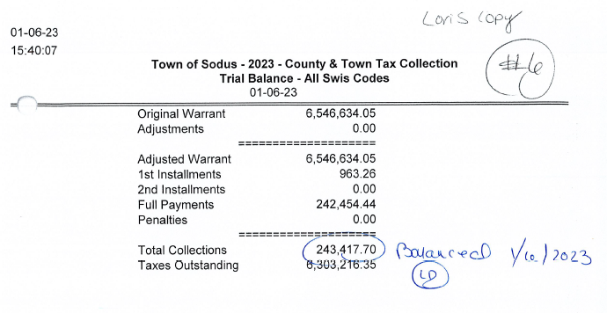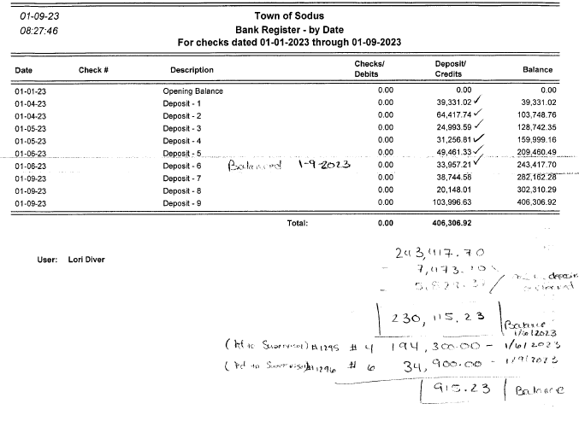

***ABSTRACT***

***RESOLUTION TO PAY ABSTRACT NO. 01***

***(01 01-2023)***

**WHEREAS,** the following bills were presented for payment on Abstract 01:

General 001-021 $ 68,015.20

Highway 001-009 $ 25,701.39

Special District 01-01 $ 1,239.68

Sewer District 01-01 $ 1,006.21

**GRAND TOTAL: $ 95,962.48**

**NOW BE IT RESOLVED**, Councilperson Cathy Willmott motioned to approve payment of these bills as reviewed for Abstract No. 01, which was seconded by Councilperson David LeRoy. Upon roll call the following votes were heard, Scott Johnson, aye; David LeRoy, aye; Don Ross, abstain (unable to vote-address was not published in a legal notice for Zoom); Chris Tertinek, aye; and Cathy Willmott; aye. Resolution Adopted.

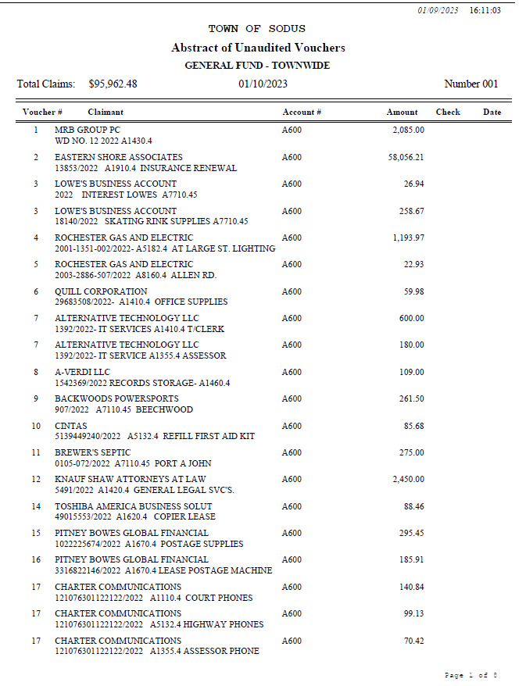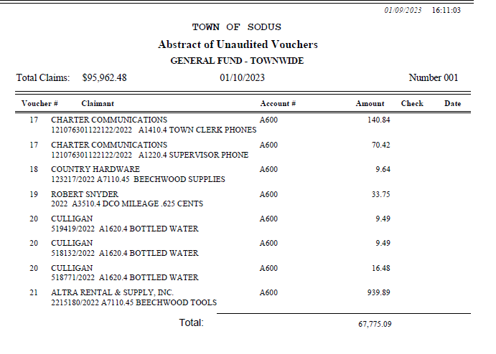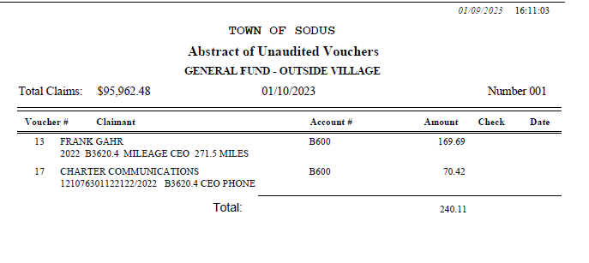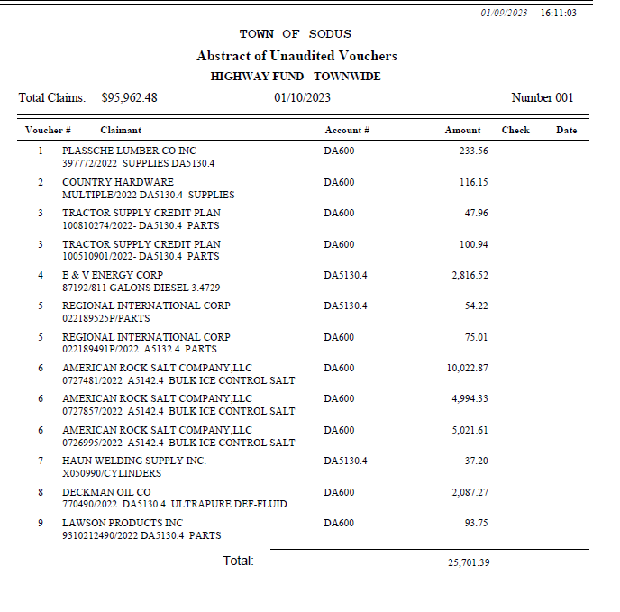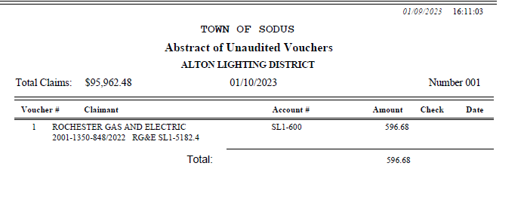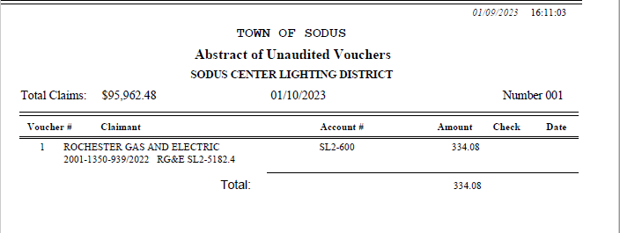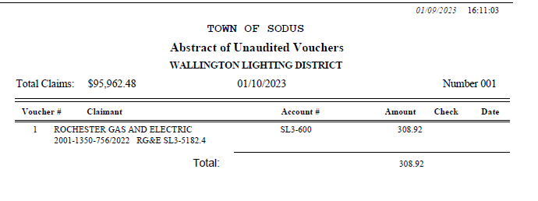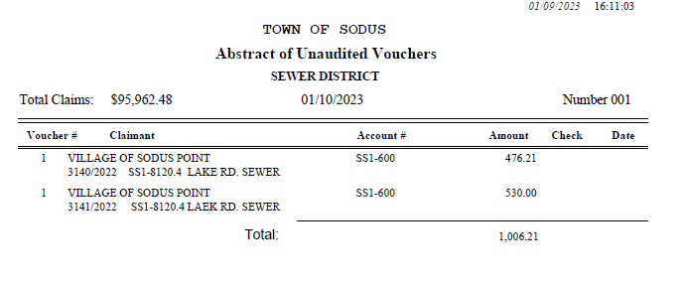

**PUBLIC COMMENTS**

Dave Doyle, MRB

Dave Doyle was present for the meeting in case the Board had any questions regarding the Salt Barn process. Dave highlighted the timeline for the Board. The next process is submitting the legal notice to the paper for BID.

**PUBLIC WORKS COMMITTEE:** ***Councilperson David LeRoy, Chair***

***(Highway, Drainage - Deputy Town Supervisor)***

***HIGHWAY REPORT:***

(Dale Pickering – Highway Superintendent)

Councilperson Chris Tertinek motioned to accept and file the monthly December 2022 report and yearly 2022 Highway Report (all reports January 2022-December 2022 combined are Dale’s Yearly report-sent via email) from Dale Pickering Highway Superintendent was seconded by Councilperson Cathy Willmott. Upon roll call the following votes were heard, Scott Johnson, aye; David LeRoy, aye; Don Ross, abstain (unable to vote-address was not published in a legal notice for Zoom); Chris Tertinek, aye; and Cathy Willmott; aye. Motion carried.

David discussed the following bullet points below on RG&E, Highway Barn and Salt Barn

* RG&E:
  + Street lights have been replaced with new LED lights. Dave LeRoy will contact RG&E to get year to date bills for a comparison.
* Salt Barn:
  + There was an informational meeting last Friday with MRB January 6, 2023. The next step is to advertise for BIDs in the legal paper January 25, 2023.
* Drainage *N/A*

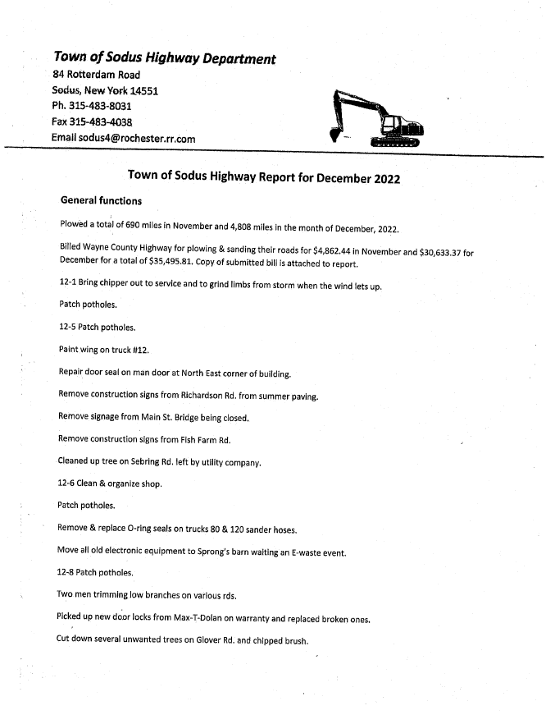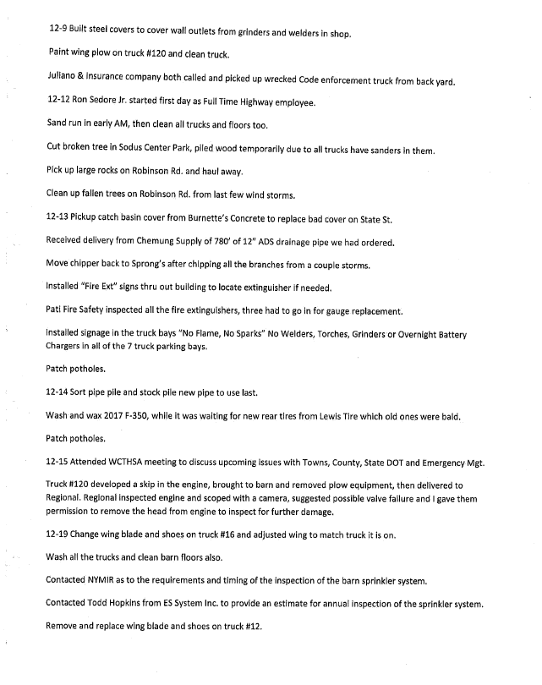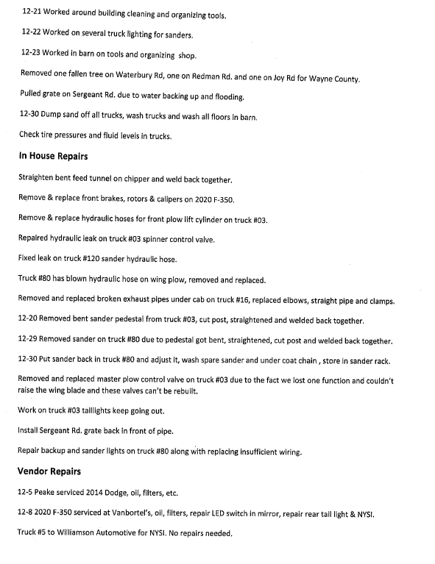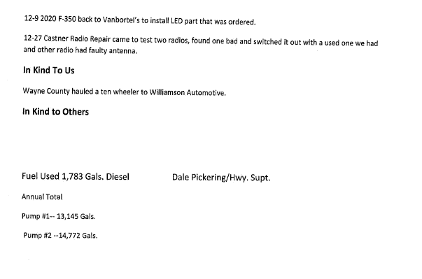

**BUILDINGS AND GROUNDS COMMITTEE: *Councilperson Chris Tertinek, Chair***

***(Town Property, Animal Control, Flood Damage Prevention)***

***CODE ENFORCEMENT REPORT:***

*Frank Gahr- CEO*

Councilperson Chris Tertinek motioned to accept the monthly December 2022 Code Enforcement Report and yearly 2022 report as written, was seconded by Councilperson David LeRoy. Upon roll call the following votes were heard, Scott Johnson, aye; David LeRoy, aye; Don Ross, abstain (unable to vote-address was not published in a legal notice for Zoom) Chris Tertinek, aye; and Cathy Willmott; aye. Motion carried.

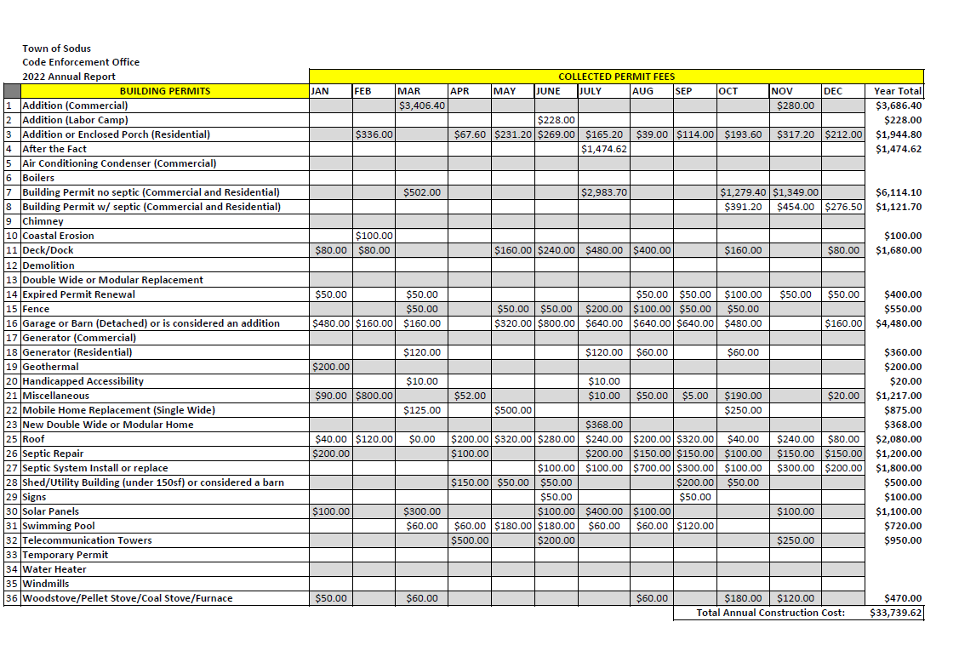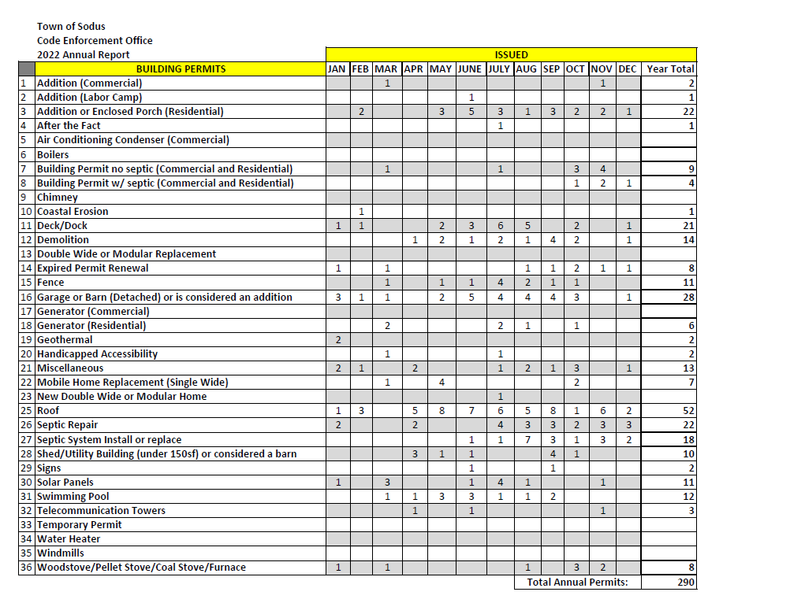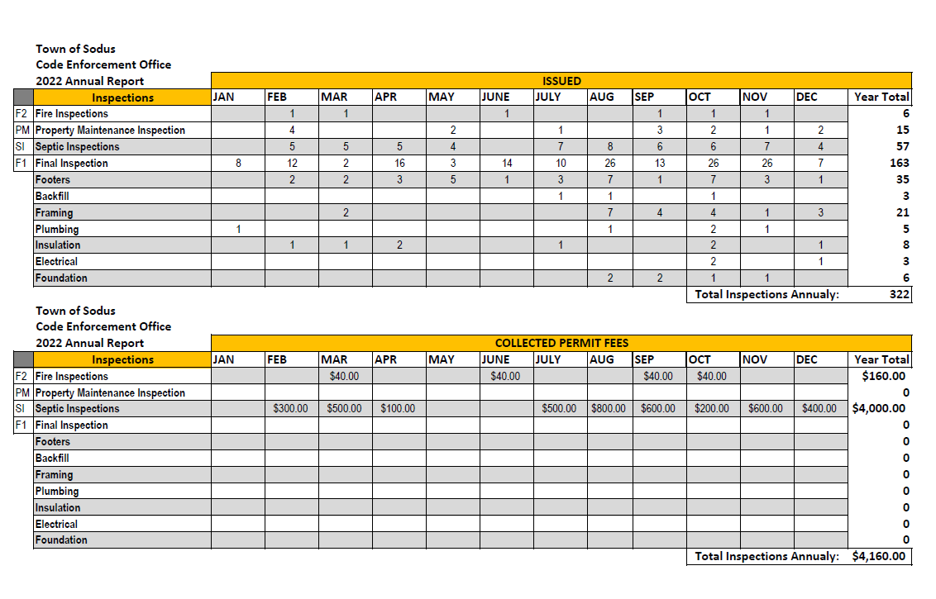

***DOG CONTROL REPORT:***

*Robert Snyder, Primary DCO*

*Vacant- Secondary DCO*

Councilperson Cathy Willmott motioned to accept the monthly December 2022 Dog Control report and yearly 2022 report as written, was seconded by Councilperson David LeRoy. Upon roll call the following votes were heard, Scott Johnson, aye; David LeRoy, aye; Don Ross, abstain (unable to vote-address was not published in a legal notice for Zoom); Chris Tertinek, aye; and Cathy Willmott; aye. Motion carried.

**December 2022 Dog Control Report**

11-28-2022 Spoke with Gloria Rodriquez about dogs running at large. She stated they will be in a kennel now from this point forward when outside.

12-09-2022 Dog bite to young woman. Dog was contained in apartment. Victim had surgery from bite. Craig Schwartz and Kevin Druschel were both involved in the case. Case is ongoing.

12-18-2022 911 Call-Dog running at large on Main St. in Sodus. The dog was picked up on Gaylord St. and taken to the Humane Society. 5:30 AM

12-30-2022 Dog complaint on Van Lare Rd. Dog was claimed to be barking nonstop. Went to the house and no one was home. There was no dog barking. Will follow-up with onsite.

Mileage: 54 miles

Robert Snyder, DCO

**Yearly 2022 DCO Report**

When I took this job back in June, I didn’t know what to expect. I have met a lot of new people some not so friendly. The job itself has made me a more independent person. Since starting as DCO, I have had 5 dog bite complaints. Nothing bad ever came out of these dog calls.

I have issued a few tickets to the dog owners for unlicensed dogs. There have been several running at large complaints that I addressed or the owner showed up to claim the dog. In addition, I have transported some dogs to the Humane Society. When a dog arrives at the Humane Society, it is checked for being microchipped. If the dogs are not claimed by their owners, they are put up for adoption.

I am looking forward to see what 2023 will bring my way.

Respectfully Submitted,

Robert Snyder, DCO

***FLOOD DAMAGE PREVENTION REPORT-Code 69:***

*Chris Tertinek, Councilperson*

Councilperson Chris Tertinek shared his flood damage prevention report. Lake Level at 244.82 ft ASL; about 7 inches higher than last month and the same as in 2022. Presently still about two inches below the long-term average. The long term forecast till mid-June will be close to the long-time average. Water is expected to crest in June.

**RECREATION/ENVIRONMENTAL COMMITTE: *Councilwoman Cathy Willmott***

***(Recreation, Assessor, Parks, Cemeteries)***

***CAMP BEECHWOOD-PARKS-CEMETERIES REPORTS:***

***Recreation Report***

***(Sheila Fisher, Recreation Director)***

Councilperson David LeRoy motioned to accept the yearly 2022 and December 2022 monthly Recreation report from Sheila Fisher, Recreation Director was seconded by Councilperson Chris Tertinek. Upon roll call the following votes were heard, Scott Johnson, aye; David LeRoy, aye; Don Ross, abstain (unable to vote-address was not published in a legal notice for Zoom); Chris Tertinek, aye; and Cathy Willmott; aye. Motion carried.

Note: Will hold Recreation Committee Meeting at month end meeting starting at 4:00 PM.

**Director’s Report**

**Sodus Recreation Board Meeting**

**January 4, 2023**

Programs:

* Girls Basketball has 22 girls participating. The Team is heading to an SU game on January 15th and possibly a Williams Smith game on January 20th. The team scrimmaged during a Sodus JV game recently.
* Soccer and Swim lessons will be held in late February / Early March. More information will be coming soon.
* The Employees for the Swim and Soccer program will need to be determined prior to the February & March programming.

Recreation Board:

* Interested Recreation Board members for the year 2023 are listed below. We will be meeting soon. Members interested are:
  + Laurie McFaul Frey- Current President
  + Tom Miller – Current Treasurer
  + Lyn VanLare- Current Board Member
  + Jen Davis – New Member
  + Mary Zecher Paton – New Member

I received no response from other previous Board members when asked if they wanted to stay on the Board.

* Sheila, Cathy, Bre & Lori will hopefully meet again soon to discuss how payments will be received for upcoming and future programming.
* Bre has created a volunteer application to be used going forward for any volunteers helping with Sodus Recreation. Thanks Bre!
* Cathy has been working on the Bylaw's with Amy.
* We will continue to work together to build the Recreations new Board format & processes as we progress through the next few months.

No Budget updates currently.

**Annual Director’s Report**

**Sodus Recreation**

**January 4, 2023**

***2022 Year in review***

Programs:

* Summer Rec 2022 had a great season!
  + Programs that children were involved in throughout the day included:
  + **Arts & Crafts & Field Fun – 169 Participants**

Arts & Crafts Program Description:

* + - Making and creating crafts, playing board games, puzzles, beads, and friendship bracelet making, cards, coloring, bird houses, iron on activities, played fidget games, planted seeds, and personalized tote bags. And many more fun activities! 😊

Field Fun Program Description:

* + - We enjoyed a menagerie of sports & activities to refresh their bodies and minds at midday and make their leisure time more interesting and enjoyable. Examples of recreation activities we provided were – kickball, soccer, tee-ball, volleyball, tag, swimming, and much more along with some old favorites like Red Rover, Hopscotch, Capture the Flag, Kick the can, Parachute, jacks, marbles
    - **Tot Art & Tot Fun- 39 Participants**:

Tot Art & Tot Fun Program Description:

* + - Children ages 3 & 4 made individual crafts much like the crafts mentioned above. They enjoyed days full of making fun projects to take home to Parents, Grandparents, and others!
    - They played many age-appropriate outdoor games, water games, sand box fun, flew kites, learned to ride small bike style toys and more.
  + **Soccer Program – 43 Participants:**

Soccer Program Description:

* + Our evening soccer program had 43 participants registered. Our program was scheduled to run each Wednesday for the 5 weeks during Summer Recreation. Unfortunately, we had to cancel the first two dates due to inclement weather, however, the next two Wednesdays went fabulously!
  + **Rec Swim Program – 140 Participants:**

Rec Swim Program Description:

* + We were able to finally get back into thew pool this year and have a full program offered this past summer! Red Cross Swim instruction was given to 140 participants over 5 weeks. The skills learned during this time are invaluable in our area being surrounded by Lake Ontario.

**Other Daily activities:**

* + Lunch & Snack daily- Usually while sitting on beach blankets enjoying the sunshine.
  + We ended the summer with a huge Carnival to include Bounce houses, popcorn, slushies, balloon animals, face painting and much, much more! Fun was had by all 😊

**This year Sodus Recreation to Field Trips to the following places:**

* Seneca Park Zoo- with 172 participants

o AMC Theatres in Webster - with 162 participants

o Rochester Red Wings game - with 178 participants

o Sodus Point Park with the Tots – 21 Participants

o Seabreeze Park with - 206 Participants & a few families

**We have also had several “In-House Entertainers” to include:**

o Grace & Grins Puppet Show

o Wayne County Sheriff’s Dept. K-9 Show

o Rich the Magic Man – Magic Show

o Foam Party by Foam Fun from Rochester

**Other programs and other miscellaneous responsibilities throughout the Recreation year:**

Feb - March 2022- Winter Indoor soccer leagues – 46 participants

Feb.-March 2022 - Winter Tot Swim – 83 participants

Jan. - March 2022 - Grades 2-5 indoor soccer – 28 participants

Sept. - March 2022 - Cooking Classes- Varied per class

April 2022 - Cole Circus- We Packed the entire Field House!! Over 400 Attended

April- June- Worked on Registrations & Staffing

June- Registration nights, and Staffing work for Summer Rec

Program

June 2022 - GRASP camp – A teen camp adventure collaborated with the 21st Century Grant.

July- August 2022 – Summer Rec Program!!

Sept 2022 – Cooking class, wrapped up summer programming

Oct. 2022 – Started planning for Basketball programming

Thank you to all of you for continuing to support the Sodus Recreation Program each year. I look forward to working on this program again in 2023. This program is a necessity in Sodus. Not only does our summer program offer families an opportunity for a fun summer for their kids but also keeps kids active, off social media (at least for a few hours), communicating with friends and staff and learning many new things each day. Many children may not have food during the summer if they did not come to our program and have the free breakfast and lunch provided by NYS and may be home alone all day while parents are at work. It keeps some of them from getting into significant trouble when they choose to be a part of our programs instead. We are not just providing a Recreation program; we are providing a safe and healthy environment for the children of our community. I thank you all for helping to provide this opportunity each year!

***Assessor’s Report***

***(Nathan Mack, Assessor)***

Councilperson David LeRoy motioned to accept and file the monthly December 2022 report and yearly 2022 Assessor’s report from Sole Assessor Nathan Mack was seconded by Councilperson Chris Tertinek. Upon roll call the following votes were heard, Scott Johnson, aye; David LeRoy, aye; Don Ross, abstain (unable to vote-address was not published in a legal notice for Zoom); Chris Tertinek, aye; and Cathy Willmott; aye. Motion carried.

tOWN OF sODUS

ASSESSOR’S OFFICE

January 5, 2023 Respectfully Submitted by: Nathan Mack

AROUND THE OFFICE

* All renewal applications for Non-profits and the Agricultural land exemptions have been mailed out. The deadline to file timely is March 1st, 2023.
* We are working diligently with the Town Clerk providing assistance in answering questions from Taxpayers regarding the Town and County tax bills.
* There are several updates regarding the Senior Citizen exemption. This is an additional partial exemption for Seniors with limited incomes. The current exemption offered by the Town, County, Sodus CSD and Village in Sodus requires an income limit less than $21,900 to receive any benefit of the exemption. This value has been the same at the County level for over 25 years. The County will be approving new sliding scale for 2023 with an income limit increasing to $24,500. It is my recommendation that that Town, School and Villages in Sodus Consider adopting the new scale.
  + New York State passed legislation requiring Towns to send a mailing notice regarding the Senior Citizens exemption to all residential properties in February. The Assessors in Wayne County are working together to figure out the most cost-effective solution for this notice.
* In 2022 we saw a return to normalcy in the day-to-day operations of the Assessment Office as New York has “opened back up” well as some changes. Kayla Sturgill, our long-time assessment clerk has accepted a position as Assessor in Galen, leaving a gap in the assessment clerk position. Canvasing with the County has been unsuccessful so far, but I am confident we will find someone to fill the shoes in 2023.
* A fresh topic in 2022 has been updating the income limits to the senior citizens exemption RPTL 467. This exemption is a based on a sliding scale income limit. The limit has not been updated in many years and it needs to be. Small increases in social security add up overtime to offset inflation but without adjusting the income scale for this exemption seniors will lose this valuable exemption. As I type this report the County and many municipalities including The Town of Sodus are onboard with updating limits for 2023.
* Below is a chart showing the last five years of residential sales across the Town. This does not include multi parcel sales or agricultural and commercial properties. The figures show a consistent number of sales and the general rise in mean sales prices over the past 5 years.

|  |  |  |  |  |
| --- | --- | --- | --- | --- |
| Time Frame | Residential Property | Min. Sale Price | Highest Sale Price | Mean Sale Price |
| December 2017-2018 | 81 Sales | $11,600 | $850,000 | $122,587 |
| December 2018-2019 | 79 Sales | $25,000 | $399,900 | $122,642 |
| December 2019-2020 | 84 Sales | $24,000 | $600,000 | $166,248 |
| December 2020-2021 | 89 Sales | $24,326 | $700,000 | $169,722 |
| December 2021-2022 | 86 Sales | $30,000 | $750,000 | $201,941 |

* Criteria: Single parcel valid sales over $10.00
* Sincerely,

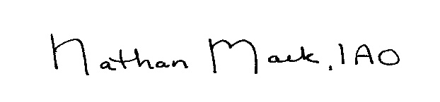

* Nathan Mack, IAO
* NYS Certified Assessor- Town of Sodus

***Camp Beechwood/Sodus Groundskeeper Report***

*(Sal Vittozzi-Caretaker-Sodus Town Groundkeeper)*

Councilperson Chris Tertinek motioned to accept the monthly December 2022 report and yearly 2022 report of Camp Beechwood-Parks & Cemeteries from Sal Vittozzi, Sodus Town Groundskeeper-Caretaker was seconded by Councilperson David LeRoy. Upon roll call the following votes were heard, Scott Johnson, aye; David LeRoy, aye; Don Ross, abstain (unable to vote-address was not published in a legal notice for Zoom); Chris Tertinek, aye; and Cathy Willmott; aye. Motion carried.

**Camp Beechwood December 2022 Report**

December was another very productive month here at the park. Due to mild weather for most of the month, we are still seeing daily hikers and dog walkers. We are also seeing many fishermen through our east entrance on a daily basis. A severe winter blast at the end of the month took down 5 trees in the pine forest which have all been cleaned up and two giant poplar trees down the main trail from the west entrance which are still in process but are nearly done. The major news of the month is the completion of our outdoor skating rink at the west entrance of the park. Most of the materials were repurposed from the rubber band bridge rebuild back in august and the rest were paid for out of our camping fund. $300 was spent on the liner for it (plus $90 for shipping), another $200 was spent ship lap, screws, and Christmas lights, and the hay bales that surround it were donated by Sodus resident, Frank Smith. Park goers flocked to the rink as soon as it froze and it was absolutely amazing to see. Throughout the rest of the winter, I will leave west entrance open during the week till 7pm for evening skates and on Friday and Saturday nights we will be staying open till 9pm for community open skates which will have music, hot beverages, and a camp fire for the skaters. $800 was also spent from our camping fund to pay for the unlimited plan for our now 8 cameras in the park for an entire year, so we will not get a bill for park security until December of 2023. At the end of the month, we still had $1211.93 left in our camping fund which was spent on tools for the park. The following tools and materials were purchased:

- 36v battery operated Stihl limb saw

- 36v battery operated Stihl hedge trimmer

- 1500 feet of string trimmer line

- 2 sets of hand pruners

- Stihl limb hatchet

- chain saw bar oil

- 2 cycle engine oil mix

- Stihl replacement string trimmer head

- 2 chain saw chain sharpeners

All in all, December was another incredibly positive month here at the park.

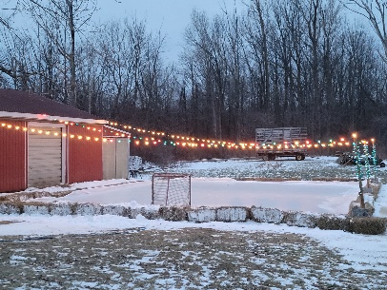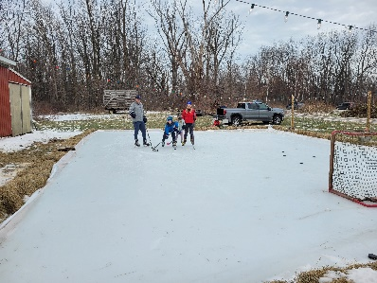

Respectfully Submitted,

Sal Vittozzi   
Caretaker

**CAMP BEECHWOOD 2022 YEARLY REPORT**

 2022 was an amazing year here at Beechwood State Park. The park has seen improvements in every aspect of its existence and park improvements will be continuing for many years to come still. We have seen an upswing in community involvement with the park and a complete change of culture from years past. Most importantly, park security is at an all-time high, vandalism is at an all-time low, and due to adding a fee for camping, the park is well on its way to becoming self-sufficient.

    The park has seen basically a complete face lift since last year. The park service completed their clean up with the removal of over 20 delinquent buildings and the pool was filled in. Most of the remaining structures were rehabbed and all received fresh coats of stain. The only buildings that have not been repaired are the pioneer lodge and a cabin on the bluff, which are both on this upcoming year's agenda. The red barn at the west entrance was also cleaned out, allowing for a year-round work space and park equipment storage.

   Community involvement has moved in a very positive direction at the park. Scout troop camping weekends increased in number and a scout camporee was held in April with over 100 scouts and their parents attending. Three major eagle scout projects were done at the park this year as well. Eagle scout, Cody Freeman, from Sodus rehabbed the fronts of 2 a-frames, built 4 sets of steps and 2 picnic tables. Eagle scout, Michael Ward from Sodus helped with the removal of the Rubber Band Bridge and the construction of new Keith Ketcham Bridge. Eagle scout, Julio Mantillo Sanchez from Henrietta built a new bridge as well, located across the wetlands at the east entrance trail. The Trail Life Boys from Seneca Falls spent a weekend putting a new metal roof on the latrine located on top of the bluff as well. We also saw a volunteer day from the Bible Baptist Church of Sodus. The Wayne County Youth Work Program sent us two young adults, Sam and Dominic Robinson of Sodus, on a weekly basis to help with park maintenance and both were a joy to have helping out at the park. We did receive some donations as well, both in materials and monetarily. Most notably, a $3000 donation from Mark Ketcham and Werner Lutz of Sodus Point, for the materials that constructed our new 140ft bridge.

   There were many highlights to our past season. In June, the dedication of the John Faulks Pavilion was a great success. We had bands play, a food truck, a local cider company, plenty of campers and it was well attended by the community even though it was held during a windstorm. It was a good litmus test for holding future community events here at the park. In July, the annual 4-H summer camp held at the east entrance was a great success as well. The program was at full capacity and the kids all had an amazing week here at the park. Most recently, the construction of a skating rink at our west entrance for the winter, seems on its way to being a big hit with the community. It was funded by the park's camping fees, has been well attended so far, and has helped spread the word of all our winter time activities here at the park.

   In 2022, the park to a giant step towards self-sufficiency. On April 1st, we added a $15 per night camping fee. We rented out nearly 300 camping sites and took in a total of $4,380 which during the summer of the highest inflation and gas prices is a great feat. The camping fees helped fund many of the projects here throughout the season and purchased many badly needed tools to continue with daily park maintenance. With the continued improvements here that are already planned, the upswing in community involvement here at the park, and the addition of the camping fee helping to fund the park, all the steps have been put in place to not only restore the park to its former glory, but to reach new heights here within the community that the park has never seen. It's been a great year here at the park and I am looking forward to many more incredible years to come.

Respectfully Submitted,

Salt Vittozzi

Caretaker

**PUBLIC SAFETY/DRAINAGE/ENVIRONMENT COMMITTEE: *Councilperson Don Ross, Chair (Fire, Ambulance, Emergency Preparedness)***

Councilperson Don Ross gave his committee reports. Ross shared that the next SESA meeting is at Sodus Center Fire Department @ 8:00 AM January 15, 2023. Note: Don’s statistical 911 report is not for public informational listing in Minutes. The report includes private residential calls and are confidential. Did not receive SESA Minutes for January 2023.

**TOWN HALL COMMITTEE: *Scott Johnson, Supervisor***

***(Personnel, Clerks, Justices, Assessor, Building Inspector, Town Council, Boards, Insurances, Finance)***

***N/A***

**CORRESPONDENCE & INFORMATION**

Motion by Councilperson Cathy Willmott to enter into Executive Session regarding medical, financial, credit or employment history of a particular person or corporation or relating to appointment promotion demotion discipline or removal was seconded by Councilperson Chris Tertinek. Upon roll call the following votes were heard, Scott Johnson, aye; David LeRoy, aye; Don Ross, abstain (unable to vote-address was not published in a legal notice for Zoom); Chris Tertinek, aye; and Cathy Willmott; aye. Motion carried.

Time: 6:30 PM

Motion by Councilperson David LeRoy to exit out of Executive Session and enter into Regular Session was seconded by Councilperson Cathy Willmott. Upon roll call the following votes were heard, Scott Johnson, aye; David LeRoy, aye; Don Ross, abstain (unable to vote-address was not published in a legal notice for Zoom); Chris Tertinek, aye; and Cathy Willmott; aye. Motion carried.

Time: 6:41 PM

**RESOLUTION**

**ZONING BOARD RE-APPOINTMENTS & NEW APPOINTMENTS**

**(01 02-2023)**

The following resolution was presented for its adoption,

**WHEREAS**, Kim Buell, John Hayslip, Don Buchwald, Sal Vittozzi and Steven Zonneville appointments ended December 30, 2022 with the Zoning Board, and

**WHEREAS**, Steven Zonneville Member-Chairman of the Zoning Board has officially moved as a Sodus resident to a Fairhaven resident, and

**BE IT RESOLVED,** the Sodus Town Board re-appoints Kim Buell and John Hayslip to the Zoning Board as Member for a two-year term effective January 1, 2023 and the term ends December 31, 2024, and

**BE IT RESOLVED,** the Sodus Town Board has moved Sal Vittozzi to the Zoning Board from his Ad-Hoc position to Member for a two-year term effective January 1, 2023 and the term ends December 31, 2024, and

**BE IT RESOLVED,** the Sodus Town Board has moved Don Buchwald from Member to Ad-Hoc Member of the Zoning Board for a one-year term effective January 1, 2023 and the term ends December 31, 2023, and

**BE IT RESOLVED,** the Sodus Town Board has moved Ray Stacy from Planning Board Member to Ad-Hoc on the Zoning Board for a one-year term effective January 1, 2023 and the term ends December 31, 2023, and

**FURTHER BE IT RESOLVED,** Steven Zonneville will not be reappointed as Zoning Board Member-Chairman hence his permanent residence has changed to Fairhaven.

Councilperson Cathy Willmott motioned to adopt resolution (02 01-2023) was seconded by Councilperson Chris Tertinek. Upon roll call, the following votes were heard Supervisor Scott Johnson, aye; LeRoy, aye; Ross, zoomed (unable to vote-address was not published in legal notice); Tertinek, aye; and Willmott, aye. Resolution Adopted.

**RESOLUTION**

**ZONING BOARD RE-APPOINTMENT & NEW APPOINTMENT**

**(03 01-2023)**

The following resolution was presented for its adoption,

**WHEREAS**, David Johnson Ad-Hoc to the Zoning Board appointment ended December 30, 2022, and

**BE IT RESOLVED,** the Sodus Town Board has moved David Johnson from Ad-Hoc Member on the Zoning Board to Chairman of the Zoning Board for a two-year term effective January 1, 2023 and the term ends December 31, 2024, and

Councilperson David LeRoy motioned to adopt resolution (03 01-2023) was seconded by Councilperson Chris Tertinek. Upon roll call, the following votes were heard Supervisor Scott Johnson, abstained; LeRoy, aye; Ross, zoomed (unable to vote-address was not published in legal notice); Tertinek, aye; and Willmott, aye. Resolution Adopted.

**RESOLUTION**

**PLANNING BOARD RE-APPOINTMENTS**

**(04 01-2023)**

The following resolution was presented for its adoption,

**WHEREAS**, Edward Grosz-Vice Chairman, Mary Zonneville and Ken Eastley’s appointments ended December 30, 2022 with the Zoning Board, and

**WHEREAS**, Ray Stacy Member of the Zoning Board has requested to move from the Planning Board as Member to the Zoning Board as Ad-Hoc Member, and

**BE IT RESOLVED,** the Sodus Town Board re-appoints Edward Grosz-Vice Chairman as Member to the Planning Board and Ken Eastley as Member to the Planning Board for a five-year term effective January 1, 2023 and the term ends December 31, 2027, and

**BE IT RESOLVED,** the Sodus Town Board has moved Ray Stacy as Planning Board Member to Ad-Hoc Member on the Zoning Board, and

**BE IT RESOLVED,** the Sodus Town Board has chosen not to reappoint Mary Zonneville as Planning Board Member since her permanent residence has changed from Sodus to Fairhaven.

Councilperson David LeRoy motioned to adopt resolution (04 01-2023) was seconded by Councilperson Chris Tertinek. Upon roll call, the following votes were heard Supervisor Scott Johnson, aye; LeRoy, aye; Ross, zoomed (unable to vote-address was not published in legal notice); Tertinek, aye; and Willmott, aye. Resolution Adopted.

Councilperson David LeRoy motioned to authorize Supervisor Johnson to sign letter of support for the Williamson-Sodus Airport for its continued airport sustainability project to upgrade and improve infrastructure was seconded by Councilperson Chris Tertinek. Upon roll call the following votes were heard, Scott Johnson, aye; David LeRoy, aye; Don Ross, (unable to vote-address was not published in legal notice; Chris Tertinek, aye; and Cathy Willmott; aye. Motion carried.

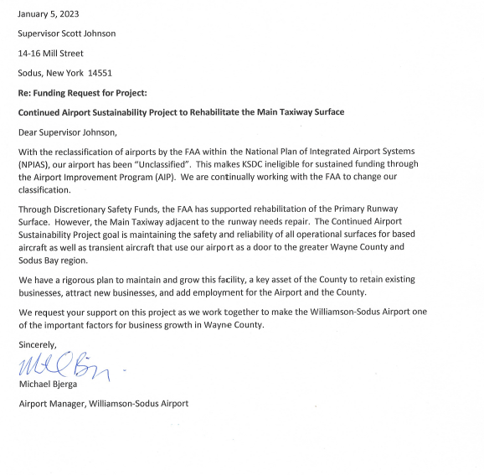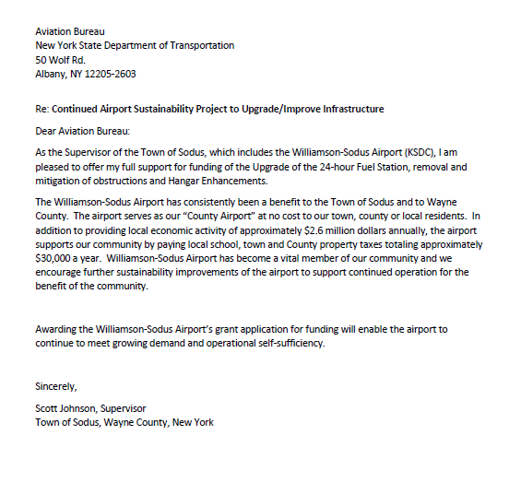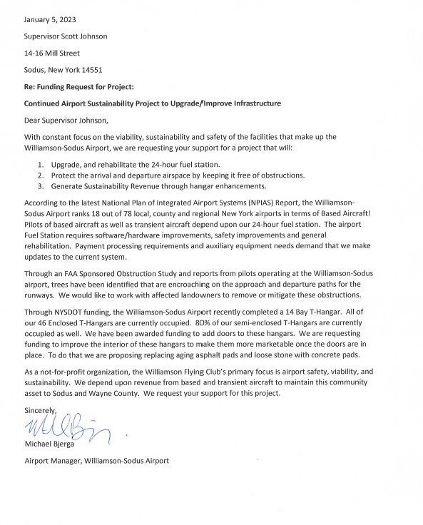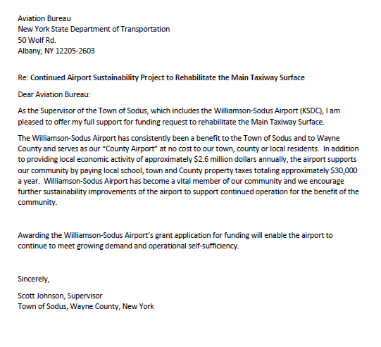

**RESOLUTION**

**WILLIAMSON LAW BOOK SUPPORT CONTRACT-TAX COLLECTION**

**(05 01-2023)**

The following resolution was presented for its adoption,

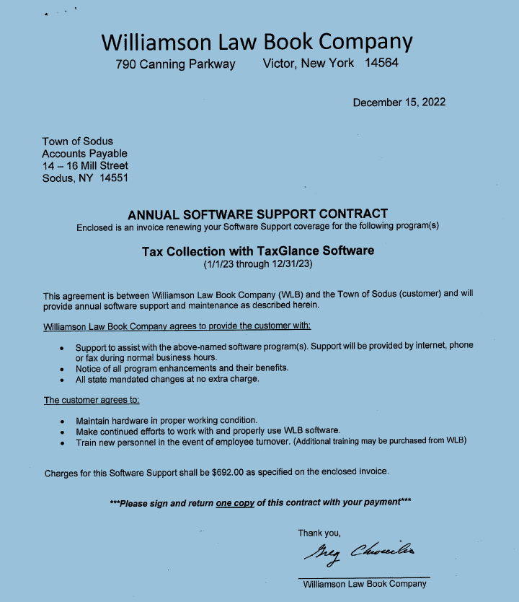

Councilperson Cathy Willmott motioned to allow Lori Diver Tax Collector to sign Annual Software Support Contract for 2023 with Williamson Law Book and to adopt this resolution (05 01-2023) was seconded by Councilperson Chris Tertinek. Upon roll call, the following votes were heard Supervisor Scott Johnson, aye; LeRoy, aye; Ross, zoomed (unable to vote-address was not published in legal notice); Tertinek, aye; and Willmott, aye. Resolution Adopted.

**RESOLUTION**

**REPAIR-INTERATIONAL 500I 6X4**

**(06 01-2023)**

The following resolution was presented for its adoption,

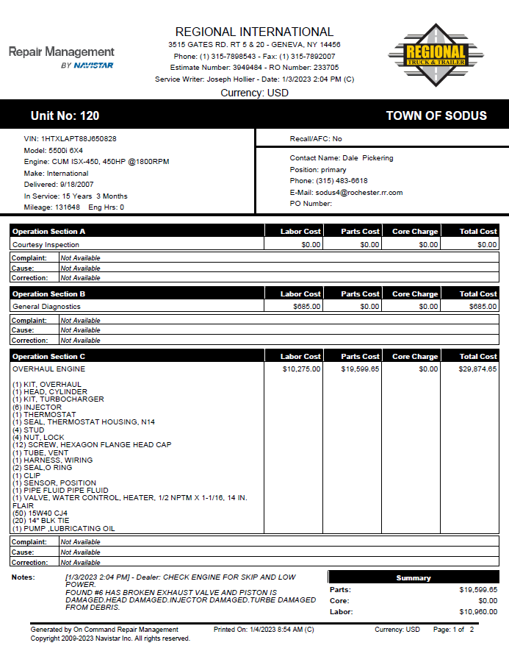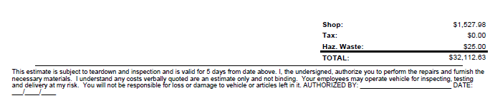

Councilperson Cathy Willmott motioned to allow Highway Superintendent Dale Pickering to authorize the repair on the International 5000xi 6x4 in the amount of $32,112.63 from the Regional International quote and to adopt this resolution (06 01-2023) was seconded by Councilperson David LeRoy. Upon roll call, the following votes were heard Supervisor Scott Johnson, aye; LeRoy, aye; Ross, zoomed (unable to vote-address was not published in legal notice); Tertinek, aye; and Willmott, aye. Resolution Adopted.

Councilperson David LeRoy motioned authorizing Town Clerk Lori Diver to send legal notice to the Lakeshore News for the salt barn bid building (written by MRB) was seconded by Councilperson Cathy Willmott. Upon roll call the following votes were heard, Scott Johnson, aye; David LeRoy, aye; Don Ross, (unable to vote-address was not published in legal notice); Chris Tertinek, aye; and Cathy Willmott; aye. Motion carried.

TOWN OF SODUS NEW SALT STORAGE BUILDING

MRB PROJECT NO. 1914.22001.000 JANUARY 2023

SECTION 00 11 13 ADVERTISEMENT FOR BIDS

**ADVERTISEMENT FOR BIDS**

**TOWN OF SODUS**

**SODUS, NEW YORK**

**NEW SALT STORAGE BUILDING**

**General Notice**

**Town of Sodus** (Owner) is requesting Bids for the construction of the following Project:

**New Salt Storage Building**

In accordance with Section 103 of Article 5-A of the General Municipal Law, sealed Bids for the construction of the Project will be received at the office of the Town of Sodus, located at 14-16 Mill Street, Sodus, New York 14551, until March 2, 2023, at 10:00 AM local time. At that time the Bids received will be publicly opened and read downstairs in the Sodus Town Courtroom.

The Project includes the following Work:

Construction of a new pre-engineered salt storage structure, approximately 12,100 s.f. and associated site work for asphalt pavement, guiderails/bollards, and utilities. The salt storage structure will be a pre-engineered, pole-barn style structure with wood trusses, columns, bracing, and barrier walls supported by a shallow foundation system. The salt storage structure will be open on one side for operations. The Work does not include any mechanical, electrical, or plumbing work.

Sealed Bids are requested for the following Contract: Contract #1: General

Project has an expected duration of 150 days.

**Obtaining the Bidding Documents**

Information and Bidding Documents for the Project can be found at the following designated website:

[www.avalonroch-planroom.com](http://www.avalonroch-planroom.com)

Bidding Documents may be downloaded from the designated website for a non-refundable fee of $49.00. Prospective Bidders are urged to register with the designated website as a plan holder, even if Bidding Documents are obtained from a plan room or source other than the designated website in either electronic or paper format. The designated website will be updated periodically with addenda, lists of registered plan holders, reports, and other information relevant to submitting a Bid for the Project. All official notifications, addenda, and other Bidding Documents will be offered only through the designated website. Neither Owner nor Engineer will be responsible for Bidding Documents, including addenda, if any, obtained from sources other than the designated website.

Bidding Documents may be examined at the offices of MRB Group (145 Culver Road, Suite 160, Rochester, NY 14620), and the Town of Sodus (14-16 Mill Street, Sodus, New York 14551), on Mondays through Fridays between the hours of 9:00 AM and 3:30 PM. Bidding Documents will not be available from MRB Group or the Owner.

**Instructions to Bidders**

The Town of Sodus, Wayne County, New York, reserves the right to reject any or all bids, or to waive any informalities, or to make an award to other than the low bidder. It further reserves the right to limit the amount of the award.

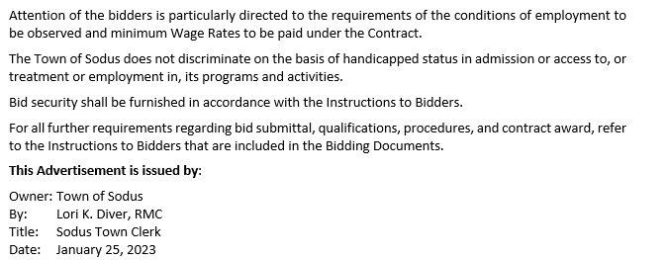

Councilperson Cathy Willmott motioned to allow Lori Diver Sodus Town Clerk to advertise legal notice for Local Law 2-2023 to amend the aged person’s exemption to adjust for inflation and to hold the public hearing on February 14, 2023 at 6:00 PM was seconded by Councilperson Chris Tertinek. Upon roll call the following votes were heard, Scott Johnson, aye; David LeRoy, aye; Don Ross, abstain (unable to vote-address was not published in legal notice); Chris Tertinek, aye; and Cathy Willmott; aye. Motion carried.

**TOWN OF SODUS**

**NOTICE OF PUBLIC HEARING**

**PLEASE TAKE NOTICE** that, pursuant to Section 20 of the Municipal Home Rule Law, a public hearing will be held by the Town Board of the Town of Sodus on February 14, 2023, at 6:00 p.m. at the Sodus Town Hall, 14-16 Mill Street, in the Town of Sodus, Wayne County, New York in the downstairs court room, to consider the adoption of Local Law No. 2 of 2023 of the Town of Sodus, amending Town Code §114-1 to increase the income qualification of the Aged Persons’ Realty Exemption from $7,200 in 12 consecutive months to a schedule determining the maximum income exemption eligibility levels and the associated exemption percentages.

All persons interested shall be given an opportunity to be heard. Local Law No. 2 of 2023 is available for public inspection during regular business hours at the Town Clerk’s office and on the Town of Sodus website at townofsodus.net.

Dated: January 10, 2023

**LORI DIVER**

Sodus Town Clerk, RMC

Councilperson David LeRoy motioned to approve Lori Diver Sodus Town Clerk to purchase a newer model replacement printer to not exceed $645.00 (Deputy Clerk printer) with shipping of $65.00 and approximately 2 hours of labor from Alternative Technology was seconded by Councilperson Cathy Willmott. Upon roll call the following votes were heard, Scott Johnson, aye; David LeRoy, aye; Don Ross, abstain (unable to vote-address was not published in legal notice); Chris Tertinek, aye; and Cathy Willmott; aye. Motion carried.

**ORGANIZATIONAL MEETING**

Councilperson Chris Tertinek motioned to set monthly compensation for 2023 Zoning and Planning Board Members to $55.00 per member and $60.00 per chairperson, which was seconded by Councilperson David LeRoy. Upon roll call the following votes were heard, Scott Johnson, aye; David LeRoy, aye; Don Ross, abstain (unable to vote-address was not published in legal notice); Chris Tertinek, aye; and Cathy Willmott; aye. Motion carried.

***RESOLUTION***

***WAGE SCHEDULE -2023***

***(07 01-2023)***

Supervisor Scott Johnson offered the following 2023 Wage Schedule for its adoption, and

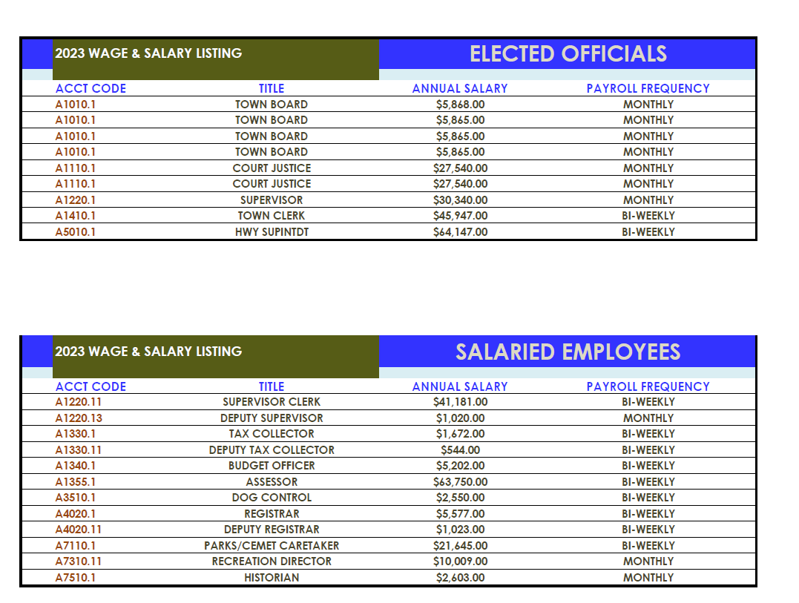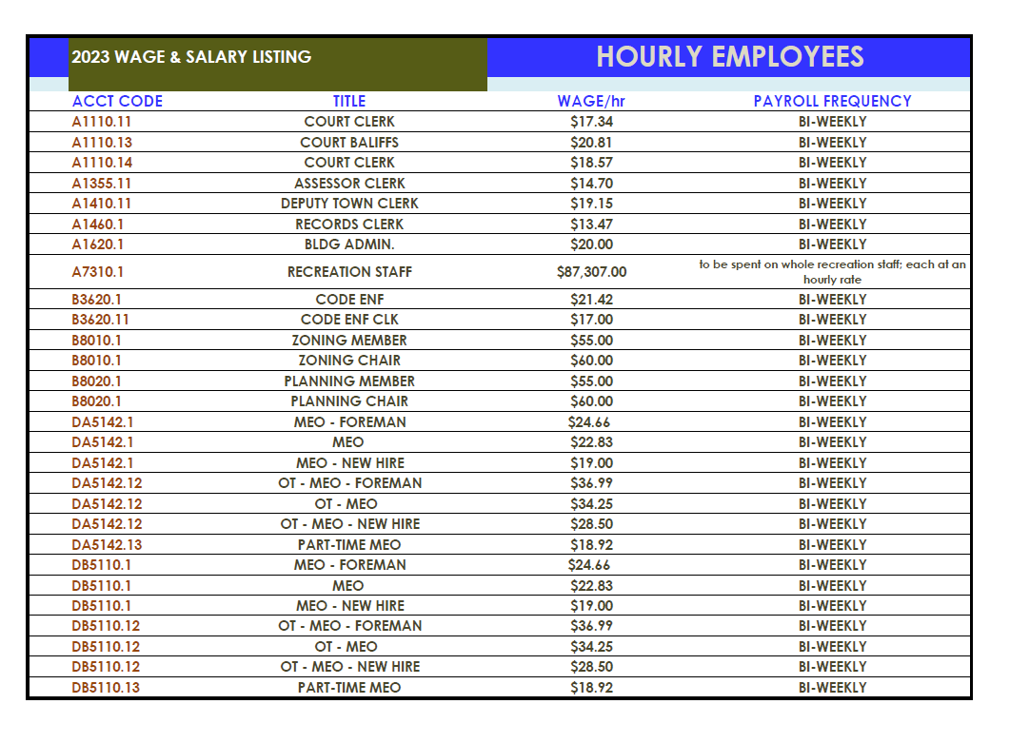

**FURTHER BE IT RESOLVED**, Councilperson Cathy Willmott motioned to set the 2023 Wage Schedule as listed was seconded by Councilperson Chris Tertinek. Upon roll call the following votes were heard, Scott Johnson, aye; David LeRoy, aye; Don Ross, abstain (unable to vote-address was not published in legal notice); Chris Tertinek, aye; and Cathy Willmott; aye. Resolution adopted.

A motion by Councilperson David LeRoy to allow the Supervisor’s Office to perform 2022 year-end budgetary transfers was seconded by Councilperson Cathy Willmott. Upon roll call the following votes were heard, Scott Johnson, aye; David LeRoy, aye; Don Ross, abstain (unable to vote-address was not published in legal notice); Chris Tertinek, aye; and Cathy Willmott; aye. Motion carried.

A motion by Councilperson David LeRoy to pay certain positions on a monthly or bi-weekly schedule was seconded by Councilperson Chris Tertinek. Upon roll call the following votes were heard, Scott Johnson, aye; David LeRoy, aye; Don Ross, abstain (unable to vote-address was not published in legal notice); Chris Tertinek, aye; and Cathy Willmott; aye. Motion carried.

A motion by Councilperson Chris Tertinek to pay bonds, notes, interest, contracts, utility, and insurance bills prior to audit was seconded by Councilperson David LeRoy. Upon roll call the following votes were heard, Scott Johnson, aye; David LeRoy, aye; Don Ross, abstain (unable to vote-address was not published in legal notice); Chris Tertinek, aye; and Cathy Willmott; aye. Motion carried.

Councilperson Cathy Willmott motioned to set the date and time for Town of Sodus Regular Town Board Meeting to the 2nd Tuesday of each month starting at 6:00 PM and the Month-End Regular Town Board Meeting to the 4th Thursday of each month starting at 4:00 PM was seconded by Councilperson David LeRoy. Upon roll call the following votes were heard, Scott Johnson, aye; David LeRoy, aye; Don Ross, abstain (unable to vote-address was not published in legal notice); Chris Tertinek, aye; and Cathy Willmott; aye. Motion carried.

**LEGAL NOTICE**

**TOWN OF SODUS**

**CORRECTION**

**Regular Town Board Meetings & Month End Town Board Meetings for 2023**

The Regular Town Board Meetings are the second Tuesday of each month and commence at 6:00 PM in the downstairs courtroom. The Month End Town Board Meetings are the fourth Thursday of the month and commence at 4:00 PM in the upstairs meeting room located at the Sodus Municipal Offices 14-16 Mill St. Sodus, NY 14551 (unless otherwise specified).

**JANUARY 10, 2023 JULY 11, 2023**

**JANUARY 26, 2023 Starting at 3:00 PM JULY 27, 2023**

**FEBRUARY 14, 2023 Starting at 5:30 PM AUGUST 08, 2023**

**FEBRUARY 23, 2023 AUGUST 24, 2023**

**MARCH 14, 2023 SEPTEMBER 12, 2023**

**MARCH 23, 2023 SEPTEMBER 28, 2023**

**APRIL 11, 2023 OCTOBER 10, 2023**

**APRIL 27, 2023 OCTOBER 26, 2023**

**MAY 09, 2023 NOVEMBER 14, 2023**

**MAY 25, 2023 November 28, 2023 Rescheduled to Tuesday at 4:00 PM**

**JUNE 13, 2023 DECEMBER 12, 2023**

**JUNE 22, 2023 DECEMBER 28, 2023**

To join the Zoom meeting:

<https://us02web.zoom.us/j/82847125844?pwd=SmVNLzJCRThnNXhONkk3eFBjR1hTdz09>

**Meeting ID: 828 4712 5844**

**Passcode: 069609**

One tap mobile

+19292056099, 82847125844#, *069609# US (New York)

+13017158592, 82847125844#, *069609# US (Washington DC)

Dial by your location

        +1 929 205 6099 US (New York)

        +1 301 715 8592 US (Washington DC)

        +1 312 626 6799 US (Chicago)

        +1 346 248 7799 US (Houston)

        +1 669 900 6833 US (San Jose)

        +1 253 215 8782 US (Tacoma)

Meeting ID: 828 4712 5844

Passcode: 069609

Find your local number: <https://us02web.zoom.us/u/kumdYNi36>

Zoom Meetings also will be located at 558 Pinnacle Dr. Hanes City, FL 33844 January 26, 2023-April 27, 2023

January 10, 2023

By Order of the Sodus Town Board

Lori Diver

Sodus Town Clerk, RMC

A motion by Councilperson David LeRoy to close the following dates /holidays for the Town of Sodus was seconded by Councilperson Cathy Willmott. Upon roll call the following votes were heard, Scott Johnson, aye; David LeRoy, aye; Don Ross, abstain (unable to vote-address was not published in legal notice); Chris Tertinek, aye; and Cathy Willmott; aye. Motion carried.

**TOWN OF SODUS**

**ADMINISTRATIVE EMPLOYEES**

**DESIGNATED HOLIDAYS AND OBSERVANCE OF HOLIDAYS – 2023**

Monday January 2, 2023 New Year’s Day Observed

Monday January 16, 2023 Martin Luther King Jr. Day

Monday February 20, 2023 Presidents Day

Friday April 7, 2023 Good Friday

Monday May 29, 2023 Memorial Day

Tuesday July 4, 2023 Independence Day

Monday September 4, 2023 Labor Day

Monday October 9, 2023 Columbus Day

Friday November 10, 2023 Veterans Day Observed

Thursday November 23, 2023 Thanksgiving

Friday November 24, 2023 Thanksgiving Observed

Friday December 22, 2023 Christmas Eve Observed

Monday December 25, 2023 Christmas Day

Friday December 29, 2023 New Year’s Eve Observed

A motion by Councilperson Chris Tertinek to set Highway Superintendent’s purchasing authorization to $1,000.00 was seconded by Councilperson David LeRoy. Upon roll call the following votes were heard, Scott Johnson, aye; David LeRoy, aye; Don Ross, abstain (unable to vote-address was not published in legal notice); Chris Tertinek, aye; and Cathy Willmott; aye. Motion carried.

A motion by Councilperson Chris Tertinek to allow designated personnel (with Board approved travel request) to attend Association of Towns Conference in NYC and/or other appropriate educational conferences was seconded by Councilperson Cathy Willmott. Upon roll call the following votes were heard, Scott Johnson, aye; David LeRoy, aye; Don Ross, abstain (unable to vote-address was not published in legal notice); Chris Tertinek, aye; and Cathy Willmott; aye. Motion carried.

Councilperson David LeRoy authorized Supervisor Johnson to deposit Interest Certificates was seconded by Councilperson Cathy Willmott. Upon roll call the following votes were heard, Scott Johnson, aye; David LeRoy, aye; Don Ross, abstain (unable to vote-address was not published in legal notice); Chris Tertinek, aye; and Cathy Willmott; aye. Motion carried.

Councilperson Chris Tertinek authorized Supervisor Johnson to sign contract and pay

$2, 250.00 to the Senior Citizen Contract and issue payment to the Go Getters was seconded by Councilperson Cathy Willmott. Upon roll call the following votes were heard, Scott Johnson, aye; David LeRoy, aye; Don Ross, abstain (unable to vote-address was not published in legal notice); Chris Tertinek, aye; and Cathy Willmott; aye. Motion carried.

Councilperson Cathy Willmott motioned to table authorization of payment to the Joy School House of $1,000.00 was seconded by Councilperson David LeRoy. Upon roll call the following votes were heard, Scott Johnson, aye; David LeRoy, aye; Don Ross, abstain (unable to vote-address was not published in legal notice); Chris Tertinek, aye; and Cathy Willmott; aye. Motion carried.

Councilperson David LeRoy authorized Supervisor Johnson to pay the Veteran Services $3,000.00, which was seconded by Councilperson Chris Tertinek. Upon roll call the following votes were heard, Scott Johnson, aye; David LeRoy, aye; Don Ross, abstain (unable to vote-address was not published in legal notice); Chris Tertinek, aye; and Cathy Willmott; aye. Motion carried.

A motion by Councilperson Cathy Willmott authorizing payment to the Home Meal Service in the amount of $3,000.00 was seconded by Councilperson Chris Tertinek. Upon roll call the following votes were heard, Scott Johnson, aye; David LeRoy, aye; Don Ross, abstain (unable to vote-address was not published in legal notice); Chris Tertinek, aye; and Cathy Willmott; aye. Motion carried.

A motion by Councilperson David LeRoy authorizing payment to the Wallington School House in the amount of $1,000.00 and $5,000.00 ARPA funds was seconded by Councilperson Cathy Willmott. Upon roll call the following votes were heard, Scott Johnson, aye; David LeRoy, aye; Don Ross, abstain (unable to vote-address was not published in legal notice); Chris Tertinek, aye; and Cathy Willmott; aye. Motion carried.

A motion by Councilperson Cathy Willmott authorizing payment to the Brickchurch Rural Baptist Cemetery in the amount of $100.00 and $5,000.00 ARPA funds was seconded by Councilperson David LeRoy. Upon roll call the following votes were heard, Scott Johnson, aye; David LeRoy, aye; Don Ross, abstain (unable to vote-address was not published in legal notice); Chris Tertinek, aye; and Cathy Willmott; aye. Motion carried.

A motion by Councilperson David LeRoy authorizing payment to the Sodus Bay Historical Society in the amount of $2,000.00 and $5,000.00 ARPA funds was seconded by Councilperson Chris Tertinek. Upon roll call the following votes were heard, Scott Johnson, aye; David LeRoy, aye; Don Ross, abstain (unable to vote-address was not published in legal notice); Chris Tertinek, aye; and Cathy Willmott; aye. Motion carried.

Councilperson David LeRoy authorized payment to the Sodus Point Tourism Booth in the amount $1,500.00 was seconded by Councilperson Cathy Willmott. Upon roll call the following votes were heard, Scott Johnson, aye; David LeRoy, aye; Don Ross, abstain (unable to vote-address was not published in legal notice); Chris Tertinek, aye; and Cathy Willmott; aye. Motion carried.

Councilperson David LeRoy motioned to appoint Town Attorney (Knauf Shaw, LLP.) and authorize Supervisor Scott Johnson to sign agreement was seconded by Councilperson Chris Tertinek. Upon roll call the following votes were heard, Scott Johnson, aye; David LeRoy, aye; Don Ross, abstain (unable to vote-address was not published in legal notice); Chris Tertinek, aye; and Cathy Willmott; aye. Motion carried.

Councilperson Cathy Willmott motioned to appoint Town Special Prosecutor (Mathew St. Martin) was seconded by Councilperson David LeRoy. Upon roll call the following votes were heard, Scott Johnson, aye; David LeRoy, aye; Don Ross, abstain (unable to vote-address was not published in legal notice); Chris Tertinek, aye; and Cathy Willmott; aye. Motion carried.

Councilperson David LeRoy motioned to appoint Breynn Crandell as the Town of Sodus Budget Officer for 2023 was seconded by Councilperson Chris Tertinek. Upon roll call the following votes were heard, Scott Johnson, aye; David LeRoy, aye; Don Ross, abstain (unable to vote-address was not published in legal notice); Chris Tertinek, aye; and Cathy Willmott; aye. Motion carried.

Councilperson David LeRoy motioned to appoint our Town Auditor – Mengel, Metzger, Barr & Co. LLP (Ray Wager) was seconded by Councilperson Cathy Willmott. Upon roll call the following votes were heard, Scott Johnson, aye; David LeRoy, aye; Don Ross, abstain (unable to vote-address was not published in legal notice); Chris Tertinek, aye; and Cathy Willmott; aye. Motion carried.

Councilperson Cathy Willmott motioned to reappoint Sandy Hopkins as Town of Sodus Historian for 2023 was seconded by Councilperson Chris Tertinek. Upon roll call the following votes were heard, Scott Johnson, aye; David LeRoy, aye; Don Ross, abstain (unable to vote-address was not published in legal notice); Chris Tertinek, aye; and Cathy Willmott; aye. Motion carried.

Councilperson Chris Tertinek motioned to designate the Town of Sodus Bank Depository as Lyons National Bank was seconded by Councilperson David LeRoy. Upon roll call the following votes were heard, Scott Johnson, aye; David LeRoy, aye; Don Ross, abstain (unable to vote-address was not published in legal notice); Chris Tertinek, aye; and Cathy Willmott; aye. Motion carried.

Councilperson David LeRoy motioned to designate the Lakeshore News Wayuga Printing as the Official Newspaper for the Town of Sodus was seconded by Councilperson Chris Tertinek. Upon roll call the following votes were heard, Scott Johnson, aye; David LeRoy, aye; Don Ross, abstain (unable to vote-address was not published in legal notice); Chris Tertinek, aye; and Cathy Willmott; aye. Motion carried.

Councilperson Chris Tertinek motioned to allow and authorize Town of Sodus Employees to attend Meetings relative to their respective departments was seconded by Councilperson David LeRoy. Upon roll call the following votes were heard, Scott Johnson, aye; David LeRoy, aye; Don Ross, abstain (unable to vote-address was not published in legal notice); Chris Tertinek, aye; and Cathy Willmott; aye. Motion carried.

Councilperson David LeRoy motioned to keep the appointments (as is) of the Town Board Committees was seconded by Councilperson Cathy Willmott. Upon roll call the following votes were heard, Scott Johnson, aye; David LeRoy, aye; Don Ross, abstain (unable to vote-address was not published in legal notice); Chris Tertinek, aye; and Cathy Willmott; aye. Motion carried.

Councilperson Cathy Willmott motioned to approve the 2023 IRS mileage rate of (.655 cents per mile for business miles driven) was seconded by Councilperson Chris Tertinek. Upon roll call the following votes were heard, Scott Johnson, aye; David LeRoy, aye; Don Ross, abstain (unable to vote-address was not published in legal notice); Chris Tertinek, aye; and Cathy Willmott; aye. Motion carried.

Councilperson David LeRoy motioned to re-appoint Alternative Technology (Dennis Lewis & Adam Breen) to perform regular IT services with the Town of Sodus, which was seconded by Councilperson Chris Tertinek. Upon roll call the following votes were heard, Scott Johnson, aye; David LeRoy, aye; Don Ross, abstain (unable to vote-address was not published in legal notice); Chris Tertinek, aye; and Cathy Willmott; aye. Motion carried.

A motion by Councilperson David LeRoy to adjourn the Organizational/Regular Town Board Meeting was seconded by Councilperson Cathy Willmott. Upon roll call the following votes were heard, Scott Johnson, aye; David LeRoy, aye; Don Ross, abstain (unable to vote-address was not published in legal notice); Chris Tertinek, aye; and Cathy Willmott; aye. Motion carried.

Meeting adjourned at 7:15 PM

Recording Secretary,

Lori K. Diver

Sodus Town Clerk, RMC