Sodus Town Board Agenda
Regular Month End-Town Board Meeting
January 26, 2023
Roll Call: (Lori Diver)
Supervisor Johnson, Councilperson LeRoy, Councilperson Ross-Zoom, Councilperson Tertinek-Absent, Councilperson Willmott

Agenda:

- Resolution authorizing payment of Abstract # 02-2023 for payment.
First_________________ Seconded____________________ (emailed).

- Nathan Mack (discussion)

- Motion allowing Nathan Mack to advertise in the Times of Wayne County for the Assessor Clerk Position.
First_________________ Seconded____________________

- Motion to change the Regular Town Board Meeting February 14, 2023 at 6:00 Pm to 5:30 PM and allow Lori Diver to advertise. This will allow the Town Board to meet with the Recreation Committee.
First_________________ Seconded____________________

- Resolution authorizing Sheila Fisher Recreation Director to obtain a town credit card with LNB for expenses incurred with the Recreation Department.
First_________________ Seconded____________________

- Motion accepting Steven Zonneville’s resignation on the Zoning Board.
First_________________ Seconded____________________

- Motion allowing the Sodus Point Fire Department to use the Town of Sodus Park across from the SPFD; June 3, August 5 and December 2, 2023.
First_________________ Seconded____________________

- Motion to adjourn meeting
First_________________ Seconded____________________

MINUTES
Minutes of the Month End Town Board Meeting commencing at 4:00 PM in the upstairs meeting room January 26, 2023 at 3:00 PM located at 14-16 Mill St. Sodus, NY 14551.
All meetings are open to the public.
In addition, this meeting was available through Zoom. Legal Notices were published and posted accordingly.

Present: Scott Johnson, Supervisor
David LeRoy, Councilperson/Deputy Supervisor
Don Ross, Councilperson (Zoom)
Cathy Willmott, Councilperson

Recording Secretary: Lori Diver Sodus Town Clerk

Absent: Chris Tertinek, Councilperson

Others Present: Amy Kendall, Town Attorney
Susie Jacobs, (Zoom)
Bree Crandell, Supervisor Clerk
Nathan Mack, Assessor

Supervisor Scott Johnson called the Month End Town Board Meeting to order commencing at 3:00 PM and Lori Diver opened with roll call. All present with the exception of Councilperson Chris Tertinek.

ABSTRACT
RESOLUTION TO PAY ABSTRACT No. 2
(08 01-2023)

WHEREAS, the following bills were presented for payment on Abstract 2:

General 022-048 $ 15,792.93
Highway 010-025 $ 28,715.42
Trust Agency 031-032 $ 3,571.41
Capital Projects 017-017 $ 92,415.49
GRAND TOTAL: $ 140,495.25

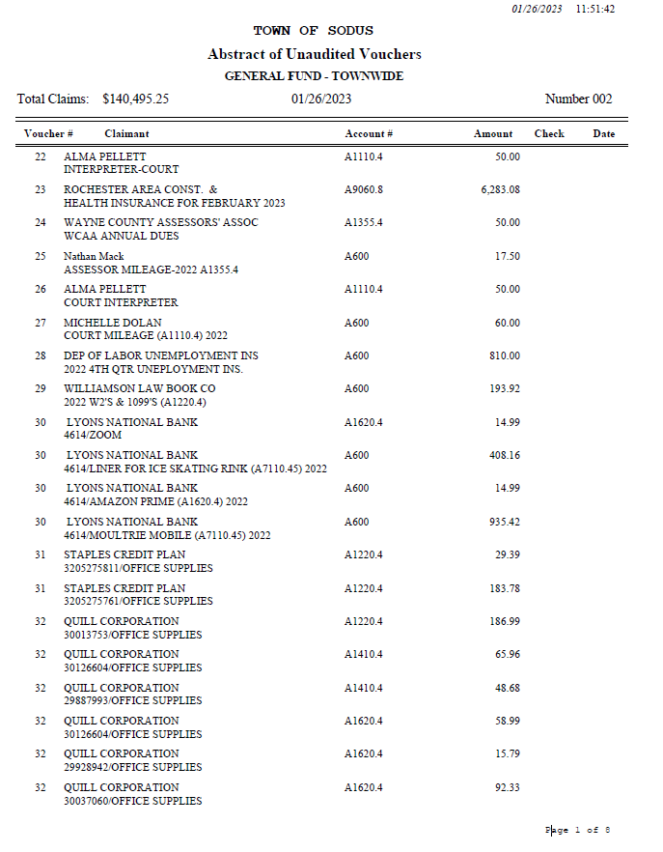

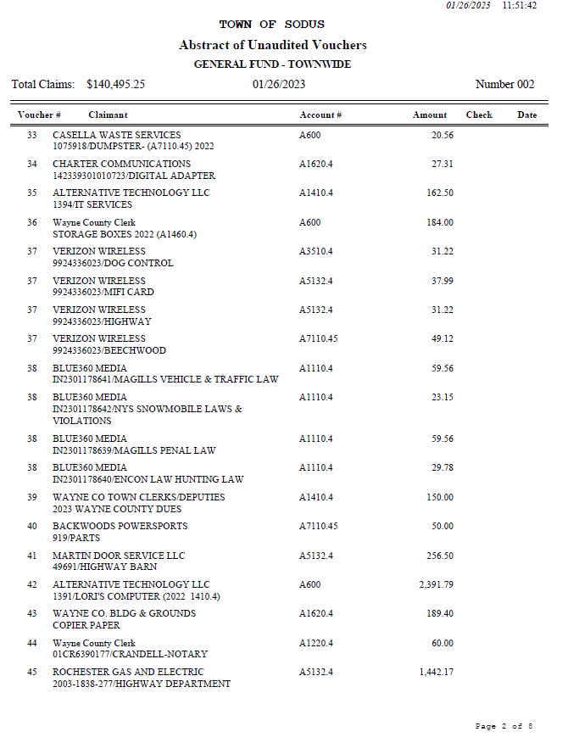

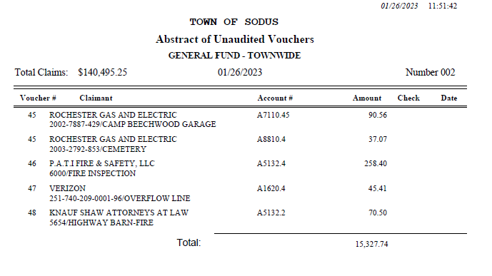
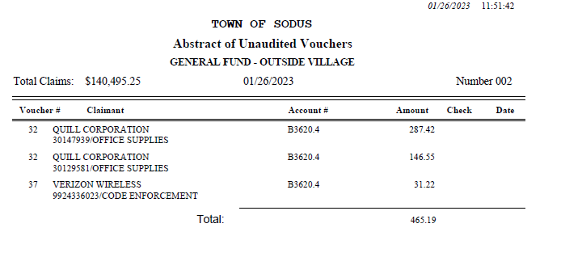
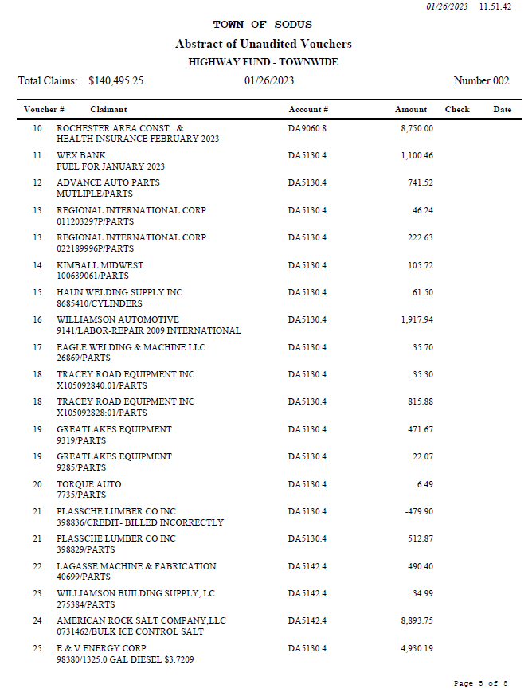

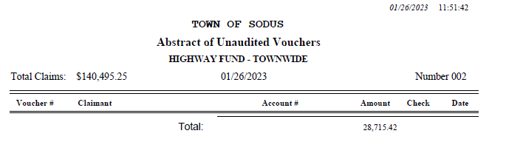
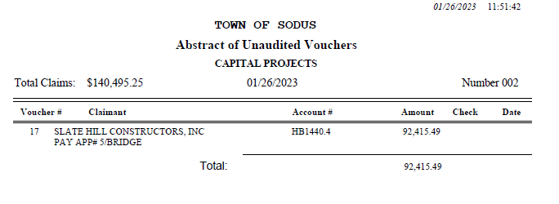
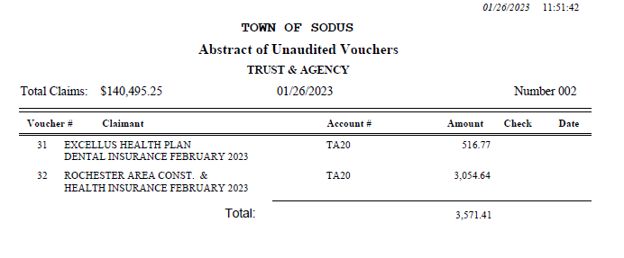

NOW BE IT RESOLVED, Councilperson David LeRoy motioned to authorize payment for Abstract # 2 as listed and adopt this resolution which was seconded by Councilperson Cathy Willmott. Upon roll call the following votes were heard, Scott Johnson, aye; David LeRoy, aye; Don Ross, aye; Chris Tertinek, absent; and Cathy Willmott; aye. Resolution Adopted.

Assessor Nathan Mack discussed with the Town Board a new law that was enacted by Governor Kathy Hochul regarding notifying seniors of the senior citizen exemption. Letter below:
RE: Senior Citizen Exemption

Dear Resident,

Property owners 65 years of age and older may be eligible for the Senior Citizen Tax Exemption on your primary residence. This is a partial exemption in addition to Enhanced STAR. The gross income for the year 2021, of all owners and their spouses, must be less than $24,500 for most governmental jurisdictions in Sodus. Senior citizens have until March 1st to apply for such exemptions with the submission of renewal applications being required annually.

In order to qualify you must:
• Be 65 years or older.
• The property must be your primary residence.
• The gross income of owners and spouses must be under $24,500 for most governmental jurisdictions.
In order to apply you must:
• Complete the application RP-467. Applications are available at the Assessor’s office or you can print them online at: https://www.tax.ny.gov/pdf/current_forms/orpts/rp467_fill_in.pdf
• Provide with the application proof of age like your driver’s license, and proof of your 2021 income. Examples include Tax returns and/or 1099 statements from Social Security and/or pensions.
• Turn in application to Assessment Office by March 1st, 2023.
If you have any questions, you can contact our office at (315) 483-6477 option #4.

Sincerely,

Nathan Mack, IAO
Town of Sodus Assessor

The Sodus Town Board decided that Nathan Mack can advertise this in our legal paper, list on the Town of Sodus website and/or mail a letter to each senior that this would affect.

Councilperson Cathy Willmott motioned to allow Nathan Mack Assessor to advertise for the Assessor Clerk position in the Times of Wayne County for two weeks which was seconded by Councilperson David LeRoy. Upon roll call the following votes were heard, Scott Johnson, aye; David LeRoy, aye; Don Ross, aye; Chris Tertinek, absent; and Cathy Willmott; aye. Motion carried.

Councilperson David LeRoy motioned to change the Regular Town Board Meeting February 14, 2023 at 6:00 PM to 5:30 PM and allow Lori Diver to advertise which was seconded by Councilperson Scott Johnson. Upon roll call the following votes were heard, Scott Johnson, aye; David LeRoy, aye; Don Ross, aye; Chris Tertinek, absent; and Cathy Willmott; aye. Motion carried.
Note: This will allow the Town Board to meet with the Recreation Committee.

TOWN OF SODUS CREDIT CARDS-LNB
RESOLUTION
- 01-2023)
NOW BE IT RESOLVED, Supervisor Scott Johnson has authority on behalf of the Town Board and the Town of Sodus to open the following credit cards at LNB bank for the Town of Sodus individuals and departments, and

FURTHER BE IT RESOLVED, the credit limit for each employee shall be set at $4,000.00 for
Sheila Fisher, Recreation Director

RESOLVED, the Town of Sodus Board hereby adopts resolution (09 01-2023). Councilperson Cathy Willmott motioned to adopt this resolution which was seconded by Councilperson David LeRoy. Upon roll call the following votes were heard, Scott Johnson, aye; David LeRoy, aye; Don Ross, aye; Chris Tertinek, absent; and Cathy Willmott; aye. Resolution Adopted.

Motion by Councilperson Cathy Willmott accepting Steven Zonneville’s resignation on the Zoning Board was seconded by Councilperson David LeRoy. Upon roll call the following votes were heard, Scott Johnson, aye; David LeRoy, aye; Don Ross, aye; Chris Tertinek, absent; and Cathy Willmott, aye. Motion carried.

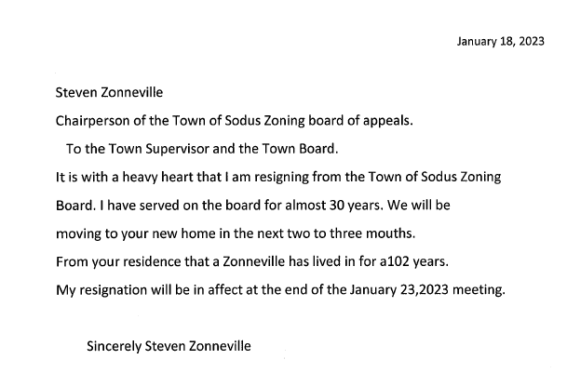
Motion by Councilperson Dave LeRoy to allow the Sodus Point Fire Department use of the Town of Sodus Park across from the SPFD; June 3, August 5 and December 2, 2023 was seconded by Councilperson Don Ross. Upon roll call the following votes were heard, Scott Johnson, aye; David LeRoy, aye; Don Ross, aye; Chris Tertinek, absent; and Cathy Willmott; aye. Motion carried.

Councilperson Cathy Willmott motioned to adjourn the Month End Town Board Meeting was seconded by Councilperson David LeRoy. Upon roll call the following votes were heard, Scott Johnson, aye; David LeRoy, aye; Don Ross, aye; Chris Tertinek, absent; and Cathy Willmott; Zoomed-unable to vote. Motion carried. 4:40 PM

Minutes Written By:
Lori K. Diver
Sodus Town Clerk, RMC

