Sodus Town Board Agenda
June 15, 2023
4:00 PM
Open with Pledge Allegiance
Roll Call: (Lori Diver)
Supervisor Johnson, Councilperson LeRoy, Councilperson Ross, Councilperson Tertinek, Councilperson Willmott
Agenda:

Local Law No. 3-2023 (Lori to read the following);

TOWN OF SODUS
NOTICE OF PUBLIC HEARING

PLEASE TAKE NOTICE that, pursuant to Section 20 of the Municipal Home Rule Law, a public hearing will be held by the Town Board of the Town of Sodus on June 15, 2023, at 4:00 p.m. at the at the Sodus Town Hall, 14-16 Mill Street, in the Town of Sodus, Wayne County, New York, Wayne County, New York, to consider the enactment of Proposed Local Law No. 3 of 2023 of the Town of Sodus, which would provide for the administration and enforcement of the New York State Uniform Fire Prevention and Building Code and the State Energy Conservation Construction Code in the Town..

All persons interested shall be given an opportunity to be heard. The Proposed Local Law No. 3 of 2023 is available for public inspection during regular business hours at the Town Clerk’s office and on the Town of Sodus website at townofsodus.net.

Dated: May 31, 2023
Lori Diver
Sodus Town Clerk, RMC

Motion to open Public Hearing ______________________Second________________________

Public Comments:

Motion to close Public Hearing ______________________Second________________________

Resolution adopting Local Law 3-2023 repealing and replacing The Town of Sodus Building and Construction and Fire Prevention Law.

Motion_____________________________Second_____________________________

Public Speakers:
N/A

Minutes: Motion to file the following minutes:
- May 16, 2023 Regular Town Board Meeting
- May 30, 2023 Month End Town Board Meeting (Supervisor Johnson must abstain)
- May 31, 2023 Special Town Board Meeting (Councilperson Willmott and Supervisor Johnson must abstain)

- Supervisor’s Report

- Town Clerk’s Report

- Tax Collection Report

- Resolution to approve Abstract #10-2023

- Public Works Committee: Councilperson David LeRoy
(Highway, Drainage)
- Motion to file Highway Superintendent’s Report

- Salt Barn:

- Safety Planning (Municipal Building) Discussion

- Drainage N/A

- Buildings and Grounds Committee: Councilperson Chris Tertinek
(Town Property, Animal Control, Code Enforcement, Flood Damage)
- Motion to file Code Enforcement Report – Frank Gahr
- Motion to file Dog Control Officer Report– Robert Snyder
- Flood Damage Prevention – Chris Tertinek

- Recreation/Environmental Committee: Councilperson Cathy Willmott
(Recreation, Assessor, Parks, Cemeteries)
- Motion to file Sodus Recreation Report-Sheila Fisher
- Motion to file Assessor’s Report – Nathan Mack
- Motion to file Camp Beachwood/Sodus Groundskeeper Report – Sal Vittozzi

- Public Safety Committee: Councilperson Don Ross
(Fire, Ambulance, Emergency Preparedness - WC, Water Authority - WC)

- Town Hall Committee: Supervisor Scott Johnson
(Personnel, Town Council, Court, Assessor, Building Inspector, Boards/Committees, Insurances, Finance, Environmental)

Correspondence & Information
- Resolution to allocate payment in the amount of $5,000.00 to Sodus Center Fire Department for their 100th anniversary celebration. This will come from the Town of Sodus Celebrations ARPA fund A7550.48.

- Resolution to approve payment for Lancaster Trucking & Excavating Inc. estimate, in the amount of $700.00 for Camp Beechwood’s distribution box. The estimate is to replace the broken distribution box, installing new concrete, flow levers, reconnecting the leach line, backfilling and leveling to rough grade (emailed).

- Discussion on Voter’s Identification letter and resolution from the Town of Huntington (emailed).

- Resolution adopting proposed Town of Sodus Code Enforcement Fee Schedule (emailed).

- Motion to advertise and hold public hearing for Local Law 4-2023 to regulate recreational vehicles and campers on Tuesday July 12, 2023 at 6:15 PM.

- Motion to advertise and hold public hearing for Local Law 5-2023 to amend the Town of Sodus Zoning Law to Impose Mandatory Regulation and Requirements on Short-Term Rentals on Tuesday July 12, 2023 at 6:30 PM.

EXECUTIVE SESSION:
- Motion to enter into Executive Session regarding medical, financial, credit or employment history of a particular person or corporation or relating to appointment promotion demotion discipline or removal.
Time_________________

- Motion to exit out of Executive Session and enter back into regular session.
Time _________________

- Motion to adjourn meeting.
Time _________________

MINUTES
Minutes of the Regular Town Board Meeting commencing at 4:00 PM in the upstairs meeting room held June 15, 2023 located at 14-16 Mill St. Sodus, NY 14551.
All meetings are open to the public.

In addition, this meeting was available through Zoom. Legal Notices were published and posted accordingly.

Present: Scott Johnson, Supervisor
David LeRoy, Councilperson/Deputy Supervisor Don Ross, Councilperson
Chris Tertinek, Councilperson
Cathy Willmott, Councilperson

Recording Secretary: Lori Diver Sodus Town Clerk

Absent: N/A

Others Present: Amy Kendall, Town Attorney
Bree Crandell, Supervisor Clerk
Dale Pickering, Highway Superintendent
Sal Vittozzi, Camp Beechwood Caretaker
Casey Carpenter, Times of Wayne County (Zoom)

Supervisor Scott Johnson called the Regular Town Board Meeting to order commencing at 4:00 PM and Lori Diver opened with roll call. All Board Members were present.

Local Law No. 3-2023 (Lori read the following);
TOWN OF SODUS
NOTICE OF PUBLIC HEARING

PLEASE TAKE NOTICE that, pursuant to Section 20 of the Municipal Home Rule Law, a public hearing will be held by the Town Board of the Town of Sodus on June 15, 2023, at 4:00 p.m. at the at the Sodus Town Hall, 14-16 Mill Street, in the Town of Sodus, Wayne County, New York, Wayne County, New York, to consider the enactment of Proposed Local Law No. 3 of 2023 of the Town of Sodus, which would provide for the administration and enforcement of the New York State Uniform Fire Prevention and Building Code and the State Energy Conservation Construction Code in the Town..

All persons interested shall be given an opportunity to be heard. The Proposed Local Law No. 3 of 2023 is available for public inspection during regular business hours at the Town Clerk’s office and on the Town of Sodus website at townofsodus.net.
Dated: May 31, 2023
Lori Diver
Sodus Town Clerk, RMC

Councilperson Cathy Willmott motioned to open the public hearing at 4:06 PM was seconded by Councilperson David LeRoy. Upon roll call the following votes were heard, Scott Johnson, aye; David LeRoy, aye; Don Ross, aye; Chris Tertinek, aye; and Cathy Willmott; aye. Motion carried.

Public Comments:
Amy Kendall Town Attorney explained Local Law 3-2023 to the public and through Zoom.

Councilperson Cathy Willmott motioned to close the public hearing at 4:12 PM was seconded by Councilperson Chris Tertinek. Upon roll call the following votes were heard, Scott Johnson, aye; David LeRoy, aye; Don Ross, aye; Chris Tertinek, aye; and Cathy Willmott; aye. Motion carried.

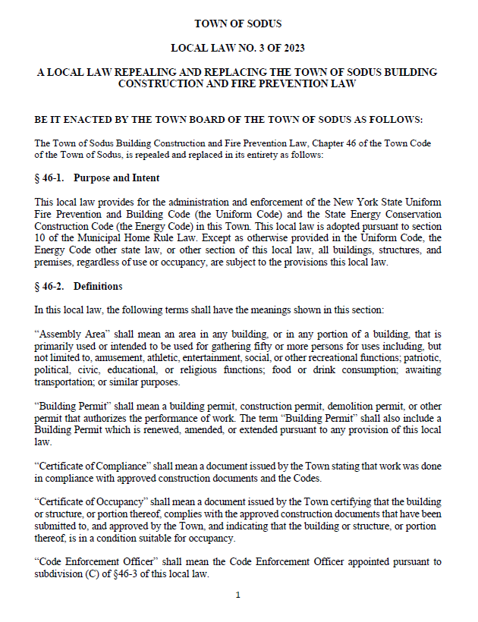

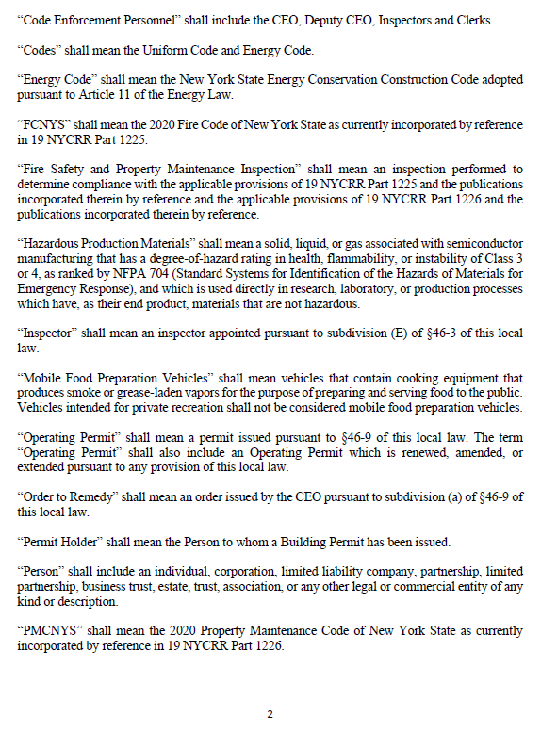

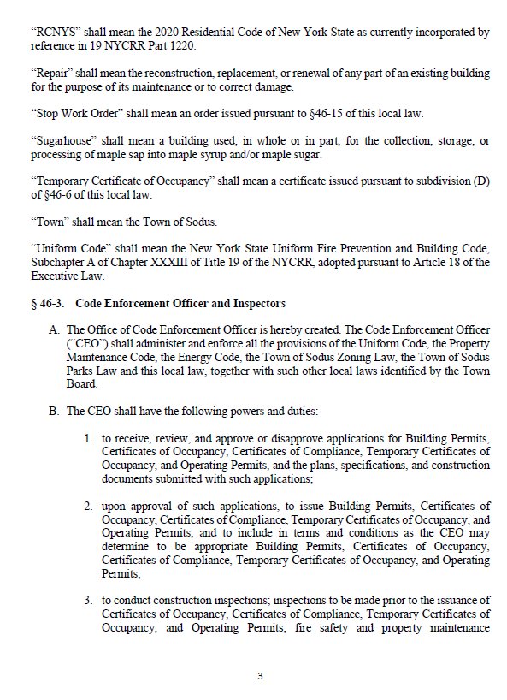
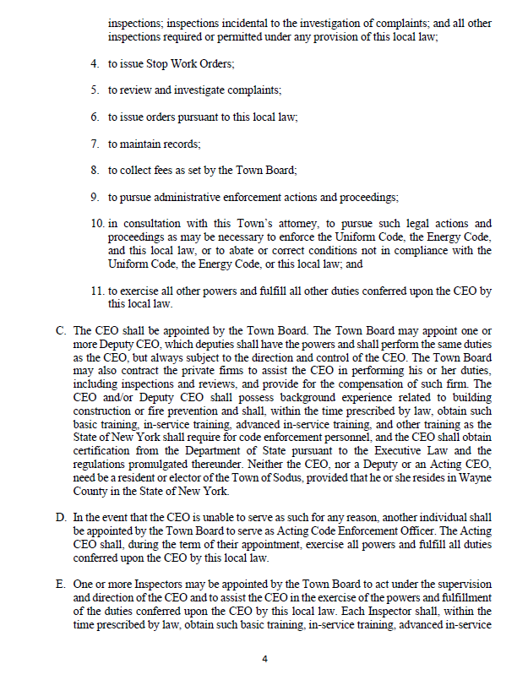

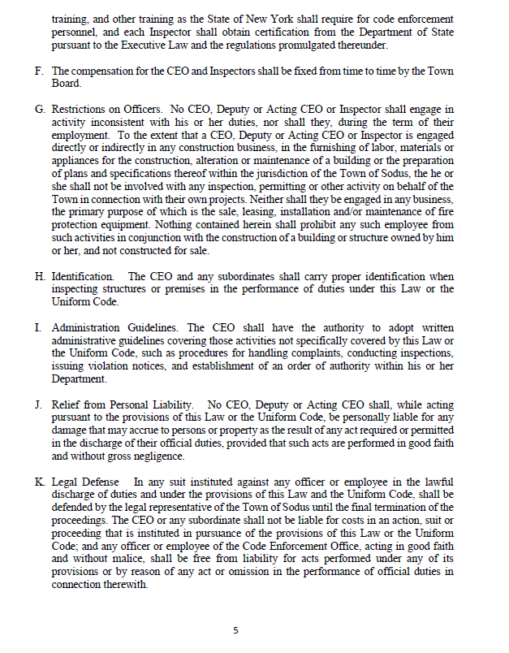

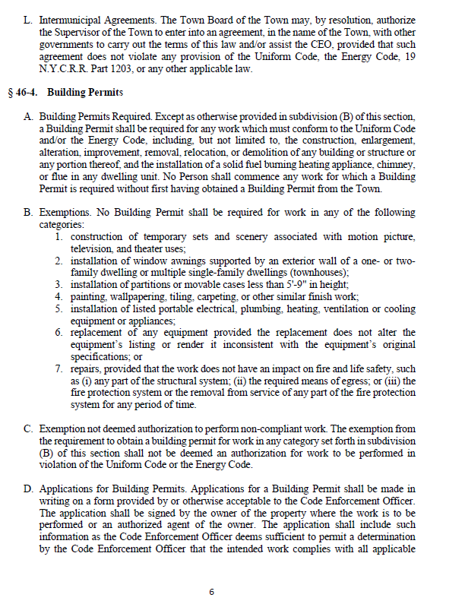

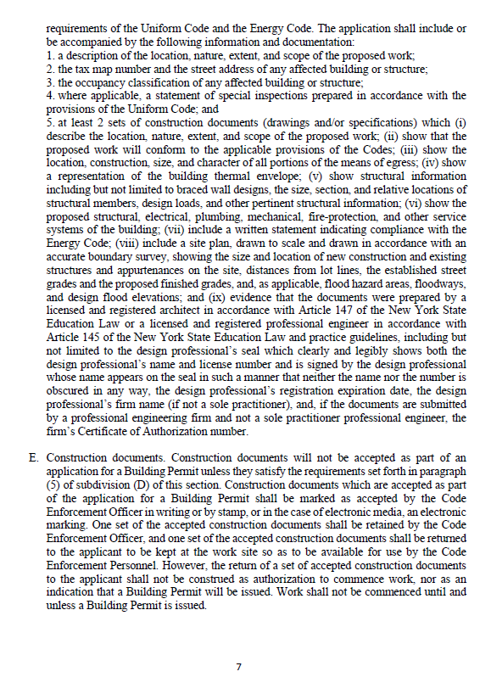

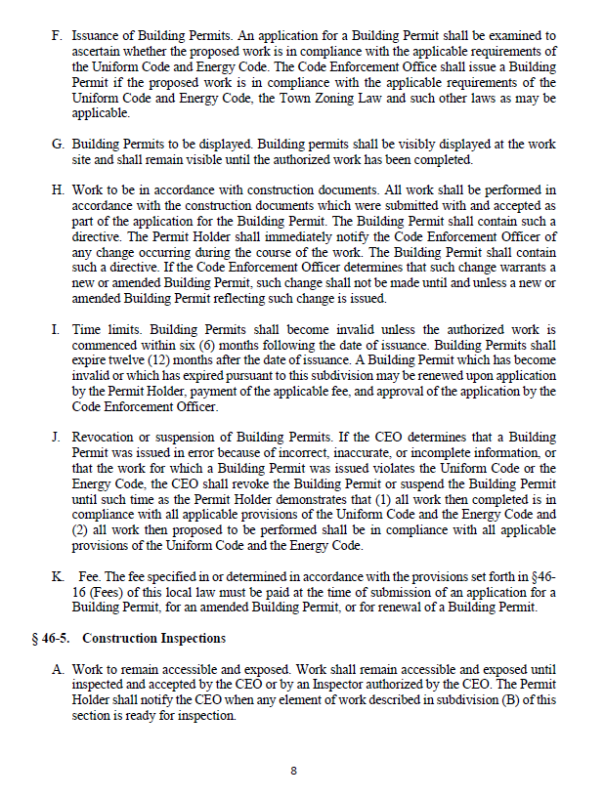

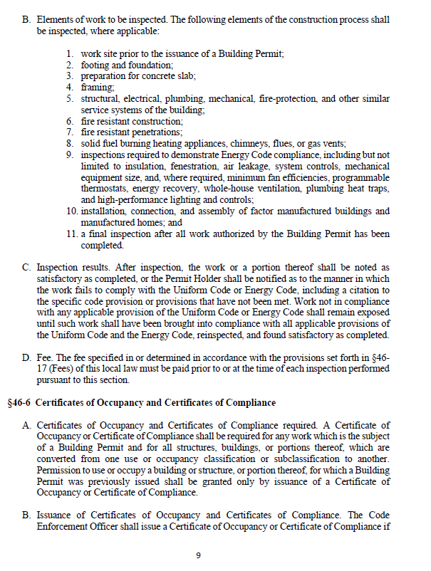
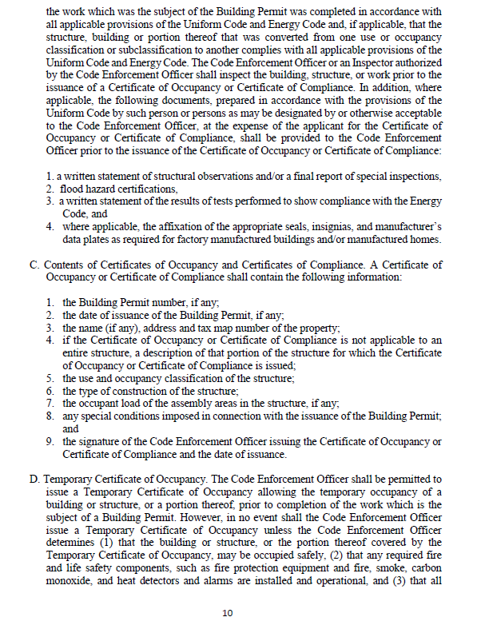

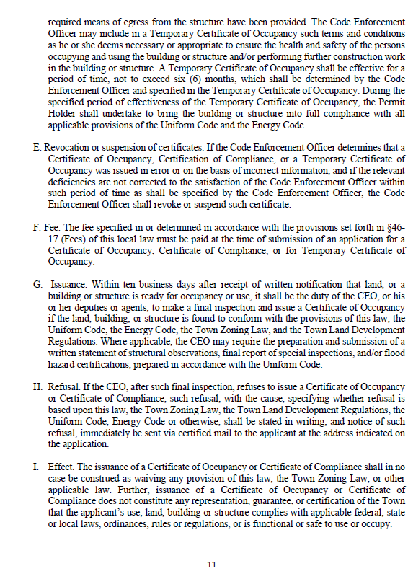

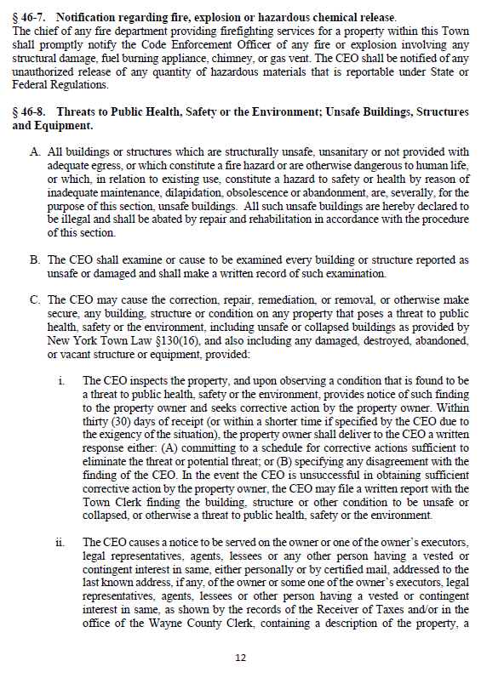

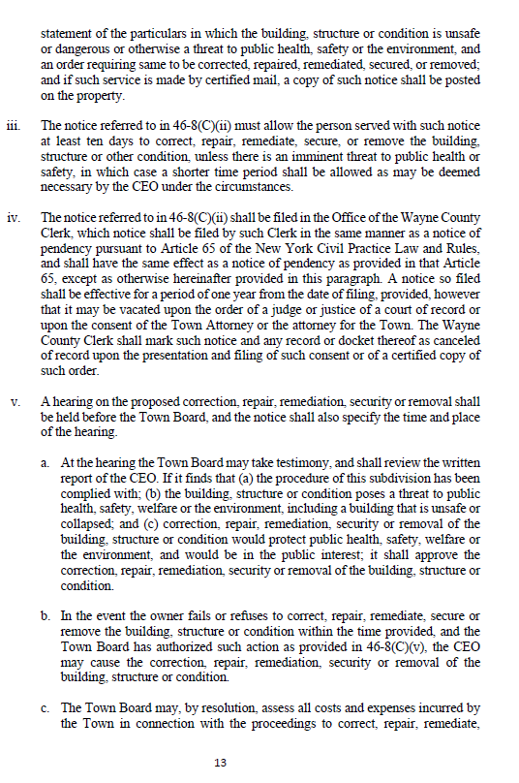

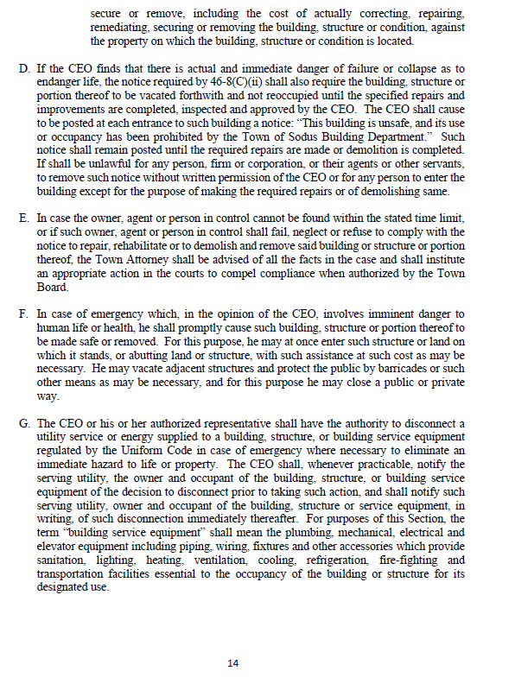

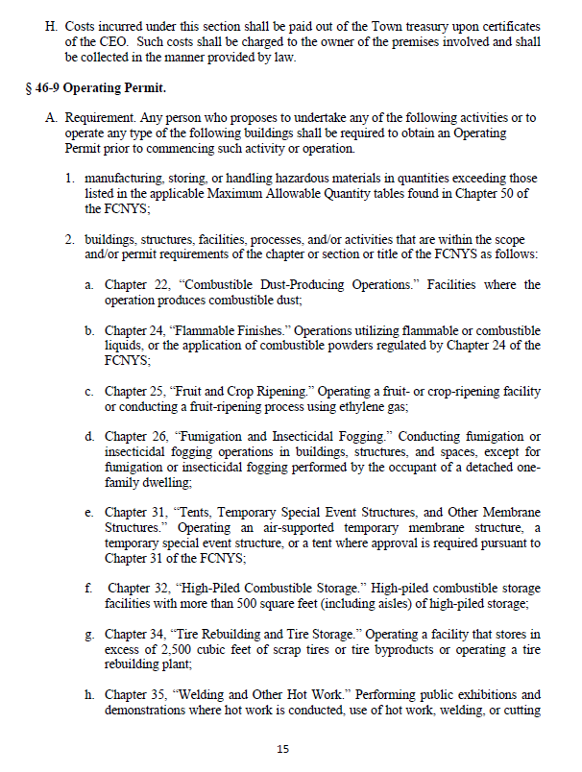

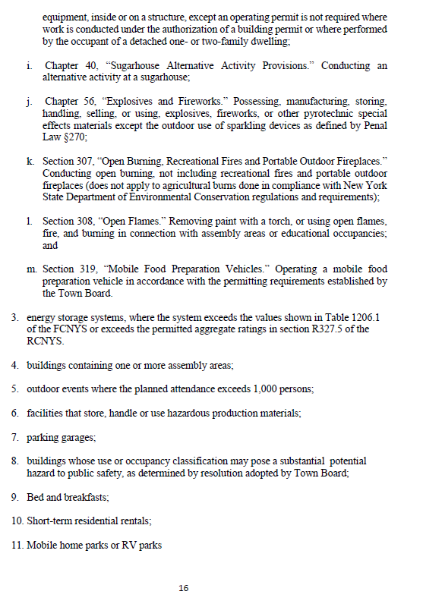
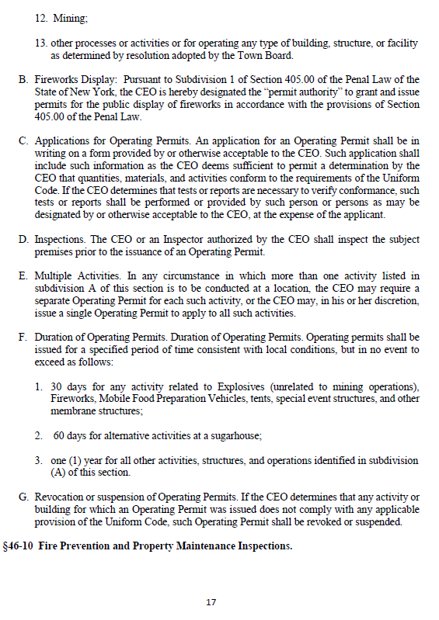

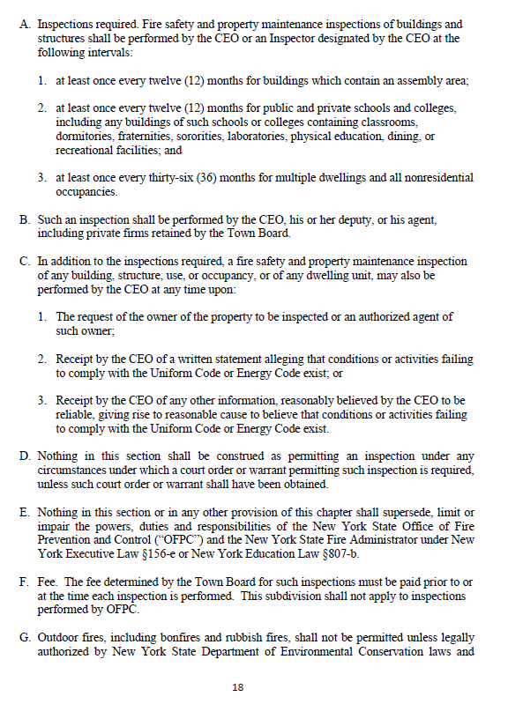

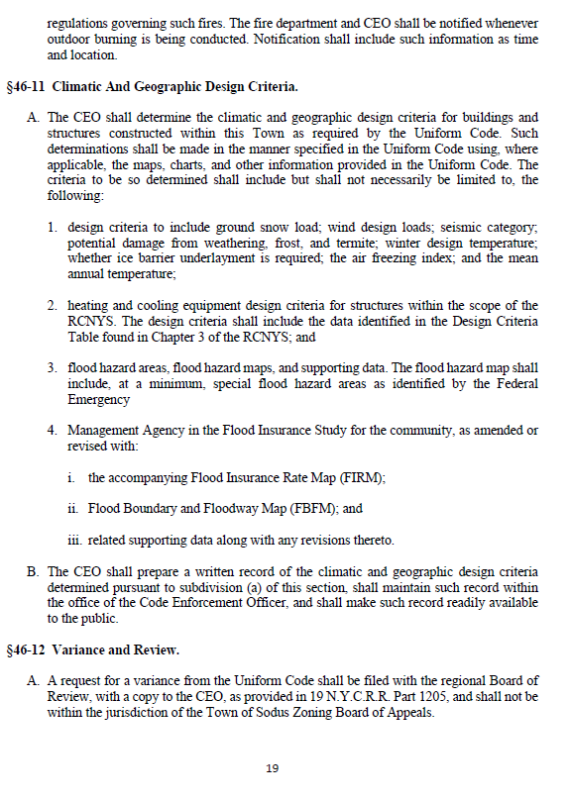

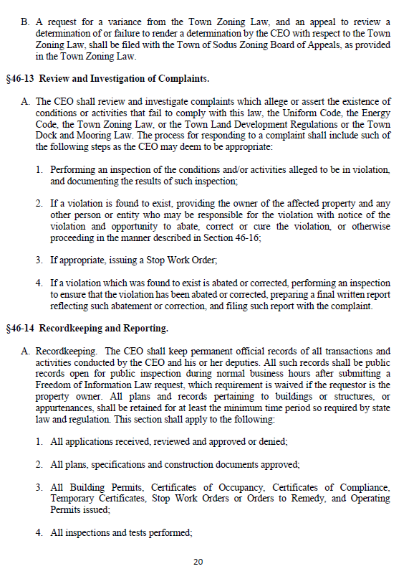

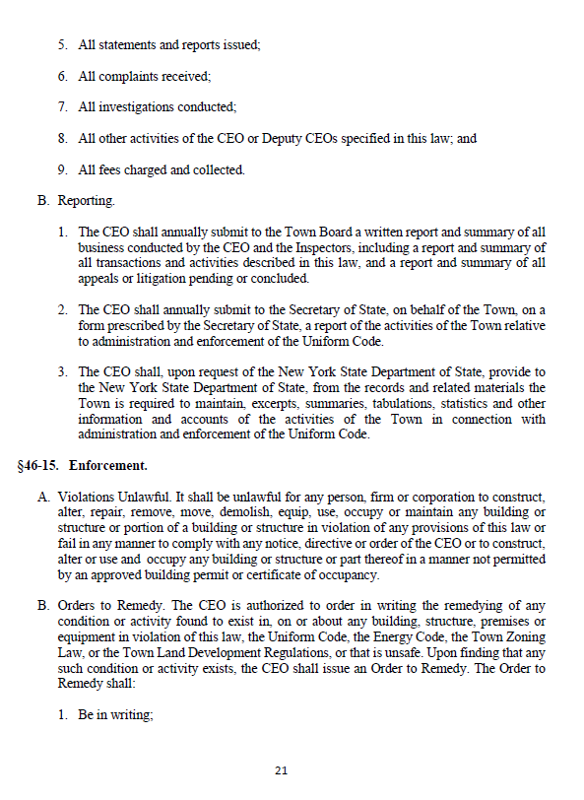
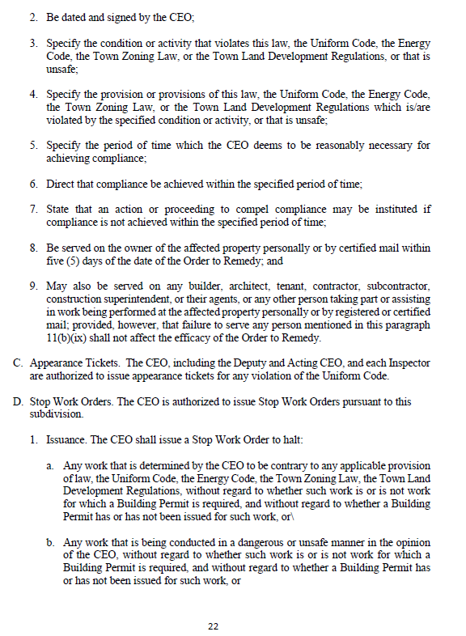

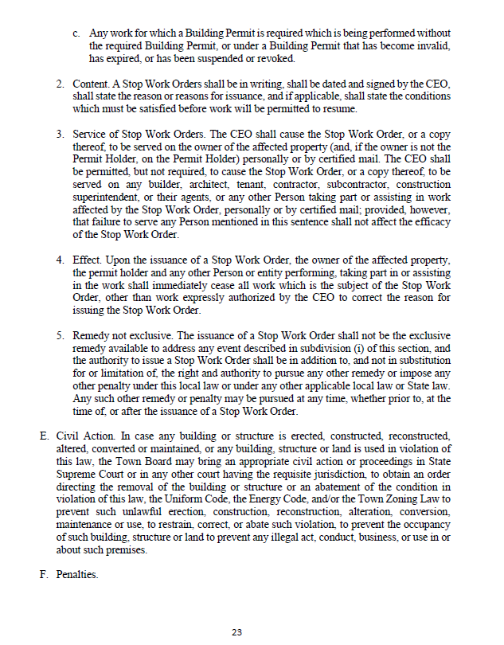

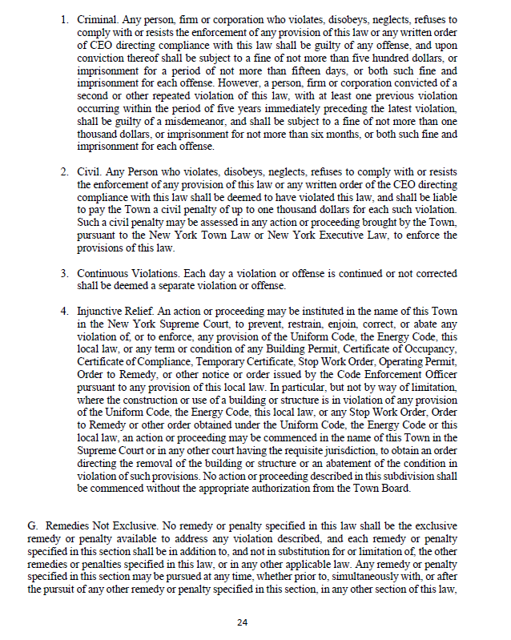

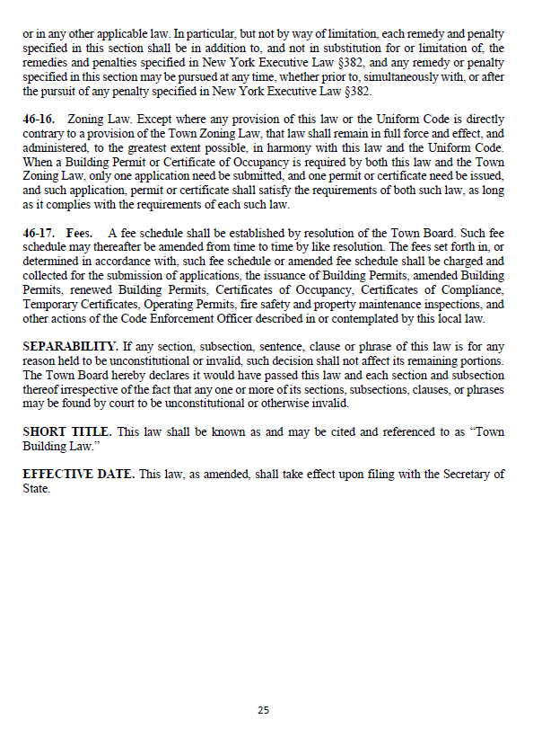

RESOLUTION
LOCAL LAW 3-2023
REPEALING AND REPLACING THE TOWN OF SODUS BUILDING AND CONSTRUCTION AND FIRE PREVENTION LAW
(01 06-2023)
NOW BE IT RESOLVED; Councilperson Chris Tertinek motioned to adopt Local Law 3-2023 was seconded by Councilperson Cathy Willmott. Upon roll call the following votes were heard, Scott Johnson, aye; David LeRoy, aye; Don Ross, aye; Chris Tertinek, aye; and Cathy Willmott; aye. Resolution Adopted.

Public Speakers:
N/A

MINUTES
Minutes from May 16, 2023 was presented to the Town Board to be filed. Councilperson Chris Tertinek motioned to file these Minutes, which was seconded by Councilperson David LeRoy. Upon roll call the following votes were heard, Scott Johnson, aye; David LeRoy, aye; Don Ross, aye; Chris Tertinek, aye; and Cathy Willmott; aye. Motion carried.

Minutes from May 30, 2023 was presented to the Town Board to be filed. Councilperson Cathy Willmott motioned to file these Minutes, which was seconded by Councilperson Don Ross. Upon roll call the following votes were heard, Scott Johnson, abstain (was absent from this meeting); David LeRoy, aye; Don Ross, aye; Chris Tertinek, aye; and Cathy Willmott; aye. Motion carried.

Minutes from May 31, 2023 was presented to the Town Board to be filed. Councilperson Chris Tertinek motioned to file these Minutes, which was seconded by Councilperson Don Ross. Upon roll call the following votes were heard, Scott Johnson, abstain (was absent from this meeting); David LeRoy, aye; Don Ross, aye; Chris Tertinek, aye; and Cathy Willmott; abstain (was absent from this meeting). Motion carried.

SUPERVISOR’S REPORT
The Supervisor’s monthly report was presented for May 2023 with Town of Sodus budgetary accounts (balances to date) including; current bank statements. Councilperson David LeRoy motioned to file this report, which was seconded by Councilperson Cathy Willmott. Upon roll call the following votes were heard, Scott Johnson, aye; David LeRoy, aye; Don Ross, aye; Chris Tertinek, aye; and Cathy Willmott; aye. Motion carried.

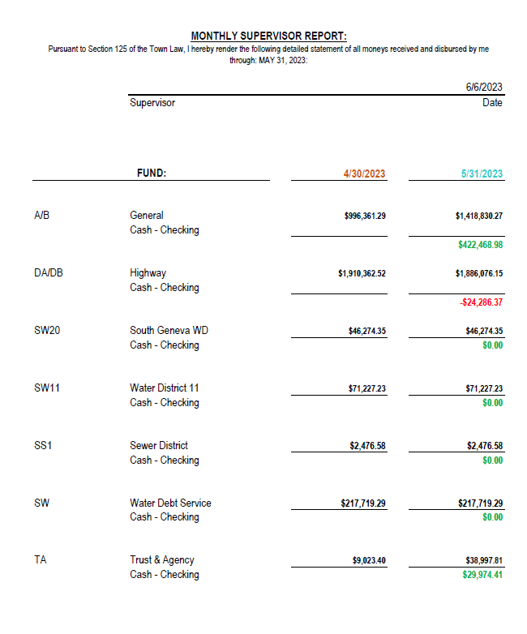

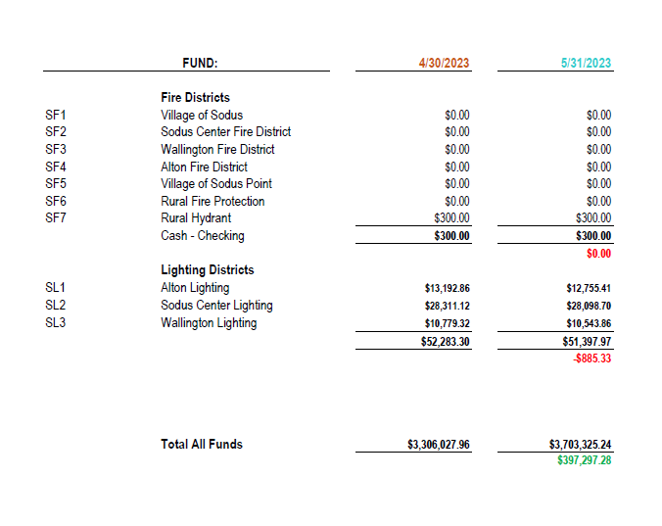

TOWN CLERK’S REPORT
The Town Clerk’s Reports, Town Clerk’s bank statements for audit and bank register for May 2023 was presented. Note: bank statement and bank register are listed in detail with Town Clerk cash book for 2023. For security reasons and confidentiality, it cannot be published in Minutes. Councilperson Don Ross motioned to file these reports, which was seconded by Councilperson David LeRoy. Upon roll call the following votes were heard, Scott Johnson, aye; David LeRoy, aye; Don Ross, aye; Chris Tertinek, aye; and Cathy Willmott; aye. Motion carried.

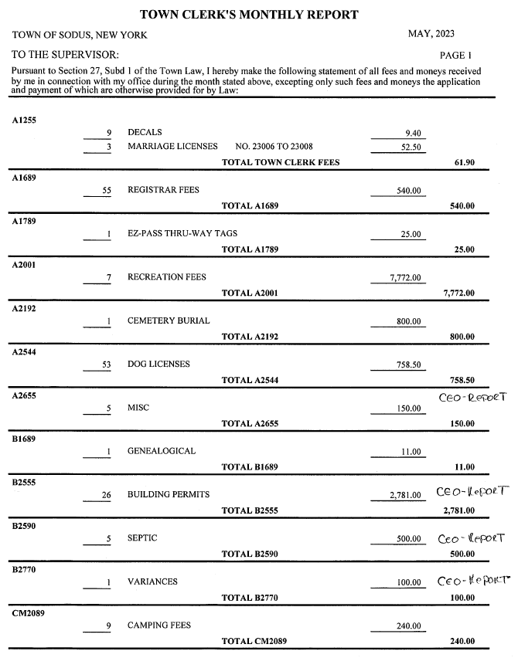

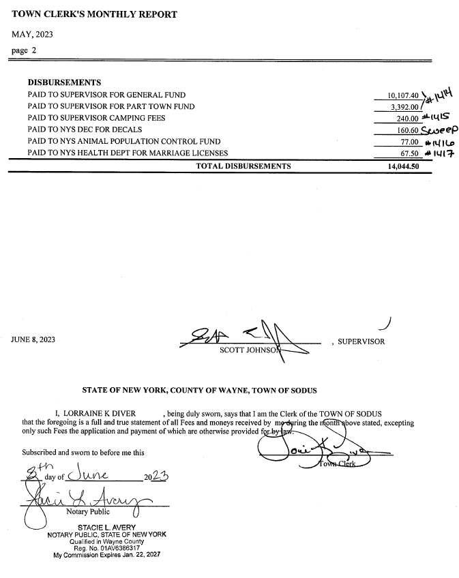

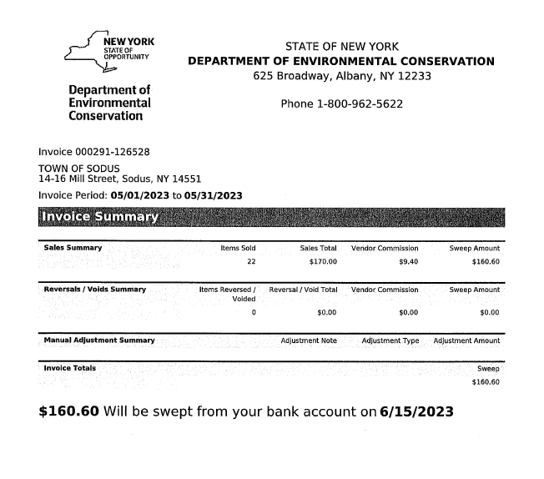
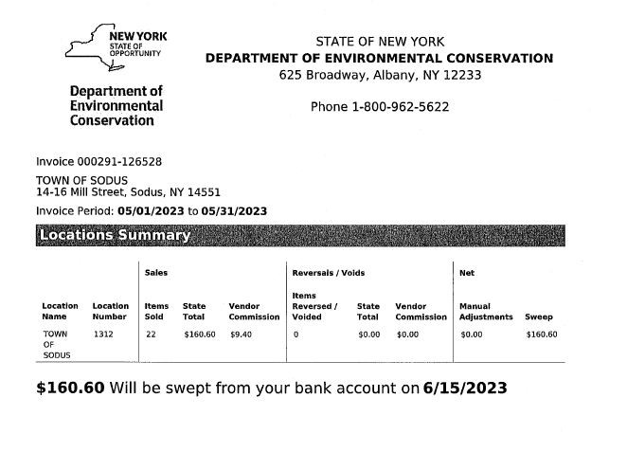

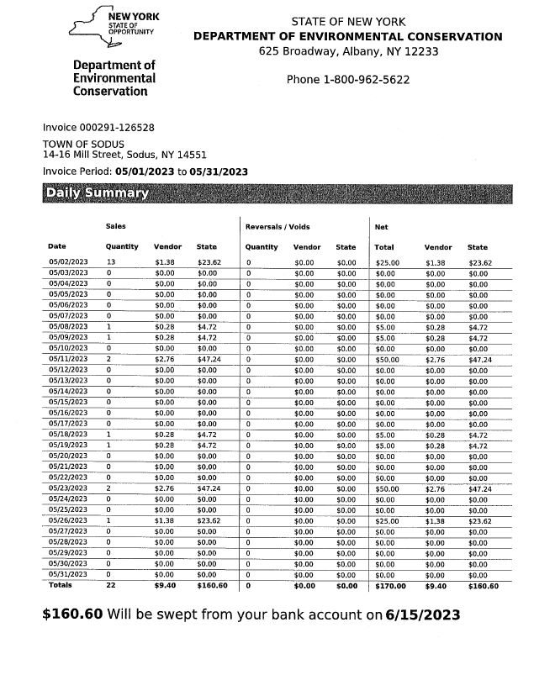

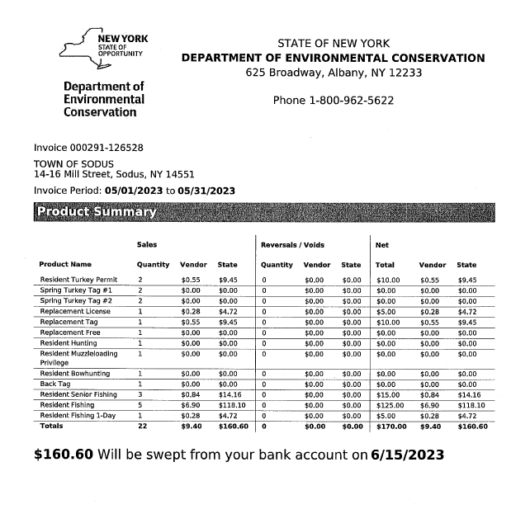

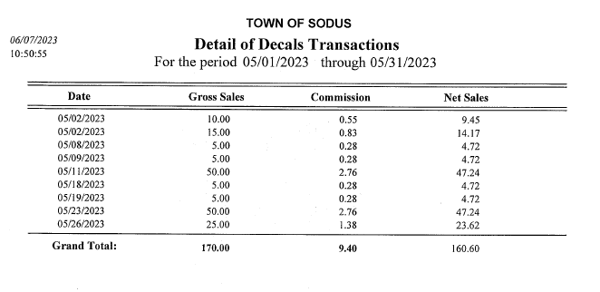

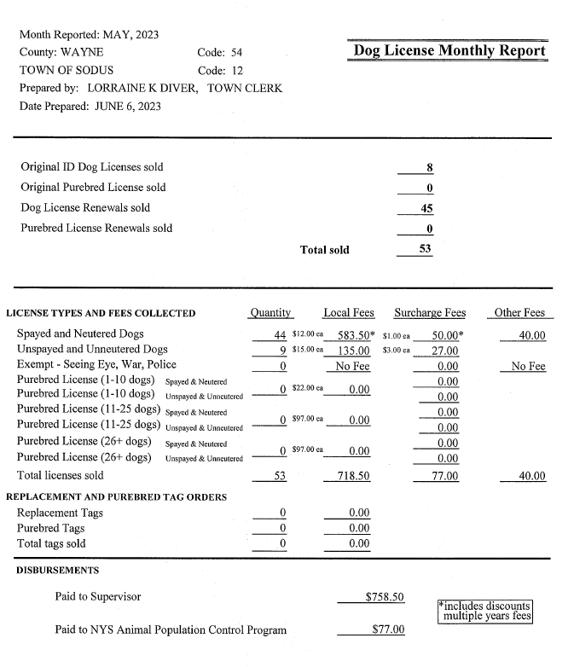

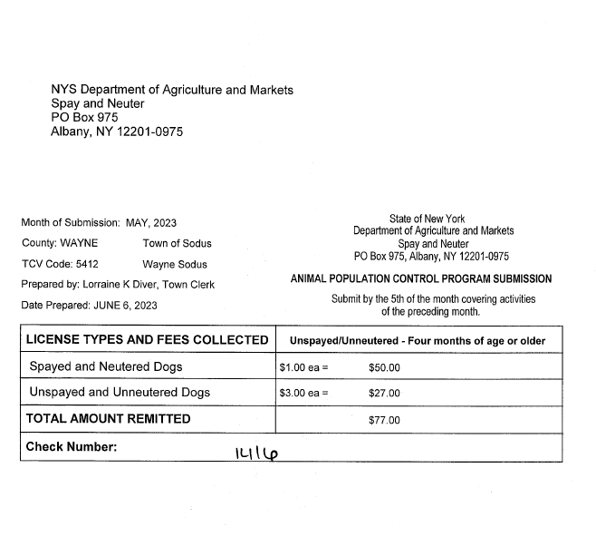
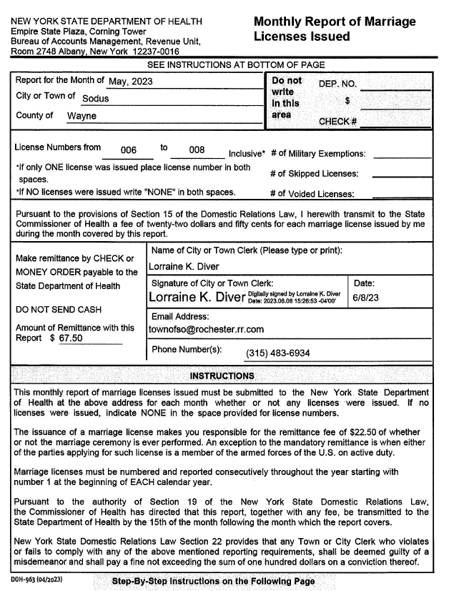

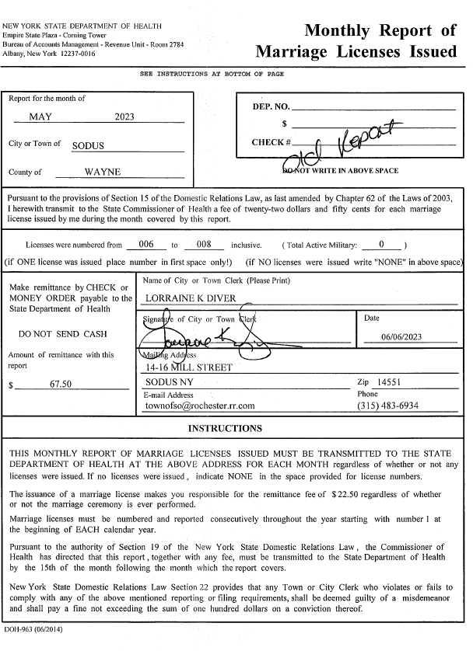

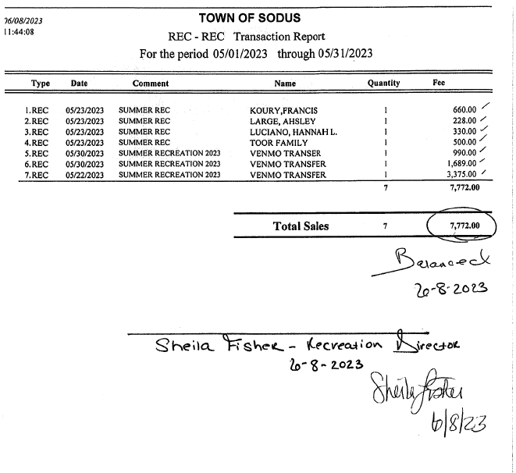

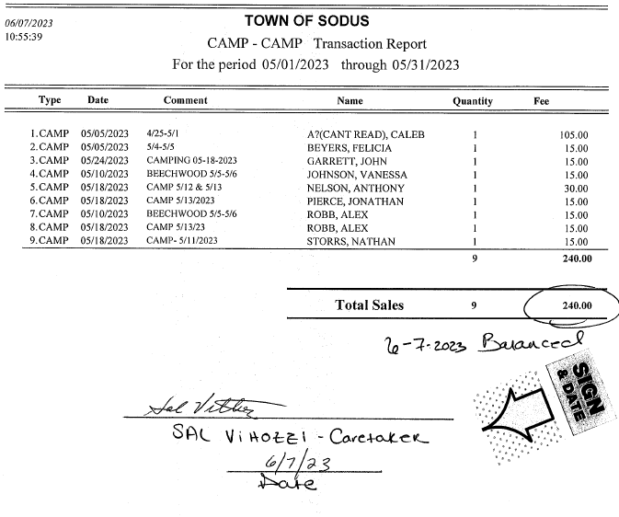

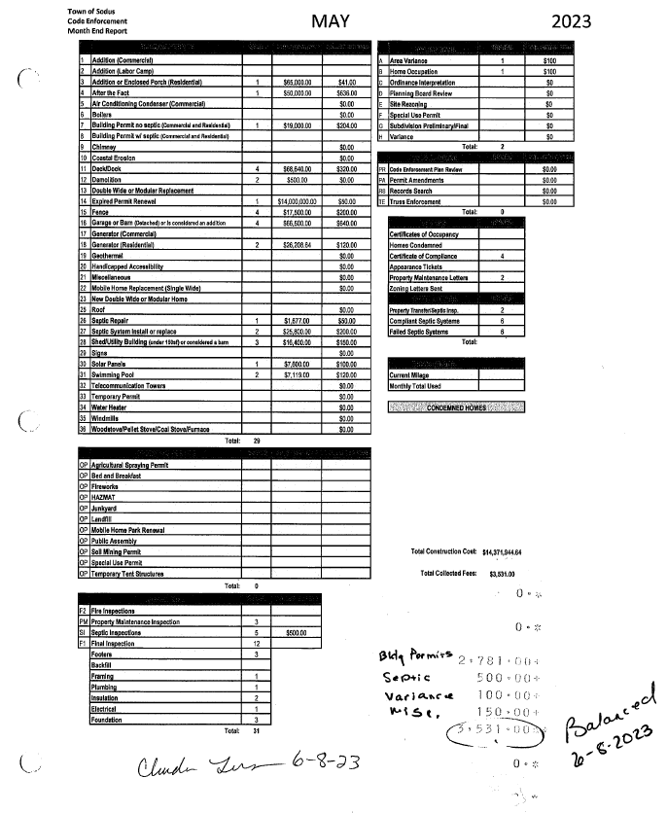

TAX COLLECTION REPORT
The Tax Collection Report, Tax Collector bank statements for audit and bank register for May 2023 was presented. Councilperson David LeRoy motioned to file this report, which was seconded by Councilperson Cathy Willmott. Upon roll call the following votes were heard, Scott Johnson, aye; David LeRoy, aye; Don Ross, aye; Chris Tertinek, aye; and Cathy Willmott; aye. Motion carried.
Note: bank statement and bank register are listed in detail with Tax Collection cash book for 2023. For security reasons and confidentiality, it cannot be published in Minutes.

*The only information provided for the May 2023 Tax Collection Report was the bank statement and bank register showing the account had a zero balance. *

ABSTRACT
RESOLUTION TO PAY ABSTRACT NO. 10
(02 06-2023)
WHEREAS, the following bills were presented for payment on Abstract 10:

General 251-271 $ 9,516.44
Highway 134-151 $ 12,530.50
Special District 013-015 $ 891.35
GRAND TOTAL: $ 22,938.29

NOW BE IT RESOLVED, Councilperson David LeRoy motioned to approve payment of these bills as reviewed for Abstract No. 10, which was seconded by Councilperson Chris Tertinek. Upon roll call the following votes were heard, Scott Johnson, aye; David LeRoy, aye; Don Ross, aye; Chris Tertinek, aye; and Cathy Willmott; aye. Resolution Adopted.

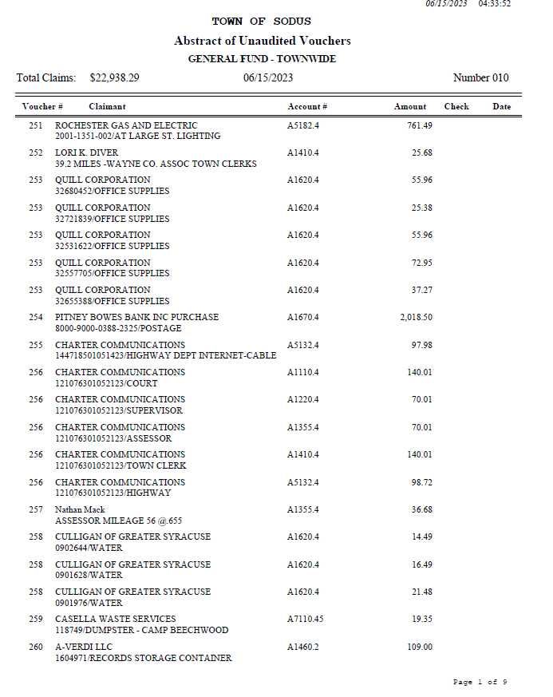

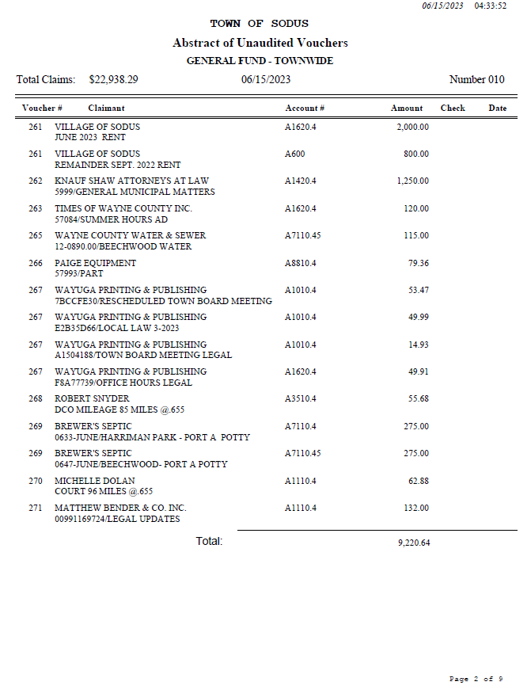

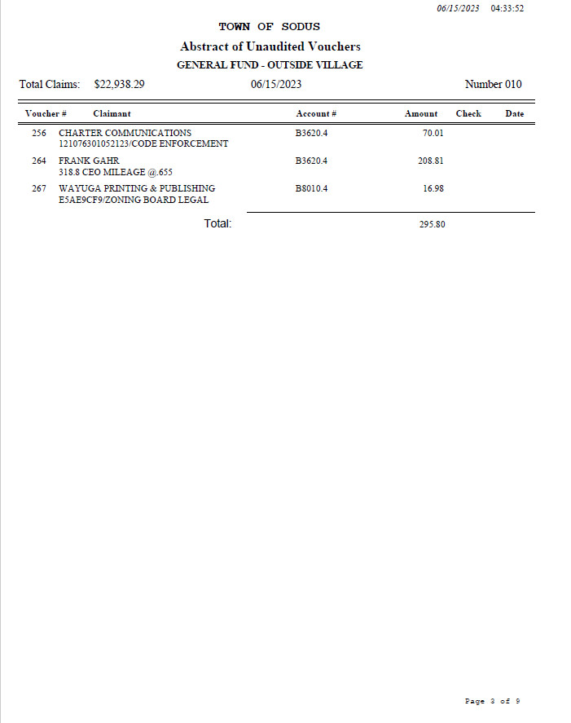

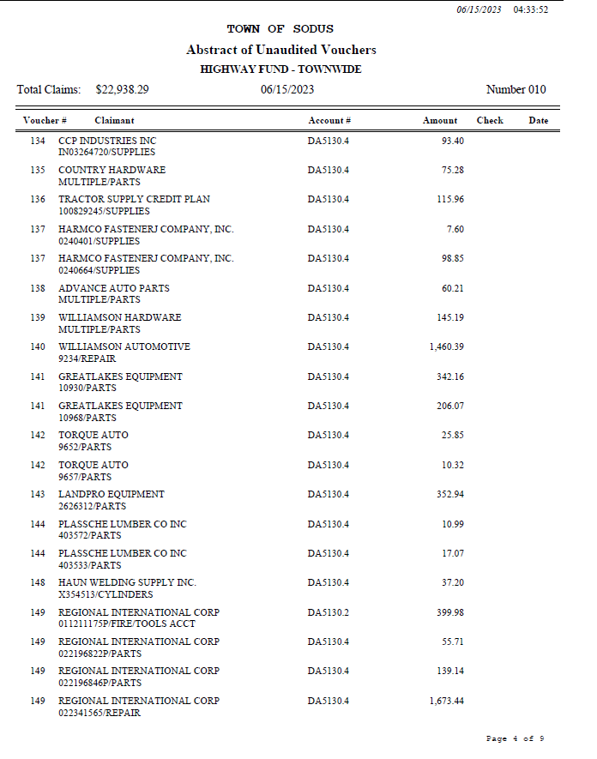

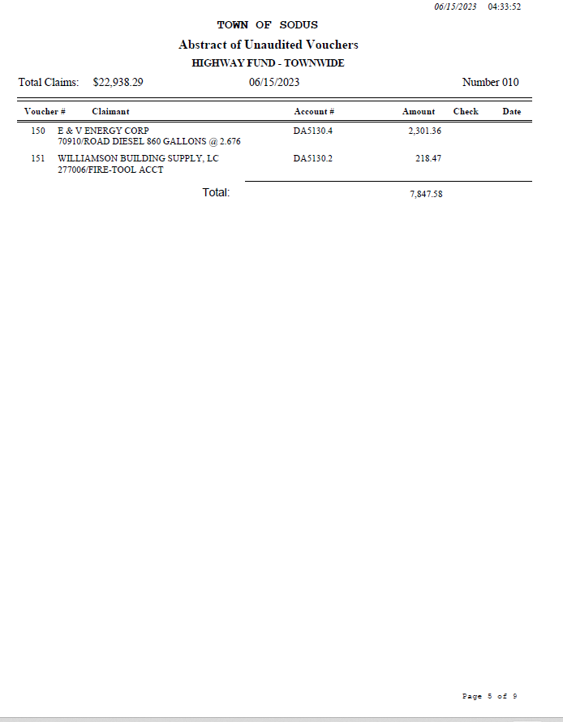

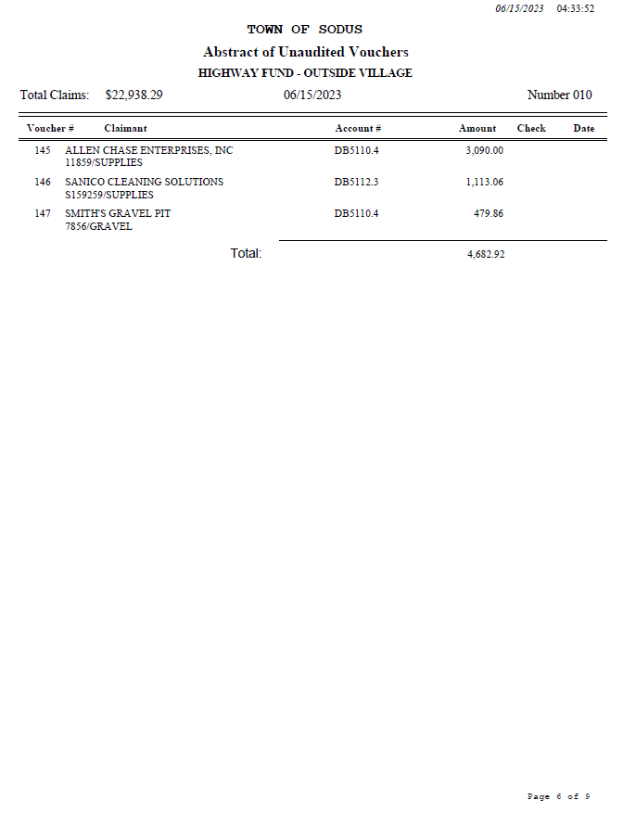

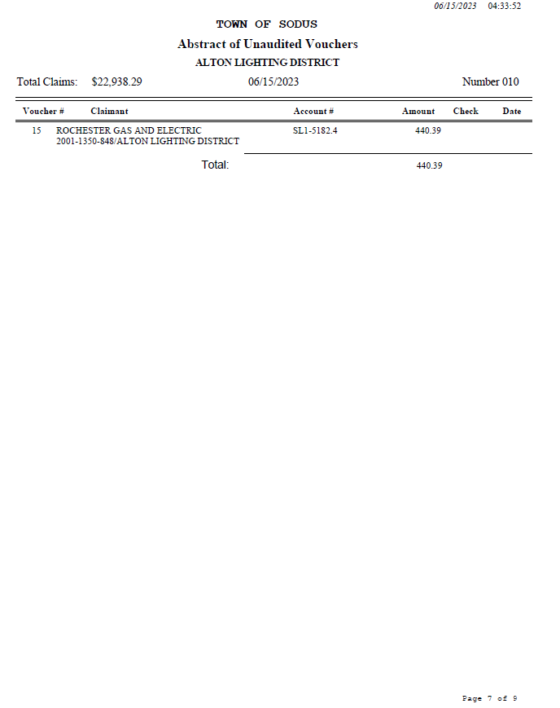

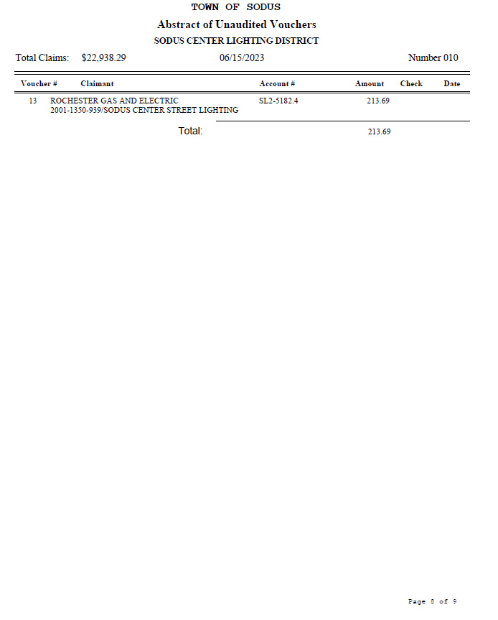

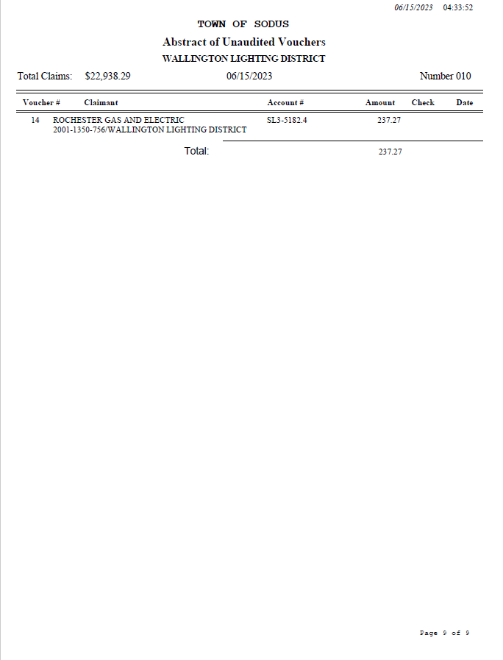

PUBLIC WORKS COMMITTEE: Councilperson David LeRoy, Chair
(Highway, Drainage - Deputy Town Supervisor)
HIGHWAY REPORT:
(Dale Pickering – Highway Superintendent)
Councilperson David LeRoy motioned to file the monthly Highway May 2023 report from Dale Pickering Highway Superintendent was seconded by Councilperson Chris Tertinek. Upon roll call the following votes were heard, Scott Johnson, aye; David LeRoy, aye; Don Ross, aye; Chris Tertinek, aye; and Cathy Willmott; aye. Motion carried.

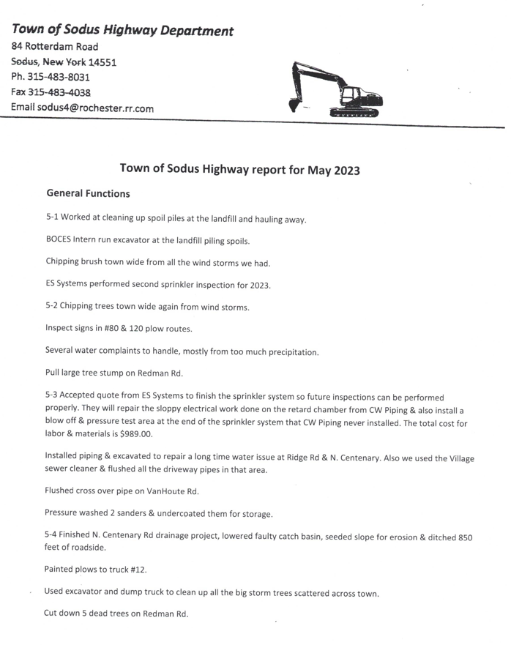

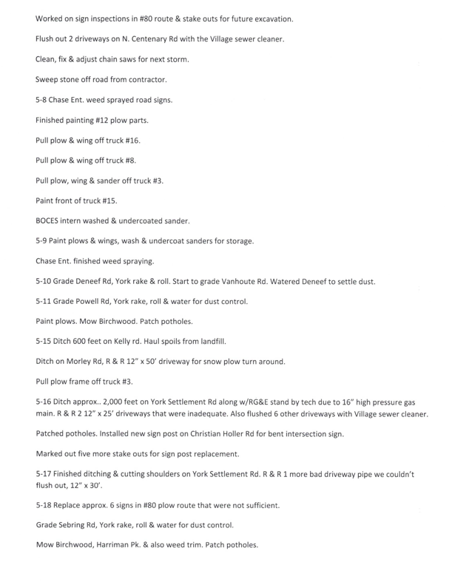
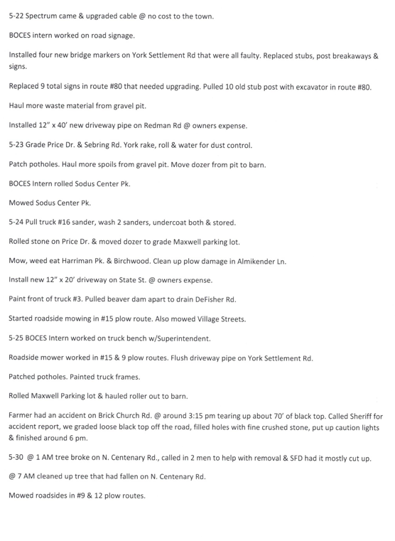
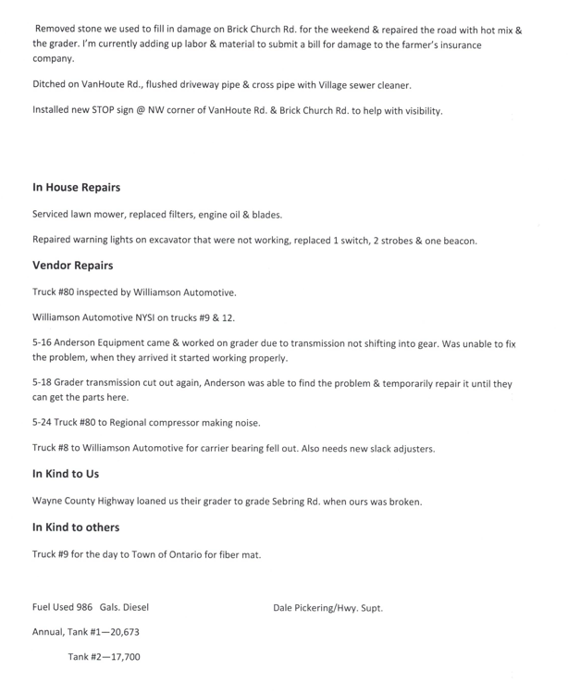
- Salt Barn: Councilperson David LeRoy discussed the delay in the build on the Salt Barn. There finally is approval to move forward with the new build.

- RG&E N/A

- Drainage N/A

- Safety Planning: Supervisor Scott Johnson shared with the Town Board that he is waiting on Wayne County Sherriff Milby to get back in touch with him regarding the “Active Shooter” training.

BUILDINGS AND GROUNDS COMMITTEE: Councilperson Chris Tertinek, Chair
(Town Property, Animal Control, Flood Damage Prevention)
CODE ENFORCEMENT REPORT:
Frank Gahr- CEO
Councilperson David LeRoy motioned to file the monthly May 2023 Code Enforcement Report as written, was seconded by Councilperson Cathy Willmott. Upon roll call the following votes were heard, Scott Johnson, aye; David LeRoy, aye; Don Ross, aye; Chris Tertinek, aye; and Cathy Willmott; aye. Motion carried.
Note: Frank Gahr finished his classes for Code Enforcement Officer.

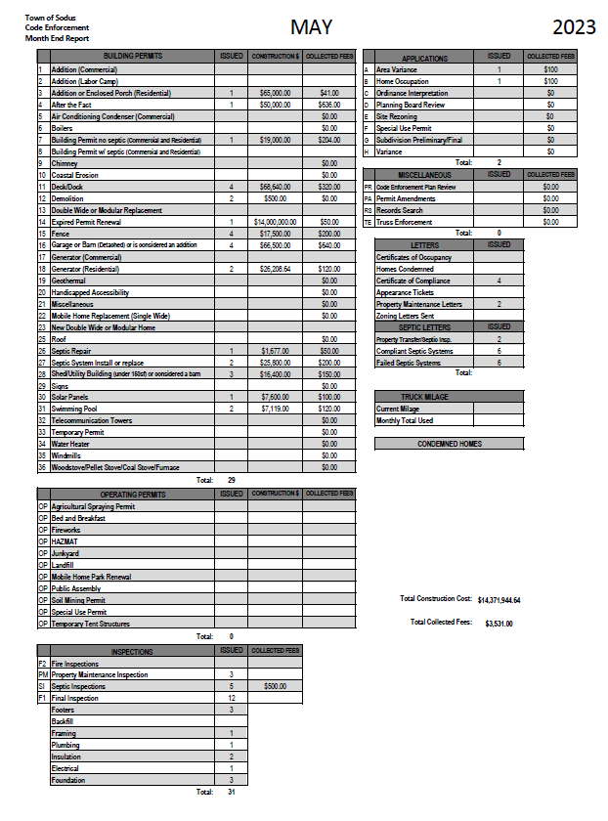

DOG CONTROL REPORT:
Robert Snyder, Primary DCO
Vacant- Secondary DCO
Councilperson David LeRoy motioned to file the monthly May 2023 Dog Control report as written, was seconded by Councilperson Cathy Willmott. Upon roll call the following votes were heard, Scott Johnson, aye; David LeRoy, aye; Don Ross, aye; Chris Tertinek, aye; and Cathy Willmott; aye. Motion carried.

May 2023 Dog Control Report
05-05-2023 Dog running on Ridge Rd. – Alton. Drove around; no dog spotted. 3:30 PM
05-14-2023 911 call-dog bite, dog owner given warning to get dog up to date on shots and license. Person that was bitten, was told to go get it looked at. 9:00 PM
05-19-2023 911 call-dog attack on another dog. Owners wanted the one dog removed. Dog was taken to the Humane Society. 5:30 PM
05-22-2023 Dog complaint-dogs running at large. Talked to owner, the dogs got out while they were working on kennel. 6:30 PM
Mileage: 85 miles traveled
Respectfully Submitted,
Robert Snyder, DCO

FLOOD DAMAGE PREVENTION REPORT-Code 69:
Chris Tertinek, Councilperson
Councilperson Chris Tertinek shared his flood damage prevention report as follows:

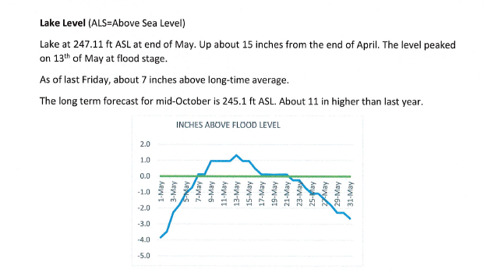

RECREATION/ENVIRONMENTAL COMMITTE: Councilwoman Cathy Willmott
(Recreation, Assessor, Parks, Cemeteries)
CAMP BEECHWOOD-PARKS-CEMETERIES REPORTS:

Recreation Report
(Sheila Fisher, Recreation Director)
Councilperson Chris Tertinek motioned to file the monthly May 2023 Recreation report from Sheila Fisher, Recreation Director was seconded by Councilperson David LeRoy. Upon roll call the following votes were heard, Scott Johnson, aye; David LeRoy, aye; Don Ross, aye; Chris Tertinek, aye; and Cathy Willmott; aye. Motion carried.

Annual Director’s Report
Sodus Recreation
June 8, 2023

Monthly Report
Programs:

- We went live with our online registration for our Summer Recreation program the week of 5/8.
- At this time, we have received a total of 108 registrations. This is for all programs and has not been broken down yet by individuals.
- I have submitted all minimum wage staff to Jay Roscup. We will be working together on their payroll going forward.
- Staff Orientation is June 28th from 12pm-4pm.
- Matt and I worked on Coordinator pay for this Summer. I submitted a request for an increase in pay for these positions, based on the years of service, to Cathy Wilmott and Bree. I asked them what the process would be to go forward with these requests, and I believe that Cathy was going to have us discuss these at the meeting.
- Staff other than Coordinators, but more than minimum wage are listed here:
- Lifeguards-
  - Isabella Bearce - $17.00
  - Jace Fredericksen $16.00
  - Isabella Wilbur - $16.00
  - Charlotte Miller $18.00/hour Coordinator for a New Games Program twice per week/ 2 hours each day.
Assessor’s Report
(Nathan Mack, Assessor)
Councilperson Don Ross motioned to file the monthly May 2023 report from Sole Assessor Nathan Mack was seconded by Councilperson Cathy Chris Tertinek. Upon roll call the following votes were heard, Scott Johnson, aye; David LeRoy, aye; Don Ross, aye; Chris Tertinek, aye; and Cathy Willmott; aye. Motion carried.

tOWN OF sODUS

ASSESSOR’S OFFICE
Date: June, 7 2023 Respectfully Submitted by: Nathan Mack

Grievance Day Fact Information

- 4 members of the Board of Assessment Review were present. Sadly, we were given news that Donald Buchwald passed away shortly before Grievance Day. I had the pleasure to work with him the past 9 years and he will greatly be missed.
- We received 3 applications from on Grievance Day. They were all related to exemption related questions and not valuation complaints.

- Notices of decision by the Board of Assessment Review have been mailed to the taxpayers.

AROUND THE OFFICE
- Corrections to the Tentative roll and changes made by the Board of Assessment Review have been made.
- Information for the Final tax roll will be turned into the County.
- Legal notices concerning the completion of the final assessment roll will be posted in the Town Hall, website and newspaper.

Camp Beechwood Report
(Sal Vittozzi, Caretaker)
Councilperson Don Ross motioned to file the monthly May 2023 Camp Beechwood report from Sal Vittozzi, Caretaker was seconded by Councilperson David LeRoy. Upon roll call the following votes were heard, Scott Johnson, aye; David LeRoy, absent; Don Ross, absent; Chris Tertinek, aye; and Cathy Willmott; aye. Motion carried.

MAY 2023 BEECHWOOD REPORT
May was an incredibly busy month here at the park. Aside from the boy scout camporee, we also hosted 6 other scout troop camping trips in May. Daily attendance is back at peak season levels and on the weekends, we're seeing a couple hundred park goers throughout the weekend. Camping also started picking up for the season as well. On Memorial Day weekend we brought in $300 in camping fees and $210 the following weekend, so it's been a good start to the official camping season. Park and cemetery maintenance has been non-stop. All mowing and trimming have been done on time, but it has definitely been a lot. All in all, it has been a great kickoff to the summer season here at the park.
Respectfully Submitted,
Sal Vittozzi, Caretaker

PUBLIC SAFETY/DRAINAGE/ENVIRONMENT COMMITTEE: Councilperson Don Ross, Chair (Fire, Ambulance, Emergency Preparedness)
Councilperson Don Ross was unable to attend the Wayne County Water and Sewer Authority meeting but, he did attend Board of Director training. Ross reported the Wallington Fire Department purchased a Ladder Truck from Clyde Fire Department. The purchase was quite the deal. The monthly SESA meeting was held. The Village of Sodus Point (Silver Waters) now has a new ambulance and the V/Sodus Point Fire Department now has a Mini Pumper. Ross’s monthly 911 report was submitted to the Board but, due to confidentiality of names listed it cannot be published in minutes.

TOWN HALL COMMITTEE: Scott Johnson, Supervisor
(Personnel, Clerks, Justices, Assessor, Building Inspector, Town Council, Boards, Insurances, Finance)
N/A

CORRESPONDENCE & INFORMATION

RESOLUTION
ALLOCATION OF 5,000.00 DOLLARS TO SODUS CENTER FIRE DEPARTMENT FOR 100TH ANNIVERSARY
(03 06-2023)
RESOLVED Councilperson Chris Tertinek motioned to allocate payment in the amount of $5,000.00 to Sodus Center Fire Department for their 100th Anniversary Celebration. This will come from The Town of Sodus ARPA fund A7550.48 was seconded by Councilperson Don Ross. Upon roll call the following votes were heard, Scott Johnson, aye; David LeRoy, aye; Don Ross, aye; Chris Tertinek, aye; and Cathy Willmott; aye. Resolution adopted.

RESOLUTION
CAMP BEECHWOOD-LANCASTER TRUCKING & EXCAVATING INC.
(04 05-2023)
BE IT RESOLVED, one written estimate was received from Lancaster Trucking & Excavating Inc. to repair Camp Beechwood’s Septic, and
NOW BE IT RESOLVED; Councilperson Cathy Willmott motioned to adopt this resolution which was seconded by Councilperson Dave LeRoy. Upon roll call the following votes were heard, Scott Johnson, aye; David LeRoy, aye; Don Ross, aye; Chris Tertinek, aye; and Cathy Willmott; aye. Resolution Adopted

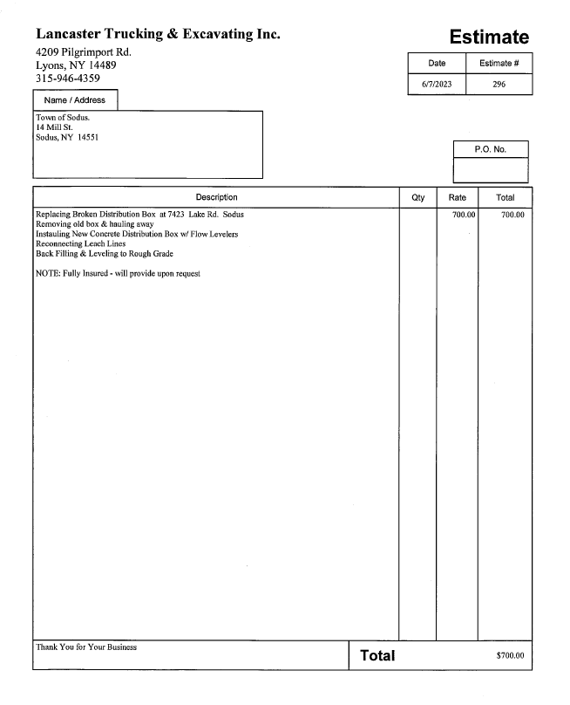

Town of Huntington sent a letter regarding a Voter’s Identification Resolution urging NY State Legislature and Governor Hochul to draft and enact legislation regarding a voter’s identification process. Councilperson Don Ross motioned to sponsor the voter identification process resolution was seconded by Councilperson Cathy Willmott. Upon roll call the following votes were heard, Scott Johnson, aye; David LeRoy, aye; Don Ross, aye; Chris Tertinek, aye; and Cathy Willmott; aye. Motion carried.
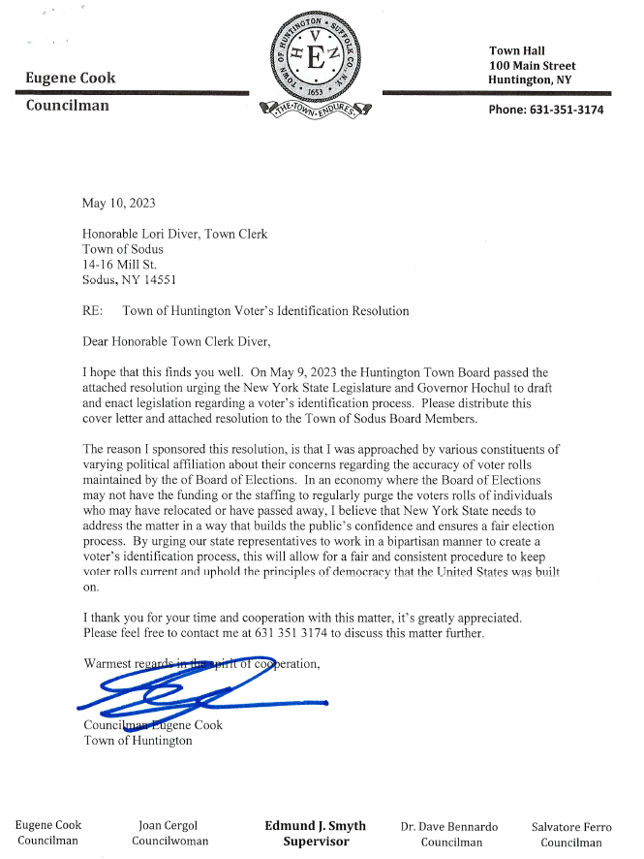

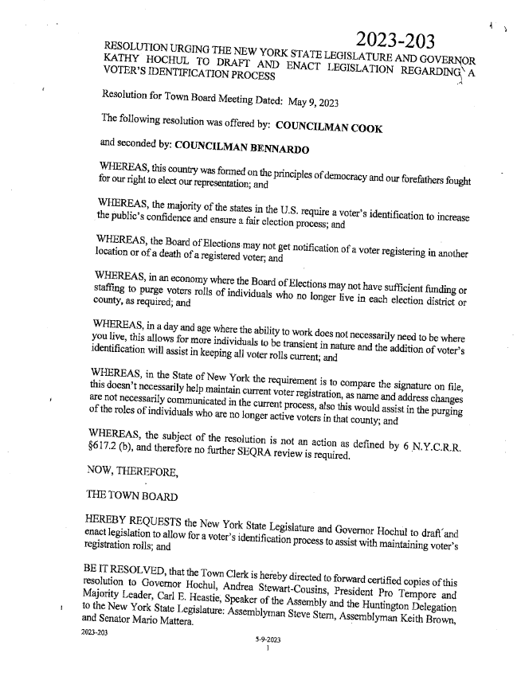
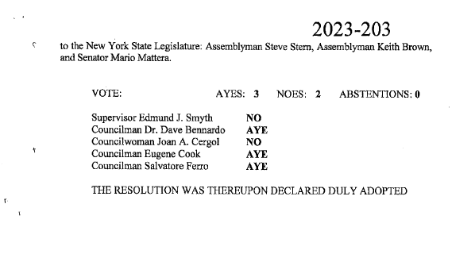
The Town Board tabled resolution for Town of Sodus Code Enforcement Fee Schedule until the June 22, 2023 Month End Town Board Meeting.

The Town Board tabled motion to advertise and hold public hearing for Local Law 4-2023 to regulate recreational vehicles and campers for Tuesday July 11, 2023 at 6:15 PM.
The Board will discuss this at the July 11, 2023 meeting and motion to hold public hearing at the August 8, 2023 Regular Town Board Meeting.

The Town Board tabled motion to advertise and hold public hearing for Local Law 5-2023 to regulate recreational vehicles and campers for Tuesday July 11, 2023 at 6:30 PM. The Board will discuss this at the July 11, 2023 meeting and motion to hold public hearing at the August 8, 2023 Regular Town Board Meeting.

Motion by Councilmember Don Ross to enter into Executive Session regarding medical, financial, credit or employment history of a particular person or corporation or relating to appointment promotion demotion discipline or removal was seconded by Councilmember Cathy Willmott. Upon roll call the following votes were heard, Scott Johnson, aye; David LeRoy, aye; Don Ross, aye; Chris Tertinek, aye; and Cathy Willmott; aye. Motion carried.
Time 5:30 PM

Motion by Councilmember Chris Tertinek to exit out of Executive Session and to enter into Regular Session was seconded by Councilmember Cathy Willmott. Upon roll call the following votes were heard, Scott Johnson, aye; David LeRoy, aye; Don Ross, aye; Chris Tertinek, aye; and Cathy Willmott; aye. Motion carried.
Time 5:52 PM

A motion by Councilperson Chris Tertinek to adjourn the Regular Town Board Meeting was seconded by Councilperson Don Ross. Upon roll call the following votes were heard, Scott Johnson, aye; David LeRoy, aye; Don Ross, aye; Chris Tertinek, aye; and Cathy Willmott; aye. Resolution adopted.

Meeting adjourned at 5:53 PM

Recording Secretary,
Lori K. Diver
Sodus Town Clerk, RMC

