Sodus Town Board Agenda
Regular Month End-Town Board Meeting
June 22, 2023
4:00 PM
Roll Call: (Lori Diver)
Supervisor Johnson, Councilperson LeRoy, Councilperson Ross, Councilperson Tertinek, Councilperson Willmott

Agenda:

- Resolution authorizing payment of Abstract # 11-2023 for payment.
First_________________ Seconded____________________ (emailed).

- Discussion/Resolution adopting proposed Town of Sodus Code Enforcement Fee Schedule (emailed-Chandra).
First_________________ Seconded____________________

EXECUTIVE SESSION:
- Motion to enter into Executive Session regarding medical, financial, credit or employment history of a particular person or corporation or relating to appointment promotion demotion discipline or removal.
Time_________________

- Motion to exit out of Executive Session and enter back into regular session.
Time _________________

- Motion to adjourn meeting
First_________________ Seconded____________________

MINUTES
Minutes of the Month End Town Board Meeting commencing at 4:00 PM in the upstairs meeting room June 22, 2023 located at 14-16 Mill St. Sodus, NY 14551.
All meetings are open to the public.

Present: Scott Johnson, Supervisor
David LeRoy, Councilperson/Deputy Supervisor
Don Ross, Councilperson
Chris Tertinek, Councilperson
Cathy Willmott, Councilperson

Recording Secretary: Lori Diver Sodus Town Clerk

Absent: N/A

Others Present: Casey Carpenter, Times of Wayne County
Chandra Jensen, Assistant to Code Enforcement Officer

Supervisor Scott Johnson called the Month End Town Board Meeting to order commencing at 4:00 PM and Lori Diver opened with roll call. All were present.

ABSTRACT
RESOLUTION TO PAY ABSTRACT No. 11
(06 06-2023)

WHEREAS, the following bills were presented for payment on Abstract 11:

General 272-282 $ 15,493.58
Highway 153-165 $ 44,389.48
Trust Agency 042-043 $ 2,923.24
Capital Projects 029-029 $ 1,734.00
GRAND TOTAL: $ 65,540.30

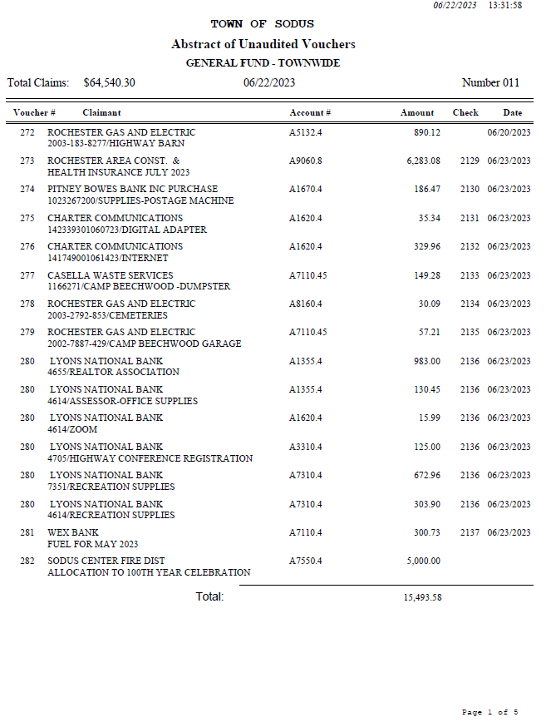

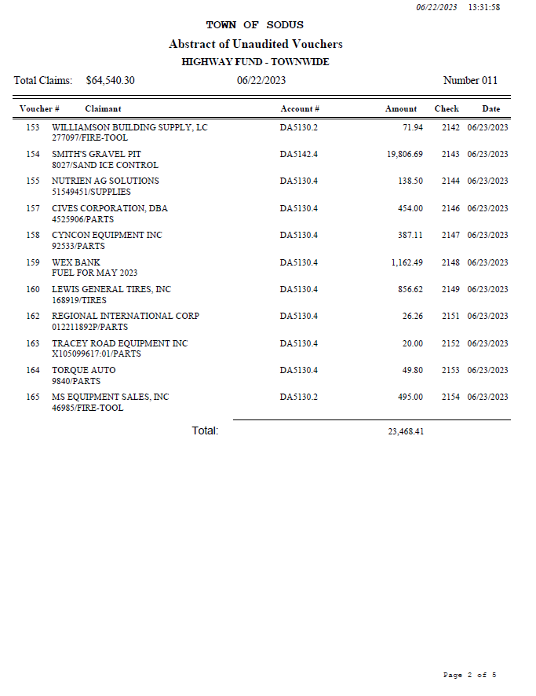

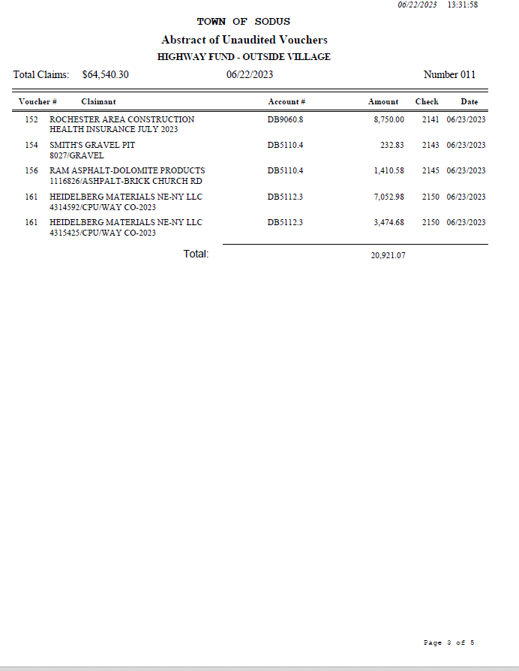

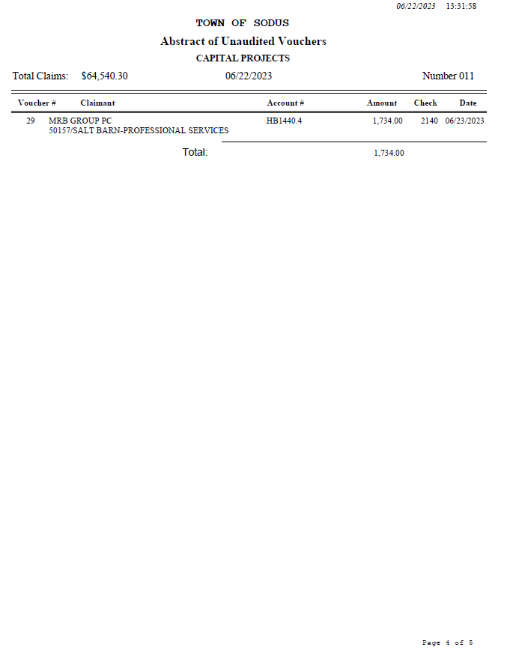

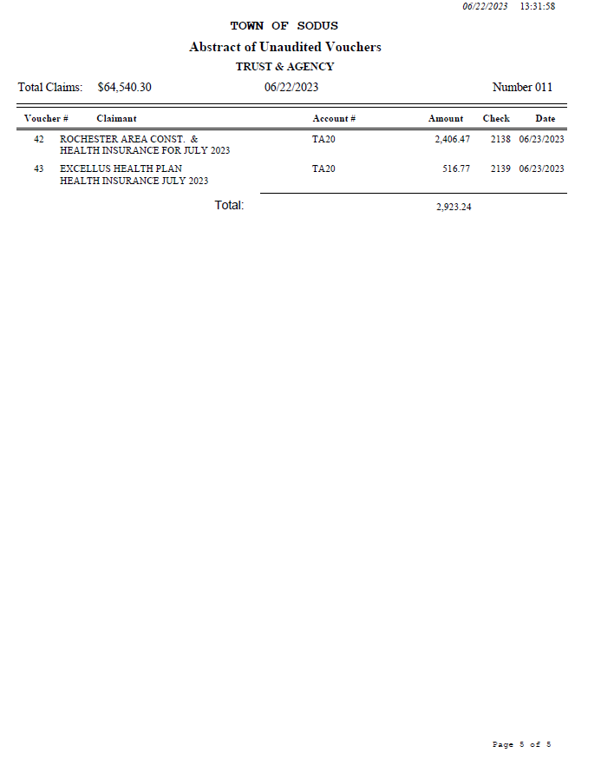
NOW BE IT RESOLVED, Councilperson Don Ross motioned to authorize payment for Abstract # 11 as listed and adopt this resolution which was seconded by Councilperson David LeRoy. Upon roll call the following votes were heard, Scott Johnson, aye; David LeRoy, aye; Don Ross, aye; Chris Tertinek, aye; and Cathy Willmott; aye. Resolution Adopted.

RESOLUTION
NEW CODE ENFORCEMENT FEE SCHEDULE
(07 06-2023)
NOW BE IT RESOLVED; Councilperson Cathy Willmott motioned to adopt the 2023 Town of Sodus Code Enforcement Fee Schedule effective July 1, 2023 as listed was seconded by Councilperson Don Ross. Upon roll call the following votes were heard, Scott Johnson, aye; David LeRoy, aye; Don Ross, aye; Chris Tertinek, aye; and Cathy Willmott; aye. Resolution Adopted.
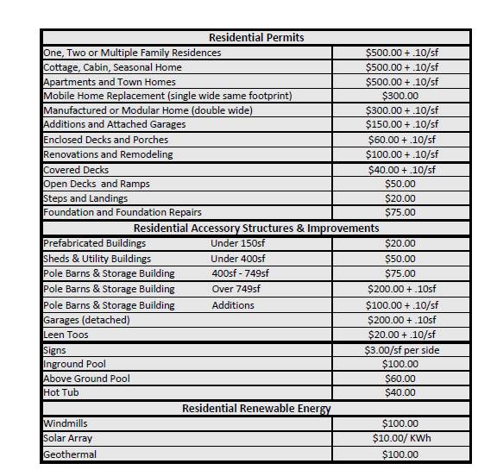
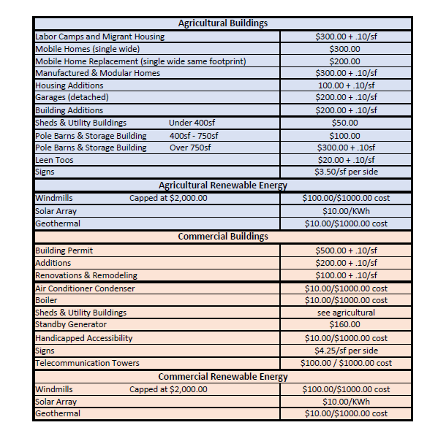

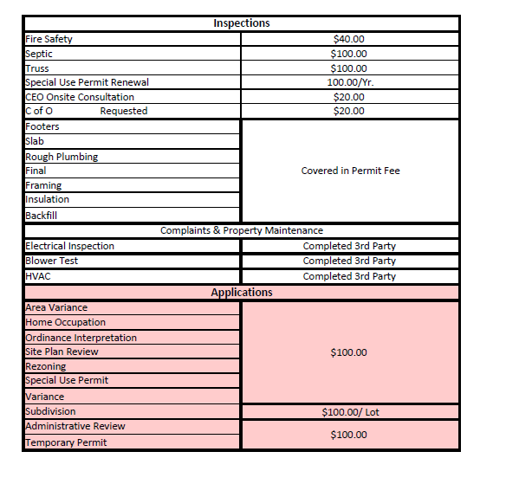
Motion by Councilmember Chris Tertinek to enter into Executive Session regarding medical, financial, credit or employment history of a particular person or corporation or relating to appointment promotion demotion discipline or removal was seconded by Councilmember Don Ross. Upon roll call the following votes were heard, Scott Johnson, aye; David LeRoy, aye; Don Ross, aye; Chris Tertinek, aye; and Cathy Willmott; aye. Motion carried.
Time 4:50 PM

Motion by Councilmember Chris Tertinek to exit out of Executive Session and to enter into Regular Session was seconded by Councilmember Don Ross. Upon roll call the following votes were heard, Scott Johnson, aye; David LeRoy, aye; Don Ross, aye; Chris Tertinek, aye; and Cathy Willmott; aye. Motion carried.
Time 4:55 PM

Councilperson Cathy Willmott motioned to adjourn the Month End Town Board Meeting was seconded by Councilperson Chris Tertinek. Upon roll call the following votes were heard, Scott Johnson, aye; David LeRoy, aye; Don Ross, aye; Chris Tertinek, aye; and Cathy Willmott; aye. Motion carried. 4:55 PM

Minutes Written By:
Lori K. Diver
Sodus Town Clerk, RMC

