Sodus Town Board Agenda
March 23, 2023
6:15 PM
Open with Pledge Allegiance
Roll Call: (Lori Diver)
Supervisor Johnson, Councilperson LeRoy, Councilperson Ross (Zoom), Councilperson Tertinek, Councilperson Willmott

EXECUTIVE SESSION (6:15 PM):
- Motion to enter into Executive Session regarding medical, financial, credit or employment history of a particular person or corporation or relating to appointment promotion demotion discipline or removal.
Time_________________

- Motion to exit out of Executive Session and enter back into regular session.
Time _________________

Public Speakers:
Dave Doyle, MRB

Agenda:
Minutes: Motion to file the following minutes:
- February 14, 2023
- February 28, 2023
- March 2, 2023
- March 6, 2023 (Cathy must abstain)

- Supervisor’s Report

- Town Clerk’s Report

- Tax Collection Report

- Resolution to Approve Bills 5-2023

- Public Works Committee: Councilperson David LeRoy
(Highway, Drainage)
- Motion to file Highway Superintendent’s Report

- Salt Barn:

- Drainage N/A

- Buildings and Grounds Committee: Councilperson Chris Tertinek
(Town Property, Animal Control, Code Enforcement, Flood Damage)
- Motion to file Code Enforcement Report – Frank Gahr
- Motion to file Dog Control Officer Report– Robert Snyder
- Flood Damage Prevention – Chris Tertinek

- Recreation/Environmental Committee: Councilperson Cathy Willmott
(Recreation, Assessor, Parks, Cemeteries)
- Motion to file Sodus Recreation Report-Sheila Fisher
- Motion to file Assessor’s Report – Nathan Mack
- Motion to file Camp Beachwood/Sodus Groundskeeper Report – Sal Vittozzi

- Public Safety Committee: Councilperson Don Ross
(Fire, Ambulance, Emergency Preparedness - WC, Water Authority - WC)

- Town Hall Committee: Supervisor Scott Johnson
(Personnel, Town Council, Court, Assessor, Building Inspector, Boards/Committees, Insurances, Finance, Environmental)
Correspondence & Information
- Resolution Awarding Contract for Construction of New Salt Storage Structure to low bidder WD Malone Trucking and Excavating, Inc., which submitted the following bid pricing; and Lump Sum Base Bid: $1,210,586.00, Alternate No. 1 Deduct: $122,000.00 and Total Base Bid Less Alt. No 1 Deduct $1,088,586.00.

- Resolution filing the 1-1-2022 to 1-1-2023 Town of Sodus Court audit, in accordance with monitoring town board compliance; Section 2019-a. The audit was completed by Councilperson Dave LeRoy on March 5, 2023.

- Motion allowing Lori Diver to advertise bids for the Town of Sodus Spring Cleanup to be held May 5th and May 6th 8:30 AM – 3:30 PM and the Fall Cleanup October 7th 8:30 AM – 3:30 PM. BID openings will be opened at the April 11th, 2023 meeting at 6:00 PM in the Sodus Town Courtroom.

- Resolution refunding the Sodus Point Neighborhood Association for local bingo fees collected locally (Town of Sodus amount collected) in the amount of $232.50 on 12/23/2019. The State Comptroller approved the refund and this authorization allows the Town Board to refund the local fee collected at 100%. There is no processing fee since the events were going to take place during 2020 (Covid) and that the Town of Sodus does not have a local law allowing for bingo. This will be disbursed at the April 11, 2023 meeting on the Abstract.

- Resolution authorizing Supervisor Scott Johnson to sign service agreement with Casella for use of dumpster at Camp Beechwood. The monthly service fee of $15.00 for a 4YD dumpster and $100.00 for each pickup fee of garbage. The term is 36 months.

- Resolution authorizing the Code Enforcement Office to purchase a Brother Business Color Laser Printer, HL-L8360CDW in the amount of $709.00 (includes labor). The current printer is breaking.

- Resolution authorizing the use of fund balance and capital project reserves for the highway salt barn. Fund Capital Projects-Salt Barn Reserve $500,000.00, Unassigned Fund Balance B $537,000.00 and Unassigned Fund Balance DB $300,000.00.

- Resolution allowing Highway Superintendent, the Sodus Town Board and the Town Supervisor to sign agreement form 284 to spend Highway Funds Chips $270,225.00, Pave NY $71,687.00, EWR $60,851.00 and POP, $47,792.00.

- Motion allowing USDA to place traps for the European Cherry Fruit Fly Program in the Town of Sodus.

- Resolution allowing Supervisor Johnson to sign NYS State Partnership Agreement C003103 Municipal Operation of Beechwood State Park Excess Revenues.

- Plow Truck/UTV side by side for Camp Beechwood discussion (Supervisor Scott Johnson).

- Letter from Laurie Verbridge Sodus Point Trustee regarding Traffic Calming Route 14 Sodus Point, NY.

- Discussion regarding Adam Breen’s (Alternative Technology) to set up .gov emails for 5-8 emails for the Town of Sodus/ approval?

- Resolution approving the 2023 Winter Sodus Recreation Payroll (as sent in an email earlier this week).

- Motion to adjourn meeting.
Time _________________
MINUTES
Minutes of the Regular Town Board Meeting March 23, 2023 held in person at the Town of Sodus courtroom commencing at 6:15 PM 14-16 Mill St. Sodus, NY.
All meetings are open to the public and by Zoom.

Present: Scott Johnson, Supervisor
David LeRoy, Councilperson/Deputy Supervisor
Don Ross, Councilperson-Zoom
Chris Tertinek, Councilperson
Cathy Willmott, Councilperson

Recording Secretary: Lori Diver, Town Clerk

Absent: N/A

Others Present: Sal Vittozzi, Groundskeeper
Bree Crandell, Supervisor Clerk -Zoom
Dale Pickering, Highway Superintendent
Knauf and Shaw, Town Attorney- (Samantha) Zoom
Casey Carpenter, Times of Wayne County-Zoom
Sheila Fisher, Recreation Director
Stacie Avery, Sodus Deputy Clerk
Dave Doyle, MRB
Frank Cavallo, Sodus Resident
Nathan Mack, Assessor

Supervisor Scott Johnson called the Regular Town Board Meeting to order commencing at 6:15 PM with the Pledge of Allegiance and Lori Diver opened with roll call.
Supervisor Johnson, Councilperson LeRoy, Councilperson Ross-Zoom, Councilperson Tertinek and Councilperson Willmott were all present.

EXECUTIVE SESSION:
- Councilperson David LeRoy motioned to enter into Executive Session regarding medical, financial, credit or employment history of a particular person or corporation or relating to appointment promotion demotion discipline or removal was seconded by Councilperson Don Ross. Upon roll call the following votes were heard, Supervisor Scott Johnson, aye; David LeRoy, aye; Don Ross, (Zoom) aye; Chris Tertinek, aye; and Cathy Willmott; aye. Motion carried.
Time: 6:16 PM

- Councilperson David LeRoy motioned to exit out of Executive Session and enter back into regular session was seconded by Councilperson Don Ross. Upon roll call the following votes were heard, Supervisor Scott Johnson, aye; David LeRoy, aye; Don Ross, aye (Zoom); Chris Tertinek, aye; and Cathy Willmott; aye. Motion carried.
Time: 6:57 PM

Public Speakers:
Dave Doyle with MRB discussed with the Sodus Town Board the updated schedule with the new build of the salt shed structure (location Sodus Town Highway Department). Doyle also helped answer questions regarding awarding the bid of the current low bidder, WD Malone Trucking and Excavating, Inc.

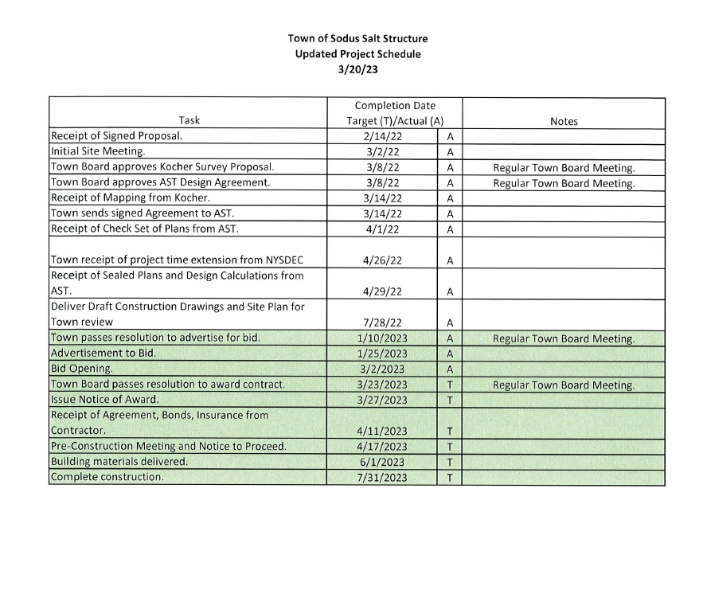

Frank Cavallo, Sodus Resident came before the Board for any update regarding the new ambulance base to be built in Sodus. Supervisor Scott Johnson stated he will speak with someone at the County regarding getting up-to-date information. Johnson did state that is a county building for an ambulance base to be built in Sodus; which in turn would help with emergency services.
MINUTES
Minutes from February 14, 2023 was presented to the Town Board to be filed. Councilperson Cathy Willmott motioned to file these Minutes, which was seconded by Councilperson Don Ross. Upon roll call the following votes were heard, Supervisor Scott Johnson, aye; David LeRoy, aye; Don Ross, (Zoom) aye; Chris Tertinek, aye; and Cathy Willmott; aye. Motion carried.

Minutes from February 28, 2023 was presented to the Town Board to be filed. Councilperson Don Ross motioned to file these Minutes, which was seconded by Councilperson David LeRoy. Upon roll call the following votes were heard, Supervisor Scott Johnson, aye; David LeRoy, aye; Don Ross, (Zoom) aye; Chris Tertinek, aye; and Cathy Willmott; aye. Motion carried.

Minutes from March 2, 2023 was presented to the Town Board to be filed. Councilperson Chris Tertinek motioned to file these Minutes, which was seconded by Councilperson Cathy Willmott. Upon roll call the following votes were heard, Supervisor Scott Johnson, aye; David LeRoy, aye; Don Ross, (Zoom) aye; Chris Tertinek, aye; and Cathy Willmott; aye. Motion carried.

Minutes from March 6, 2023 was presented to the Town Board for approval. Councilperson Don Ross motioned to file these Minutes, which was seconded by Councilperson Chris Tertinek. Upon roll call the following votes were heard, Supervisor Scott Johnson, aye; David LeRoy, aye; Don Ross, (Zoom) aye; Chris Tertinek, aye; and Cathy Willmott; abstained-absent. Motion carried.

SUPERVISOR’S REPORT
The Supervisor’s monthly report was presented for February 2023. Councilperson Don Ross motioned to file this report, which was seconded by Councilperson Cathy Willmott. Upon roll call the following votes were heard, Supervisor Scott Johnson, aye; David LeRoy, aye; Don Ross, aye (Zoom); Chris Tertinek, aye; and Cathy Willmott; aye. Motion carried.

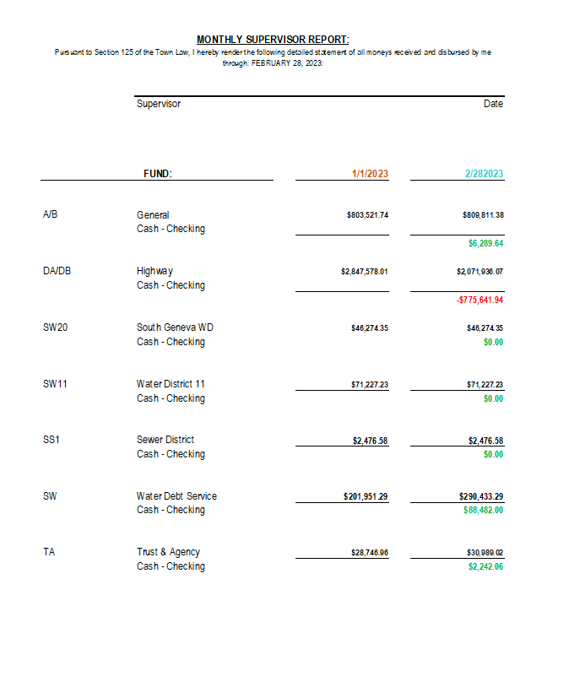

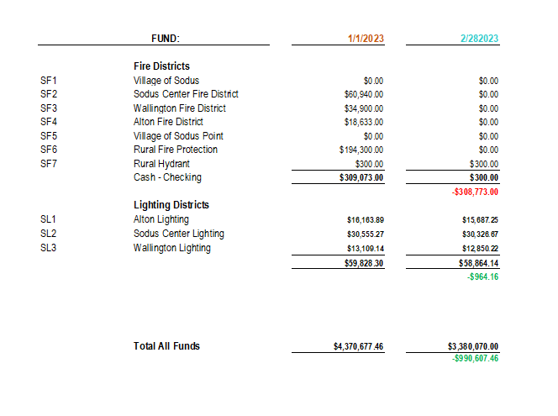
TOWN CLERK’S REPORT
The Town Clerk’s Reports, Town Clerk’s bank statements for audit and bank register for February 2023 was presented. Note: bank statement and bank register are listed in detail with Town Clerk cash book for 2023. For security reasons and confidentiality, it cannot be published in Minutes. Councilperson David LeRoy motioned to file these reports, which was seconded by Councilperson Cathy Willmott. Upon roll call the following votes were heard, Supervisor Scott Johnson, aye; David LeRoy, aye; Don Ross, aye (Zoom); Chris Tertinek, aye; and Cathy Willmott; aye. Motion carried.

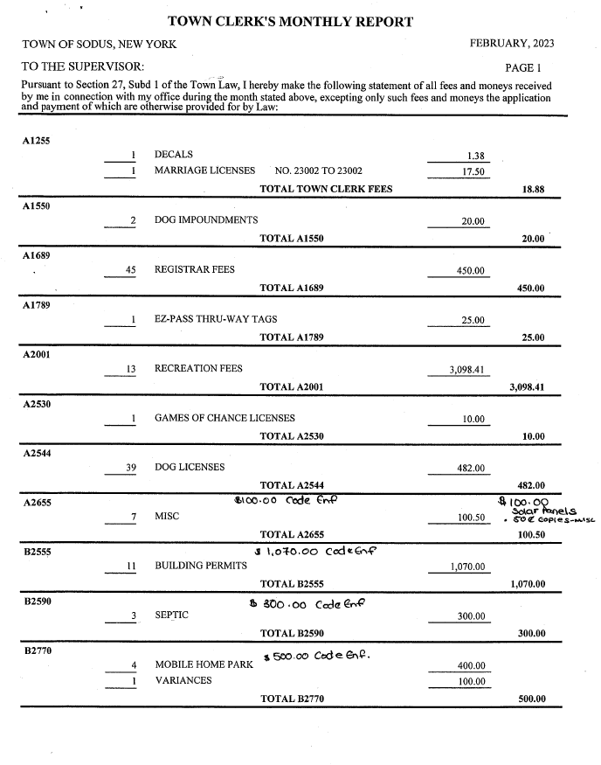

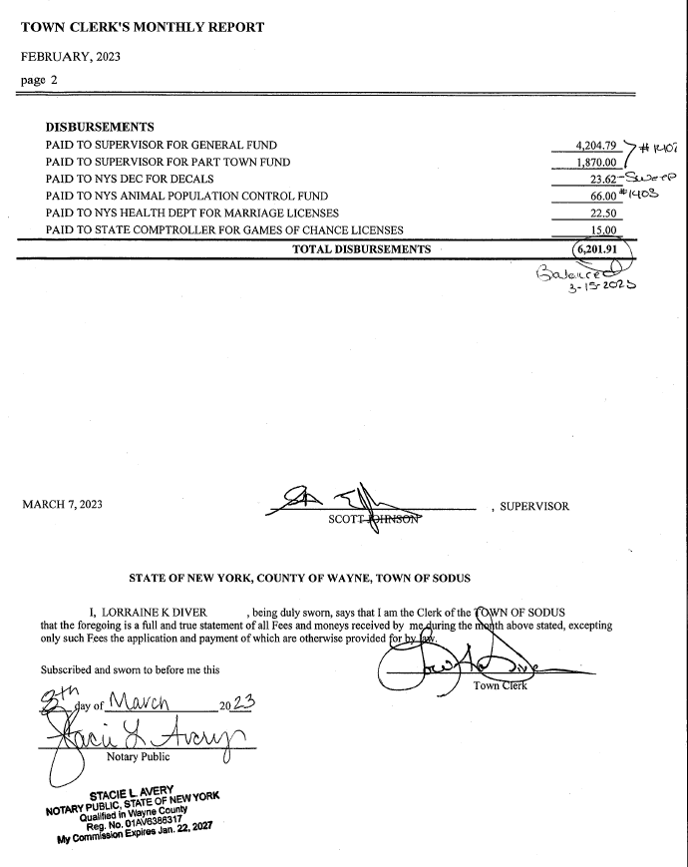

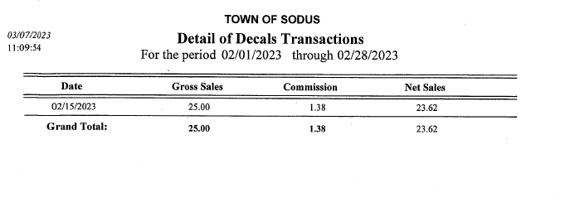

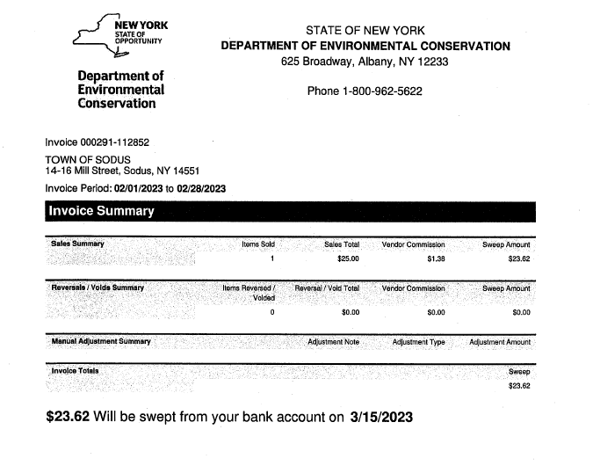

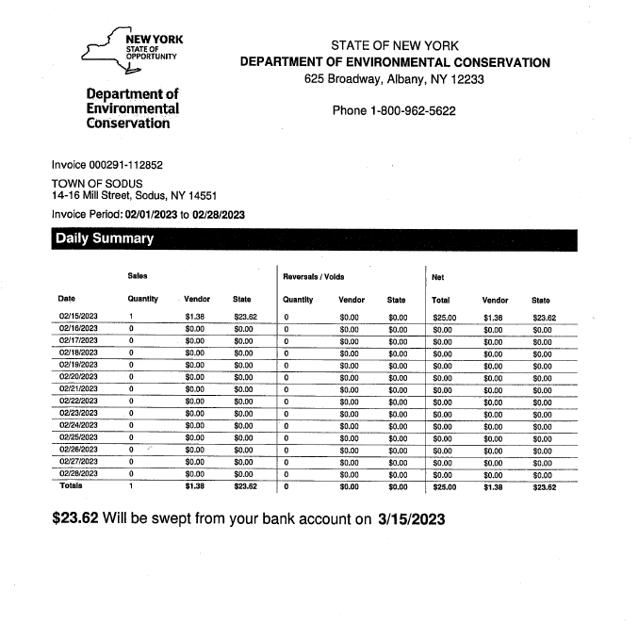

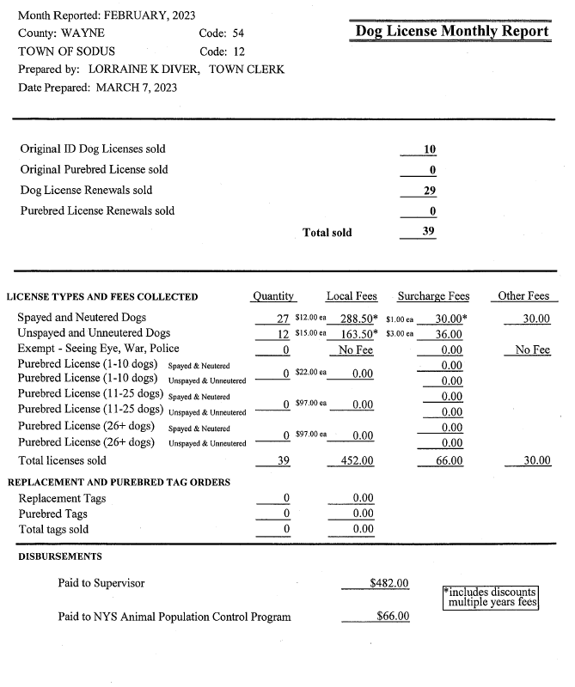

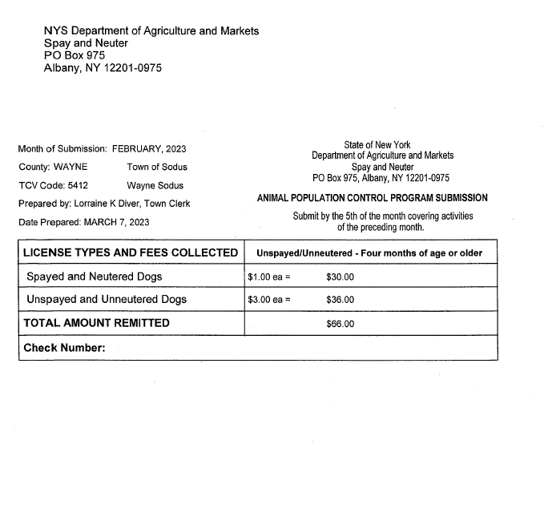

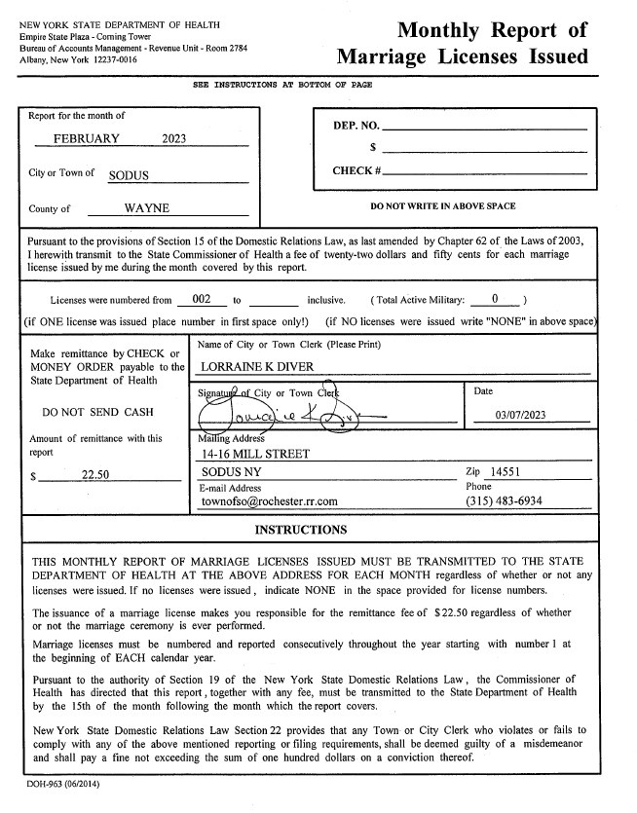

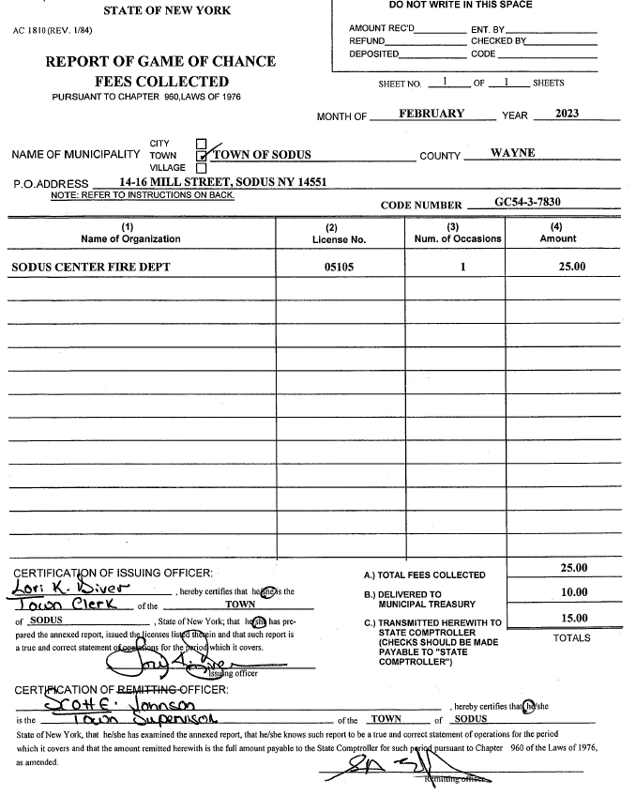

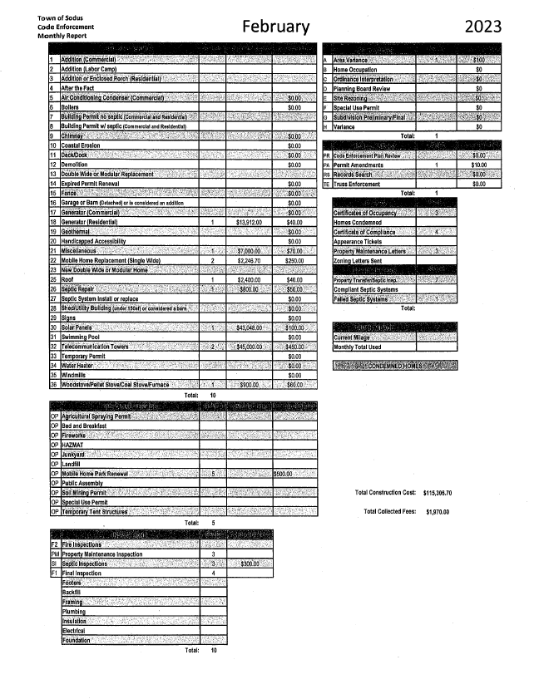

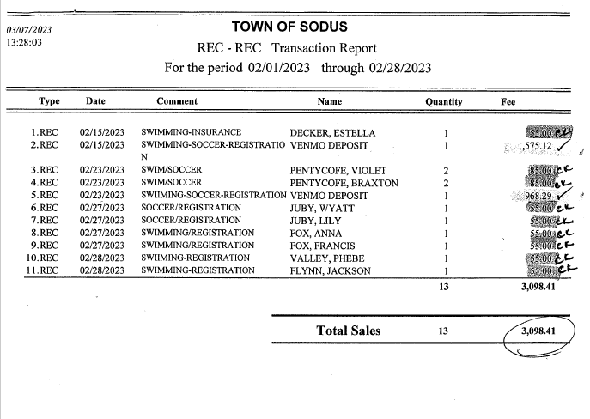

TAX COLLECTION REPORT
The Tax Collection Report, Tax Collector bank statements for audit and bank register for February 2023 was presented. Councilperson Chris Tertinek motioned to file this report, which was seconded by Councilperson David LeRoy. Upon roll call the following votes were heard, Supervisor Scott Johnson, aye; David LeRoy, aye; Don Ross, aye (Zoom); Chris Tertinek, aye; and Cathy Willmott; aye. Motion carried.
Note: bank statement and bank register are listed in detail with Tax Collection cash book for 2023. For security reasons and confidentiality, it cannot be published in Minutes.

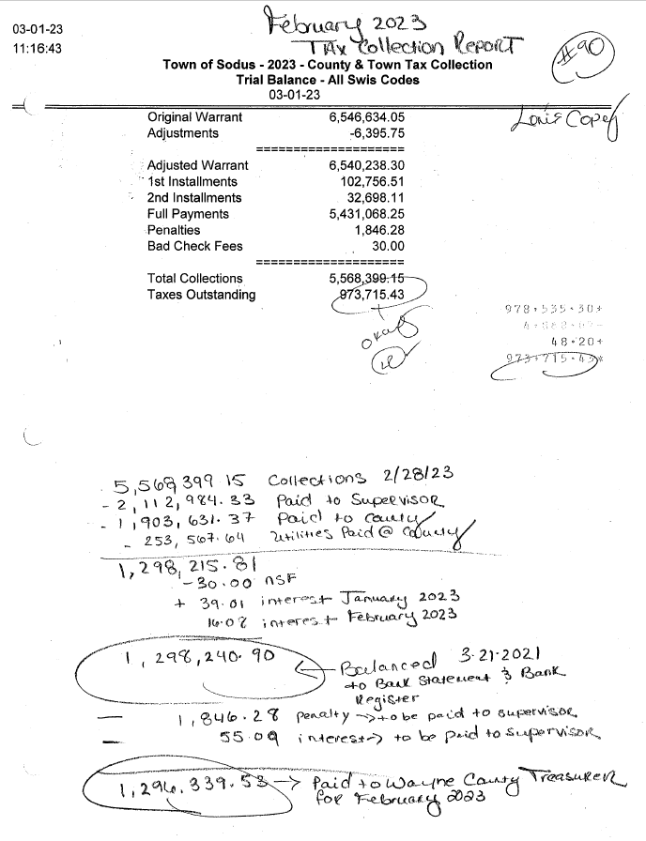

ABSTRACT
RESOLUTION TO PAY ABSTRACT NO. 05
(01 03-2023)
WHEREAS, the following bills were presented for payment on Abstract 05:

General 108-148 $ 27,122.02
Highway 059-084 $ 102,207.28
Special District 006-007 $ 5,634.34
Special Dist. Reg. 001-001 $ 69,679.00
Trust & Agency 035-037 $ 25,117.24
Capital Projects 020-024 $ 7,597.74
GRAND TOTAL: $ 237,357.62

NOW BE IT RESOLVED, Councilperson David LeRoy motioned to approve payment of these bills as reviewed for Abstract No. 05, which was seconded by Councilperson Don Ross. Upon roll call the following votes were heard, Supervisor Scott Johnson, aye; David LeRoy, aye; Don Ross, aye (Zoom); Chris Tertinek, aye; and Cathy Willmott; aye. Resolution Adopted.

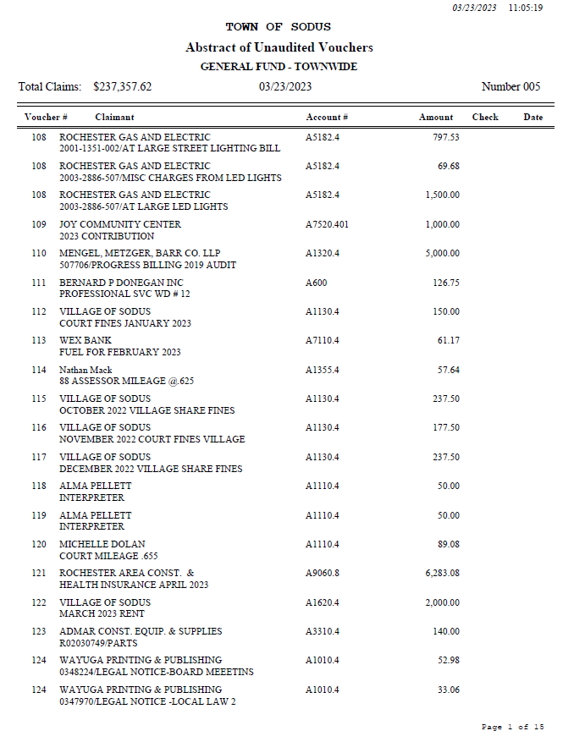

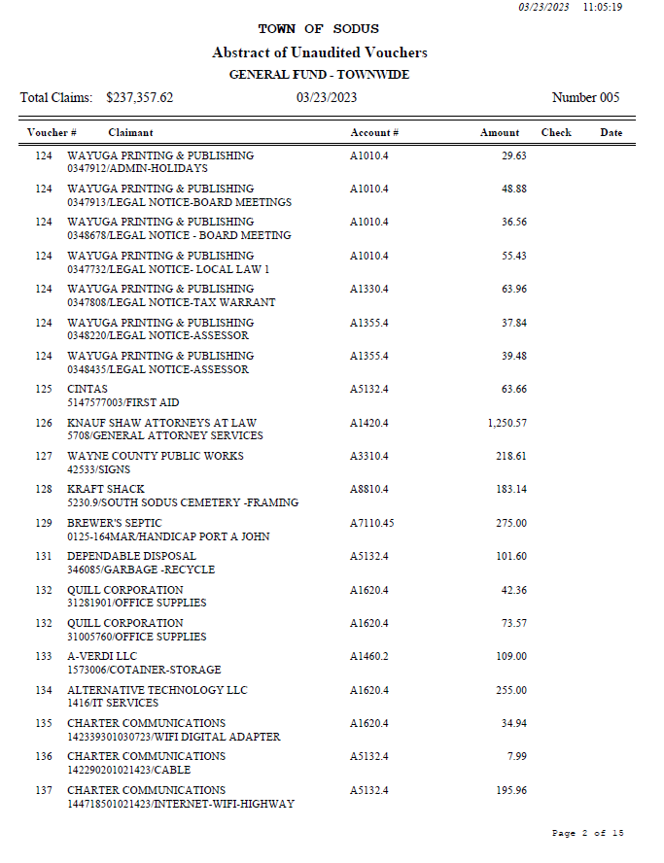

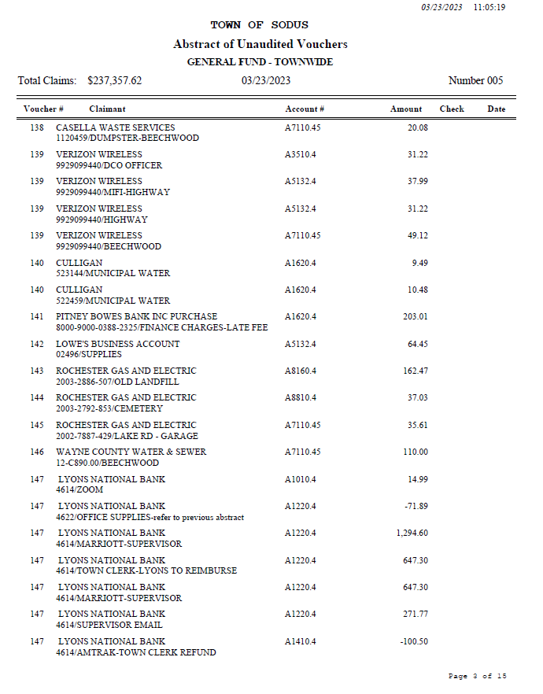

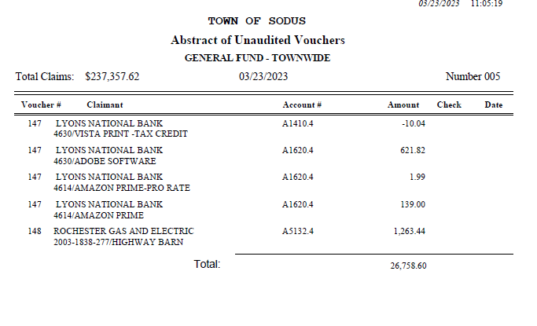

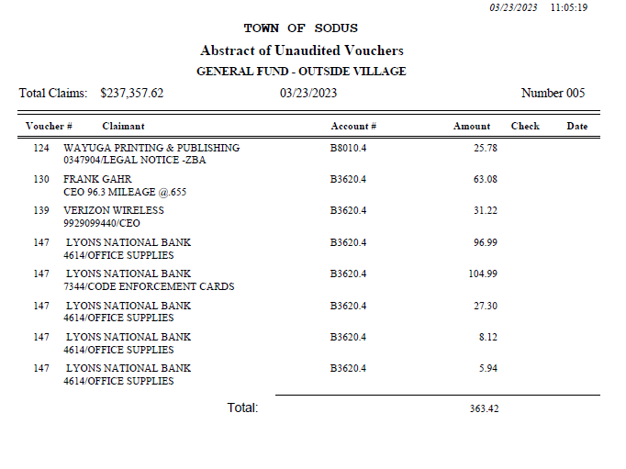

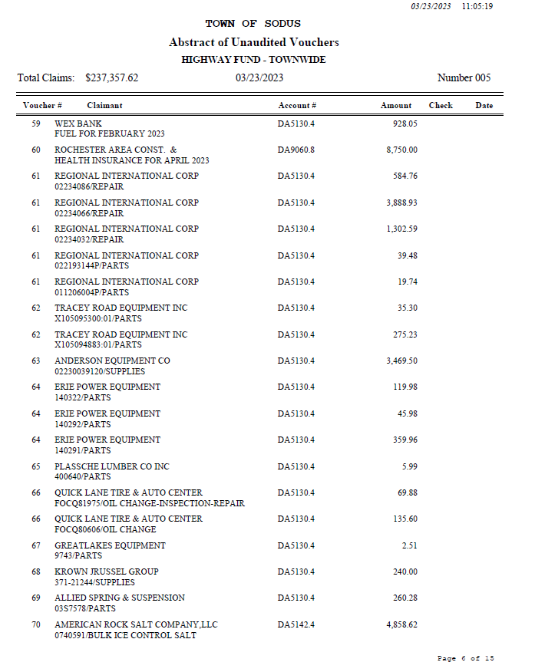

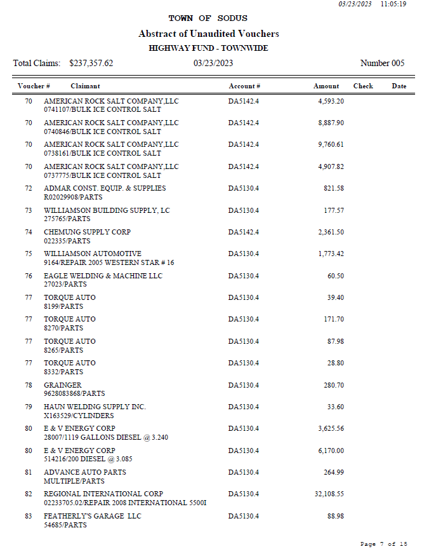

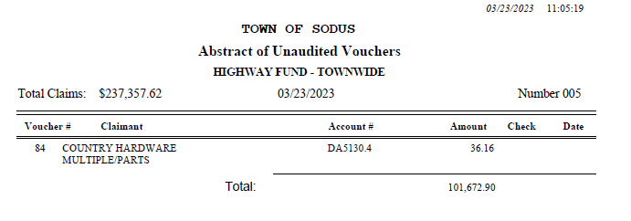

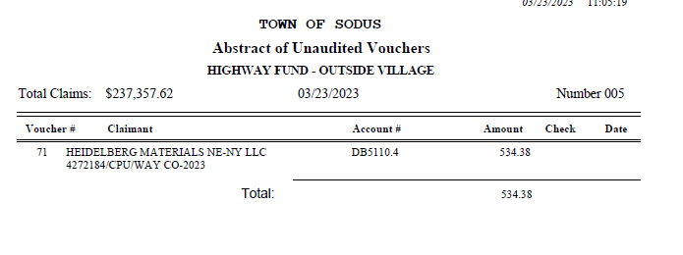

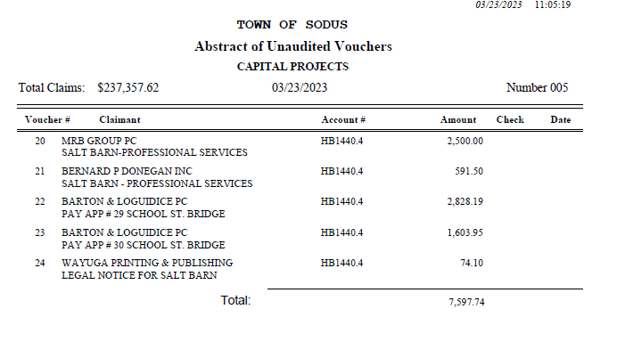

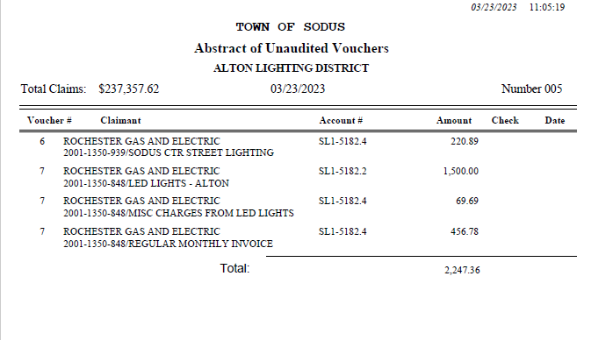

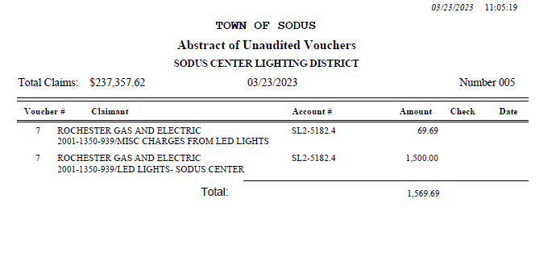

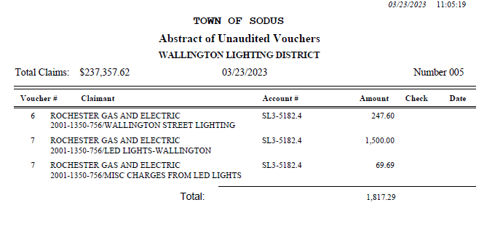

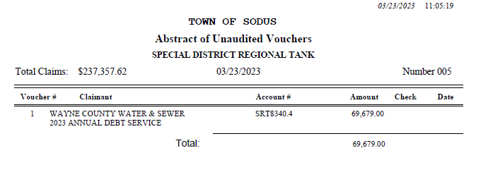

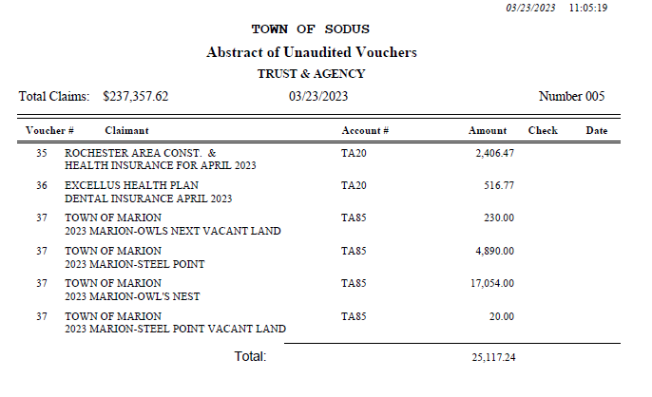
PUBLIC WORKS COMMITTEE: Councilperson David LeRoy, Chair
(Highway, Drainage - Deputy Town Supervisor)
HIGHWAY REPORT:
(Dale Pickering – Highway Superintendent)
Councilperson Chris Tertinek motioned to file the monthly Highway February 2023 report from Dale Pickering Highway Superintendent was seconded by Councilperson Don Ross. Upon roll call the following votes were heard, Supervisor Scott Johnson, aye; David LeRoy, aye; Don Ross, aye (Zoom); Chris Tertinek, aye; and Cathy Willmott; aye. Motion carried.

- Salt Barn:
  - Dave Doyle, MRB discussion under public comments.
- RG&E N/A

- Drainage N/A

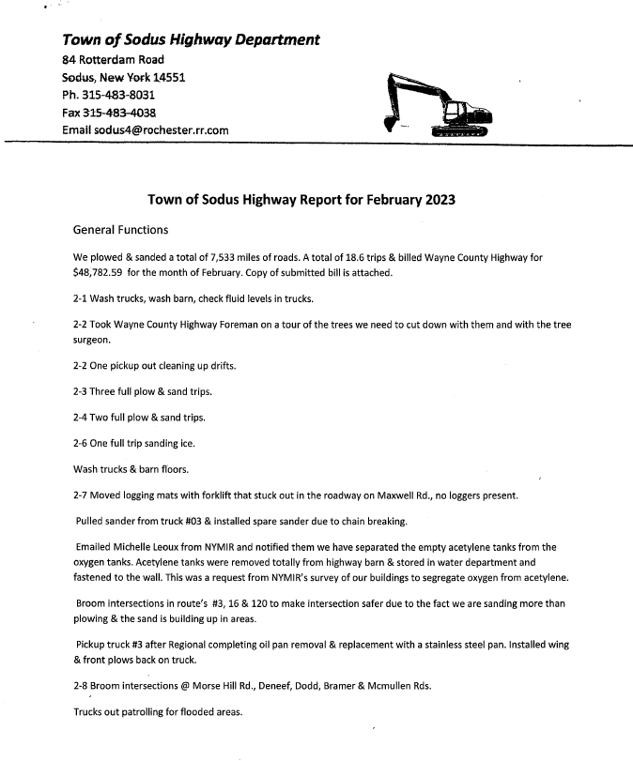

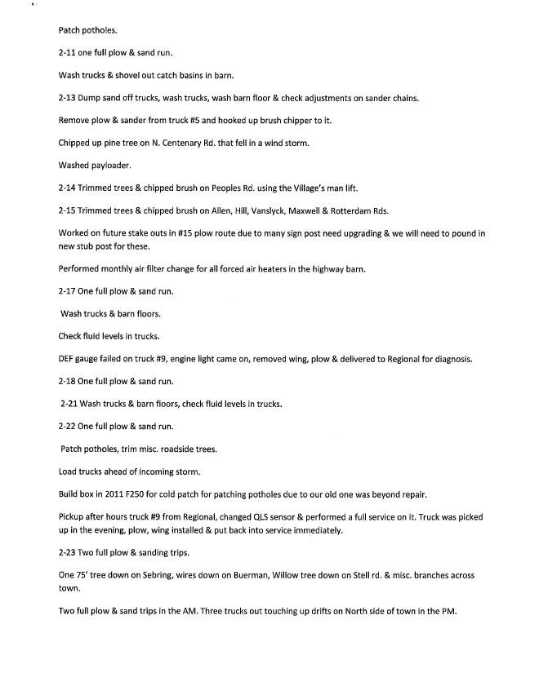
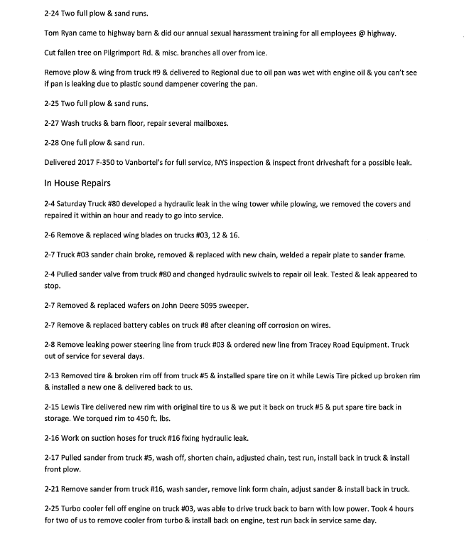

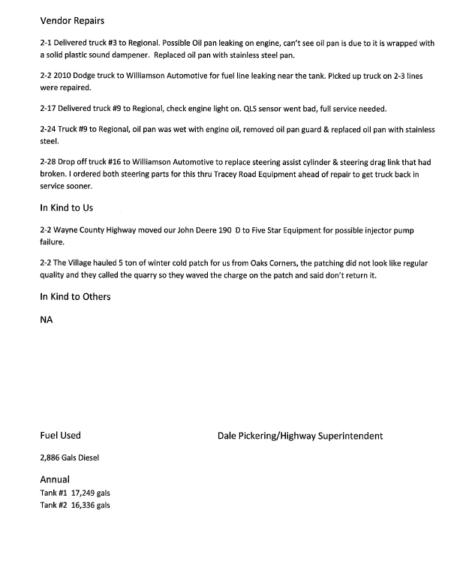

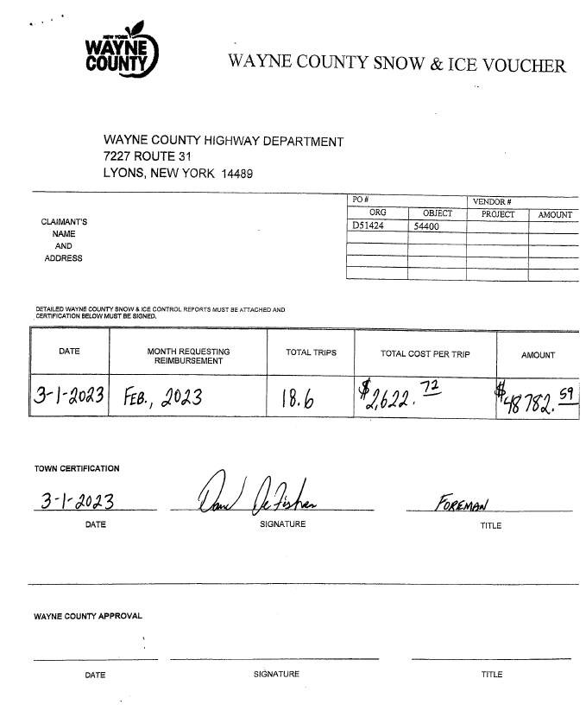

BUILDINGS AND GROUNDS COMMITTEE: Councilperson Chris Tertinek, Chair
(Town Property, Animal Control, Flood Damage Prevention)
CODE ENFORCEMENT REPORT:
Frank Gahr- CEO
Councilperson David LeRoy motioned to file the monthly February 2023 Code Enforcement Report as written, was seconded by Councilperson Don Ross. Upon roll call the following votes were heard, Supervisor Scott Johnson, aye; David LeRoy, aye; Don Ross, aye (Zoom); Chris Tertinek, aye; and Cathy Willmott; aye. Motion carried.
(See page 38)
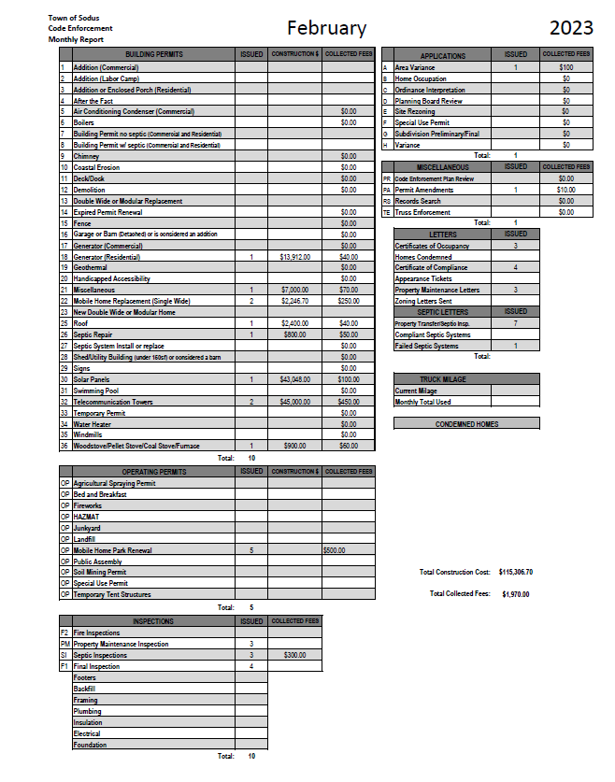

DOG CONTROL REPORT:
Robert Snyder, Primary DCO
Vacant- Secondary DCO
Councilperson Chris Tertinek motioned to file the monthly February 2023 Dog Control report as written, was seconded by Councilperson Dave LeRoy. Upon roll call the following votes were heard, Supervisor Scott Johnson, aye; David LeRoy, aye; Don Ross, aye (Zoom); Chris Tertinek, aye; and Cathy Willmott; aye. Motion carried.

February 2023 Dog Control Report
02-10-2023 Dog was hit on corner of Rt. 14 and York Settlement Rd. Truck did not stop; the dog was killed. 7:00 PM
02-18-2023 911 Call- Williamson State Trooper found dead dog on side of the road. He believes the dog was shot. Craig Schwartz was called. 10:30 AM
02-24-2023 911 Call- 2 dogs running at large on Rt. 104 & Rt. 14. Dogs were taken to Humane Society. 3:00 PM

Mileage: 140 Miles (Submitted at month end Town Board Meeting 2-28-2022 and paid on Abstract #3)
Respectfully Submitted,
Robert Snyder, DCO

FLOOD DAMAGE PREVENTION REPORT-Code 69:
Chris Tertinek, Councilperson
Councilperson Chris Tertinek shared his flood damage prevention report. The lake is at 245.6 ft ASL; up about 4 inches from last report. Presently 5 inches above long-term average. The long term forecast for mid-August is 245.6 ft ASL; 2 inches above the long-term forecast. Tertinek is expecting low water for the fall.

RECREATION/ENVIRONMENTAL COMMITTE: Councilwoman Cathy Willmott
(Recreation, Assessor, Parks, Cemeteries)
CAMP BEECHWOOD-PARKS-CEMETERIES REPORTS:
Recreation Report
(Sheila Fisher, Recreation Director)
Councilperson Cathy Willmott motioned to file the monthly February 2023 Recreation report from Sheila Fisher, Recreation Director was seconded by Councilperson Chris Tertinek. Upon roll call the following votes were heard, Supervisor Scott Johnson, aye; David LeRoy, aye; Don Ross, aye (Zoom); Chris Tertinek, aye; and Cathy Willmott; aye. Motion carried.

Director’s Report
Sodus Recreation Board Meeting
March 6, 2023

Programs:
- Soccer and Swim lessons started this past Saturday, March 4th.
- We had a very successful first day! Unfortunately, due to weather we did have some parents message to say they would start next weekend.

Currently, we have:
- 41 Soccer players in the 2yr old/PreK/K age group
- 35 Soccer players in the 1st/2nd/3rd grade level
- 50 Swimmers in the 1st session, 8 babies under 3 yrs old
- 47 Swimmers in the 2nd session, 14 babies under 3 yrs old
- 37 Swimmers in the 1st session, 8 babies under 3 yrs old

Winter Program Profit to date:
Total profit as of 3/4/23 from Soccer, Swimming and Registration & Insurance fees are:
- $5707.15
We still have fees to be collected.

Employees:
- Our Winter program consists of the following employees:
A full detailed list was emailed to Cathy Wilmott 2/27.
- 18 Instructors @ $14.20 per hour, Current NYS minimum wage
- 4-5 Supervisor/Coordinators @ $18.00 per hour, same rate as last year
- 2- Co-Coordinators @ $16.00 per hour, same rate as last year
- Approximate payroll for Winter Programs $6100.00

Supervisors receive planning hours for their programs. Therefore, they will have an average of 40 hours total for the Winter programs. Instructors will have an average of 6-20 hours, depending on the dates, programs and hours worked.
Not all Instructors are working every Saturday, which is why we have 18. We have student Instructors attending the Senior Trip and who are in the Musical, therefore they need certain Saturdays off.

Recreation Board:
- The next Recreation Board meeting is March 20th @ 5:30pm in the Town Hall Board Room.

Budget updates:
No payroll has been submitted for the 2023 budget year thus far.

Assessor’s Report
(Nathan Mack, Assessor)
Councilperson David LeRoy motioned to file the monthly February 2023 report from Sole Assessor Nathan Mack was seconded by Councilperson Cathy Willmott. Upon roll call the following votes were heard, Supervisor Scott Johnson, aye; David LeRoy, aye; Don Ross, aye (Zoom); Chris Tertinek, aye; and Cathy Willmott; aye. Motion carried.

tOWN OF sODUS

ASSESSOR’S OFFICE
Date: March 8, 2023 Respectfully Submitted by: Nathan Mack
AROUND THE OFFICE

- The March 1st deadline for exemptions has passed. We are processing the applications and updating our system with the information.
- Taxpayers who applied but do not qualify, or did not renew their exemptions to will be notified via mail with a notice of removal/denial.
- Between now and May, notices of changes in assessment will be mailed to notify taxpayers of changes in value proposed on the Tentative Assessment roll for 2023.
- I will be scheduling informal review meetings and doing inspections to give Taxpayers the opportunity to discuss their property values before the Tentative Roll.
Camp Beechwood/Sodus Groundskeeper Report
(Sal Vittozzi-Caretaker-Sodus Town Groundkeeper)
Councilperson Cathy Willmott motioned to file the monthly February 2023 report of Camp Beechwood-Parks & Cemeteries from Sal Vittozzi, Sodus Town Groundskeeper-Caretaker was seconded by Councilperson Don Ross. Upon roll call the following votes were heard, Supervisor Scott Johnson, aye; David LeRoy, aye; Don Ross, aye (Zoom); Chris Tertinek, aye; and Cathy Willmott; aye. Motion carried.

February 2023 Beechwood Report
February was a fairly slow yet productive month here at the park. Unseasonably warm weather at the beginning of the month gave me a chance to start the spring cleanup early. Trails are being cleared of debris daily for hikers and skiers and I have been working on clearing out the multiflora rose headed down the west entrance trail to the old pool field. We did see 2 sets of campers in February for a total $45 brought in. In the first week of march, we did see one unfortunate incident down here where a local person stole 15 Norway spruce saplings from our pine forest, but I saw him leaving the park with the trees and he was caught on our cameras. He was arrested by state troopers very quickly and will go through the court process. The stolen trees were returned by the state troopers and are currently being kept alive behind the red barn until replanting occurs. We have also been contacted by multiple scout troops about camping trips in the spring, so our schedule is filling up fast.

Submitted by,
Sal Vittozzi
Groundskeeper

PUBLIC SAFETY/DRAINAGE/ENVIRONMENT COMMITTEE: Councilperson Don Ross, Chair (Fire, Ambulance, Emergency Preparedness)
Councilperson Don Ross gave his committee reports. Ross reported the SESA Meeting was at the Alton Fire Department Sunday March 19, 2023 at 8:30 AM. Breakfast was served. SESA Minutes and the Wayne County 911 report was sent. (Reports cannot be included because of detailed personal information).

TOWN HALL COMMITTEE: Scott Johnson, Supervisor
(Personnel, Clerks, Justices, Assessor, Building Inspector, Town Council, Boards, Insurances, Finance)
N/A

CORRESPONDENCE & INFORMATION

RESOLUTION
AWARDING CONTRACT FOR CONSTRUCTION NEW SALT STORAGE STRUCTURE
(02 03-2023)
(See page 43-44)

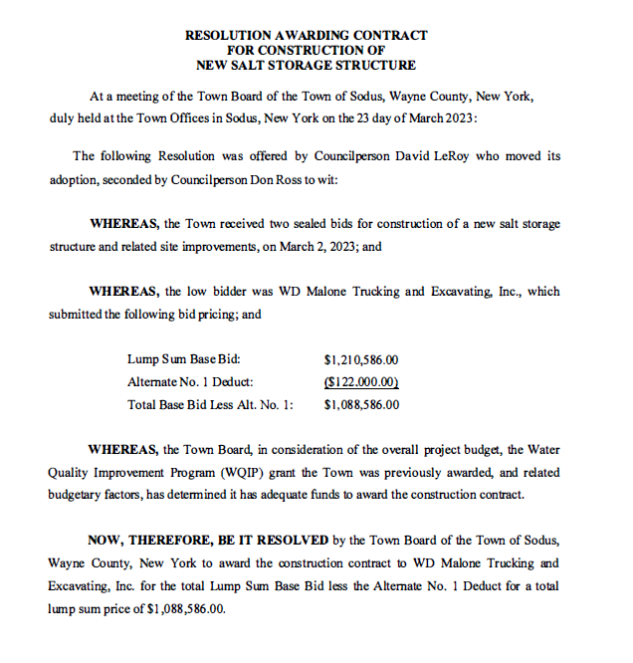

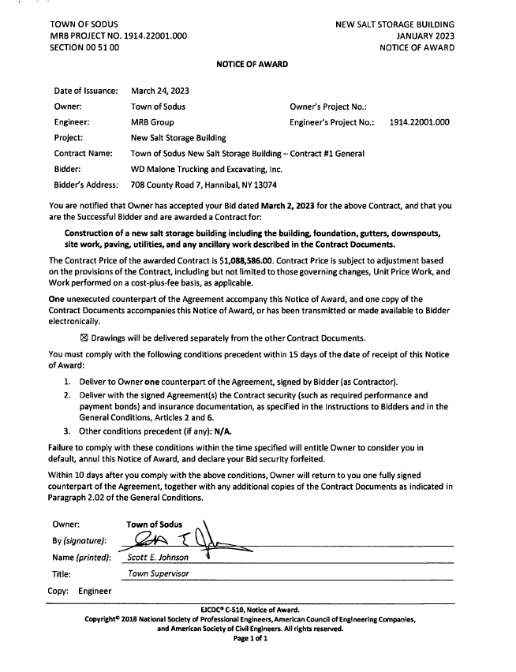
Councilperson David LeRoy motioned to adopt resolution (02 03-2023) was seconded by Councilperson Don Ross. Upon roll call the following votes were heard, Supervisor Scott Johnson, aye; David LeRoy, aye; Don Ross, aye (Zoom); Chris Tertinek, aye; and Cathy Willmott; aye. Resolution Adopted.

TOWN OF SODUS COURT FISCAL EXAMINATION -2022
(03 03-2023)
Supervisor Johnson offered the following resolution for its adoption:

WHEREAS, The NYS Unified Court System requires that the Town of Sodus Court’s records are examined for each fiscal year and that the Town of Sodus notifies accordingly that it was conducted, and

NOW THEREFORE BE IT RESOLVED, Deputy Supervisor David LeRoy conducted the examination of the Town of Sodus Court fiscal records for 2022 and found the review of records in good standing, and

FURTHER BE IT RESOLVED, Councilperson Chris Tertinek motioned to adopt this resolution was seconded by Councilperson Don Ross. Upon roll call the following votes were heard, Supervisor Scott E. Johnson, aye; David LeRoy, aye; Don Ross, (Zoom) aye; Chris Tertinek, aye; and Cathy Willmott, aye. Resolution adopted.

Motion by Councilperson Cathy Willmott to table decision on Spring and Fall Cleanup for 2023 was seconded by Councilperson Chris Tertinek. Upon roll call the following votes were heard, Supervisor Scott Johnson, aye; David LeRoy, aye; Don Ross, aye (Zoom); Chris Tertinek, aye; and Cathy Willmott; aye. Motion carried.

RESOLUTION
REFUNDING NEIGHBORHOOD ASSOCIATION FOR LOCAL BINGO-2023
(04 03-2023)
The following resolution was presented for its adoption:

WHEREAS, on December 23, 2019 the Sodus Point Neighborhood Association paid for a Bingo License at the Sodus Town Clerk’s Office for Bingo to take place in Sodus Point for 2020 and;

WHEREAS, in 2020 Covid-19 occurred shutting down most facilities from holding any events and;

WHEREAS, the Sodus Point Neighborhood Association asked if they could get a refund for these events not taking place and;

WHEREAS, the Town Clerk Lori Diver contacted the NY State Comptroller’s Office asking if the Sodus Point Neighborhood Association could get a refund and;

WHEREAS, the NY State Comptroller’s Office at a later date contacted Lori Diver Sodus Town Clerk and informed her that the Town of Sodus does not have an ordinance for Bingo to take place in the Town of Sodus, the license should have never been issued and;

WHEREAS, at a later date the NY State Comptroller’s Office notified Lori Diver Sodus Town Clerk that they would process the application for the Sodus Point Neighborhood Association and;

WHEREAS, the Lori Diver was informed that the normal process for a refund would take an incredible amount of time to process given many were asking for a refund due to Covid 19 and;

WHEREAS, the normal process would be for NY State to refund the State fees collected and the Town of Sodus to refund for the Town fees collected minus a processing fee and;

WHEREAS, the Town Clerk’s Office contacted Tracy Rubino Director of the NY State Racing and Wagering Commission regarding this erroneous collection and;

WHEREAS, the Town Clerk Lori Diver was unaware that a bingo license could not be issued to anyone hence there was no ordinance to do so in the Town of Sodus and;

WHEREAS, Tracy Rubino informed Town Clerk Lori Diver that she would contact the NY State Comptroller’s Office to inform them there would not be a processing fee since the events were never held and;

WHEREAS, the Town Clerk contacted the NY State Comptroller’s Office throughout 2020-2021-2022 and 2023 regarding this issue again about processing this refund and;

WHEREAS, Renee Malo with the Justice Court Fund emailed Town Clerk Lori Diver December 1, 2022 informing her that the bingo refund had been processed to the Sodus Point Neighborhood Association and;

WHEREAS, the State share of the refund was in the amount of $348.75 waiving the processing fee of $50.00 ($30.00 State/$20.00 Town) per the advisement of the NYS Gaming Commission and;

WHEREAS, the Town Clerk Lori Diver was advised per phone call from Renee Malo in March 2023 that the Town can reimburse the Sodus Point Neighborhood Association the Town fee collected in the amount of $232.50 and;

NOW BE IT RESOLVED, the Town of Sodus will issue a refund to the Sodus Point Neighborhood Association in the amount of $232.50 on the April 11, 2023 Abstract and;

FURTHER BE IT RESOLVED, Motion by Councilperson Cathy Willmott to authorize this resolution was seconded by Councilperson David LeRoy. Upon roll call the following votes were heard, Supervisor Scott Johnson, aye; David LeRoy, aye; Don Ross, aye (Zoom); Chris Tertinek, aye; and Cathy Willmott; aye. Resolution Adopted.

RESOLUTION
CASELLA DUMPSTER-BEECHWOD
(05 03-2023)
The following resolution was presented for its adoption:
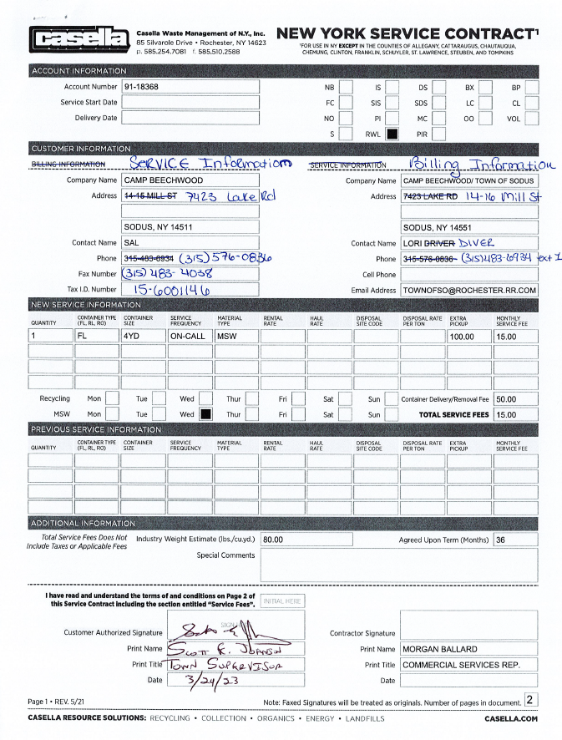

FURTHER BE IT RESOLVED, Motion by Councilperson Cathy Willmott to authorize Supervisor Johnson to sign agreement with Casella Waste Management of N.Y., Inc. for dumpster and garbage services for Camp Beechwood and adopt this resolution was seconded by Councilperson Chris Tertinek. Upon roll call the following votes were heard, Supervisor Scott Johnson, aye; David LeRoy, aye; Don Ross, aye (Zoom); Chris Tertinek, aye; and Cathy Willmott; aye. Resolution Adopted.

RESOLUTION
ALTERNATIVE TECHNOLOGY TECHNICAL SOLUTIONS
(06 03-2023)
The following resolution was presented for its adoption:

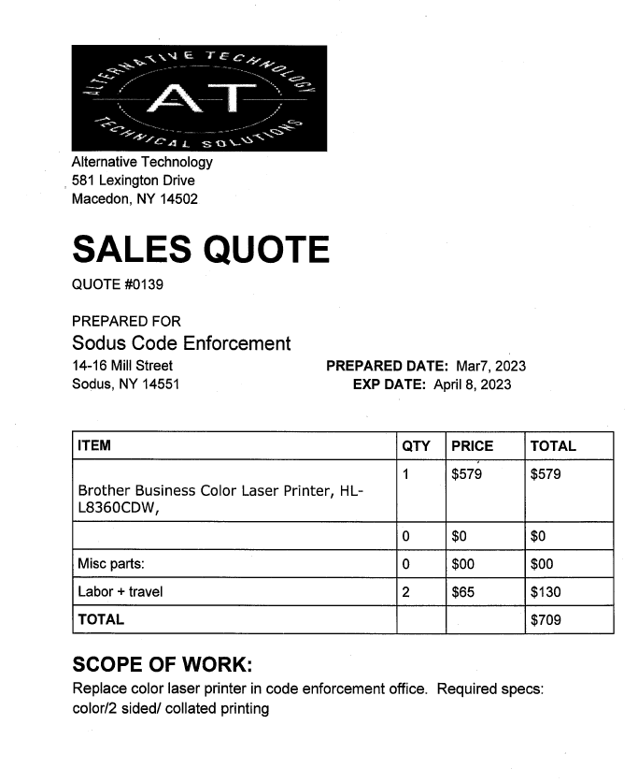

FURTHER BE IT RESOLVED, Motion by Councilperson David LeRoy to authorize the Code Enforcement Office to purchase one new and unused Brother Business Color Laser Printer, HL-L8360CDW in the amount of $579.00, labor and travel of $130.00 was seconded by Councilperson Chris Tertinek. Upon roll call the following votes were heard, Supervisor Scott Johnson, aye; David LeRoy, aye; Don Ross, aye (Zoom); Chris Tertinek, aye; and Cathy Willmott; aye. Resolution Adopted.

RESOLUTION
AUTHORIZING THE USE OF FUND BALANCE AND CAPITAL PROJECT RESERVES FOR THE HIGHWAY SALT BARN:
(07 03-2023)
The following resolution was presented for its adoption:

WHEREAS, at a meeting of the Town Board on March 6, 2023, the Town Board by Resolution awarded the Salt Barn Bid, and
WHEREAS, the Town Board desires to appropriate Unassigned Fund Balance in the B and DB Fund, and
WHEREAS, the Town Board also desires to use funds in the Capital Project – Salt Barn Fund HB1440.4 Appropriated in the 2023 Budget.
BE IT RESOLVED, that the use of the following Fund Balance and Reserves are appropriated as follows:
FUND | AMOUNT
CAPITAL PROJECTS - SALT BARN RESERVE  Appropriated in the 2023 Budget | $500,000.00
UNASSIGNED FUND BALANCE B | $537,000.00
UNASSIGNED FUND BALANCE DB | $300,000.00

BE IT RESOLVED, that the Clerk to the Supervisor is hereby authorized to make the above financial transfers and amend the 2023 budget.
Adopted at a meeting of the Sodus Town Board on this 23rd day of March, 2023.

FURTHER BE IT RESOLVED, Motion by Councilperson Chris Tertinek to adopt this resolution was seconded by Councilperson Cathy Willmott. Upon roll call the following votes were heard, Supervisor Scott Johnson, aye; David LeRoy, aye; Don Ross, aye (Zoom); Chris Tertinek, aye; and Cathy Willmott; aye. Resolution Adopted.

RESOLUTION
AGREEMENT TO SPEND HIGHWAY FUNDS FORM 284
(08 03-2023)
The following resolution was presented for its adoption,

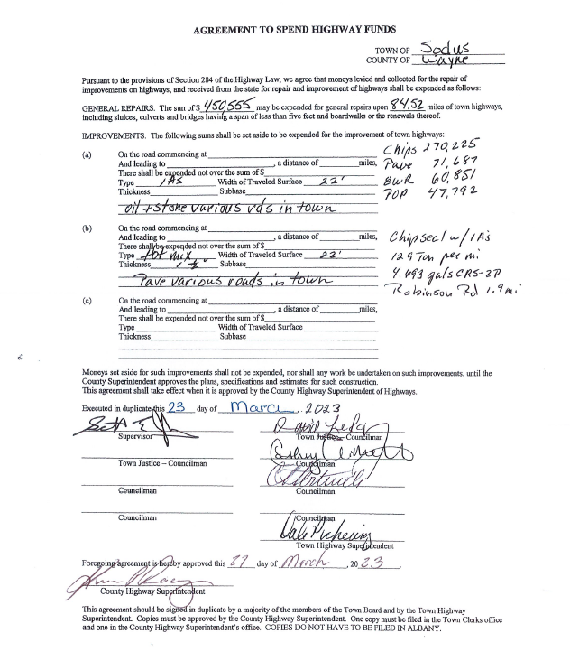
FURTHER BE IT RESOLVED, Motion by Councilperson David LeRoy to adopt this resolution was seconded by Councilperson Cathy Willmott. Upon roll call the following votes were heard, Supervisor Scott Johnson, aye; David LeRoy, aye; Don Ross, aye (Zoom); Chris Tertinek, aye; and Cathy Willmott; aye. Resolution Adopted.

A motion by Councilperson Don Ross allowing USDA to place traps for the European Cherry Fruit Fly Program in The Town of Sodus was seconded by Councilperson David LeRoy. Upon roll call, the following votes were heard Supervisor Scott Johnson, aye; LeRoy, aye; Ross (Zoom) aye; Tertinek, aye; and Willmott, aye. Motion carried.

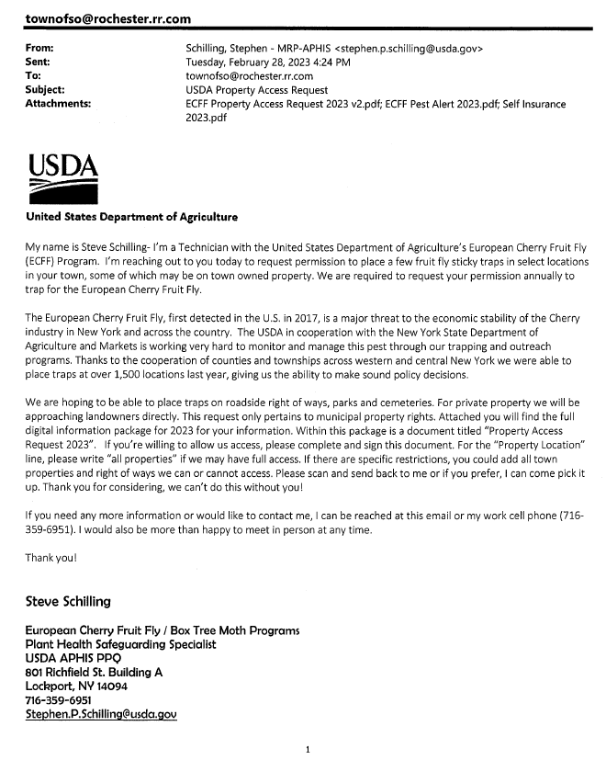

RESOLUTION
NYS PARTNERSHIP AGREEMENT C003103 MUNICIPAL OPERATION OF BEECHWOOD STATE PARK EXCESS REVENUES
(09 03-2023)
The following resolution was presented for its adoption,
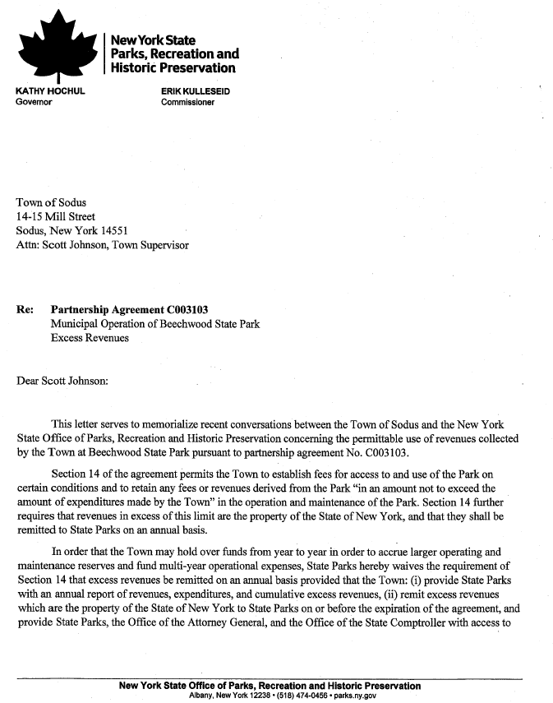

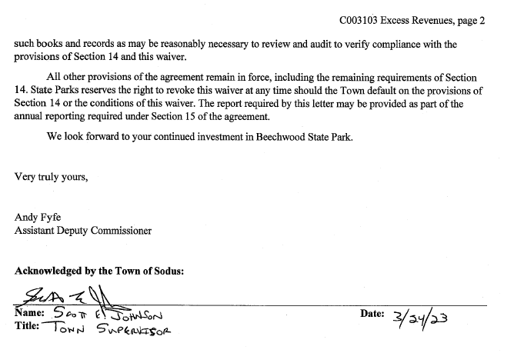BE IT RESOLVED, Councilperson David LeRoy motioned to adopt resolution and authorize Supervisor Johnson to sign agreement was seconded by Councilperson Cathy Willmott. Upon roll call the following votes were heard, Supervisor Scott Johnson, aye; David LeRoy, aye; Don Ross, aye (Zoom); Chris Tertinek, aye; and Cathy Willmott; aye. Resolution Adopted.

The Sodus Town Board discussed purchasing plow truck/UTV side by side for Sal Vittozzi Caretaker for the use at Camp Beechwood. Supervisor Scott Johnson said he would get together with Sal and price out UTV’s. Further discussion will follow in the next meeting for specifications, pricing and bidding out the vehicle.

Letter submitted to the Sodus Town Board by Laurie Verbridge Sodus Point Trustee regarding “Traffic Calming Study” on Route 14 in Sodus Point.

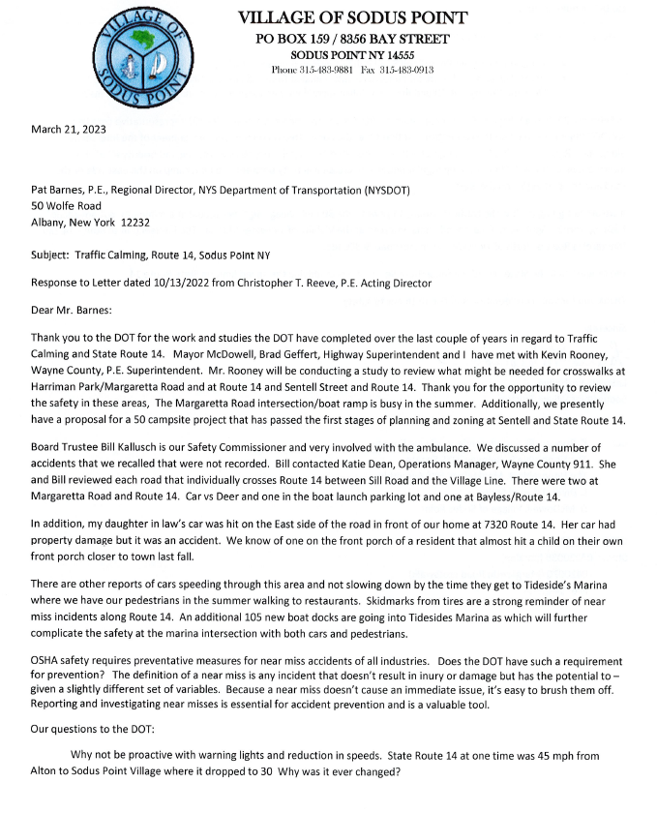

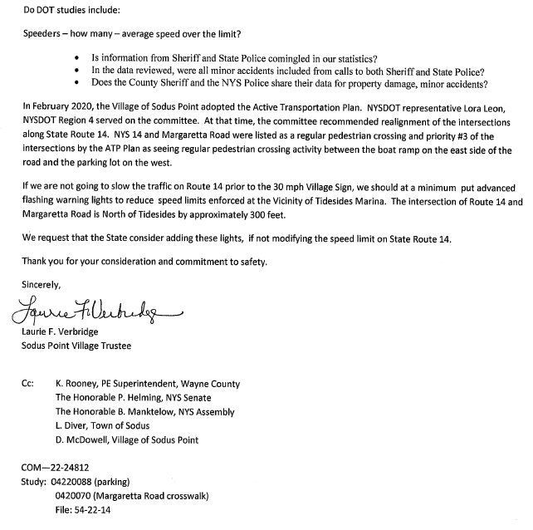

Discussion was held regarding Adam Breen’s (Alternative Technology) to set up .gov emails for the Town of Sodus. The current emails the Town of Sodus is using .rr.com and .twcbc.com with Spectrum have become an outdated domain and pose security issues. Before any decisions can be made, a detailed quote will have to be submitted for a decision to be made on behalf of the Board.

Discussion was held with the Sodus Town Board and Town Clerk Lori Diver regarding Town Board Agenda cutoffs. Town Clerk Lori Diver asked the Town Board if it would be okay to start asking for the agenda items to be cut off one week prior to Board Meetings. The Board was in agreement with this.

RESOLUTION
AUTHORIZING THE FOLLOWING POSITIONS AND SET THE HOURLY RATE OF PAY FOR THE 2023 SODUS RECREATION WINTER PROGRAM:
(10 03-2023)
The following resolution was presented for its adoption,

WHEREAS, the Recreation Director, the Recreation Committee and the Town Board Liaison discussed the following staff needed and the Hourly rate of pay for the 2023 Sodus Recreation Winter Program, and
WHEREAS, the following are the recommendations.
NUMBER OF STAFF MEMBERS | POSITION / TITLE | RATE OF PAY
1 | Life Guard | $16.00 / Hour
18 | Instructor | $14.20 / Hour
4 | Supervisor / Coordinator | $18.00 / Hour
1 | Assistant Director | $18.00 / Hour
3 | Registrar/Coordinator | $16.00 / Hour

BE IT RESOLVED, that the following staff with position / titles are authorized and set the Hourly rate of pay as indicated for the 2023 Sodus Recreation Winter Program.

BE IT RESOLVED, that the Clerk to the Supervisor is authorized to pay the following positions per the above schedule. This a 2023 Budgeted Item.
Adopted at a meeting of the Sodus Town Board on this 23rd day of March, 2023.

FURTHER BE IT RESOLVED, Councilperson Cathy Willmott motioned to adopt resolution and authorize was seconded by Councilperson Don Ross. Upon roll call the following votes were heard, Supervisor Scott Johnson, aye; David LeRoy, aye; Don Ross, aye (Zoom); Chris Tertinek, aye; and Cathy Willmott; aye. Resolution Adopted.

Councilperson Cathy Willmott motioned to allow Nathan Mack Assessor to repost Assessor Clerk position as 15 hours a week with a wage of $15.44 per hour and to advertise in the Times of Wayne County and the Lakeshore News was seconded by Councilperson David LeRoy. Upon roll call, the following votes were heard Supervisor Scott Johnson, aye; LeRoy, aye; Ross (Zoom), aye Tertinek, aye; and Willmott, aye. Motion carried.

A motion by Councilperson Don Ross to adjourn the Regular Town Board Meeting was seconded by Councilperson David LeRoy. Upon roll call, the following votes were heard Supervisor Scott Johnson, aye; LeRoy, aye; Ross (Zoom) aye; Tertinek, aye; and Willmott, aye. Motion carried.

Meeting adjourned at 8:10 PM

Recording Secretary,
Lori K. Diver
Sodus Town Clerk, RMC

