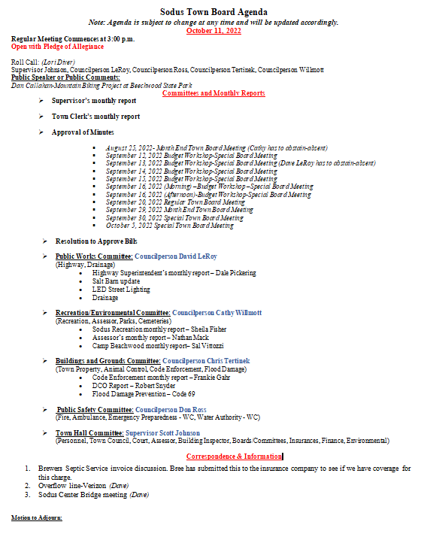

MINUTES
Minutes of the Regular Town Board Meeting commencing at 3:00 PM at the Rural Baptist Cemetery hosted by, Andrea & Wayne Vermuelen October 11, 2022 located at 5494 South Geneva Rd. Sodus, NY 14551.
All meetings are open to the public.
This meeting was not available through zoom hence, there was no electricity at the location or internet.
Legal Notices were published and posted accordingly.

Present: Scott Johnson, Supervisor
David LeRoy, Councilperson/Deputy Supervisor
Don Ross, Councilperson
Chris Tertinek, Councilperson

Recording Secretary: Lori Diver, Sodus Town Clerk-RMC

Absent: Cathy Willmott, Councilperson

Others Present: Wayne & Andrea Vermuelen, Rural Baptist Cemetery Caretakers
Anne Hudson, Sodus Resident
Sal Vittozzi, Camp Beechwood Caretaker
Robert Snyder, DCO
Dan Callahan, Bike Trail-Beechwood
Nate Hillegeer, Bike Trail-Beechwood

Supervisor Scott Johnson called the Regular Town Board Meeting to order commencing at 3:00 PM with the Pledge of Allegiance and Lori Diver opened with roll call. Councilperson Cathy Willmott was absent.

PUBLIC SPEAKER:
(Dan Callahan-Mountain biking Project at Beechwood State Park)
Dan Callahan came before the Board to discuss biking trails that he would like to see at Camp Beechwood for non-motorized bikers. He handed out a map (see below) of the proposed bike trails.
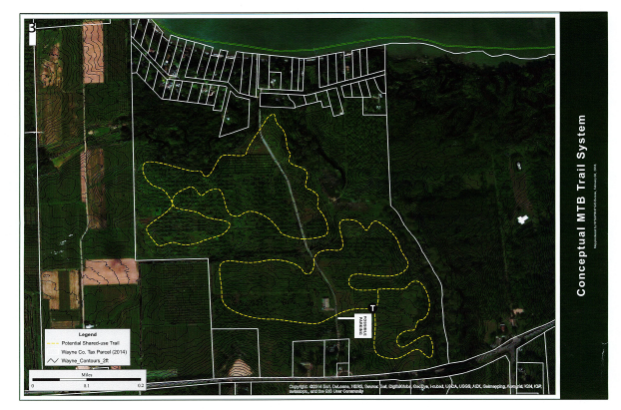
Supervisor Scott Johnson and Groundskeeper Sal Vittozzi will talk with Marcus Reil from the NY State Parks & Rec. If Reil is okay with the trail moving forward, then possibly the next step would be to talk to the homeowners near the path. Anne Hudson from the public stated she was on the original Camp Beechwood Committee when the park was first leased to the Town from the State of New York. Supervisor Johnson stated he would be in touch with Callahan. Callahan thanked the Town Board for the help.

PUBLIC SPEAKER:
(Andrea & Wayne Vermuelen Rural Baptist Cemetery history)
Andrea & Wayne were very excited that the Town Board decided to have its meeting at the Rural Baptist Cemetery Meeting House. They also thanked the Town Board for the generous allotment in monies for the cemetery for 2023, all that Dale Pickering Highway Superintendent and his crew have helped with at the cemetery and all the support the Town has given.

Wayne shared at the front inside entrance of the Meeting House are several picture boards placed with the history and work done at the cemetery. They have received money from the State of New York through the Hazardous Fund to help with some of the repairs.

Blasting that used to be done through the Quarry years ago, moved many of the monuments. They shifted through time and caused many of them to be unstable. Dynamite used to be used differently many years ago but, today when the Quarry blasts, you would never know it is happening.

There have been many repairs to the Meeting House in the cemetery but, it is all to keep the building in its original condition. They had a huge bat problem in the attic of the church. They had a bat abatement done. It was quite the process to have the bats abated but, today they have no issues with bats in the Meeting House at all. The next big project will be the slate roof. The soffits and eaves are rotted. They did fill all the holes with caulking.

They are still selling many cemetery plots to families of the deceased. It is a very active cemetery. The Town will help take down three trees that need to be removed and that are a hazard.

Wayne shared about the Baptistery they found last year in the Meeting House that was used as a church. They would like to display this Baptistery for others to see safely. It was well hidden for over a 100 years.

It was discussed that the Board would be willing to write a letter supporting the Rural Baptist Cemetery to Senator Pam Helming and Assemblyman Brian Manktelow.

Again Andrea and Wayne thanked the Board and community for having the Town meeting at the Meeting House. The Board thanked the Vermuelen’s for opening up the Meeting House for the Town, sharing the history and for the water and snacks during the meeting. Kudos to the Vermuelen’s for keeping such an important piece of history alive in our township.

SUPERVISOR’S REPORT
The Supervisor’s report was presented for September 2022. Councilperson Don Ross motioned to accept and file this report, which was seconded by Councilperson David LeRoy. Upon roll call the following votes were heard, Scott Johnson, aye; David LeRoy, aye; Don Ross, aye; Chris Tertinek, aye; and Cathy Willmott; absent. Motion carried.

MONTHLY SUPERVISOR REPORT:
To the Town Board of the Town of Sodus:
Pursuant to Section 125 of the Town Law, I hereby render the following detailed statement of all moneys received and disbursed by me through SEPTEMBER 30, 2022:
 | 10/6/2022
 | Supervisor |  |  | Date
 | FUND: | AUGUST 31, 2022 BALANCE |  | SEPTEMBER 30, 2022 BALANCE
A/B | General | $581,887.12 |  | $494,044.76
 | Cash - Checking
 |  |  | Monthly ? or ? | -$87,842.36
DA/DB | Highway | $2,223,921.89 |  | $2,136,738.10
 | Cash - Checking
 |  |  | Monthly ? or ? | -$87,183.79
SW20 | South Geneva WD | $44,521.35 |  | $44,521.35
 | Cash - Checking |  | Monthly ? or ? | $0.00
SW11 | Water District 11 | $63,624.23 |  | $63,624.23
 | Cash - Checking |  | Monthly ? or ? | $0.00
SS1 | Sewer District | $2,476.58 |  | $2,476.58
 | Cash - Checking |  | Monthly ? or ? | $0.00
SW4 | Water Operating | $120,242.86 |  | $120,242.86
 | Cash - Checking |  | Monthly ? or ? | $0.00
TA | Trust & Agency | $38,433.63 |  | $39,674.01
 | Cash - Checking |  | Monthly ? or ? | $1,240.38
 | FUND: | AUGUST 31, 2022 BALANCE |  | SEPTEMBER 30, 2022 BALANCE
 | Fire Districts
SF1 | Village of Sodus | $0.00 |  | $0.00
SF2 | Sodus Center Fire District | $0.00 |  | $0.00
SF3 | Wallington Fire District | $0.00 |  | $0.00
SF4 | Alton Fire District | $0.00 |  | $0.00
SF5 | Village of Sodus Point | $0.00 |  | $0.00
SF6 | Rural Fire Protection | $0.00 |  | $0.00
SF7 | Rural Hydrant | $300.00 |  | $300.00
 | Cash - Checking | $300.00 |  | $300.00
 |  |  | Monthly ? or ? | $0.00
 | Lighting Districts
SL1 | Alton Lighting | $13,695.63 |  | $13,162.26
SL2 | Sodus Center Lighting | $28,679.90 |  | $28,390.97
SL3 | Wallington Lighting | $12,117.99 |  | $11,844.81
 |  | $54,493.52 |  | $53,398.04
 |  |  | Monthly ? or ? | -$1,095.48
 | Total All Funds | $3,129,901.18 |  | $2,955,019.93
 |  |  | Monthly ? or ? | -$174,881.25

TOWN CLERK’S REPORT
The Town Clerk’s Report, Town Clerk’s bank statements for audit, and bank register for September 2022 were presented. Councilperson Chris Tertinek motioned to accept and file these reports, which was seconded by Councilperson Don Ross. Upon roll call the following votes were heard, Scott Johnson, aye; David LeRoy, aye; Don Ross, aye; Chris Tertinek, aye; and Cathy Willmott; absent. Motion carried.
Note: Town Clerk bank register and bank statement made available upon request with banking detailed info to be redacted. Not published for security reasons.
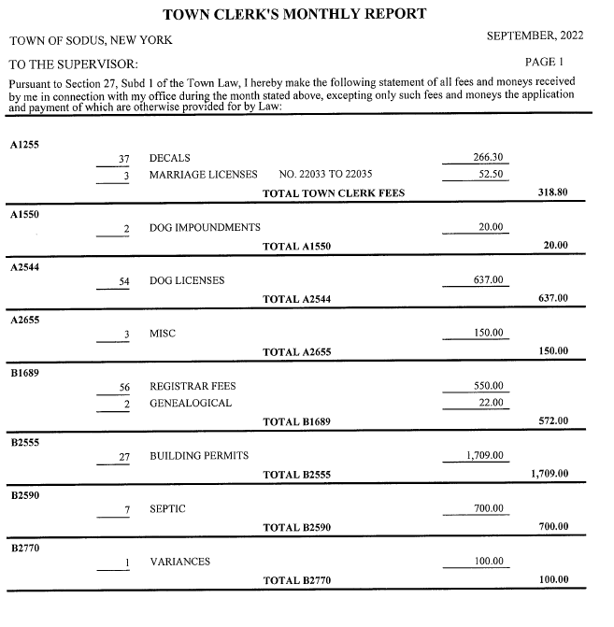

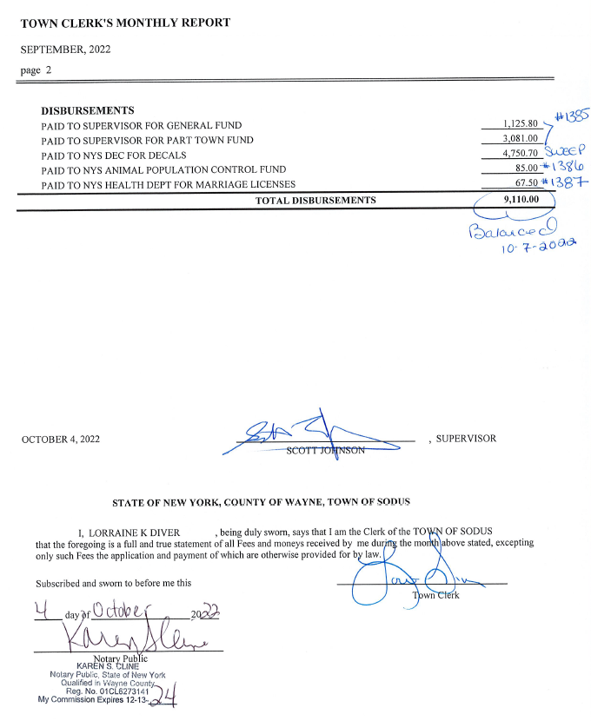

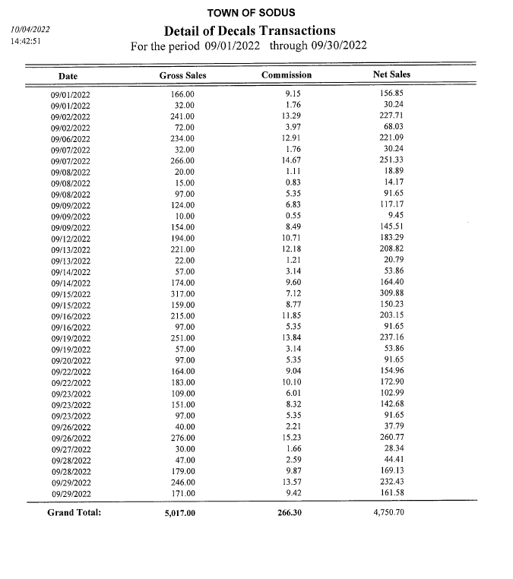
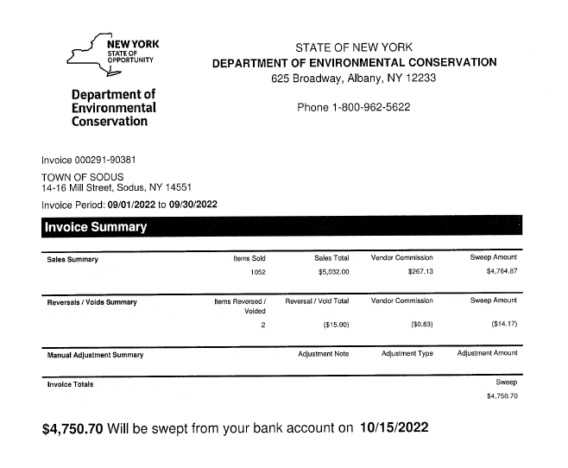
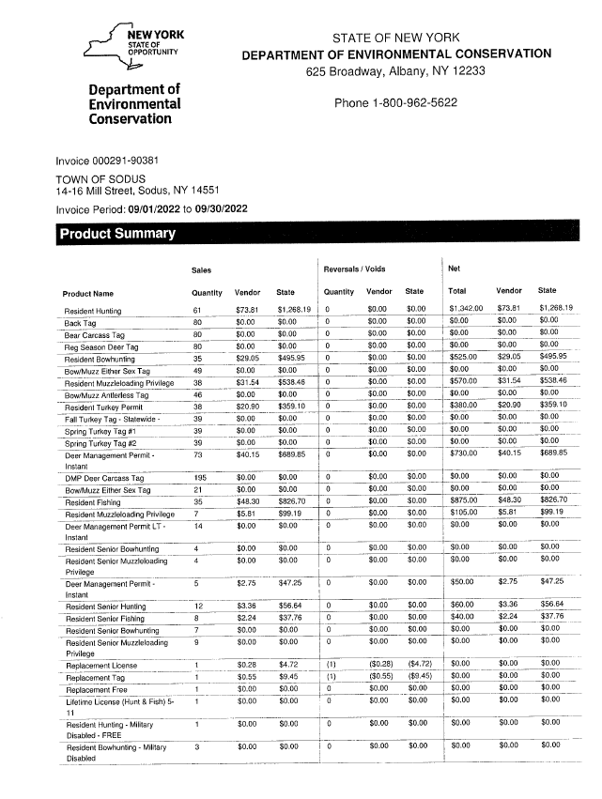

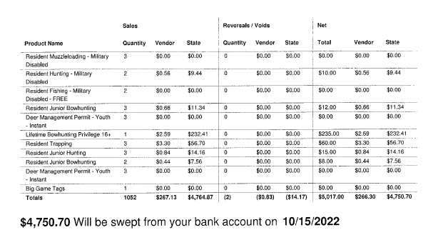
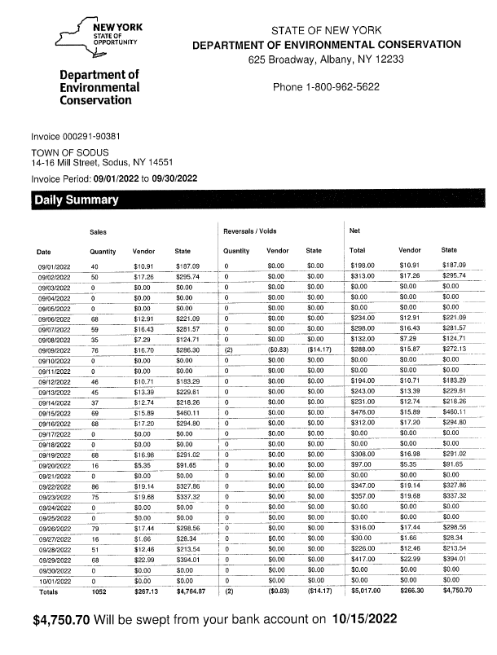
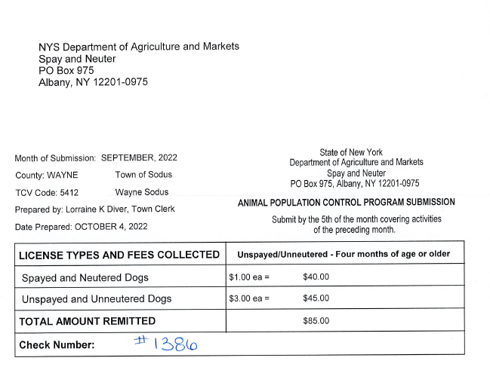
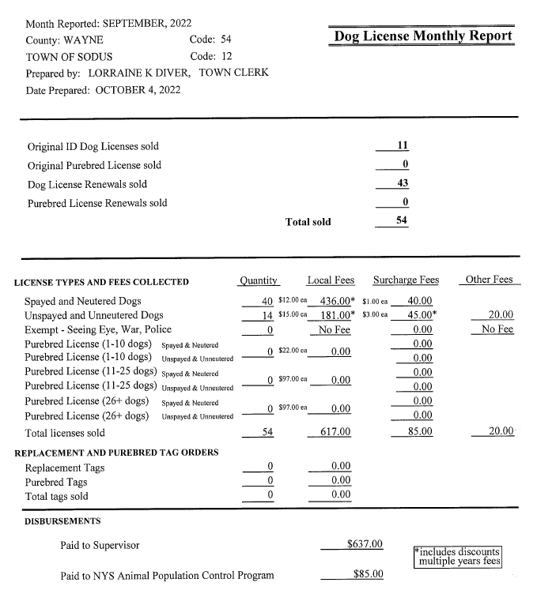
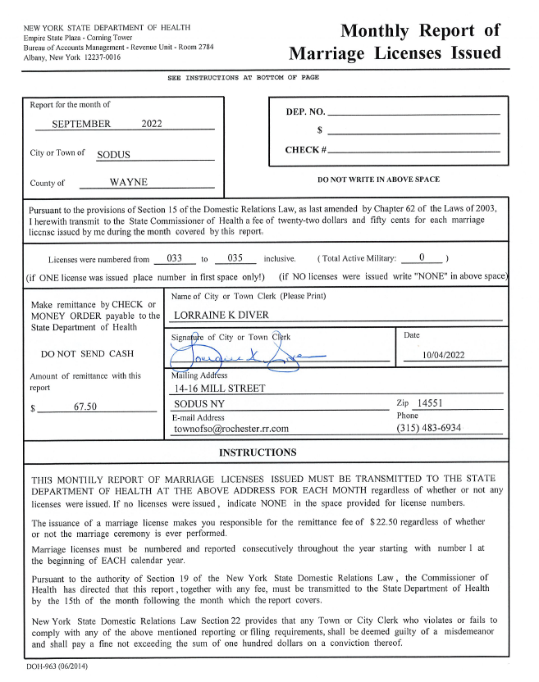

MINUTES
Minutes from August 25, 2022 was presented to the Town Board for approval. Councilperson Don Ross motioned to accept and file these Minutes, which was seconded by Councilperson Chris Tertinek. Upon roll call the following votes were heard, Scott Johnson, aye; David LeRoy, aye; Don Ross, aye; Chris Tertinek, aye; and Cathy Willmott; absent. Motion carried.

Minutes from September 12, 2022 was presented to the Town Board for approval. Councilperson Don Ross motioned to accept and file these Minutes, which was seconded by Councilperson Chris Tertinek. Upon roll call the following votes were heard, Scott Johnson, aye; David LeRoy, aye; Don Ross, aye; Chris Tertinek, aye; and Cathy Willmott; absent. Motion carried.

Minutes from September 13, 2022 was presented to the Town Board for approval. Councilperson Don Ross motioned to accept and file these Minutes, which was seconded by Councilperson Chris Tertinek. Upon roll call the following votes were heard, Scott Johnson, aye; David LeRoy, abstain; Don Ross, aye; Chris Tertinek, aye; and Cathy Willmott; absent. Motion carried.

Minutes from September 14, 2022 was presented to the Town Board for approval. Councilperson Don Ross motioned to accept and file these Minutes, which was seconded by Councilperson Chris Tertinek. Upon roll call the following votes were heard, Scott Johnson, aye; David LeRoy, aye; Don Ross, aye; Chris Tertinek, aye; and Cathy Willmott; absent. Motion carried.

Minutes from September 15, 2022 was presented to the Town Board for approval. Councilperson Don Ross motioned to accept and file these Minutes, which was seconded by Councilperson Chris Tertinek. Upon roll call the following votes were heard, Scott Johnson, aye; David LeRoy, aye; Don Ross, aye; Chris Tertinek, aye; and Cathy Willmott; absent. Motion carried.

Minutes from September 16 (Morning), 2022 was presented to the Town Board for approval. Councilperson Don Ross motioned to accept and file these Minutes, which was seconded by Councilperson Chris Tertinek. Upon roll call the following votes were heard, Scott Johnson, aye; David LeRoy, aye; Don Ross, aye; Chris Tertinek, aye; and Cathy Willmott; absent. Motion carried.

Minutes from September 16 (Afternoon), 2022 was presented to the Town Board for approval. Councilperson Don Ross motioned to accept and file these Minutes, which was seconded by Councilperson Chris Tertinek. Upon roll call the following votes were heard, Scott Johnson, aye; David LeRoy, aye; Don Ross, aye; Chris Tertinek, aye; and Cathy Willmott; absent. Motion carried.

Minutes from September 20, 2022 was presented to the Town Board for approval. Councilperson Don Ross motioned to accept and file these Minutes, which was seconded by Councilperson Chris Tertinek. Upon roll call the following votes were heard, Scott Johnson, aye; David LeRoy, aye; Don Ross, aye; Chris Tertinek, aye; and Cathy Willmott; absent. Motion carried.

Minutes from September 29, 2022 was presented to the Town Board for approval. Councilperson Don Ross motioned to accept and file these Minutes, which was seconded by Councilperson Chris Tertinek. Upon roll call the following votes were heard, Scott Johnson, aye; David LeRoy, aye; Don Ross, aye; Chris Tertinek, aye; and Cathy Willmott; absent. Motion carried.

Minutes from September 30, 2022 was presented to the Town Board for approval. Councilperson Don Ross motioned to accept and file these Minutes, which was seconded by Councilperson Chris Tertinek. Upon roll call the following votes were heard, Scott Johnson, aye; David LeRoy, aye; Don Ross, aye; Chris Tertinek, aye; and Cathy Willmott; absent. Motion carried.

Minutes from October 5, 2022 was presented to the Town Board for approval. Councilperson Don Ross motioned to accept and file these Minutes, which was seconded by Councilperson Chris Tertinek. Upon roll call the following votes were heard, Scott Johnson, aye; David LeRoy, aye; Don Ross, aye; Chris Tertinek, aye; and Cathy Willmott; absent. Motion carried.

ABSTRACT
RESOLUTION TO PAY ABSTRACT No. 17
- 10-2022)
WHEREAS, the following bills were presented for payment on Abstract 17:

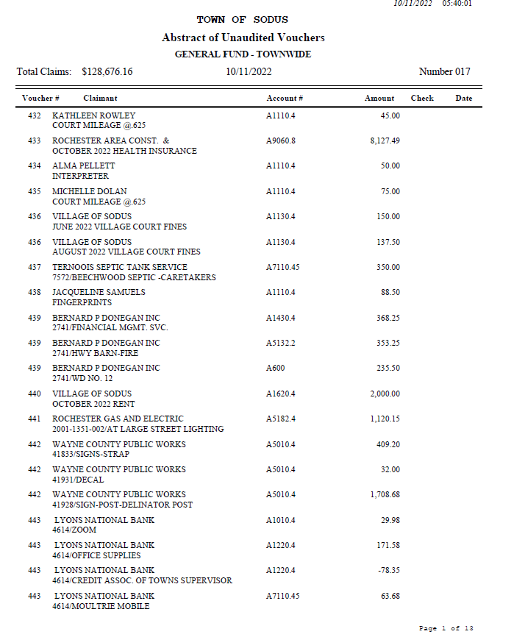

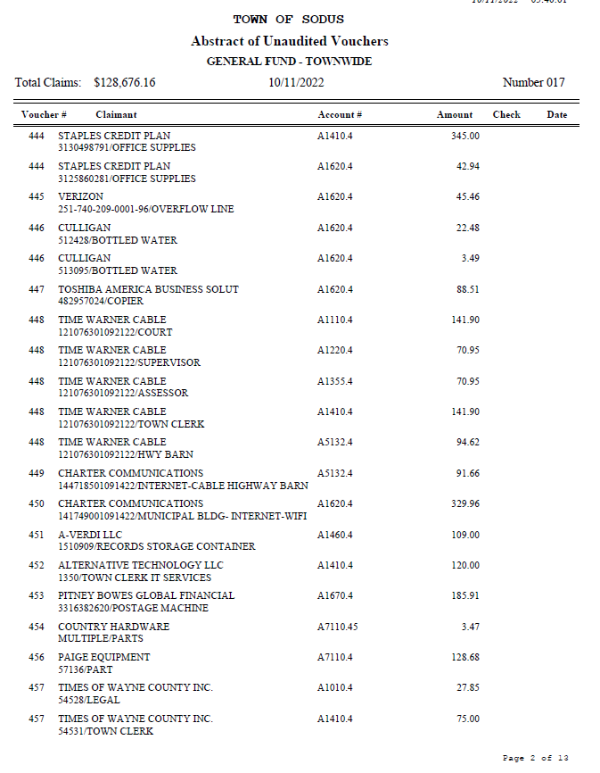

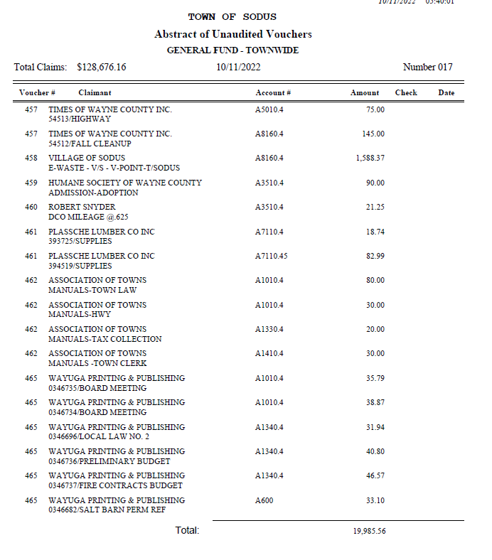

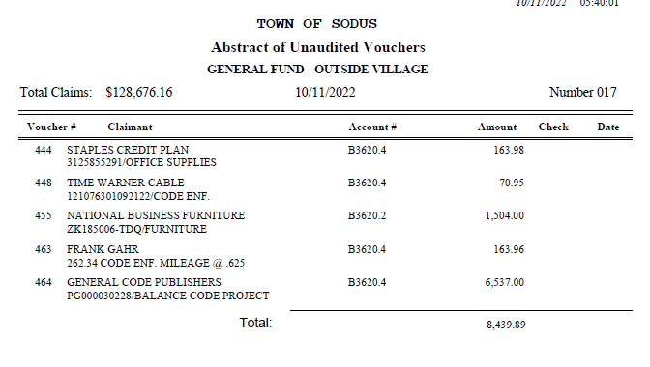

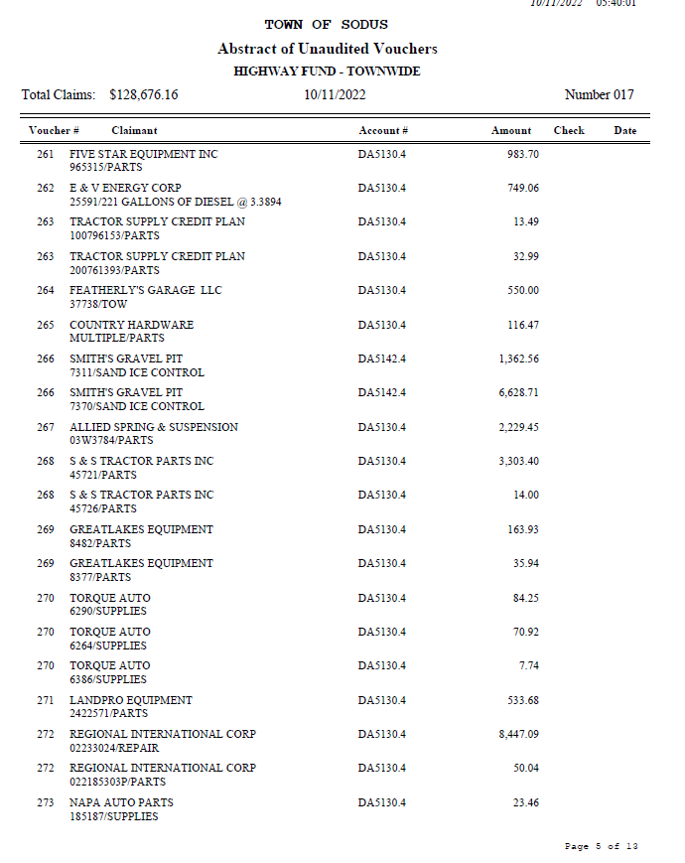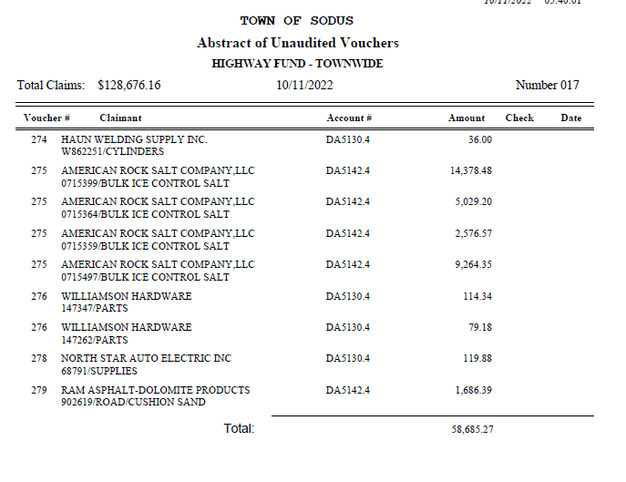
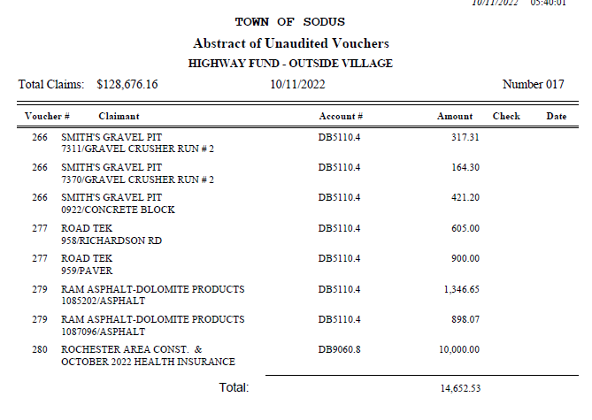
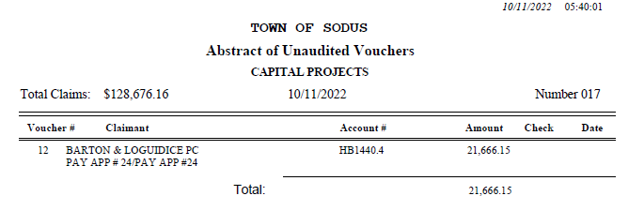
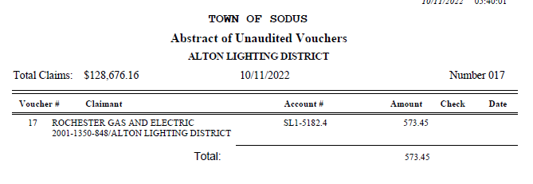 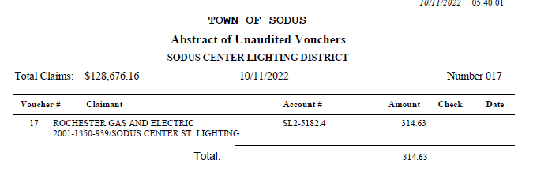 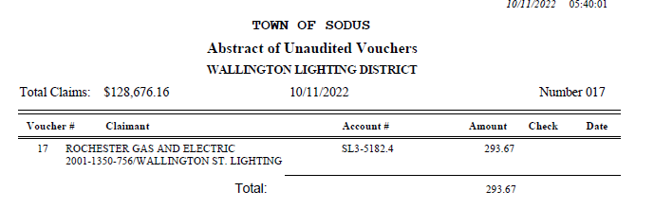 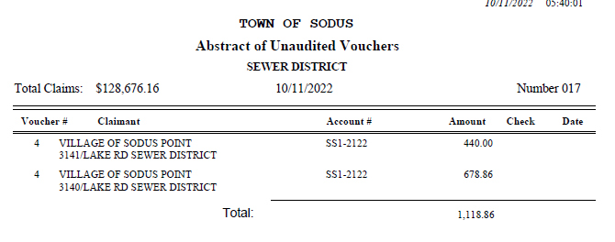 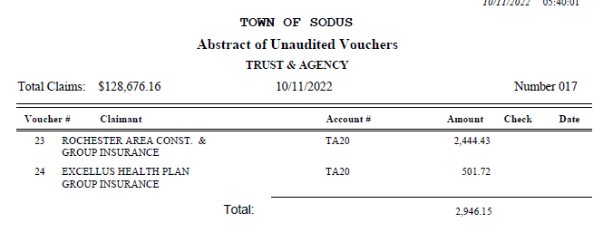 NOW BE IT RESOLVED, Councilperson David LeRoy motioned to authorize payment for Abstract # 17 as listed and adopt this resolution which was seconded by Councilperson Chris Tertinek. Upon roll call the following votes were heard, Scott Johnson, aye; David LeRoy, aye; Don Ross, aye; Chris Tertinek, aye; and Cathy Willmott; absent. Resolution Adopted.

PUBLIC WORKS COMMITTEE: Councilperson David LeRoy, Chair
(Highway, Drainage - Deputy Town Supervisor)
HIGHWAY REPORT:
(Dale Pickering – Highway Superintendent)
Councilperson David LeRoy motioned to accept and file the monthly September 2022 Highway Report from Dale Pickering Highway Superintendent was seconded by Councilperson Don Ross. Upon roll call the following votes were heard, Scott Johnson, aye; David LeRoy, aye; Don Ross, aye; Chris Tertinek, aye; and Cathy Willmott; absent. Motion carried.

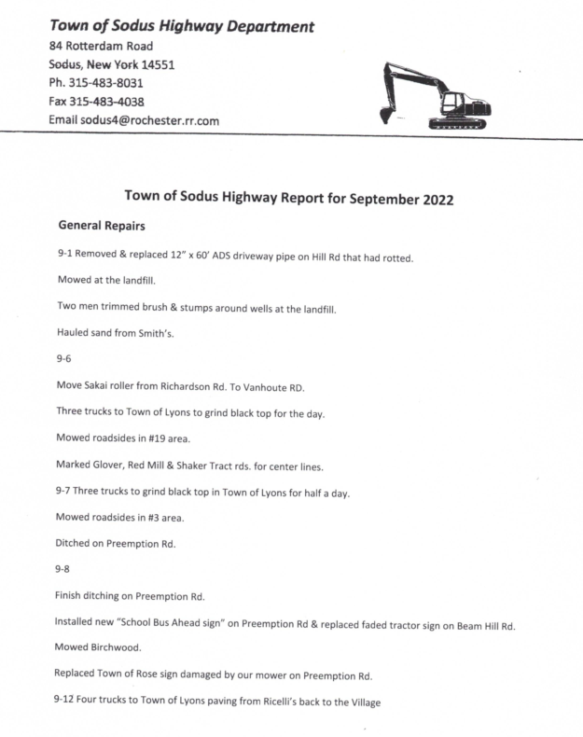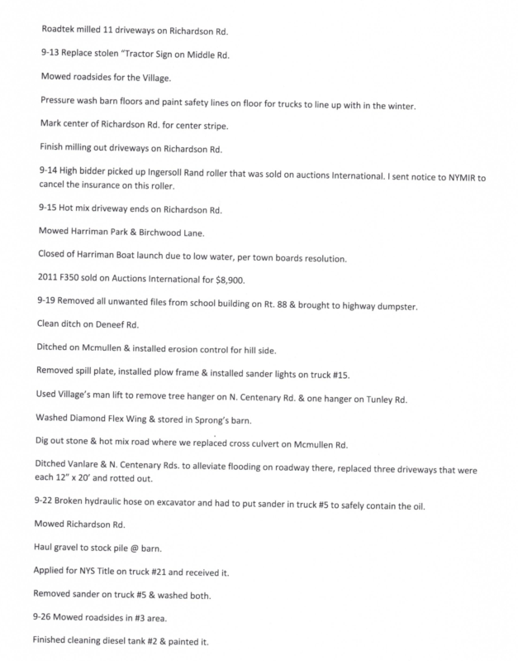
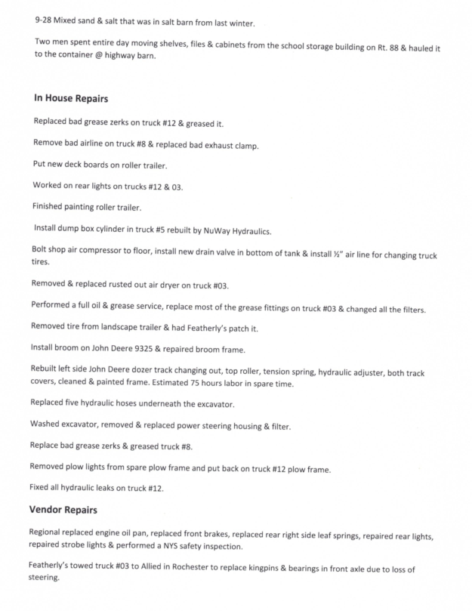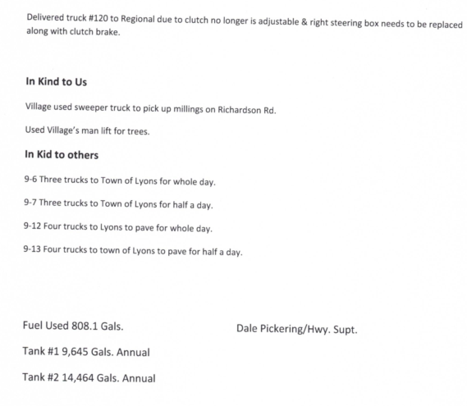
LED STREET LIGHTING:
Councilperson David LeRoy said Tim Hitman with RG&E is waiting on lights.

SALT BARN UPDATE:
Councilperson David LeRoy discussed that the Salt Barn will be much more hence, the delay.

DRAINAGE
N/A

RECREATION/ENVIRONMENTAL COMMITTE: Cathy Willmott, Councilperson
(Recreation, Assessor, Parks, Cemeteries)
Recreation Report
Councilperson David LeRoy motioned to accept and file the monthly September 2022 Town Recreation Report from Director, Sheila Fisher was seconded by Councilperson Don Ross. Upon roll call the following votes were heard, Scott Johnson, aye; David LeRoy, aye; Don Ross, aye; Chris Tertinek, aye; and Cathy Willmott; absent. Motion carried.

Director’s Report
Sodus Recreation Board Meeting
Oct.6, 2022

Programs:
- We are looking to see if there is any interest in the Fall/Winter Travel Boys Basketball Program to begin in December ‘22. If so, they will practice on Mondays & Wednesdays from 6pm-8pm and games will be on Saturdays.
- Fall Girls Basketball Program with Katie Hall will begin 10/17. They will practice on Tuesday & Thursday evenings and Saturdays.

Budget:
- There are no other programs for 2022 that will need any payroll.
- As you are aware, we have been meeting with the Town Board regarding the Budget Proposal for 2023.

Assessor’s Report
(Nathan Mack, Assessor)
Assessor Nathan Mack was ill the last week, hence no report.

Camp Beechwood/Sodus Groundskeeper Report
(Sal Vittozzi-Caretaker-Sodus Town Groundkeeper)
Councilperson Don Ross motioned to accept the monthly September 2022 Camp Beechwood-Parks & Cemeteries Report from Sal Vittozzi; Sodus Town Groundskeeper-Caretaker was seconded by Councilperson David LeRoy. Upon roll call the following votes were heard, Scott Johnson, aye; David LeRoy, aye; Don Ross, aye; Chris Tertinek, aye; and Cathy Willmott; absent. Motion carried.

September 2022 Camp Beechwood Report
September was another very productive month here at the park. Camping numbers started out busy and tapered off towards the end of the month due to excessive rain. We collected $585 in camping fees for September. 39 sites were rented with a total of 117 campers for the month. Mowing and trail trimming are still being done on a weekly basis and more mulch beds have been added at the west entrance, as well as in the main field around the park benches. The park is looking great. The rain at the end of the month threw off the mowing schedule a little bit at the cemeteries but we are still up to date with all the mowing. Extra cleanup was done at the Joy rd. cemetery also. There is white maintenance building on the property which was completely engulfed in trees and vines, as well as large family plot which was engulfed too. Both areas were cleared are looking great again. All in all, September was another very positive month for the park and cemeteries.

BUILDINGS AND GROUNDS COMMITTEE: Councilperson Chris Tertinek, Chair
(Town Property, Animal Control, Flood Damage Prevention)
CODE ENFORCEMENT REPORT:
(Frankie Gahr- CEO)
Councilperson David LeRoy motioned to accept the monthly September 2022 Code Enforcement Report was seconded by Councilperson Don Ross. Upon roll call the following votes were heard, Scott Johnson, aye; David LeRoy, aye; Don Ross, aye; Chris Tertinek, aye; and Cathy Willmott; absent. Motion carried.
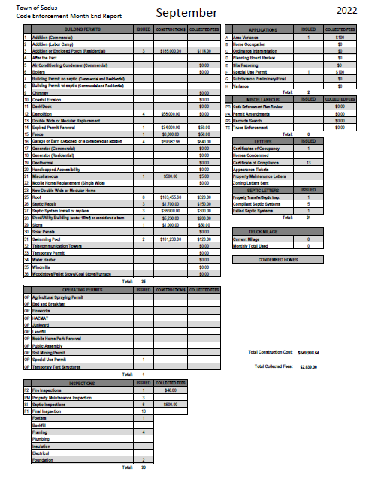

DOG CONTROL REPORT:
(Robert Snyder, Primary DCO)
(Vacant Position- Secondary DCO)
Councilperson Chris Tertinek motioned to accept the monthly September 2022 Dog Control Report was seconded by Councilperson Don Ross. Upon roll call the following votes were heard, Scott Johnson, aye; David LeRoy, aye; Don Ross, aye; Chris Tertinek, aye; and Cathy Willmott; absent. Motion carried.
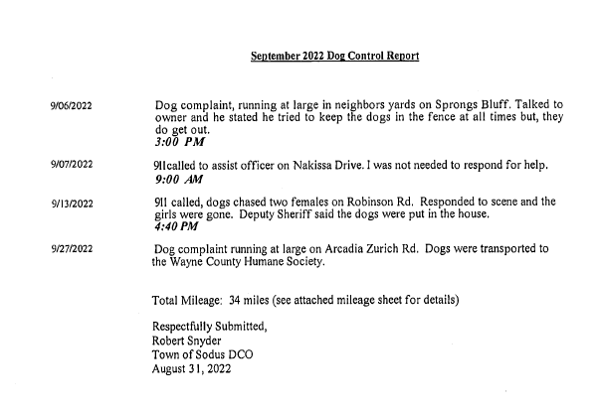
FLOOD DAMAGE PREVENTION REPORT-Code 69:
(Chris Tertinek, Councilperson)
Councilperson Chris Tertinek gave his monthly Flood Damage Prevention Report.
Lake Level
- The lake level is at 244.2 ft. ABSL. About 0.67 ft. below long-term average.
- Expect lake level to remain below long-term average nearly ½ ft. through till mid-March. No flooding expected next year. Looks like another low-level year.

PUBLIC SAFETY/DRAINAGE/ENVIRONMENT COMMITTEE: Councilperson Don Ross, Chair (Fire, Ambulance, Emergency Preparedness)
Councilperson Don Ross gave his monthly report.
WCWSA is now located out at York Settlement Rd. installing water lines for the Regional Water Project. SESA meeting was held. Wallington Fire Department now has cold water suits and sled on site. Fire Prevention will be held October 14th @ SCSD from 9:00 AM to 12:00 PM. Just a side note, Silver Waters attends almost every event.

TOWN HALL COMMITTEE: Scott Johnson, Supervisor –
(Personnel, Clerks, Justices, Assessor, Building Inspector, Town Council, Boards, Insurances, Finance)

CORRESPONDENCE & INFORMATION

Brewers Septic submitted an invoice for a damaged port a john from a tree falling on it and graffiti written on at Camp Beechwood (see attached).
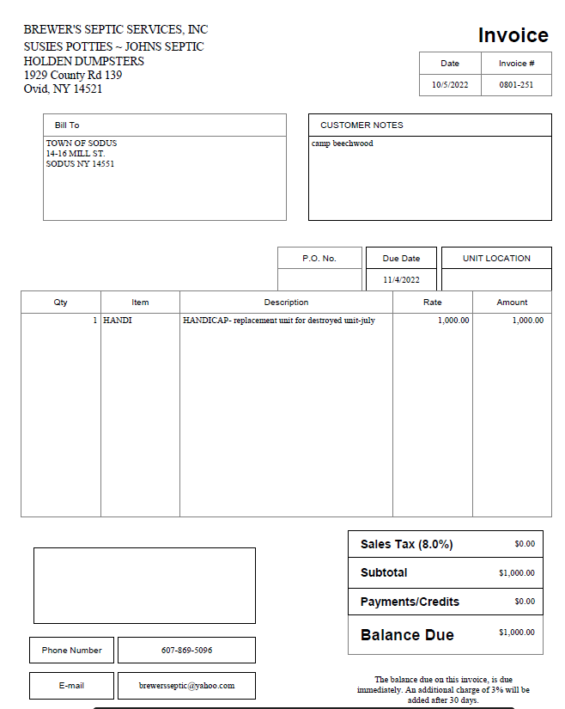

The invoice will be tabled and not payed at this time. Supervisor Scott Johnson will speak with Brewers Septic regarding the damaged port a john. Currently the Town of Sodus has no written contract with Brewers regarding if a port a john is damaged by a natural cause or any other reason. Town Clerk Lori Diver spoke with Brewers regarding the invoice and they said since the port a john also had graffiti (pictures below) on it they needed to charge us for a replacement. They informed me that a new port a john outright is well over $3,000.00.

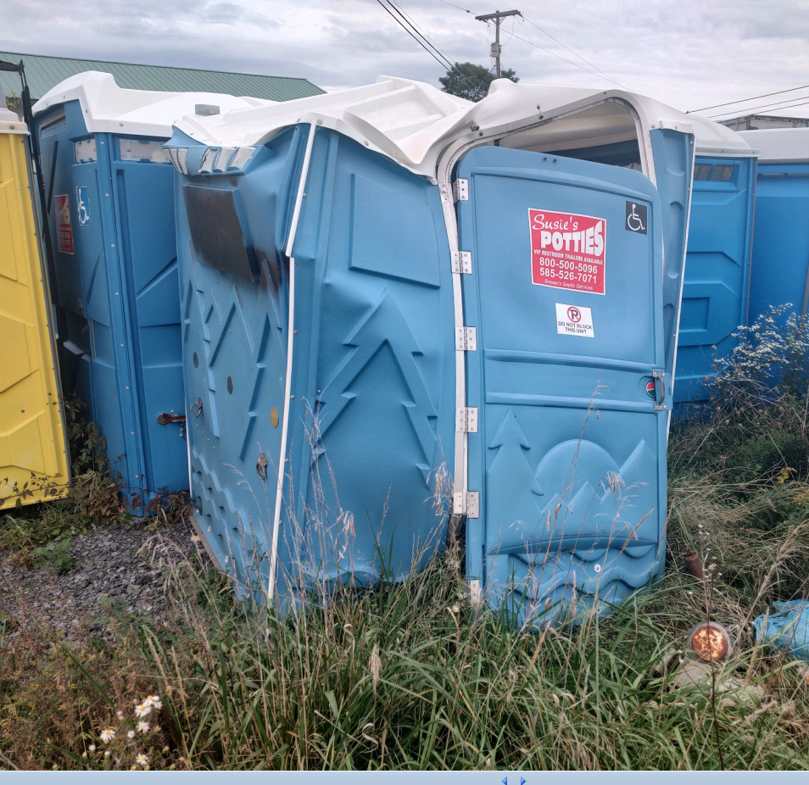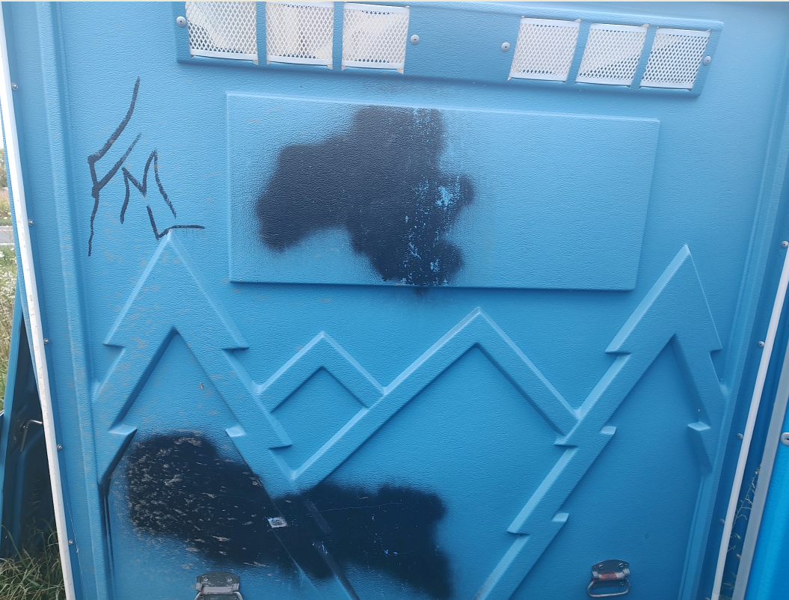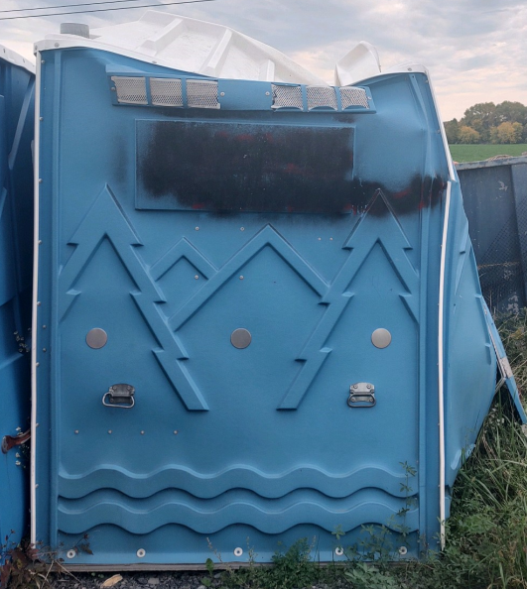

Discussion was held regarding the overflow line that has been with the Town of Sodus for years. Lori Diver Town Clerk shared that at an Emergency Mgmt.seminar (years ago) it was suggested that a muncipality should have a hard wired line with a phone that is non-computerized in case of a technology attack on our systems. Councilperson David LeRoy questioned why we have been paying around $45.00 monthly for this line. He would like to see the Town of Sodus pair with the Village of Sodus for the service and expense. Lori Diver Town Clerk will speak with the Village of Sodus to see if they are willing to share the expense.

The Sodus Center School Street Bridge is around 75% complete. Heritage was on site today. Wayne County Water & Sewer Authority installed the new water line. The last thing they need to do is lay down the asphalt. The Bridge should be complete November 8, 2022 for the Town of Sodus to do an onsite inspection November 8, 2022 at 1:00 PM. The dedication ceremony will take place sometime in early Spring of 2023 once a few minor details are completed.

Councilperson David LeRoy motioned to adjourn the meeting was seconded by Councilperson Don Ross. Upon roll call the following votes were heard, Scott Johnson, aye; David LeRoy, aye; Don Ross, aye; Chris Tertinek, aye; and Cathy Willmott; absent. Motion carried.

Meeting adjourned at 4:26 PM
Recording Secretary,

Minutes Written By:
Lori Diver
Sodus Town Clerk, RMC

