Sodus Town Board Agenda
Note: Agenda is subject to change at any time and will be updated accordingly.
September 20, 2022
Regular Meeting Commences at 2:00 p.m.
Open with Pledge of Allegiance
Motion to enter into Executive Session regarding a personnel issue involving particular persons
Motion to exit out of Executive Session and enter into regular session

Roll Call: (Lori Diver)
Supervisor Johnson, Councilperson LeRoy, Councilperson Ross, Councilperson Tertinek, Councilperson Willmott
Public Speaker or Public Comments:
N/A
Committees and Monthly Reports
- Supervisor’s monthly report

- Town Clerk’s monthly report

- Approval of Minutes

    - Regular Town Board Meeting August 9, 2022

- Resolution to Approve Bills

- Public Works Committee: Councilperson David LeRoy
(Highway, Drainage)
- Highway Superintendent’s monthly report – Dale Pickering
- Salt Barn update
- LED Street Lighting
- Drainage

- Recreation/Environmental Committee: Councilperson Cathy Willmott
(Recreation, Assessor, Parks, Cemeteries)
- Sodus Recreation monthly report – Sheila Fisher
- Assessor’s monthly report – Nathan Mack
- Camp Beachwood monthly report– Sal Vittozzi

- Buildings and Grounds Committee: Councilperson Chris Tertinek
(Town Property, Animal Control, Code Enforcement, Flood Damage)
- Code Enforcement monthly report – Frankie Gahr
- DCO Report – Robert Snyder
- Flood Damage Prevention – Code 69

- Public Safety Committee: Councilperson Don Ross
(Fire, Ambulance, Emergency Preparedness - WC, Water Authority - WC)

- Town Hall Committee: Supervisor Scott Johnson
(Personnel, Town Council, Court, Assessor, Building Inspector, Boards/Committees, Insurances, Finance, Environmental)

Correspondence & Information
- Motion to accept Allan VanAcker’s letter of resignation/retirement letter with the Sodus Town Highway Department. His last day of work is September 29, 2022.

- Motion to accept Mark C. Brownell letter of resignation/retirement letter with the Sodus Town Highway Department. His last day of work is September 29, 2022.

- Thank you card from Karen Cline.

- Resolution to hire Costich Engineers for Beechwood State Parking and Access Road Design Services, to hire Stony Creek Archaeology to conduct the Phase 1A cultural resource investigation and to re-advertise for the grant administration per Sharon Lilla’s recommendations.

- Motion to cancel the Month End September 22, 2022 board meeting and to reschedule and advertise for September 29, 2022 at 4:00PM in the upstairs meeting room.

- Resolution authorizing adoption of the Wayne County multi-jurisdictional hazard mitigation plan

- Motion to allow Lori Diver Sodus Town Clerk to advertise for the Digital Clerk position for 20 hours per week, non-benefited and the hourly rate to be determined upon hiring.

Motion to Adjourn:
DRAFT MINUTES
Minutes of the Regular Town Board Meeting commencing at 2:00 PM in the upstairs meeting room September 20, 2022 located at 14-16 Mill St. Sodus, NY 14551.
All meetings are open to the public.
In addition this meeting was available through Zoom.
Legal Notices were published and posted accordingly.

Present: Scott Johnson, Supervisor
David LeRoy, Councilperson/Deputy Supervisor
Don Ross, Councilperson
Chris Tertinek, Councilperson
Cathy Willmott, Councilperson

Recording Secretary: Lori Diver, Sodus Town Clerk-RMC

Absent: N/A

Others Present: Bree Crandell, Supervisor Clerk
Susie Jacobs, Internal Auditor (Zoom)
Amy Kendall, Town Attorney

Supervisor Scott Johnson called the Regular Town Board Meeting to order commencing at 2:00 PM with the Pledge of Allegiance and Lori Diver opened with roll call. All were present.

Councilperson David LeRoy motioned to enter into Executive Session regarding a personnel issue with a particular person at 2:00 PM was seconded by Councilperson Cathy Willmott. Upon roll call the following votes were heard, Scott Johnson, aye; David LeRoy, aye; Don Ross, aye; Chris Tertinek, aye; and Cathy Willmott; aye. Motion carried.

Councilperson Don Ross motioned to exit out of Executive Session and to enter into Regular Session at 4:46 PM was seconded by Councilperson David LeRoy. Upon roll call the following votes were heard, Scott Johnson, aye; David LeRoy, aye; Don Ross, aye; Chris Tertinek, aye; and Cathy Willmott; aye. Motion carried.

PUBLIC SPEAKER:
N/A

SUPERVISOR’S REPORT
The Supervisor’s report was presented for August 2022. Councilperson Cathy Willmott motioned to accept and file this report, which was seconded by Councilperson Chris Tertinek. Upon roll call the following votes were heard, Scott Johnson, aye; David LeRoy, aye; Don Ross, aye; Chris Tertinek, aye; and Cathy Willmott; aye. Motion carried.

MONTHLY SUPERVISOR REPORT:
To the Town Board of the Town of Sodus:
Pursuant to Section 125 of the Town Law, I hereby render the following detailed statement of all moneys received and disbursed by me through AUGUST 31, 2022:
 | 9/7/2022
 | Supervisor |  |  | Date
 | FUND: | JULY 31, 2022 BALANCE: |  | AUGUST 31, 2022 BALANCE:
A/B | General | $878,004.56 |  | $581,887.12
 | Cash - Checking
 |  |  | Monthly ↑ or ↓ | -$296,117.44
DA/DB | Highway | $2,258,719.45 |  | $2,223,921.89
 | Cash - Checking
 |  |  | Monthly ↑ or ↓ | -$34,797.56
SW20 | South Geneva WD | $44,521.35 |  | $44,521.35
 | Cash - Checking |  | Monthly ↑ or ↓ | $0.00
SW11 | Water District 11 | $63,624.23 |  | $63,624.23
 | Cash - Checking |  | Monthly ↑ or ↓ | $0.00
SS1 | Sewer District | $2,476.58 |  | $2,476.58
 | Cash - Checking |  | Monthly ↑ or ↓ | $0.00
SW4 | Water Operating | $120,242.86 |  | $120,242.86
 | Cash - Checking |  | Monthly ↑ or ↓ | $0.00
TA | Trust & Agency | $56,233.78 |  | $38,433.63
 | Cash - Checking |  | Monthly ↑ or ↓ | -$17,800.15
 | FUND: | JULY 31, 2022 BALANCE: |  | AUGUST 31, 2022 BALANCE:
 | Fire Districts
SF1 | Village of Sodus | $0.00 |  | $0.00
SF2 | Sodus Center Fire District | $0.00 |  | $0.00
SF3 | Wallington Fire District | $0.00 |  | $0.00
SF4 | Alton Fire District | $0.00 |  | $0.00
SF5 | Village of Sodus Point | $0.00 |  | $0.00
SF6 | Rural Fire Protection | $0.00 |  | $0.00
SF7 | Rural Hydrant | $300.00 |  | $300.00
 | Cash - Checking | $300.00 |  | $300.00
 |  |  | Monthly ↑ or ↓ | $0.00
 | Lighting Districts
SL1 | Alton Lighting | $14,218.71 |  | $13,695.63
SL2 | Sodus Center Lighting | $28,962.20 |  | $28,679.90
SL3 | Wallington Lighting | $12,362.98 |  | $12,117.99
 |  | $55,543.89 |  | $54,493.52
 |  |  | Monthly ↑ or ↓ | -$1,050.37
 | Total All Funds | $3,479,666.70 |  | $3,129,901.18
 |  |  | Monthly ↑ or ↓ | -$349,765.52

TOWN CLERK’S REPORT
The Town Clerk’s Report, Town Clerk’s bank statements for audit, and bank register for August 2022 were presented. Councilperson Cathy Willmott motioned to accept and file these reports, which was seconded by Councilperson David LeRoy. Upon roll call the following votes were heard, Scott Johnson, aye; David LeRoy, aye; Don Ross, aye; Chris Tertinek, aye; and Cathy Willmott; aye. Motion carried.
Note: Town Clerk bank register and bank statement made available upon request with banking info to be redacted. Not published for security reasons.
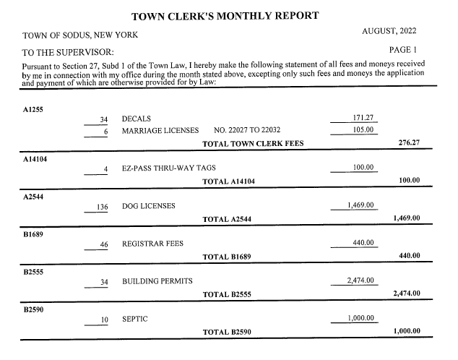

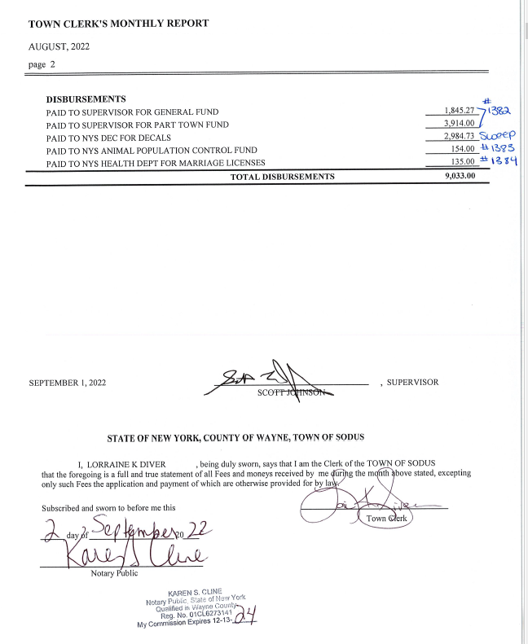
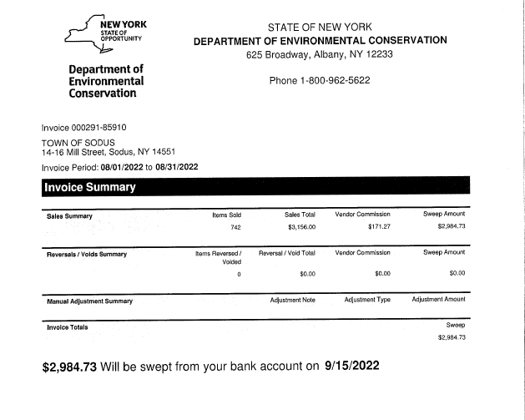
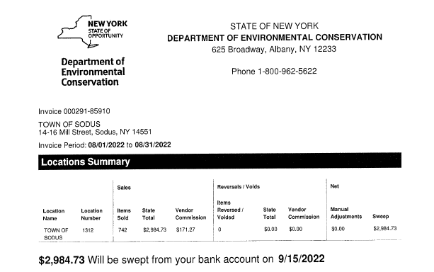

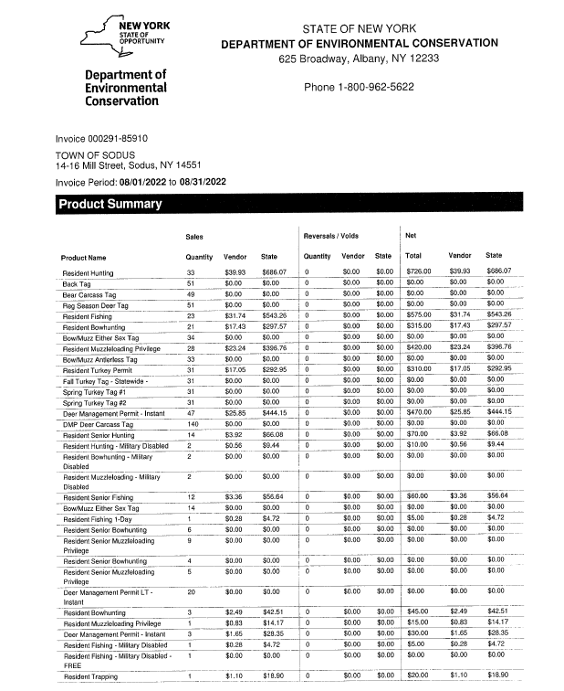

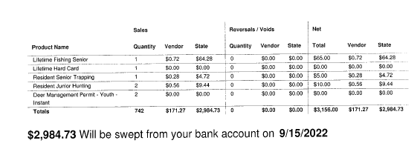
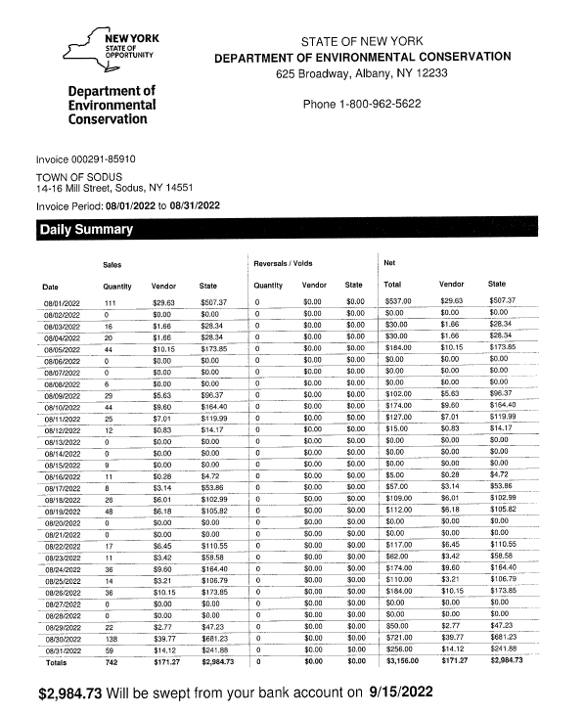
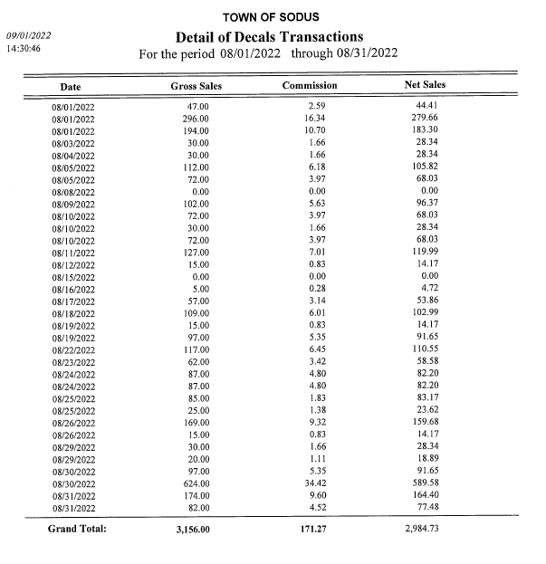
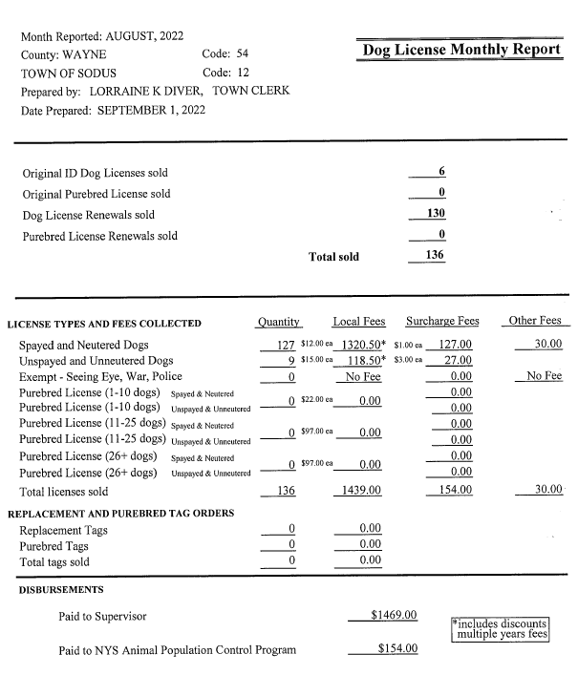
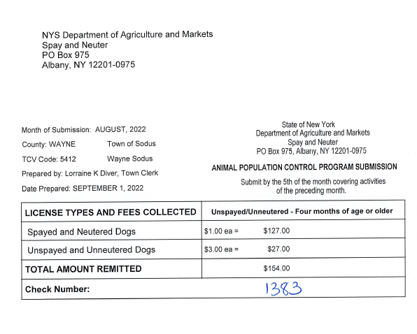

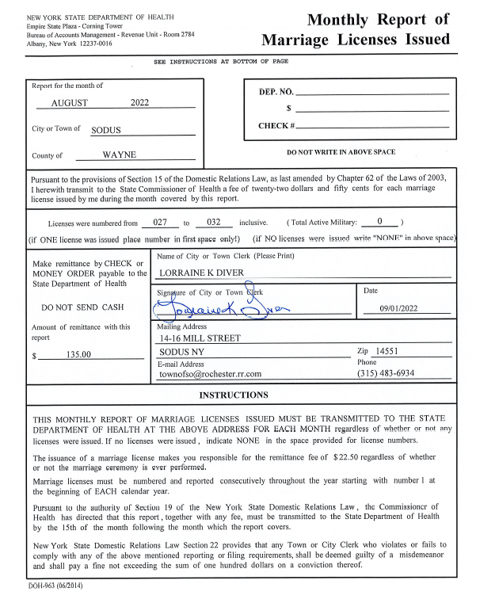

MINUTES
Minutes from August 9, 2022 was presented to the Town Board for approval. Councilperson Chris Tertinek motioned to accept and file these Minutes, which was seconded by Councilperson David LeRoy. Upon roll call the following votes were heard, Scott Johnson, aye; David LeRoy, aye; Don Ross, aye; Chris Tertinek, aye; and Cathy Willmott; aye. Motion carried
.

ABSTRACT
RESOLUTION TO PAY ABSTRACT No. 16
- 9-2022)
WHEREAS, the following bills were presented for payment on Abstract 16:

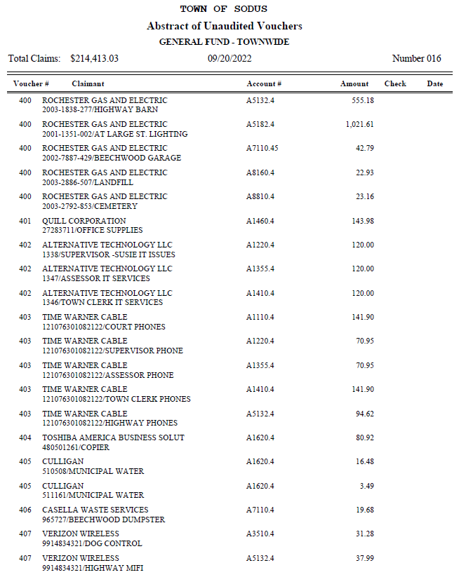

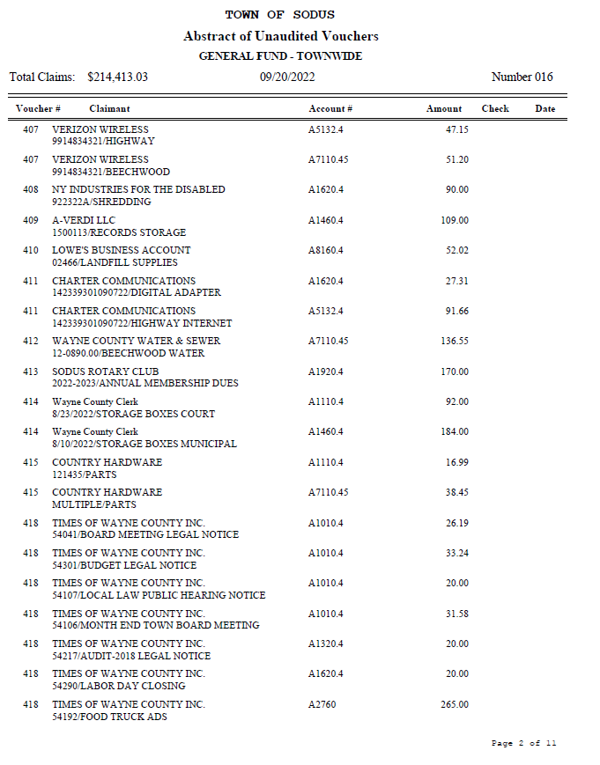
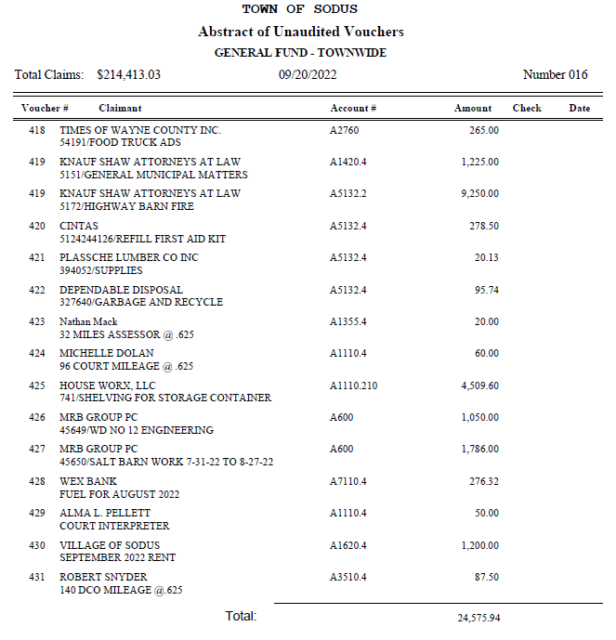
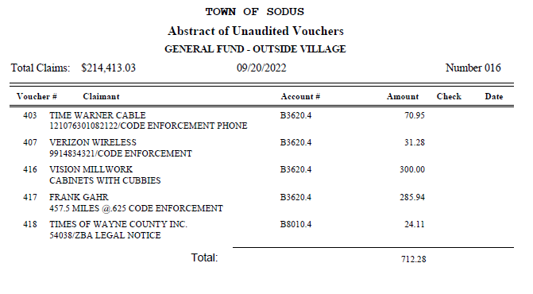
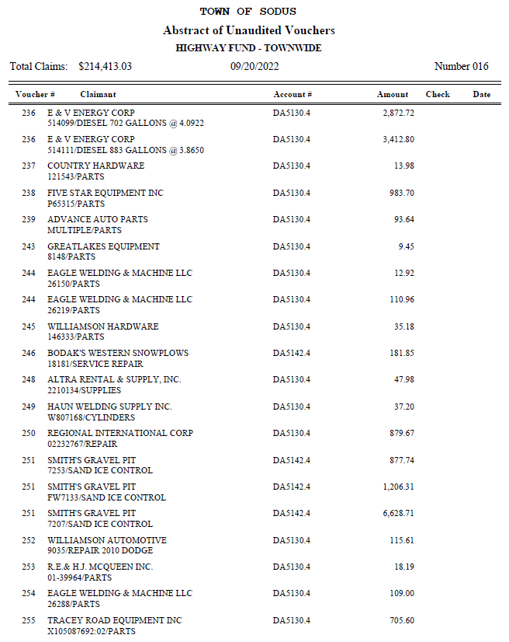
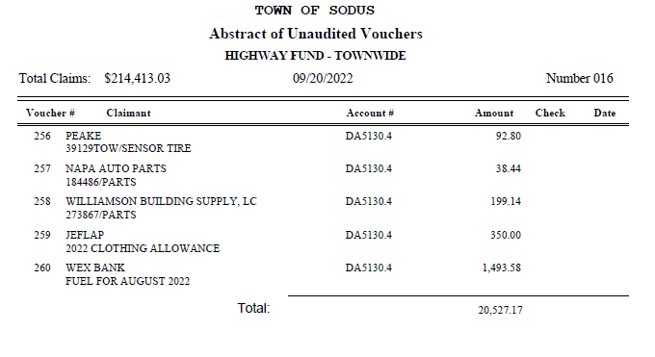
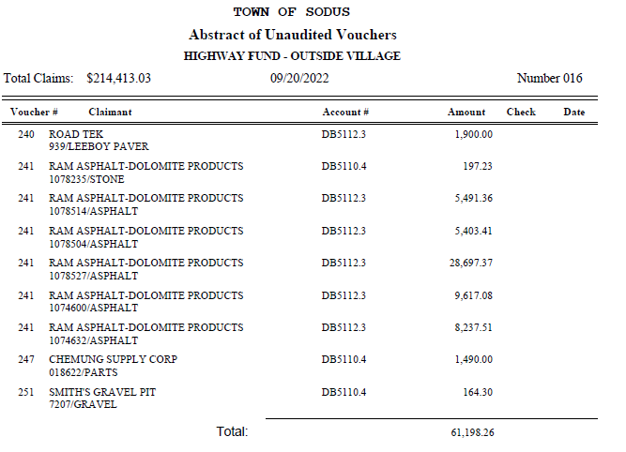
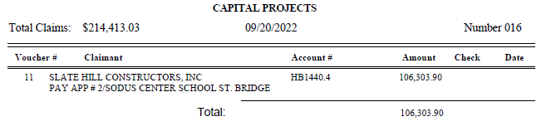
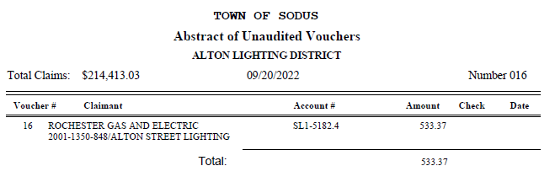
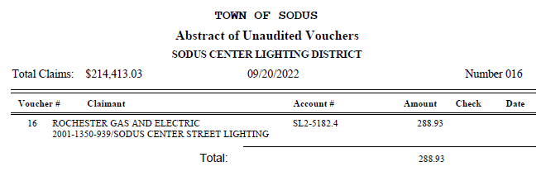
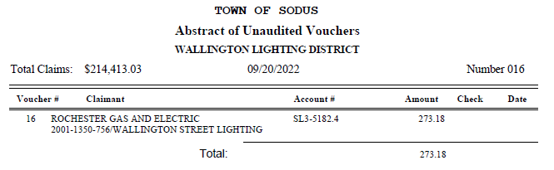

NOW BE IT RESOLVED, Councilperson Cathy Willmott motioned to pay Abstract # 16 as listed and adopt this resolution which was seconded by Councilperson David LeRoy. Upon roll call the following votes were heard, Scott Johnson, aye; David LeRoy, aye; Don Ross, aye; Chris Tertinek, aye; and Cathy Willmott; aye. Resolution Adopted.

PUBLIC WORKS COMMITTEE: Councilperson David LeRoy, Chair
(Highway, Drainage - Deputy Town Supervisor)
HIGHWAY REPORT:
(Dale Pickering – Highway Superintendent)
Councilperson Cathy Willmott motioned to accept and file the monthly August 2022 Highway Report from Dale Pickering Highway Superintendent was seconded by Councilperson Don Ross. Upon roll call the following votes were heard, Scott Johnson, aye; David LeRoy, aye; Don Ross, aye; Chris Tertinek, aye; and Cathy Willmott; aye. Motion carried.

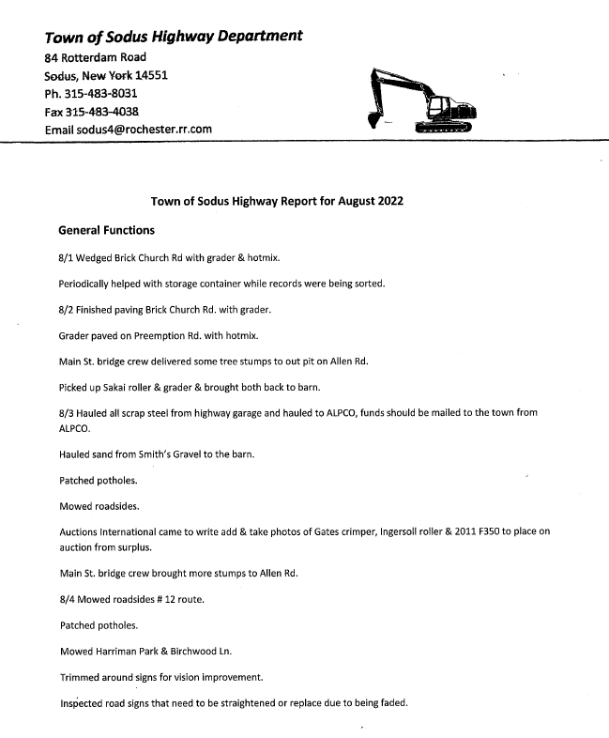

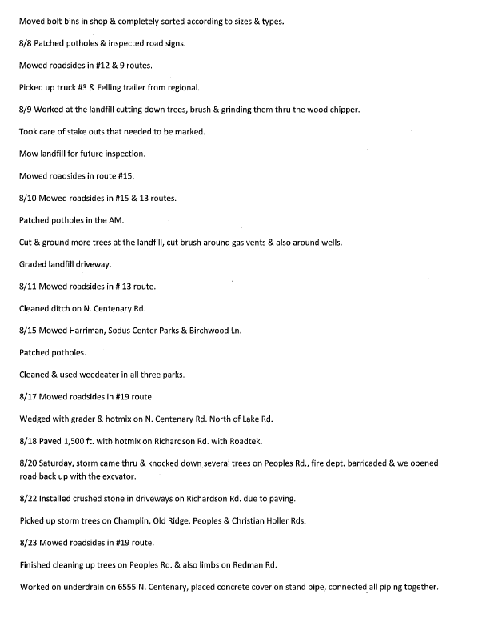
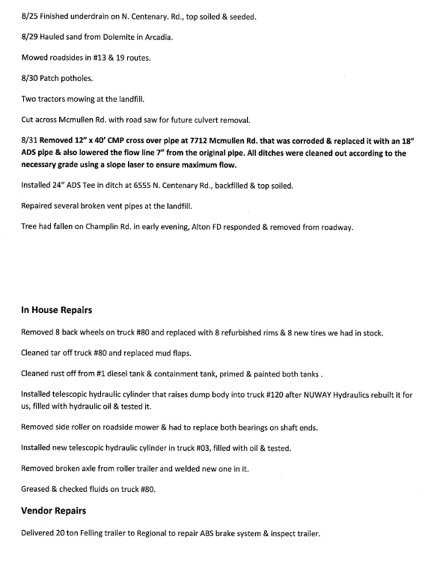
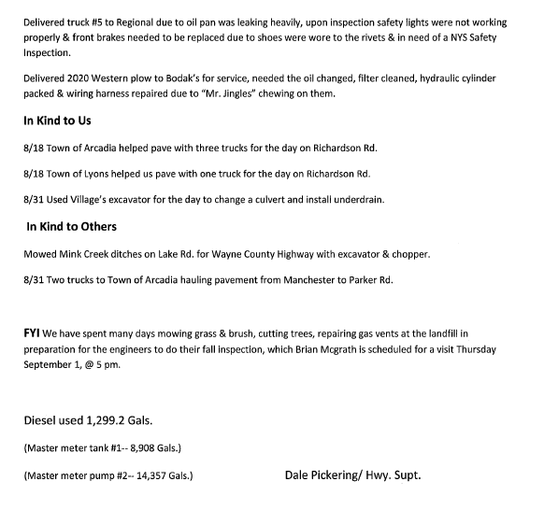
LED STREET LIGHTING:
Councilperson David LeRoy is waiting for the schedule of when the new LED lights will be installed.

SALT BARN UPDATE:
Councilperson David LeRoy discussed the Salt Barn should be built and completed by end of 2023.

DRAINAGE
N/A

RECREATION/ENVIRONMENTAL COMMITTE: Cathy Willmott, Councilperson
(Recreation, Assessor, Parks, Cemeteries)
Recreation Report
Councilperson David LeRoy motioned to accept and file the monthly August 2022 Town Recreation Report from Director, Sheila Fisher was seconded by Councilperson Cathy Willmott. Upon roll call the following votes were heard, Scott Johnson, aye; David LeRoy, aye; Don Ross, aye; Chris Tertinek, aye; and Cathy Willmott; aye. Motion carried.
Director’s Report
Sodus Recreation
September 5, 2022

Monthly Report
Programs:

- Our Summer Program ended very successfully. We ended with a total of 243 children between our summer program & soccer program.

- Our Soccer program has had issues the past several summers due to inclement weather forcing us to cancel 1 or 2 evenings of our program. These sessions are difficult to reschedule based on employee availability and other obligations that families have. We have decided that going forward we are going to hold our Soccer program in the Fall rather than the Summer. This way we will not run into the severe heat elements. If we run into rain or thunder we can host the program indoors without the concern of heat. We will still hold our winter program as usual.
- Currently, we are wrapping up cooking programs.

Budget:
We have submitted our 2023 Budget Worksheet with increases in payroll. We have a report prepared which supports the need for the increase. Please keep in mind while reviewing our budget worksheet that our department has not requested any increase since prior to 2006, when I took this position as Director.

Assessor’s Report
(Nathan Mack, Assessor)
Councilperson Don Ross motioned to accept and file the monthly August 2022 Assessor’s Report from Sole Assessor, Nathan Mack was seconded by Councilperson Chris Tertinek. Upon roll call the following votes were heard, Scott Johnson, aye; David LeRoy, aye; Don Ross, aye; Chris Tertinek, aye; and Cathy Willmott; aye. Motion carried.

tOWN OF sODUS

ASSESSOR’S OFFICE
Date: September 8, 2022 Respectfully Submitted by: Nathan Mack

AROUND THE OFFICE
- The Schools have sent out tax bills to property owners in Wayne County. Our office is in cooperation with assisting Taxpayers who may have questions or providing them with resources to help understand/gather information.
- As it was last year, seniors who signed up for the Income verification program previously with New York State do not need to complete an annual renewal for the Enhanced Star. New York State will contact them directly if they have any questions. Exemption Renewals for the agricultural land exemption and the low income senior exemption will be mailed out later in the year.
Camp Beechwood/Sodus Groundskeeper Report
(Sal Vittozzi-Caretaker-Sodus Town Groundkeeper)
Councilperson Don Ross motioned to accept the monthly August 2022 Camp Beechwood-Parks & Cemeteries Report from Sal Vittozzi; Sodus Town Groundskeeper-Caretaker was seconded by Councilperson Chris Tertinek. Upon roll call the following votes were heard, Scott Johnson, aye; David LeRoy, aye; Don Ross, aye; Chris Tertinek, aye; and Cathy Willmott; aye. Motion carried.

AUGUST 2022 BEECHWOOD REPORT
August was a very busy month here at the park. We were full of hikers, dog walkers, and park goers all month long. Camping numbers increased as well. We raised $975 in camping fees in the month of august. Mowing is still being done on a weekly basis and the park is looking beautiful. There was also another bridge built in the park in august. The bridge was another Eagle Scout project and is located over the swampy area headed up the hill from the east entrance. Both new bridges are getting rave reviews from everyone who comes to the park. All in all, august was a very positive and productive month here at the park.

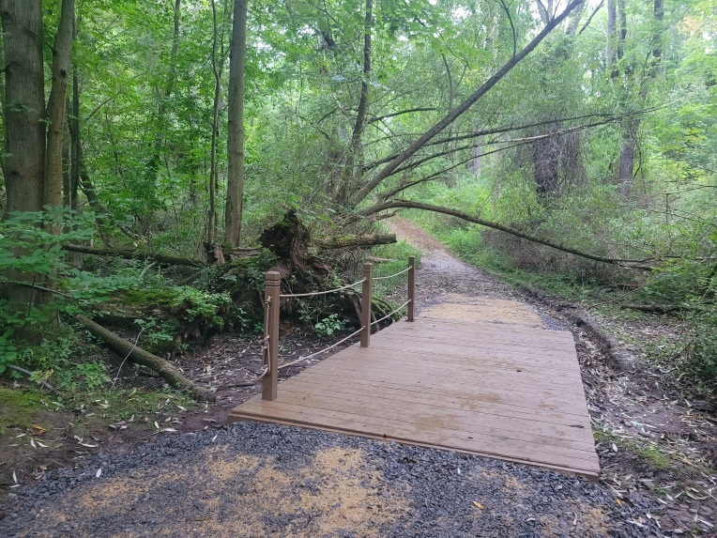

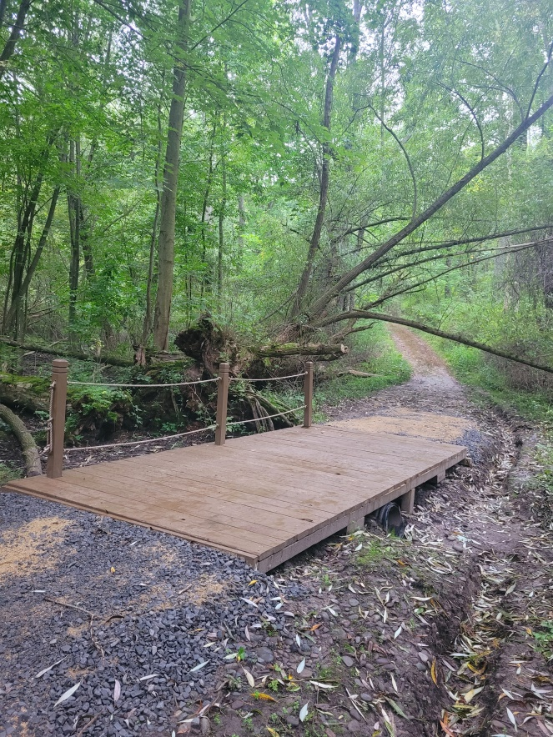

BUILDINGS AND GROUNDS COMMITTEE: Councilperson Chris Tertinek, Chair
(Town Property, Animal Control, Flood Damage Prevention)
CODE ENFORCEMENT REPORT:
(Frankie Gahr- CEO)
Councilperson Cathy Willmott motioned to accept the monthly August 2022 Code Enforcement Report was seconded by Councilperson David LeRoy. Upon roll call the following votes were heard, Scott Johnson, aye; David LeRoy, aye; Don Ross, aye; Chris Tertinek, aye; and Cathy Willmott; aye. Motion carried.
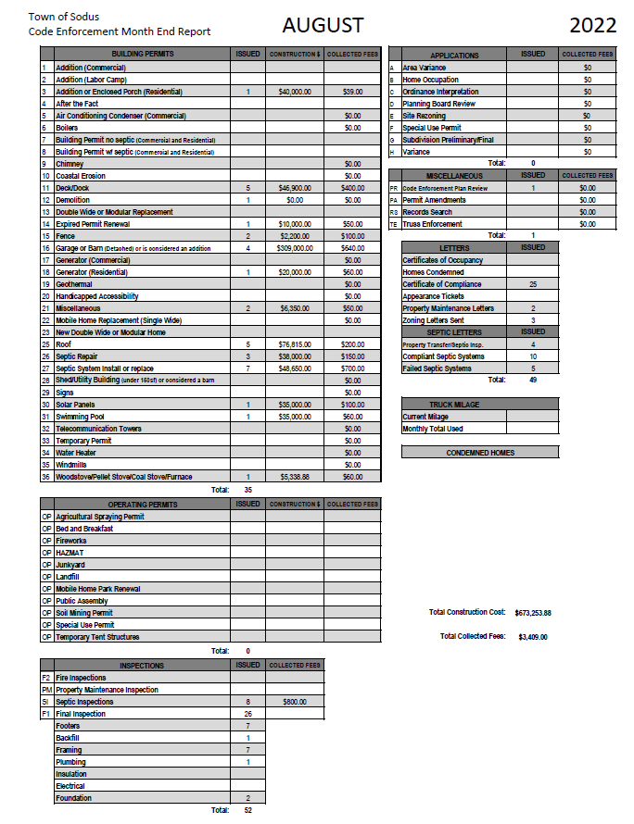

DOG CONTROL REPORT:
(Robert Snyder, Primary DCO)
(Vacant Position- Secondary DCO)
Councilperson Don Ross motioned to accept the monthly August 2022 Dog Control Report was seconded by Councilperson Cathy Willmott. Upon roll call the following votes were heard, Scott Johnson, aye; David LeRoy, aye; Don Ross, aye; Chris Tertinek, aye; and Cathy Willmott; aye. Motion carried.

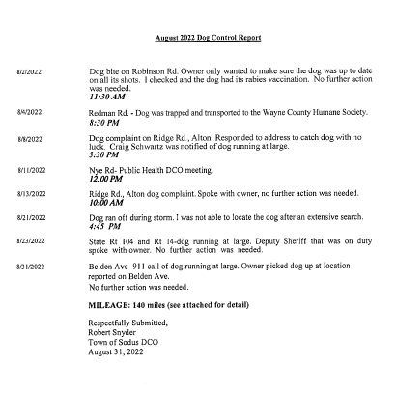
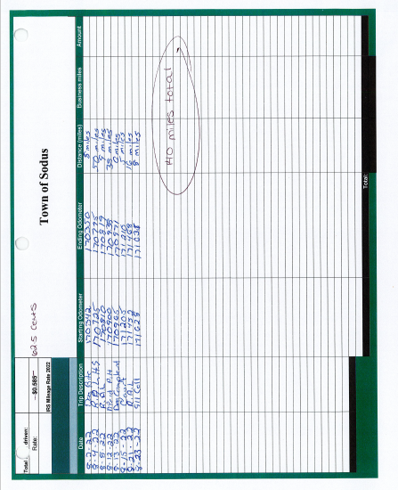

FLOOD DAMAGE PREVENTION REPORT-Code 69:
(Chris Tertinek, Councilperson)
Councilperson Chris Tertinek gave his monthly Flood Damage Prevention Report.
Lake Level
- Level dropped nearly 10” in the past 30 days to 244.6 ft ASL, about 6” below long-term average. Boats are becoming mud buggies.
- Forecasted low will occur in mid-November.
- Unless the Ottawa basin has a lot of snow/rain in the winter months, next year will be another year of low water.

PLANNING BOARD –ZONING BOARD
Chris discussed the number of members that are on the Planning Board vs. the Zoning Board. He asked the Town Board the following:
- He would like to see five members on planning vs. the seven that are currently on the board.
- Two Ad-Hoc Members
- Full members to serve for five years and staggered over five years (the term does end at the same time).
- Ad-Hoc Members to serve a one year term.
Lori Diver Sodus Town Clerk will reach out to Town Attorney Amy Kendall to discuss current local law for terms and number of members.

PUBLIC SAFETY/DRAINAGE/ENVIRONMENT COMMITTEE: Councilperson Don Ross, Chair (Fire, Ambulance, Emergency Preparedness)
Councilperson Don Ross gave his monthly report. The 911 call report and SESA Minutes were sent by email. Because of the length, they will remain on file with the Town Clerk’s Office.

Ross reported that Fire Prevention Week will be held at the Sodus Central School District in October 2022.

The Regional Water Project should be complete on RT. 88.

Ross mentioned that he was informed that with the new Marijuana Law in place, it does not make someone with a CDL exempt. If someone test shows positive, they still are in violation and operating under the influence.

TOWN HALL COMMITTEE: Scott Johnson, Supervisor –
(Personnel, Clerks, Justices, Assessor, Building Inspector, Town Council, Boards, Insurances, Finance)

CORRESPONDENCE & INFORMATION

Councilperson Don Ross motioned to accept Allan VanAcker’s letter of resignation/retirement letter with the Sodus Town Highway Department was seconded by Councilperson Chris Tertinek. His last day of work is September 29, 2022. Upon roll call, the following votes were heard Supervisor Scott Johnson, aye; LeRoy, aye; Ross, aye; Tertinek, aye; and Willmott, aye. Resolution Adopted.
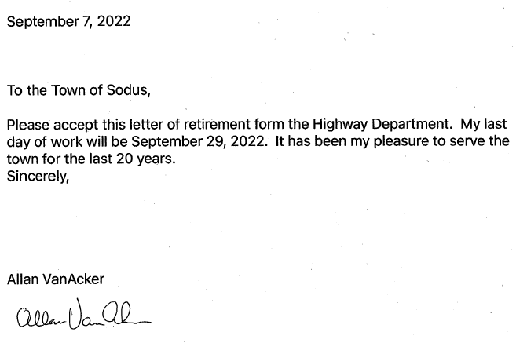

Councilperson Cathy Willmott motioned to accept Mark C. Brownell letter of resignation/retirement letter with the Sodus Town Highway Department was seconded by Councilperson Don Ross. His last day of work is September 29, 2022. Upon roll call, the following votes were heard Supervisor Scott Johnson, aye; LeRoy, aye; Ross, aye; Tertinek, aye; and Willmott, aye. Resolution Adopted.
Karen Cline Village Clerk sent the Town of Sodus Employees a thank you card for the donation to the Wayne County Humane Society regarding her brother’s passing.

CAMP BEECHWOOD STATE PARK
RESOLUTION
- 9-2022)
WHEREAS, Supervisor Johnson presented the following resolution; and

NOW BE IT RESOLVED, Councilperson Cathy Willmott motioned to hire Costich Engineers for Beechwood State Park and Access Road Design Services; in addition to hire Stony Creek Archeology to conduct the Phase 1A cultural resource investigation and to re-advertise for the grant administration per Sharon Lilla’s recommendations was seconded by Councilperson David LeRoy. Upon roll call the following votes were heard, Scott Johnson, aye; David LeRoy, aye; Don Ross, aye; Chris Tertinek, aye; and Cathy Willmott; aye. Resolution Adopted.

Councilperson David LeRoy motioned to cancel the Month End September 22, 2022 meeting and to reschedule and advertise for September 29, 2022 at 4:00 PM in the upstairs meeting room was seconded by Councilperson Cathy Willmott. Upon roll call the following votes were heard, Scott Johnson, aye; David LeRoy, aye; Don Ross, aye; Chris Tertinek, aye; and Cathy Willmott; aye. Motion carried.

WAYNE COUNTY MULTI-JURISDICTIONAL HAZARD MITIGATION PLAN
RESOLUTION
- 9-2022)

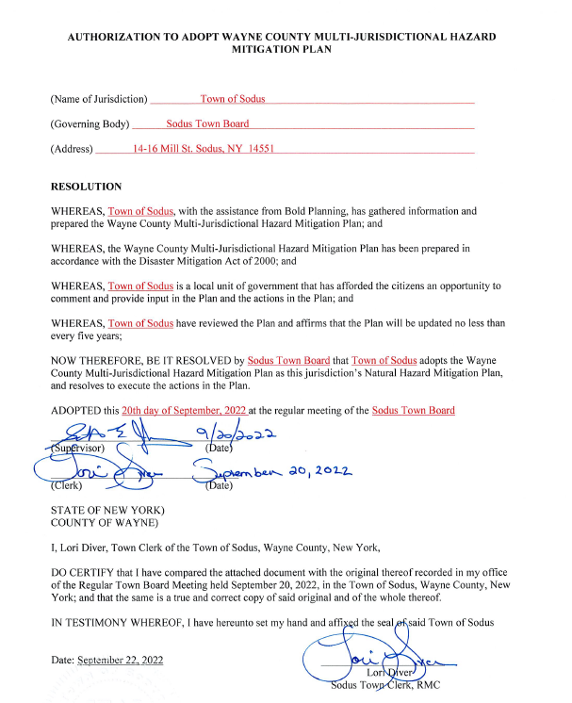

NOW BE IT RESOLVED, Councilperson Chris Tertinek motioned to adopt this resolution was seconded by Councilperson Cathy Willmott. Upon roll call the following votes were heard, Scott Johnson, aye; David LeRoy, aye; Don Ross, aye; Chris Tertinek, aye; and Cathy Willmott; aye. Resolution Adopted.

Councilperson Don Ross motioned to allow Lori Diver Sodus Town Clerk to advertise for the Digital Clerk position. The position is 20 hours per week, non-benefited and the hourly rate will be disclosed upon hiring was seconded by Councilperson Chris Tertinek. Upon roll call the following votes were heard, Scott Johnson, aye; David LeRoy, aye; Don Ross, aye; Chris Tertinek, aye; and Cathy Willmott; aye. Motion carried.

Councilperson Cathy Willmott motioned to adjourn the meeting was seconded by Councilperson Chris Tertinek. Upon roll call the following votes were heard, Scott Johnson, aye; David LeRoy, aye; Don Ross, aye; Chris Tertinek, aye; and Cathy Willmott; aye. Motion carried.

Meeting adjourned at 5:25 PM
Recording Secretary,

Minutes Written By:
Lori Diver
Sodus Town Clerk, RMC

