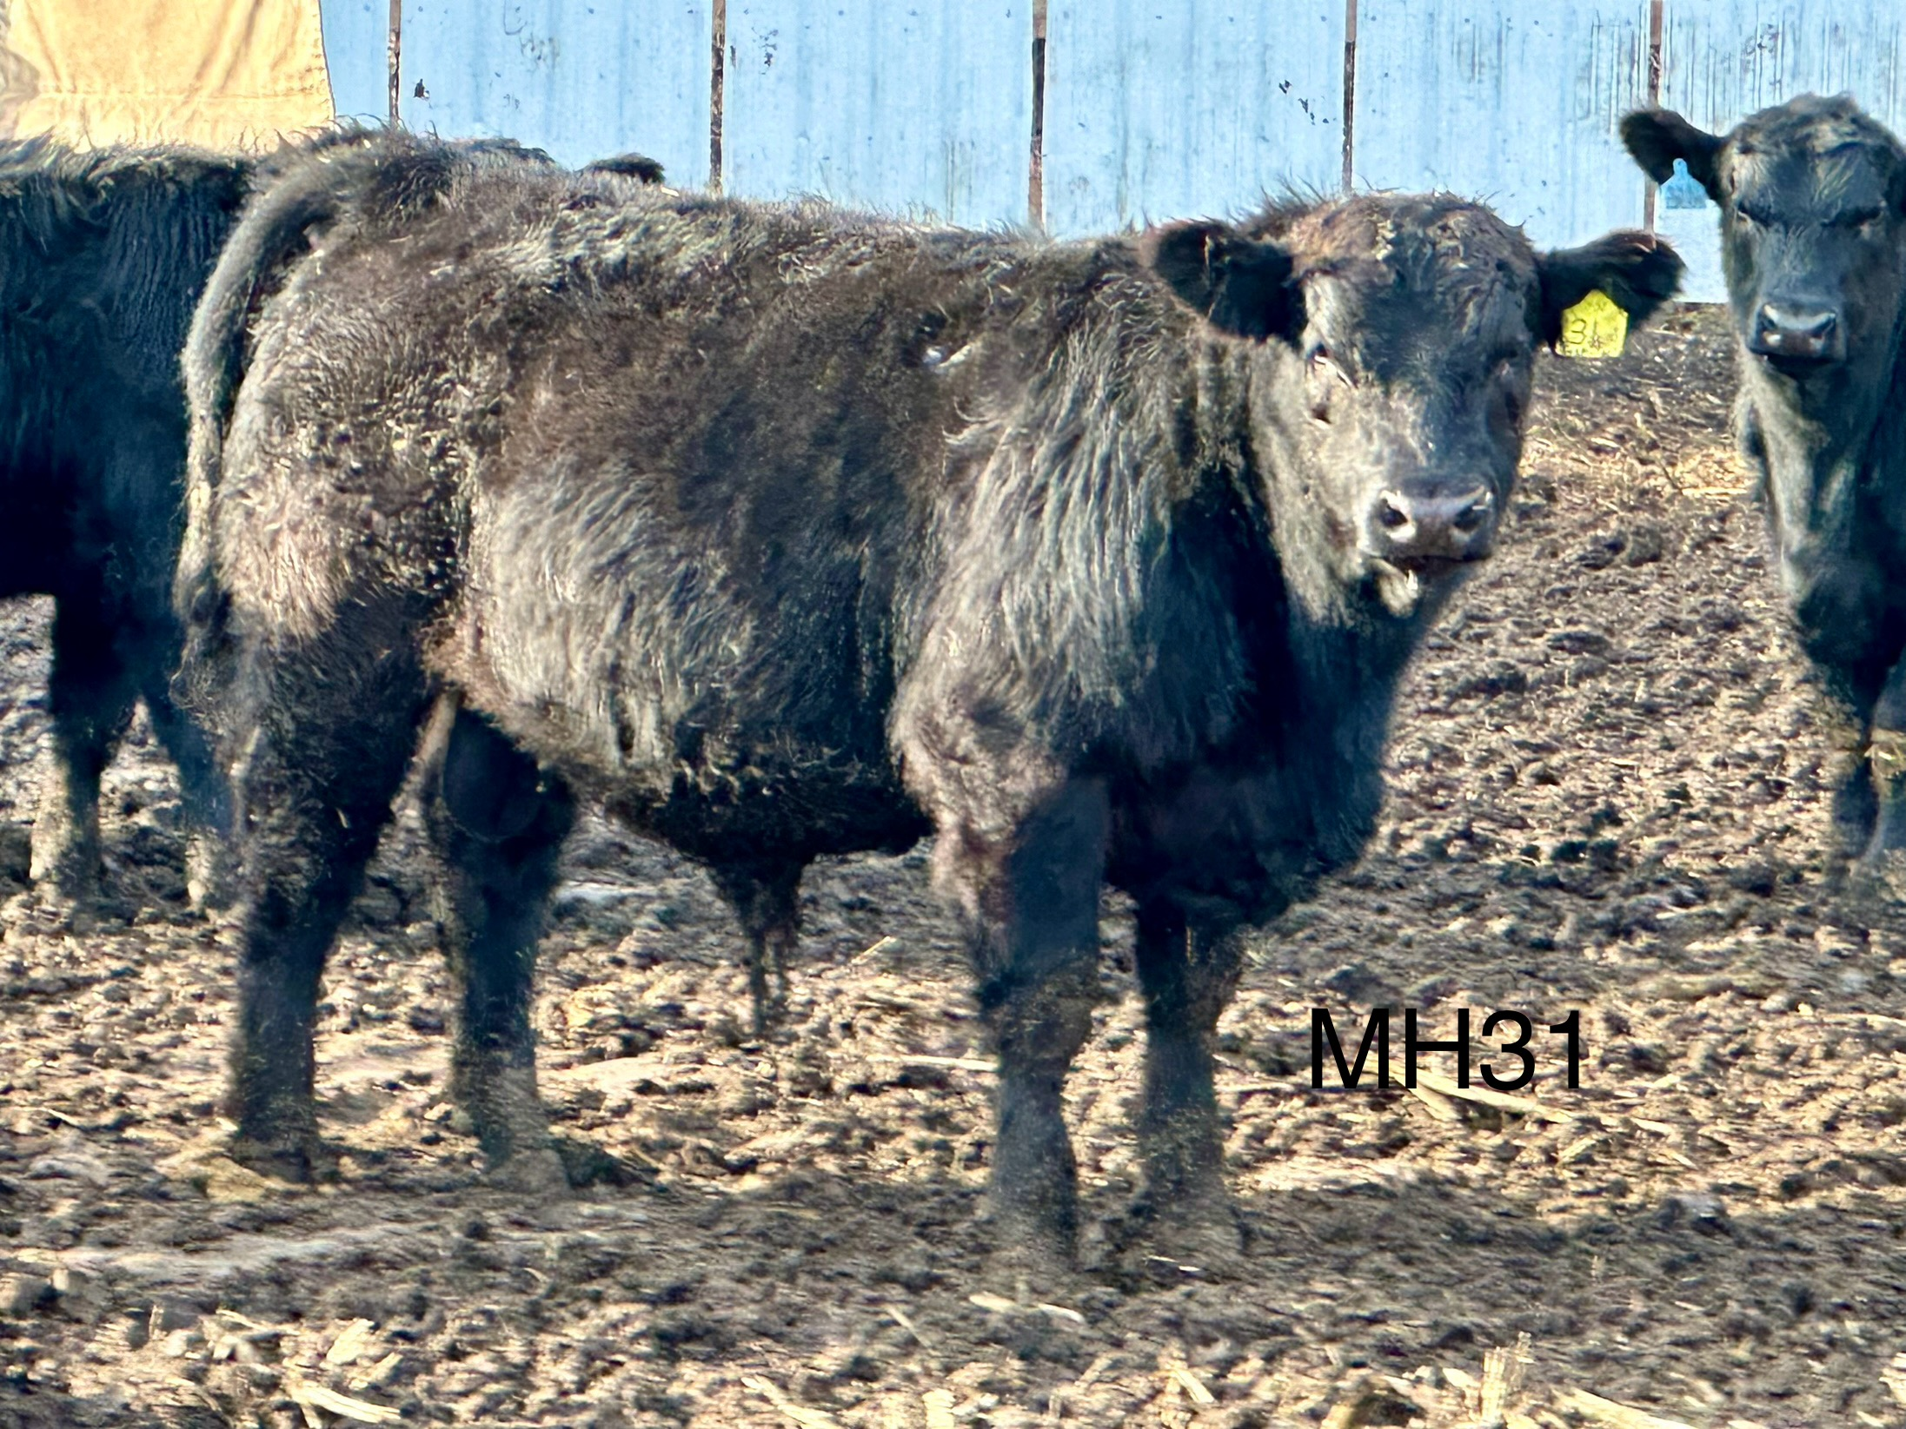MH31 bull out of Justified and a Capitalist cow.  Sale Process:  We will have the same format as in years past:  - Viewing of the bulls/heifers will begin at 10 am  - Sale order is determined by use of bid boards with the highest bid bull to start the sale ($3000 minimum bid)  - Complimentary lunch before the sale  - Bulls kept at no additional charge until June 1, 2024 (payment due upon delivery of bull to your farm)  - Heifer payment due day of sale with pick up soon after sale as arranged. |  |  | LOCATION OF SALE:  4747 240th Ave Webb, IA 51366  (East of Jim’s farm at Dave Hermstad’s)  About Sale:  Yearling bulls and heifers sold by Jim Larson, Marc & Drew Hinners, Tom Young, and Greg & David Hermstad  Contact Us:  Phone: (712)260-6144 Jim or Marcia at (712)260-6145;  Email: larsonj@evertek.net  Web: www.larsonangus.com Address: 4685 Hwy 71 Sioux Rapids, IA 50585.  Larson Angus Farm Annual Bull/Heifer Sale  4747 240th Ave Webb, IA 51366 |  |  | LAF324 out of LAF826(Diverse) shined up by this working LAF402(Absolute) cow.  Larson Angus Farm Annual Bull/Heifer Sale  - March 30, 2024 at 1pm  - Bull/Heifer Sale

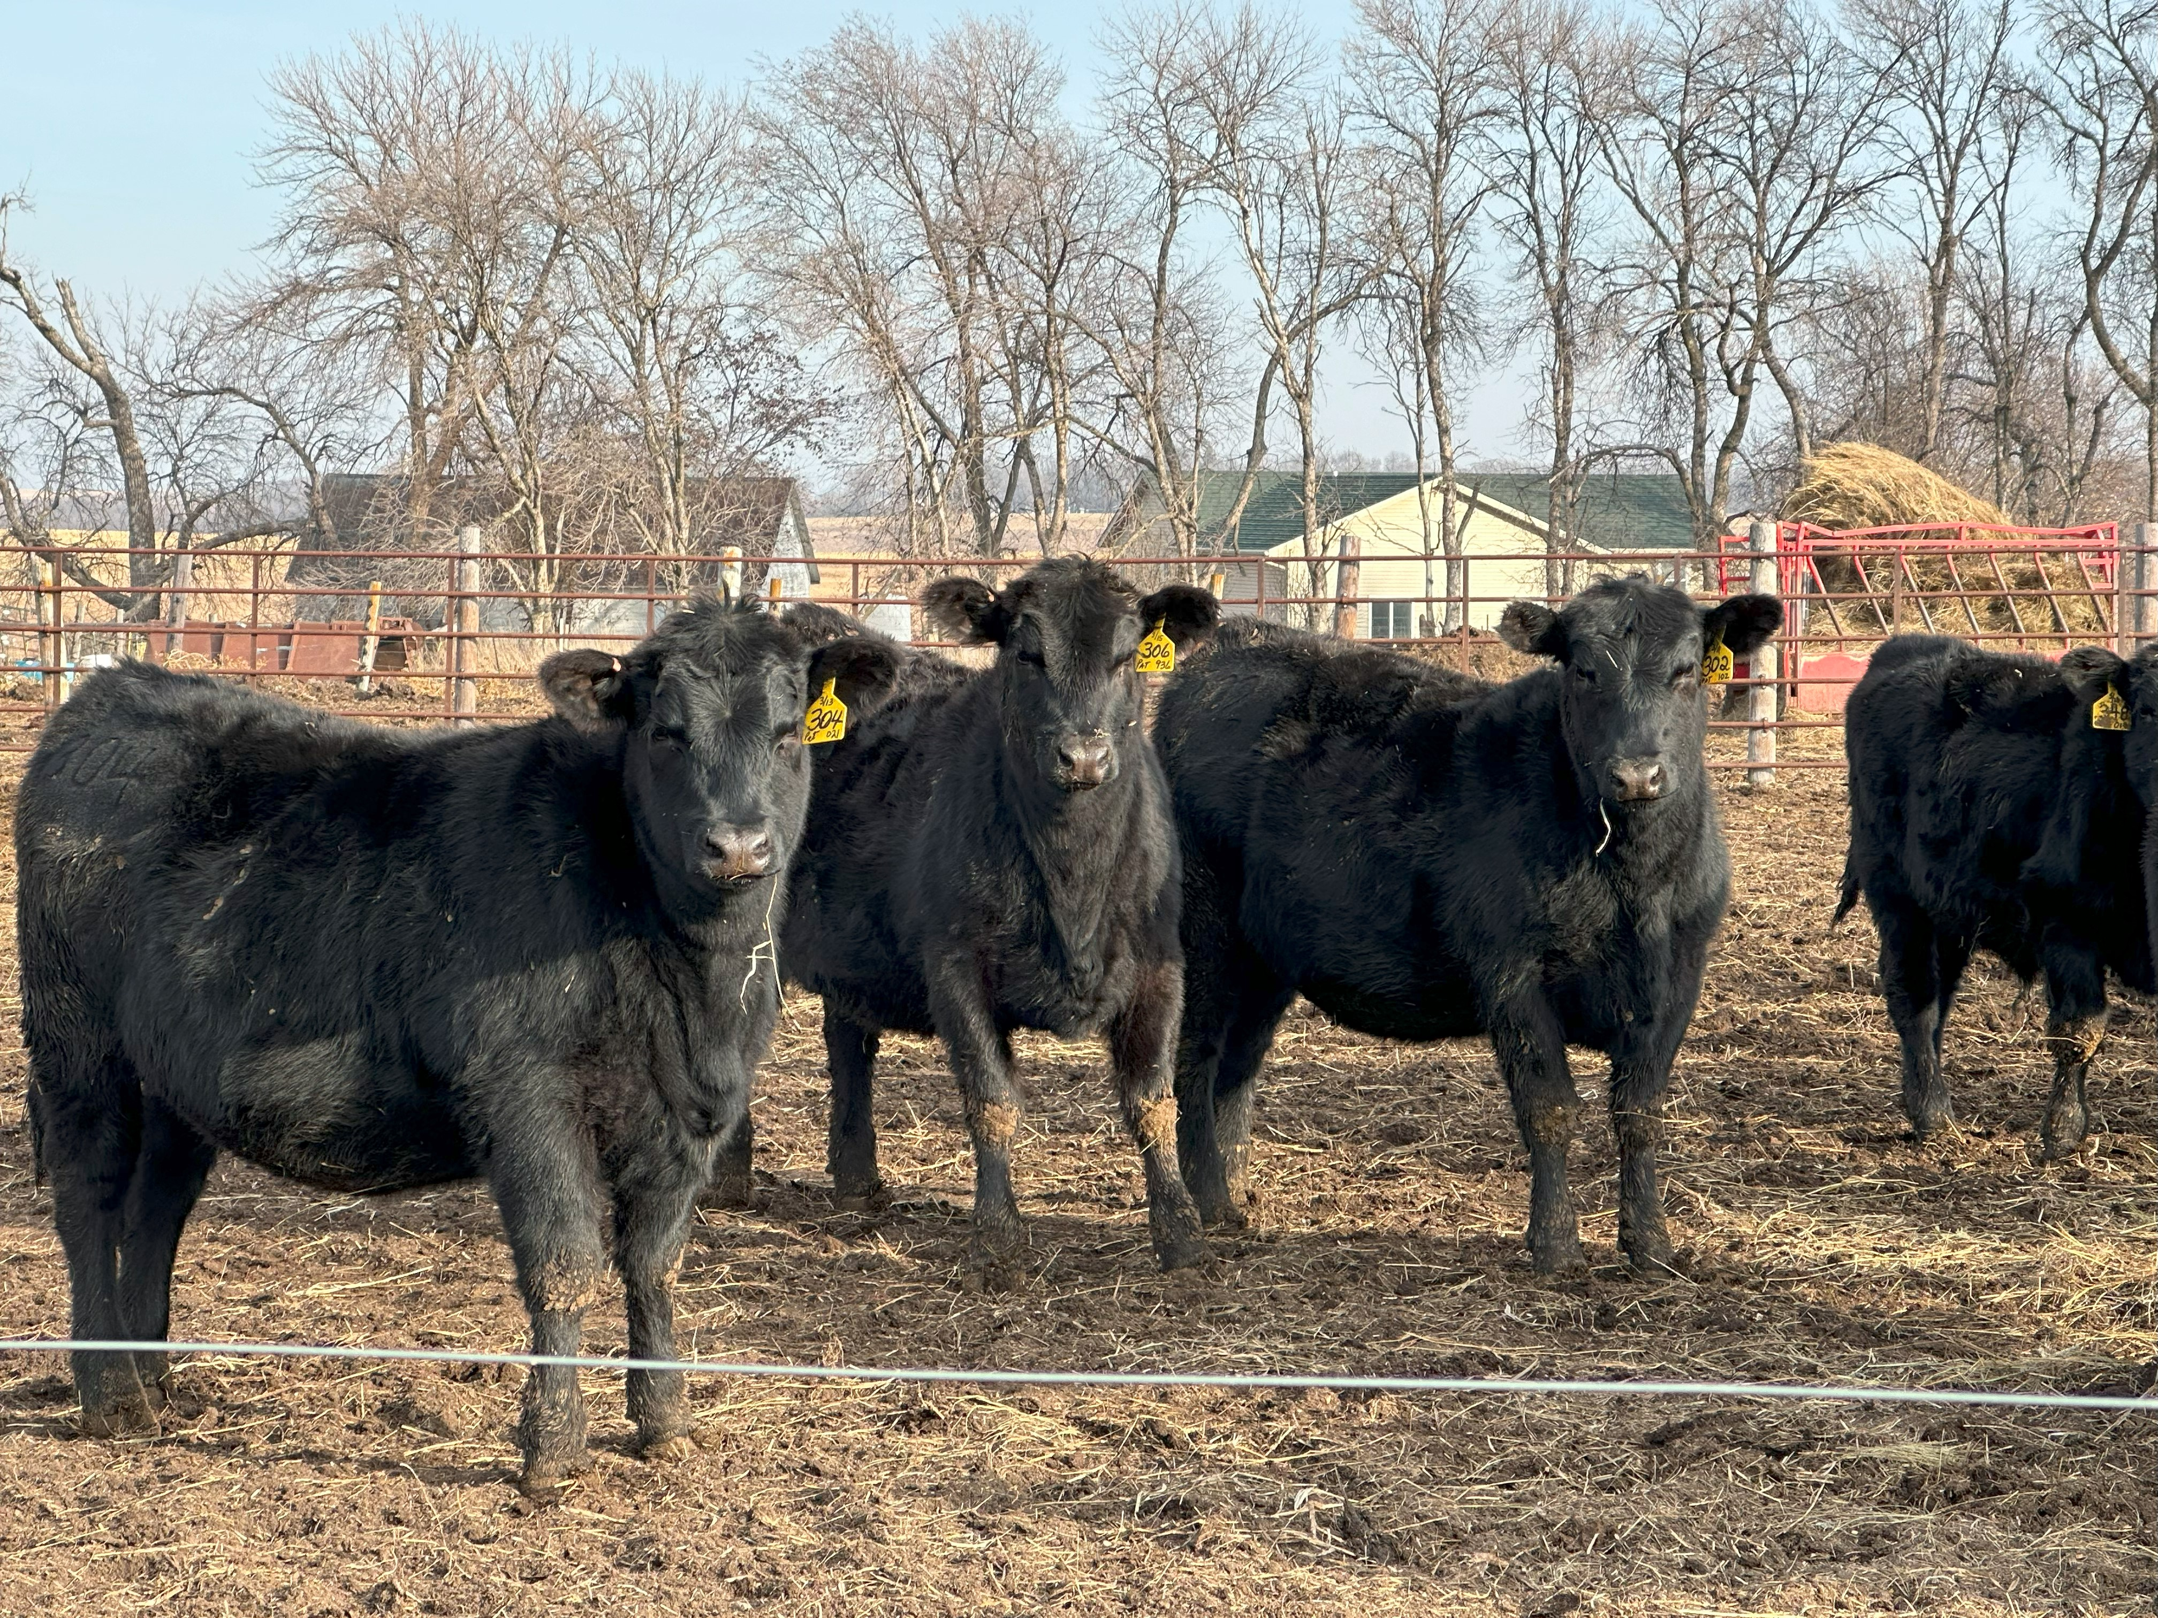  2023 Heifers-Always Jim’s favorites  Good Bulls Produce Good Cows  As most of you know, the heifers we raise are difficult for Jim to part with. The heifers this year were sired by Tehama Patriarch, LAF105(Accomplishment), Stellar, and LAF826 (Diverse). We will decide which heifers will sell in the next couple months. We generally ask that the heifers are picked up shortly after the sale, but alternate arrangements can be made for additional charge. Payment is due sale day. Give Jim a call if you would like to come see the heifers at our farm prior to sale day. |  |  | The people we meet are why we are still in the business.  We love having a chance to re-connect with those of you that have purchased animals or been to our sales. It is always a special day when we get a chance to meet new people who share the same ideas about raising quality cattle.  We pride ourselves in managing a closed herd to help prevent spread of disease. Through use of AI and over 50 years of managing we can offer healthy ready to work animals that will improve your herd.  We welcome visitors to check out the animals prior to the sale.  Please feel free to give us a call if you want to come view the animals or talk about them. Jim can be reached at (712)260-6144 or Marcia (712)260-6145. Marc Hinners and the Hermstad brothers can also be contacted to arrange a time to view the bulls. |  |  | 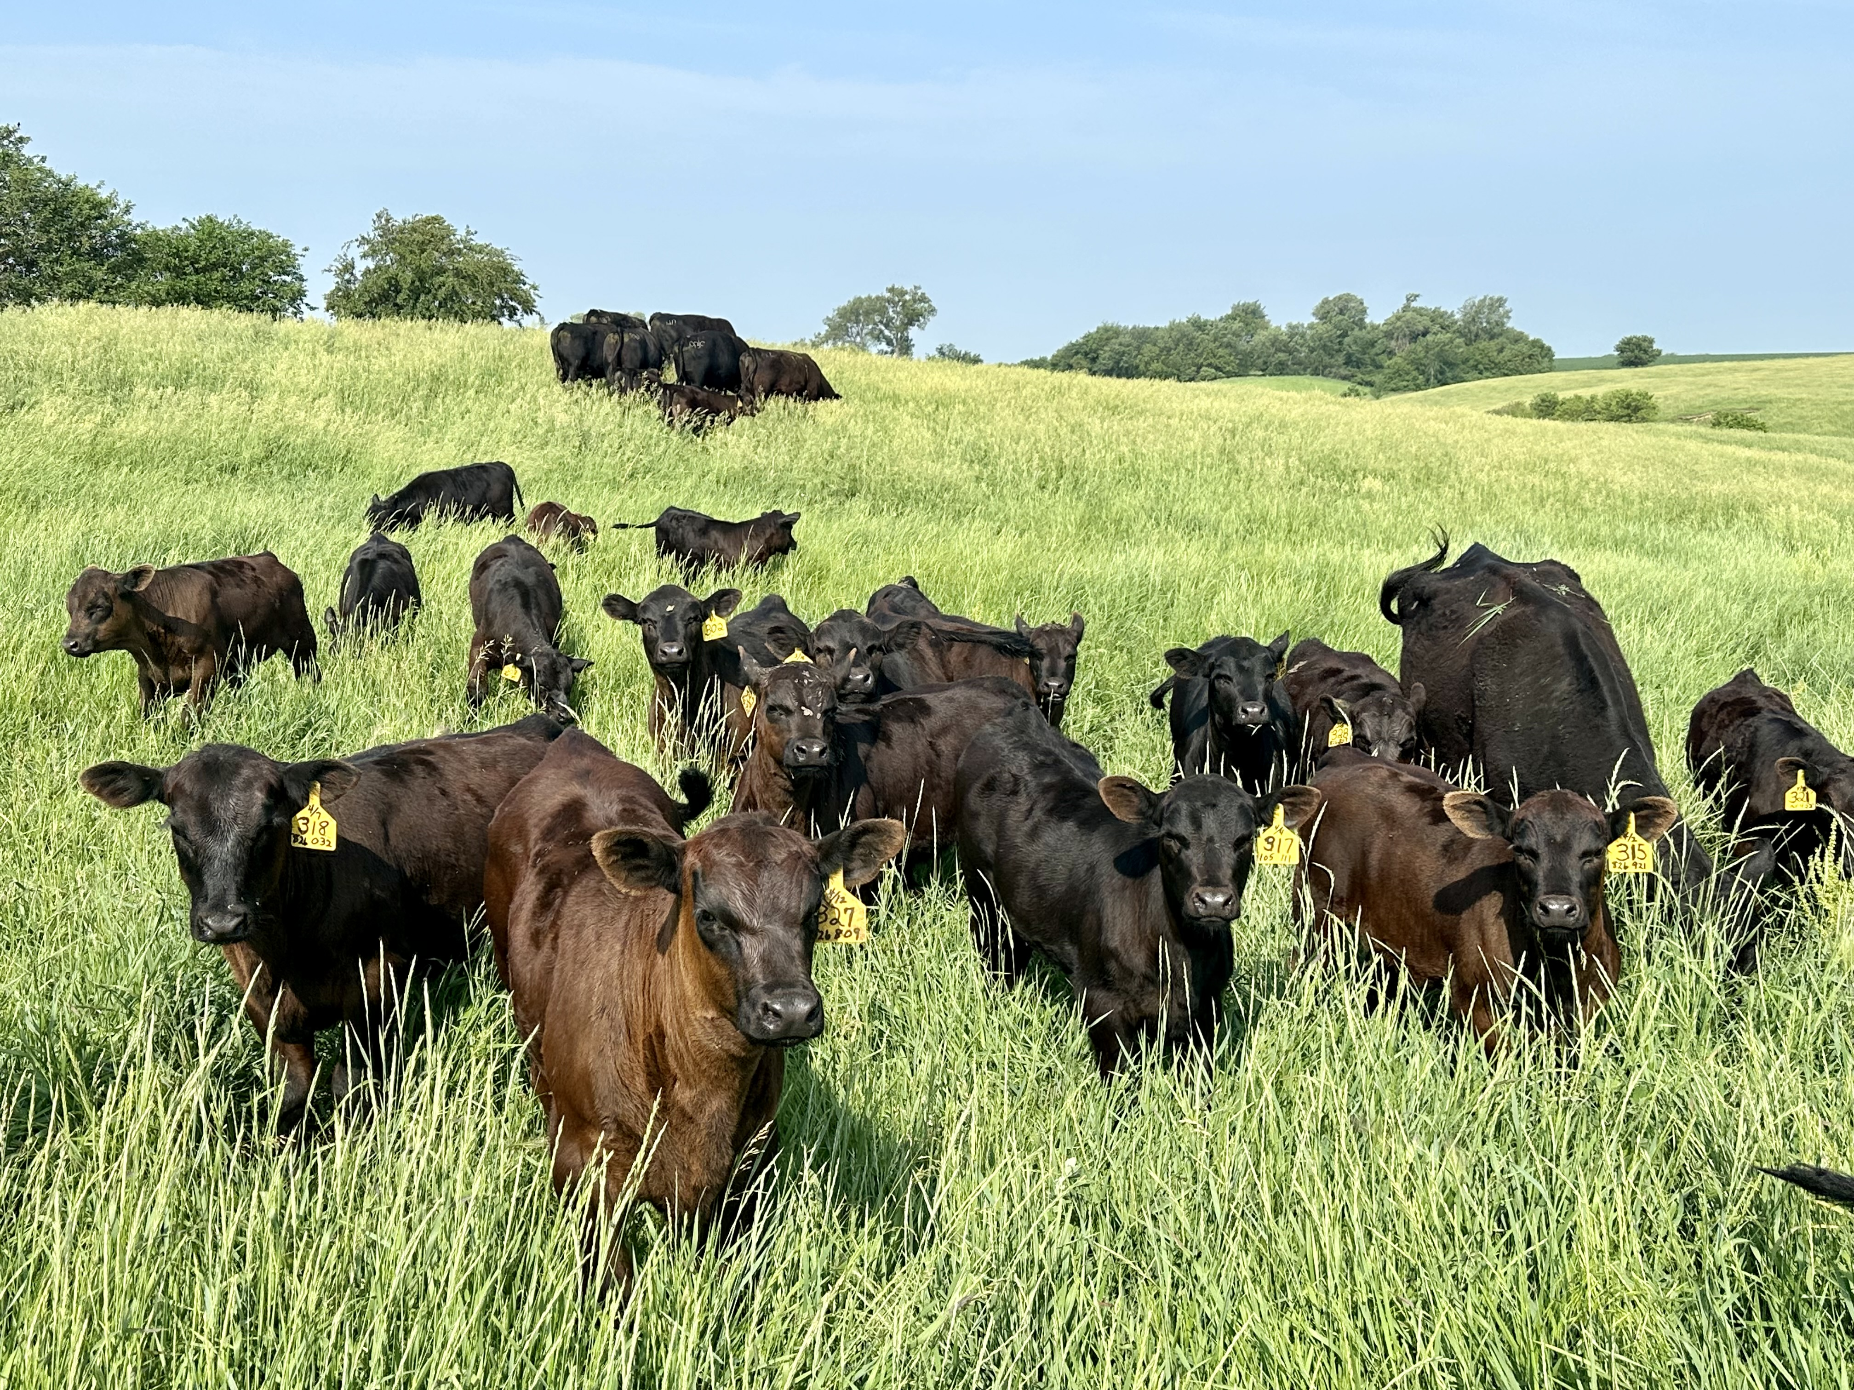  2023 Calves fun to see grow in the green summer grass.  We strive to offer quality animals that will go to work for you to develop quality cattle.  Weights and Semen Checks  We will send out additional Newsletters in February and March with final weights for the bulls. Our plan is to have them semen tested March 18th. We feel that this is important as we won’t sell you a bull that isn’t going to be able to get his job done.  Bulls are out of Patriarch, Justified, LAF826(Diverse), and other home raised bulls.  Stay tuned for updated information. We hope this letter finds you all well. Happy New Year from the Larson Family.

