Expert Roofing & Guttering Ltd

Business Portfolio
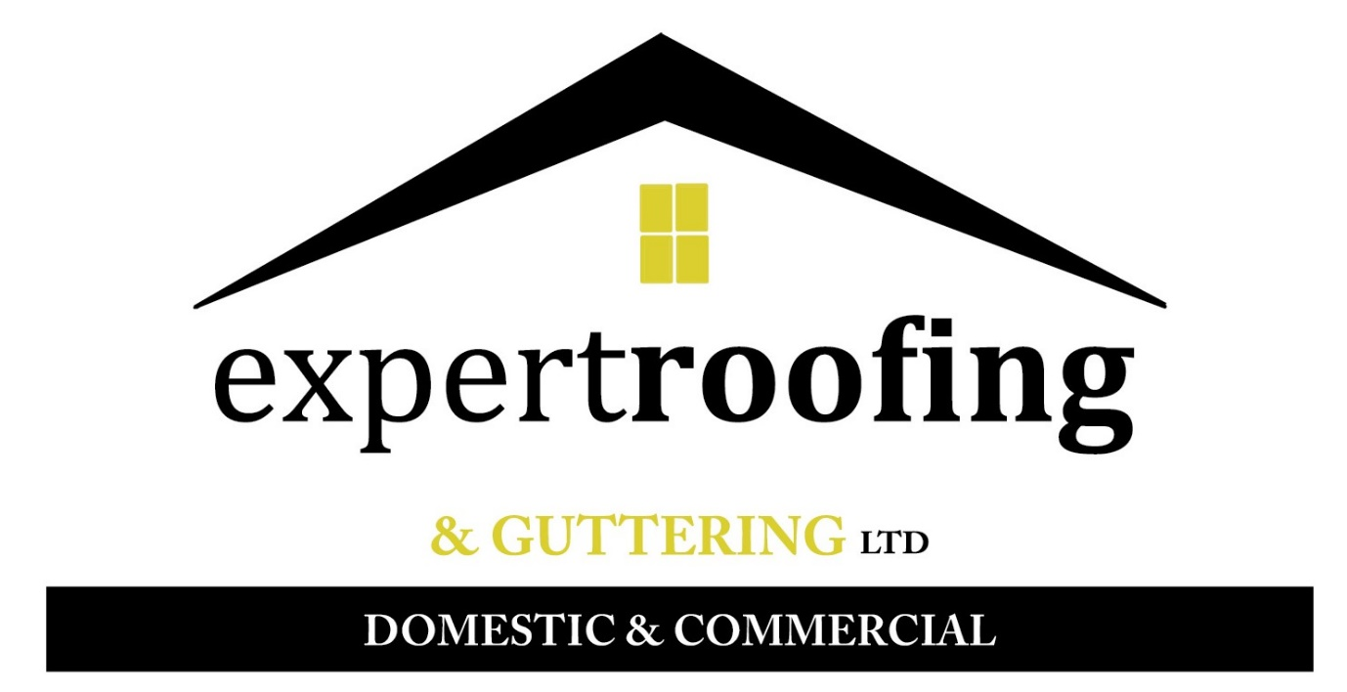

Company Profile

We are a national roofing contractor primarily based in Wigan, offering a wide variety of services across the UK. We are not limited with what we can do as within the business, we offer roofing and scaffolding services. We provide a 24 hr call out service to allow peace of mind to our customers in the event of emergencies. In addition to this, we will always provide a free quote before completion of any work, providing the customer with information on the issues and a cost for the works required.
We have been in the roofing business for 20 years and over this time we have built a reputation for delivering quality work to customer requirements at a reasonable and competitive cost.
We are a no-nonsense company and will always supply an honest appraisal on all jobs, with a guarantee to deliver on our promises. We are proud of our company and even more proud of our ability to give customers what they expect on time, within budget and to a high standard of workmanship.
We have a strong presence in the construction industry to help both domestic and commercial customers with a range of different problems that can be faced from small jobs to a full re-roof or working on a new build construction site.
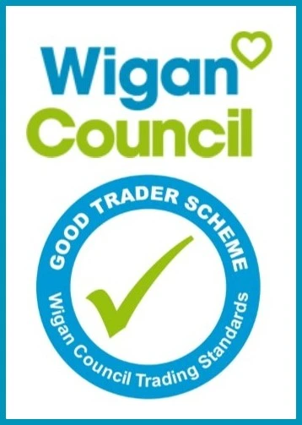

Our Services

Roofing Services
Expert Roofing and Guttering Ltd provide a wide range of roofing services including roof repairs, gutter cleaning, new roof installation, flat roof repairs and new flat roofs, tiling, slating, leadwork, pointing, ridge and hip tiles as well as the supply and installation of guttering, fascia’s and soffits. Our team of roofing professionals are highly experienced and fully qualified in their field. We have the ability and experience to complete work of any size. As well as working for domestic and commercial clients, we also have the ability to work on new build sites.

What’s important in a Roofing Company?
When using the services of a roofing company it’s important that you choose a company that is fully insured and guarantees their work. All re-roofs and large work will come with a guarantee.
At Expert Roofing you’ll be pleased to know that we do not use sub contracted labour and the team are happy to offer their expert advice on the best way to solve your roofing problem.

Roof repairs and replacement services on a local and national basis
Our team undertake all size of jobs, from a minor repair to replacing a whole roof from our base in the heart of the North West. We are a local roofing contractor with national reach.
In addition, we also offer a 24hr emergency call out service where a temporary fix will be provided, and a further quote submitted. Whether you are looking for a re-roof or simple repairs we are the name you can trust to complete the work.
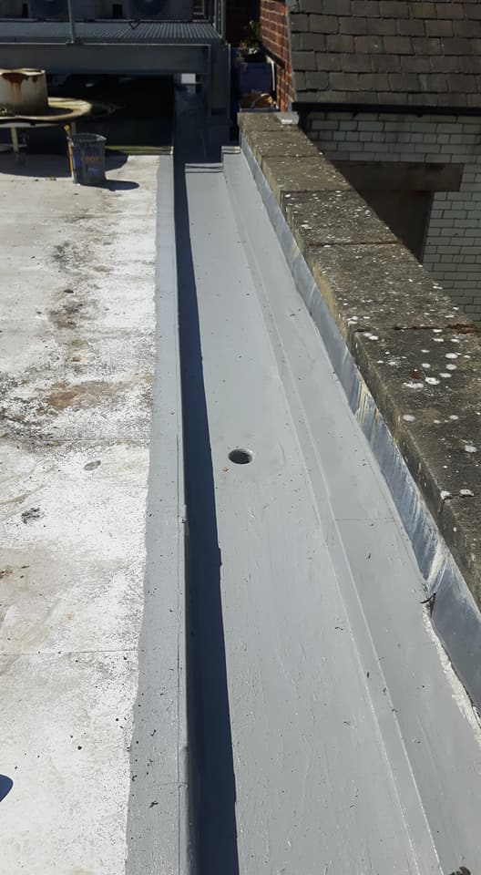
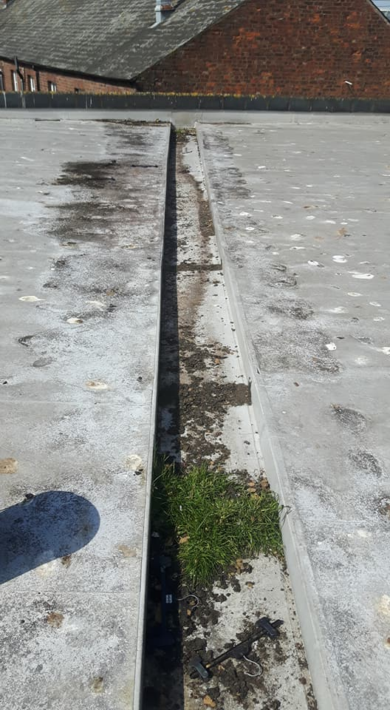

Large projects we have completed

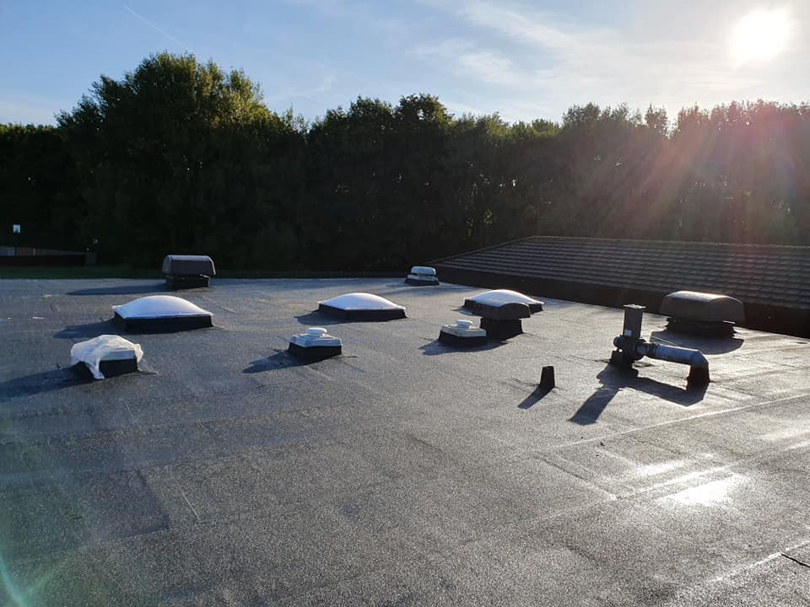
Shevington High School:
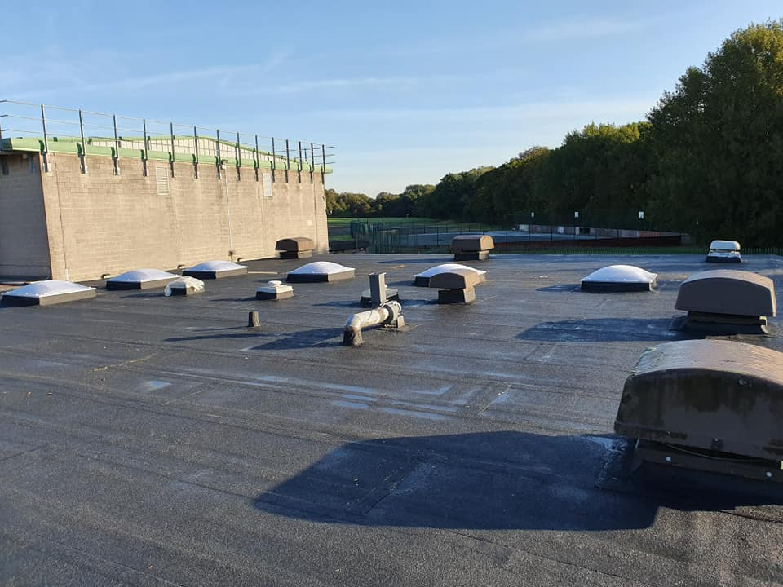

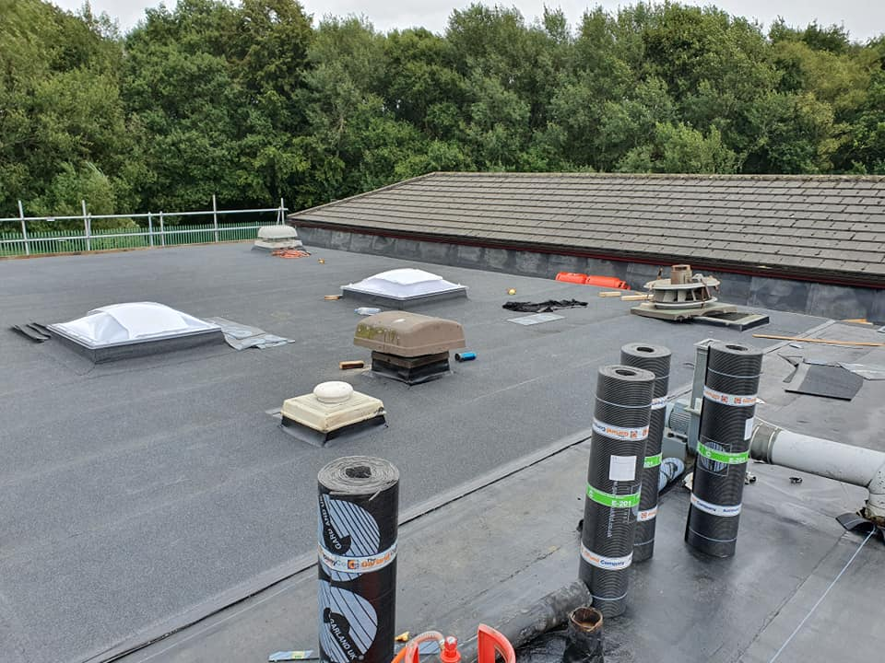
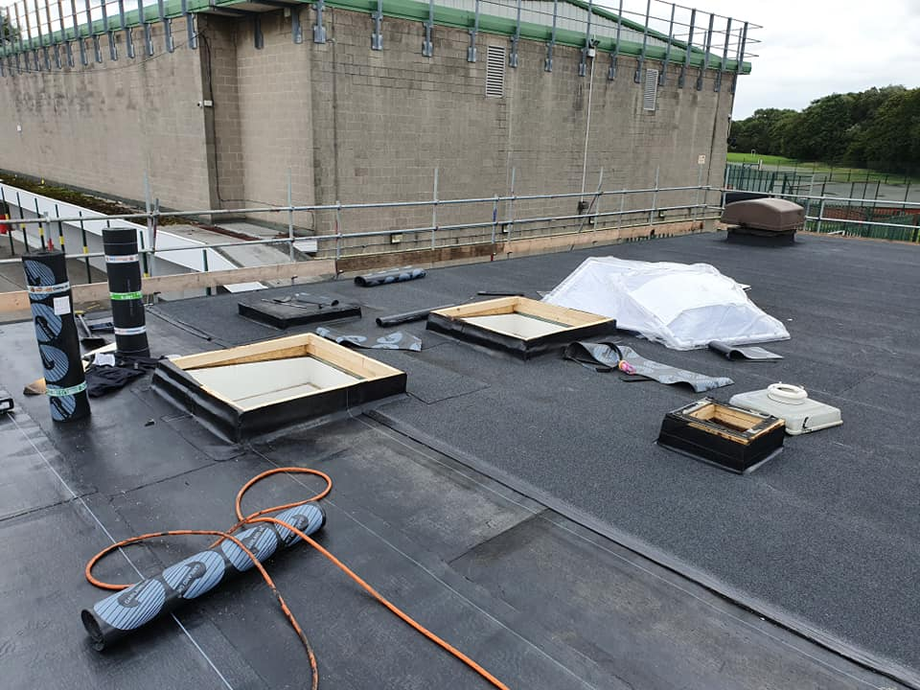
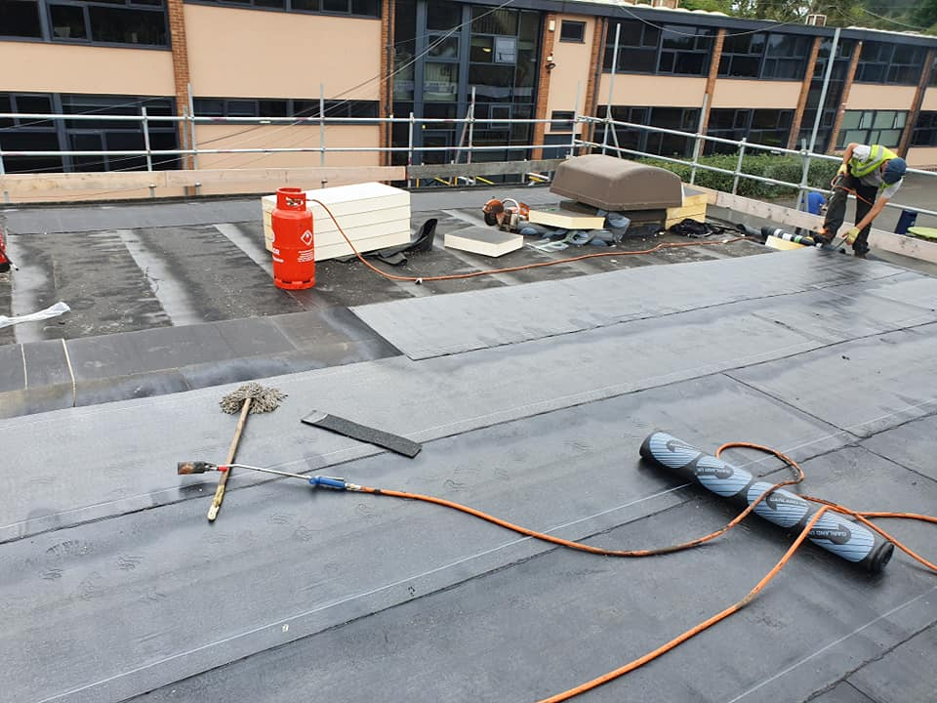

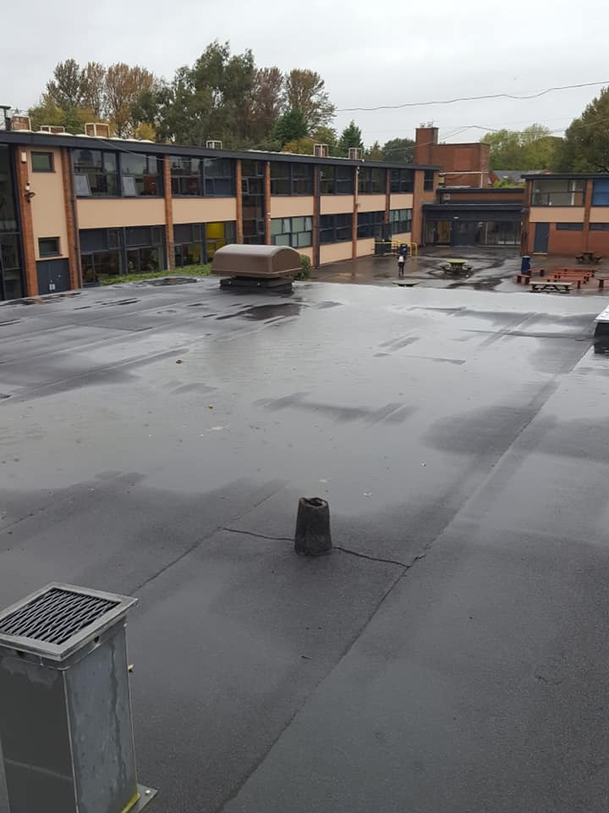
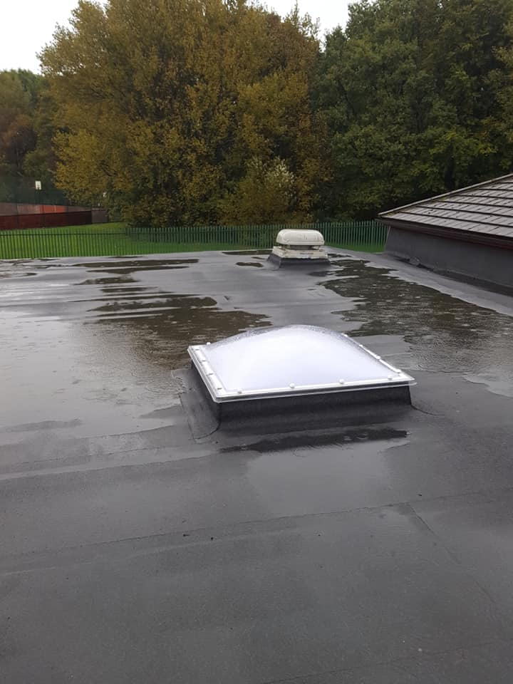
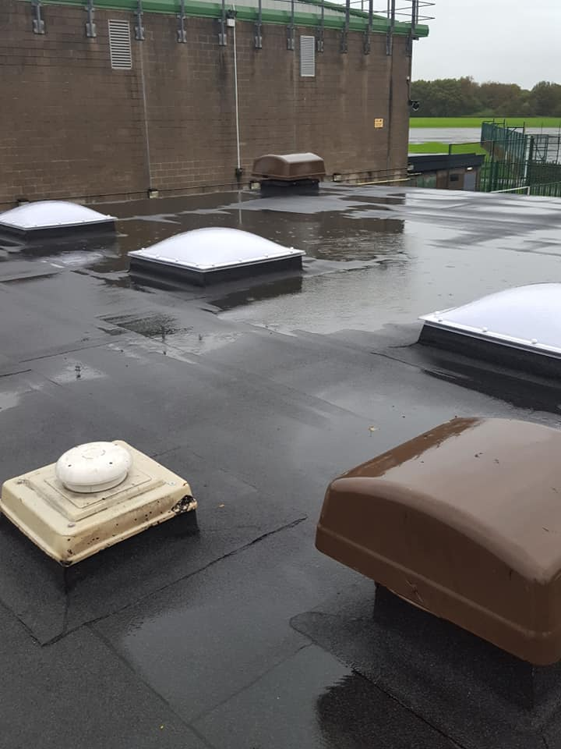

Clarendon Primary School:
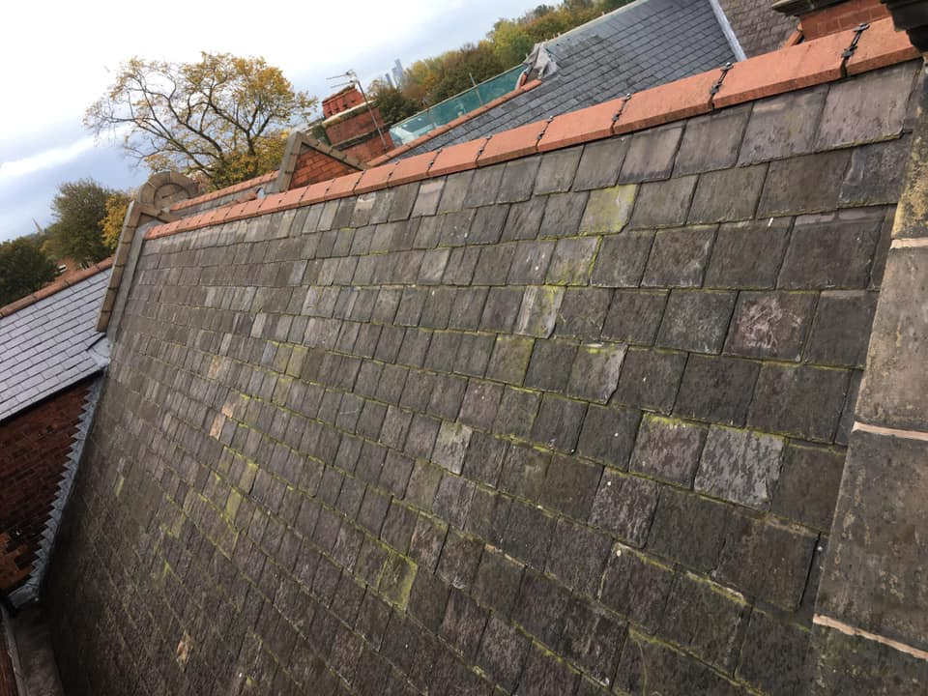
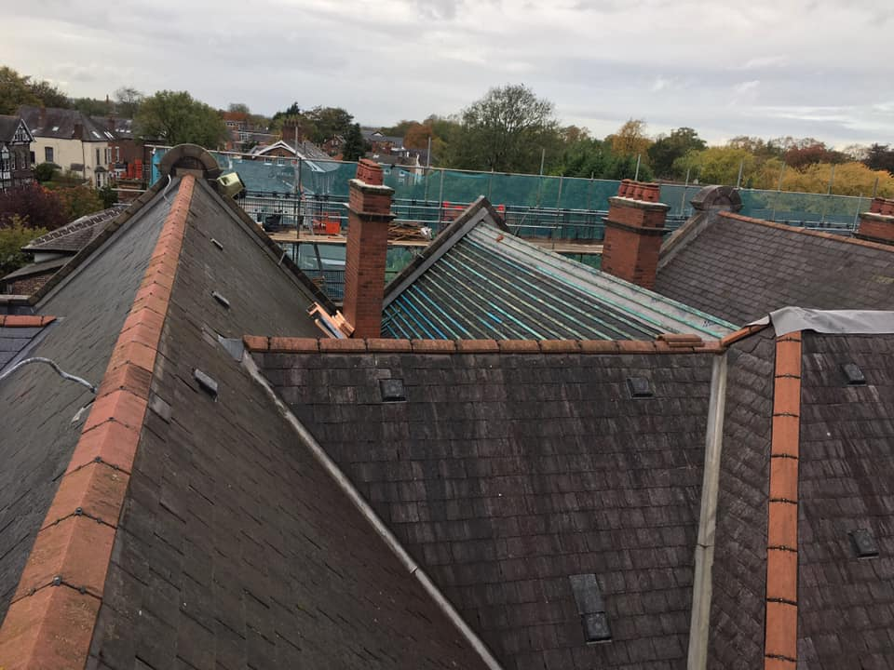

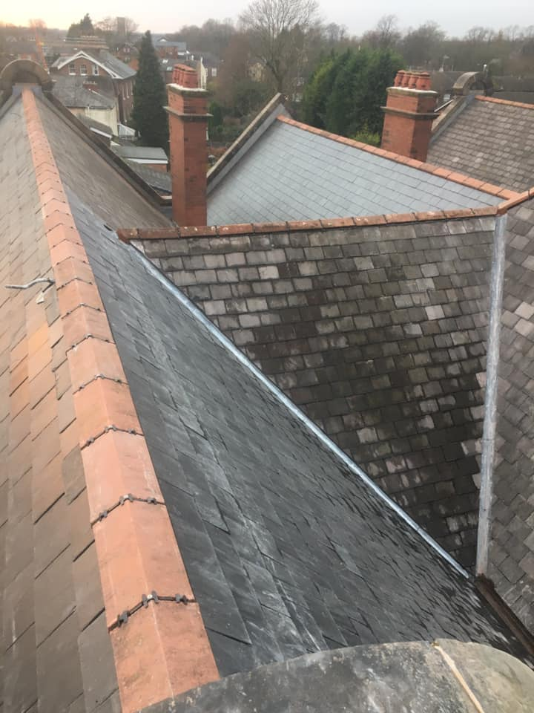
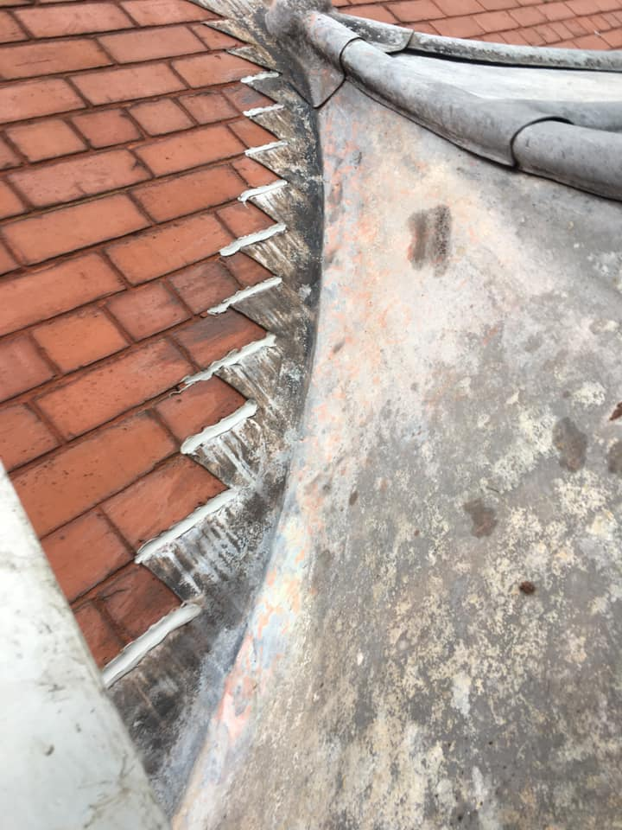
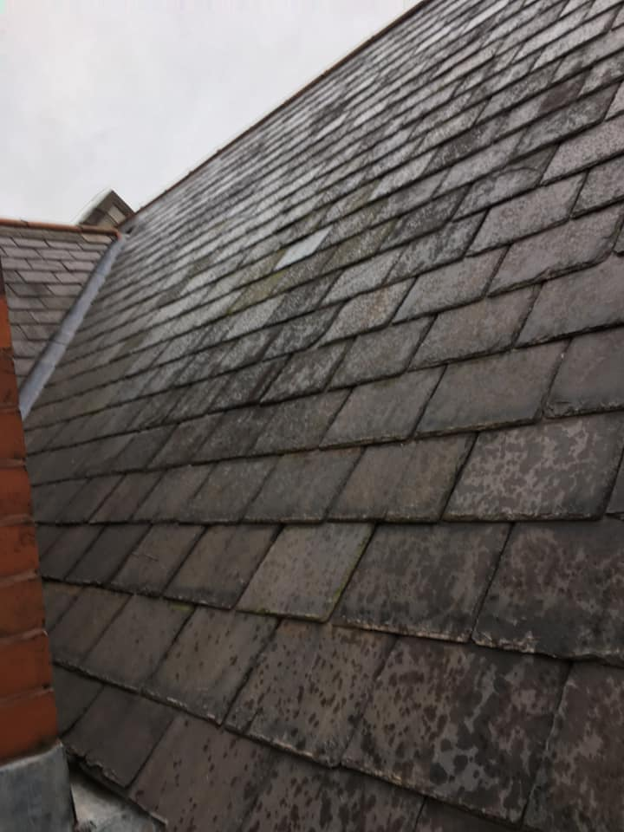

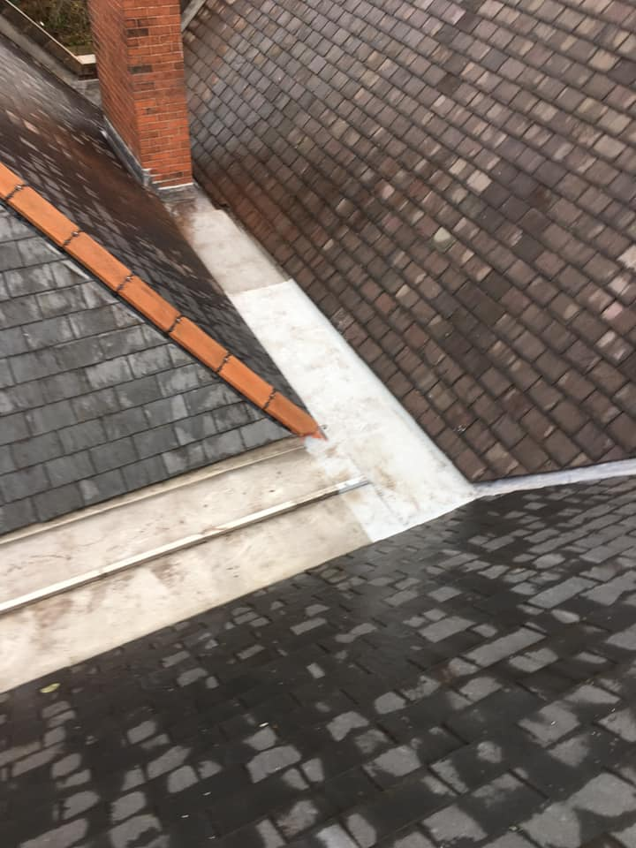
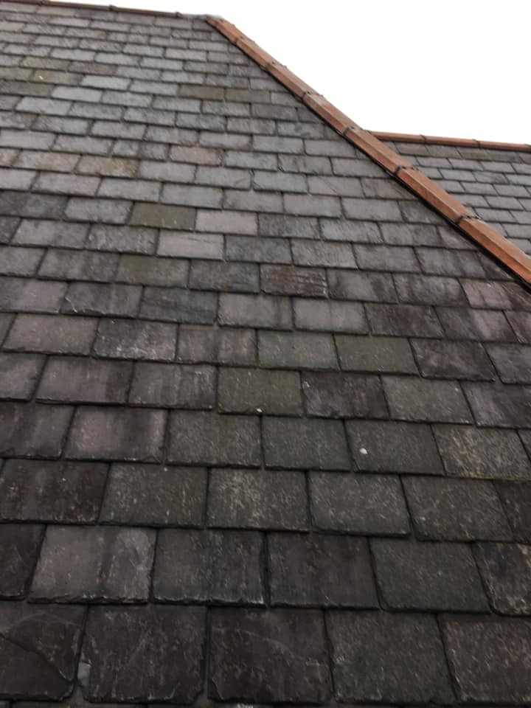
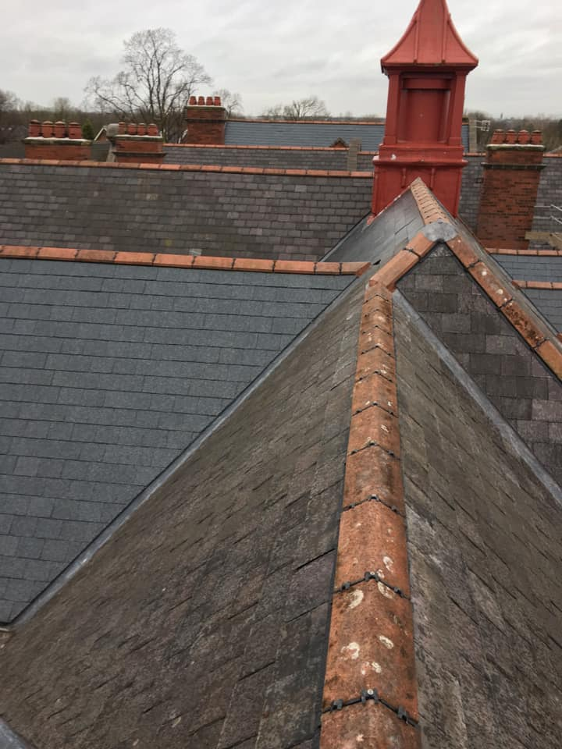

Residential – Strip and Re-Tile:
Chimney to be removed /Strip existing tile and batten /Fit new underlay, tile batten and lead/Remove existing pots & cap
Pre-strip
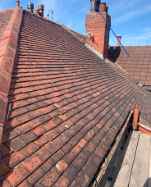
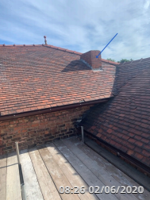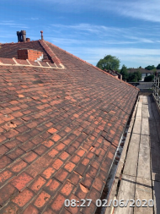

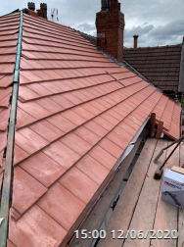
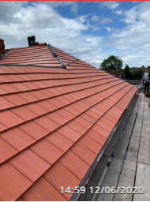
Progress
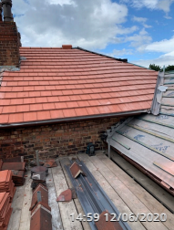
Complete
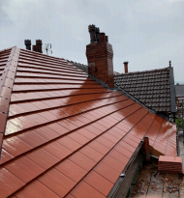
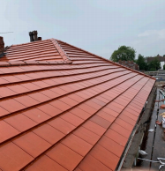
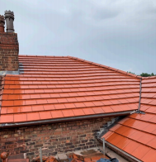

Mobile Engineering Work Platform

We provide a Mobile Engineering Work Platform when required for access on any works that we complete. We also hire out the Platform (including driver/operator) for customers who need access for their own works / surveys. Prices are given at the time of application and are competitive.

Scaffolding

We use the services of expert scaffolding contractors with whom we have built a close working relationship over many years. This means that we can offer a seamless service and arrange any access requirements for all our works. This is a benefit to our customers who can leave all the arrangements to us. We follow all HSE guidelines regarding working at height and all our scaffolding is erected by CISRS qualified and experienced scaffold engineers.
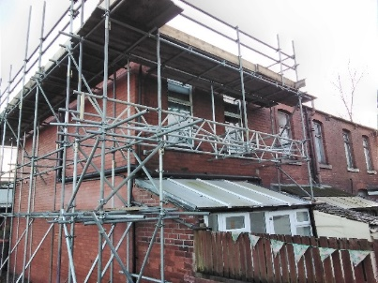
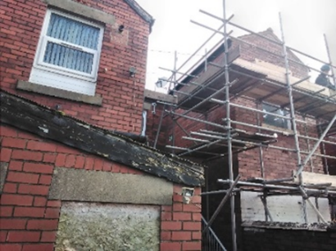

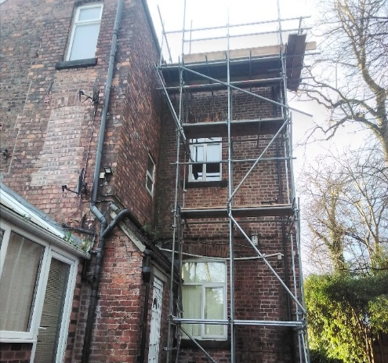
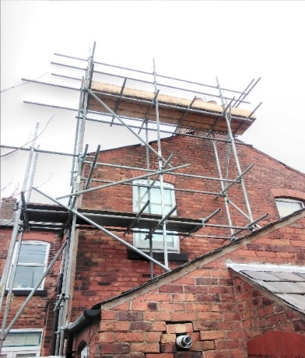

Objectives

At Expert Roofing & Guttering Ltd, we are committed to providing quality customer service and are always working to better ourselves. One of our main objectives is to ensure the customer is happy and satisfied, customer service is a basic quality that can make a huge difference in business performance. From office staff to roofing teams, we aim to provide the best possible customer service.
As a business, we take health and safety very seriously and we are highly focused on the risks that exist in our line of work. We put all our energy into providing a safe environment for both staff and customers.

Company standards and procedures

To ensure that work is being completed to the highest standards, as a business we pride ourselves on customer satisfaction and ensuring that we meet the relevant requirements that are necessary for the nature of our work. To make sure we always meet these high standards, we are highly invested in staff training. All our roofing teams have the skills to complete the work they are given, and our accreditation and training prove this.
When arriving at a work site, we will complete a health and safety check to make sure the site is safe for planned work to begin. If not, the relevant measures will be taken. The work will then be carried out in a safe manner with high consideration and detail being paid to the project. Following completion of works every site will be left clean and tidy with a final check in with the customer before leaving.
Our friendly and approachable office staff work hard to make sure that all back-office processes are running smoothly, this includes providing customers with written quotations and invoices along with being the first point of contact for customer issues or queries.

Accreditation

Expert Roofing & Guttering Ltd is registered on the Wigan Good Trader Scheme with 5-star reviews, the scheme allows customers to leave honest feedback on the service they have received, and the quality of the job completed. We have recently won a mark of excellence award based on our reviews. This demonstrates our focus on service and quality.
We are also meeting the guidelines to be fully trained/accredited with other organisations, including:

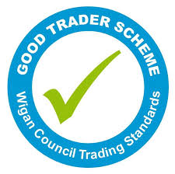

Testimonials

Below are just a few of the reviews that have been left on our review sites:
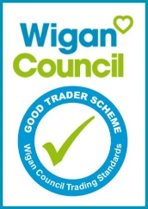
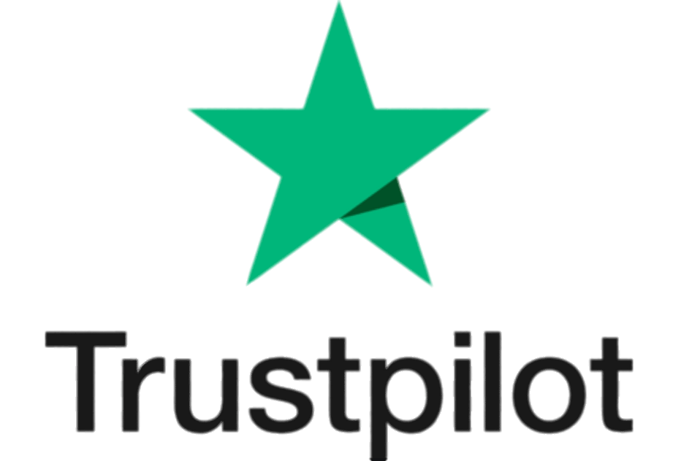

18-Oct-2021
“No hesitation in recommending this business. Legit, genuine company. Very happy with the quality of the work carried out. I was not asked to pay up front only when I was happy job was completed. I was provided with proper paperwork with company address etc.
No issues at all. Thanks expert roofing.”
05-Mar-2021
“Recently had some work completed by Expert Roofing. Professional, efficient and carried out the work to an exceptionally high standard. Couldn't be any happier. Fantastic company.”
30-Oct-2019
“Very professional and helpful. Emma in the office went above and beyond to help me when I had a problem. Thank you so much!”
28-June-2019
“First class quality workmanship , all done to the highest standard. the lads were outstanding they worked so hard everything was precise and professional”.
28-Nov-2018
“Very friendly and helpful. The job on the day needed extra work which was described fully and completed without anything being added to the bill. Top service”
16-May-2018
“I am very happy with the job and the professional way it was done. the builders were excellent and very polite and kept me informed at all times. Very, very happy thank you”.
30-Nov-2017
“Brilliant service, explained what had caused the damage and the leak and gave a step by steps process of how it was to be fixed”
31-Aug-2017
“Great team of lads, work done to great standards, area left clean and in good order. Time scales kept to and maintained. No job too big or too small. would definitely use again and would recommend”.

Contact Information

Our office is open Monday to Friday between 8am and 5pm and we are always happy to help.
For all enquiries, please contact the office via telephone or email.
We can be contacted 24 hours a day, 7 days a week for emergencies only.
Office telephone number: 01942 665512

You can find our office at:
21 Hallgate
Wigan
WN1 1LR

For any enquires outside of office hours, please leave an email at expertroofingsales@gmail.com
Visit our website at www.ergltd.co.uk

You can also find us on Facebook & Instagram by searching for: @ExpertRoofingGuttering

