MASSAGE INTAKE FORM

Name: ____________________________________ Date of Birth: ___________________ Gender: _______

Address: ______________________________________ City: ________________________ Zip: _________

Phone #s - Home: ____________________ Cell: _____________________ Work: ____________________
Email Address: ____________________________ May we contact you for promotional purposes? Yes/No

Emergency Contact: _______________________________ Phone Number: _________________________

Occupation: _____________________________________ Are you pregnant? Yes | No

General Health: __________________________________ Flexibility: None Poor Good Excellent

How did you hear about us? _____________________________________________________________
What is your main reason for our services? Relaxation | Pain Relief | Therapeutic | Other
If you are experiencing pain, please indicate: Sharp | Dull | Throbbing | Other
Where in your body is the pain located? ____________________________________________________
Is the pain: Worse in morning | Worsens during the day | same all the time | Worse at night
Is the pain related to an injury? Yes | No Please specify: _______________________________________
Has the pain been diagnosed by a physician? Yes | No Please specify: ____________________________
Are you presently being treated by a physician or other medical personnel? Yes | No
If yes, please list physician’s name and reason for treatment or problem: ___________________________
______________________________________________________________________________________
Do you have high blood pressure, diabetes or any allergies? Yes | No Please specify: _______________
Are you on any medication? Yes | No Please specify: _________________________________________
This information is useful for the therapist to be more effective in his/her treatment. It is not within the scope of practice of a massage therapist to diagnose; this information is for assessment purposes only and is intended to help you become more familiar and conscious of your health and well-being. Information exchanged during any treatment is kept confidential.
PLEASE FULL OUT BOTH SIDES
Signed: Date:

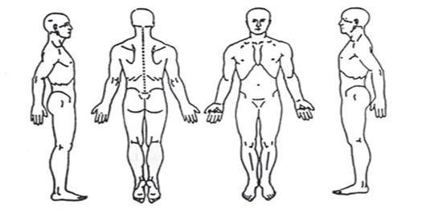
Medical History
In order to plan a massage session that is safe and effective, I need some general information about your medical history.
Are you currently under medical supervision? Yes | No
If yes, please explain:_____________________________________________________________________
Is there anything else about your health history that you think would be useful for your massage practitioner to know to plan a safe and effective massage session for you? ______________________________________
S____________________________________________________________________________
O____________________________________________________________________________
A____________________________________________________________________________
P____________________________________________________________________________
Massage Therapist Signature: ____________________________________________________ Date: ________

