John Colborn

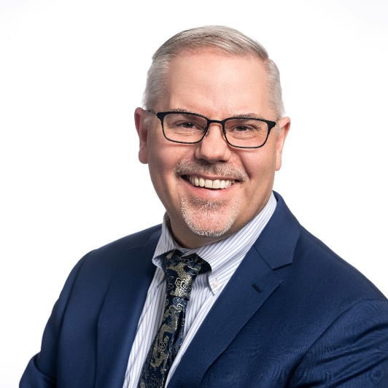 | John Colborn is a consultant working at the intersection of workforce development, human services, and educational achievement to advance life outcomes for disadvantaged people.  His clients include national trade associations, philanthropy, and workforce and education nonprofits.  Previously, John served for six years as Chief Operating Officer of JEVS Human Services, a multi-faceted nonprofit organization serving the greater Philadelphia region. In this role, he oversaw the organization’s efforts to enhance the dignity, independence, and life opportunities for over 25,000 young people and adults annually, directing programs providing education and skills development, job readiness and career services, vocational rehabilitation, recovery services, adult day and residential services, and home care services.  John has amassed over 30 years of experience with community-based and national nonprofits, including the Aspen institute, Ford Foundation, and Philadelphia-based Reinvestment Fund.  Colborn holds a BA from Oberlin College and a Master of Business Administration from the Wharton School at the University of Pennsylvania.  John lives with his husband and their dog, Petey, in Philadelphia.

