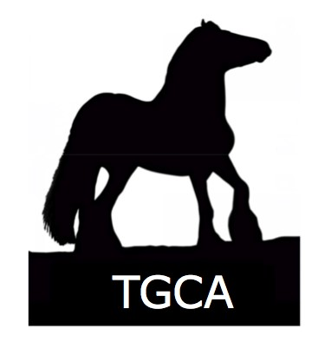
TGCA STUD BOOK UPGRADE FORM
COMPLETE TO:   ADD known breeding and provide a DNA sample to allow Equine to be moved into a higher stud book, subject to current stud book rules
 

Send to: TGCA, PO BOX 1120, CANTERBURY, CT1 9UL, UK

PLEASE COMPLETE SECTIONS 1 AND 6 (IN BLOCK CAPITALS)
 |  | 1 EQUINE DETAILS
Name of Horse:
Date of Birth:
Country of Birth:
Breeder Name & Address: |  | (if known)
Indicate: |  | Mare       Stallion        Gelding 
Colour: |  |  |  | Height at maturity:
Microchip No:
Passport ULEN Number: |  | (not required if you are applying for a new TGCA passport)
2 HORSE OWNER DETAILS

Name: |  |  | Telephone No:
Address:
Email: |  |  | TGCA Membership Number:
APPLICATION FOR:-SUPPLEMENTARY STUD BOOK 2 :
If you are requesting SSB2 passport: then please submit hairs for a DNA profile to be processed.
APPLICATION FOR: -SUPPLEMENTARY STUD BOOK 1:
Please complete section 4 , if your pedigree can be proven please send in DNA profile samples with your application.
Clearly mark the name with each separate DNA sample and submit in separate sample bags

Complete the below pedigree form.

More information regarding stud book levels can be found in TGCA stud book reference guide on the web site

3
P
EDIGREE CHART-for SSB2 & 1 application
Sire:
Grand Sire:
Colour:
Great Grand Sire:
Colour:
Height:
Breed Society:
Great Grand Dam:
Height:
Breed
Grand Dam:
Colour:
Great Grand Sire:
Society:
Height:
Breed Society:
Great Grand Dam:
Name of Your
Horse:
Grand Sire:
Colour:
Great Grand Sire:
Dam:
Colour:
Height:
Breed
Society:
Great Grand Dam:
Height:
Breed
Grand Dam:
Colour:
Great Grand Sire:
Society:
Height:
Breed Society:
Great Grand dam:
4 DNA
A DNA Sample must be supplied with submission of this form
By signing and completing this application form it is understood that you agree to abide by the TGCA membership codes of practice, and DNA profiling procedures, a copy of this is available on request from TGCA Ltd head administration office.
PLEASE COMPLETE SECTION 6
5 REGISTRATION DECLARATION
I HEREBY CERTIFY THAT ALL INFORMATION BOTH ENTERED ONTO THIS FORM AND SUPPLIED IN SUPPORT OF MY HORSE REGISTRATION APPLICATION ARE CORRECT.
Date: |  | Signature*:

6 PAYMENT CALCULATION
Service |  | Please tick | Rate | Amount Enclosed £
Studbook  SSB2:  Entry Fee  SSB1  6 sets of DNA |  |  | Member £40  NON Member £50  Member £45  NON Member £65
DNA Profiling Fee  (required for SSB1 and SSB2) |  |  | members per profile £45  non members per profile £50  per sample
 |  |  | Outside UK postage - £5
If outside UK please add an EXTRA £5 postage |  |  | Total Payable
 | Payment method (please tick)   ONLINE: at http://www.tgca.co.uk/guidesrates.htm  CHEQUE:made out to ‘TGCA Ltd’ and MUST HAVE bank card details on the reverse side  CASH: Please send using recorded delivery |  | Turnaround From receipt of ALL required paperwork and payment:  General 15 -20 working days  .  Refund policy: All refunds will be subject to a £10 administration fee.

PLEASE ENSURE YOU HAVE: COMPLETED THIS FORM IN FULL

- SENT PAYMENT IN FULL Either online or enclosed

- SENT PROOF OF BREEDING & required DNA sample

SEND TO : TGCA Ltd , PO BOX 1120 CT1 9UL
FOR GUIDANCE: Please refer to 'How to Register Your Horse’ stud book structure please see http://www.tgca.co.uk/registeryourhorse.htm
TGC Horse Registration Form 01-01-2018
*

