**Three Wishes Assignment**

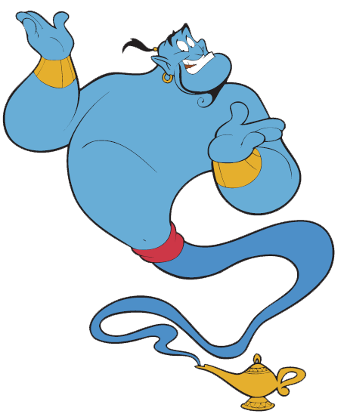

**Part I–Three Wishes**

**First,** watch the following clip from *Aladdin*:

<https://www.youtube.com/watch?v=zB1oTrDyu-c>

In the clip, Aladdin receives several wishes from a genie.

***Miraculously*, you too have just been granted three wishes!**

In order to receive them, you must document them on paper. **However, before finalizing your wishes, think carefully about what you truly want.** What is most important to you and why?

Spend the next 10 minutes brainstorming your wishes before making them final.

Finalize your wishes by following these instructions:

1. Use an 8 ½ x 11 piece of paper
2. Use either portrait or landscape style
3. Include your name and period in the upper left corner of the paper
4. Include a current image of you (not hand drawn)
5. Write out your three wishes and *be specific* when describing them (see my examples below)
6. Include color images that relate to your wishes (if you do not have access to a color printer, hand draw your images)
7. Use creativity and showcase your personality!

**What NOT to do:**

Susan Stegner 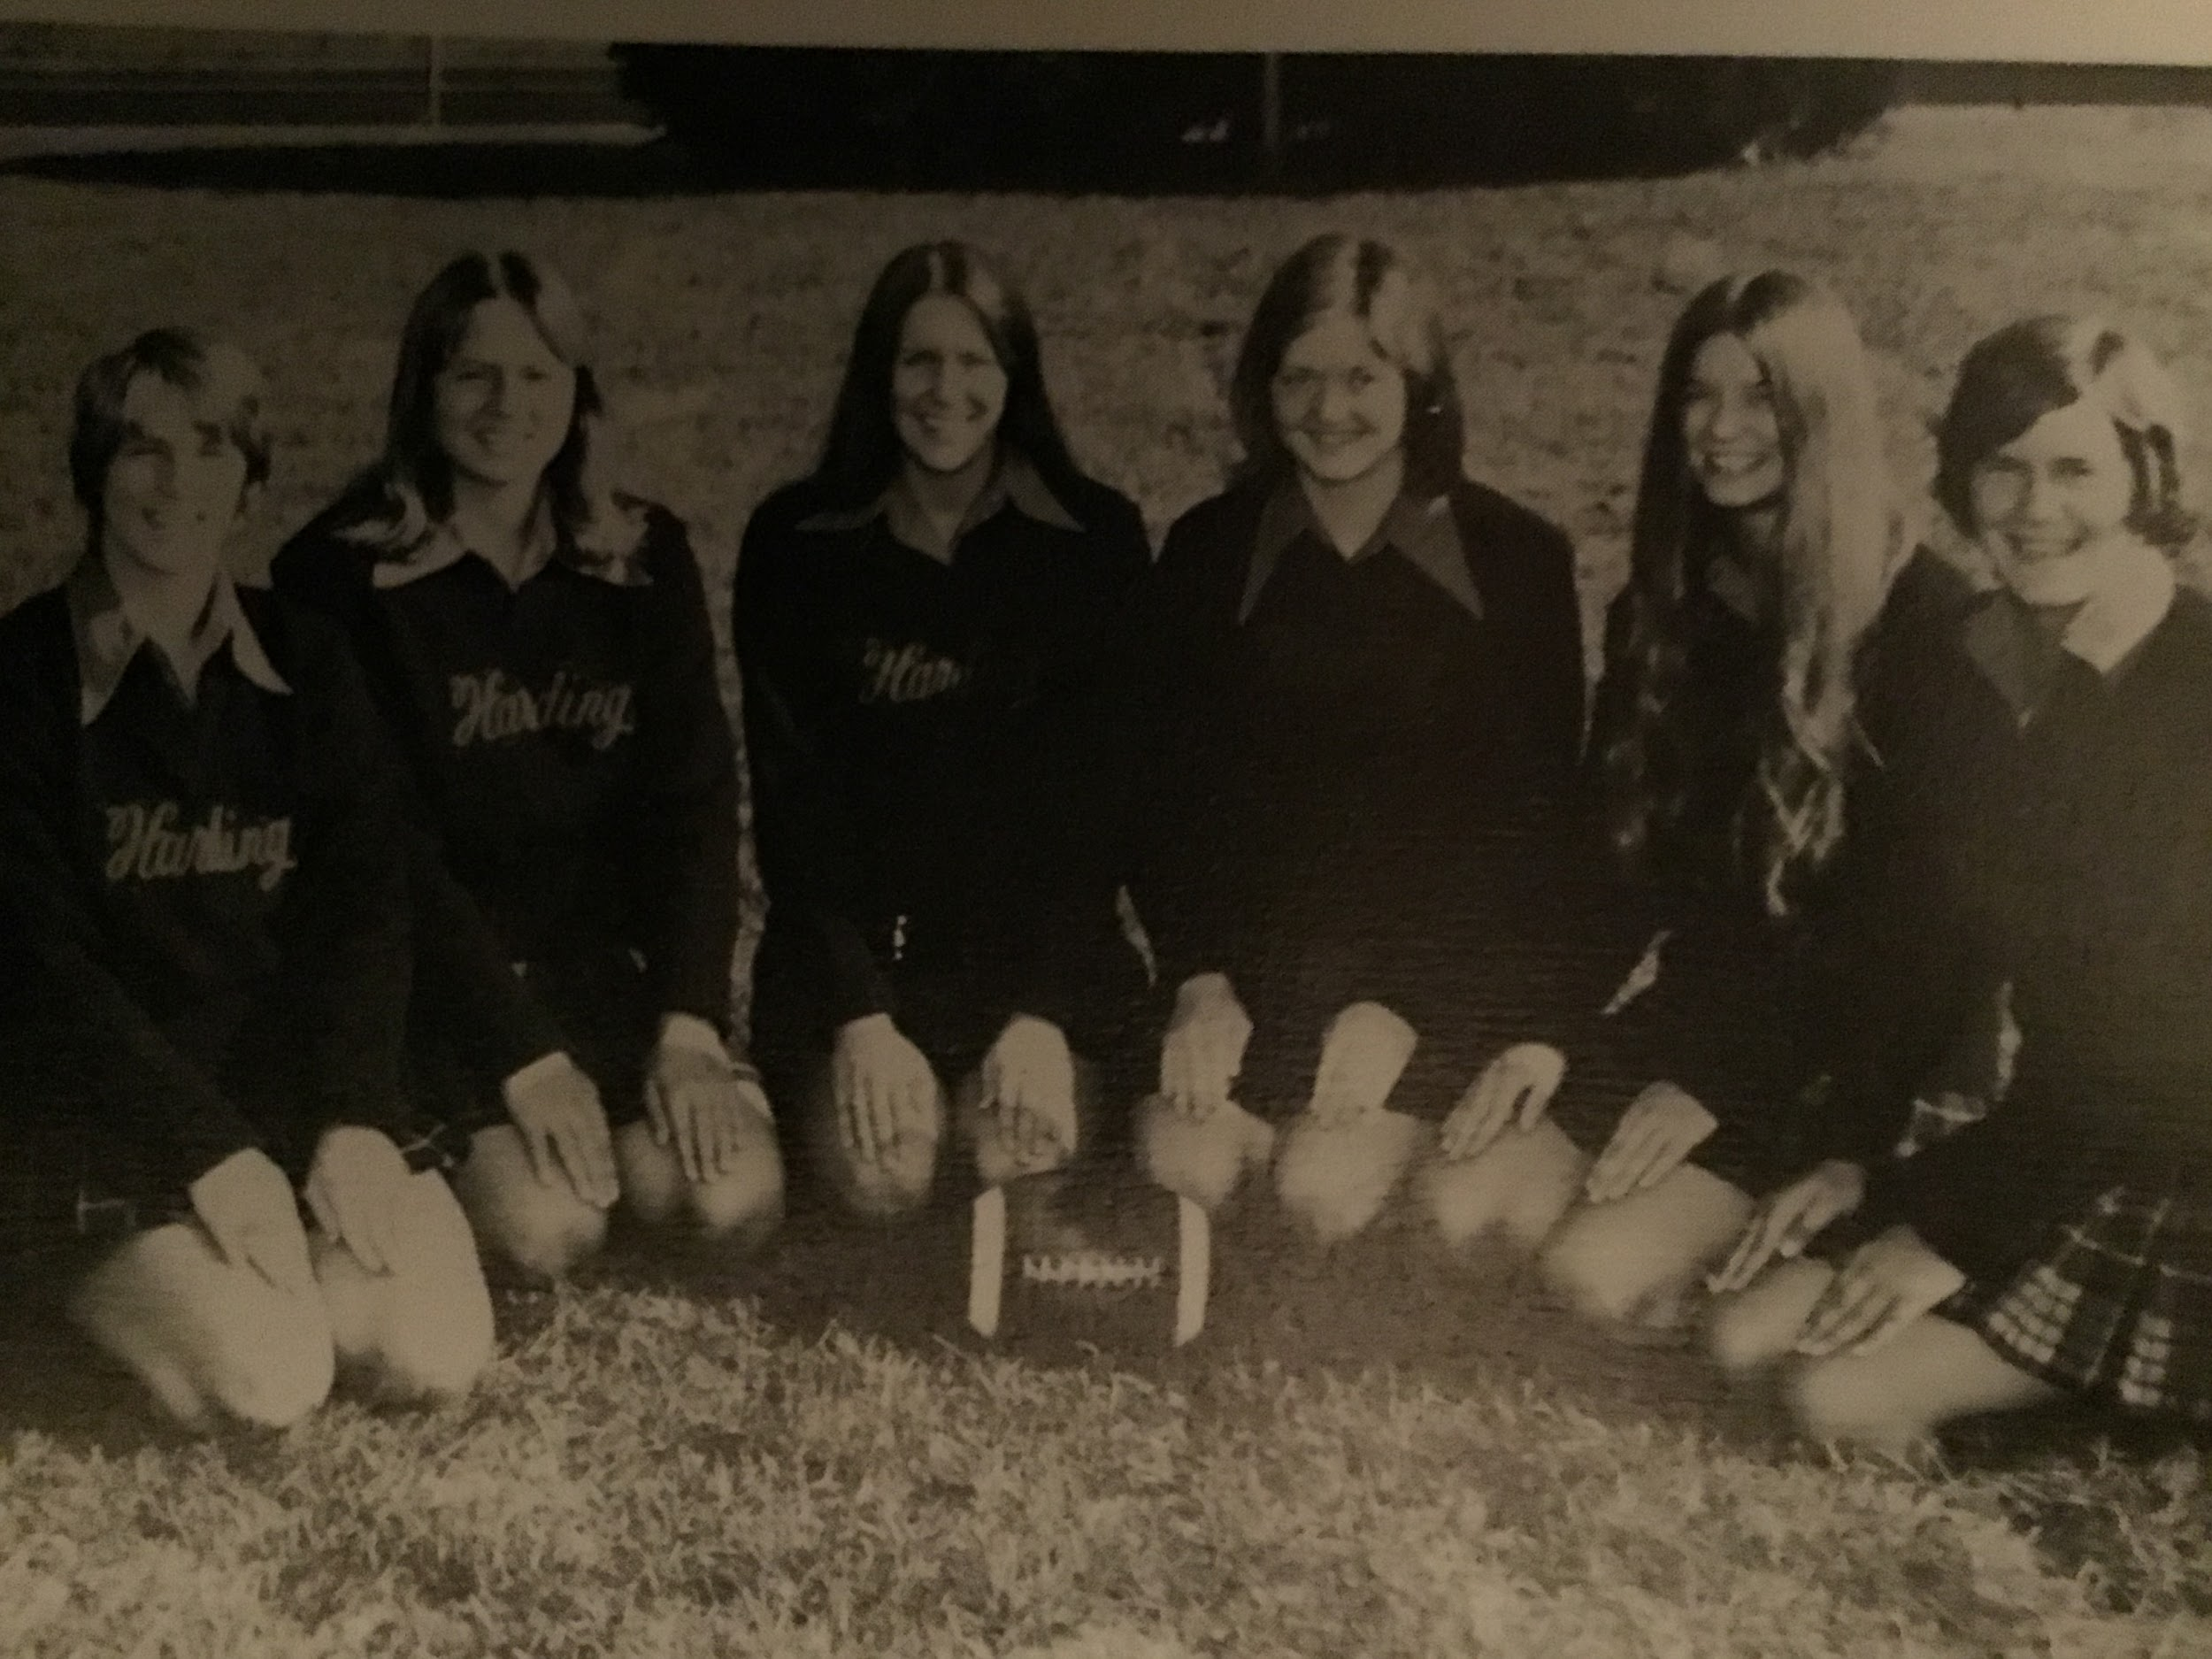

Wish One:

I wish for a cool boyfriend. 

Wish Two:

I wish to go to a great college. 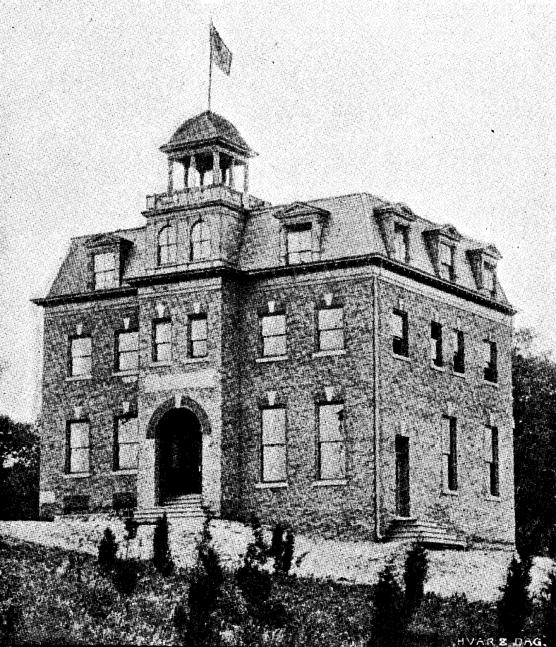

Wish Three:

Good grades. 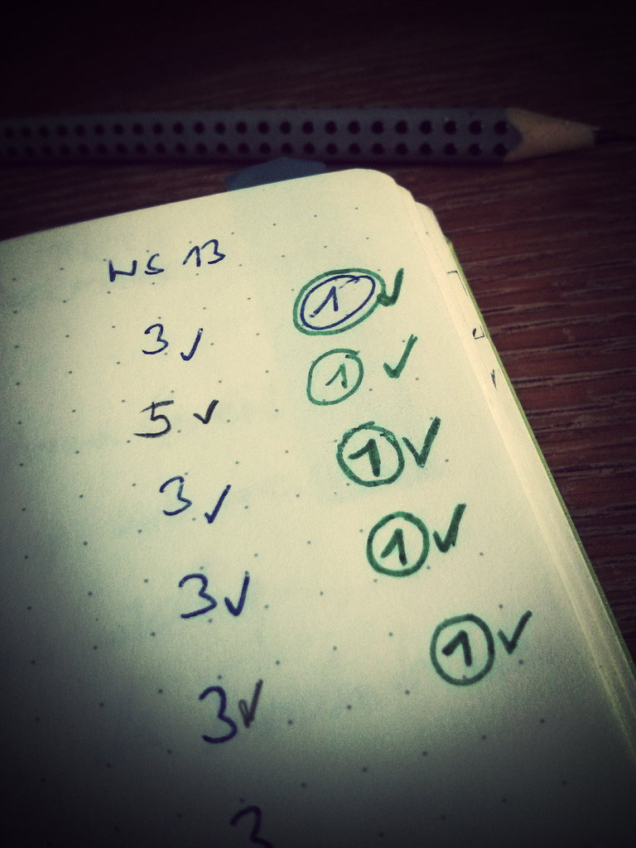

**What TO do:**

Miss Zepeda’s 3 Wishes



**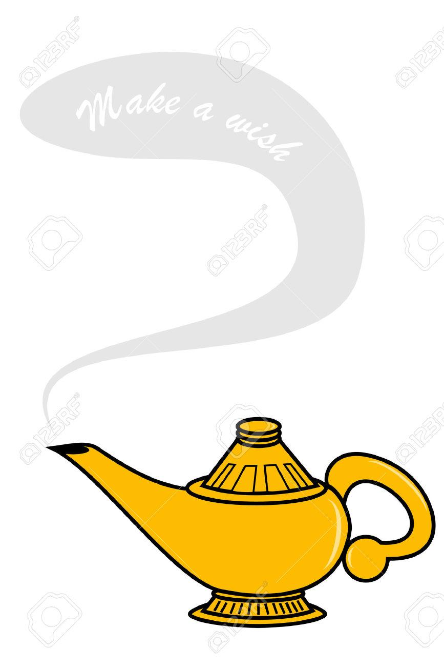*I wish to…*be hired as an English teacher at Tesoro High School next year.**

***I wish to…*have all of my college student loans paid off by tomorrow morning so I can save money for retirement.**

***I wish…*my mom and dad would remain financially, physically, emotionally, and spiritually healthy for forty more years.**

 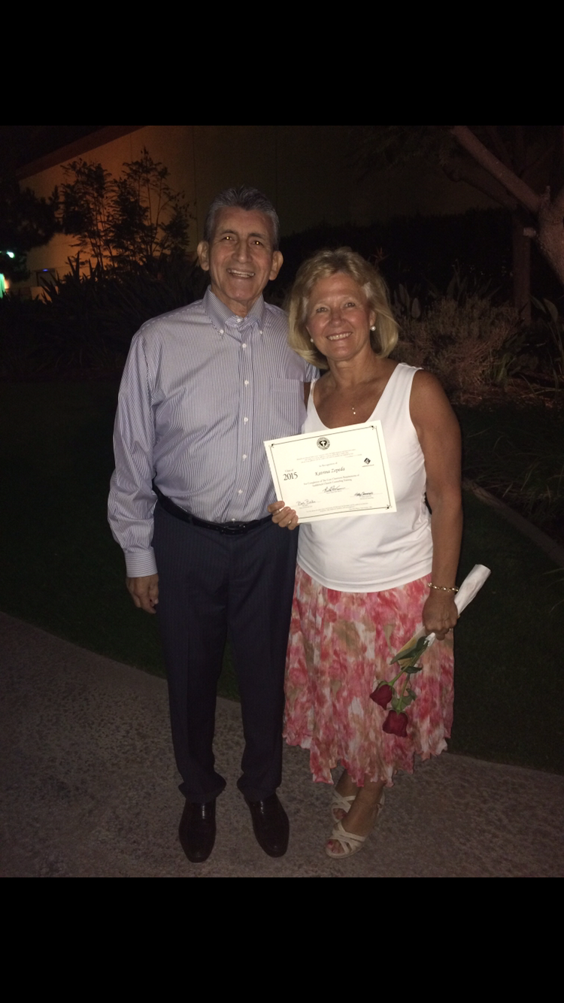 

**Part II–Wish Reflection Paragraph**

Now that you have documented your three wishes, you need to assess yourself based on your wishes. ***Who are you?* *What do your wishes say about your personality or what’s important to you? How will you make your wishes come true? What stands in your way?***

You will write a cohesive paragraph about yourself based on your wishes and criteria from *Habits of the Heart* *and Mind.* Which of the qualities listed below do your wishes reflect? Use your wishes as evidence for the conclusions you draw about yourself. Your paragraph should be a minimum of 8-12 sentences.

PARAGRAPH INSTRUCTIONS:

* A strong topic sentence that reflects what you will cover in the paragraph
* 3 specific wishes
* 3 pieces of evidence from RISE and PRIME (See below).
* Transitions between sentences
* Active verbs and descriptive language
* A sentence that draws a conclusion about who you are.
* Proper grammar and writing conventions

**Habits of the Heart (RISE)**

* **Respect**– The ability to hold others and one’s self in high regard and honor. The ability to recognize the worth and rights of others and one’s self. The ability to demonstrate how personal values influence behavior and a set of principles by which to guide one's life to become better
* **Interact** – The ability to work with others. The ability to make appropriate provisions for accepting and giving support from and to the instructor or other students.
* **Service to the Common Good** – The ability to take ownership of the community we belong to (social responsibility).
* **Engagement** – The ability to take ownership of one’s actions (personal responsibility).

**Habits of the Mind (PRIME)**

* **Precision of Expression** – The ability to explain, describe and show content standards and conventions in an exact and careful manner.
* **Relevance** – The ability to understand meanings and connections between subjects in the classroom to themselves and the world around. The ability to ask “Why does this matter?”
* **Innovation** – The ability to look at and/or create new ways of expressing or thinking about concepts.
* **Metacognition**– The ability to reflect. The ability to think about thinking. The ability to look at and consider concepts, themes and subjects from more than one point of view…even considering and looking at opposing viewpoints.
* **Evidence** – The ability to support or provide proof for an argument, thesis, solution, or point of view.