1st May 2023 Price List ( 1 item * Limited Time Offer )
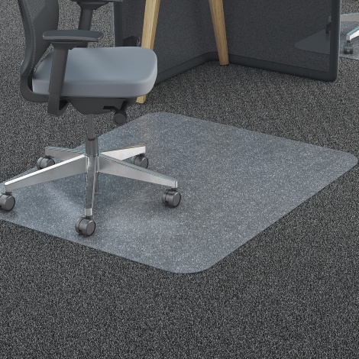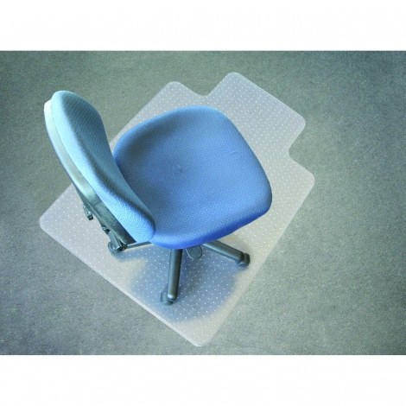
The Full Chair Mat Range from these Top Brands FLOORTEX , JASTEK , MARBIG A great range of products to compliment our BURO Seating range or just to make life better for your Office , Work Space or factory area .
Available in Super Strong Poly Carbonate or PVC for Carpeted and Hard Floor Areas .
Listed is the Basic Info , for Full detail call me for a brochure or visit our Website www.qualitybusinessimaging.co.nz and get all the Specifications , Features and Benefits .
They will give great protection and increase life span for your Carpets and Hard Surface areas , stop chair “ wheel rutting” , legs “spiking “and give your space a cleaner healthier look , are easy clean , while allowing easier access in and out of your chair at the desk :
0331550 FLOORTEX Chairmat Ultimate Poly Carbonate Hard Floor Rectangle 120 x 150cm $283.00
0275620 JASTEK Chairmat Budget PVC Low Pile Carpet Key Hole shape 91 x 122cm $123.00
0275630 JASTEK Chairmat PVC Low Pile Carpet Key Hole shape 114 x 134cm $229.90
0275680 JASTEK Chairmat PVC Medium Pile Carpet Key Hole 91 x 112cm $239.90
49565 JASTEK Chairmat SIT OR STAND Key Hole 91 x 134cm $199.90 LIMITED STOCK on OFFER While stock lasts *
87105 MARBIG Chairmat Carpet DELUXE Key Hole shape 115 x 134cm $279.90
87101 MARBIG Chairmat Carpet DELUXE Key Hole shape 90 x 120cm $234.85
87220 MARBIG Chairmat Carpet DURAMAT Key Hole Shape 90 x 120cm $191.90 LIMITED STOCK While Stock Lasts
87225 MARBIG Chairmat Carpet DURAMAT Key Hole shape 115 x 134cm $208.75
87191 MARBIG Chairmat Carpet Poly Carbonate Rectangle 120 x 150cm $349.90
87190 MARBIG Chairmat Carpet Poly Carbonate Rectangle 90 x 120cm $239.90
87201 MARBIG Chairmat Hard Floor ECONOMAT PVE Key Hole shape 91 x 121cm $195.90
87207 MARBIG Chairmat Hard Floor ECONOMAT Key Hole shape 115 x 134cm $249.90
All prices plus GST .

