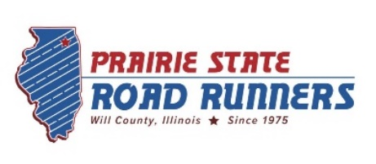
Circuit Race Checklist – 2024

 | Winterfest 5km | Feb 3
 | Frosty 5 mile | Feb 10
 | Manhattan Irish Fest Parade 5km | Mar 2
 | Forge Trail Quarter Marathon | Mar 9
 | Shamrock Shuffle 8k (Credit Only) | Mar 24
 | Springfest 5km | April 16
 | Run for Respect 5km | April 21
 | BeActive NAMI 5km | May 18
 | Braidwood 5km | May 19
 | Annual Membership Picnic!!! | June 2
 | Tinley Park Stars and Stripes 5km | June 30
 | Veterans Liberty Run/Walk 2 mile | July 3
 | Sundowner 5km | Jul 18
 | PSRR Free 5km | Aug 2
 | Will Country Brew Fest 5km (Credit Only) | Aug 24
 | Herscher and Hare 5km | Sept 1
 | Hidden Gem Half Marathon | Sept 7
 | Plainfield Harvest Fest 5km | Sept 29
 | JJC Foundation 5km | Oct 6
 | Forte 5km | Oct 19
 | Gobbler Hobbler 10km | Nov 10
 | Poultry & Pie Predictor (Credit Only) | Nov 28
 | Santa Hustle 5km | Dec 7
 | Club Destination Races (Non-Circuit Races)
 | Galena Sky (Galena) | May 11
 | Bix 7 (Davenport) | July 27
 | Carrera de los Muertos (Chicago) | Oct 27

*Not all dates have been confirmed and are subject to change.

