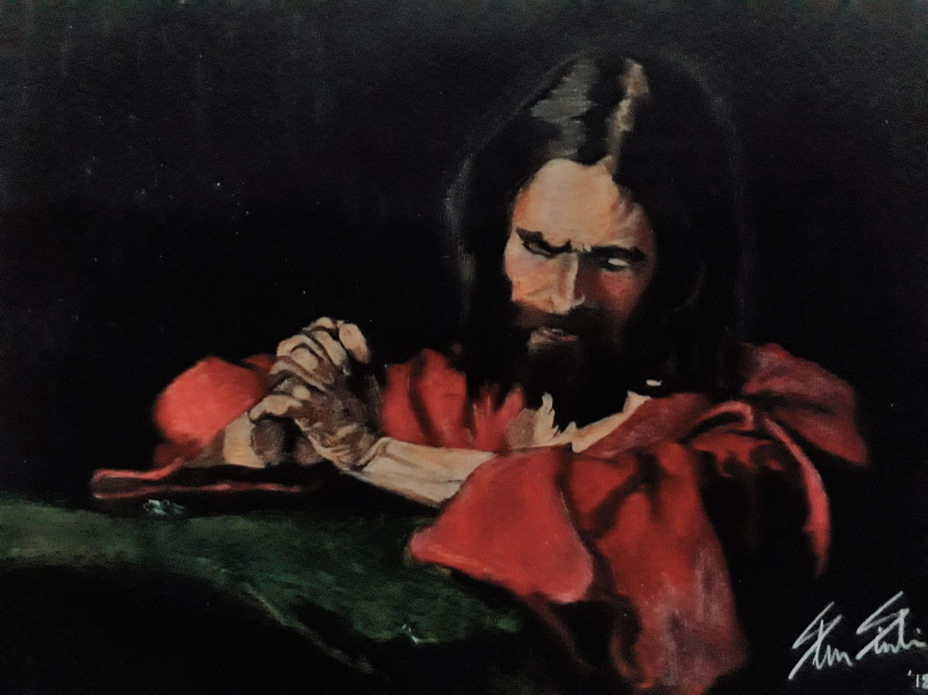

The Savior of the World

Humbly bowed on bended knee,
Filled with love for you and me,
In a garden spot – Gethsemane;
Was the Savior of the World.

The sin we thought was so much fun
Was now upon God’s perfect Son;
Not my will but thine be done,
Said the Savior of the World.

And as He saw the world in sin,
The many souls that Satan would win,
A groan came up from deep within,
The Savior of the World.
Then blood came out from every pore,
To pay the price for evermore,
And open up eternal life’s door,
Through the Savior of the World.

By reaching down He found the heart,
To do God’s will and fulfill His part,
It was not the end, but just the start,
For the Savior of the World.

For now, He daily shows His love for me,
And says, “My child, come follow me.
So we again with God may be.
I’m your Savior; the Savior of the World.”

