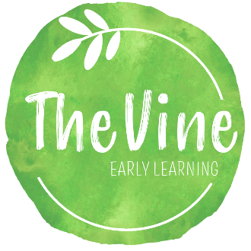
SU00222
NATURE EXPLORATION CONSENT FORM

I/We, _____________________________________________, the parent(s)/guardian(s) grant The Vine Early Learning, Inc. permission to allow my/our child, _____________________________________________ to participate in nature exploration on campus. I acknowledge that such exploration may be spontaneous and unplanned at the discretion of any staff and/or teacher.

By initialing below:
_______ I/We give full consent for my child to participate in nature exploration at The Vine Early Learning, Inc.
_______ I/We do not consent to my/our child participating in nature exploration at The Vine Early Learning, Inc. I/we recognize that in declining my/our consent, my/our child may be asked to join another classroom of different aged children for any number of hours.

_________________________ Date _____________________________________________
Parent/Guardian Signature
_________________________ Date _____________________________________________
Parent/Guardian Signature

Classroom _________________________

