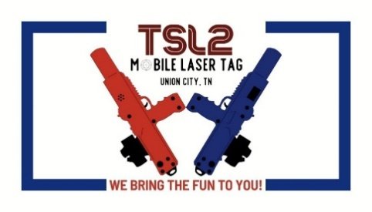
Laser Tag Hold Harmless Agreement and Waiver
Each individual participant (or authorized guardian, if minor) must read and sign this release of liability prior to participating in any laser tag event.
In order to participate in a TSL2 Mobile Laser Tag game or activity, I, the undersigned, agree and acknowledge that there is risk of injury from these activities and/or from the equipment involved.
I freely assume all such risks, both known and unknown, and assume full responsibility for my participation and safety.
I have read and understand the rules, including all safety-related rules, and agree to fully comply with all rules and regulations during my participation. (See Page 2)
I, for myself, and on behalf of my heirs, assigns, personal representatives and next of kin hereby release and hold harmless TSL2 Mobile Laser Tag, their officers, officials, agents, or employees, from any and all liability for injury, disability, death, loss or damage to personal property.
I acknowledge, understand, and agree that I have read this release of liability and assume all risk associated with participating and that I sign this release of liability voluntarily and without inducement.
Player's Name: ___________________________________ Age: ______ Date of Birth: _______________
Home Address: ________________________________________________________________________
Telephone Number: _____________________ Email Address: ___________________________________
Adult Player's Signature: _______________________________________ Date Signed: _______________
Minor Age Participants (under age 18)
All participants under the age of 18 at the time of the event must have a parent or guardian sign below.
I hereby certify that I am the parent or guardian with legal responsibility for the above-signed participant and agree to his/her participation and release and hold harmless TSL2 Mobile Laser Tag, their officers, officials, agents, or employees from any and all liability for his/her injury, disability, death, loss or damage to personal property.
I acknowledge that I have read this release of liability in its entirety and assume all risk for the above-named minor and sign this release voluntarily and without inducement.
Parent/Guardian Signature______________________________________ Date Signed: ______________
Parent/Guardian Name (Print)_____________________________________________________________
Additional Player: ___________________________________ Age: ______ Date of Birth: _______________
Additional Player: ___________________________________ Age: ______ Date of Birth: _______________
Additional Player: ___________________________________ Age: ______ Date of Birth: _______________
TSL2 Mobile Laser Tag Playing and Safety Rules

- Pre-Game Briefing – All players must attend a pregame briefing. This briefing will go over any game borders or safety concerns.

- Laser Tag is a Non-Contact Sport – You are not playing Rugby-tag! Laser Tag is designed to be a non-contact sport. Any purposeful contact with an opponent is grounds for removal from the game. Players who purposefully make contact with their opponents will be considered “out” and will leave the game.

- Laser Tag Sensors Must be Visible during Gameplay – Covering the laser tag sensor to prevent your tagger from receiving tags is poor sportsmanship and any player who covers their sensor will be considered “out” and will leave the game.

- Equipment Failure – If a tagger fails mid-game that player must return to the referee table with the tagger.

- Sportsmanship is Important – If you cheat to win, you haven’t really won! Sportsmanship is essential to a good laser tag experience. Any lying or cheating should not be tolerated and should result in disqualification of the player who does so. Hiding your sensor (see rule #2), or any other dubious acts are against the rules! Nobody likes a cheater!

- Keep Laser Tag Fun – Remember: Laser Tag isn’t currently an Olympic sport, there are no contracts or scholarships on the line. The number one reason to play laser tag is to have fun. Being frustrated or angry is literally against the rules of laser tag. If you feel that way during a laser tag match, take a few minutes, grab a refreshment and get your chill on!

- Bunkers and Equipment – There will be no jumping, climbing, or running into the bunkers. The bunders are to hide behind, not to be used as weapons. Do not move the bunkers.

- Tagger / Laser Tag Gun – The Tagger strap must always be secured around your neck and arm. Taggers are not swords or fighting sticks. (See rule #1) Players will not be allowed to hit or fight with taggers.

- Game Boxes – Game Boxes are not to be moved or tampered with. The only game box players will need to touch will be the Flag boxes.

Penalty for Rule Breaking
Players will get one warning if a player does not follow rules, they will be removed from game play. Depending on the infraction the player could be asked not to return to the game playing area.

