Kids Que Grilling Competition Application

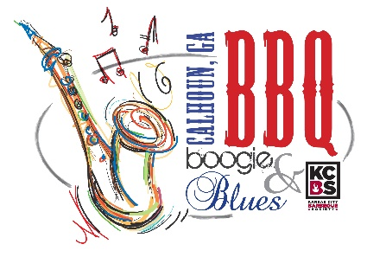
Friday, April 26, 2024

Turn-In Time – 7 p.m.

Kids Cook Meeting – 5:30 p.m. at the Calhoun Depot

For all the future grill-masters in training, this contest is for the little ones ages 15 & under!
Hamburger will be the meat entry and provided to each contestant.
Contestants must provide their own grill.
The child cook should do the preparation, cooking and presentation. One adult will be allowed to assist, but children are encouraged to do as much as possible on their own. Entries will be submitted in the numbered containers provided by organizers. Judging will be on appearance, tenderness/texture and taste. Awards will be presented Friday night.

Child’s Name _____________________________________________________ Date __________________
Adult’s Name ____________________________________________________________________________
Address _____________________________________ City _______________ State _____ Zip _________
Phone ____________________________ Email ________________________________________________

Entry Fee $25 $ ________________

T- Shirt Size (specify youth or adult size) ________________

Mail completed application with fees to: Misty Caudle, P.O. Box 248, Calhoun, GA 30703. Please make checks payable to the DDA.

For questions or additional information, contact Misty Caudle at 706-602-5620.

General Release: Contestant does hereby and forever discharge the Gordon County Chamber of Commerce/Convention & Visitors Bureau, City of Calhoun Government, all sponsoring organizations and their directors, officers, employees, agents and volunteers from all manner of the actions, suits, damages, claims, and demands whatsoever in law or equity from any loss or damage arising out of or in conjunction with application to or participation in the BBQ Boogie & Blues, which is not responsible for any injury sustained by contestants or guests. The undersigned has read and shall comply with all rules of this application and further agrees to notify all members of his/her team about these important rules and assumes full responsibility for team conduct and compliance. Further, I hereby grant full permission to the BBQ Boogie & Blues and/or its agents authorized by them, to use any photographs, video tapes, motion pictures recordings or any other record of the event for any legitimate purpose.

SIGNATURE OF PARENT/GUARDIAN ___________________________________________________

*Prizes will be based on the number of entries.

