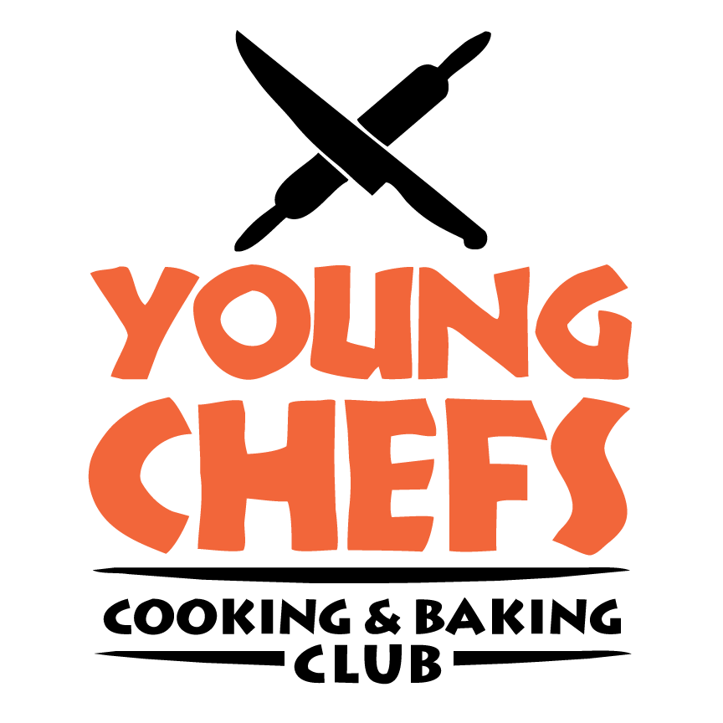
Registration Form 2023
Delicious Occasions “Young Chefs Summer Cooking Classes”

Full payment is required at the time of registration prior to class start time. Class size is limited. Registration is non-refundable. (There will be no exceptions made to this rule because of the very limited number of spots open in these classes.) Registration is taken on a first come, first serve basis.
Dress Code: This will be strictly enforced for the safety of your Young Chefs.
Young Chefs should be dressed comfortably but with safety in mind. No open-toed shoes are allowed; shoes must be closed and slip-resistant. Clothing should not be loose. Hand Jewelry should not be worn. Hair clips or bands for long hair should be worn. Fingernails need to be clean and cut low.
Course being registered for

Young Chefs Beginners _____ Young Chefs International _____ Cookie workshop___
Young Chefs Baking _____ Young Chefs College Edition_____ CupCake workshop____
Young Chefs Gourmet_____ Young Chef Cake Decorating ______
Please submit one form completed by parent or guardian with deposit for each participant
Details of Young Chef
Name (Last, MI, First) _________________________________________________________________________________
Home Address _______________________________________________________________________________________________
Date of Birth _______________________ Gender M / F ____________________
School Attending_______________________________________________________________________________
Parent/ Guardian Contact Information
Name ______________________________________________ Cell/Home Phone _______________________
Work Phone _______________________ E-mail _________________________
Emergency Contact ________________________________________________________________
Relationship _____________________ Cell/Home Phone _______________________ Work Phone
How did you hear about our classes? ___________________________________________________________
Please list all persons authorized to pick up your Young Chef from Cooking
Camp_________________________________________________________________________________________

Emergency Medical Contact Information
Family Physician/Pediatrician __________________________________________________________________________________
Contact Number ____________________________________ Alt. Number (if any) ___________________________________

Staying safe and healthy
While cooking can be a lot of fun it also requires attention and care. Answering the following questions will help us to:
- Be informed
- Staff appropriately to the level of care our students require
- Plan menus!
- Does He/ She have any medical and/or food allergies? ___ yes ___ no
If yes, please list _____________________________________________________________________________________________
- Does He/She have any dietary restrictions (other than allergies)? ___ yes ___ no
If yes, please list _____________________________________________________________________________________________
- Does He/ She have any needs that will require special attention? ___yes ___ no
If yes, please explain __________________________________________________________________________________________
- Please tell us what you, as the parent/guardian, hope for your child to gain from these cooking classes _________________________________________________________________________________________________

Emergency Release
The undersigned person agrees that in case of an emergency at Delicious Occasions Young Chefs Cooking Classes! involving _______________________________ and they are unable to be contacted, the parent/guardian gives permission for staff personnel present to contact the doctor listed above or alternative doctor and permit whatever treatment is deemed necessary by the doctor for the emergency.
_________________________________________________________________________________________________
Name ____________________________________________________________________
Signature _________________________________________
Date ___________________________________
Consent Form, Assumption of Risk, and Release
I hereby authorize , ___________________________________, to participate fully in the Delicious Occasions Young Chef Cooking Classes. In consideration for permission to participate, I do hereby, for myself and my heirs and assigns, and on behalf of my child/ward, and for his or her heirs and assigns, release and agree to identify and hold harmless Delicious Occasions (Latoya Panton), and any of the participating staff, their officers, agents, and employees from any and all liability, loss, claim, demand, action or cause of action which arises or may arise or be occasioned in any way by such participation. I understand that the goal of Delicious Occasions Cooking classes is to provide a safe, fun and enriched environment during class hours. I understand that staff will provide for each individual needs to the best of their ability, but that it is not only impossible, but undesirable to have a staff member constantly overseeing each student. Therefore, given the common dangers and tool use of a kitchen, accidents may happen. I have read the above and understand and agree to its content.
Name __________________________________________________________
Signature ________________________________________
Date _________________________________________

Photo Release
Please check one of the options below:

Yes I do give permission for Delicious Occasions to use photos and videos of my child on its website, social media and advertisements

No I do not give permission for Delicious Occasions to use photos of my child on its website, social media and advertisements.

Child’s name__________________Parent’s Name____________________Signature___
Young Chefs
Summer Cooking Classes

Cooking Survey 2023
All Young Chefs classes are designed to meet the interests and tastes of the students. Please have your young chef complete and return this survey so we can create unique menus just for them.

Name: __________________________________________________________________
My Allergies to food are ____________________________________________________________________________________________________________________________________________________________
My favorite meals and foods are: ____________________________________________________________________________________________________________________________________________________________
My least favorite meals and foods are: ____________________________________________________________________________________________________________________________________________________________
My favorite cuisine is: ____________________________________________________________________________________________________________________________________________________________
In cooking class I would really like to learn:
____________________________________________________________________________________________________________________________________________________________
My cooking experience is:
1 2 3 4 5 6 7 8 9 10
I think I know what a cutting board is I could crush a Master Chef
My eating adventures include:
1 2 3 4 5 6 7 8 9 10
PBJ and Mac and Cheese that were made for me I have conquered sushi and beetroot

