DO NOT let HP update your printer’s firmware!
Some manufacturers are continuing to send your printer updates in order to lock your printer into accepting only HP branded cartridges. These updates are sent to your printer via the internet, usually without you knowing.
Cartridges that were working perfectly, may not work immediately after a refill and this is because of an update from the printer company. Do not fall prey to this, or you will be forced into using their cartridges only.
SOLUTION
If you wish to continue saving money on cartridges, Island Ink Jet & Engraving suggests you change your printer settings to disallow automatic updates. Please take time to do this as soon as possible. For further information please research the internet on how to do this by typing your printer model followed by “disable automatic updates” into the search bar. Worst case, you may have to remove the software from your computer and reinstall it.

Disabling automatic HP firmware updates via the printer's control panel

Please follow the instructions below:
1. Click on the dark blue bar at the top (the one with a setup sign, Wi-Fi sign and an ink drop).
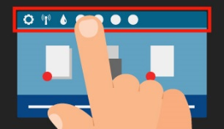
2. A new menu appears. Click on Setup at the top left of the menu.
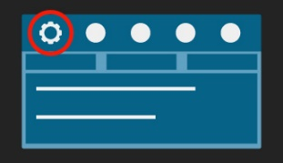
3. The configuration menu will open. Scroll down to Printer Maintenance.
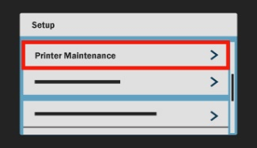
4. Click on Printer Maintenance and then on Update the Printer.
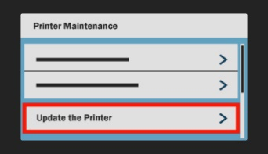
5. Choose Printer Update options and then Do Not Check.
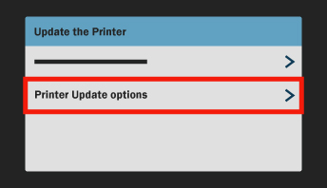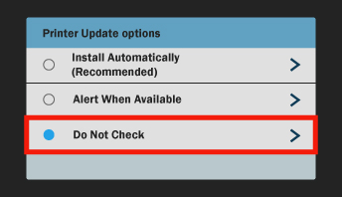

6. Press NO when asked if you want to turn on Printer Updates.
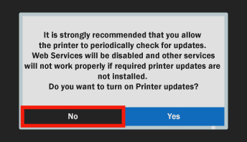
Going forward HP will not be able to alter your firmware and you can continue using Cartridge People Own Brand cartridges without any issues

Disabling automatic HP firmware updates using the control panel on your PC

1. Open HP update option.
- Windows 10: Click Start, click All apps, click HP and click HP Update.

- Windows 8: Choose Windows + Q on your keyboard, type HP Update in the search bar and click
on HP Update in the results list.

- Windows 7/Vista: Click Start, click All programmes, click HP and click HP Update.

- Windows XP: Click Start, click All programmes, click on the HP map and click HP Software Update.

- OS X: Mac uses its own software! No updates will take place via OS X.

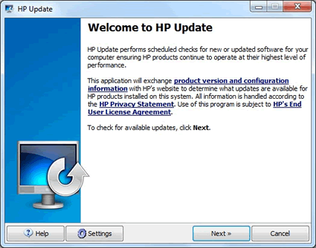
2. Click on the Settings button. The HP Update Settings popup will appear.
3. Select Never and click on the OK button.
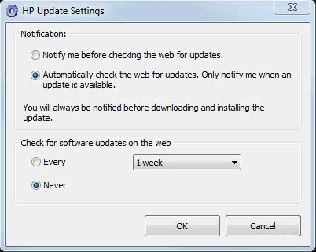
Close the HP Update program by clicking the cross.

